**Exam Request Builder (ERB) Job Aid**

Go to the VA intranet site and navigate to the Job Aids section.

Click on the “Exam Request Builder” link.

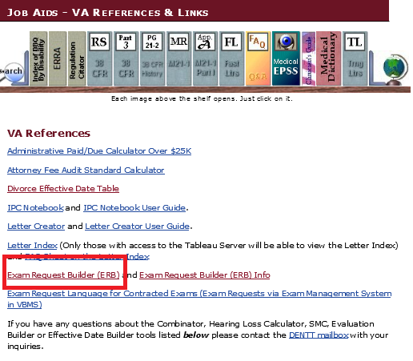

Click on “Run Exam Request Builder”.

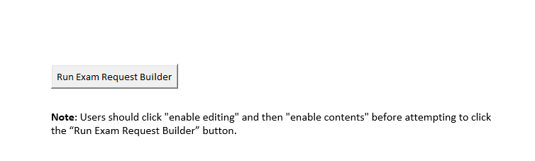

If the Veteran’s profile screen is open in VBMS then the following information can be pulled right from VBMS from selecting the “Import Veteran’s info” button on the bottom left. Otherwise you will have to fill it out.

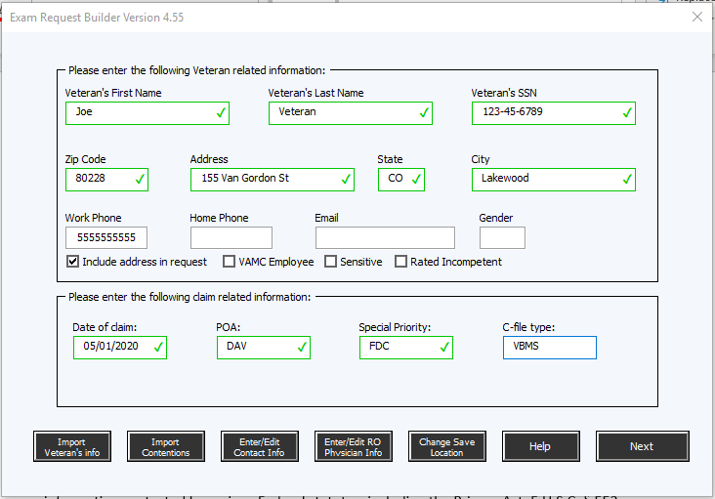

ERB will ask a few yes or no questions such as the 2 below. The veteran only needs to report if he/she needs an in-person examination.

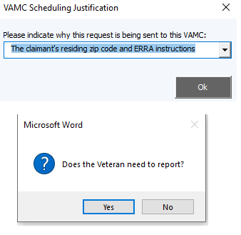

Complete the required fields at the top of the screen and then hit “Add exam.” If you need a mental exam and a medical opinion, then you would select “Yes” when it asks you if you want another exam. Then click the “OK” box

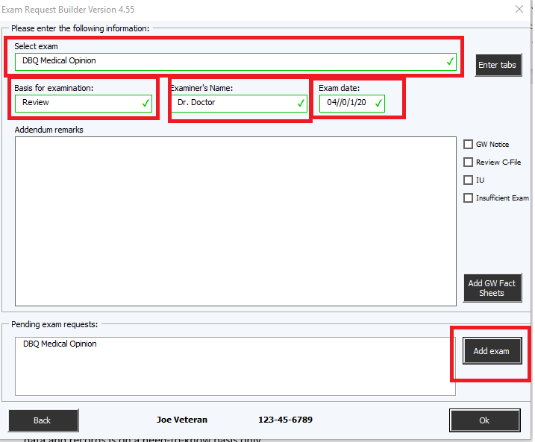

Select “No” for automatically entering in tracked items

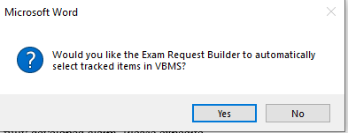

**Then ERB will create your exam request for CAPRI. You will still need to update it. (See the tracked changes below in red):**

Joe Veteran

123-45-6789

Veteran's Contact Information in VBA Systems:

Work Phone: 5555555555

Home Phone:

Email:

Address:

155 Van Gordon St

Lakewood, CO 80228

The Veteran has filed a fully developed claim. Please expedite.

Date of claim: 05/01/2020

Days pending: 20

Attention C&P clinical staff - This exam request was scheduled at your location based on the claimant's residing zip code and ERRA instructions.

These remarks were generated using version 4.55 of the Exam Request Builder (ERB_v_4.55).

**The Veteran does NOT need to report for the following exam(s):**

DBQ Medical Opinion

____________________________________________________________________________

***Addendum only***

***Veteran need not report***

**DBQ Medical Opinion:**

Examiner, please see TAB A, DBQ dated xx-xx-xxxx, in addition to Tab B, evidence dated xx-xx-xxxx, please reconcile the conflicting medical evidence on the Veteran's competency.”

Please direct any questions regarding this request to:

Your name here

Phone number: your phone number here

Email: your email here