**VBMS Job Aid**

Before requesting a medical opinion, the contentions for the claim must be correct. The classification should be “competency” because if administrative issue is used, VBMS will not allow you to request an exam. (administrative issue should be used for contentions that do not require medical opinions such as dependency or COLA adjustments)

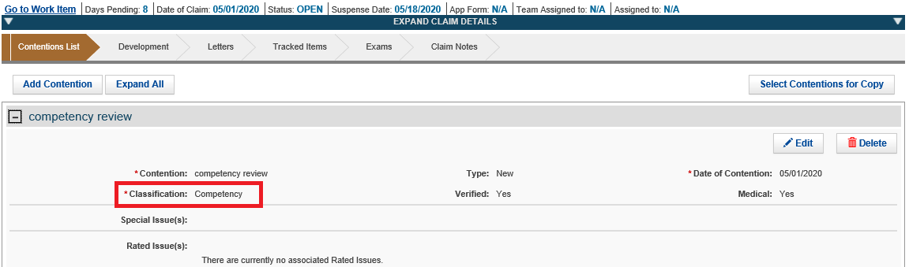

Move to the “exams” chevron and hit “create new request”

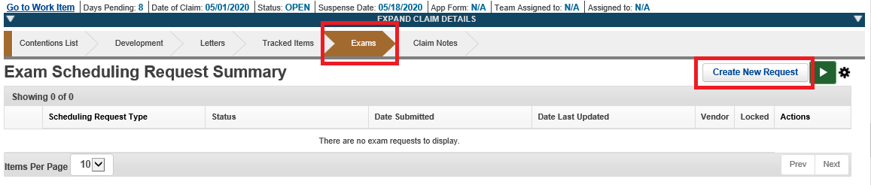

Select your contention (in this case the competency review) and move forward on the exam bar by clicking the “claim information” bar.

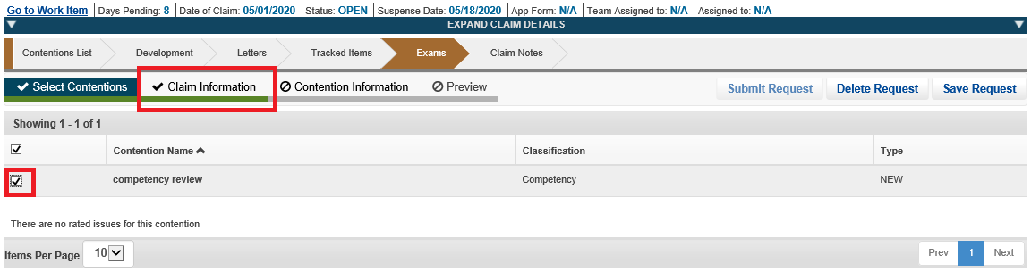

Complete any necessary claim information such as the “Veteran Priority Issues” drop down which would indicate if the veteran had a priority issue such as homeless. At this time, you can also check to make sure the mailing address is correct.

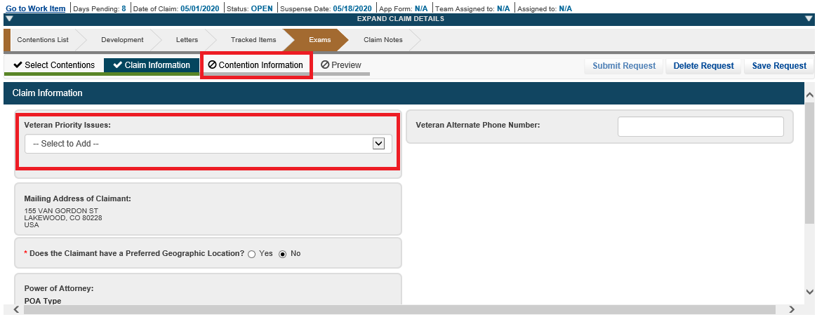

Then complete the “Contention Information” bar. Note, this bar will remain grey until all the necessary information is completed. Once completed, it will turn green.

Select “Ace Eligible” as the veteran does not need to be seen by an examiner for the medical official to review the current evidence and give an opinion.

“Contention Priority Issues” are for contention specific priorities such as 1151 or POW exams.

“Is Specialty Language Needed” drop down should not be needed as it is for claims for compensation and/or pension. For example, you can use this drop down for a direct or secondary service connection.

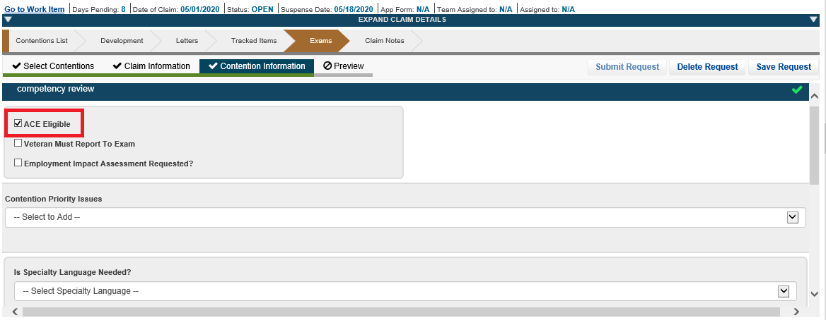

Continue scrolling on the “Contention Information” tab to the box where a DBQ can be selected. If “DBQ Medical Opinion” does not populate automatically on the box on the right, you will need to use the search box on the left. Start typing “medical opinion” and “DBQ medical opinion” should populate and you can select it and then move it to the box on the right by using the arrows in the middle of the page.

Under special instructions is where you will ask the examiner for your specific opinion and reference your bookmarks. An example of a medical opinion is “Examiner, please see TAB A, DBQ dated xx-xx-xxxx, in addition to Tab B, evidence dated xx-xx-xxxx, please reconcile the conflicting medical evidence on the Veteran's competency.”

See manual reference for information on bookmarks

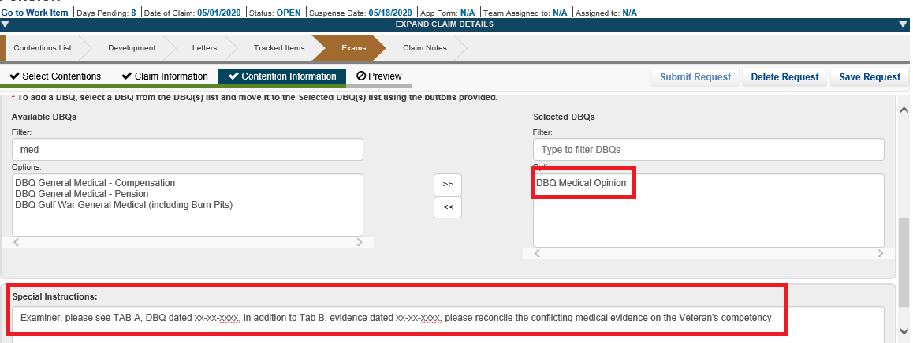

Once the “Contention Information” bar is highlighted green, it means all information on this bar is complete and you are ready to move on. You can select the “Preview” bar. When this is selected, a new tab is opened with a preview with the medical opinion request. Review the request for accuracy. At this time, the request can be changed. When the exam is ready, hit the “Submit Request” button.

Once the medical opinion is submitted, a tracked item will be entered into VBMS.

