

**Pension & Fiduciary Service**

**Inquiry Response Highlights**

**April 2020**

# Table of Contents

Table of Contents 1

**Pension Management Center Related Inquiries** 1

Apportionment Manual Review Question 1

Amended Death Certificate 3

Burial Expense Definition 3

Clarification Request 4

Recognition of Applications to SSA as an Application For DIC 5

**Fiduciary HUB Related Inquiries** 7

Question Regarding Excellent Situation During Use of VVC 7

Clarification on COVID-19 8

**P&F Service Information** 9

P&F Service Contact Information 9

Disclaimer 9

# **Pension Management Center Related Inquiries**

# Apportionment Manual Review Question

**Target Audience**: PMC Claims Processors

**Question**:Can you please clarify the inconsistency between the CFR and the M21-1 in relation to apportionments?

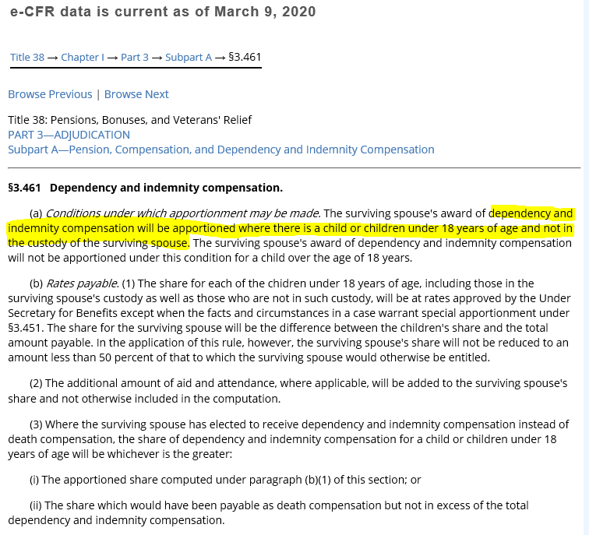

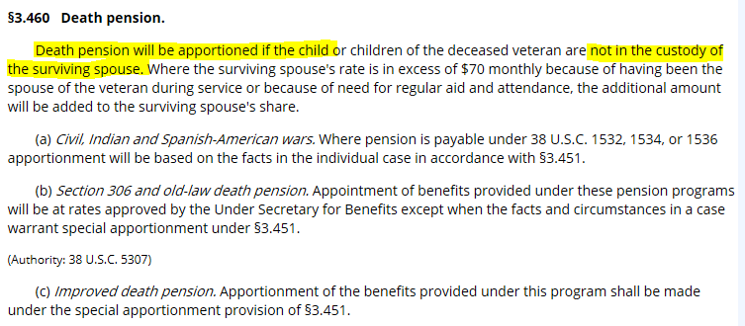

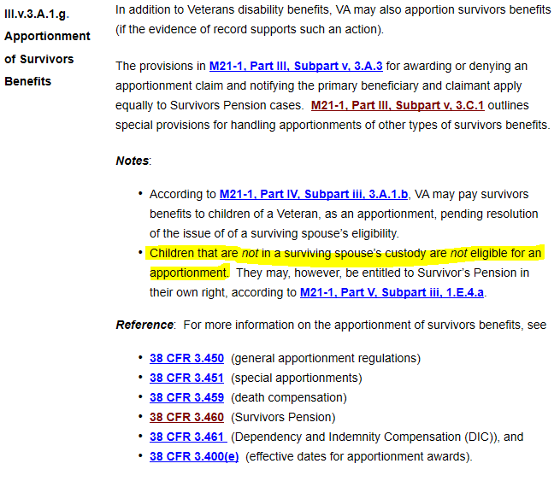

Should III.v.3.A.1.g be updated to match the CFR or is the CFR being updated to match the manual?

**Response**: You are correct that there was a discrepancy between the manual and the CFRs.  The notes section of M21-1, Part III, Subpart v, 3.A.1.g was relocated to M21-1, Part III, Subpart v, 3.A.1.b and modified to state:

* *VA may* ***not*** *apportion a surviving spouse’s current-law Survivors Pension to a child that is not in the surviving spouse’s custody.  (The child, in this case, might be entitled to Survivors Pension in his/her own right.)*
* *The policy described in the previous bullet does* ***not*** *apply if the surviving spouse is receiving Section 306 or Old Law survivors pension.*

**Result:** M21-1 was updated on April 9, 2020.

# Amended Death Certificate

**Target Audience**: PMC Claims Processors

**Question:** There is a discrepancy between PMCs whether an amended death certificate meets the criteria of 38 CFR 3.211.  One PMC considers an amended death certificate acceptable, unless there is reasonable indication of fraud or misrepresentation, without further development or medical opinion.  It is deemed an acceptable document if it is registered in the state or community, signed by coroner or medical officer where the death occurred.  It appears another PMC has a different interpretation of 38 CFR 3.211, requiring a medical opinion to determine service-connection.

References:  38 CFR 3.211, 38 CFR, 3.156, M21-1.IV.iii.1.B.1,  M21-1.I.1.C.4, M21-1.III.iv.2.B.1, M21-1.IV.iii.2.A.1, M21-1.III.iii.5.B.5

Confirmation that our interpretation is correct to improve consistency amongst the three PMCs and reduce rework.

**Response**: [38 CFR 3.211](https://www.law.cornell.edu/cfr/text/38/3.211) establishes the criteria for documents accepted as proof of death. An amended death certificate meets these criteria as it is a public record. Whether or not the amended death certificate establishes service connected (SC) death is a separate determination under [38 CFR 3.303](https://www.ecfr.gov/cgi-bin/text-idx?SID=ec77fe6281362da308b326ca36cccb6b&mc=true&node=se38.1.3_1303&rgn=div8) and [3.312](https://www.ecfr.gov/cgi-bin/text-idx?SID=c29d15a45b6f3790a3e4a9657be1abc8&mc=true&node=se38.1.3_1312&rgn=div8). To determine if additional evidence is needed to resolve a claim for SC death, please refer to [M21-1, Part IV, Subpart iii, 1.B.1.e and h](https://vaww.vrm.km.va.gov/system/templates/selfservice/va_kanew/help/agent/locale/en-US/portal/554400000001034/content/554400000032420/M21-1-Part-IV-Subpart-iii-Chapter-1-Section-B-Dependency-and-Indemnity-Compensation-DIC?articleViewContext=article_view&isFeatured=undefined&topic=undefined) which note what the evidence must show to grant SC death and when a medical opinion is required.

**Result:** Clarification provided.

# Burial Expense Definition

**Target Audience**: PMC Claims Processors

**Question**: The manual reference M21-1 V.i.3.D.3.d. Definition: Burial Expenses, tells us “The term burial expenses includes all normal expenses incident to disposition of the remains of deceased persons.” M21-1 V.i.3.D.3.e. Allowing a Deduction for Burial Expenses, tells us “If an expense would be allowable for purposes of paying VA burial benefits, consider it a burial expense for purposes of final expense deduction”, and is therefore also affected by what should be considered as burial expenses.

Should this reference be interpreted literally to mean expenses only related to the disposition of the deceased person should be considered? Examples of this type of expense include casket and opening of grave. Or are all funeral expenses considered expenses incident to the disposition of the remains (burial expenses)? Expenses in question are those commonly found on funeral receipts such as food, flowers, music, clergy, lead car, limo for transportation of widow, death certificate copies, and newspaper notice. After reaching out to the other PMCs, it seems that we are all interpreting the reference to mean that food, flowers, and music should not be considered expenses incident to the remains of a deceased person. However, if the reference is considered more liberally, it could be interpreted to mean that we should count these expenses as burial expenses.

**Response**: Per [M21-1, Part V, Subpart i, 3.D.3.d](https://vaww.vrm.km.va.gov/system/templates/selfservice/va_kanew/help/agent/locale/en-US/portal/554400000001030/content/554400000014370/M21-1-Part-V-Subpart-i-Chapter-3-Section-D-Reduction-of-Income-Due-to-Unreimbursed-Expenses#3), the term burial expenses includes all normal expenses incident to disposition of the remains of deceased persons.  The reference should be interpreted to mean only expenses related to the disposition of the deceased person such as casket and grave opening.  This does not mean claims processors should develop for a receipt for the sole purpose of verifying the expense except when there is a suspicion of fraud.  When reducing income due to unreimbursed last expenses or paying burial benefits the claims processor can continue to accept the full reported amounts unless a non-burial expense is noted by the evidence of record.

**Result:** Clarification provided.

# Clarification Request

**Target Audience**: PMC Claims Processors

**Question:** The PMC is seeking clarification based on the most recent manual update regarding Recognition of Applications to SSA as an Application for DIC. M21-1IV.iii.3.A.3.a

Is a request to the Social Security Administration (SSA) from a widow for the lump sum death benefits ($255.00), including a phone call reporting the Veteran’s death, sufficient to show intent to apply for Survivor’s Benefits based on VanValkenburg v. Shinseki, 38 CFR 3.153. and 38 U.S.C. 5105(b)?

Yes. The United States Court of Appeals for Veterans Claims (CAVC) in addressing the issue of a jointly prescribed form noted that Congress enacted the Servicemen’s and Veterans’ Survivor Benefits Act (SVSBA) in 1956 with the intent of eliminating the administrative paperwork roadblocks that applicants for Federal surviving spouse benefits had to work through to receive full benefits, and facilitating a streamlined process by which surviving spouses could file an application for benefits at either SSA or VA that would automatically constitute an application for benefits at the other agency.

Currently, there are no Survivor benefit forms that have been jointly prescribed by both agencies. The Court noted further use of electronic and telephonic communication had become more practical and prevalent and notification of death to SSA did not need to result in an award of Survivor’s benefits in order to constitute an application for Survivor’s benefits for DIC effective date purposes. The Court accepted the Secretary’s representation any claim, sufficient to reflect an intent to apply for Survivor’s benefits, that is filed with SSA will suffice to establish the effective date for certain VA Survivor benefits. 38 CFR 3.153, M21-1 IV.iii.3.A.3.a, Van Valkenburg v. Shinseki, and 38 U.S.C. 5105(b).

**Response**: Yes, based on [38 CFR 3.153](https://www.ecfr.gov/cgi-bin/text-idx?SID=892355755094f0d55a7d9b8d5a3c20c5&mc=true&node=pt38.1.3&rgn=div5#se38.1.3_1153), [*Van Valkenburg v. Shinseki*](https://vaww.vrm.km.va.gov/system/templates/selfservice/va_kanew/help/agent/locale/en-US/portal/554400000001034/content/554400000015455/Van-Valkenburg-v-Shinseki-Jul-24-2009-23-VetApp-113), Jul 24, 2009, 23 Vet.App. 113, and [38 U.S.C. 5105(b)](https://www.law.cornell.edu/uscode/text/38/5105), a request to the Social Security Administration (SSA) from a widow for the lump sum death benefits ($255.00)that includes a phone call reporting the Veteran’s death, is sufficient to show intent to apply for Dependency and Indemnity Compensation (DIC) benefits only. Where an intent to apply for survivor’s benefit is demonstrated, per [38 CFR 3.153](https://www.ecfr.gov/cgi-bin/text-idx?SID=892355755094f0d55a7d9b8d5a3c20c5&mc=true&node=pt38.1.3&rgn=div5#se38.1.3_1153), consider the date of an application for survivor’s benefits filed with SSA as a result of the death of a Veteran on or after January 1, 1957, for establishing the effective date for DIC.

**Result:** Clarification provided.

# Recognition of Applications to SSA as an Application For DIC

**Target Audience**: PMC claims processors; PMC Management

**Background**: In reviewing the current manual reference, **M21-1 IV.iii.3.A.3.a. (Recognition of Applications to SSA as an Application For DIC)**, which was updated on January 16, 2020 “*to clarify when to recognize applications from SSA as an application for Dependency and Indemnity Compensation*,” the Milwaukee PMC would like further clarification on certain aspects of this reference, along with whether the response found in the November 2018 FAQ section still apply and how this updated reference relates to the court findings of [Van Valkenburg v. Shinseki](https://vaww.vrm.km.va.gov/system/templates/selfservice/va_kanew/help/agent/locale/en-US/portal/554400000001034/content/554400000015455/Van-Valkenburg-v-Shinseki-Jul-24-2009-23-VetApp-113?query=3.153).  Mainly, we are looking to clarify if VA may accept any type of form filed with SSA requesting survivor’s benefits, as a result of the death of a Veteran on or after January 1, 1957, to establish an earlier effective date for Dependency and Indemnity Compensation (DIC).  The updated manual reference seems contradictory to the findings of [Van Valkenburg v. Shinseki](https://vaww.vrm.km.va.gov/system/templates/selfservice/va_kanew/help/agent/locale/en-US/portal/554400000001034/content/554400000015455/Van-Valkenburg-v-Shinseki-Jul-24-2009-23-VetApp-113?query=3.153), as well as the first response provided in the FAQ section of the November 2018 PMC Bulletin.

**P&F Response dated April 20, 2018 (shown in italics) with Follow-up Questions and Reponses now noted within April 2020 Inquiry Response Highlights:**

***Inquiry 1:*** *Is a request to SSA from a widow for the lump sum death benefit ($255) sufficient to show intent to apply for survivors benefits based on VanValkenburg v. Shinseki and 38 CFR 3.153?*

***Response:****Yes, United States Court of Appeals for Veterans Claims (Court), in addressing the issue of a “jointly prescribed form,” noted that Congress enacted the Servicemen’s and Veterans’ Survivor Benefits Act (SVSBA) in 1956 with the intent of eliminating the administrative maze that applicants for Federal surviving-spouse benefits had to work through to receive full benefits, and facilitating a streamlined process by which surviving spouses could file an application for benefits at either SSA or VA that would automatically constitute an application for benefits at the other agency.*

*The Court indicated that a clear picture of whatever might have constituted a “jointly prescribed form” in the past is now largely ineffective in fulfilling the intent of Congress in passing the SVSBA.  In this context, the Court accepted the Secretary’s representation that any claim, sufficient to reflect an intent to apply for survivor’s benefits, that is filed with SSA will suffice to establish the effective date for certain VA survivor benefits.  Per M21-1 IV.iii.3.A.3.d, this applies to DIC and VA survivors pension.*

***Inquiry 2:*** *Is a surviving spouse’s claim for benefits based on an application for children’s benefits sufficient for application of 38 CFR 3.153 for a surviving spouse’s claim?*

***Response:*** *No, a claim filed by a surviving spouse on behalf of another individual does not constitute a claim by a surviving spouse for their own benefit.*

**Question 1:** May VA accept any type of form filed with SSA requesting survivor’s benefits, as a result of the death of a Veteran on or after January 1, 1957, to establish an earlier effective date for Dependency and Indemnity Compensation (DIC)?

**Response 1**: Yes, consider any application for survivor’s benefits filed with SSA as a result of the death of a Veteran on or after January 1, 1957, to establish an earlier effective date for DIC.

**Question 2**: Does the response found in the November 2018 FAQ section still apply?

**Response 2**: Yes, with the exception of the last paragraph below, which no longer applies:

“A VA Form 21-4182 is required if the Veteran’s death occurred prior to August 6, 2012. For deaths occurring on or after August 6, 2012, a form is no longer required. However, VA still needs to receive some communication showing intent to file for VA survivors’ benefits, submitted to SSA. (38 U.S.C. § 5105)”

VA does not require the receipt of a VA Form 21-4182 to establish an earlier effective date for DIC, irrespective of when the Veteran’s death occurred.

**Question** **3**: How does this updated reference relate to the court findings of Van Valkenburg v. Shinseki?

**Response 3**: M21-1 IV.iii.3.A.3.a was updated on April 23, 2020, to comply with Van Valkenburg v. Shinseki. Notes identifying specific form requirements filed with SSA that were considered necessary to preserve a DIC effective date were removed. As noted in response 1, any claim sufficient to reflect an intent to apply for survivor’s benefits, that is filed with SSA, will suffice to establish the effective date for certain VA survivor benefits

**Question 4**: Please clarify if the date of August 6, 2012 still has any significance, and if so, what that is, and whether VA Form 21-4182 is required if the Veteran’s death occurred prior to August 6, 2012?

**Response 4**: The August 6, 2012 date has no bearing on VA’s establishment of an earlier effective date for DIC based upon a filing of a claim for survivors’ benefits to SSA. As noted in Response 2, VA does not require the receipt of a VA Form 21-4182 to establish an earlier effective date for DIC, irrespective of when the Veteran’s death occurred.

Please note: Section 503 of Public Law 112-154 (August 6, 2012) seemed to codify what VA had represented to the Court of Appeals for Veterans Claims in Van Valkenburg v. Shinseki, 23 Vet. App. 113 (2009), to be its practice of establishing an effective date for DIC based on the date of receipt of a claim for survivors’ benefits by SSA.

**Result:** M21-1 was updated on April 23, 2020.

# **Fiduciary HUB Related Inquiries**

# Question Regarding Excellent Situation During Use of VVC

**Target Audience**: Field Examiners

FPM 2.D.9.c. states the following regarding an Excellent situation:

***Excellent Situation***: Constitutes a situation in which the beneficiary is stable with little change expected in their health, capacity, and lifestyle.  The beneficiary is generally satisfied with their situation and has all of their needs and wants met within their means.  The beneficiary/fiduciary relationship shows no signs of strain.  There are no red flags or common indicators of misuse identified.

Two points of discussion have arisen due to the implementation of VVC exams.

1. We will not have any Excellent situations because we cannot visit the beneficiary face to face. Because we cannot verify the beneficiary’s well-being using a VVC, the situation cannot be Excellent.

2. We can have Excellent situations using VVC exams because a VVC exam is not much different than a Streamlined exam (we have Excellent situation Streamlined exams) and the requirements for Excellent situation mention nothing about seeing the beneficiary face to face or a beneficiary’s home in-person.

Our questions are as follows:

**Question 1**:  While using VVC and telephone exams, are we allowed to still have Excellent situations and schedule future exams as such?

**Response 1**:  Yes; Refer to the April 3, 2020, FAQ (attached) provided by P&F Service, field examiners are to use normal scheduling protocols following a VVC field examination.

**Question 2:** While using VVC and telephone exams, must every exam situation be rated at Good or Poor due to COVID-19?

**Response 2:** No; No change has occurred with protocol for analyzing the beneficiary’s situation when completing a field examination using VVC. Per FPM 2.D.9.c provides a definition of an excellent, good, or poor situation when analyzing the situation of a beneficiary.

**Result:** Clarification provided.



# Clarification on COVID-19

**Target Audience**: Field Examiners

**Question**: Should the COVID-19 statement be placed somewhere specific in the FELUX?

**Response**: P&F Service issued email guidance on March 23, 2020, which provides temporary guidance for documenting telephone and VA video connect (VVC) interviews to ensure continual operational readiness. The guidance can be found at this link: [*Expansion of Temporary Field Examination Protocols- Testing Video Connect*](https://vbaw.vba.va.gov/PENSIONANDFIDUCIARY/pension/docs/Updated_Temporary_Field_Examination_Protocols_3-23-20_Final_.pdf), under the topic of *Documenting VVC Interviews* and includes the following information:

“In the field examination report, the FE must update the INTERVIEW INFORMATION Section to indicate that the interview was conducted using VVC. To do so, the FE must

* add an interview to the field examination report using the QUICK CREATE: INTERVIEW
* indicate the actual date of the interview was completed in the DATE INTERVIEWED field
* select Telephone from the HOW CONTACTED field
* update the NOTES field with the phrase “Completed using the VVC platform”, and
* ensure the information is saved to the field examination report.”

**Result:** Clarification provided.

# **P&F Service Information**

# P&F Service Contact Information

Policy and Procedure questions from the PMCs or Fiduciary Hubs should be submitted to P&F Service at [VAVBAWAS/CO/P&F POL & PROC](mailto:PFPOLPROC.VBACO@va.gov) by the Quality Review coach or PMC/Fiduciary HUB Division Management.

P&F Service would like to remind you that all inquiries sent to the Policy and Procedures Mailbox must include the references previously researched, key words or phrases used to search in CPKM. P&F Service is available to assist when there is confusion about a certain policy or procedure, however, PMCs and Fiduciary Hubs are required to research and attempt to resolve the issue before sending the question to the P&F Service Policy and Procedures Mailbox. Additionally, including all words used to search topics in CPKM will allow P&F Service to add those search words into CPKM if they were not already in the metadata for a certain manual reference.

Training and Quality questions can be directed to: [VAVBAWAS/CO/P&F TNG QUAL OVRST](mailto:PFTNGQUALOVRST.VBACO@va.gov).

Systems-related questions can be directed to: [VAVBAWAS/CO/P&F BUS MGMT](mailto:PFBUSMGMT.VBAVACO@va.gov).

# Disclaimer

Please note that all responses provided are for informational purposes only. If changes to the M21-1 Adjudication Procedures Manual or Fiduciary Program Manual (FPM) are needed, they are made in conjunction with the response. The M21-1 and FPM supersede any inquiry response.