(VSR VIP Pre-D & Post-D) Systems Compliance
Instructor Lesson Plan
Time Required: 1 Hour

Table of Contents

Lesson Description 2
Introduction to Systems Compliance 4
Topic 1: Systems Compliance 5
Lesson Review, Practical Exercise, and Wrap-up 11

Lesson Description
The information below provides the instructor with an overview of the lesson and the materials that are required to effectively present this instruction.
TMS # | 4555291
Prerequisites | None
target audience | The target audience for Systems Compliance is VSR Entry-Level.  Although this lesson is targeted to teach the VSR Entry-Level employee, it may be taught to other VA personnel as mandatory or refresher type training.
Time Required | 1 hour
Materials/  TRAINING AIDS | Lesson materials:  - Systems Compliance PowerPoint Presentation  - Systems Compliance Trainee Handout
Training Area/Tools | The following are required to ensure the trainees are able to meet the lesson objectives:  - Classroom or private area suitable for participatory discussions  - Seating, writing materials, and writing surfaces for trainee note taking and participation  - Handouts, which include a practical exercise  - Computer with PowerPoint software to present the lesson material
Pre-Planning | - Become familiar with all training materials by reading the Instructor Lesson Plan while simultaneously reviewing the corresponding PowerPoint slides. This will provide you the opportunity to see the connection between the Lesson Plan and the slides, which will allow for a more structured presentation during the training session.  - Become familiar with the content of the trainee handouts and their association to the Lesson Plan.  - Practice is the best guarantee of providing a quality presentation. At a minimum, do a complete walkthrough of the presentation to practice coordination between this Lesson Plan, the trainee handouts, and the PowerPoint slides and ensure your timing is on track with the length of the lesson.  - Ensure that there are copies of all handouts before the training session.  - When required, reserve the training room.  - Arrange for equipment such as flip charts, an overhead projector, and any other equipment (as needed).  - Talk to people in your office who are most familiar with this topic to collect experiences that you can include as examples in the lesson.  - This lesson plan belongs to you. Feel free to highlight headings, key phrases, or other information to help the instruction flow smoothly. Feel free to add any notes or information that you need in the margins.
Training Day | - Arrive as early as possible to ensure access to the facility and computers.  - Become familiar with the location of restrooms and other facilities that the trainees will require.  - Test the computer and projector to ensure they are working properly.  - Before class begins, open the PowerPoint presentation to the first slide. This will help to ensure the presentation is functioning properly.  - Make sure that a whiteboard or flip chart and the associated markers are available.  - The instructor completes a roll call attendance sheet or provides a sign-in sheet to the students. The attendance records are forwarded to the Regional Office Training Managers.

Introduction to Systems Compliance
INSTRUCTOR INTRODUCTION |  | Complete the following:  - Introduce yourself  - Ensure that all learners can access the required handouts
time required |  | 0.25 hours
Purpose of Lesson  Explain the following:  Slide 2 |  | This lesson is intended to teach trainees how to accurately update VA systems during the claims process. It will also help refresh the knowledge of those already familiar with the topic.  This lesson will contain discussions and exercises that will allow the trainee to gain a better understanding of:  - Systems Compliance
Motivation  Slide 2 | Reducing the number of Task 11 errors will help achieve better claims processing accuracy resulting in less rework of claims. It will also allow resources to be allocated where they are truly needed, improving timeliness in the processing of Veteran’s claims.
Lesson Objectives  Discuss the following:  Slide 3  Handout 2 | In order to accomplish the purpose of this lesson, the VSR will be required to accomplish the following lesson objectives.  At the end of this lesson, the VSR will be able to:  - Identify all systems compliance elements that must be reviewed on a case  - Recognize errors associated with each systems compliance element
STAR Error code(s) | Task 11
References  Slide 4  Handout 3 | Explain where these references are located in the workplace.  - M21-1, Part III, Subpart ii, 2.B.2.c, Determining the Proper DOC for Claims Establishment Purposes  - M21-1, Part III, Subpart ii, 3.C, System Updates  - M21-1, Part III, Subpart iii, 1.F, Record Maintenance During the Development Process  - M21-4, Appendix B, End Product Codes  - M21-4, Appendix C, Index of Claim Attributes  - M21-4, Chapter 6, Appendix A, VSR Task Based Quality Review Checklist

Topic 1: Systems Compliance
Introduction | This topic will allow the trainee to Identify all systems compliance elements that must be reviewed and their associated errors.
Time Required | 0.5 hours
OBJECTIVES/  Teaching Points  Topic begins on slide 5 | Topic objectives:  - Identify all systems compliance elements that must be reviewed on a case  - Recognize errors associated with each systems compliance element  The following topic teaching points support the topic objectives:  - Date of Claim (DOC)  - End Product (EP)  - Payee’s Address & Direct Deposit Information  - Veteran’s Service  - Power of Attorney (POA)  - Corporate Flashes  - Special Issues  - Contentions  - Tracked Items
Date of Claim (DOC)  Slide 6  Handout 4 | Explain the differences in dates of claim, based on the type of claim:  The date of claim (DOC), for most claims, is the earliest date a VA Facility received the claim; or the day after Release from Active Duty (RAD), also known as “RAD+1,” for Benefits Delivery at Discharge (BDD) claims.  The DOC for matching programs and Work Items is the date shown on the message or, if no date is shown, the date of the review.  The DOC for Due Process is the date the EP is established for the proposed adverse action. The original letter should be generated and released within 5 days of the EP 600 DOC.  The DOC for EP 930 is the same DOC of the underlying EP prematurely cleared or the same DOC of the underlying EP incorrectly processed.

End Product (EP)  Slide 7  Handout 4 | Explain that the following is critical in the allocation of resources and workload management. If EPs are incorrect, resources are not assigned where they are truly needed, and workload will get shuffled around causing delays.  The correct EP and associated claim label should be selected, based on claim type and number of contentions.  Although incorrect claim labels are comments, not a systems compliance error, the correct claim label should be used when available. A list of available claim labels is shown in M21-4, Appendix C.1.b, Index of Claim Labels.  Note: Third digit modifiers are not a systems compliance error.  To change the claim information, click “Edit Claim Detail,” on the claim information screen:  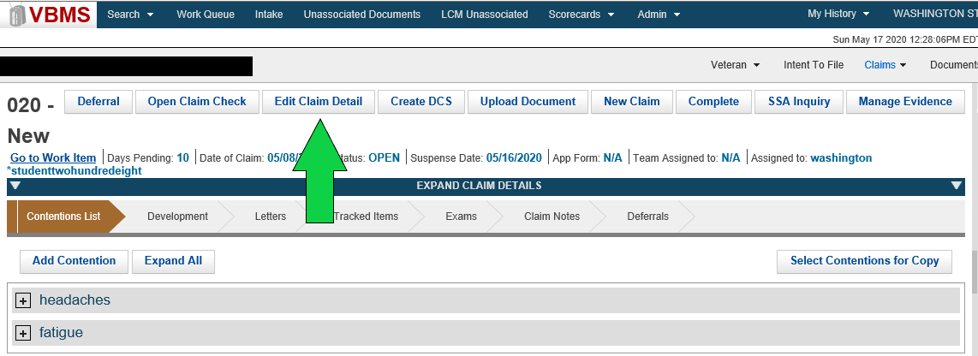
Payee’s Address & Direct Deposit Information  Slide 8  Handout 5 | Discuss the following:  Check the most recently submitted documents, or communication from the Veteran, for current address (including a temporary address) and Direct Deposit (a.k.a. Electronic Funds Transfer (EFT)) information. Ensure they are updated in all systems.  Note: Lack of correct direct deposit information is not an error unless there is a running award.  To change the Veteran’s personal, address, and/or Direct Deposit information, click on the appropriate  [pencil] icon or the “Edit EFT Information” button on the Veteran Profile screen:  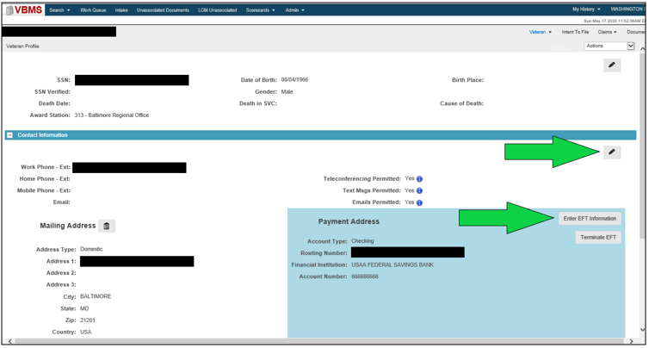
Veteran’s Service  Slide 9  Handout 5-6 | Explain the following:  The Veteran’s service information must be verified and updated in VBMS. Required service periods include:  - All active duty periods associated with the claim  - Active military service by reason of award of SC  Additional specific entry requirements for non-active duty service are discussed in M21-1, Part III, Subpart ii, 3.C.  In VBMS, check the information on the Military Service screen and change if needed (there should be a “Yes” under VADS and/or Verified):  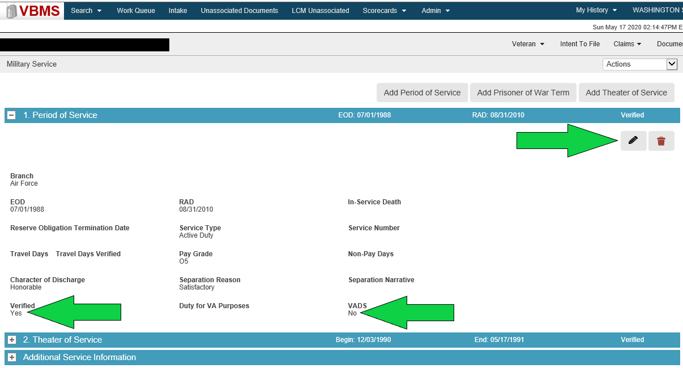
Power of Attorney (POA)  Slide 10  Handout 6 | In addition to the information below, explain that one of the most common Task 11 errors is failure to update the Chg of Addr Auth box and sometimes there’s a glitch in the system clears that box at CEST.  Designation of a POA must be received on an acceptable and complete VA Form 21-22, Appointment of Veterans Service Organization as Claimants Representative, or VA Form 21-22a, Appointment of Individual as Claimant’s Representative. Make sure the correct POA and accesses are reflected in VBMS. Proper revocation of the previous POA is also a mandatory action a VSR must take when processing a claim.  Check the information on the POA screen and change, if needed:  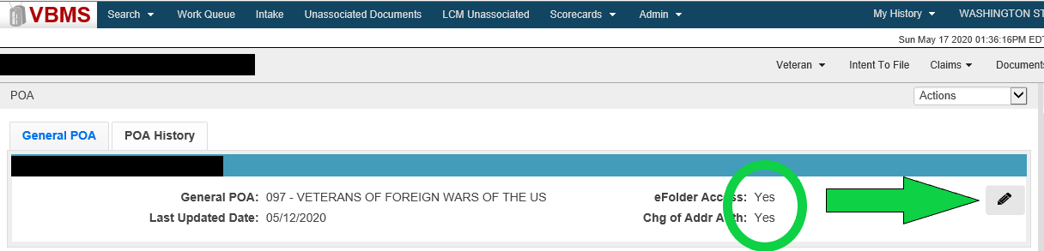
Corporate Flashes  Slide 11  Handout 7 | Corporate flashes are claimant-specific indicators which represent an attribute, fact, or status that is unlikely to change. A corporate flash can either be automatically generated by the system or managed manually by a user. Available corporate flashes not generated by the system must be identified and updated when applicable. Ensure all appropriate corporate flashes are added (e.g. POW, Homeless, Attorney Fee, Restricted Access, etc.). Currently, corporate flashes can only be entered using the Corporate Flashes function in Share:  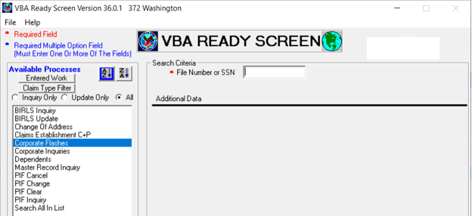

Special Issues  Slide 12  Handout 7 | Special issues are claim-specific or issue-specific indicators and can represent a certain claim type, disability or disease, or another special notation that is only relevant to a particular claim or issue. Special issues must be identified and inputted when applicable. If a special issue exists and applies to the claim or issue, it is required. Common special issues are: Agent Orange, Fully Developed Claim, and Potential Under/Overpayment.  Special issue indicators are found underneath each contention on the Contentions List on the claim information screen. *See the screen shot under “Contentions,” for where to update special issues.  Note: Only designated special issues are errors (M21-4, Chapter 6, Appendix A.d-e).
Contentions  Slide 13  Handout 8 | Discuss that is important to ensure contentions are correct and in the Veteran’s own words.  Identify and confirm each claimed issue under the Contentions List “chevron” on the claim information screen. This includes the contentions, classification, type, date of contention and whether or not is medical. For dependency issues, each claimed dependent must be listed as a separate contention.  Important: The contention classification must be correct for rating contentions, to aid with correct DBQ selection in Exam Management System (EMS).  To change Contention information, go to the “Contentions List” screen and click on the [pencil] Edit icon:  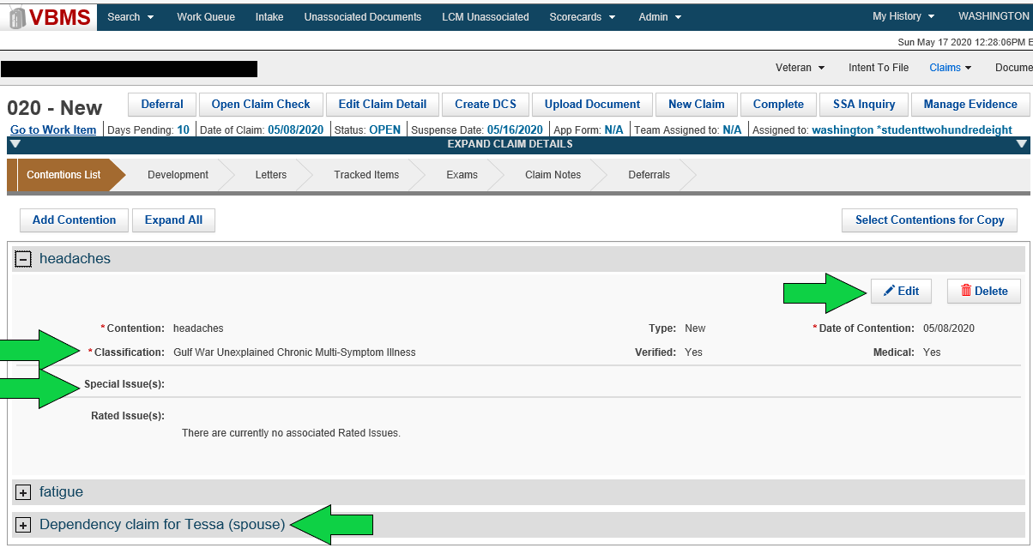
Tracked Items  Slide 14  Handout 8-9 | Tracked Items are required to control receipt, or non-receipt, of all requested evidence. They are not required if tracking is no longer warranted because the records have been received or are unnecessary (e.g. DPRIS records that have been received and uploaded while a VSR is still processing the claim).  Some are created automatically (e.g. after submission of EMS requests and finalization of development letters created in VBMS) and some must be manually entered (e.g. Secondary Action Required for exam reviews, DOMA requests, and PIES requests).  Important: Incorrect use of custom tracked items, unnecessary tracked items, and follow-up vs. extending suspense, are errors.  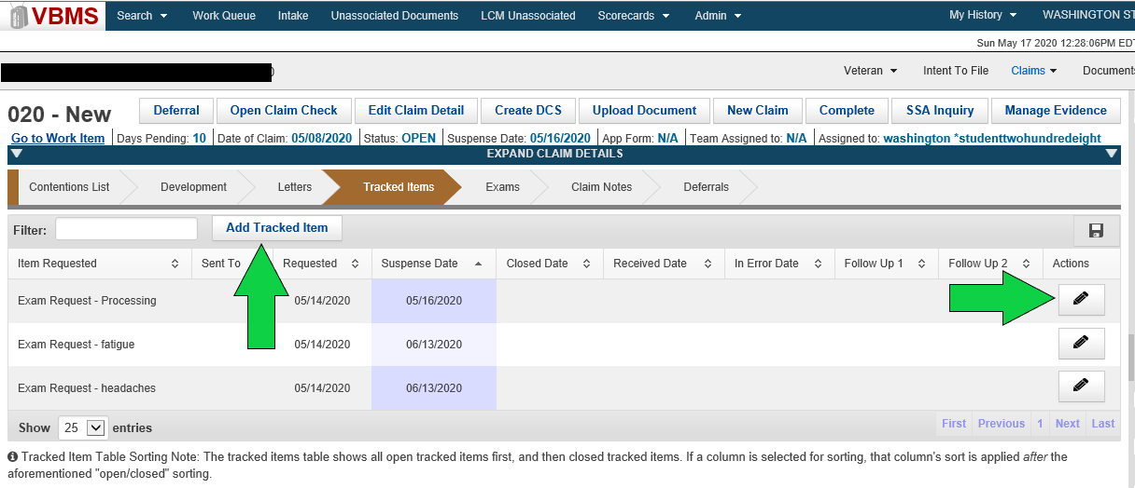
DEMONSTRATION | Demonstrate how to access M21-4, Chapter 6, Appendix A, VSR Task Based Quality Review Checklist, and scroll to Task 11. Also inform trainees that the Task 11 checklist is listed as an attachment in the trainee handout.
Regional Office Specific Topics | At this time add any information pertaining to:  - Station quality issues with this lesson  - Additional State specific programs/guidance on this lesson

Lesson Review, Practical Exercise, and Wrap-up
Introduction  Discuss the following: | The Systems Compliance lesson is complete.  Review each lesson objective and ask the trainees for any questions or comments, then move on to the practical exercise.
Time Required | 0.25 hours
Lesson Objectives | You have completed the Systems Compliance lesson.  You should be able to:  - Identify all systems compliance elements that must be reviewed on a case  - Recognize errors associated with each systems compliance element
Practical Exercise  Handout 11 | Option 1:  Allow the trainees a few minutes to answer the questions.  Ask if there are any questions about the information then proceed to the review.  Option 2:  Ask the questions out loud to the trainees for a group response or call on certain people/offices to answer the question.  Ask if there are any questions about the information presented in the exercise.

