(VSR VIP Pre-D & Post-D) Systems Compliance

Trainee Handout

**Table of Contents**

Objectives 2

References 3

Topic 1: Systems Compliance 4

Attachment A: VSR Task Based Quality Review Checklist -Task 11 10

Practical Exercise 11

Objectives

* Identify all systems compliance elements that must be reviewed on a case
* Recognize errors associated with each systems compliance element

References

* [M21-1, Part III, Subpart ii, 2.B.2.c](https://vaww.vrm.km.va.gov/system/templates/selfservice/va_kanew/help/agent/locale/en-US/portal/554400000001034/content/554400000014119/M21-1-Part-III-Subpart-ii-Chapter-2-Section-B-Claims-for-Disability-Compensation-and-or-Pension-and-Claims-for-Survivors-Benefits#2c), Determining the Proper DOC for Claims Establishment Purposes
* [M21-1, Part III, Subpart ii, 3.C](https://vaww.vrm.km.va.gov/system/templates/selfservice/va_kanew/help/agent/locale/en-US/portal/554400000001034/content/554400000014125/M21-1-Part-III-Subpart-ii-Chapter-3-Section-C-System-Updates), System Updates
* [M21-1, Part III, Subpart iii, 1.F](https://vaww.vrm.km.va.gov/system/templates/selfservice/va_kanew/help/agent/locale/en-US/portal/554400000001034/content/554400000071983/M21-1-Part-III-Subpart-iii-Chapter-1-Section-F-Record-Maintenance-During-the-Development-Process), Record Maintenance During the Development Process
* [M21-4, Appendix B](https://vaww.vrm.km.va.gov/system/templates/selfservice/va_kanew/help/agent/locale/en-US/portal/554400000001034/content/554400000011474/Appendix%20B.%20End%20Product%20(EP)%20Codes), End Product Codes
* [M21-4, Appendix C](https://vaww.vrm.km.va.gov/system/templates/selfservice/va_kanew/help/agent/locale/en-US/portal/554400000001034/content/554400000036570/Appendix%20C.%20Index%20of%20Claim%20Attributes), Index of Claim Attributes
* [M21-4, Chapter 6, Appendix A](https://vaww.vrm.km.va.gov/system/templates/selfservice/va_kanew/help/agent/locale/en-US/portal/554400000001034/content/554400000037939/Chapter%206.%20%20Quality%20Review%20Team%20(QRT)#A), VSR Task Based Quality Review Checklist

Topic 1: Systems Compliance

**Date of Claim (DOC)**

The date of claim (DOC), for most claims, is the earliest date a VA Facility received the claim; or the day after Release from Active Duty (RAD), also known as “RAD+1,” for Benefits Delivery at Discharge (BDD) claims.

The DOC for matching programs and Work Items is the date shown on the message or, if no date is shown, the date of the review.

The DOC for Due Process is the date the EP is established for the proposed adverse action. The original letter should be generated and released within 5 days of the EP 600 DOC.

The DOC for EP 930 is the same DOC of the underlying EP prematurely cleared or the same DOC of the underlying EP incorrectly processed.

**End Product (EP)**

The correct EP and associated claim label should be selected, based on claim type and number of contentions.

Although incorrect claim labels are comments, *not* a systems compliance error, the correct claim label should be used when available. A list of available claim labels is shown in *M21-4, Appendix* ***C.1.b, Index of Claim Labels*.**

***Note:*** Third digit modifiers are *not* a systems compliance error.

To change the claim information, click “Edit Claim Detail,” on the claim information screen:

**Payee’s Address & Direct Deposit Information**

Check the most recently submitted documents, or communication from the Veteran, for current address (including a temporary address) and Direct Deposit (a.k.a. Electronic Funds Transfer (EFT)) information. Ensure they are updated in all systems.

***Note:*** Lack of correct direct deposit information is not an error unless there is a running award.

To change the Veteran’s personal, address, and/or Direct Deposit information, click on the appropriate  [pencil] icon or the “Edit EFT Information” button on the Veteran Profile screen:

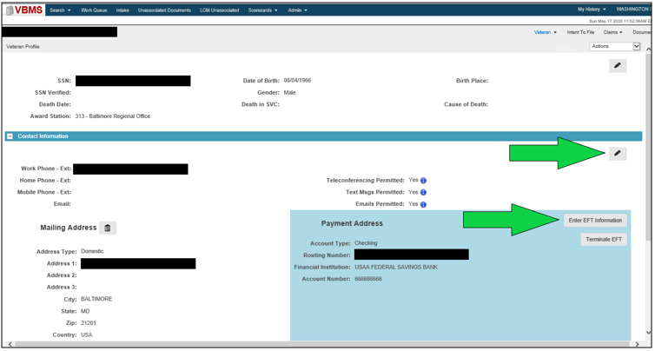

**Veteran’s Service**

The Veteran’s service information must be verified and updated in VBMS. Required service periods include:

* All active duty periods associated with the claim
* Active military service by reason of award of SC

Additional specific entry requirements for non-active duty service are discussed in *M21-1, Part III, Subpart ii, 3.C.*

In VBMS, check the information on the Military Service screen and change if needed (there should be a “Yes” under VADS and/or Verified):

**Power of Attorney (POA)**

Designation of a POA must be received on an acceptable and complete *VA Form 21-22, Appointment of Veterans Service Organization as Claimants Representative*, or *VA Form 21-22a, Appointment of Individual as Claimant’s Representative*. Make sure the correct POA and accesses are reflected in VBMS. Proper revocation of the previous POA is also a mandatory action a VSR must take when processing a claim.

Check the information on the POA screen and change, if needed:

**Corporate Flashes**

Corporate flashes are **claimant**-specific indicators which represent an attribute, fact, or status that is unlikely to change. A corporate flash can either be automatically generated by the system or managed manually by a user. Available corporate flashes not generated by the system must be identified and updated when applicable. Ensure all appropriate corporate flashes are added (e.g. POW, Homeless, Attorney Fee, Restricted Access, etc.). Currently, corporate flashes can only be entered using the Corporate Flashes function in Share:

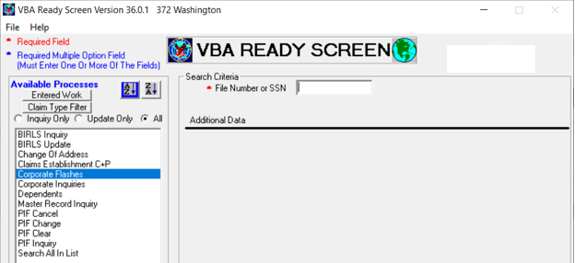

***Note:*** Only designated corporate flashes are errors (*M21-4, Chapter 6, Appendix A.d-e*).

**Special Issues**

Special issues are **claim**-specific or ***issue***-specific indicators and can represent a certain claim type, disability or disease, or another special notation that is only relevant to a particular claim or issue. Special issues must be identified and inputted when applicable. If a special issue exists and applies to the claim or issue, it is required. Common special issues are: Agent Orange, Fully Developed Claim, and Potential Under/Overpayment.

Special issue indicators are found underneath each contention on the Contentions List on the claim information screen. *See the screen shot under “Contentions,” for where to update special issues.

***Note:*** Only designated special issues are errors (*M21-4, Chapter 6, Appendix A.d-e*).

**Contentions**

Identify and confirm each claimed issue under the Contentions List “chevron” on the claim information screen. This includes the contentions, classification, type, date of contention and whether or not is medical. For dependency issues, each claimed dependent must be listed as a separate contention.

***Important:*** The contention classification must be correct for rating contentions, to aid with correct DBQ selection in Exam Management System (EMS).

To change Contention information, go to the “Contentions List” screen and click on the  [pencil] Edit icon:

**Tracked Items**

Tracked Items are required to control receipt, or non-receipt, of all requested evidence. They are *not* required if tracking is no longer warranted because the records have been received or are unnecessary (e.g. DPRIS records that have been received and uploaded while a VSR is still processing the claim).

Some are created automatically (e.g. after submission of EMS requests and finalization of development letters created in VBMS) and some must be manually entered (e.g. *Secondary Action Required* for exam reviews, DOMA requests, and PIES requests).

***Important:*** Incorrect use of custom tracked items, unnecessary tracked items, and follow-up vs. extending suspense, are errors.

Attachment A: VSR Task Based Quality Review Checklist -Task 11

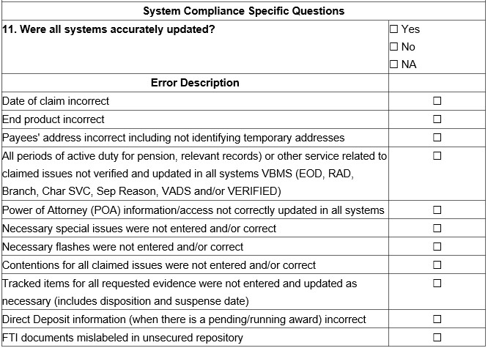

***Note:*** This checklist can be found in *M21-4, Chapter 6, Appendix A*.

Practical Exercise

1. What is the **10th** Systems Compliance Error description listed in *M21-4, Chapter 6, Appendix A.a.11, VSR Task Based Quality Review Checklist, Task 11*?
2. What should the DOC be for an EP 930?
3. Which screen in VBMS do you check to confirm the POA can access the eFolder and change the Veteran’s address?
4. Which program is used to add corporate flashes?
5. Is it an error to have an incorrect tracked item?
6. Where can you find a list of available claim labels?
7. True or False. All claimed dependents should be listed under one contention.