Monthly Benefits Delivery at Discharge (BDD) and

Integrated Disability Evaluation System (IDES) Conference Call Read Ahead

Compensation Service

BDD/IDES/Mil Pay Staff (212A)

May 12, 2020—2 PM ET

The Compensation Service BDD/IDES/Mil Pay Staff hosts this call to announce updates and address issues and questions related to the BDD/IDES Programs. All Military Services Coordinators (MSCs), Disability Rating Activity Sites (DRAS), Regional Offices and other VA personnel supporting BDD/IDES are invited to participate.

This read-ahead is provided to facilitate discussion during the conference call.

**Change to Call Notes:** The Call Notes from the previous month’s call will be an appendix to the current month’s Read Ahead (there is no longer a separate Call Notes document). The Call Notes for the April Call are in Appendix 1 of this Read Ahead. The TMS # for this month’s call will be provided during the call and should be active with-in a week of the call’s completion. A Calendar Blast will notify the field when the TMS # is active.

Please sign–up for the [C&P Calendar Subscription Service](http://vbacodmoint1.vba.va.gov/bl/21/calendar/cal_Subscribe.asp) to receive notification that the read-ahead is available and for notification when the TMS number is active.

**Call-in Information and New Guidance**

**Call in info:**

[Join Skype Meeting](https://meet.RTC.VA.GOV/andrew.reese/JDC6LJZ6)

844-358-7954, 844-210-0201 or 844-894-0415. Code is 496808907#.

The IM/Chat session will be disabled during the call. Ask questions over the phone during the call or send an email to the appropriate staff corporate mailbox.

When the presenter unmutes the audience for questions, follow the guidance below to unmute yourself:

1. If you are dialed in through your computer (select Use Skype for Business when signing into Skype), you must find your name in the attendee list and unmute yourself by right clicking the microphone.
2. If you are dialed in through a phone (select “Call me at” or “Don’t Join Audio” when signing into Skype), unmute yourself using *6.
3. Do not unmute yourself if you do not need to speak.

COVID-19 Topics for Discussion

**COVID-19**

This is a very difficult time, things are very fluid, and some changes/decisions are happening as we speak. We appreciate your patience, flexibility and support during these trying times. Contact the [BDD Mailbox](mailto:VAVBAWAS/CO/PREDISCHARGE%20%3cPredischarge.VBACO@va.gov%3e) or [IDES Mailbox](mailto:VAVBAWAS/CO/IDES%20%3cIDES.VBACO@VA.GOV%3e) as needed.

**BDD and IDES Exam Policy**

VBA’s guidance remains that all BDD/IDES exams should be submitted through VBA Contractors. At this point, VBA is unable to grant Regional Offices (ROs) and/or MSCs an exception to this policy. VBA and VHA’s Leadership are in continued discussions to determine the action plan to resume face to face examinations. Any change to this policy will come from VBA’s Leadership, not ROs and/or MSCs.

MSCs must continue to request BDD/IDES exams from contract providers via EMS, as discussed on the [April 2020 IDES/BDD Teleconference.](https://vbaw.vba.va.gov/VBADOD/docs/IDES/CorrectedApril2020BDDIDESCallReadAheadFinal.docx) If you have questions or concerns; please submit them through our [BDD Mailbox](mailto:VAVBAWAS/CO/PREDISCHARGE%20%3cPredischarge.VBACO@va.gov%3e) or [IDES Mailbox](mailto:VAVBAWAS/CO/IDES%20%3cIDES.VBACO@VA.GOV%3e).

Notifying IDES/BDD SMs of Potential Exam Delays

MSCs must advise SMs that exams may be delayed significantly as a result of current COVID-19 related restrictions. MSCs should explain that the exam provider will contact the SM as soon as the required exams are able to be scheduled; *however, there is no projected timeline for the resumption of face to face exams*. MSCs must not assume that any notice of exam delays will be provided by the vendor. SMs who had appointments scheduled prior to the COVID-19 Pandemic were notified by text message if those appointments were cancelled, however, no further communication from the vendors should be assumed until the required exams can be scheduled. As of this call, a text message is not being sent to SMs whose exams have yet to be scheduled. The only text message being sent, which was discussed last month, is to those SMs whose exams were scheduled but cancelled.

**Accepting Typed/Digital Signatures on Forms**

The Office of Field Operations (OFO) has been distributing a series of emails with a document titled Novel Coronavirus (COVID-19), General Information. The document dated April 16 states VA will accept typed/digital signatures instead of wet signatures on its forms. The document is posted on the [BDD](https://vbaw.vba.va.gov/vbadod/predischarge.asp) and [IDES](https://vbaw.vba.va.gov/vbadod/IDES.asp) homepages.

**Handling IDES Referrals with Exam Delays and/or VTA Deferments**

In any IDES case with a Prepare Claim Start Date (PCSD) in VTA, the MSC must determine whether the referral is complete and process the case accordingly.

If the referral is complete, the MSC must process the case through the ordering of exams and update VTA as required by standard IDES procedure. The standard MSC actions are required **even if the case is in deferment.**

***Important:*** When exams cannot be completed due to COVID-19 related delays, the case must remain pending in the Medical Evaluation Stage, not the Claim Development (CD) Stage.

If the referral is incomplete (i.e. missing STRs, the Servicemember (SM) cannot be reached for initial interview), the MSC must remove the PCSD from VTA and complete the actions described in [M21 III.i.2.D.3.d.(step 5)](https://vaww.vrm.km.va.gov/system/templates/selfservice/va_kanew/help/agent/locale/en-US/portal/554400000001034/content/554400000033257/M21-1-Part-III-Subpart-i-Chapter-2-Section-D-Overview-of-the-Integrated-Disability-Evaluation-System-IDES-and-Initial-Claims-Development?query=ides#3g).

MSCs should run the Pending CD Report at least once a week to identify cases requiring MSC action. The CD goal is 5 days for Active Duty and 11 days for Non-Active Duty.

Note: Putting a case in deferment in VTA is a DoD function. VA users can’t put a case in deferment. VA has recommended that PEBLOs request deferment after exams have been requested. But regardless of when or if the PEBLO requests deferment of a VTA case, if the case has a PCSD in VTA, the MSC must complete all required actions.

Deferring Exams vs Withdrawing Claimed Conditions in IDES Cases

We have gotten reports that some MSCs are assisting SMs complete a VA Form 21-4138 asking that exams for claimed conditions be deferred until after IDES. However, at this time, IDES Exams cannot be “deferred.” All conditions (both claimed and referred) must be examined before the Medical Evaluation Stage can be considered complete and the case moved forward. If the SHA and exams for all referred conditions have been completed, and the SM wants the claim to move forward without the completion of claimed condition exams, the SM can withdraw any claimed conditions not yet examined. MSCs should never encourage a SM to withdraw a claim, but it is an acceptable option for SMs with a completed SHA and completed referred condition exams that would like to transition from service as early as possible. The SM can then choose to file a claim after separation for those withdrawn conditions.

General Topics for Discussion

Index of Monthly Conference Call Read Ahead Topics

A document containing all the topics from past Monthly Calls is now available on the [BDD](https://vbaw.vba.va.gov/vbadod/predischarge.asp) and [IDES](https://vbaw.vba.va.gov/vbadod/IDES.asp) homepages. This reference may be useful when trying to locate information that was discussed on previous teleconferences. Using key terms and the Search function in MS Word (Hold the CTRL and F keys), users can see in which month the topic/term was discussed. The index contains the IDES Call topics from January 2013 to May 2018 and the BDD/IDES Combined Call topics from June 2018 to present.  The document will be updated with-in a week after the current month’s call.

**Issues with VA Forms**

VA Form 21-526EZ was recently involved in a project that focused on adding character limiting format. The Forms Staff is aware that usability issues have arisen and are in progress of fixing them.

IDES Specific Topics

**Segmented Lane Assignment in IDES Cases**

Currently, [M21-1 III.i.2.D.3.d. step 2](https://vaww.vrm.km.va.gov/system/templates/selfservice/va_kanew/help/agent/locale/en-US/portal/554400000001034/content/554400000033257/M21-1-Part-III-Subpart-i-Chapter-2-Section-D-Overview-of-the-Integrated-Disability-Evaluation-System-IDES-and-Initial-Claims-Development?query=IDES#3d), indicates that MSCs should assign EP 689s to the *IDES (National)* segmented lane. This required a VBMS Super-User at the RO to create the lane to make it available for the MSCs’ use.  However, it is no longer necessary to assign 689s to the *IDES (National)* lane, and the reference to the *IDES (National)* lane will be removed from [M21-1 III.i.2.D.3.d.](https://vaww.vrm.km.va.gov/system/templates/selfservice/va_kanew/help/agent/locale/en-US/portal/554400000001034/content/554400000033257/M21-1-Part-III-Subpart-i-Chapter-2-Section-D-Overview-of-the-Integrated-Disability-Evaluation-System-IDES-and-Initial-Claims-Development?query=IDES#3d) in the next update to this section.

The Segmented Lane entry no longer serves to inform NWQ routing; however, VBMS still requires an entry in the Segmented Lane field. Until this field is removed from VBMS, MSCs may select either *Core (National)* or *IDES (National)* as the Segmented lane when establishing EP 689s.

Current IDES Program Timeliness

As outreach specialists and VA’s frontline contact with SMs and Veterans, it is vital that we are realistic in our communications regarding claims processing times. Below is the current program timeliness data (ADC) for April 2020.

|  |  |  |
| --- | --- | --- |
| **Stage/Phase** | **IDES Goal (AD/NAD)** | **April 2020 (AD/NAD)** |
| **Claim Dev** | **5/11** | **11/13** |
| **Medical Stage** | **32** | **52/43** |
| **Proposed Ratings** | **20** | **17/29** |
| **Recon Ratings** | **4** | **6/5** |
| **Exit Interviews** | **14** | **8/16** |
| **Final Ratings** | **20/na** | **23/na** |

**Source:** VTA Completed Reports May 4, 2020 (8am ET).

**Note:** VA using the goals from the 230-day process.

BDD Specific Topics

**Incorrect Establishment of BDD Claims**

As we continue to track processing of BDD claims, we are reminding ROs and intake sites of the importance of accurate claims establishment.  BDD claims are unique as they reflect a future date of claim, display the BDD claim label, and must be established in accordance with [M21-1, III.i.2.A.2.c](https://vaww.vrm.km.va.gov/system/templates/selfservice/va_kanew/help/agent/locale/en-US/portal/554400000001034/content/554400000014099/M21-1-Part-III-Subpart-i-Chapter-2-Section-A-General-Information-on-Pre-Discharge-Claims#2c).

The most common BDD claims establishment errors include BDD claims established as a normal pending non-diary claim with a past date of claim instead of a future date of claim, Veteran (post-discharge) claims and BDD-Excluded claims incorrectly labeled as a BDD claim, and assigning the incorrect Pre-Discharge Type of “BDD” in VBMS.

The BDD claim label is the first selection in the VBMS claims establishment drop down menu which can easily be selected in error during establishment.  When selecting the Pre-Discharge Type, only claims submitted 180 to 90 days prior to the Release from Active Duty (RAD) date should select "BDD” as shown below in Fig. 1.  Claims submitted 89 days or less prior to RAD date must select “Quick Start” as shown below in Fig. 2.

As a reminder, while the Quick Start program has been discontinued, VBMS has not yet updated the Quick Start selection to BDD-Excluded. We are asking ROs and intake sites to pay close attention to these critical steps when establishing claims.  These errors challenge the integrity of the BDD inventory data and cause significant delays with claim processing.  If you have questions regarding BDD and BDD-Excluded claims establishment or any other BDD processing questions, please send your inquiry to the [Pre-Discharge Mailbox](mailto:VAVBAWAS/CO/PREDISCHARGE%20%3cPredischarge.VBACO@va.gov%3e).

Fig. 1: BDD Claims Establishment

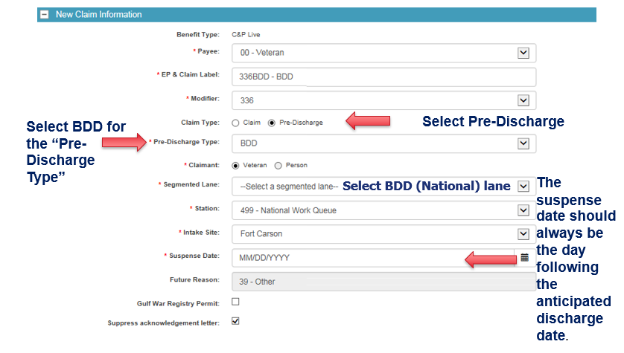

Fig. 2: BDD-Excluded Claims Establishment

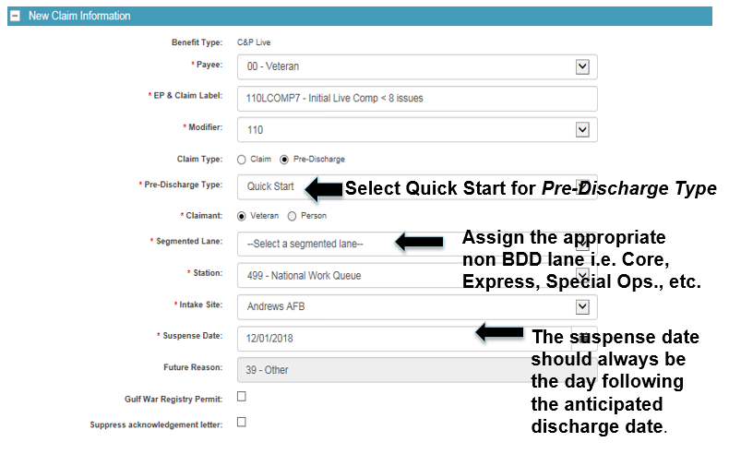

**BDD Claims Scanning**

There have been reports of ROs sending BDD claims to Centralized Mail instead of following the guidance in [M21-1, III.i.2.B.2.b](https://vaww.vrm.km.va.gov/system/templates/selfservice/va_kanew/help/agent/locale/en-US/portal/554400000001034/content/554400000014101/M21-1-Part-III-Subpart-i-Chapter-2-Section-B-Division-of-Responsibilities-for-Processing-Benefits-Delivery-at-Discharge-BDD-and-BDD-Excluded-Claims#2b). This guidance mandates all BDD claims must first be established in VBMS upon receipt, per [M21-1, III.i.2.B.2.b (Step 3)](https://vaww.vrm.km.va.gov/system/templates/selfservice/va_kanew/help/agent/locale/en-US/portal/554400000001034/content/554400000014101/M21-1-Part-III-Subpart-i-Chapter-2-Section-B-Division-of-Responsibilities-for-Processing-Benefits-Delivery-at-Discharge-BDD-and-BDD-Excluded-Claims#2b), then, the claims documents will be forwarded for VCIP scanning or scanned locally, after the BDD claim is established, per [M21-1, III.i.2.B.2.b (Step 5)](https://vaww.vrm.km.va.gov/system/templates/selfservice/va_kanew/help/agent/locale/en-US/portal/554400000001034/content/554400000014101/M21-1-Part-III-Subpart-i-Chapter-2-Section-B-Division-of-Responsibilities-for-Processing-Benefits-Delivery-at-Discharge-BDD-and-BDD-Excluded-Claims#2b). Sending BDD claims to Centralized Mail before properly establishing them in VBMS can cause significant processing delays and the success of the BDD program is dependent on priority processing.

**Updated BDD Intake Site and MSC Coaches List**

The former BDD Coordinator/Intake Site list has been replaced on the [Pre-Discharge Intranet site](https://vbaw.vba.va.gov/vbadod/predischarge.asp) with the [BDD Intake Site and MSC Coaches List - May 2020](https://vbaw.vba.va.gov/VBADOD/docs/predischarge/Updated_BDD_Intake_Site_and_MSC_Coaches_List_May2020.xls). The list includes the military installations that have a BDD intake site, the Regional Office associated with that intake site, the type of presence at the installation i.e. full time or itinerant, and the MSC point of contact which is the MSC/BDD Coach. This information was provided by each District. If any information on this list needs to be updated, please contact the [Pre-Discharge Mailbox](mailto:VAVBAWAS/CO/PREDISCHARGE%20%3cPredischarge.VBACO@va.gov%3e).

**Service Verification for BDD Claims**

There have been reports of VSRs contacting SMs while on active duty for verification of service for their current period of service.

As stated in [M21-1, III.i.2.B.4.d](https://vaww.vrm.km.va.gov/system/templates/selfservice/va_kanew/help/agent/locale/en-US/portal/554400000001034/content/554400000014101/M21-1-Part-III-Subpart-i-Chapter-2-Section-B-Division-of-Responsibilities-for-Processing-Benefits-Delivery-at-Discharge-BDD-and-BDD-Excluded-Claims#4h), rating decisions for BDD claimants will be completed while the SM is still on active duty in order to reduce processing time. As is emphasized in [M21-1, Part III, Subpart ii, 6.B.2.a](https://vaww.vrm.km.va.gov/system/templates/selfservice/va_kanew/help/agent/locale/en-US/portal/554400000001034/content/554400000044297/M21-1,-Part-III,-Subpart-ii,-Chapter-6,-Section-B---Service-Requirements-and-Verification-of-Eligibility), and [M21-1, Part III, Subpart ii, 6.A.1.e](https://vaww.vrm.km.va.gov/system/templates/selfservice/va_kanew/help/agent/locale/en-US/portal/554400000001034/content/554400000014143/M21-1,-Part-III,-Subpart-ii,-Chapter-6,-Section-A---Establishing-Veteran-Status), BDD claims ***must not be deferred for service verification***.  The current period of service for BDD claimants will not be verified until after RAD.

There have also been reports the instructions in [M21-1, III.i.2.B.4.i](https://vaww.vrm.km.va.gov/system/templates/selfservice/va_kanew/help/agent/locale/en-US/portal/554400000001034/content/554400000014101/M21-1-Part-III-Subpart-i-Chapter-2-Section-B-Division-of-Responsibilities-for-Processing-Benefits-Delivery-at-Discharge-BDD-and-BDD-Excluded-Claims#1h) have not been followed such as not updating the future suspense date (future date of claim) when the discharge date changes. As stated in [M21-1, III.i.2.B.4.i](https://vaww.vrm.km.va.gov/system/templates/selfservice/va_kanew/help/agent/locale/en-US/portal/554400000001034/content/554400000014101/M21-1-Part-III-Subpart-i-Chapter-2-Section-B-Division-of-Responsibilities-for-Processing-Benefits-Delivery-at-Discharge-BDD-and-BDD-Excluded-Claims#1h), if SMs remain on active duty beyond their anticipated discharge date, the RO must:

* attempt to contact the SM to obtain a new discharge date, and
* follow the instructions in the table below

**Exception**:  If a SM remains on active duty because his/her service department referred the SM into IDES, follow the instructions in [M21-1, Part III, Subpart i, 2.D.8.c](https://vaww.vrm.km.va.gov/system/templates/selfservice/va_kanew/help/agent/locale/en-US/portal/554400000001034/content/554400000033257/M21-1,-Part-III,-Subpart-i,-Chapter-2,-Section-D---Overview-of-the-Integrated-Disability-Evaluation-System-(IDES)-and-Initial-Claims-Development).

| **If the Servicemember ...** | **Then the ROJ must ...** |
| --- | --- |
| * plans to remain on active duty more than 180 days from the current date, or * the ROJ is unsuccessful after three attempts to contact the service member | * dispose of any hard-copy, unpromulgated rating decisions under [RCS VB-1, Part I, Item number 13-052.200](http://www.benefits.va.gov/WARMS/docs/admin20/rcs/part1/sec13.doc) * delete unpromulgated rating decisions from VBMS-R * retain all other accumulated documentation in the claims folder * deny the claim using the Return to Active Duty drop-down selection on the BASIC ELIGIBILITY tab in VBMS-A, and * notify the Servicemember of the reason for denial.   **Note**:  To remove an unpromulgated rating decision from VBMS-R, select the claims folder number from the work pending queue and select Return to Files Without Update. |
| provides a discharge date that is 180 days or fewer from the current date | * enter a note into VBMS indicating the new discharge date, and * edit the claim detail in VBMS to the proper future suspense date (RAD+1).   If VBMS will not allow a change to the proper future suspense date to the current EP   * change the pending EP to an EP 400 * cancel the EP 400 * establish a new BDD or BDD-excluded diary EP based on the new discharge date * update any tracked items if necessary, and * return the claim to the rating activity if an in-service rating decision was previously completed. |

Current BDD Program Timeliness

As outreach specialists and VA’s frontline contact with SMs and Veterans, it is vital that we are realistic in our communications regarding claims processing times. Below is the current program timeliness data as of May 5, 2020.

|  |  |  |
| --- | --- | --- |
| **Data Points** | **Goal** | **May 5, 2020** |
| **Completed FYTD** |  | **19,126** |
| **Receipts FYTD** |  | **18,677** |
| **Pending** |  | **3,571** |
| **# Completed w/in 30 Days of Discharge** |  | **11,925** |
| **% Completed w/in 30 Days of Discharge** | **100%** | **62.3%** |
| **Avg. Days to Complete FYTD** | **30** | **43** |

**Source:** Tableau BDD History Report, May 6, 2020

Upcoming Teleconferences

The next BDD/IDES Call is scheduled for Tuesday, June 9, 2020, at 2PM ET. Please submit IDES questions and proposed topics for discussion to the [IDES Mailbox](mailto:VAVBAWAS/CO/IDES%20%3cIDES.VBACO@VA.GOV%3e), and BDD questions and proposed topics for discussion to the [BDD Mailbox](mailto:VAVBAWAS/CO/PREDISCHARGE%20%3cPredischarge.VBACO@va.gov%3e) no later than close of business (COB), Wednesday May 27, 2020.

The next BDD/IDES Coaches Call is scheduled for June 4, 2020. Please submit IDES questions and proposed topics for discussion to the [IDES Mailbox](mailto:VAVBAWAS/CO/IDES%20%3cIDES.VBACO@VA.GOV%3e), and BDD questions and proposed topics for discussion to the [BDD Mailbox](mailto:VAVBAWAS/CO/PREDISCHARGE%20%3cPredischarge.VBACO@va.gov%3e) no later than COB, Friday May 22, 2020.

Open Floor

**Appendix 1:** **Call Notes from the April 2020 Comp Service BDD/IDES Conference Call**

The following notes provide a summary of questions and discussion from the April BDD/IDES Conference Call. For a complete description of the topics discussed on the call please review the [April Read Ahead](https://vbaw.vba.va.gov/vbadod/IDES.asp).

Requesting BDD and IDES Exams During the COVID-19 Pandemic Memo

An MSC stated their intake site has a MOU that directs all exams will be completed by VHA. No new exam requests should be submitted to VHA. Until further notice, all exam requests should be submitted in the Exam Management System (EMS) in VBMS to VBA contract vendors. If the exam was cancelled by VHA and any part of the exam was not completed, request the exam in EMS. If some of the exams have already been completed by VHA and other exams on that same exam request are pending, do not take any action on those exam requests. For BDD claims, the Medical Disability Examination Program Office (MDEPO) will contact NWQ to recall claims where VHA has cancelled the exam request in order to request the exam again. If the Servicemember has moved, update the address in VBMS to the correct address.

**Transmission of BDD Applications/Documents via eBenefits/SAFE**

There is no requirement to annotate BDD claims documents received through eBenefits, SEP, or D2D with the date of receipt or a date stamp, but only if the documents were received through eBenefits, SEP, or D2D. If the BDD claims documents were received through e-mail or SAFE, upload a copy of the e-mail, where the documents were received, to the VBMS eFolder in order to show the date of receipt of these documents. This requirement only applies to BDD claims documents received through e-mail or SAFE.

VBA Contract Exam Priority

There has been discussion by VBA Leadership regarding priority processing once the examiners can conduct in-person exams; however, the decision on how to prioritize these exams has not been determined. If you have questions, contact the Medical Disability Examination Program Office (MDEPO) at [ContractExam.VBAVACO@va.gov](mailto:ContractExam.VBAVACO@va.gov).

Service Verification

There was a question during the call regarding if it is required to update service verification in SM Profile. Per [M21-1, III.ii.3.C.7.a](https://vaww.vrm.km.va.gov/system/templates/selfservice/va_kanew/help/agent/locale/en-US/portal/554400000001034/content/554400000014125/M21-1,-Part-III,-Subpart-ii,-Chapter-3,-Section-C---System-Updates#7a), all periods of active service must be verified and updated in VBMS. The period of active duty should only be verified and updated in VBMS after the discharge date has passed and that period of active duty was verified.