# Cloning ESR from closed/canceled EP Job Aid

ESR “Cloning” functionality allows users to create a rework or a new ESR from an ESR on a closed or canceled EP without manual re-keying all the previously captured information.

For example, an EP 600, EP 930 or IDES claim can be established by cloning the contentions from a previous EP 020 that proposed reduction of a rated disability, or an EP that was cancelled or closed erroneously, or an IDES EP. This occurs when establishing the EP 600, EP 930 or IDES EP.

Using the Contention copying process will make sure the Contentions needed for the cloned ESR are already on the claim. It is not required to use a claim with “copied contentions”, but when trying to clone an ESR, the contentions from that ESR you want to have examined must be on the contention list for the new EP.

## TOPIC 1: REWORK

When a claim has been canceled/closed and contentions from previously completed ESR requires a “Rework”, the user is able to submit a rework from an exam on a previously closed/canceled EP. The rework functionality would then be used from a previously completed ESR.

**Step 1:** Click on the 'Claims' tab; Click on the 'Include Inactive' checkbox Click on the Closed EP that as the original ESR

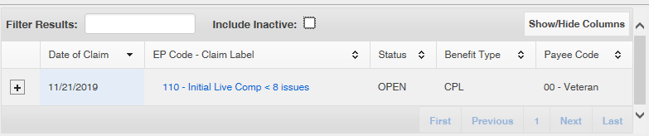

**Step 2:** Click on the Closed EP that has the original ESR requiring a rework

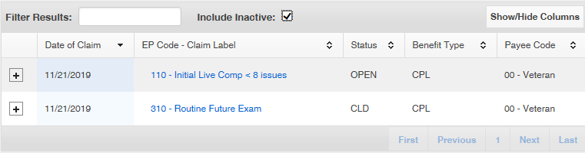

**Step 3**: From ESR summary the user will select “Rework on new claim” from the “*actions*” drop down menu for the ESR requiring the rework

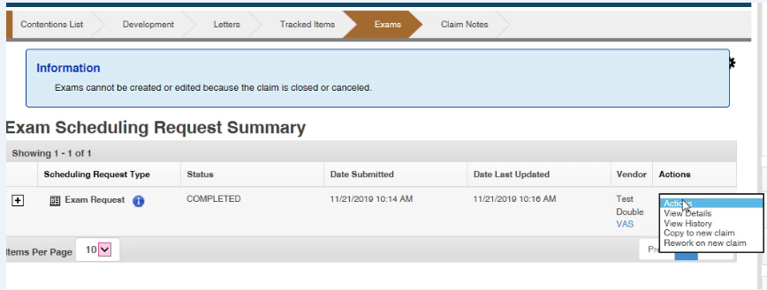

**Step 4:** Clickon the 'Eligible Claims with same Payee Code' dropdown and select the claim with EP code that requires the Rework.

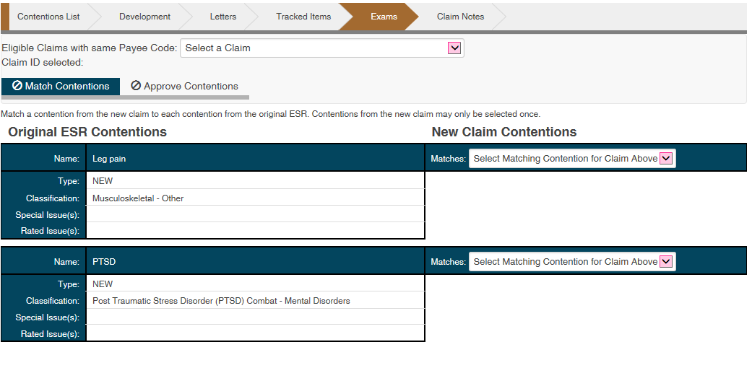

**Step 5:** Click on the Matches dropdown from the 'New Claim Contentions' dropdown. Select each Contention from the Matches dropdown.

**Step 6:** Once the contentions are selected the Match Contentions button will turn green and you may click on the Approve Contentions tab.

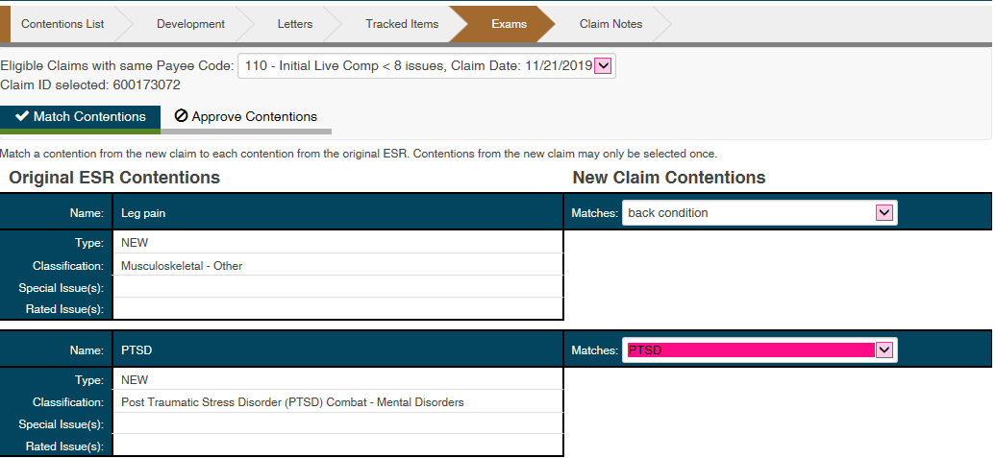

**Step 7:** Verify that the 'Before Updates' tab has the list of contentions from new EP that you selected. Verify that the 'After Updates' tab has the list of contentions from closed/canceled EP. If you approve a match that is different than the before the contention information will be overwritten on the claim. Ensure that there is no erroneous overwrite of a required contention on the claim.

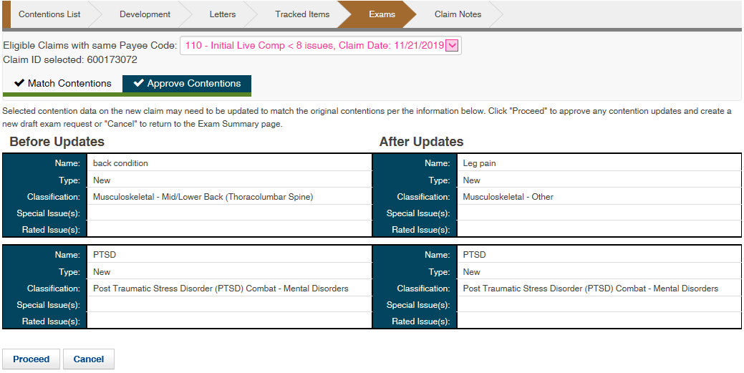

**Step 8:** Click on the Proceed button on the bottom of the page.



Exam Rework Request is created on the EP that was selected with Draft Status and Select Contentions page is displayed.  
**Note**: The contentions created on the new EP will be displayed.

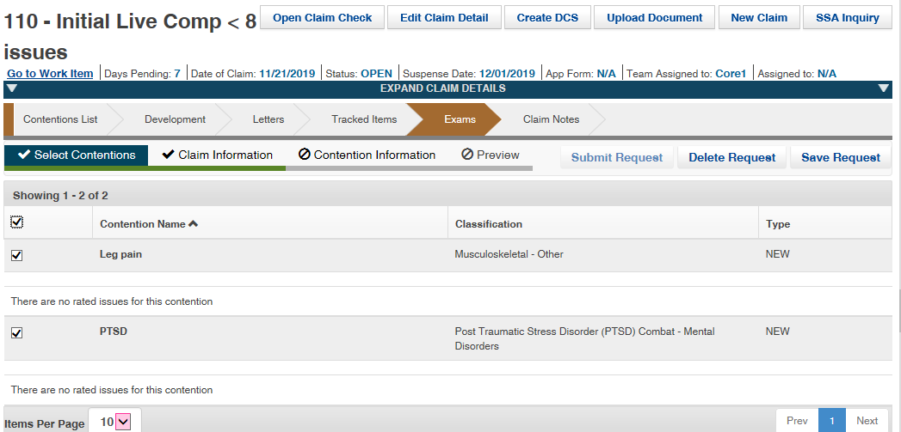

**Step 9**: User must provide a Rework Type by using the drop-down arrow and then choosing insufficiency or clarification. Users must then select the “Rework Reasons” and provide a detailed rationale for the rework.

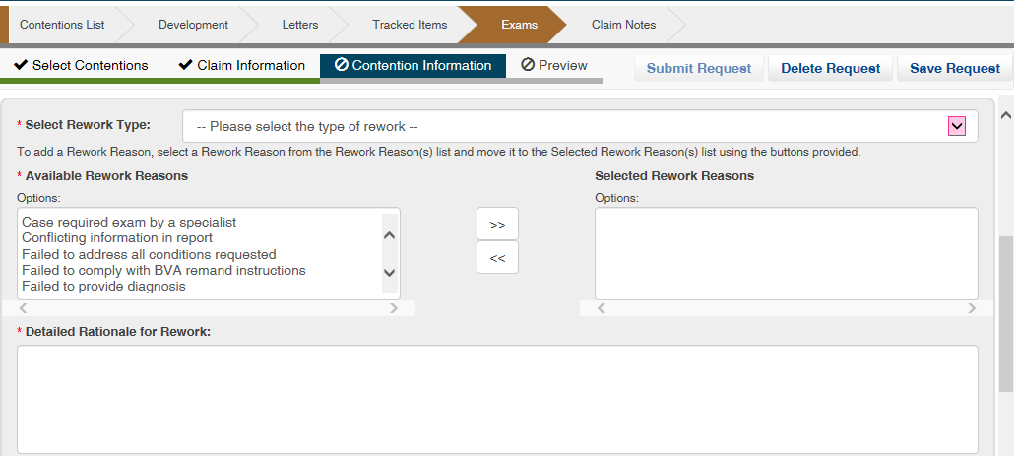

**Step 10:** User will select the appropriate DBQ and provide any special instructions if necessary.

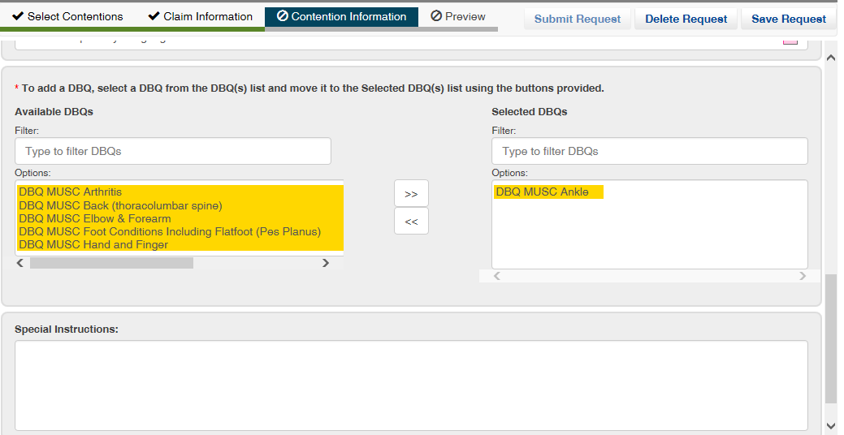

**Step 11**: Next click ‘Preview’ from the Exam subcategories list. This will generate a PDF of the rework Exam Scheduling Request (ESR), which will contain the information provided to the examiner. Review the PDF and validate that all necessary information is included, then can close out the PDF. If any information needs to be amended, you can go back and update as necessary. You can now click ‘Submit Request

## TOPIC 2: Copy

ESR “Copy” functionality allows users to recreate, with minimal input, a new ESR which had been previously cancelled or completed. This functionality can now be utilized on an ESR that is under a previously canceled/closed EP. The function is to be mainly utilized for previously cancelled ESR(s).

**Note:** When a previously completed ESR does not have the “Rework” function available, the user is required to submit a new request using specified special instructions to the MDE Vendor. The copy functionality would then be used from a previously completed ESR.

**Step 1:** Click on the 'Claims' tab; Click on the 'Include Inactive' checkbox Click on the Closed EP that as the original ESR



**Step 2:** Click on the Closed EP that has the original ESR requiring a rework



**Step 3**: From ESR summary the user will select “Copy to new claim” from the “*actions*” drop down menu for the ESR you wish to copy.



**Step 4:** Clickon the 'Eligible Claims with same Payee Code' dropdown and select the claim with EP code that requires the exam.

**Step 5:** Click on the Matches dropdown from the 'New Claim Contentions' dropdown. Select each Contention from the Matches dropdown.



**Step 6:** Once the contentions are selected the Match Contentions button will turn green and you may click on the Approve Contentions tab.



**Step 7:** Verify that the 'Before Updates' tab has the list of contentions from new EP that you selected. Verify that the 'After Updates' tab has the list of contentions from closed/canceled EP. If you approve a match that is different than the before the contention information will be overwritten on the claim. Ensure that there is no erroneous overwrite of a required contention on the claim.



**Step 8:** Click on the Proceed button on the bottom of the page.



A new Exam Request is created on the EP that was selected with Draft Status and Select Contentions page is displayed.  
**Note**: The contentions created on the new EP will be displayed.

**Step 9:** Under “Select Contentions” tab the user will select all contentions or individual contentions to be copied.



**Step 10:** The user will select the “Contention Information” tab and verify all DBQ(s) and specialty language, if applicable.

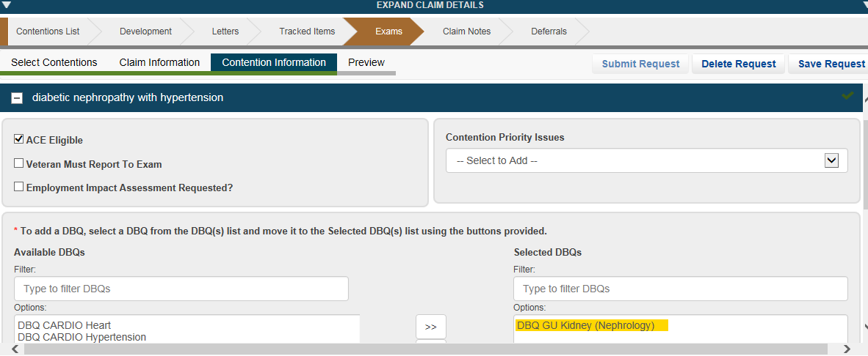

**Step 11:** The user will then select “Preview” and ensure the ESR is accurate prior to clicking submit.