Identifying Contentions and Classifications
Instructor Lesson Plan
Time Required: 1.75 Hours

Table of Contents

Lesson Description 2
Topic 1: Contentions 5
Topic 2: Classifcations 10
Practical Exercise 16
Lesson Review, Assessment, and Wrap-up ..................................................................................17

Lesson Description
The information below provides the instructor with an overview of the lesson and the materials that are required to effectively present this instruction.
TMS # | 4527852
Prerequisites | There are no required prerequisites to this class.
target audience | The target audience for entry level Claims Assistants (CA) and entry level Veteran Service Representatives (VSR).  This training may be used as refresher training for CAs, VSRs, AQRS, Rating Veteran Service Representative, or RQRS once determined it is needed.
Time Required | 1.75 hours
Materials/  TRAINING AIDS | Lesson materials:  - Identifying Contentions and Classifications PowerPoint Presentation  - Identifying Contentions and Classifications Trainee Handouts
Training Area/Tools | The following are required to ensure the trainees are able to meet the lesson objectives:  - Classroom or private area suitable for participatory discussions  - Seating, writing materials, and writing surfaces for trainee note taking and participation  - Handouts, which include a practical exercise  - Large writing surface (easel pad, chalkboard, dry erase board, overhead projector, etc.) with appropriate writing materials  - Computer with PowerPoint software to present the lesson material  Trainees require access to the following tools:  - VA TMS to complete the assessment  - Compensation Pension (CPKM) Portal  - Index of DBQ/Exams by Disability  - Medical EPSS
Pre-Planning | - Become familiar with all training materials by reading the Instructor Lesson Plan while simultaneously reviewing the corresponding PowerPoint slides. This will provide you the opportunity to see the connection between the Lesson Plan and the slides, which will allow for a more structured presentation during the training session.  - Become familiar with the content of the trainee handouts and their association to the Lesson Plan.  - Practice is the best guarantee of providing a quality presentation. At a minimum, do a complete walkthrough of the presentation to practice coordination between this Lesson Plan, the trainee handouts, and the PowerPoint slides and ensure your timing is on track with the length of the lesson.  - Ensure that there are copies of all handouts before the training session.  - When required, reserve the training room.  - Arrange for equipment such as flip charts, an overhead projector, and any other equipment (as needed).  - Talk to people in your office who are most familiar with this topic to collect experiences that you can include as examples in the lesson.  - This lesson plan belongs to you. Feel free to highlight headings, key phrases, or other information to help the instruction flow smoothly. Feel free to add any notes or information that you need in the margins.
Training Day | - Arrive as early as possible to ensure access to the facility and computers.  - Become familiar with the location of restrooms and other facilities that the trainees will require.  - Test the computer and projector to ensure they are working properly.  - Before class begins, open the PowerPoint presentation to the first slide. This will help to ensure the presentation is functioning properly.  - Make sure that a whiteboard or flip chart and the associated markers are available.  - The instructor completes a roll call attendance sheet or provides a sign-in sheet to the students. The attendance records are forwarded to the Regional Office Training Managers.

Introduction to Identifying Contentions and Classifications
INSTRUCTOR INTRODUCTION |  | Complete the following:  - Introduce yourself  - Orient learners to the facilities  - Ensure that all learners have the required handouts
time required |  | 0.25 hours
Purpose of Lesson  Explain the following: |  | This lesson is intended to provide the claims assistant with detailed training on identifying contentions and classifications at establishment. This lesson will contain discussions and exercises that will allow you to gain a better understanding of:  - The Contention  - The Classification
Lesson Objectives  Discuss the following:  Slide 2  Handout 3 | In order to accomplish the purpose of this lesson, the claims assistant will be required to accomplish the following lesson objectives.  The CA will be able to:  - Determine and identify contention(s) made by the claimant.  - Recognize how to enter a contention appropriately.  - Determine the most appropriate contention classification.  - Recognize how to enter the classification appropriately.
Explain the following: | Each learning objective is covered in the associated topic. At the conclusion of the lesson, the learning objectives will be reviewed.
Motivation | The proper identification and entry of the claimed condition is a requirement of claims established. Additionally, the selection of the proper contention classification is imperative for quality management and the exam automation functionality. All claims processors are responsible for the proper listing of contentions and selections of classifications. Accurate input is essential for reporting and accounting purposes.

References  Slide 3  Handout 3 | Explain where these references are located in the workplace.  All M21-1 references are found in the CPKM.  - M21-1, Part III, Subpart iii, 1.F, Record Maintenance During the Development Process  - M21-1 Part III, Subpart iii, 5.L.1.e, EP Control When Requesting Evidence/Information Required to Add a Dependent in a Decision Notice  - M21-1, Part III, Subpart v, 10.A, 800 Series Work Items and Cost-of-Living Allowance (COLA) Adjustments  - Medical EPSS  - DBQ Switchboard  - Index of DBQ/Exams by Disability

Topic 1: Contentions
Introduction | This topic will allow the trainee to understand that listing contentions for each claim is mandatory and should be entered as soon as they are identified. The contention classification is also a required system component when entering a contention. The contention list is available via eBenefits and are transparent for the Veteran.
Time Required | 0.5 hours
OBJECTIVES/  Teaching Points | Topic objectives:  - Determine and identify contention(s) made by the claimant.  - Recognize how to enter a contention appropriately.  The following topic teaching points support the topic objectives:  - Listing contentions for each claim is mandatory.  - The contention list is available via eBenefits and are transparent for the Veteran.  - Understand when an additional End Product is required for dependency.
Contentions  Slides 5-12  Handout 4-6 | The claims processor should enter issues as contentions when they are:  - Expressly claimed by the claimant/Veteran/authorized representative, and/or  - Put at issue and requires development.  They should be entered as soon as they are identified and should be easy to understand and in “the claimant’s own words’, as appropriate. All employees reviewing a claim are responsible for ensuring all contentions are correct and verified.  Important:  - This information will be made available via eBenefits.  - Non-rating contentions should relate to the specific benefit being sought.  - Dependency claims request a mandatory language and format.  - Claims derived from Work Items must have a contention.  - Sometimes the claim requires two separate contentions like a claim for total disability due to individual unemployability is treated as a claim for increase in the service-connected (SC) disabilities the Veteran identifies as causing unemployability. Therefore, the identified SC disabilities should be entered as individual contentions.  Example 1:  VA receives a claim for "increase in diabetes mellitus to include heart, depression, and numbness in hands." The contentions should be entered as  - diabetes mellitus  - heart condition  - depression, and  - numbness in hands.  Example 2:  A Veteran submits a claim for “ringing in the ears”. The contention should be entered as “ringing in the ears”.  Example 3:  A Veteran submits a claim to add a spouse and a child to a running award. Create separate contentions for the spouse and child as follows:  - Dependency claim for [name of spouse], and  - Dependency claim for [name of child].  Example 4:  VA receives a Work Item 840: Combat-Related Special Compensation (CRSC)/Concurrent Retirement and Disability Payments (CRDP) Audit Error Worksheet (AEW).  - VA would establish an End Product (298), CRSC/CRDP Processing.  - Add Potential Under/Overpayment as a special issue  - Clear the 840 work item that the Hines ITC established (if applicable)  Note: The proper date of claim for the EP 298 is the date of the (AEW), which is found in the upper, right-hand corner of the worksheet.  M21-1, Part III.v.10.A hyperlinks are provided directing specific actions when establishing End Products from Work Items.  When establishing claims, a review of any prior rating decision should be reviewed through SHARE corporate record, the last rating decision within the eFolder, or the Rated Issues + icon within the VBMS contention page.  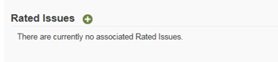  Example 5:  A Veteran submits a claim for "bilateral knee condition". A review of the corporate record indicates the Veteran is service connected for right knee patellofemoral pain syndrome and was previously denied for a left knee strain.  The contentions should be entered as follows:  - right knee patellofemoral pain syndrome (claimed as bilateral knees), and  - left knee strain (claimed as bilateral knees).  When an original claim for benefits (EP 110 or EP 010) is received with a VA Form 21-686c, Declaration of Status of Dependents, we must add the dependents noted as contentions.  When a VA Form 21-686c, Declaration of Status of Dependents, is received and it is an initial non-original claim, then a separate EP 130 will need to be established.  Explain: Reason for establishing a separate claim for dependency on a non-original claim is VA is entitled to additional credit for processing the claim and length of time for processing EP 130s may be significantly shorter than compensation claims.  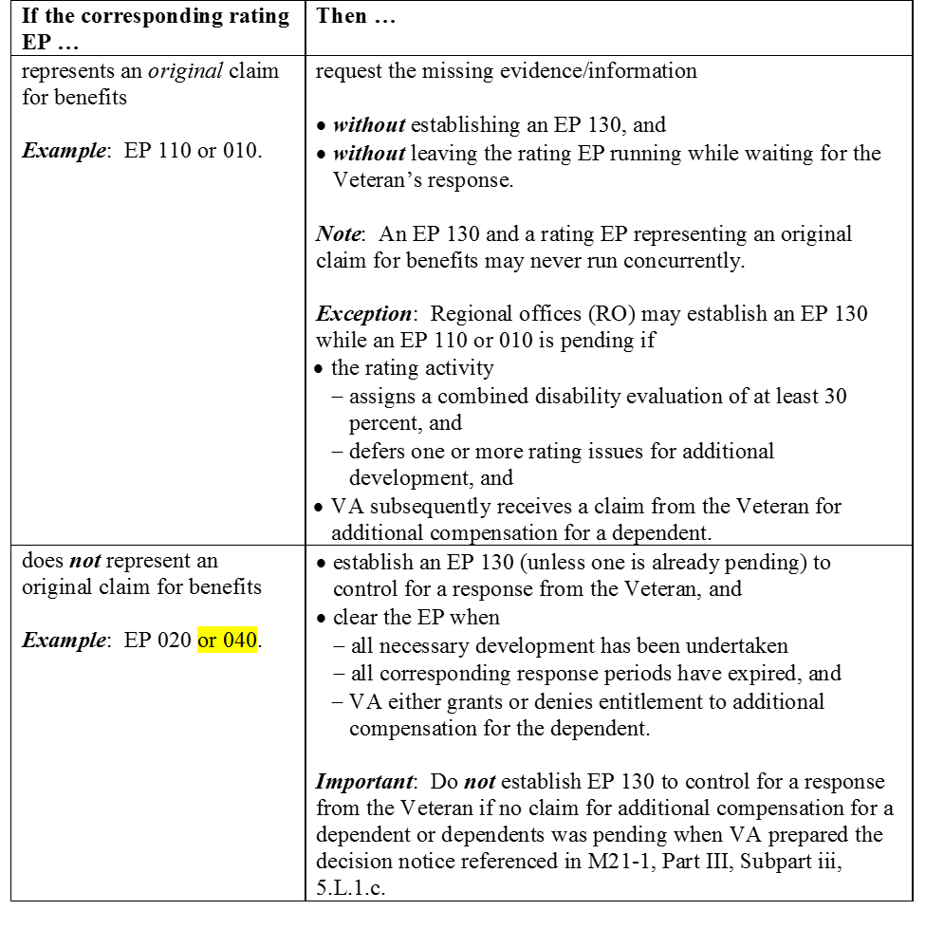
Verifying the Contention  Slide 13  Handout 6 | All contentions must be verified in order for them to be available via eBenefits. Contentions automatically entered by the system that are missing critical information, such as the contention classification, will be marked as unverified. The claims processor must update the missing/incorrect information and select SAVE. The contention will then be marked as verified and viewable in eBenefits.  All employees reviewing a claim are responsible for ensuring all contentions are correct and verified.
note(s) | Explain the CA job is to properly identify and input contentions. Ensuring all contentions are input correctly at the first initial review will reduce the amount of rework later in the claims process.
DEMONSTRATION | Demonstrate in VBMS how to enter a contention properly. Locate a live claim to read through and identify the contentions.

Topic 2: Classifcations
Introduction | This topic will allow the trainee to identify the proper contention classification. Classifications are used for the exam management functionality.
Time Required | 0.5 hours
OBJECTIVES/  Teaching Points | Topic objectives:  - Determine the most appropriate contention classification.  - Recognize how to enter the classification appropriately.  The following topic teaching points support the topic objectives:  - Listing proper classification for each contention is mandatory.  - The classification is imperative to the exam management  functionality and is all claims processors responsibility.
Classification and Medical Field  Slide 14-15  Handout 6-7 | The CLASSIFICATION and MEDICAL fields are required components when entering a contention. The classification is associated with the contention being entered, you are associating the medical condition. This information is used in the exam management functionality and it is imperative the classification is correct.  - When selecting a classification, use  - appropriate medical verbiage that corresponds to the claimed medical condition, instead of the claimant’s original language, and  - the Administrative classification only for non-rating issues, such as dependency.  - Select Yes in the MEDICAL field if the contention may require an examination or medical opinion to make a determination. Otherwise, select No.  Exception: Individual unemployability as a contention must be identified by  - selecting Unemployability as a classification in order to complete necessary specific development actions in VBMS, and  - Selecting Yes in the MEDICAL field.
How do I choose the Classification?  Slide 16  Handout 7 | The user selects the appropriate medical verbiage that corresponds to the claimed medical condition. This is different than the plain language contention entered previously.  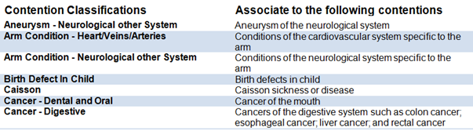  Non-Rating issues, to include dependency, should be updated to “administrative”.
Medical Terminology Resources  Slide 17  Handout 7-8 | Whenever in doubt about which contention classification to select for a condition, you may use one of the following sources.  Index of DBQ/Exams by Disability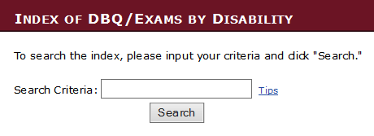  Medical EPSS    DBQ Switchboard  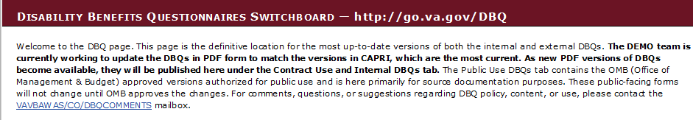  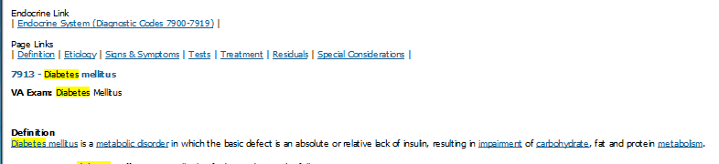
Index of DBQ/Exams by Disability  Slide 18  Handout 8 | Example 6: Veteran submits a claim for service connection for diabetes mellitus. The claimed condition of “diabetes” can be typed into the search criteria.  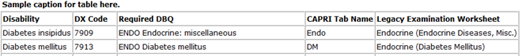  Reviewing the results provided, you know to choose “Endocrine” as the classification for the claimed condition.
Medical EPSS  Slide 19  Handout 8 | Example 6: Veteran submits a claim for service connection for diabetes mellitus. The claimed condition of “diabetes” can be typed into the search criteria.  v  Reviewing the results provided, you know to choose “Endocrine” as the classification for the claimed condition.
DBQ Switchboard  Slide 20  Handout 9 | Example 6: Veteran submits a claim for service connection for diabetes mellitus. The claimed condition of “diabetes” can be typed into the Control + F (find function).  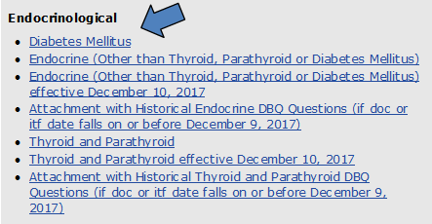  Reviewing the results provided, you know to choose “Endocrine” as the classification for the claimed condition.
Index of DBQ/Exams by Disability  Slide 21  Handout 9 | Example 7: The Veteran claimed “erectile disfunction” on the VA Form 21-526EZ. A search of “erectile disfunction” produced no results within the Index of DBQ/Exams by Disability page. A new search of “erec” produced a result of “erectile dysfunction” and “hysterectomy”.  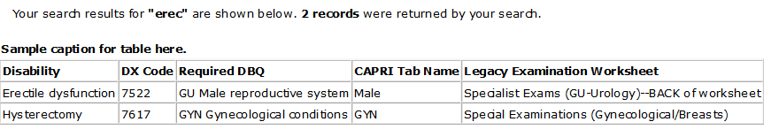
DBQ Switchboard  Slide 22  Handout 9-10 | By looking at the results from the initial search table it produced two results. If uncertain, then utilizing the DBQ Switchboard would produce the following:  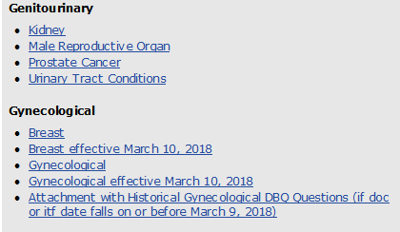  Further investigation within “Male Reproductive Organ” worksheet by using the Control + F (for find key word “erectile”) would yield erectile dysfunction located on page 2. Male Reproductive Organ was listed under the “Genitourinary” header.
Medical EPSS  Slide 23  Handout 10 | Example 7: The Veteran claimed “erectile disfunction” on the VA Form 21-526EZ. A search of “erectile disfunction” produced no results. A new search of “erectile” produced a result of “erectile dysfunction”.  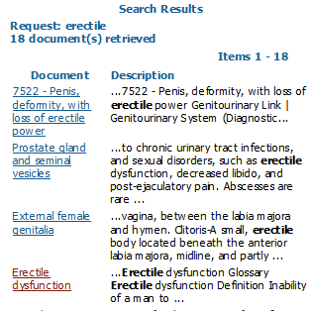  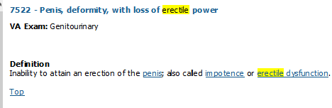  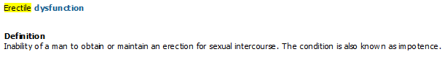  Reviewing the results provided, you know to choose “Genitourinary” as the classification for the claimed condition.
VBMS Input  Slide 24  Handout 11 | 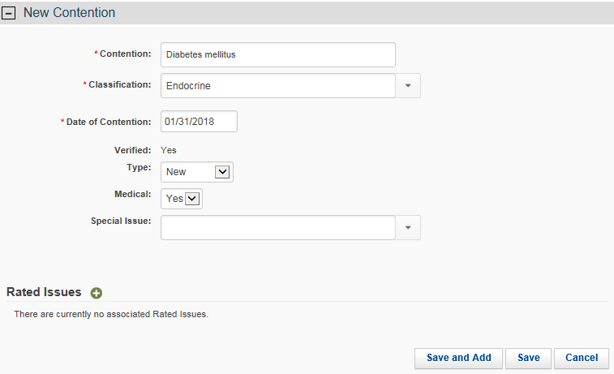    Example 6: You received a claim from a Veteran claiming service connection for diabetes mellitus.
VBMS Input and Putting It All Together  Slides 25-26  Handout 11-12 | Example 7: The Veteran claimed “erectile disfunction” on VA Form 21-526EZ.  By typing “ge” the list started to populate and here is where the user would select “Genitourinary” as the classification.  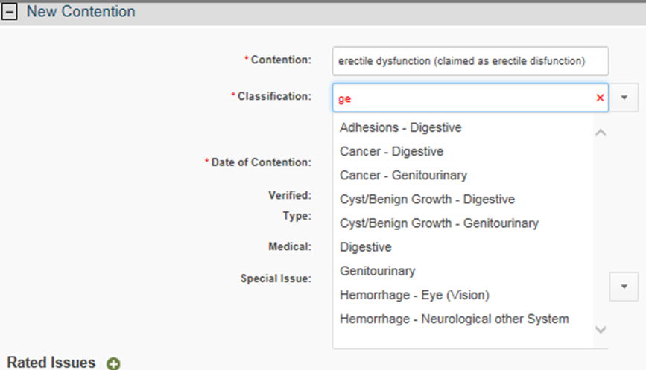  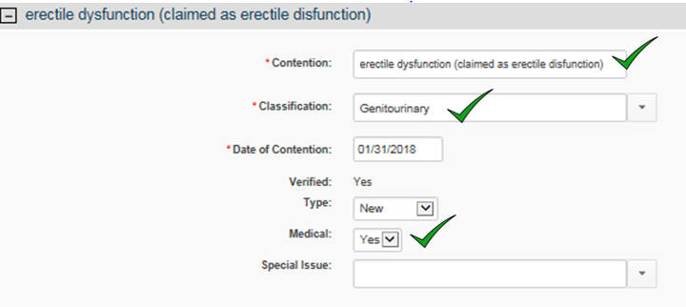
DEMONSTRATION | Demonstration how to enter the classification and how to use the job aids provided.

Practical Exercise
Time Required |  | 0.25 hours
EXERCISE |  | Ask if there are any questions about the information presented in the exercise, and then proceed to the Review.
PRACTICAL EXERCISE  Handout 13 |  | Directions: Use any of the following tools along with the CONTENTION CLASSIFICATION JOB AID found in attachment A to determine the proper contention classification.  Index of DBQ/Exams by Disability  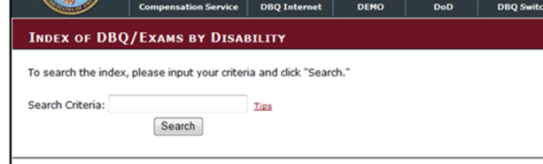  Medical EPSS  DBQ Switchboard  - ringing in ears  - diabetes mellitus  - heart condition  - dependency claim for Salley  - depression  - individual unemployablity

Lesson Review, Assessment, and Wrap-up
Introduction  Discuss the following: | The Identifying Contentions and Classifications lesson is complete.  Review each lesson objective and ask the trainees for any questions or comments.
Time Required | 0.25 hours
Lesson Objectives | You have completed the Identifying Contentions and Classifications lesson.  The trainee should be able to:  - Determine and identify contention(s) made by the claimant.  - Recognize how to enter a contention appropriately.  - Determine the most appropriate contention classification.  - Recognize how to enter the classification appropriately.
Assessment | Remind the trainees to complete the on-line assessment in TMS to receive credit for completion of the course.  The assessment will allow the participants to demonstrate their understanding of the information presented in this lesson.

