Monthly Benefits Delivery at Discharge (BDD) and

Integrated Disability Evaluation System (IDES) Conference Call Notes

Compensation Service

BDD/IDES/Mil Pay Staff (212A)

September 10, 2019—2 PM ET

**Conference Call Notes**

The Compensation Service BDD/IDES/Mil Pay Staff hosts this monthly conference call to announce updates and address issues and questions related to the BDD and IDES Programs. All Military Services Coordinators (MSCs), Disability Rating Activity Sites (DRAS), Regional Offices and other VA personnel supporting BDD and IDES are invited to participate.

Prior to the conference call, a read-ahead was provided to facilitate discussion during the call. To receive notification when the read-ahead becomes available for upcoming calls, please sign up for the [C&P Calendar Subscription Service](http://vbacodmoint1.vba.va.gov/bl/21/calendar/cal_Subscribe.asp).

The Conference Call Notes below include the information that was provided on the original read-ahead, as well as a summary of the discussion that took place during the call. These notes may also expand upon and/or provide any needed clarification of the topics addressed on the call or in the read-ahead; as such, all call attendees are encouraged to review the call notes, with attention to the information in the shaded blocks, which has added to the original read-ahead.

TMS # VA 4527416 has been created to provide training credit for the September 2019 BDD/IDES Teleconference. To receive training credit, you must sign into TMS and self-assign the course.  The evaluation must be completed to receive credit.

Topics for Discussion

### DoD SAFE

ARMDEC SAFE has been replaced by DoD SAFE. The new URL is <https://safe.apps.mil/>. An email was sent from OFO to all Districts on August 13th with information and a factsheet. One of the major changes is non-CAC users have to request a Drop-Off from a CAC user in order to upload and send files.

Ex: MSC emails/calls PEBLO requesting a Drop-Off. PEBLO will go into SAFE and click the Request a Drop-Off icon.

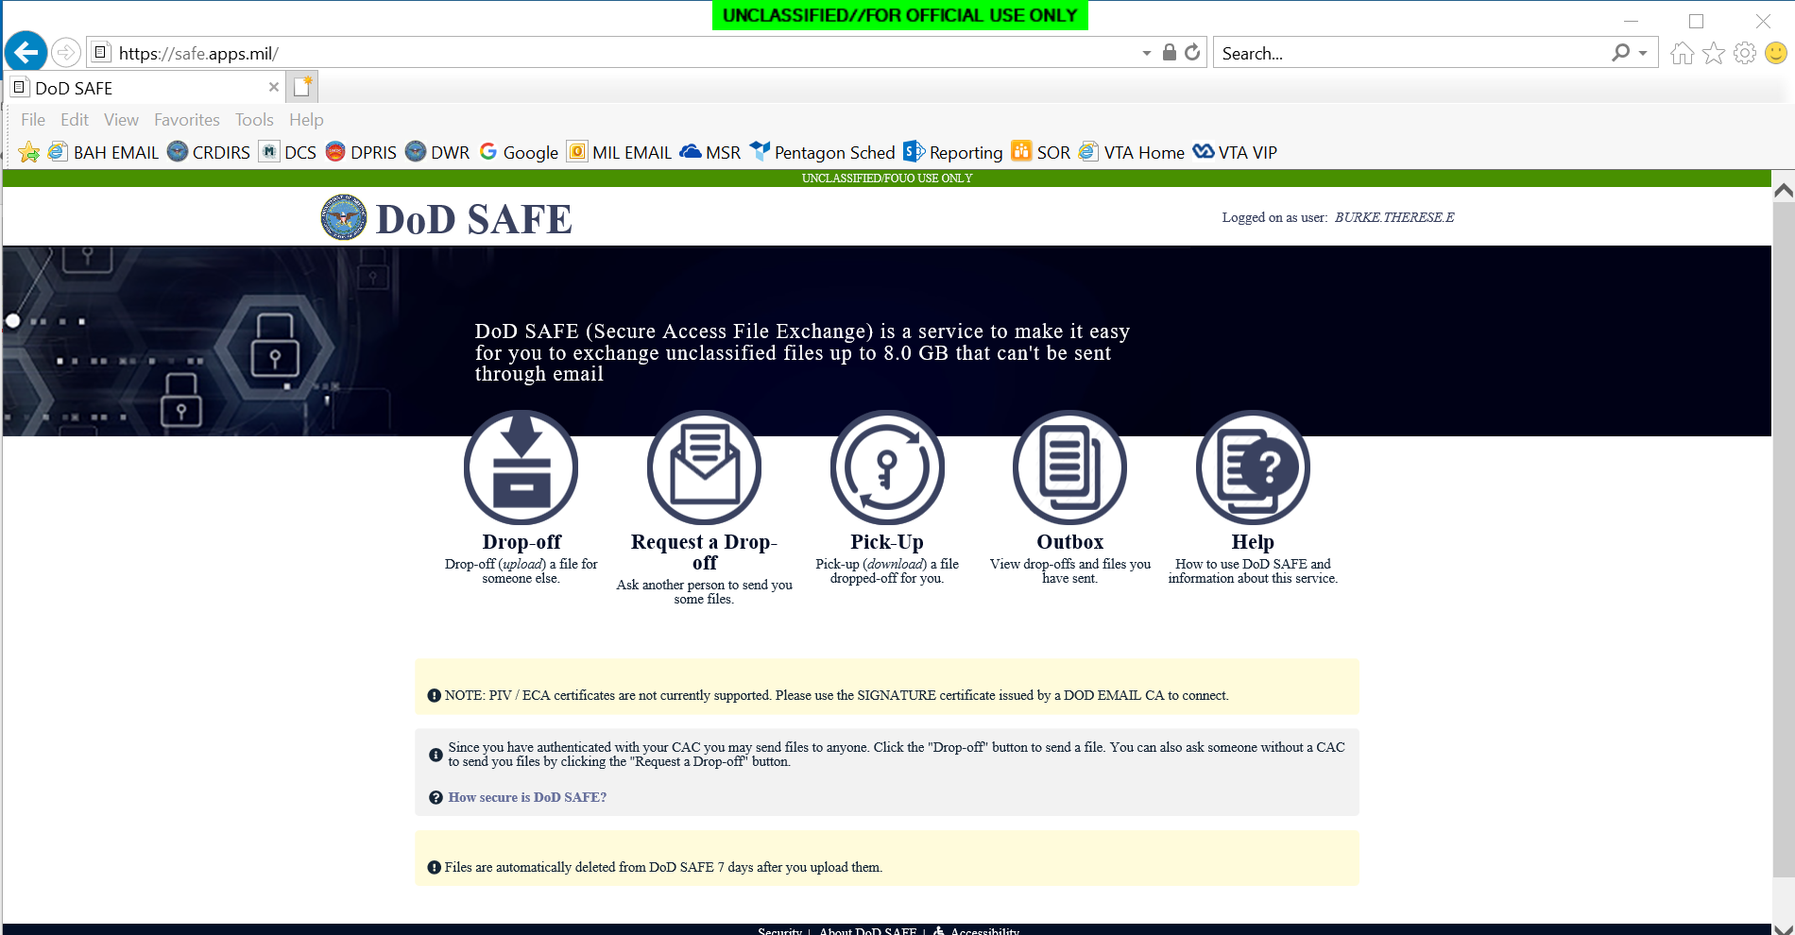

PEBLO will fill in the required information and click Send the Request.

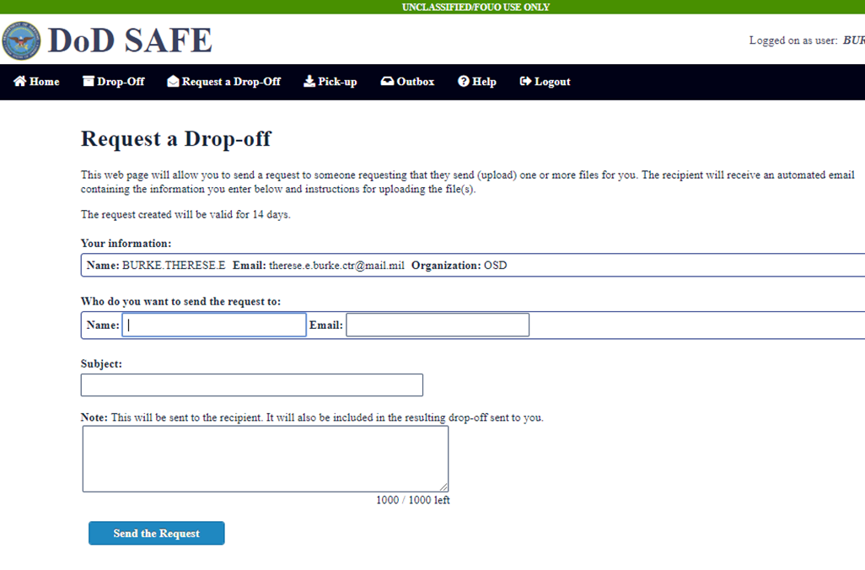

SAFE will send a notification to the MSC with a Drop-Off link.

From: NoReplyTo@mail.mil <NoReplyTo@mail.mil>

Sent: Friday, August 23, 2019 10:59 AM

To: Reese, Andrew, VBAVACO <Andrew.Reese@va.gov>

Subject: [EXTERNAL] [DoD SAFE] Testing 23 Aug 2019

Andrew Reese,

This is a request from Wendy Burger of OSD.

Please click on the link below and drop off the file or files I have requested.

The link is only valid for 14 days from the time of this email.

More information is in the note below.

https://safe.apps.mil/req.php?req=431312366719

MSC will upload files, change/add emails and check boxes as needed (encryption box if sending PII/PHI). When complete, click Drop-off Files. If you encrypt, you will be required to create a Passphrase and send it to the PEBLO in a separate email. SAFE does not send the Passphrase.

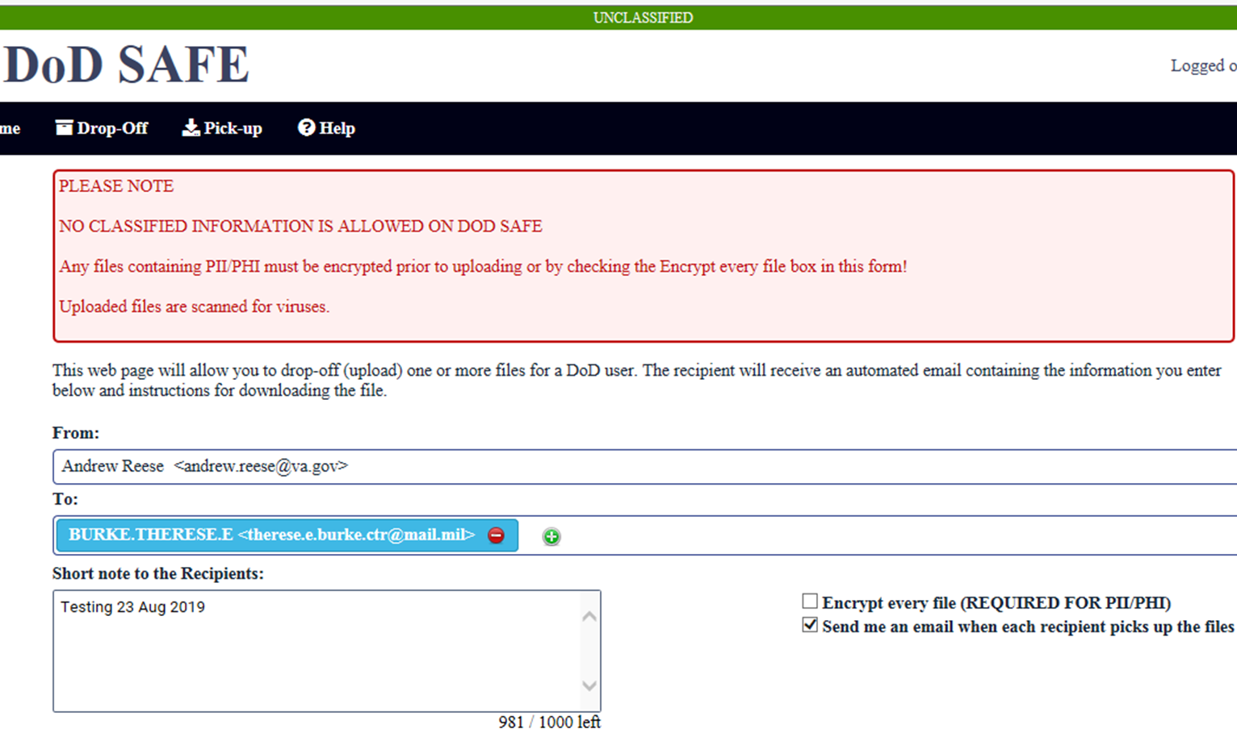

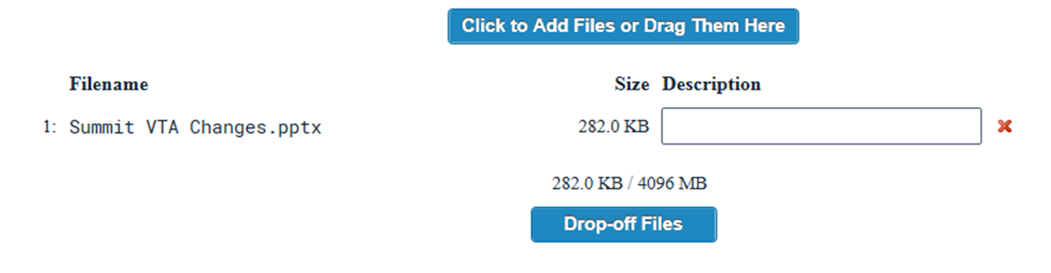

MSC should see the Drop-Off Completed message after clicking Drop-off Files.

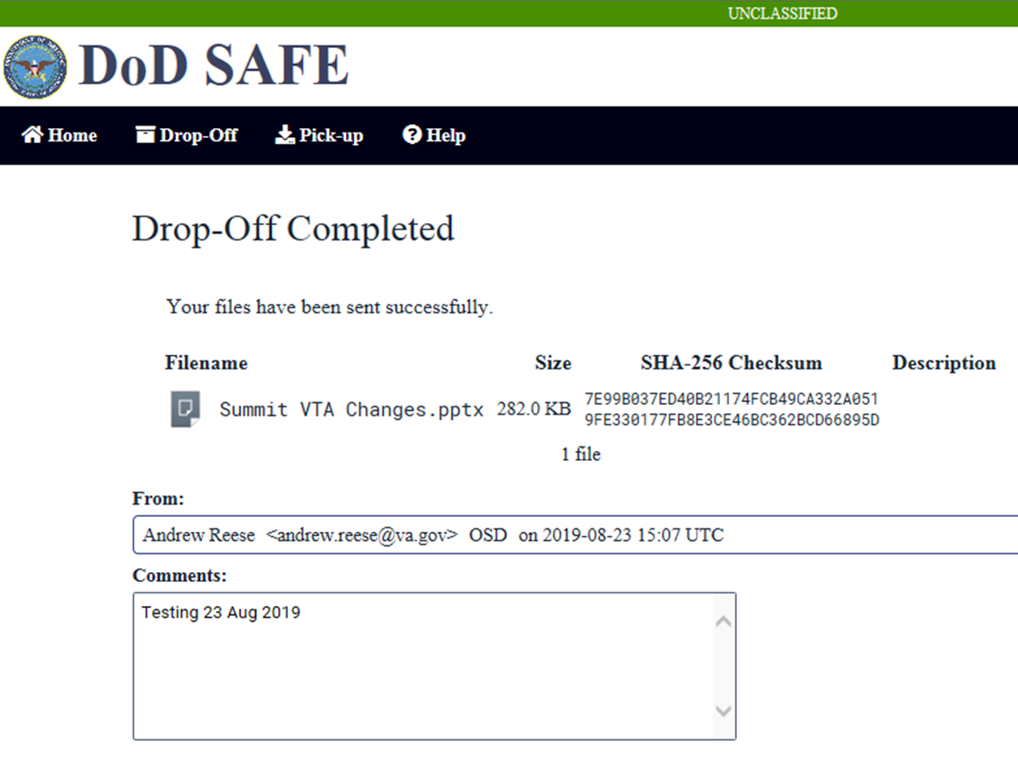

Notes:

1. The use of DoD SAFE requires more coordination/support from the PEBLO as compared to using ARMDEC SAFE. Each location that uses SAFE will need to work on a coordination plan. In order to reduce the # of request emails/calls to the PEBLO, one location has developed a plan that when the PEBLO receives the auto-email from VTA that the Medical Evaluation End Date has been entered, the PEBLO will send the Drop-Off request to the MSC, and MSC will upload/send the exams.
2. A Drop-Off request is required for every transaction.

**ERB-S Discontinued; ERB Updated**

The ERB-S tool has been discontinued. [lll.iv.3.A.10.b](https://vaww.vrm.km.va.gov/system/templates/selfservice/va_kanew/help/agent/locale/en-US/portal/554400000001034/content/554400000015809/M21-1-Part-III-Subpart-iv-Chapter-3-Section-A-Examination-Requests-Overview?query=III.iv.3.A.10#10) now stipulates that claims processors requesting examinations via EMS must use the [***Supplemental Language Matrix***](https://www.knowva.ebenefits.va.gov/system/templates/selfservice/va_ssnew/help/customer/locale/en-US/portal/554400000001018/content/554400000105052/Supplemental-Language-Matrix) to identify the types of claims that require supplemental language and find the required language to be added to the exam request.

Some common claim types that require supplemental language are listed below. (refer to [lll.iv.3.A.10.b](https://vaww.vrm.km.va.gov/system/templates/selfservice/va_kanew/help/agent/locale/en-US/portal/554400000001034/content/554400000015809/M21-1-Part-III-Subpart-iv-Chapter-3-Section-A-Examination-Requests-Overview?query=III.iv.3.A.10#10) for a complete listing)

* peripheral nerve examination
* musculoskeletal joint examination
* examination of female claimants for systemic illness

**Important:** When requesting a SHA exam, if any of the specific claim types shown in [lll.iv.3.A.10.b](https://vaww.vrm.km.va.gov/system/templates/selfservice/va_kanew/help/agent/locale/en-US/portal/554400000001034/content/554400000015809/M21-1-Part-III-Subpart-iv-Chapter-3-Section-A-Examination-Requests-Overview?query=III.iv.3.A.10#10) are indicated on the exam request, the special language must be added (regardless of whether the body-system specific DBQ was specifically request).

**Exception to MST Checklists Requirement**

As indicated in [III.i.2.D.4.c](https://vaww.vrm.km.va.gov/system/templates/selfservice/va_kanew/help/agent/locale/en-US/portal/554400000001034/content/554400000033257/M21-1,-Part-III,-Subpart-i,-Chapter-2,-Section-D---Overview-of-the-Integrated-Disability-Evaluation-System-(IDES)-and-Initial-Claims-Development" \l "4c). and discussed on the [May 2019 IDES/BDD Teleconference Call](https://vbaw.vba.va.gov/VBADOD/docs/IDES/May2019BDDandIDESCallNotesFinal.docx) it is not necessary for MSCs to develop for stressors in PTSD claims from active duty IDES participants. [III.i.2.D.4.c](https://vaww.vrm.km.va.gov/system/templates/selfservice/va_kanew/help/agent/locale/en-US/portal/554400000001034/content/554400000033257/M21-1,-Part-III,-Subpart-i,-Chapter-2,-Section-D---Overview-of-the-Integrated-Disability-Evaluation-System-(IDES)-and-Initial-Claims-Development#4c) further stipulates that MSCs must refer cases to the MST coordinator only in the limited cases that require stressor development (typically limited to cases involving non-Active duty participants). As indicated during the May Call, this guidance is equally applicable to BDD claimants.

[lll.iv.4.O.3.g](https://vaww.vrm.km.va.gov/system/templates/selfservice/va_kanew/help/agent/locale/en-US/portal/554400000001034/content/554400000076270/M21-1-Part-III-Subpart-iv-Chapter-4-Section-O-Mental-Disorders?query=Part%20III,%20Subpart%20iv,%20Chapter%204,%20Section%20O%20%E2%80%93%20Mental%20Disorders#3) was recently updated to indicate that in any rating decision addressing an MST related condition, three MST related checklists (primarily concerned with stressor verification) must be completed and uploaded to the claims folder. However, in consideration of the special circumstances of Pre-Discharge claims, which prevent the need for stressor verification, Compensation Service and Office of Field Operations have determined that an exception to the MST checklists requirement is warranted in cases involving:

* IDES participants who are currently serving on active duty and
* BDD participants

**Important:** Use of the MST checklists remains mandatory in MST claims from IDES participants serving in the National Guard or Reserve who are not currently on active duty.

The rationale for this exception is as outlined in [III.i.2.D.4.c](https://vaww.vrm.km.va.gov/system/templates/selfservice/va_kanew/help/agent/locale/en-US/portal/554400000001034/content/554400000033257/M21-1,-Part-III,-Subpart-i,-Chapter-2,-Section-D---Overview-of-the-Integrated-Disability-Evaluation-System-(IDES)-and-Initial-Claims-Development#4c): Pre-Discharge claimants will receive in-service VA examinations. An in-service diagnosis of PTSD (or other MST-related condition) would be sufficient to support a grant on a direct basis.  Alternatively, VA examination results showing no diagnosis would also make stressor development unnecessary.

This exception is effective immediately; an update to [lll.iv.4.O.3.g](https://vaww.vrm.km.va.gov/system/templates/selfservice/va_kanew/help/agent/locale/en-US/portal/554400000001034/content/554400000076270/M21-1-Part-III-Subpart-iv-Chapter-4-Section-O-Mental-Disorders?query=Part%20III,%20Subpart%20iv,%20Chapter%204,%20Section%20O%20%E2%80%93%20Mental%20Disorders#3) to acknowledge this exception is forthcoming. OFO will also send out notification regarding this topic to the field for distribution.

**Question:** Will there be guidance regarding the MST Checklist sent to the field?

**Answer:** An email from OFO was sent on September 11, 2019 to all field offices regarding the requirement. Manual updates are forthcoming.

**Question:** Is the MST DEV Checklist required for Title 32 NG for BDD claim?

**Answer:** Since the BDD program does not accept non-active duty claimants, there is no requirement for the checklist.

IDES Specific Topics

**Handling IDES Cases with Previous STRs in VA Possession**

PEBLOs are generally responsible for providing all STRs for current and previous periods of service (POS) as part of a compete IDES referral package—except when the prior STRs are in VA possession.

**Note:** If a SM was *immediately* assigned to a Reserve unit after being released from active duty, his/her service department should have sent the SMs STRs to that unit for storage and maintenance. These records are considered in *DoD possession* and should be provide with the IDES referral.

If the PEBLO provides a referral without STRs from a previous POS (and indicates that the records are missing or not in DoD possession), the MSC must determine if the records are in VA possession and take any appropriate action to ensure the records are available in the eFolder. Required MSC action in these instances is summarized below.

* Determine if the records are included in the VBMS eFolder. Records may be in the eFolder if the participant filed a previous VA claim, or as part of the RMC File Bank Extraction Project.
* If the STRs are not in the VBMS eFolder, the MSC must determine the end date of the previous POS, and take action according to the table shown in [lll.iii.2.B.2.e.](https://vaww.vrm.km.va.gov/system/templates/selfservice/va_kanew/help/agent/locale/en-US/portal/554400000001034/content/554400000014155/M21-1,-Part-III,-Subpart-iii,-Chapter-2,-Section-B---Migration-of-Service-Records-and-the-Procedures-for-Obtaining-Them#2)
* **If the records were previously stored at the RMC** (but not yet shown in the eFolder):
  + check the [RMC Source Material Tracking System (SMTS) Portal](https://rmc.csra.com/ro) to determine the status of the STR, and
  + add tracked items as required by [lll.iii.2.l.2.a.](https://vaww.vrm.km.va.gov/system/templates/selfservice/va_kanew/help/agent/locale/en-US/portal/554400000001034/content/554400000014163/M21-1,-Part-III,-Subpart-iii,-Chapter-2,-Section-I---Control-and-Follow-Up-of-Requests-for-Service-Records#2)

**Note**: VBA employees can access the SMTS Portal with their PIV credentials, but must first complete the SMTS Portal Training in TMS, (*VA 4472819).*

* **If the records are stored at NPRC,** use PIES to request the records as required by [lll.iii.2.A.3.h.](https://lll.iii.2.A.3.h.)

**Determining the Effective Date in Non-Active Duty IDES Cases**

As discussed on the July IDES/BDD Teleconference call, the date of the receipt of the VA Form 21-0819 will serve as the date of claim for the EP 689, and in claims from Veterans who are not serving on active duty, this same date will generally serve as the effective date of award for all issues IDES issues (i.e., all issues raised during the initial interview with the MSC). This policy is specified by lll,i.2.F.2.d (step 5).

The VA Form 21-0819 (in and of itself) no longer represents a formal VA claim; however, the form continues to maintain the function to preserve an effective date when a formal claim is submitted during the initial IDES interview with the MSC. In this respect, the VA Form 21-0819 is similar to an intent to file (ITF).

In NAD cases, when a formal clam is submitted at the initial interview, the VA Form 21-0819 is a DOC placeholder, all applicable effective date rules may be applied based on the date of receipt of the VA Form 21-0819.

A VA Form 21-0819 does **not** serve to preserve an effective date if:

* + - The participant declines to file a VA claim at the initial interview
    - For any issues raised after the conclusion of the initial interview

**Note:** When a participant indicates his or her intent to file a VA claim, but is unable or unwilling to return the form immediately at the interview, VA will wait up to five days for the return of the application. In these instances, the initial interview is considered “concluded” upon the return of the application or the expiration of the 5 days (whichever occurs first).

Any issues that are formally claimed after the IDES initial interview are not considered “IDES issues”. In NAD cases, the effective date for these issues will be determined by the date the formal application was received-without consideration of the date of the VA Form 21-0819.

**Important:** The information regarding effective dates above is applicable to NAD cases only. In AD cases, the effective date for all issues formally claimed while the participant is serving on active duty, will be the day following discharge.

**No Requirement for DRAS Notification to MSC of Proposed Rating Completion**

[lll.i.2.E.3.m](https://vaww.vrm.km.va.gov/system/templates/selfservice/va_kanew/help/agent/locale/en-US/portal/554400000001034/content/554400000046269/M21-1,-Part-III,-Subpart-i,-Chapter-2,-Section-E---Department-of-Veterans-Affairs-(VA)-Responsibilities-Based-on-Medical-Evaluation-Board-(MEB)-and-Physical-Evaluation-Board-(PEB)-Outcomes#3) indicates that the DRAS is responsible for providing a copy of the BEL and proposed rating to the MSC. The requirement was meant to ensure that the MSC had a copy of these documents to respond to questions from the PEBLO. Prior to use of the VBMS eFolder, this meant the DRAS had to email copies to the MSC. However, at this time, the requirement to provide these documents to the MSC is considered fully satisfied by the documents’ availability in the eFolder. There is no further requirement for any additional notice or communication to the MSC. DRAS employees may have continued the practice of emailing the MSC assigned when the proposed was complete, but have recently been advised to discontinue the practice, as eliminating this action will save time. It’s understood that MSCs may now be accustomed to this notice, and that some may have put this notice to use as a signal to begin exit interview activity. However, MSCs are reminded that exit interview action is not tied to the completion of the proposed rating--exit interviews should not be completed until the PEBLO enters the Final Disposition Date in VTA.  Exit Interview completion should be managed using Pending Exit Interview Report in VTA.

IDES Summit

The Providence DRAS hosted an IDES Summit the week of August 12th. Representatives from Comp Service, Seatte and Providence DRAS’, Northeast and Pacific Districts, the Services and the Coast Guard were on hand. A Lean Six Sigma work group conducted an IDES improvement exercise to improve IDES. There were also numerous discussions and briefings.

DRAS Reminders to MSCs

MSCs are reminded about the following items. Small, proactive tweaks in the IDES process can have a large, positive effect on VA’s work and the SMs and Veterans we serve.

1. Please specify extremity(ies) claimed, i.e. write “right leg” rather than solely “leg” on the VA Form 21-526EZ.

2. Consolidation of claims: While it is understood that medical background is not there, MSCs should consider counseling SMs when the same condition is being claimed numerous ways.

Example: Back condition claimed 15 different ways.

3. Development: If working a National Guard or Reserve case, please assist with service verification / obtaining all relevant orders. Close tracked items when appropriate.

4. Provide counseling if the SM is already service-connected for static conditions (Guard/Reserves, generally).

Example a: is SM repeating claims from a previous rating decision by which he/she already has a static, highest possible evaluation (tinnitus at 10%, etc.)?

We are not asking MSCs to leap to extremes regarding medical and legal decisions; rather, to advise where and when it makes reasonable sense to do so.

5. Please review the VA Forms 21-0819 / 21-526EZ / 21-4138 claimed conditions with the SM prior to officially filing the claim. Sometimes at VA Exams, the SM indicates surprise by the conditions being addressed. Claims filed should be current, chronic conditions and should be expressly claimed by the SM. When claims are vague or not current and chronic, this raises the possibility of quality errors for the Rater, confusing examination reports, as well as poor service for the SM.

6. If possible, please produce the same dates of receipt for the respective claims forms (21-0819, 21-526EZ, 21-4138), as this would streamline VA dates of claim/entitlement processing. Please ensure that all claims forms are signed by the SM and uploaded to VBMS.

7. If the entrance exam is missing, please initiate development to obtain it.

8. If you notice that the SM is terminally ill, seriously ill/injured, very seriously ill/injured, experiencing financial hardship, and/or homeless, please contact the DRAS so that these cases are on our radar as soon as possible.

**Question:** Are we still required to verify any service prior to the current period of service?

**Answer:** Yes

VA Form 686C and Other Forms

All personnel should ensure they are not using out-dated forms. The VA Forms website is located at <http://vaww.va.gov/vaforms/>.

Current IDES Program Timeliness

As outreach specialists and VA’s frontline contact with SMs and Veterans, it is vital that we are realistic in our communications regarding claims processing times. Below is the current program timeliness data (ADC) as of September 3, 2019.

|  |  |
| --- | --- |
| **August 2019** | **IDES** |
| **Claim Dev (AD/NAD)** | **6/28** |
| **Exams to PEBLO** | **3** |
| **Medical Stage** | **40** |
| **Proposed Ratings (AD/NAD)** | **29/58** |
| **Recon Ratings (AD/NAD)** | **18/23** |
| **Exit Interviews** | **7** |
| **Final Ratings (AD)** | **27** |

**Source:** VTA Completed Reports September 3, 2019 (9am ET)

VTA Reminders

**VTA v.2.4.4**

VTA v.2.2.4 is scheduled for release on September 15, 2019. VA specific items are in Appendix 1.

BDD Specific Topics

### Secondary Action Required Tracked Item

### BDD claims processors must follow guidance in [1 I.1.C.3.l](https://vaww.vrm.km.va.gov/system/templates/selfservice/va_kanew/help/agent/locale/en-US/portal/554400000001034/content/554400000014066/M21-1-Part-I-Chapter-1-Section-C-Requesting-Records#3l) regarding BDD claims where examinations have not been requested. Per [I.1.C.3.l (Step 2)](https://vaww.vrm.km.va.gov/system/templates/selfservice/va_kanew/help/agent/locale/en-US/portal/554400000001034/content/554400000014066/M21-1-Part-I-Chapter-1-Section-C-Requesting-Records#3l), if examinations have not been requested for BDD excluded claims, enter a permanent claim level VBMS note stating that BDD excluded examinations are not required to be requested until after discharge. Establish a tracked item using the SECONDARY ACTION REQUIRED from the COMPMGT menu with a suspense of the day after discharge. The maximum days allowed in VBMS for this tracked item is 120 days. If the SMs anticipated discharge date is over 120 days, enter a suspense date of 120 days. Enter a VBMS note indicated the maximum days allowed in VBMS for this tracked item is 120 days and include the SMs anticipated discharge date.

We are currently working the Compensation Service Quality Review Staff regarding this tracked item requirement and if new M21-1 guidance is published, we will include it on the subsequent monthly BDD/IDES Conference Call. Any questions can be sent to the Quality Review Staff mailbox, VAVBAWAS/CO/QRT, [QRT.VBACO@va.gov](mailto:QRT.VBACO@va.gov).

**Veterans Service Organizations and BDD Claims Documents Scanning**

ROs receiving BDD claims from VSOs must not send these claims documents to Centralized Mail as this will severely delay the time sensitive processing of the BDD claim. Per [III.i.2.B.2.b](https://vaww.vrm.km.va.gov/system/templates/selfservice/va_kanew/help/agent/locale/en-US/portal/554400000001034/content/554400000014101/M21-1,-Part-III,-Subpart-i,-Chapter-2,-Section-B---Division-of-Responsibilities-for-Processing-Benefits-Delivery-at-Discharge-(BDD)-and-BDD-Excluded-Claims) (Step 5), all BDD claims documents will be forwarded for VCIP scanning or scanned locally. This topic was included in the [August 2019 VSCM Conference Call/Compensation Service Bulletin (CSB)](https://vaww.vrm.km.va.gov/system/templates/selfservice/va_kanew/help/agent/locale/en-US/portal/554400000001034/content/554400000125236/CSB-2019-08-August#10).

**BDD In-Service Rating Decisions and Service Verification/STRs Development**

Claims processors must not develop for service verification and subsequent STRs for SMs still on AD that have submitted a BDD claim until after discharge. These SMs have already submitted a copy of their STRs prior to discharge. Service will be verified and the automated request for STRs in VBMS will be completed after discharge per [III.i.2.B.4.e](https://vaww.vrm.km.va.gov/system/templates/selfservice/va_kanew/help/agent/locale/en-US/portal/554400000001034/content/554400000014101/M21-1,-Part-III,-Subpart-i,-Chapter-2,-Section-B---Division-of-Responsibilities-for-Processing-Benefits-Delivery-at-Discharge-(BDD)-and-BDD-Excluded-Claims) (Steps 8 and 9). The BDD claim must not be deferred for service verification per [III.i.2.B.4.e](https://vaww.vrm.km.va.gov/system/templates/selfservice/va_kanew/help/agent/locale/en-US/portal/554400000001034/content/554400000014101/M21-1,-Part-III,-Subpart-i,-Chapter-2,-Section-B---Division-of-Responsibilities-for-Processing-Benefits-Delivery-at-Discharge-(BDD)-and-BDD-Excluded-Claims) (Step 1). Per [III.i.2.B.4.e](https://vaww.vrm.km.va.gov/system/templates/selfservice/va_kanew/help/agent/locale/en-US/portal/554400000001034/content/554400000014101/M21-1,-Part-III,-Subpart-i,-Chapter-2,-Section-B---Division-of-Responsibilities-for-Processing-Benefits-Delivery-at-Discharge-(BDD)-and-BDD-Excluded-Claims), if all other development actions have been completed, a rating decision will be generated and finalized while the SM is on AD. However, the rating decision will not be promulgated until the day after discharge. This topic was also included in the [August 2019 VSCM Conference Call/CSB](https://vaww.vrm.km.va.gov/system/templates/selfservice/va_kanew/help/agent/locale/en-US/portal/554400000001034/content/554400000125236/CSB-2019-08-August#10).

Current BDD Program Timeliness

As outreach specialists and VA’s frontline contact with SMs and Veterans, it is vital that we are realistic in our communications regarding claims processing times. Below is the current program timeliness data as of September 3, 2019.

|  |  |
| --- | --- |
| **September 2, 2019** | **BDD** |
| **Completed FYTD** | **30,111** |
| **Receipts FYTD** | **33,386** |
| **Pending** | **4,077** |
| **# Completed w/in 30 Days of Discharge** | **15,050** |
| **% Completed w/in 30 Days of Discharge** | **49.9%** |
| **Avg. Days to Complete FYTD** | **55.2** |

**Source:** Tableau BDD History Report and PA&I Daily Snapshot, September 3, 2019

Open Floor

Next Teleconferences

The next BDD/IDES Call is scheduled for Tuesday, October 8, 2019 at 2PM ET. Please submit IDES questions and proposed topics for discussion to the [IDES Mailbox](mailto:VAVBAWAS/CO/IDES%20%3cIDES.VBACO@VA.GOV%3e), and BDD questions and proposed topics for discussion to the [Pre-Discharge BDD Mailbox](mailto:VAVBAWAS/CO/PREDISCHARGE%20%3cPredischarge.VBACO@va.gov%3e) no later than COB, Thursday, September 26, 2019.

The next BDD/IDES Coaches Call is scheduled for Thursday, September 12, 2019 at 2PM ET.

Next month’s BDD/IDES Coaches call is scheduled for Thursday October 10, 2019 at 2PM ET. Please submit IDES questions and proposed topics for discussion to the [IDES Mailbox](mailto:VAVBAWAS/CO/IDES%20%3cIDES.VBACO@VA.GOV%3e), and BDD questions and proposed topics for discussion to the [Pre-Discharge BDD Mailbox](mailto:VAVBAWAS/CO/PREDISCHARGE%20%3cPredischarge.VBACO@va.gov%3e) no later than COB, Thursday, September 26, 2019.

**Appendix 1: VTA v.2.4.4**

**CR987016: MSC tab – changes to the Return to Duty Letter Date**

When changes to the MSC tab data (Final Disposition selection/MEB Results selection) result in disabling the Return to Duty Letter Date field, any value in that field is now deleted, in addition to being rendered “read-only”.

**CR987308: Exam Provider Timeliness reports**

Both the pending and completed Exam Provider Timeliness reports display a new column, “MEB MTF”, just to the left of the “Service” column.

The completed Exam Provider Timeliness report is changed to include cases where the SHA Exam Returned Date or the Other Exam Returned Date fall within the date-range filter criteria, instead of including cases where the SHA Exam Requested Date or the Other Exam requested Date fell within the date-range filter criteria.

**CR996142: Exam Review Completed report**

This report now includes all of the Exam Reviews for a case, rather than just the first Exam Review. Each Exam Review will display as a separate record in the report.

**CR1006865: Pending Proposed Rating report**

In addition to including cases where the Proposed Rating Request Date is populated, this report will also include cases where the Proposed Rating Request Date is blank, but the VA Proposed Rating Start Date is populated.

**CR1006866: Pending Reconsideration Rating report**

In addition to including cases where the Date Reconsideration Rating Requested is populated, this report will also include cases where the Date Reconsideration Rating Requested is blank, but the VA Reconsideration Rating Start Date is populated.