# Modifications Job Aid

Users may modify an existing Exam Scheduling Request (ESR) for the following reasons:

* Cancel a Contention
* Cancel Entire Scheduling Request
* Change Address
* Modify Appointments
* Provide special instructions

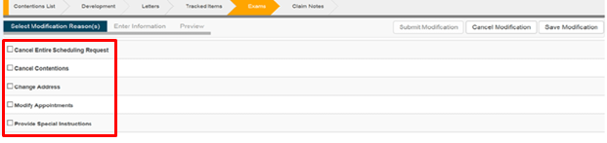

**Note:** The ability to modify the ESR is dependent on the status of the ESR and completion of each contention.

## Topic 1: Canceling Contentions

The user needs to verify that the contention being canceled meets the following conditions:

* Appointment Date has not passed for the contention being cancelled
* The scheduled appointment is greater than one day from the cancellation
* ESR level status is in “Open” status

**Step 1:** User will select “Create Modification” from the “Actions” drop down.

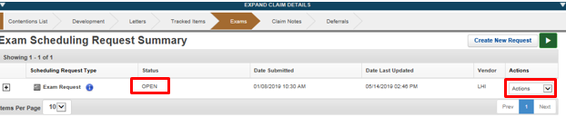

**Step 2:** User will select the “Create Modification” function

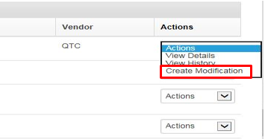

**Step 3:** The user will select “Cancel Contentions”

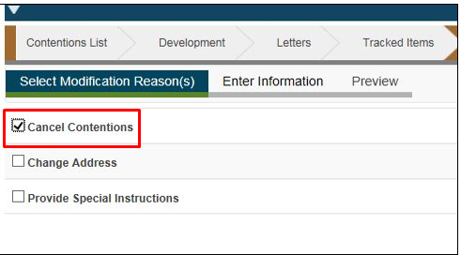

**Step 4:** User will then select the Enter Information Tab and select Contention(s) requiring cancellation. The appropriate reason for cancellation will need to be selected. If “other” is chosen, the user should enter the specified reason for canceling the contention not listed.

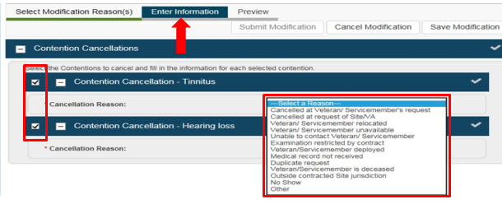

**Step 5:** User will then select the “Preview” tab and the PDF will generate showing contentions to be cancelled. Then click “Submit”, there is also the option to “Cancel” the Modification.

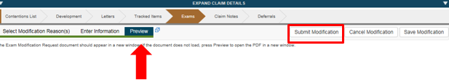

## Topic 2: Cancel Entire Scheduling Request

The user needs to verify that **all** contention(s) being canceled have the following conditions:

* Appointment Date has not passed (All Contentions)
* The scheduled appointment is greater than one day from the cancellation
* ESR status is in “Open”

**Step 1:** User will select “Create Modification” from the “Actions” drop down, as shown above in Topic 1 and select “Create Modification”. Then select “Cancel Entire Scheduling Request”.

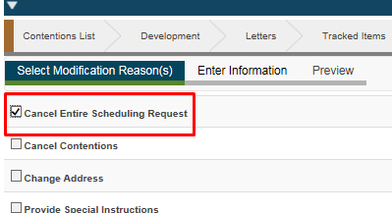

**Step 2:** User will select the “Enter Information” tab and select the reason for canceling the entire ESR request. If “other” is chosen, the user will have to enter the specified reason for canceling the contention not listed in the drop-down menu.

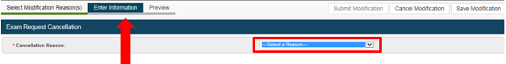

Step 3: User will then select the “Preview” tab and the PDF will generate showing the ESR is being cancelled. Then click “Submit”, there is also the option to “Cancel” the Modification.



## Topic 3: Change Address

The user needs to verify that the contention(s) that need address to be updated have the following conditions:

* Appointments have not been scheduled
* ESR status is in “Open”

**Step 1:** User will select “Create Modification” from the “*actions*” drop down menu, as shown above in Topic 1 and select “Create Modification”. Then select “Change Address”.

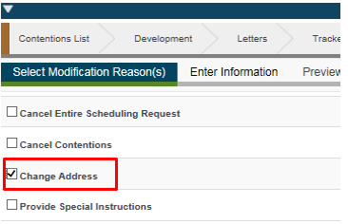

**Step 2:** User will select the “Enter Information” tab and select the “Preferred Geographical Location”.

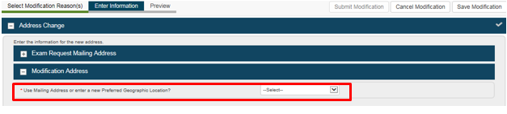

**Step 3:** The user can now enter where the Veteran currently resides.

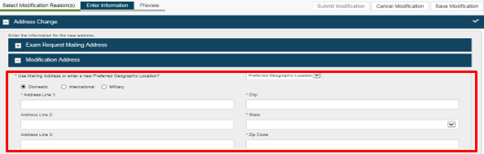

**Step 4:** User will then select the “Preview” tab and the PDF will generate showing the change of address. Then click “Submit”, there is also the option to “Cancel” the Modification.

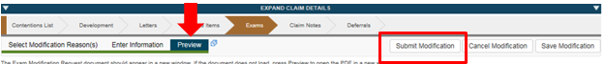

## TOPIC 4: Modifying Appointments

The user will not be given the option to modify the appointment if the following conditions exist:

* Appointment date has passed for the contention being modified
* The scheduled appointment is less than one full calendar day from the date the user desires to cancel
* ESR status is not in an “Open” State

**Note:** It is not a defect if the Appointment modification option is not available in these conditions.

**Step 1:** User will select “Create Modification” from the “Actions” drop down, as shown above in Topic 1 and select “Create Modification”. Then select “Modify Appointments”.

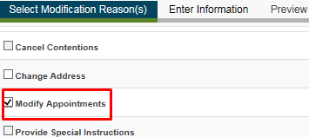

**Step 2:** User will select the “Enter Information” tab and select the appointment(s) needing modification. Then the user will select to reschedule or cancel appointment using the “Type” drop down. The user will then enter the reason for the reschedule.

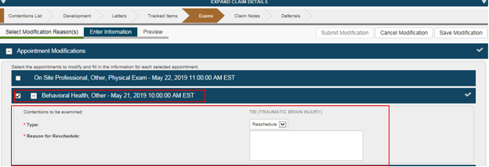

**Step 3:** The user will then select the “Preview” tab and the PDF will generate showing the modification of the appointment(s). Then click “Submit”, there is also the option to “Cancel” the Modification.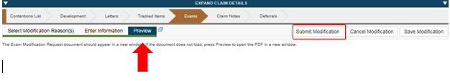

## Topic 5: Special Instructions

Special Instructions allow a user to send additional instructions that may have been left off an ESR to the MDE Vendor. The user needs to verify that when providing special instructions, the following conditions exist:

* Appointments are in the future (appointments are not within 1 full calendar day of the date of the modification)
* ESR level status is in “Open”

**Note:** The Special Instructions option will only list contentions with future appointments. If the Special Instructions block has no listed contentions, all of the appointments are passed and this is not a defect.

**Step 1:** User will select “Create Modification” from the “Actions” drop down, as shown above Topic 1 and select “Create Modification”. Then select “Provide Special Instructions”.

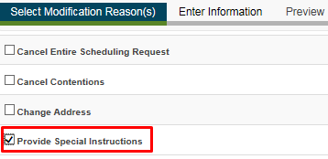

**Step 2:** User will select the “Enter Information” tab and select the contention(s) needing special instructions. The user will then provide the special instructions in the field provided.

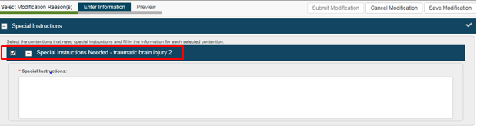

**Step 3:** User will then select the “Preview” tab and the PDF will generate showing the special instruction(s). Then click “Submit”, there is also the option to “Cancel” the Modification

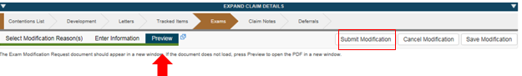

# Modification Terminology

**Cancel Entire Scheduling Request**: Use this option to cancel the exam scheduling

request. If you select this option, you cannot select any other modification reasons.

**Cancel Contentions**: Use this option to cancel one or more contentions on the exam

scheduling request.

**Change Address**: Use this option to add or edit a preferred geographic address, or

use the current mailing address in the Veteran Profile.

**Modify Appointments**: Use this option to request that an appointment be

rescheduled or cancelled. Submitting a request does not automatically reschedule or

cancel appointments. This option is only shown if at least one appointment has been

scheduled for the exam scheduling request.

**Provide Special Instructions**: Use this option to add special instructions for one or

more contentions on the exam scheduling request.