# Rework Job Instruction Sheet

Prior to ordering a Rework exam request, the user must ensure that the ESR is in a “Completed” status. Additionally, the following messaging must be reflected in the history:

* ESR acknowledgement
* appointment completed
* results available package for each contention requiring the rework

**Note:** Any section marked with a red asterisk is a required field and must be filled out to move on.

Completed Status is depicted below:

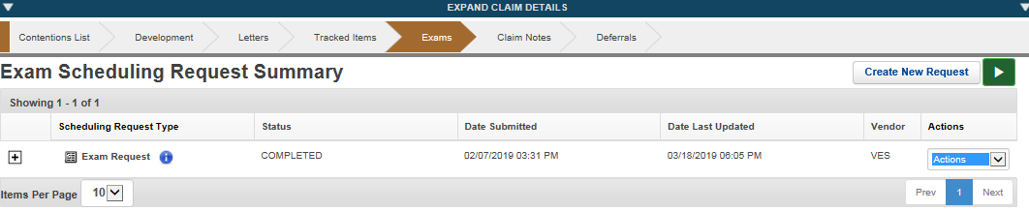

Use history functionality to review the messages.

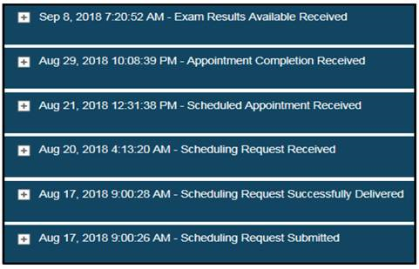

**Step 1:** Click Rework from the “*actions*” drop down menu

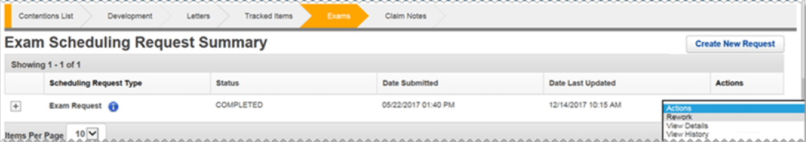

**Step 2:** Check the box for each contention that requires rework.

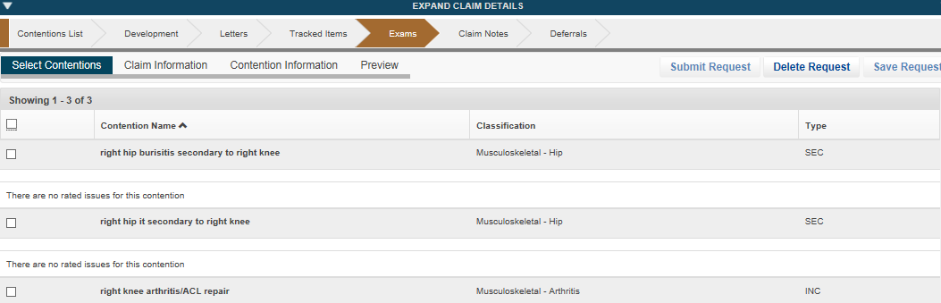

**Step 3:** Verify the mailing address of the Veteran and the Claim Priority.

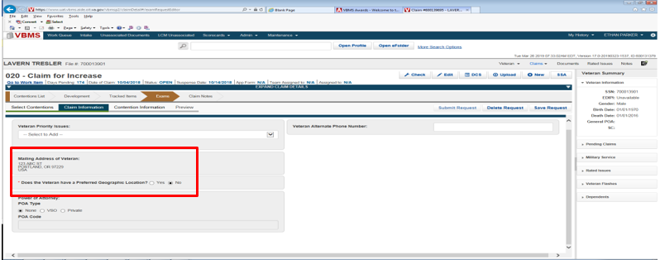

**Step 4:** If the Veteran is residing in a temporary address use the “Preferred Geographic Location” option.

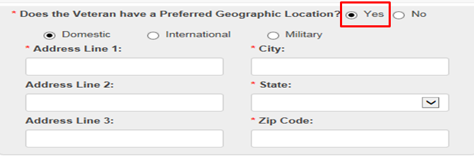

**Step 5:** User must provide a Rework Type by using the drop-down arrow and then choosing insufficiency or clarification. Users must then select the “Rework Reasons” and provide a detailed rationale for the rework.

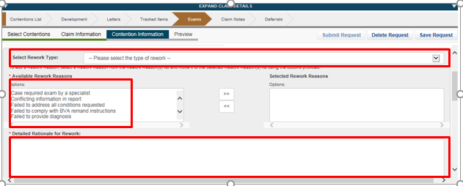

**Step 6:** User will select the appropriate DBQ and provide any special instructions if necessary.

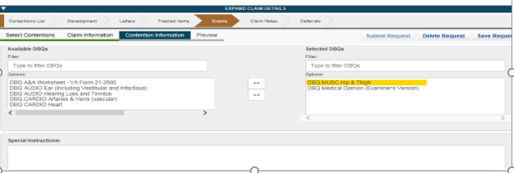

**Step 7:** Next click ‘Preview’ from the Exam subcategories list. This will generate a PDF of the rework Exam Scheduling Request (ESR), which will contain the information provided to the examiner. Review the PDF and validate that all necessary information is included, then can close out the PDF. If any information needs to be amended, you can go back and update as necessary. You can now click ‘Submit Request’:

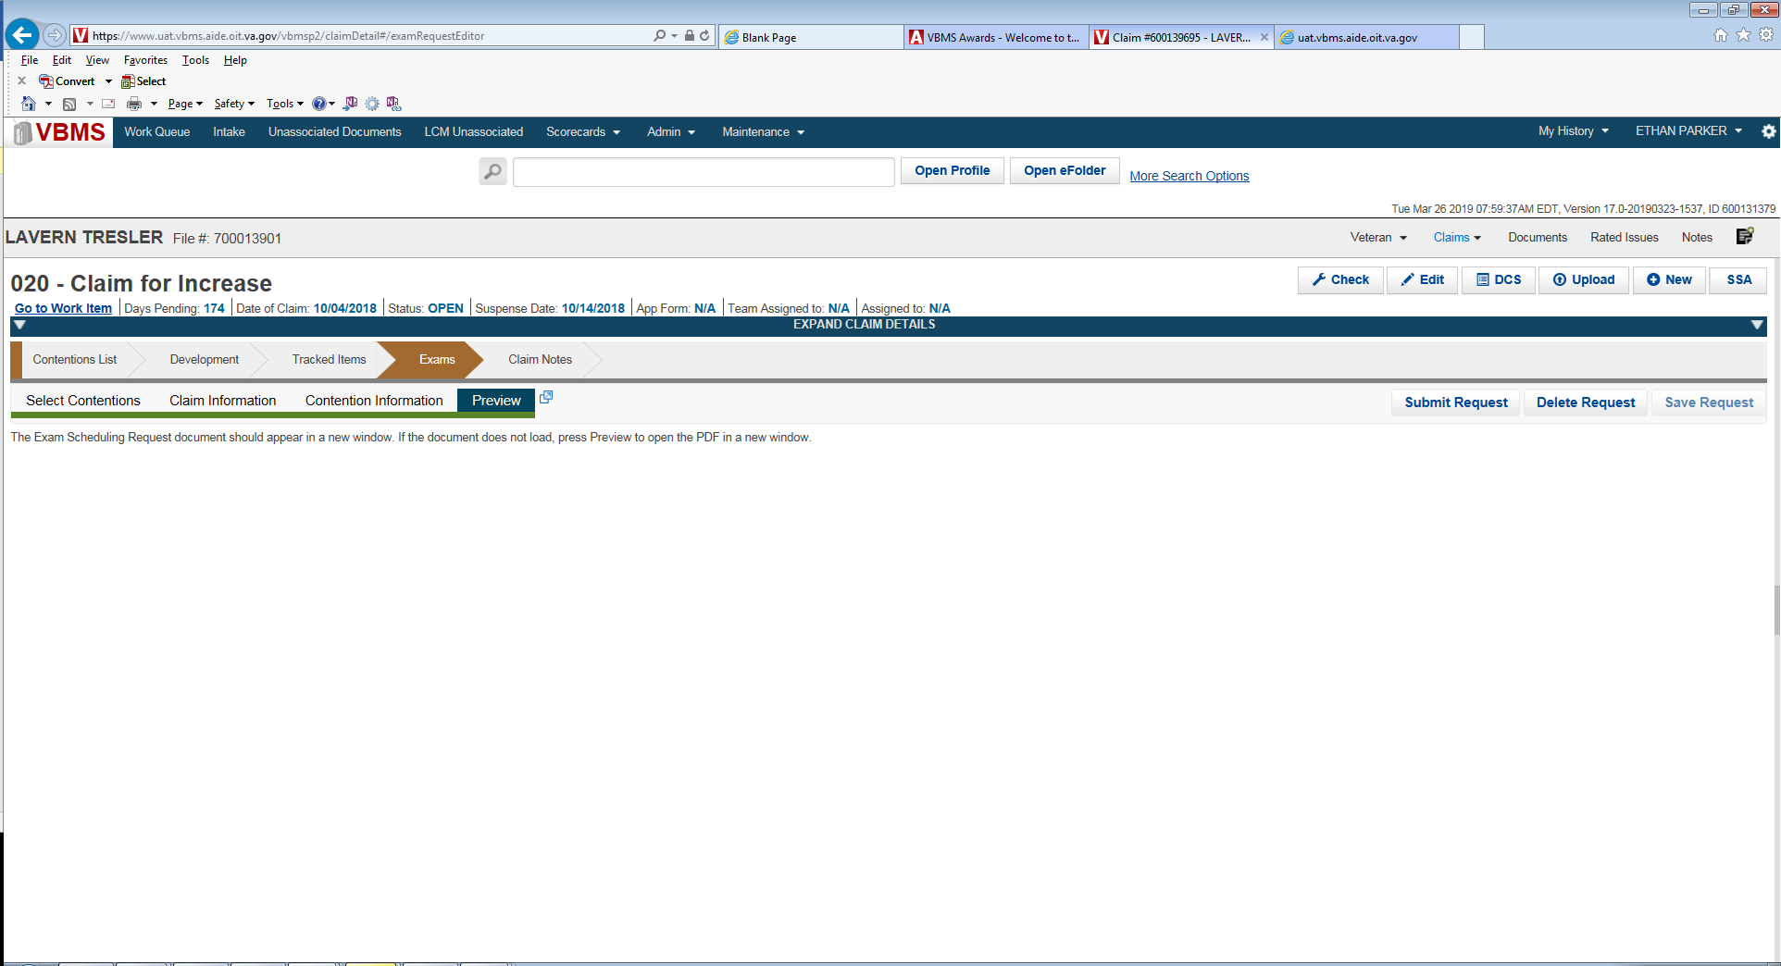

**Step 8:** EMS will automatically select the vendor that previously completed the original examination(s).

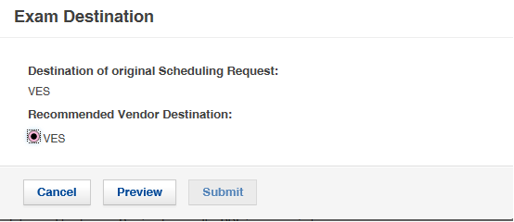

**Step 9:** After clicking ‘Preview’ and again reviewing the Rework ESR, you can now click ‘Submit’. Once you submit from this point, you cannot make changes to the ESR. You can only modify the ESR once the submission is in “*open*” status.

**Step 10:** Prior to ordering the Rework exam, if at any point you must close out before submitting the request, you can return to the Exam chevron and if you had saved your work, you will be able to edit your draft request.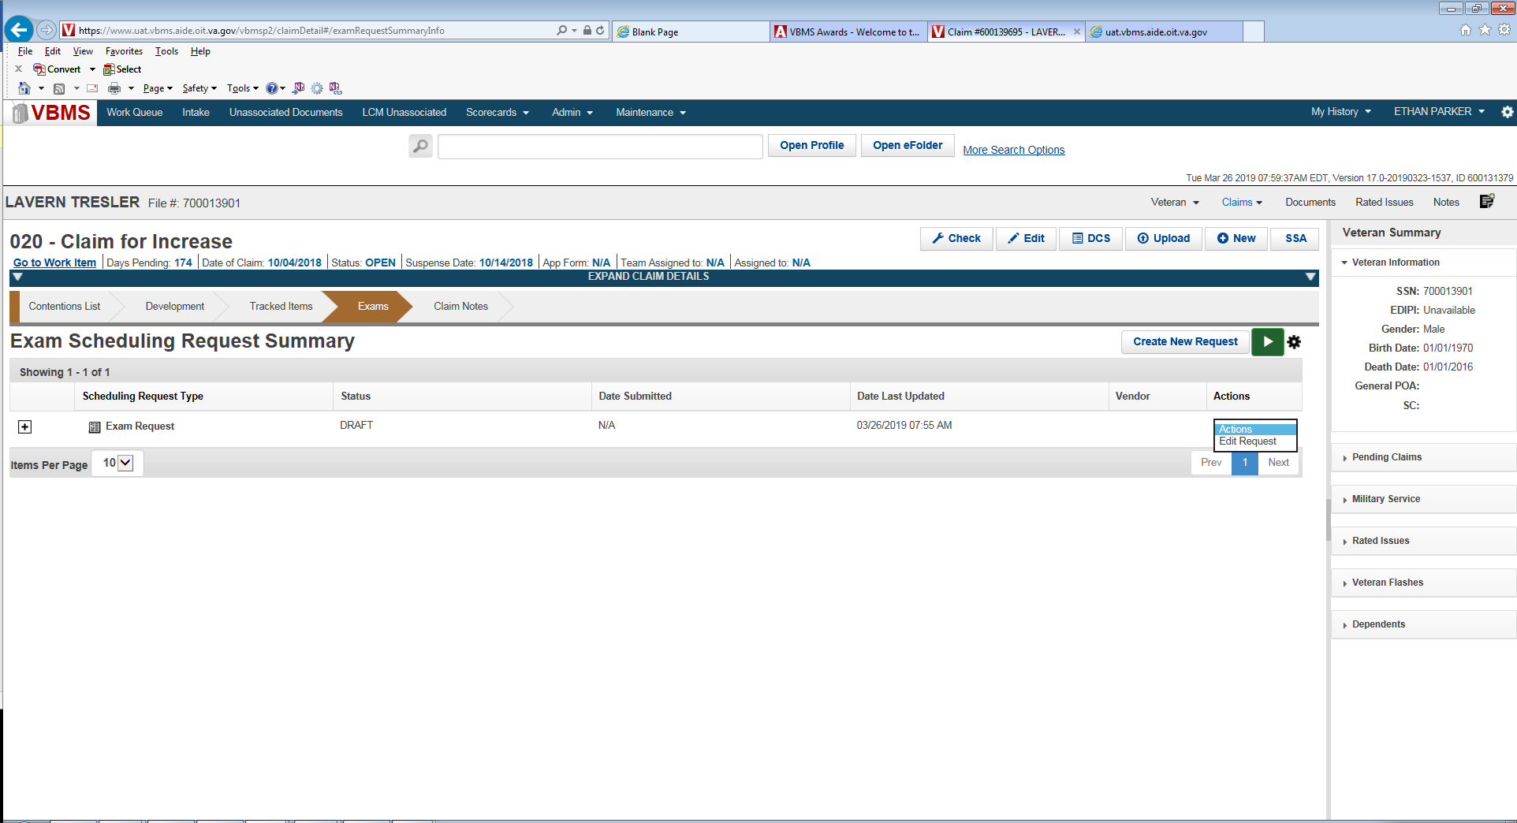

**Step 11:** Upon submitting the Rework ESR, you should verify that the correct “Tracked Items” were created and that the claim suspense updated appropriately:

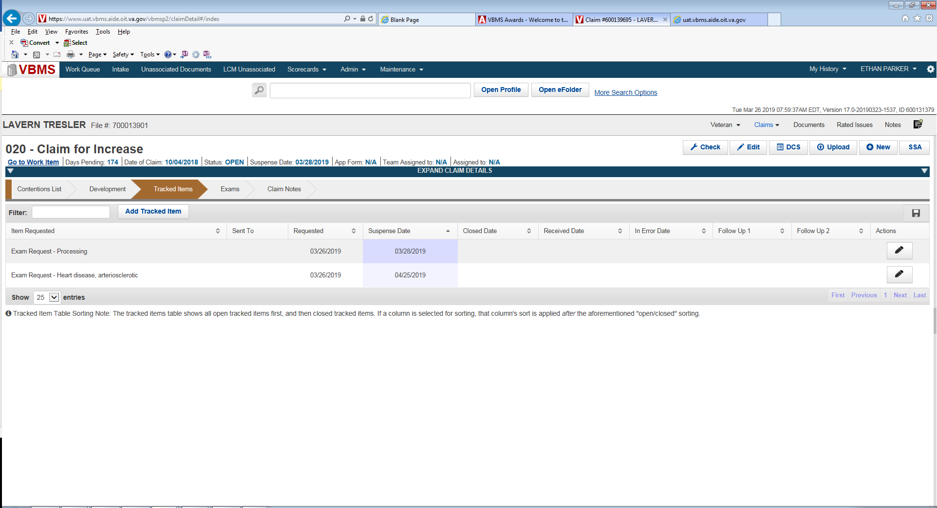

**Step 12:** After the Rework ESR has been submitted, you can review the Rework ESR metadata by clicking the Newspaper icon from the Exams Chevron: The status will indicate “Processing” until the ESR has been accepted by the MDE Vendor. Once the MDE Vendor has accepted the ESR, the status will show “Triage” or “Open”.

