# ESR Copy Job Aid

ESR “Copy” functionality allows users to recreate, with minimal input, a new ESR which had been previously cancelled or completed. The function is to be mainly utilized for previously cancelled ESR(s).

## TOPIC 1: REWORK

When a previously completed ESR does not have the “Rework” function available, the user is required to submit a new request using specified special instructions to the MDE Vendor. The copy functionality would then be used from a previously completed ESR.

**Step 1:** From ESR summary the user will select “Copy” from the “*actions*” drop down menu for the ESR being requested.

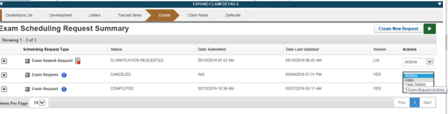

**Step 2:** Under “Select Contentions” tab the user will select all contentions or individual contentions to be copied.

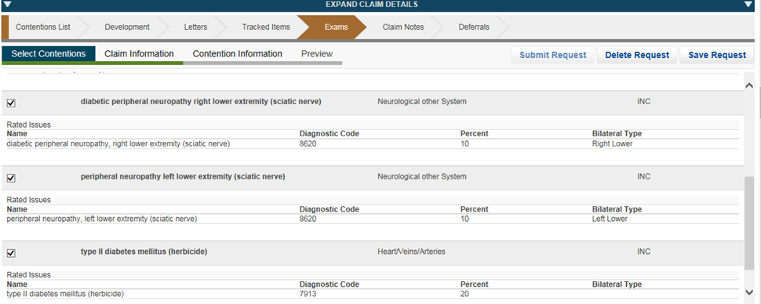

**Step 3**: The user will verify address and POA/VSO type for the claimant.

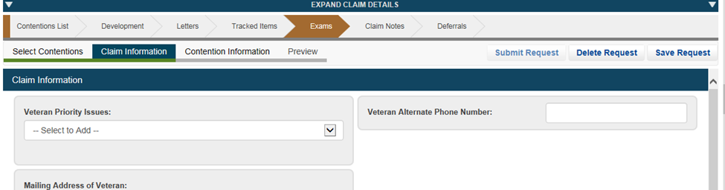

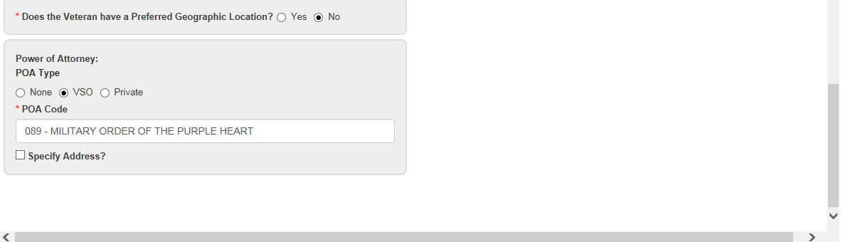

**Step 4:** The user will select the “Contention Information” tab and verify all DBQ(s) and specialty language, if applicable.

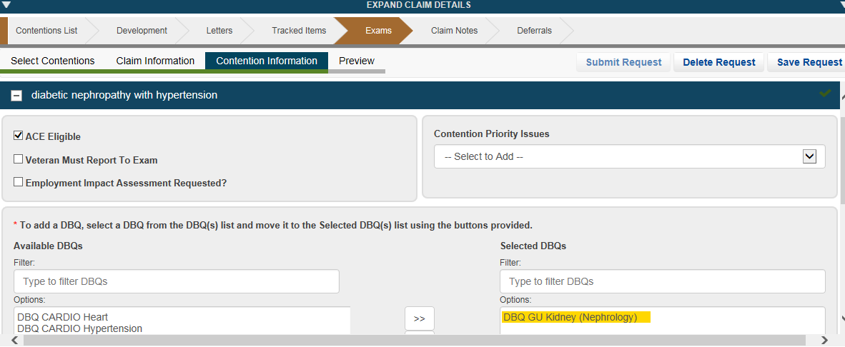

**Step 5:** The user will then select “Preview” and ensure the ESR is accurate prior to clicking submit.