# Contract Exam Scheduling Request (ESR) Job Aid

Prior to ordering an EMS exam, the user must ensure that a contention is correctly identified in the contention development tab. It is essential that the user has the correct options identified in the drop downs as this directly affects the ability to order exam.

**Note:** Any section marked with a red asterisk is a required field and must be filled out to move on.

## TOPIC 1: Adding Contentions

**Step 1**: Click Add Contentions Button

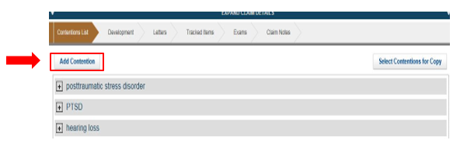

**Step 2:** Add contention and select corresponding contention classification

**Step 3:** Verify date of contention

**Step 4**: Verify the correct type of contention from drop down menu (New, Increase, Reopen, RFE)

**Note:** It is required to select the correct contention classification, from the drop down menu, as identified in the DBQ search index for EMS to suggest to the appropriate DBQ examination

**Note:** It is required to select the correct contention type to ensure the correct standard language is added to the ESR for the contention.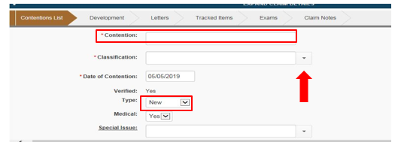

**Step 5:** If increase is selected as type of contention, the user must associate a rated issue

**Note:** If the Veteran is claiming an increase for a extremity that is rated SC for 2 or more diagnostic codes, (for example Veteran is claiming an increase for his right knee and has 3 rated disabilities for the right knee) then all associated SC rated disabilities need to be added to the contention.

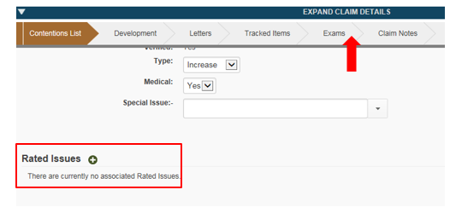

**Step 6:** User selects appropriate rated issue (s)

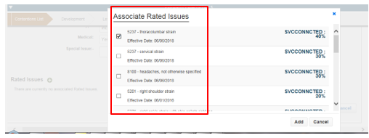

## Topic 2 Creating Exam Scheduling Request (ESR)

**Step 1:** Click the exam chevron. Once the exam chevron is selected the “Click Create New Request” will appear.

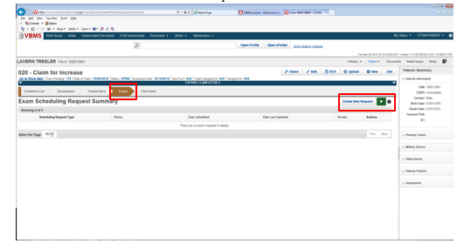

**Step 2:** Select box for the appropriate contention(s). The Claim Information button will turn green and you may click it to proceed. If the system does not allow you to select a contention, this means that there is an error in the way the data or attributes in the contention tab was entered. The user must revert back to the contention and revise accordingly:

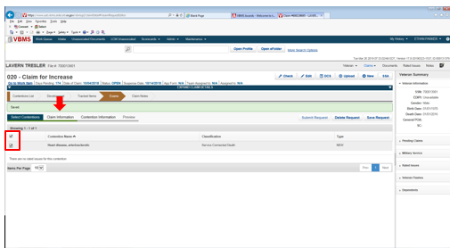

**Step 3:** Identify, if applicable, any Veteran priority issues.

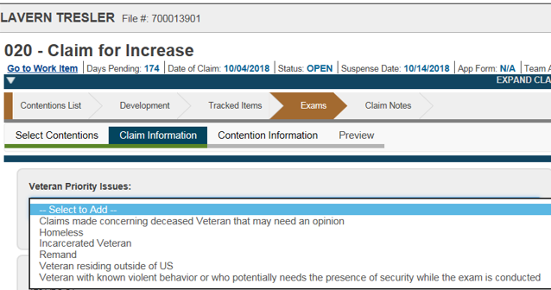

**Step 4:** Verify Veteran’s address. If alternate address is needed or the Veteran is temporarily relocated, use the temporary Geographic Location, to enter the temporary address.

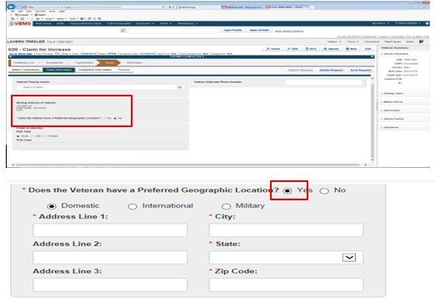

1. User has option to select whether the claim is Ace eligible, Veteran must report to exam or Employment Impact Assessment is requested.
2. If a MO or specialty language is needed the user must select an appropriate opinion or examination verbiage, if not the system automatically populates standard language based on the contention type, classification, and DBQ selection.
3. User must select any appropriate contention level priority issues, such as 1151.

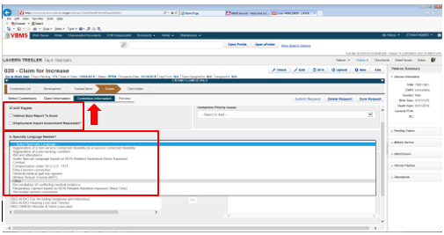

1. Depending on the specialty language chosen users must ensure that red asterisk fields are populated accordingly, and tabbed evidence is noted in the tab evidence description field.
2. The “Other” specialty instruction option allows a user a blank field in case a new MO type is needed that is not currently available in the Specialty language drop down.

**Note:** If additional specialty language is needed use drop down menu

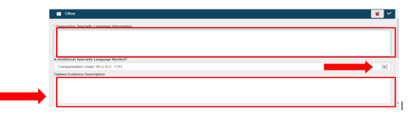

**Step 5**: Next, the user will select a corresponding DBQ based on the contentions. You can select from the full list below, or type in a keyword search based on the DBQ needed. EMS will highlight the recommended DBQ based on the classification chosen for the contention. After selecting the DBQ in the ‘Available DBQs’ section, you slide it over into the ‘Selected DBQs’ section:

**Note:** If a medical opinion is required and the DBQ does not have the opinion language embedded you must always select ‘DBQ Medical Opinion (Examiner’s Version)’ **in addition** to the DBQ selected for the contention.

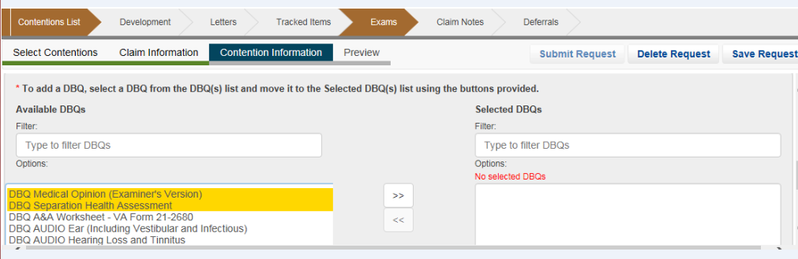

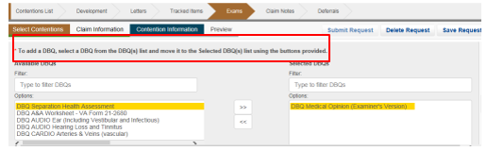**Step 6.** Next click ‘Preview’ from the Exam subcategories list. This will generate a PDF Exam Scheduling Request (ESR) which will contain the information provided to the examiner. Review the PDF and validate that all necessary information is included, then can close out the PDF. If any information needs to be amended, you can go back and update as necessary. You can now click ‘Submit Request’:

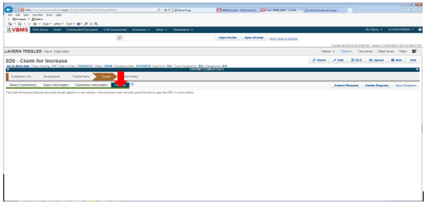

**Step 7:** The user will select the recommended MDE Vendor destination. If an alternate MDE Vendor must be chosen, the user must use the “View Alternate Vendor Destinations”.

**Note**: Use of Alternate MDE Vendor destination will require a justification.

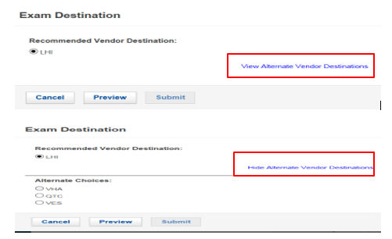

**Step 8:** After clicking ‘Preview’ and again reviewing the ESR, you can now click ‘Submit’. Once you submit from this point, you cannot make changes to the ESR. You can only modify the ESR once the submission is in “triage” or “open” status.

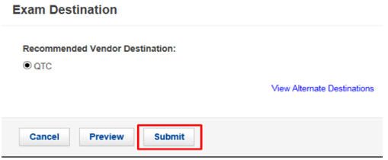

**Step 9:** Prior to ordering the exam, if at any point you must close out before submitting the request, you can return to the Exam chevron and if you had saved your work, you will be able to edit your draft request.

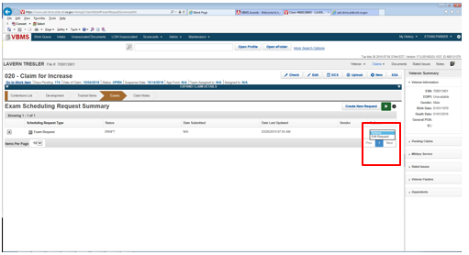

**Step 10:** Upon submitting the ESR, you should verify that the correct ‘Tracked Items’ were created and that the claim suspense updated appropriately:

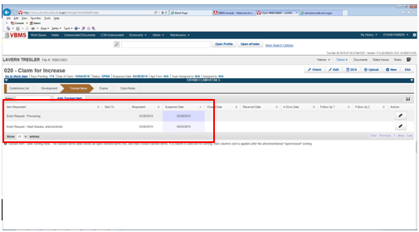

**Step 11:** After the ESR has been submitted, you can review the ESR metadata by clicking the Newspaper icon from the Exams Chevron: The status will indicate “Processing” until the ESR has been accepted by the MDE Vendor. Once the MDE vendor has accepted the ESR, the status will show “Triage”.

