## RATING DECISIONS FOR THE INTEGRATED DISABILITY EVALUATION SYSTEM (IDES) TRAINEE HANDOUT

**Table of Contents**

Motivation and Lesson Purpose 2

Objectives 3

References 3

Topic 1: Rating Decision Preparation 4

Topic 2: Components of a Rating Decision 5

Topic 3: The Code Sheet 15

Topic 4: Ancillary Benefits and the Benefit Estimate Letter (BEL) 21

Attachment A: Benefits Eligibility Letter (BEL) 23

Practical Exercise 24

# MOTIVATION AND LESSON PURPOSE

**Motivation**: The Military Service Coordinator (MSC) is responsible for explaining the proposed and final rating decision(s) to the Veteran or Service member enrolled in the IDES system.

The MSC’s comprehensive understanding of the elements of a rating decision allows the SC to effectively explain the proposed and final rating decision(s) to Veterans or Service members enrolled in IDES system.

**Lesson Purpose:** This lesson provides the MSC basic information and describes the RVSR’s responsibility to review all evidence in the Veteran’s eFile, consider and apply all laws which are applicable for each clamed condition, identifies the VA system wised to create a rating decision and the components of a rating decision related to IDES applicants.

Knowledge checks are incorporated after each topic, the audience will have the opportunity to participated in the knowledge check as the power point progresses. The knowledge checks assist learners in recalling the information presented after each topic and provides the opportunity for learners to describe and identify key information from each section.

A practical exercise at the end of the lesson is a cumulative review of material presented during the lesson., the instructor will provide information about the practical exercise at the end of the lesson.

# OBJECTIVES

* Recognize evidence a Rating Veteran Service Representative (RVSR) needs to consider in the rating decision.
* Explain which Veterans Administration System used to create a rating.
* Identify the components of a proposed and final rating decision
* Explain the difference between an IDES proposed rating versus the final raring and, • Describe the components of a Benefits Estimate Letter (BEL) and when it is required.

# REFERENCES

[38 C.F.R 3.306 Aggravation of preservice disability](https://www.ecfr.gov/cgi-bin/retrieveECFR?gp=&SID=64bfb7cbf268cc998993324171693b6c&mc=true&n=pt38.1.3&r=PART&ty=HTML)

[38 C.F.R 3.350 - Special monthly compensation ratings.](https://www.ecfr.gov/cgi-bin/retrieveECFR?gp=&SID=64bfb7cbf268cc998993324171693b6c&mc=true&n=pt38.1.3&r=PART&ty=HTML)

[38 C.F.R Part 4 - Schedule for rating disabilities](https://www.ecfr.gov/cgi-bin/retrieveECFR?gp=&SID=64bfb7cbf268cc998993324171693b6c&mc=true&r=PART&n=pt38.1.4)

[M21-1, Part III,i,2,D - Overview of the Integrated Disability Evaluation](https://vaww.vrm.km.va.gov/system/templates/selfservice/va_kanew/help/agent/locale/en-US/portal/554400000001034/content/554400000033257/M21-1-Part-III-Subpart-i-Chapter-2-Section-D-Overview-of-the-Integrated-Disability-Evaluation-System-IDES-and-Initial-Claims-Development?query=IDES)

[System (IDES) and Initial Claims Development](https://vaww.vrm.km.va.gov/system/templates/selfservice/va_kanew/help/agent/locale/en-US/portal/554400000001034/content/554400000033257/M21-1-Part-III-Subpart-i-Chapter-2-Section-D-Overview-of-the-Integrated-Disability-Evaluation-System-IDES-and-Initial-Claims-Development?query=IDES)

[M21-1, Part III,i,2,F - Special Situations Related to the Integrated Disability](https://vaww.vrm.km.va.gov/system/templates/selfservice/va_kanew/help/agent/locale/en-US/portal/554400000001034/content/554400000046277/M21-1-Part-III-Subpart-i-Chapter-2-Section-F-Special-Situations-Related-to-the-Integrated-Disability-Evaluation-System-IDES?query=IDES)

[Evaluation System (IDES)](https://vaww.vrm.km.va.gov/system/templates/selfservice/va_kanew/help/agent/locale/en-US/portal/554400000001034/content/554400000046277/M21-1-Part-III-Subpart-i-Chapter-2-Section-F-Special-Situations-Related-to-the-Integrated-Disability-Evaluation-System-IDES?query=IDES)

[M21-1, Part III.i,2,C - Ancillary Benefits and Other Issues Involving](https://vaww.vrm.km.va.gov/system/templates/selfservice/va_kanew/help/agent/locale/en-US/portal/554400000001034/content/554400000014102/M21-1-Part-III-Subpart-i-Chapter-2-Section-C-Ancillary-Benefits-and-Other-Issues-Involving-Pre-Discharge-Claims) Pre Discharge Claims

[M21-1, Part III,i,2,E - Department of Veterans Affairs (VA) Responsibilities](https://vaww.vrm.km.va.gov/system/templates/selfservice/va_kanew/help/agent/locale/en-US/portal/554400000001034/content/554400000046269/M21-1-Part-III-Subpart-i-Chapter-2-Section-E-Department-of-Veterans-Affairs-VA-Responsibilities-Based-on-Medical-Evaluation-Board-MEB-and-Physical-Evaluation-Board-PEB-Outcomes)

[Based on Medical Evaluation Board (MEB) and Physical Evaluation Board](https://vaww.vrm.km.va.gov/system/templates/selfservice/va_kanew/help/agent/locale/en-US/portal/554400000001034/content/554400000046269/M21-1-Part-III-Subpart-i-Chapter-2-Section-E-Department-of-Veterans-Affairs-VA-Responsibilities-Based-on-Medical-Evaluation-Board-MEB-and-Physical-Evaluation-Board-PEB-Outcomes)

[(PEB) Outcomes](https://vaww.vrm.km.va.gov/system/templates/selfservice/va_kanew/help/agent/locale/en-US/portal/554400000001034/content/554400000046269/M21-1-Part-III-Subpart-i-Chapter-2-Section-E-Department-of-Veterans-Affairs-VA-Responsibilities-Based-on-Medical-Evaluation-Board-MEB-and-Physical-Evaluation-Board-PEB-Outcomes)

[M21-1, Part III, i,2,E.3 Proposed Ratings](https://vaww.vrm.km.va.gov/system/templates/selfservice/va_kanew/help/agent/locale/en-US/portal/554400000001034/content/554400000046269/M21-1-Part-III-Subpart-i-Chapter-2-Section-E-Department-of-Veterans-Affairs-VA-Responsibilities-Based-on-Medical-Evaluation-Board-MEB-and-Physical-Evaluation-Board-PEB-Outcomes)

[M21-1 Part III. iv - General Rating Process](https://vaww.vrm.km.va.gov/system/templates/selfservice/va_kanew/help/agent/locale/en-US/portal/554400000001034/topic/554400000003092/Subpart-iv-General-Rating-Process)

# TOPIC 1: RATING DECISION PREPARATION

Rating Veteran Service Representative’s (RVSRs) assigned to the Disability Rating Activity Site (DRAS) prepares the rating decisions for IDES participants.

The RVSR must consider the following when preparing the rating decision:

* Provisions of all pertinent laws and regulations
* 1945 Schedule for Rating Disabilities
* Policy statements
* Procedures
* Administrators’ and Secretaries’ decisions
* Court of Appeals for Veterans Claims (CAVC) precedent opinions
* Other legal precedents governing the Department of Veterans Affairs (VA)

After considering all applicable, laws, evidence of record, VA policies, procedures, the 1945 Schedule for Rating Disabilities and any other applicable information, the RVSR uses Veterans Benefits Management System – Rating (VBMS-R) to produce an IDES rating decision.

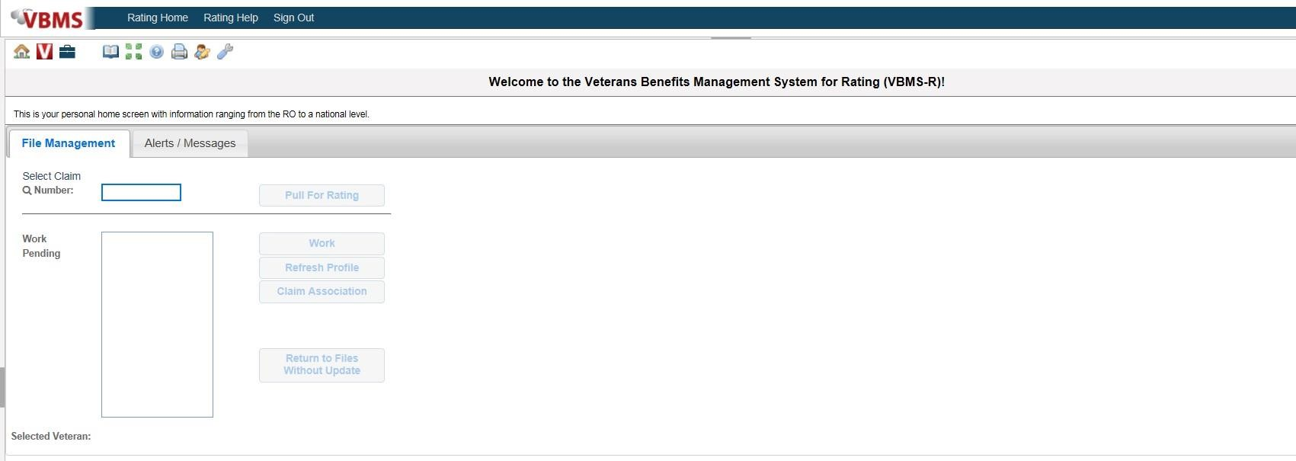

# TOPIC 2: COMPONENTS OF A RATING DECISION

A rating decision consists of two sections, the:

* Rating Narrative
* Code Sheet

There are two types of IDES rating decisions:

* Proposed ratings
* Final ratings

A rating decision is a record purpose document detailing the formal determination made by the regional office (RO) rating activity regarding one or more issue of benefit entitlement.

The information provide on a rating decision provides the decision(s) made and an explanation supporting each decision.

The Rating Narrative is composed of a narrative explanation of the determination on benefit entitlement.

The Rating Narrative consists of 5subparts,

* Introduction
* Decision
* Evidence
* Reasons for Decision
* References

**Proposed Rating Decision Introduction**

A proposed rating decisions Introduction Section includes:

* Includes the Servicemember’s name and branch of service
* Informs the Servicemember that the rating decision is produced in order to help DoD determine a final disposition for unfit conditions
* Instructs the Servicemember that the proposed rating decision determines potential entitlement to VA disability compensation
* Explains to the Servicemember that the rating decision would be null and void for VA benefits purposes if they are later shown to lack the requisite character of discharge, and
* Notes that if the Servicemember is found fit for duty, the rating decision would be null and void for VA benefits entitlement

The following is an example of a proposed ratings introduction for an IDES participant.

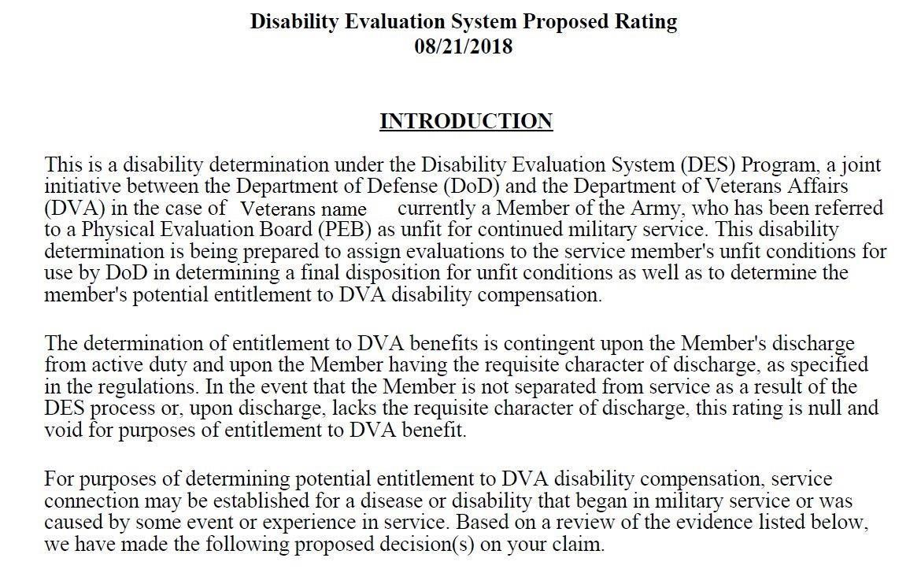

**Final Rating Decision Introduction**

On a final rating decision, the introduction section identifies:

* The claimant
* Veteran’s qualifying periods of service
* Any special considerations such as Former Prisoner of War (POW) status
* Date the claim was received
* Type of claim received

An example of a final rating decisions introduction

**Decision Section**



In the Decision section, all issues are considered, and the outcomes are discussed in a logical manner that addresses awards before denials, and any ancillary benefits considered and addressed.

* The decision section lists the specific outcome for each award or denied issue addressing:
* Service connection (SC), conditions referred, claimed or found on exam
* An increased evaluation, or
* Ancillary benefits, such as special monthly compensation (SMC) and Decisions are listed in a logical manner ensuring,
* All issues are addressed
* Awards before denials
* Award evaluations are in descending order of evaluation
* Similar decisions grouped together, and
* Related conditions, example: injuries from a single accident.

A Decision example has been provided below.

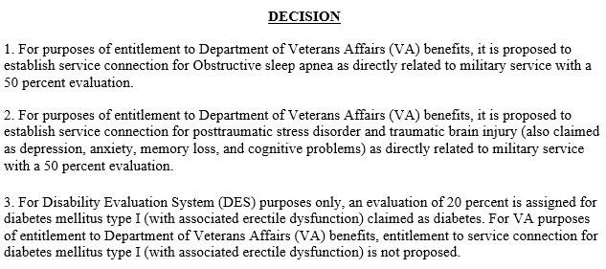

Note: DRAS is required to propose an evaluation for all unfitting (PEB referred) conditions even if VA will not be granting service connection of the condition for disability compensation purposes

**Overview of the Evidence Section**

The Evidence section is a listing of all evidence considered in arriving at the decision, which may include but is not limited to:

* Service treatment records (STRs)
* Service personnel records
* Private and VA treatment records
* VA or contract examination reports, to include Disability Benefits Questionnaires (DBQs)
* Lay statements, and/or
* Written or oral testimony, to include court related transcripts.

The date VA received evidence is often a factor when determining legal entitlement to benefits; consequently, decision makers must ensure the receipt date listed in VBMS is as accurate as possible for any evidence listed in a decision.

If an earlier date of receipt is discovered, edit the document properties in the electronic claims folder to show the correct date

The identified evidence is listed in the evidence section of the rating following the formats noted in the table below.

|  |  |  |  |
| --- | --- | --- | --- |
| **If the *Evidence* section identifies ...** | | **Then list the evidence type and ...** | |
| service records, such as STRs or personnel records | | the date of receipt [MM-DD-YYYY], and the period of service associated with the records [MMYYYY to MM-YYYY].  ***Example***: STRs received on June 20, 2017, for the period October 2006 to November 2010. | |
| VA treatment records | | the name of the facility, and dates covered by the records [MM-DDYYYY to MM-DDYYYY].  ***References***: For more information on the  requirement to obtain VA medical records, see [**M21-1 iii.1.C.2.b**,](https://vaww.vrm.km.va.gov/system/templates/selfservice/va_kanew/help/agent/locale/en-US/portal/554400000001034/content/554400000014156/M21-1,-Part-III,-Subpart-iii,-Chapter-1,-Section-C---Requesting-Evidence-From-Federal-Record-Custodians) and means for obtaining VA medical records, see [**M21-**](https://vaww.vrm.km.va.gov/system/templates/selfservice/va_kanew/help/agent/locale/en-US/portal/554400000001034/content/554400000014156/M21-1,-Part-III,-Subpart-iii,-Chapter-1,-Section-C---Requesting-Evidence-From-Federal-Record-Custodians)**1** [**III. iii.1.C.2.d**.](https://vaww.vrm.km.va.gov/system/templates/selfservice/va_kanew/help/agent/locale/en-US/portal/554400000001034/content/554400000014156/M21-1,-Part-III,-Subpart-iii,-Chapter-1,-Section-C---Requesting-Evidence-From-Federal-Record-Custodians) | |
| private medical records | | the name of the facility or physician date of receipt, and dates covered by the records [MM-YYYY to MM-YYYY].  ***Example***: Medical records, Dr. Jones, received February 1, 2017, for the period May 2012 to Feb 2016. | |
| VA or contract examination(s) | | identify the  examining facility/contractor, and date the exam was conducted. | |
| **If the *Evidence* section identifies ...** | | **Then list the evidence type and ...** | |
| other government, including Federal and State records | | the name of the source (agency, facility, etc.), and date of receipt.  ***Example***: Social Security Administration records received on March 8, 2017. | |
| lay statement(s) | | the source of the statement, and date of receipt. | |
| forms | | the full name of the form, and date of receipt. | |
| evidence requested, but not received | | in the following format: *Private medical records requested from [****provider’s or facility’s name****], but not received*. | |
| evidence considered in a prior VA decision | | by separately stating each piece of evidence considered in a format consistent with this table’s guidance.    ***Note***: Include the prior decision as an entry in the *Evidence* list if the decision itself is relevant for consideration in connection with the current decision. | |
| any medical evidence that is confidential under [**38 U.S.C**](http://www.law.cornell.edu/uscode/text/38/7332)  [**7332** (](http://www.law.cornell.edu/uscode/text/38/7332)certain medical records relating to human immunodeficiency virus  (HIV) infection, substance abuse, or sickle cell anemia) | | by specifying only, the relevant date and name of the medical facility. | |
| non-relevant records not requested | follow the documentation requirements specified in [**M21-1**](https://vaww.vrm.km.va.gov/system/templates/selfservice/va_kanew/help/agent/locale/en-US/portal/554400000001034/content/554400000014066/M21-1,-Part-I,-Chapter-1,-Section-C---Duty-to-Assist-with-Obtaining-Records-and-a-Medical-Examination-or-Opinion)[**I.1.C.4.f**.](https://vaww.vrm.km.va.gov/system/templates/selfservice/va_kanew/help/agent/locale/en-US/portal/554400000001034/content/554400000014066/M21-1,-Part-I,-Chapter-1,-Section-C---Duty-to-Assist-with-Obtaining-Records-and-a-Medical-Examination-or-Opinion) | |

An example of an Evidence section provided below.

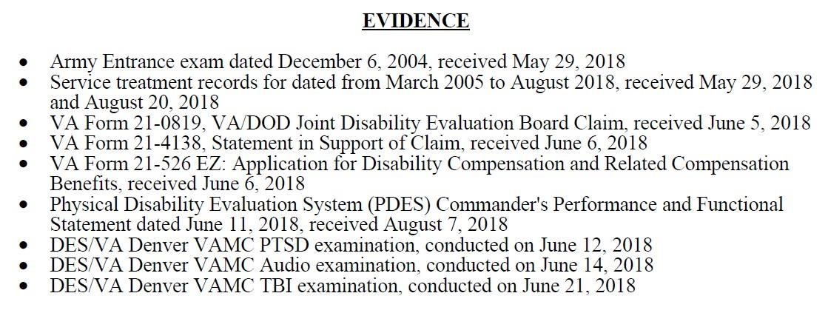

**Narrative Section**

The Narrative in a rating is to concisely cite and evaluate all relevant facts considered in making the decision.

There are two distinct types of narratives created in a rating decision,

**Short-Form**

The short-form rating narrative requires minimum explanation of the basic elements of the decision. It is characterized by standard automated language and limited free text.

**Long- Form**

The long-form rating narrative must be used in certain types of claims to thoroughly and adequately discuss the reason a decision was made. The Narrative section is generated by automated language from VBMS-R, with the addition of free text. A few examples of conditions where a long-form format would be used are, legacy appeals, higher-level reviews (HLR), and Nehmer claims. For a complete list go to M21-1 III.iv.6.C.7.a

Note: a rating decision may contain a mix of both the short-form narrative convention and the long-form.

**Reasons for Decision-Grant**

|  |  |
| --- | --- |
| **If ...** | **Then the *Reasons for Decision* must address the ...** |
| awarding the claim | benefit being awarded and legal basis for the award (for example, secondary SC)  laws and regulations applicable to the claim fact that all elements required to decide the issue were met, and all findings are favorable to the claimant assigned evaluation, if applicable effective date |
| **If ...** | **Then the *Reasons for Decision* must address the ...** |
|  | basis for the current evaluation, if applicable  requirements for the next higher evaluation, if applicable potential for routine future examination, if applicable, and reason for the effective date. ***Exceptions***: An effective date explanation is ***not*** required when  the assigned effective date is the date of the claim's receipt, or  the day following discharge from active duty service, or granting SC for the cause of death/entitlement to  Dependency and Indemnity Compensation (DIC). |

Below is an example of a Short-Form award of a decision grant.

*Service connection for arthritis of the cervical spine has been established as directly related to military service. (38 CFR 3.303, 38 CFR 3.304)*

*The effective date of this grant is August 1, 2017. Service connection has been established from the day VA received your claim. When a claim of service connection is received more than one year after discharge from active duty, the effective date is the date VA received the claim. (38CFR 3.400)* An *evaluation of 20 percent is assigned from August 1, 2017.*

*We have assigned a 20 percent evaluation for your arthritis of the cervical spine based on:*  *• Forward flexion of the cervical spine greater than 15 degrees but not greater than 30 degrees*  *Additional symptom(s) include:*

* *X-ray evidence of traumatic arthritis*
* *Combined range of motion of the cervical spine greater than 170 degrees but not greater than335 degrees*
* *Painful motion upon examination*

*The provisions of 38 CFR §4.40 and §4.45 concerning functional loss due to pain, fatigue, weakness, or lack of endurance, incoordination, and flare-ups, as cited in DeLuca v. Brown and Mitchell v. Shinseki, have been considered and are not warranted.*

**Reasons for Decision Confirm and Continue (C&C)**

|  |  |
| --- | --- |
| **If ...** | **Then the *Reasons for Decision* must address the ...** |
| confirming and continuing an existing evaluation | basis for the current evaluation laws and regulations applicable to the claim findings that are favorable to the claimant under [**38 CFR 3.104(c)**, i](https://www.ecfr.gov/cgi-bin/text-idx?SID=3a65915b4097601a1669dd2b46ab0339&mc=true&node=se38.1.3_1104&rgn=div8)f any requirements for the next higher evaluation absence of evidence demonstrating sustained improvement, if applicable, and potential for routine future examination, if applicable.  ***Note***: The VBMS-R glossary fragment *CCEVAL* may be selected to insert supplemental language into the *Reasons for Decision*. |

C&C decisions may be appropriate for Reserve or National Guard members.

**Reasons for Decision Rating Denial**

|  |  |
| --- | --- |
| **If ...** | **Then the *Reasons for Decision* must address the ...** |
| denying the claim | theory of SC being addressed in the decision (for example, direct  SC), if applicable claimant’s contention(s) benefit denied laws and regulations applicable to the claim, and reason for denial, including the criteria required to grant SC  element(s) required to grant the claim that were not met, and findings favorable to the claimant under [**38 CFR 3.104(c)**,](https://www.ecfr.gov/cgi-bin/text-idx?SID=3a65915b4097601a1669dd2b46ab0339&mc=true&node=se38.1.3_1104&rgn=div8) if any.  ***Note***: If there are multiple bases of SC and/or multiple denial reasons being addressed, relevant text must be added to the rating Narrative in order to discuss the unmet elements and favorable findings relative to each claimed and reasonably raised theory of SC.  ***Reference***: For more information on considering unclaimed theories of SC, see [**M21-1, Part III, Subpart ii, 2.B.1.m**.](https://vaww.vrm.km.va.gov/system/templates/selfservice/va_kanew/help/agent/locale/en-US/portal/554400000001034/content/554400000014119/M21-1,-Part-III,-Subpart-ii,-Chapter-2,-Section-B---Claims-for-Disability-Compensation-and-or-Pension,--and-Claims-for-Survivors-Benefits) |

An Example of a Traditional Short-Form Denial

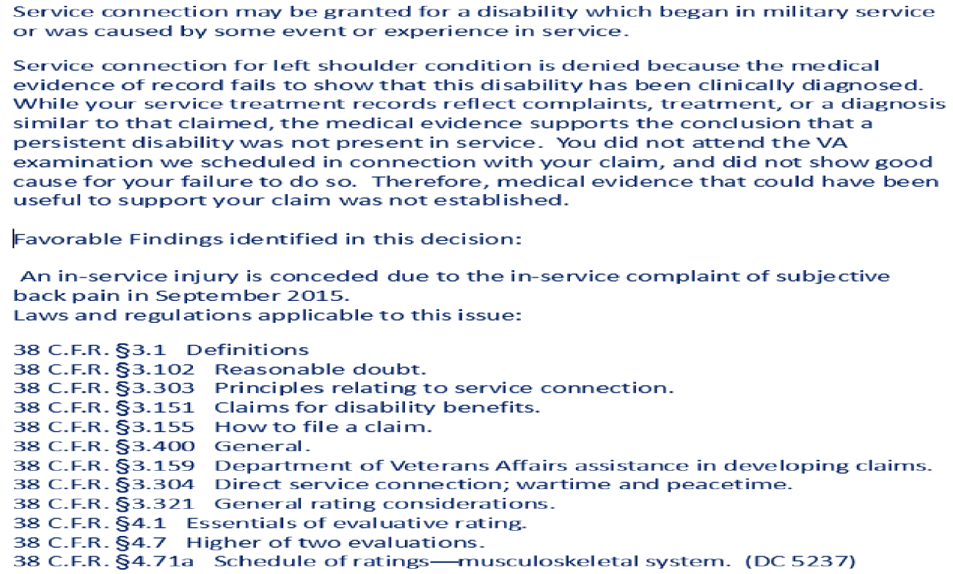

An example of an IDES Long-Form Denial

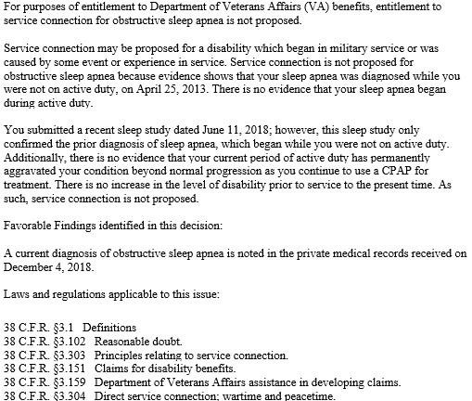

**References**

The Reference section is automatically generated by VBMS-R to note which laws and regulations govern entitlement to veteran benefits.

An example of a Reference section of

a rating.

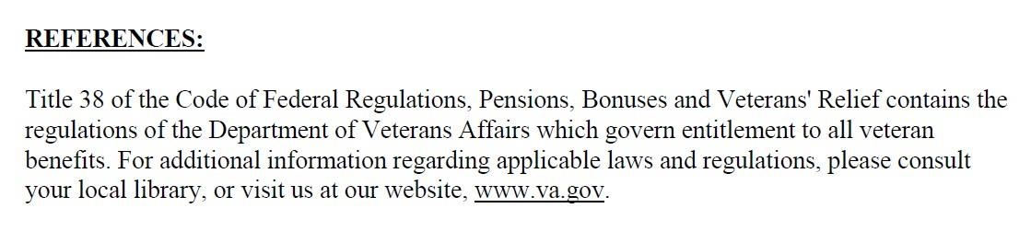

# TOPIC 3: THE CODE SHEET

The second component of the rating decision is the code sheet, the code sheet is broken down into the following subparts:

* Data Table
* Jurisdiction
* Associated Claim(s)
* Coded Conclusions
* Special Notations and Template Fields
* Signature(s)

**Data Table**

The Data Table includes:

* Personal Identifying Information (PII) such as Social Security Number, Period of Service (POS), Power of Attorney (POA), file number and date of rating,
* Any future exam date(s)
* SMC code(s)
* Combat Status Code
* Additional service code

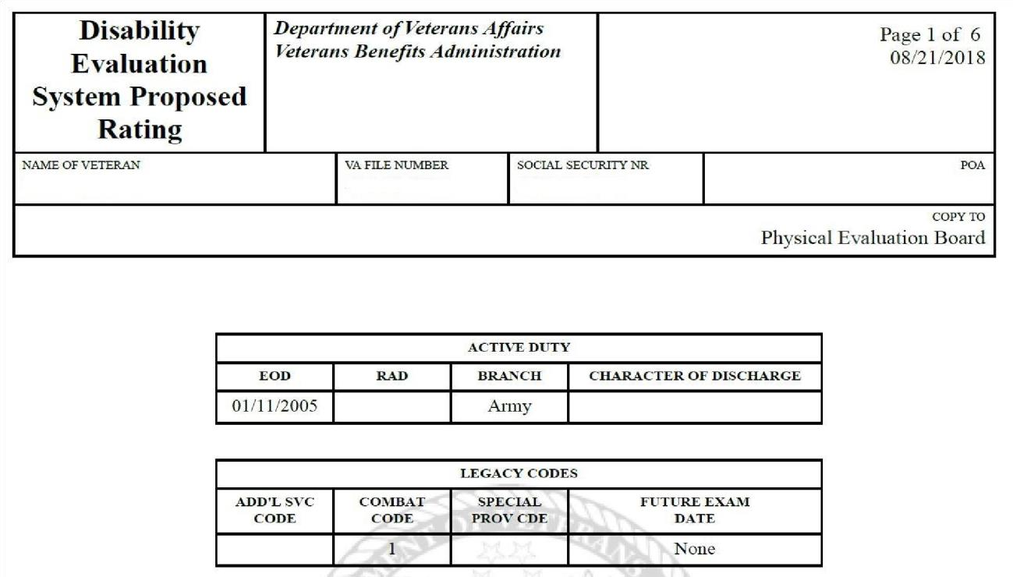

**Note:** On IDES proposed ratings for Service members who are still serving on active duty, there should be an Entered on Active Duty (EOD) date listed without a Release from Active Duty (RAD) date in the data table. Future exam date coding shows up as “None” on all proposed rating code sheets, even in cases where a future exam would be necessary. The actual future exam indicators only show up on final rating decisions.

**Jurisdiction**

The Jurisdiction of the Code sheet,

* appears below the heading section
* explains why the case is before the rating activity
* refers to the claim at issue, and • cites the pertinent jurisdictional date.

The Jurisdiction section describes the type of claim that was decided and the date that it was received. It also shows the associated Pending Issue File (PIF).



**Associated Claims**

The Associated Claim(s) section

* appears below the Jurisdiction
* includes 689 end product(s) (EP) associated with the contentions/claims be processed along with the DOC(s) of the claim(s) • cites the type of claim(s)

**Associated** **Claim(s):** 689; Disability Evaluation System; 06/05/2018

**The Proposed Rating Code Sheet**

On proposed IDES rating decisions, the Coded Sheet is organized in the following manner:

* Proposed Disability Evaluation Rating System (DES) Service Connected, for proposed grants of SC, or
* Proposed DES Not Service Connected, for proposed denials of SC.
* Proposed SMC entitlement
* Ancillary benefit entitlement

**Note:** Proposed rating decision code sheets for active-duty members only list the issues being addressed in connection with the pending IDES claim. Any prior SC or NSC decisions will be carried forward on the final DES rating.

**IDES Proposed Coded Conclusion**

The Coded Conclusions section provides the list of conditions that are proposed DES service connected or proposed not DES service connected. This section may also include all **previous rating for Reserve or National Guard members.**

38 CFR Part 4, Rating Schedule for Disabilities, is used to determine disability codes and percentages of evaluation.

**Analogous Codes**

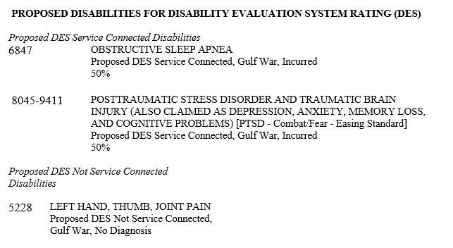

When a condition unlisted in the rating schedule is encountered, it is permissible to rate it under a closely related disease or injury, in which not only the functions affected, but the anatomical localization and symptoms are closely analogous.

Two diagnostic codes are shown on the code sheet. The first code begins with two number representing the rating schedule body system and ends in “99” to indicate it is an analogous rating. The second code is the one used to rate the claimed disability.

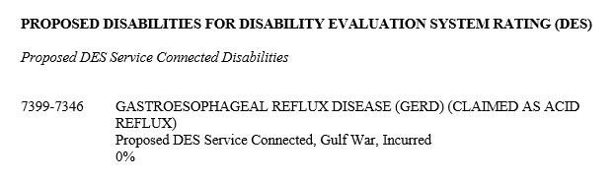

**Note**: A DC *may not* end in *99* unless it is the *first* four-digit code in an analogous code.

Keep in mind hyphenated codes do *not* necessarily denote analogous ratings. A hyphenated DC may be used to identify the proper evaluation of a disability or a residual from disease.

The *first* DC of a hyphenated code identifies the diagnosed disease or condition. The *second* DC of a hyphenated code identifies the criteria in the rating schedule used to evaluate the disability.

**Combined Evaluations**

The percentage of disabilities is not added together but is determined based on the combined rating table and bilateral factor located in 38 C.F.R. §4.25.



**Exception:** Proposed evaluations, such as under the IDES program or proposed reductions, are not reflected in the combined evaluation.

**Note:** VBMS-R automatically calculates each combined evaluation effective date based on the issues established and effective dates entered. [VA Disability Rating Calculator](http://cptraining.vba.va.gov/C%26P_Training/Job_Aids/Quick_Ref.htm)

**Special Monthly Compensation (SMC)**

Special Monthly Compensation (SMC) recognizes the severity of certain disabilities or combinations of disabilities by adding an additional compensation to the basic rate. The most common Special Monthly Compensation (SMC) grants are:

* Loss of use of (SMC K)
* Aid and attendance (SMC L)
* Statutory Housebound (SMC S)

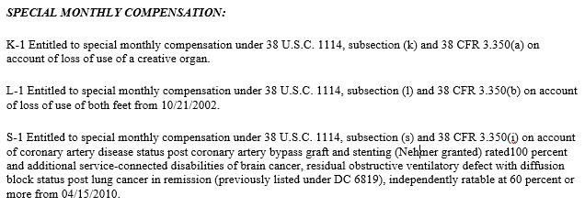

**Special Notations**

The primary purpose of notations made in the Special Notations field on the Code sheet are to, record special remarks or approvals applicable to the rating decision, and communicate any instruction or administrative message to the authorizing authority. Occasionally, the RVSR will input comments in the Special Notations box, which can include:

* Interpretation of the rating schedule on the claim (Reviewer notes)
* special instructions to authorization (such as soliciting a claim for an issue found on exam)
* Reminders for the final rating
* Entitlement to ancillary benefits

A sample of the Special Notification field seen below.



**The Final Rating Code Sheet**

On final IDES rating decisions (post separation and Reserve/NG members) the coded conclusion will:

* identify the PEB-referred disabilities with special issue coding following the disability name
* any condition for which disability severance pay was received • combat or non-combat

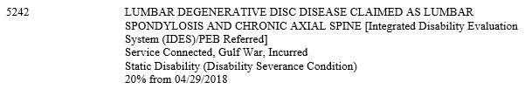

# TOPIC 4: ANCILLARY BENEFITS AND THE BENEFIT ESTIMATE LETTER (BEL)

The following are more commonly seen ancillary benefits that may be addressed on the rating, if applicable:

* Eligible for Civil Service Preference
* Entitled to Adaptive Equipment Only
* Entitled to Automobile and Adaptive Equipment
* Entitled to Loan Guaranty Benefits
* DEA under [38 U.S.C. Chapter 35](https://www.law.cornell.edu/uscode/text/38/part-III/chapter-35)
* SAH under [38 CFR 3.809](https://www.ecfr.gov/cgi-bin/text-idx?SID=eb7493eb29df5c572d488350d31b4925&node=se38.1.3_1809&rgn=div8)
* Special housing adaptation (SHA) awards under [38 CFR 3.809a](https://www.ecfr.gov/cgi-bin/text-idx?SID=eb7493eb29df5c572d488350d31b4925&node=se38.1.3_1809a&rgn=div8)
* Automobile and adaptive equipment under [38 CFR 3.808](https://www.ecfr.gov/cgi-bin/text-idx?SID=eb7493eb29df5c572d488350d31b4925&node=se38.1.3_1808&rgn=div8)
* Vocational rehabilitation and employment, and
* Loan guaranty for surviving spouses under [38 CFR 3.805](https://www.ecfr.gov/cgi-bin/text-idx?SID=eb7493eb29df5c572d488350d31b4925&node=se38.1.3_1805&rgn=div8)

Active-duty IDES participants are eligible for and automatically entitled to Vocational Rehabilitation and Employment (VR&E) services. MSC’s must direct the participant to an IDES Vocational Rehabilitation Counselor (VRC) when the service member expresses interest in VR&E services.

Veterans who have a compensable SC disability maybe eligible for a waiver of the VA home loan funding fee, if VA Form 26-1880, Request for a Certificate of Eligibility is received, MSC’s must act by forwarding the form to the appropriate regional loan center (RLC) as well as ascertain if the service member plans to use VA’s home loan program and advise the service member to let his/her lender know a pre-discharge claim is pending.

**Benefits Estimate Letter (BEL)**

The purpose of the BEL is to provide the participant with a proposed estimate of VA benefits to assist him/her with financial planning following discharge from active duty. The BEL contains;

* Salutation and gratitude for the SMs service
* Overview of the MEB finding and notification that eligibility to VA benefits is contingent on the requisite character of service on discharge • Purpose of the BEL
* What the VA is proposing, and
* What the SM may be entitled to if separated

**Note:** The DRAS must include dependents on the BEL when VA Form 21-686c, Declaration of Status of Dependents, is of record and complete.

See [M21-1 III.I.2.E.6.Exhibit: Benefits Estimate Letter (BEL) for IDES](https://vaww.vrm.km.va.gov/system/templates/selfservice/va_kanew/help/agent/locale/en-US/portal/554400000001034/content/554400000046269/M21-1-Part-III-Subpart-i-Chapter-2-Section-E-Department-of-Veterans-Affairs-VA-Responsibilities-Based-on-Medical-Evaluation-Board-MEB-and-Physical-Evaluation-Board-PEB-Outcomes?query=Benefit%20estimate%20letter) [Participants](https://vaww.vrm.km.va.gov/system/templates/selfservice/va_kanew/help/agent/locale/en-US/portal/554400000001034/content/554400000046269/M21-1-Part-III-Subpart-i-Chapter-2-Section-E-Department-of-Veterans-Affairs-VA-Responsibilities-Based-on-Medical-Evaluation-Board-MEB-and-Physical-Evaluation-Board-PEB-Outcomes?query=Benefit%20estimate%20letter)

# ATTACHMENT A: BENEFITS ELIGIBILITY LETTER (BEL)

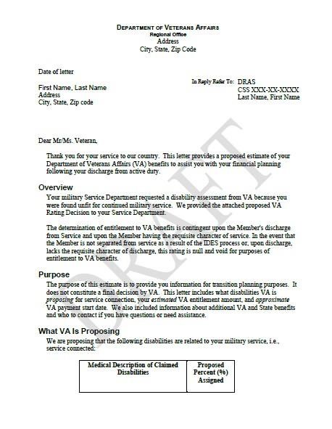

# PRACTICAL EXERCISE

Directions: Answer all the questions as directed by the instructor.

1. Identify the two types of IDES rating decision.

1. Name the two sections of the rating decision?
2. Rating Narrative and Code Sheet
3. Introduction and Decision
4. Short and Long Narratives
5. None of the above

1. Name the five parts of a Rating Narrative.

1. A Confirm and Continue (C&C) decision may be appropriate for what type of service member.
2. IDES participant is in the Reserves
3. IDES participant is discharged from service
4. IDES participant is in National Guard
5. Both A and C

1. What is the EP Code for a proposed rating?
2. EP 010 B. EP 130
3. EP 689
4. EP 685

1. What does 38 CFR 3.350 cover?
2. Definition of SMC
3. Types of SMC and eligibility criteria for this additional benefit
4. Definition of Permanent and Total disabilities
5. None of the above
6. The acronym BEL stands for what?
7. Benefits Entitlement Letter
8. Beginning Entitlement Letter
9. Beginning Estimate Letter
10. Benefits Estimate Letter

1. What is the purpose of the BEL?
   * 1. Notifies the Service member of the proposed rating decision.
     2. Informs the Service member of what VA is proposing.
     3. Lists benefits Service member may be entitled to receive in addition to the rating decision
     4. All the Above

1. How many sections make up the Rating Decision?
2. Five
3. Two
4. Four
5. Three

1. How many sections are in a Rating Narrative?
2. Five
3. Two
4. Four
5. Three