VA Appeals Modernization Act Informal Conferences


March 2020 —Version 2.0

AMA Informal Conferences (0.5 hour)

Lesson Overview
Purpose of the Lesson: | This course provides students with an overview of informal conferences, and an understanding of how to conduct and document informal conferences for a higher-level review.
Prerequisite Training Requirements: | Prior to taking the VA Appeals Modernization Act Informal Conferences, employees must complete:  - Appeals Modernization Act 201
Target Audience: | This lesson is for DROs, RQRSs, AQRSs, and SVSRs who are assigned to the Decision Review Operations Centers (DROCs) and the Rapid Appeals Modernization Program (RAMP) Sites.
Lesson References: | - Public Law (PL) 115-55, Veterans Appeals Improvement and Modernization Act of 2017  - 38 CFR §3.2601, Higher-level review  - M21-5, 5.3, Requests for Informal Conferences  - RAMP Standard Operating Procedures (Phase 3)
Lesson Objective: | At the end of this lesson, students will be able to:  - Conduct and document informal conferences for a higher-level review.

Instructor Notes
This course provides students with an overview of informal conferences, and an understanding of how to conduct and document informal conferences for a higher-level review.

PowerPoint Slides | Instructor Activities
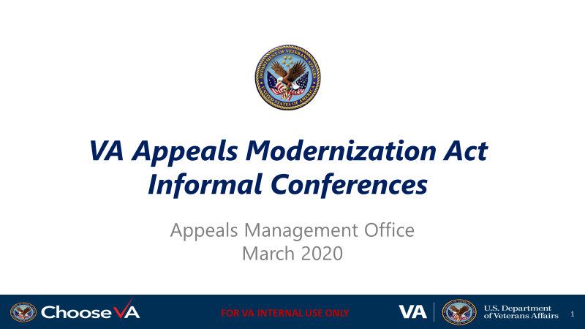 | The INSTRUCTOR must take attendance and turn over the attendance sheet to the station’s training manager.  DISPLAY slide 1 “VA Appeals Modernization Act Informal Conferences”  INTRODUCE yourself as the instructor and introduce fellow instructors.  INTRODUCE the lesson.
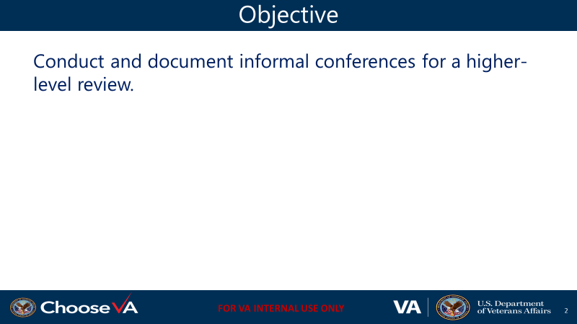 | DISPLAY slide 2 “Objective”  REVIEW the learning objective.
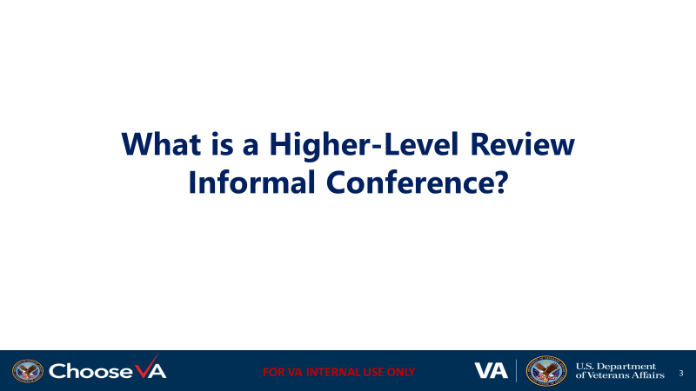 | DISPLAY slide 3 “What is a Higher-Level Review Informal Conference?”
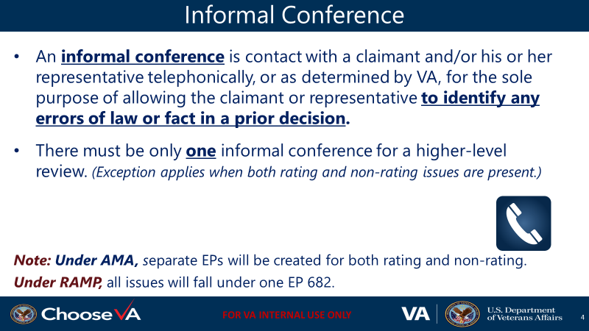 | DISPLAY slide 4 “Informal Conference”  REVIEW the definition of informal conference.  EMPHASIZE to the students that there must be only one informal conference for a higher-level review.
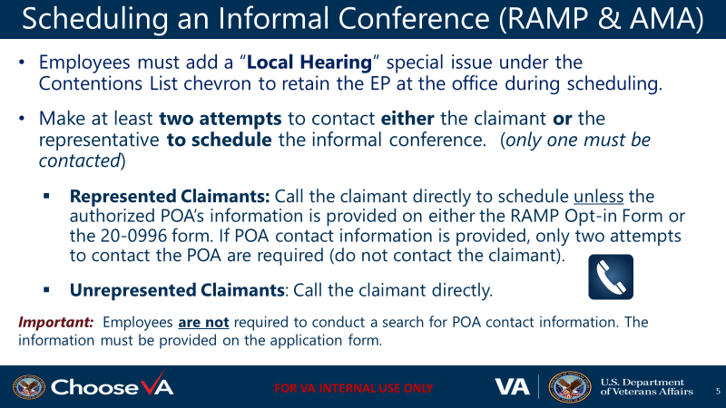 | DISPLAY slide 5 “Scheduling an Informal Conference (RAMP & AMA)”  TELL the students a “Local Hearing” special issue must be added under the Contentions List chevron to retain the EP at the office during scheduling of the informal conference.  TELL the students that at least two attempts to contact the claimant and/or representative to schedule the informal conference must be made.
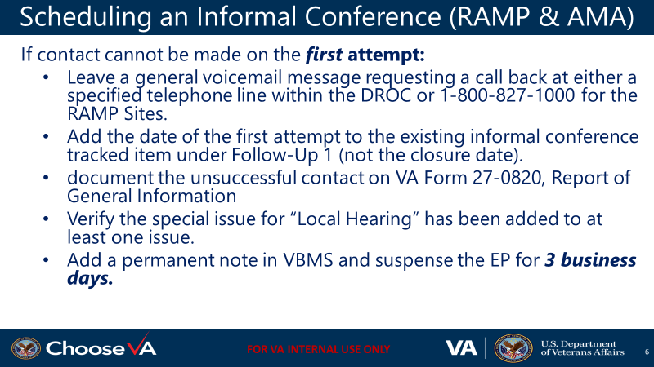 | DISPLAY slide 6 “Scheduling an Informal Conference (RAMP & AMA)”  TELL the students it is best practice to wait until the informal conference is scheduled to conduct a review of the record in preparation.
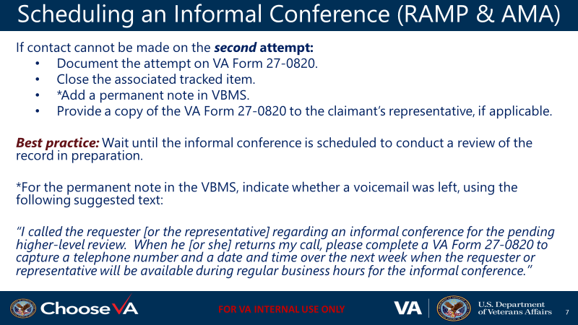 | DISPLAY slide 7 “Scheduling an Informal Conference (RAMP & AMA)”  TELL the students facts not present prior to the closing of the evidentiary record should not be documented.
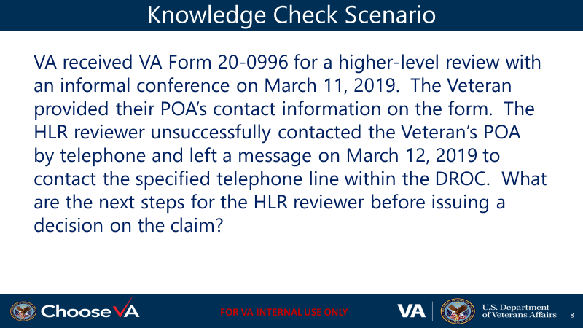 | DISPLAY slide 8 “Knowledge Check Scenario”
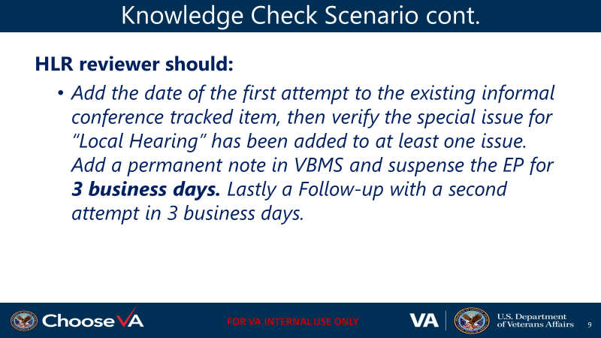 | DISPLAY slide 9 “Knowledge Check Scenario cont.”
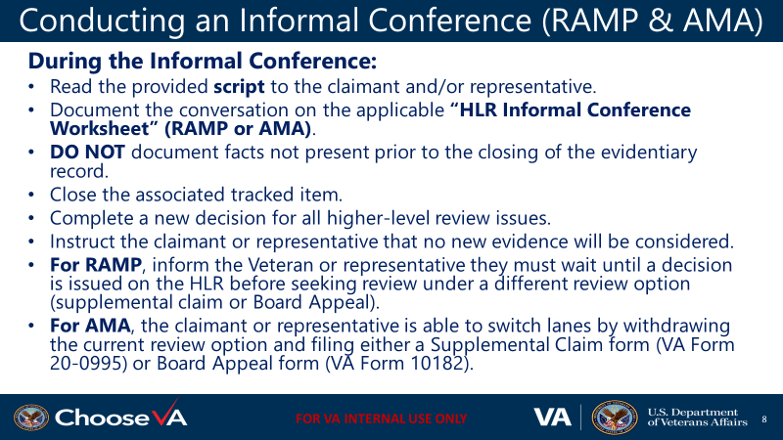 | DISPLAY slide 10 “Conducting an Informal Conference (RAMP & AMA)”  REVIEW the steps for conducting an informal conference (RAMP & AMA)
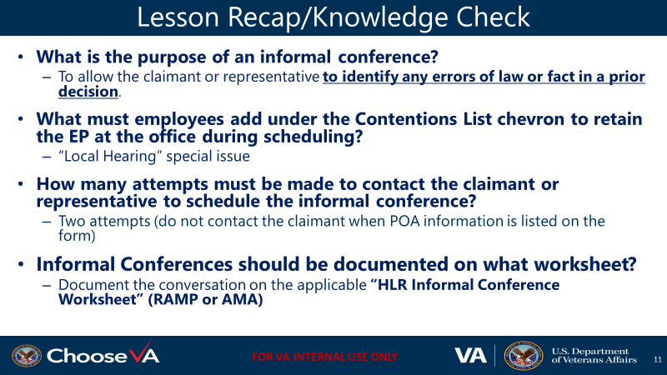 | DISPLAY slide 11 “Lesson Recap/Knowledge Check”
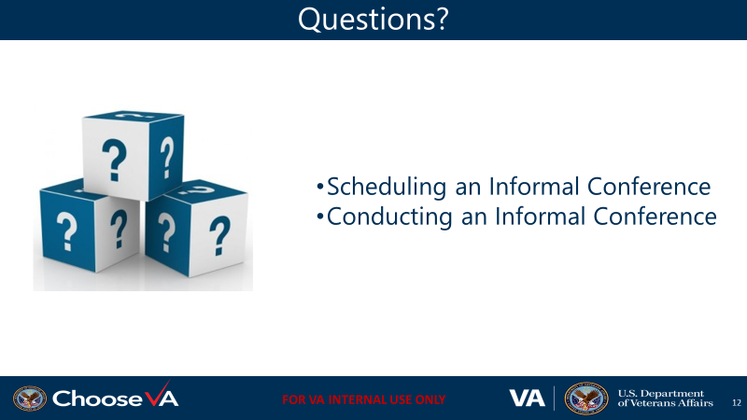 | DISPLAY slide 12 “Questions”  REVEIEW the lesson objectives from the course
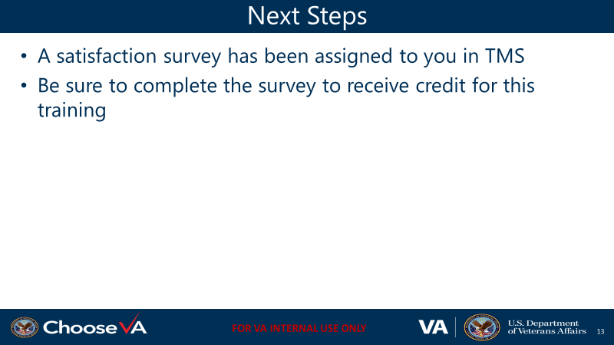 | DISPLAY slide 13 “Next Steps”

