DPRIS and PIES

Trainee Handout

**Table of Contents**

Objectives 2

References 3

Topic 1: DPRIS 4

Topic 2: PIES 12

Practical Exercise 15

# Objectives

* Identify the purpose and functions available through the Defense Personnel Records Information Retrieval System (DPRIS) Web organization and Personnel Information Exchange System (PIES)
* Identify what records are available through DPRIS and PIES
* Demonstrate how to create a request and navigate the functions within DPRIS Web and PIES

# References

* M21-1, Part III, Subpart iii.2.A, General Information on Service Records
* M21-1, Part III, Subpart iii.2.D, Requesting Information and Records Through the Personnel Information Exchange System (PIES)
* M21-1, Part III, Subpart iii, 2.I,4, Requests for Records Through the Defense Personnel Records Information Retrieval System (DPRIS)
* DPRIS Website User Guide (located within DPRIS website under HELP tab)
* PIES User Guide
* DPRIS Web to PIES Cross Reference Guide

All M21-1 references are found in the [Live Manual Website](https://vaww.compensation.pension.km.va.gov/)

# Topic 1: DPRIS

**DPRIS Overview**

The Defense Personnel Records Information Retrieval System (DPRIS) Website provides authorized users with access to digital electronic images of Official Military Personnel Files (OMPF). DPRIS is now the primary internet portal supporting external electronic access by authorized government agencies to any of the military services’ digital OMPF repositories (except the Coast Guard). In the past, information from these records was typically provided via hardcopy, with requests for information and responses to such requests mailed through the U.S. Postal Service. Regardless of the form in which the information is obtained, all users are required by law to safeguard the information contained in the OMPF, as directed by the Privacy Act of 1974 and HIPAA (Health Insurance Portability and Accountability Act).

**DPRIS Advantages**

Some advantages of DPRIS include:

* Provides a standard index of all images contained in each of the services’ OMPF Systems (except Coast Guard)
* Includes a follow-up message capability
* Single-source repository for most branches
* On average, images are received in less than 48 hours, with many images received within minutes

**VSR Roles and Responsibilities**

As a DPRIS user, there are several roles and responsibilities associated with this assigned duty:

* Initiate requests for military personnel records information
* Upload the request and available records into the Veteran’s eFolder
* Communicate with local managers, DPRIS Web staff via User Assistance Forms, and Central Office to solve problems.
* Initiate and manage secure follow-up messages
* Access DPRIS Web Information, Help Website Modules, and submit automated User Requests Assistance Forms

**Personnel Records Available Through DPRIS**

Not every Veteran’s OMPF is available through DPRIS. There are specific dates associated with each branch of service as to when each branch of service began retaining Veterans’ OMPFs into their imaging system.

The Veteran’s OMPF should be available through DPRIS if his/her service obligation ended on or after the following dates:

Army: October 1, 1994*

Navy: January 1, 1995

Marine Corps: January 1, 1999

Air Force: October 1, 2004

There are no Coast Guard records currently available in DPRIS.

*Note: Army Discharge and Retirement date shown in the DPRIS User Guide under DPRIS Help tab incorrectly shows October 1, 2002.

For Army service obligations that ended between October 1, 1994, and September 30, 2002, users should make the DPRIS request as indicated per M21-1, Part III, Subpart iii, 2.I.4.a. If a negative response is given, user should make a request through NPRC, per M21-1, Part III, Subpart iii, 2.B.5.b.

**National Guard and Reserve Service**

When determining if the OMPF records are available through DPRIS Web, you must take Reserves and National Guard duty into consideration. The easiest way to think about this is the word *obligation*. It does not matter if the person served on Active Duty, Reserves, National Guard, or in all three; it is when there is no further obligation that matters.

If there is no further obligation, use the date of discharge to determine the proper records custodian.

If there is an obligation remaining, VSR can utilize Veterans Information Solution (VIS) to verify date of service and obligation and Joint Legacy Viewer (JLV) to obtain STRs. The complete service records for the Veteran will remain with the unit until their obligation is complete.

For more information on how to determine whether a Veteran has an additional service obligation, please see M21-1 Part III, Subpart iii, Chapter 2.B.1.b.

**Using DPRIS**

The normal means of entry to the website is through its home page at <https://www.dpris.dod.mil>, which includes a public area open to all internet users. Type in the website address in your browser and hit enter. The DPRIS homepage will be displayed. It is recommended that this website address be added to your Favorites list.

Each Regional Office will have a different person in charge of registering users. You will need to contact the DPRIS super user or your manager at your station to become an authorized user.

Log-in using your PIV Card and PIN.

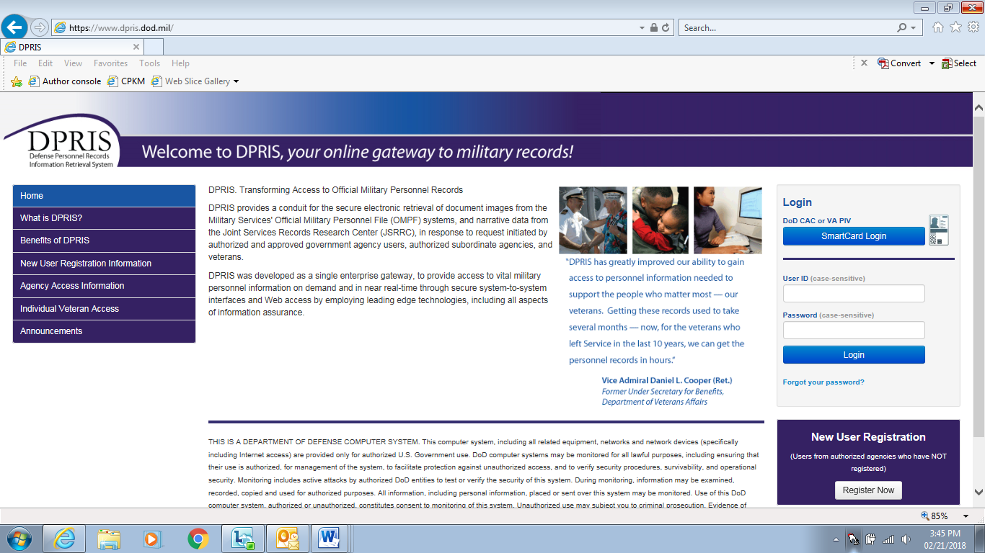

**Requests**

Link to the Create Request Form, where you can create a new query for information from a digital OMPF record maintained by one of the military services or submit a request to JSRRC.

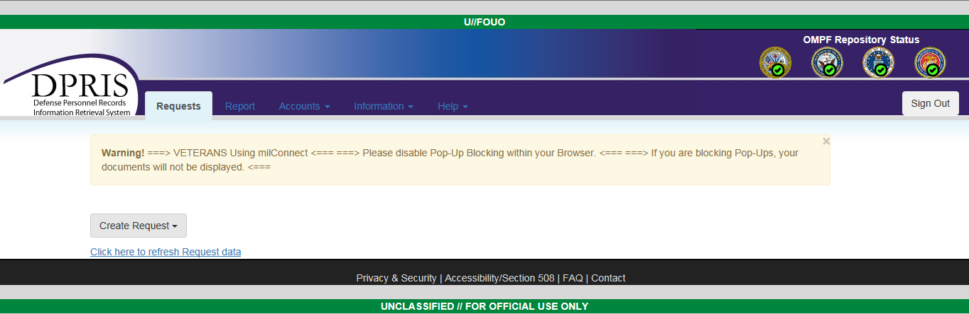

When the *Create Request* link is selected, the page shown below is displayed. When the OMPF Request link on this page is selected, the OMPF Request Form is displayed as shown on the following page. The OMPF repositories will vary, based upon the authorization approved for the agency. For example, if an agency is only authorized to submit requests to the Navy and Army repositories, only the checkboxes for the Navy and Army would be displayed on this form. The Air Force and Marine Corps0 checkboxes would not be visible on the form. The Document Index codes that are displayed will also vary, based upon the access level approved for the user. To create an OMPF request, you need to complete the form and click the *Submit* button.

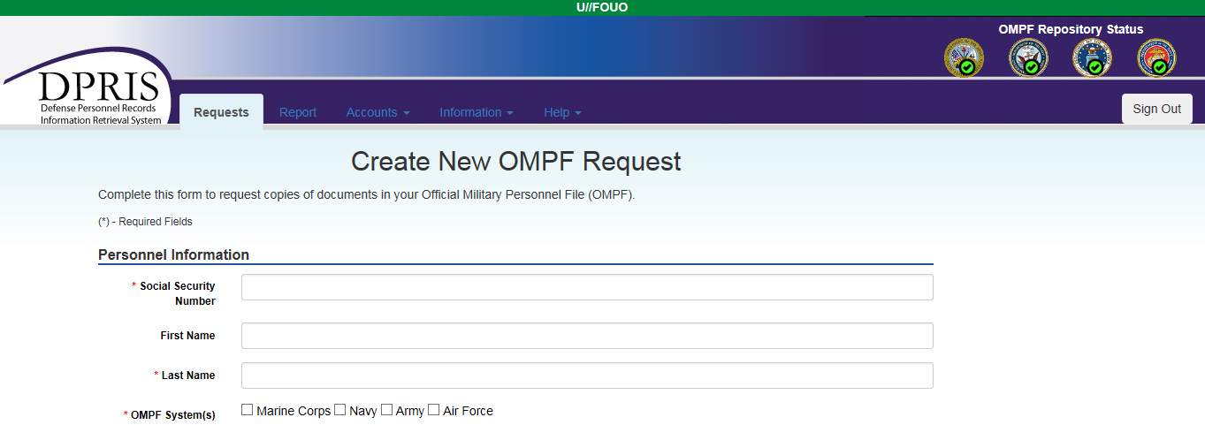

Your authorization level is pre-established by your manager during the registration process. This process determines the types of documents (i.e., groups and subgroups of the DPRIS Standard Index) that will be visible to you on the OMPF Request Form and that can be used in a request to the military service OMPF repositories.

**Document Indexing Scheme**

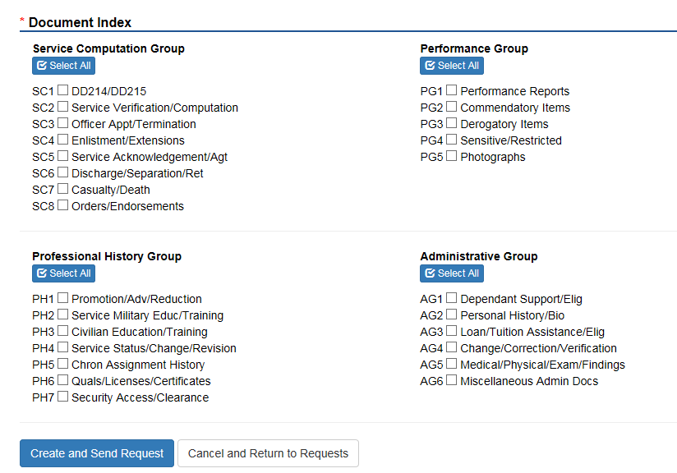

**DPRIS Groups and Subgroups**

All documents in the digital OMPF inventory can be assigned to one of the following four major functional groups and subgroups:

* Service Computation: Documents that record service entry and discharge, length of service, service agreements, appointments, commissions, statements of cumulative service, and other similar time specific data.
* Performance: Documents that record a service member’s performance including evaluations, fitness reports, effectiveness reports, commendatory or derogatory items, and other performance-specific data.
* Professional History: Documents that record promotions, education, training, chronological listing of assignments, qualifications and similar historical data
* Administrative: Documents that record administrative actions or personal information regarding dependents, tuition assistance, medical and dental reports, insurance, and other miscellaneous administrative data.

Each of the military services manages their OMPF digital records systems differently. Rather than requiring users to learn each indexing system, DPRIS has developed a standard index. Each document within the four military services’ OMPF systems has been mapped to the DPRIS standard indexing scheme. It shows the four major functional document groupings.

**Remember:** A screenshot of this request page needs to be uploaded into the Veteran’s eFolder in VBMS. The screenshot must capture the specific details of the request and will only capture the request page and no other parts of the screen. The request should be uploaded using the following attributes, per M21-1, Part III, Subpart iii, 2.I.4.a:

| **In the document field …** | **Enter …** |
| --- | --- |
|  |  |
| SUBJECT | *Personnel Records Request Screenshot.* |
| CATEGORY – TYPE | *Correspondence - Miscellaneous: Identification Materials*. |
| SOURCE | *DPRIS*. |
| DATE OF RECEIPT | the date the request was submitted*.* |

**Requests**

This link will display a list of your requests that you have submitted. It will show requests for which responses have been received from one or more of the military service OMPF systems or from JSRRC and requests that are still pending. This is the default page that opens after a successful user login. It is often useful to return to this screen from other pages within the secure area of the Website via this link.

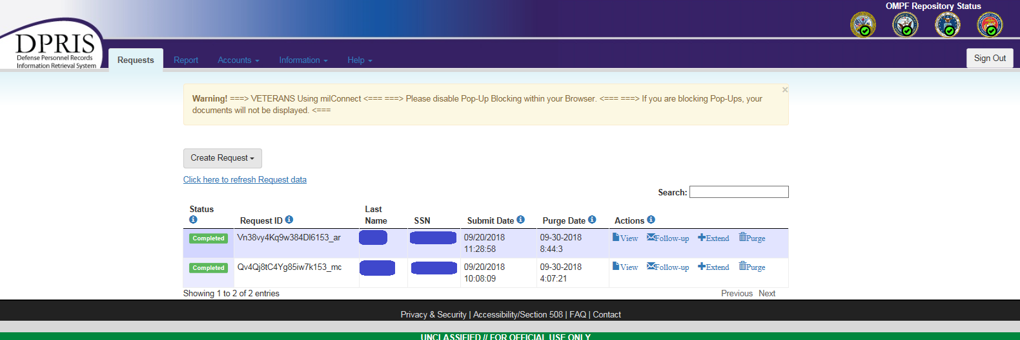

Options under Requests page:

* Request ID: This column lists Request IDs that have received a response from an OMPF repository or JSRRC. If multiple requests are displayed, they are initially sorted by the Request ID. However, multiple requests can be sorted in a different order by clicking on the arrow in either the Social Security Number (SSN) or Date column headings.
* Last Name: Lists the Last Name of the Veteran that you requested files for.
* SSN: Lists the SSNs associated with each of your active requests.
* Submit Date: This column lists the date and time each request was submitted.
* Purge Date: This column displays the date that the response will be purged from the DPRIS system. This is normally ten days. After a requested response is purged, non-image data pertaining to the request remains available via the Reports option, but the response is no longer displayed on the Requests page.

Links under Actions:

* View – Click to view and download the documents received as a PDF
* Follow-up – To send a follow-up message to DPRIS about a request
* Extend – To extend the purge date
* Purge – To delete the request from the system

**Help**

The DPRIS Help Desk can be contacted from most of the DPRIS pages by clicking on the Help link located on the bar near the top of each page. After clicking the link, you are taken to the Help area of the Website.

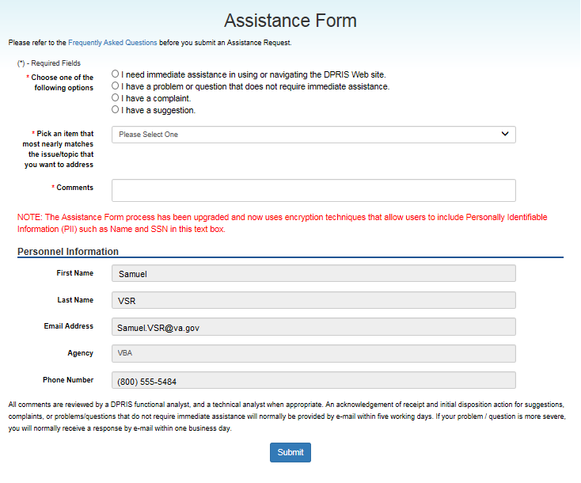

* The *Submit a New Assistance Form* link will take you to the DPRIS Assistance Form.
* The *Frequently Asked Questions (FAQ)* link will provide you with regularly asked questions and answers concerning DPRIS.
* The *Help on Images* link provides you with information concerning documents available in the Services’ OMPF systems.
* The *Documents* link provide the capability to download the most recent version of the DPRIS Users Guide.

To communicate with the DPRIS Help Desk, you would click on *Submit a New Assistance Form*. A screen will be displayed containing the Assistance Form. It allows you to:

* Request immediate assistance with using or navigating the DPRIS Web site
* Report deficiencies and problems encountered with the performance of DPRIS that do not require immediate assistance
* Submit a complaint
* Submit suggestions to improve the DPRIS user interface and functional design.

You are required to select options in the top sections of the form to specify the general nature and urgency of the communication.

# Topic 2: PIES

**PIES Overview**

Personnel Information Exchange System

VA application used to request Service Treatment Records (STRs) and Personnel Records from the National Personnel Records Center (NPRC) and the individual branches of service.

**STRs the NPRC Houses**

|  |  |
| --- | --- |
| **If the Veteran last served in the…** | **and service ended prior to…** |
| Army | October 16, 1992 |
| Navy | January 31, 1994 |
| Air Force | May 1, 1994, if separated from active duty  June 1, 1994 if separated from  National Guard or Reserves |
| Marine Corps | May 1, 1994 |
| Coast Guard | May 1, 1998 |

These dates can be found in M21-1, Part III, Subpart iii, 2.A.3.d**.**

**Personnel Records the NPRC Houses**

|  |  |
| --- | --- |
| **If the Veteran last served in the…** | **and had no service on or after…** |
| Army | October 1, 1994 |
| Navy | January 1, 1995 |
| Air Force | October 1, 2004 |
| Marine Corps | January 1, 1999 |

These dates can be found in M21-1, Part III, Subpart iii, 2.A.3.e**.**

**PIES Inputs**

If this is the first request, once the file number is entered, click “Submit to PIES.”

If this is not the first request, click “Submit to BIRLS.” The Veteran Identification Data (VID) from BIRLS is transferred to PIES.

Input the Date of Claim and EP.

Once entered, click on the curved black arrow (Next Page icon).

Input your request (O50 – Furnish Complete Medical/Dental Records <STRS> and Entire Personnel File at NPRC).

Ensure all information is correct.

Click on yellow rectangle to submit the request (Submit icon).

Once back at the Home Screen, click “Search Existing,” type in the file number, and click “Submit to PIES.”

Double-click the request and print as a PDF to upload into the eFolder.

NOTE: Please use the PIES Users guide for further instructions.

**Using PIES**

***DO***

* Update BIRLS, making sure that all fields contain valid data BEFORE making a PIES request
* Check for the status of your request on the Branch of Service tabs, particularly if the overall status is complete, but there are no responses
* Check PIES Help whenever you are not sure of the dates when morning reports are available or the branches of service that maintain them
* Check PIES Help for the time frames when clinical records are available
* Check for redundancy in your requests, particularly if you have selected more than 5 request items

***DON’T***

* Use PIES for requesting service medical records located at the VA RMC (376 or 375)
* Repeat your request by using request code O99
* Mix requests for finance information with requests for service or medical information
* Address requests for service or medical records yourself, unless you have confirmation of where they are
* Allege clinical treatment for a period in excess of one year, unless the patient was actually hospitalized that long
* Allege overlapping dates of service in the periods of service grids
* Compose a request (O99) when a programmed request item already exists
* Enter the duty status as “Active”, unless the “Veteran” is currently on active duty in the branch of service about which you are inquiring

**DPRIS to PIES Cross Reference Guide**

The DPRIS to PIES Cross Reference Guide can be found on the Compensation Service Intranet Site under PreDischarge & Interagency Collaborations (212) staff. Click the link titled “PIES/DPRIS” then scroll to **Additional Materials and Job Aids for PIES and DPRIS** to open the*DPRIS Web to PIES Cross Reference Guide.*

# Practical Exercise

1. Name two of the Groups on the Document Indexing Scheme in DPRIS.
2. Logistics Group and Administration Group
3. Military History Group and Professional History Group
4. Service Computation Group and Performance Group
5. Name one example of a document received through DPRIS.
6. DD-214
7. VA Form 21-22
8. CAPRI Progress Notes
9. Where can we find the DPRIS to PIES Cross-reference Guide?
10. Under the “Hey VA” logon each day in the office
11. On the Compensation Service Intranet page under Procedures – PIES/DPRIS
12. On VA PULSE
13. For a VBMS claim, which PIES code do you use for a claim for PTSD?
14. O19
15. O18
16. O43
17. O50
18. When requesting STRs from the NPRC, which branch of service requires a discharge date before 10/16/1992?
19. Army
20. Navy
21. Air Force
22. Marine Corps
23. What type of records is primarily requested through DPRIS?
24. Medical
25. Finance
26. Personnel
27. Recreational
28. DPRIS provides authorized users access to digital electronic images of each military branch except for the ____________________.
29. Army
30. Navy
31. Air Force
32. Coast Guard
33. Marine Corps