The Hematologic and Lymphatic System (RVSR IWT)
Instructor Lesson Plan
Time Required: 2.0 Hours

Table of Contents

Lesson Description 2
Introduction to The Hematologic and Lymphatic System 4
Topic 1: Common Hematologic and Lymphatic Conditions 9
Topic 2: Special Considerations for Rating Purposes 19
Topic 3: Review of Rating Materials 25
Lesson Review, Assessment, and Wrap-up 26

Lesson Description
The information below provides the instructor with an overview of the lesson and the materials that are required to effectively present this instruction.
TMS # | 4487985
Prerequisites | None
target audience | The target audience for The Hematologic and Lymphatic System (RVSR IWT) is RVSR Challenge trainees.  Although this lesson is targeted to teach the RVSR Challenge trainees, it may be taught to other VA personnel as mandatory or refresher type training.
Time Required | 2 hours
Materials/  TRAINING AIDS | Lesson materials:  - The Hematologic and Lymphatic System (RVSR IWT) PowerPoint Presentation  - The Hematologic and Lymphatic System (RVSR IWT) Job Aid
Training Area/Tools | The following are required to ensure the trainees are able to meet the lesson objectives:  - Classroom or private area suitable for participatory discussions  - Seating, writing materials, and writing surfaces for trainee note taking and participation  - Hematologic and Lymphatic Job Aid  - Large writing surface (easel pad, chalkboard, dry erase board, overhead projector, etc.) with appropriate writing materials  - Computer with PowerPoint software to present the lesson material
Pre-Planning | - Become familiar with all training materials by reading the Instructor Lesson Plan while simultaneously reviewing the corresponding PowerPoint slides. This will provide you the opportunity to see the connection between the Lesson Plan and the slides, which will allow for a more structured presentation during the training session.  - Become familiar with the content of the trainee handouts and their association to the Lesson Plan.  - Practice is the best guarantee of providing a quality presentation. At a minimum, do a complete walkthrough of the presentation to practice coordination between this Lesson Plan, the trainee handouts, and the PowerPoint slides and ensure your timing is on track with the length of the lesson.  - Ensure the job aid is distributed to trainees.  - When required, reserve the training room.  - Arrange for equipment such as flip charts, an overhead projector, and any other equipment (as needed).  - Talk to people in your office who are most familiar with this topic to collect experiences that you can include as examples in the lesson.  - This lesson plan belongs to you. Feel free to highlight headings, key phrases, or other information to help the instruction flow smoothly. Feel free to add any notes or information that you need in the margins.
Training Day | - Arrive as early as possible to ensure access to the facility and computers.  - Become familiar with the location of restrooms and other facilities that the trainees will require.  - Test the computer and projector to ensure they are working properly.  - Before class begins, open the PowerPoint presentation to the first slide. This will help to ensure the presentation is functioning properly.  - Make sure that a whiteboard or flip chart and the associated markers are available.  - The instructor completes a roll call attendance sheet or provides a sign-in sheet to the students. The attendance records are forwarded to the Regional Office Training Managers.

Introduction to The Hematologic and Lymphatic System
INSTRUCTOR INTRODUCTION |  | Complete the following:  - Introduce yourself  - Orient learners to the facilities  - Ensure that all learners have the required job aid
time required |  | 0.15 hours
Purpose of Lesson  Explain the following: |  | This lesson is intended to provide an introduction to and an overview of the VA Schedule of Ratings for Disabilities, as well as relevant regulatory provisions and procedural directives, as they pertain to the hematologic and lymphatic system. This lesson will contain discussions and exercises that will allow you to gain a better understanding of:  - Common hematologic and lymphatic conditions;  - Special considerations for rating purposes.
Lesson Objectives  Discuss the following:  Slide 2 | To fulfill the purpose of this lesson, the RVSR Challenge trainee will be required to accomplish the following lesson objectives.  - Discuss general rating considerations that involve evaluating hematologic and lymphatic conditions.  - Demonstrate how to prepare a rating decision involving the hematologic and lymphatic system.
Explain the following: | Each learning objective is covered in the associated topic. At the conclusion of the lesson, the learning objectives will be reviewed.
Motivation | Many disabilities within the hematologic and lymphatic system are subject to presumptive service connection. As an RVSR, you will need to be aware of these special considerations to produce accurate rating decision.
STAR Error code(s) | A2, C2, D1
References  Slides 3-4 | Explain where these references are located in the workplace.  All references are found in the Knowledge Management Portal:  - 38 CFR 3.105(e), Reduction in evaluation - compensation  - 38 CFR 3.114, Change in law or Department of Veterans Affairs issue  - 38 CFR 3.307, Presumptive service connection for chronic, tropical, or prisoner-of-war related disease, disease associated with exposure to certain herbicide agents, or disease associated with exposure to contaminants in the water supply at Camp Lejeune; wartime and service on or after January 1, 1947  - 38 CFR 3.309, Disease subject to presumptive service connection  - 38 CFR 3.311, Claims based on exposure to ionizing radiation  - 38 CFR 3.313, Claims based on service in Vietnam  - 38 CFR 3.316, Claims based on chronic effects of exposure to mustard gas and Lewisite  - 38 CFR 3.344, Stabilization of disability evaluations  - 38 CFR 3.400, Effective dates – General  - 38 CFR 3.951, Preservation of disability ratings  - 38 CFR 4.117, Schedule of ratings – hematologic & lymphatic systems  - M21-1, Part III, Subpart iv, 4.K, Hematologic and lymphatic systems  - M21-1, Part III, Subpart iv, 5.B, Principles of disability evaluation  - M21-1, Part III, Subpart iv, 8.D, Reductions in awards  - M21-1, Part IV, Subpart ii, 2.C, Service connection (SC) for disabilities resulting from exposure to environmental hazards or service in the Republic of Vietnam (RVN)
Hematologic system overview and major components  Slide 5 | Slide:  - Hematologic  - Previously referred to as “hemic”  - Defined as “of or relating to blood and blood forming organs”  - Function  - Deliver oxygen and nutrients to all tissues  - Removes waste  - Transports gases, blood cells, immune cells, antibodies, and hormones throughout the body  - Diseases can affect production of blood and its components  - Hematologic components  - Red and white blood cells, platelets, plasma, bone marrow, and spleen.  Discussion:  The hematologic system, previously referred to as the hemic system, is responsible for delivering oxygen and nutrients to all tissues, removing waste from the blood, and transporting gases, blood cells, immune cells, antibodies, and hormones throughout the body.  This system is comprised of blood cells, platelets, plasma, bone marrow, and spleen.  Blood cells are made in the bone marrow. There are three types of blood cells – red, white, and platelets. Red blood cells, also called erythrocytes, carry oxygen that is inhaled from the lungs, throughout the body, and back to the lungs, where carbon dioxide is exhaled.  White blood cells (WBC), also called leukocytes, are cells of the immune system. There are five main types of white blood cells – neutrophils, lymphocytes, eosinophils, monocytes, and basophils – whose job it is to protect the body from infection and diseases. Most WBCs are made in the bone marrow, but some are made in glands in the body.  Platelets, also called thrombocytes, are tiny cells that help the body form clots to stop bleeding.  Plasma is a liquid that holds blood cells in suspension. Plasma accounts for 55 percent of the body’s total blood volume.  Bone marrow is the soft fatty substance in the cavities of the bones. It is here where blood cells are produced and stem cells are contained.  Lastly, the spleen is an organ found under the ribcage, above the stomach, in the left upper quadrant of the abdomen. Its function is to filter blood as part of the immune system. The spleen is also considered part of the lymphatic system.  It is difficult to separate out where the hematologic system ends and lymphatic system begins, as many of the functions are interrelated. Because of this, they co-exist in the same section of the rating schedule and are discussed together.
Lymphatic overview and major components  Slide 6 | Slide:  - Lymphatic  - Defined as “of or relating to lymph, or its secretion”  - Function  - Removal of excess fluids from body tissues  - Absorption of fatty acids and subsequent transport of fat into the circulatory system  - Production of immune cells  - Diseases can affect immune functions and digestion  - Lymphatic components  - Includes lymph fluid, vessels, nodes, or organs (tonsils, adenoids, spleen, thymus)  Discussion:  The lymphatic system is a network of tissues and organs that help rid the body of waste/toxins and transports fats, and it is where immune cells are produced. It is comprised of lymph, lymph vessels, lymph nodes, the tonsils and thymus, and the spleen.  Lymph fluid is formed when the interstitial fluid (fluid in the interstices of the all body tissue) is collected through lymph capillaries or vessels. The vessels transport the waste/toxins, fats, or immune cells throughout the body.  Lymph nodes are glands that are located throughout the body, with the largest groupings found in the neck, armpit, and groin, that filter substances that travel in the lymphatic fluid. Swollen lymph nodes may indicate exposure to bacteria or viruses and can also be a signal of something more severe like an infection or disease.  The tonsils and thymus, though part of the lymphatic system, are typically not evaluated under this section of the rating schedule, so they will not be discussed further.
Hematologic and lymphatic highlights  Slide 7 | Slide:  - Common conditions  - Anemias  - Leukemias  - Lymphomas  - Multiple myeloma  - Chronic myelogenous leukemia  - AL amyloidosis  - Special considerations  - Effective dates  - Presumptive service connection  - Non-Hodgkin’s lymphoma and herbicide exposure  - Other considerations  - Review of rating materials  - Rating schedule  - DBQ  - VBMS-R  Discussion:  Now that we have discussed what the hematologic and lymphatic system functions are, we will move forward and discuss common conditions that you will see as an RVSR, which include anemias, leukemias, lymphomas, multiple myeloma, chronic myeloid leukemia, and AL amyloidosis.  We will then discuss special considerations for rating purposes, such as effective dates and presumptive service connection. Lastly, we will review our rating materials, such as the rating schedule, DBQ, and VBMS-R demo.

Topic 1: Common Hematologic and Lymphatic Conditions
Introduction | This topic will introduce the trainee to several of the most commonly encounted and evaluated hematologic and lymphatic conditions.
Time Required | 0.75 hours
Common hematologic and lymphatic conditions  Slide 8 | Slide:  (Topic Header Slide) - Common hematologic and lymphatic conditions  Discussion:  Many of the disabilities featured in the hemic and lymphatic body system are uncommonly encountered in everyday rating practice. The hematologic and lymphatic disabilities that arise most frequently for rating consideration are anemias, leukemias, lymphomas, multiple myeloma, chronic myeloid leukemia, and AL amyloidosis. We will discuss each one individually.
Anemias  Slide 9 | Slide:  - Anemia, hypochromic-microcytic and megaloblastic, such as iron-deficiency and pernicious anemia, under DC 7700, was removed in rating schedule update on December 9, 2018  - Replaced with four new diagnostic codes  - 7720 – Iron deficiency anemia  - 7721 – Folic acid deficiency  - 7722 – Pernicious anemia and Vitamin B₁₂ deficiency anemia  - 7723 – Acquired hemolytic anemia  Discussion:  Medically, anemia is a condition characterized by a low number of erythrocytes (i.e. red blood cells) in the hemoglobin, resulting from an imbalance between blood production and loss. This condition was historically evaluated under diagnostic code 7700 based on red blood cell morphology and did not account for other types of anemia. When the rating schedule changed on December 9, 2018, diagnostic code 7700 was deleted and replaced by four new diagnostic codes to account for the major types of anemia.  The four major types of anemia are iron deficiency anemia, folic acid deficiency, pernicious anemia and Vitamin B12 deficiency anemia, and acquired hemolytic anemia.
Diagnostic codes 7720 and 7721  Slide 10 | Slide:  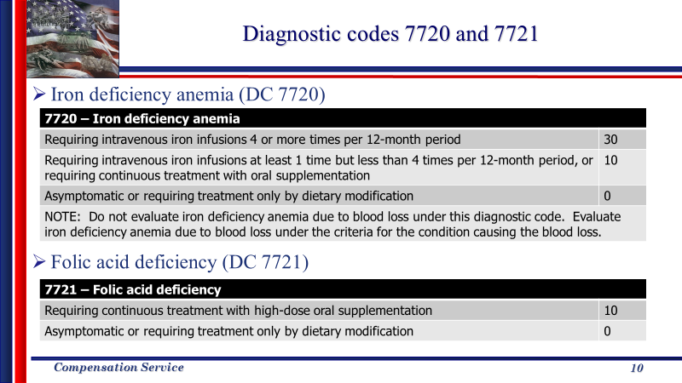  Discussion:  Iron deficiency anemia is evaluated under diagnostic code 7720 and is defined as a decrease in total body iron content. Iron is an important component of hemoglobin, the substance in red blood cells that carries oxygen from your lungs and transports it throughout the body. If your body does not have enough iron, it cannot produce enough healthy oxygen-carrying red blood cells. This can cause a variety of symptoms like fatigue, dizziness, weakness, pale skin, shortness of breath, etc.  This condition is evaluated at 30, 10, or 0 percent. A 30 percent would be assigned when the condition requires intravenous iron infusions 4 or more times per 12-month period.  A 10 percent evaluation would be assigned when the condition requires intravenous iron infusions at least 1 time but less than 4 times per 12 month period, or requires continuous treatment with oral supplementation.  A noncompensable evaluation would be assigned if the condition is asymptomatic or requires treatment only by dietary modification.  Iron deficiency anemia due to blood loss should not be evaluated under this diagnostic code, but rather evaluated under the condition causing the blood loss (i.e. duodenal ulcer, or hemorrhoids).  Folic acid deficiency is evaluated under diagnostic code 7721. Folic acid assists with the production and maintenance of new red blood cells, and in pregnanet women it is critical for the development of a healthy fetus. When there is not enough folic acid in the body, symptoms are similar to iron deficiency anemia. These symptoms include fatigue, weakness, lethargy, pale skin, irritability, etc.  The prevalence of folic acid deficiency has decreased in the United States because this form of anemia is correctable with dietary modification and oral supplementation.  This diagnostic code provides an evaluation of 10 or 0 percent. A 10 percent would be warranted if the condition requires treatment with high-dose oral supplementation. A noncompensable evaluation would be assigned if the condition is asymptomatic or requires treatment only by dietary modification.
Diagnostic code 7722  Slide 11 | Slide:  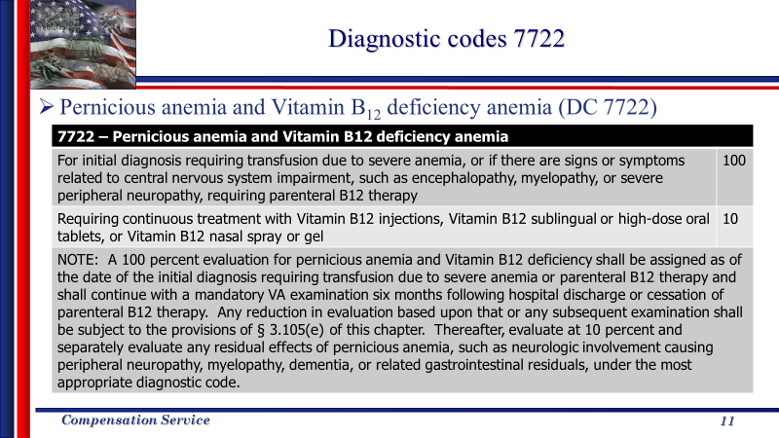  Discussion:  Pernicious anemia and vitamin B₁₂ deficiency anemia are evaluated under diagnostic code 7722. Vitamin B₁₂ helps keep the body’s nerve and blood cells healthy. Deficiency of vitamin B12 can be caused by dietary avoidance (vegetarian/vegan), malabsorption, gastrectomy or gastric bypass, inflammatory bowel disease (IBD), pancreatic insufficiency, use of histamine 2-blockers and proton pump inhibitors.  Persons with a vitamin B₁₂ deficiency may exhibit no symptoms, or they may have symptoms such as fatigue, weakness, lightheadedness, glossitis, constipation, diarrhea, numbness, tingling, problems walking, etc. When treatment for this condition is unsuccessful or the condition is left untreated, it can develop into pernicious anemia.  Pernicious anemia is the most common severe form of vitamin B₁₂ deficiency and requires lifelong treatment with vitamin B₁₂.  A 100 percent evaluation is assigned for pernicious anemia and vitamin B₁₂ deficiency anemia for an initial diagnosis that requires transfusion due to severe anemia or if there are signs and symptoms related to central nervous system impairment, such as encephalopathy, myelopathy, or severe peripheral neuropathy, requiring parenteral B₁₂ therapy.  The provisions of 38 CFR § 3.105(e) apply six months following hospital discharge or cessation of parenteral B₁₂ therapy. Thereafter, evaluate at 10 percent and separately evaluate any residual effects, such as neurological involvement causing peripheral neuropaty, myelopathy, dementia, or related gastrointestinal residuals, under the most appropriate diagnostic code.  An evaluation of 10 percent is assigned for continuous treatment with vitamin B₁₂ injections, vitamin B₁₂ sublingual or high-dose oral tablets, or vitamin B₁₂ nasal spray or gel.
Diagnostic code 7723  Slide 12 | Slide:  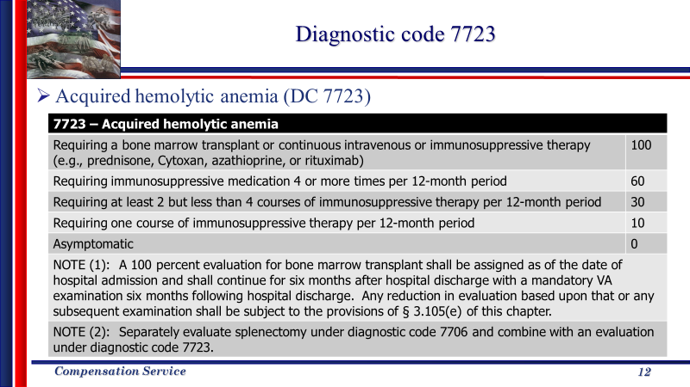  Discussion:  Acquired hemolytic anemia is evaluated under diagnostic code 7723. It is a condition that occurs in individuals who previously had a normal red blood cell system, and some other disease or factor casuses the body to destroy red blood cells.  This condition can be evaluated as 100, 60, 30, 10, or 0 percent based on frequency and type of treatment, which include bone marrow transplant, or immunosuppressive treatment. The provisions of 38 CFR 3.105(e) apply six months following hospital discharge.

Leukemia  Slide 13 | Slide:  - Diagnostic code 7703includes all leukemias except chronic myelogenous leukemia  - Leukemia is a malignancy of the blood-forming cells in blood marrow  - Evaluate:  - 100 percent during active disease or during a treatment phase  - If reduction is warranted after mandatory review examination, provisions of § 3.105(e) apply  - Otherwise evaluate residuals under the appropriate diagnostic code(s)  - 0 percent for chronic lymphocytic leukemia or monoclonal B-cell lymphocytosis (MBL), asymptomatic, Rai Stage 0  Discussion:  Leukemia is a malignancy of blood-forming cells in bone marrow. Its diagnostic criteria, associated with DC 7703 under 38 CFR 4.117, are typical of those associated with all conditions involving malignancy. For VA rating purposes, most service-connected malignancies receive a 100 percent evaluation during active disease or during and for six months following treatment phase. If and when malignancy dissipates, the evaluation is reduced so as to reflect the severity of any existing residuals.  In cases of chronic lymphocytic leukemia (CLL) or monoconal B-cell lymphocytosis, a noncompensable evaluation may be assigned when the Veteran’s asymptomatic, low risk level CLL is at Rai 0.  For most cancers, staging is the process of finding out how far the cancer has spread. CLL does not usually form tumors, but rather spreads to other organs by the time it is found. The outlook is dependent upon other information, such as results of lab tests or imaging tests. In cases of CLL, Rai staging (pronounced rye) is used and is based on lymphocytosis. There are five stages of the Rai staging system based on blood tests and physical exam.  Veterans with CLL or monoconal B-cell lymphocytosis of intermediate risk (Rai Stage I or II) and high risk (Rai Stage III or IV) are usually started on treatment, and thus the 100 percent evaluation would likely be assigned.

Special consideration for CLL (DC 7703)  Slide 14 | Slide:  - Historically, prior to December 9, 2018  - Permanent and total (P&T) grants for chronic lymphocytic leukemia was routinely granted based on diagnosis alone, regardless of stage.  - Following change in the rating schedule on December 9, 2018:  - Permanent and total (P&T) entitlement for chronic lymphocytic leukemia is now granted based on a facts-found.  - If reduction is warranted following mandatory review exam, apply provisions of 38 CFR 3.105(e).  - Grants of P&T established prior to the rating schedule change for this condition will be maintained (38 CFR 3.951).  Discussion:  Prior to the change in the hematologic and lymphatic systems rating schedule on December 9, 2018, chronic lymphocytic leukemia (CLL) was evaluated at 100 percent, regardless of the stage, and a permanent and total (P&T) entitlement was granted routinely.  This is no longer the case with new claims submitted on or after December 9, 2018, the date of the rating schedule change. The current rating critiera under DC 7703 is based on facts found. A noncompensable evaluation is assigned for CLL that is asymptomatic, or at Rai Stage 0.  In the event you review a claim where CLL was previously assigned a permanent and total evaluation prior to December 9, 2018, do not reduce this evauation or remove the P&T entitlement, regardless of stage, unless an unusual situation arises where true improvement from the prior status is actually shown.  Under 38 CFR 3.951, a change in the rating schedule is not ground for reduction. In this scenario, maintaining the evaluation under the historic rating critiera is more advantageous to the Veteran.
Lymphomas  Slide 15 | Slide:  - Lymphoma is a condition characterized by solid tumor formation in lymphatic glands and/or lymphoid tissues  - Hodgkin’s lymphoma, diagnostic code 7709  - Evaluate:  - 100 percent during active disease or during a treatment phase  - If a reduction is warranted following mandatory review exam, apply provisions of § 3.105(e).  - Non-Hodgkin’s lymphoma, diagnostic code 7715  - Evaluate:  - 100 percent during active disease, during a treatment phase, or with indolent and non-contiguous phase of low grade NHL  - If a reduction is warranted following a mandatory review exam completed at two years after discontinuance of treatment, apply provisions of § 3.105(e).  Discussion:  Lymphoma is characterized by solid tumor formation in lymphatic glands and/or lymphoid tissues. Based upon the characteristic of the malignant cells present, lymphomas are diagnostically classified into two categories – one (Hodgkin’s lymphoma) rather narrow, and the other (non-Hodgkin’s lymphoma (NHL)) fairly broad.  The diagnostic critiera for hodgkin’s lymphoa under 7709 and NHL under 7715 is typical of other diagnostic codes involving malignancy. However, for non-Hodgkin’s lymphoma a 100 percent evaluation may also be assigned when the condition is indolent and in a non-contiguous phase of low grade NHL.  Both diagnostic codes require a review examination following cessation of treatment. If a reduction is warranted, evaluate under the appropriate diagnostic code and apply the provisions of 38 CFR § 3.105 (e). Review exam for Hodgkin’s lymphoma should occur six months after cessation of treatment. For non-Hodgkin’s lymphoma, the review examination is performed two years after cessation of treatment.
Multiple myeloma  Slide 16 | Slide:  - A malignancy resulting from the proliferation of abnormal plasma cells in the bone marrow.  - Evaluate:  - 100 percent for symptomatic multiple myeloma  - Mandatory examination required five years after diagnosis of symptomatic multiple myeloma.  - If reduction is warranted following mandatory review exam, apply provisions of § 3.105(e) and § 3.344(a) and (b).  - 0 percent for asymptomatic, smoldering, or monoclonal gammopathy of undetermined significance (MGUS)  Discussion:  Multiple myeloma is a cancer of the plasma cells (white blood cell) in the bone marrow. The malignant plasma cells accumulate in the blood marrow, crowding out the normal plasma cells that help fight infection. The overgrowth of these plasma cells results in tumors that are deposited primarily in the bones, but also in the kidneys and other organs. Though this condition is rarely curable, it is highly manageable.  A 100 percent evaluation is assigned when there is symptomatic multiple myeloma.  A noncompensable evaluation is assigned when the condition is asymptomatic, smoldering, or monoclonal gammopathy of undetermined significance (MGUS).  Smoldering multiple myeloma is a precursor to stage 1 of multiple myeloma. It is asymptomatic, slow-growing, and may not require treatment.  Monoclonal gammopathyof undetermined significance (MGUS) is a condition in which an abnormal protein (monoclonal protein) is in the blood. People who have it are at a higher risk of developing myeloma.
Special consideration for multiple myeloma (DC 7712)  Slide 17 | Slide:  - Historically, prior to December 9, 2018:  - Permanent and total (P&T) entitlement for multiple myeloma was routinely granted based on diagnosis alone.  - Following change in the rating schedule on December 9, 2018:  - Permanent and total (P&T) entitlement for multiple myeloma is granted on a facts-found basis.  - If reduction is warranted following mandatory review exam, apply provisions of 38 CFR 3.105(e)  - Grants of P&T established prior to the rating schedule change for this condition should be maintained (38 CFR 3.951)  Discussion:  Similar to CLL, before the change in the hematologic and lymphatic systems rating schedule on December 9, 2018, multiple myeloma was evaluated at 100 percent, regardless of the stage. Along wit this, permanent and total (P&T) entitlement was granted routinely.  This is no longer the case with new claims submitted on or after December 9, 2018, the date of the rating schedule change.  In the event you review a claim where multiple myeloma was previously assigned a 100% permanent and total evaluation prior to December 9, 2018, do not reduce this evauation or remove the P&T entitlement, unless an unusual situation arises where true improvement from the prior status is actually shown.  Under 38 CFR 3.951, a change in the rating schedule is not ground for reduction. In this scenario, maintaining the evaluation under the historic rating critiera is more advantageous to the Veteran.
Chronic myelogenous leukemia (CML), DC 7719  Slide 18-19 | Slide 18:  - Includes chronic myeloid leukemia and chronic granulocytic leukemia  - Only leukemia condition NOT evaluated under diagnostic code 7703, leukemia  - Evaluate at 100, 60, or 30 percent, based on frequency and type of treatment and whether or not the Veteran is in remission  Slide 19:  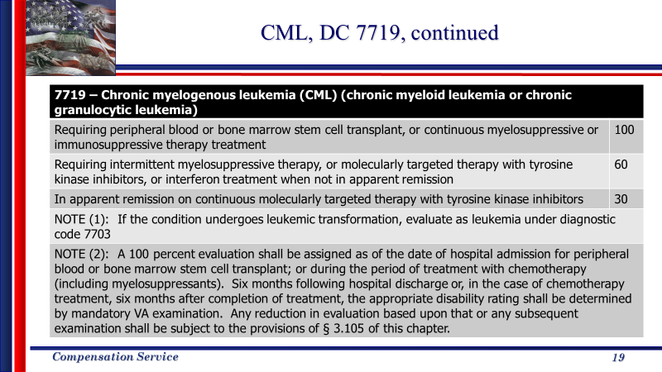  Discussion:  Chronic myelogenous leukemia is a cancer that affects the blood and bone marrow. This condition can also be called chronic myeloid leukemia and chronic granulocytic leukemia. This is the only leukemia that is not evaluated under DC 7703.  Patients with CML are never “cured” with current therapy, but often have no evidence of the disease at a molecular level, which is called complete molecular remission. These patients require continuous treatment, because otherwise they would relapse. These patients are considered to have active disease, even when they would otherwise appear to be in remission.  An evaluation of 100, 60, or 30 percent are assigned, based on the frequency and type of treatment, and whether or not they are in apparent remission.  A 100 percent evaluation is assigned when the Veteran requires peripheral blood or bone marrow stem cell transplant, or continuous myelosuppressive or immune suppressive therapy. A review exam should be scheduled six months following discharge from the hospital or completion of treatment. The provisions of 38 CFR 3.105(e) apply if a reduction is warranted.  A 60 percent is assigned when the Veteran requires intermittent myelosuppressive therapy, or molecularly targeted therapy with tyrosine kinase inhibitors (when not in apparent remission) or interferon treatment.  And a 30 percent evaluation is assigned when the Veteran is in apparent remission on continuous molecularly targeted therapy with tyrosine kinase inhibitors.  If the condition undergoes leukemic transformation, evaluate the condition under diagnostic code 7703.
AL Amyloidosis  Slide 20 | Slide:  - A bone marrow disorder where plasma cells produce abnormal antibody (immunoglobulin) protein that is deposited in and around tissues, nerves, and organs.  - Evaluate as 100 percent  - Assign a permanent and total evaluation  Discussion:  AL amyloidosis is a bone marrow disorder where plasma cells produce abnormal antibody (immunoglobulin) protein that is deposited in and around tissues, nerves, and organs. Immunoglobulins are composed of four protein chains: two light chains (kappa or lambda) and two heavy chains, of which there are several types.  In AL amyloidosis, it is the light chains that become misfolded, and the abnormal, misfolded result is the forming of amyloid. With AL amyloidosis, A is for the amyloid, and L is for the light chain.  This condition is to be evaluated at 100 percent with no future examination. Entitlement to Chapter 35 would also be warranted.

Topic 2: Special Considerations for Rating Purposes
Introduction | This topic will allow the trainee to become familiar with special considerations that apply to numerous disabilities of the hematologic and lymphatic system.
Time Required | 0.5 hours
Special Considerations for Rating Purposes  Slide 21 | Slide:  Header – Special Considerations for Rating Purposes  Discussion:  Now that we have discussed some of the commonly evaluated conditions for the hematological and lymphatic system, let’s take a look at some of the special considerations that you will have to keep in mind when evaluating these conditions.
Effective dates  Slide 22 | Slide:  - Rating schedule for the hematologic and lymphatic system changed on December 9, 2018.  - Liberalizing legislation does not apply to the change in rating schedule  - Consider general effective date rules (38 CFR § 3.400)  - Consider application of 38 CFR § 3.114 in assigning effective dates for presumptive service connection when warranted.  Discussion:  The rating schedule for the hematologic and lymphatic system was changed on December 9, 2018. Liberalizing legislation does not apply to changes in the rating schedule, therefore general effective date rules apply.  Several conditions in this body system are subject to presumptive service connection, which may impact your effective date decision. Be sure to consider application of 38 CFR §3.114 in assigning effective dates for presumptive service connection. When evaluating claims for presumptive service connection, effective date rules associated with liberalizing legislation apply when the evidence of record shows the the claimant met all eligibility criteria for the liberalized benefit on the effective date of the liberalizing law or VA issue and that such eligibility existed continuously from that date to the date of claim or administrative determination of entitlement.
Terminology  Slide 23 | Slide:  - The following terms may be used interchangeably to satisfy the criteria for the 100 percent rating criteria in certain diagnostic codes:  - Stem cell transplant  - Bone marrow transplant  - Bone marrow stem cell transplant  - Peripheral blood transplant  - Peripheral blood stem cell transplant  - This terminology applies to diagnostic codes:  - 7702, 7704, 7716, 7718, 7719, 7723, 7724 and 7725  Discussion:  Many of the hematologic conditions in the rating schedule can be treated with stem cell transplants.  A stem cell transplant, is a procedure used to infuse healthy cells, called stem cells, into the body to replace damaged or diseased bone marrow.  The cells used in a stem cell transplant can come from bone marrow or peripheral blood. Therefore, the terms stem cell transplant, bone marrow transplant, bone marrow stem cell transplant, peripheral blood transplant, and peripheral blood stem cell transplant, may be used interchangeably and all satisfy the criteria for the 100-percent rating criteria.  This interchangeable terminology applies to diagnostic codes 7702, 7704, 7716, 7718, 7719, 7723, 7724, and 7725.
Chronic presumptive disabilities  Slide 24 | Slide:  - Per 38 CFR § 3.309(a), chronic hematologic and lymphatic conditions which may be service connected on a presumptive basis include:  - Anemia, primary  - Hodgkin’s lymphoma  - Non-Hodgkin’s lymphoma  - Leukemia (any)  - Purpura idiopathic, hemorrhagic (DC 7705 “purpura hemorrhagic” is defined as “immune (idiopathic) thrombocytopenia”)  - The chronic diseases above are all one-year presumptive diseases per 38 CFR § 3.307(a)(3).  Discussion:  Anemia, Hodgkin’s lymphoma, non-Hodgkin’s lymphoma, any and all leukemia, and thrombocytopenia (synonymous with idiopathic purpura, per MEPSS) are all covered under 38 CFR 3.309(a)’s one-year presumptive provision. If they manifest to a compensable degree within one year of discharge, they should be service connected on a presumptive basis. Likewise, as “chronic” conditions, if they manifest during service, they may be service-connected at any subsequent point without the need for an etiological medical opinion.  In regards to anemia, this presumption is extended to diagnostic codes 7720-7723, iron deficiency anemia, folic acid deficiency, pernicious anemia and Vitamin B12 deficiency, and acquired hemolytic anemia, that were added to the rating schedule on December 9, 2018. This does not extend to anemia that is caused by another condition, in which case it should be evaluated under the appropriate body system.
Radiation presumptive disabilities  Slide 25 | Slide:  - Per 38 CFR § 3.309(d), radiation related hematologic and lymphatic conditions which may be service connected on a presumptive basis include:  - Leukemia (other than CLL)  - Lymphomas (except Hodgkin’s lymphoma)  - Multiple myeloma  - Per 38 CFR § 3.311, ionizing radiation radiogenic diseases, related hematologic and lymphatic conditions which may be service connected on a presumptive basis include:  - Leukemia (except CLL)  - Multiple myeloma  - Lymphomas (other than Hodgkin’s lymphoma)  - Other cancers  Discussion:  Leukemias other than chronic lymphocytic leukemia (CLL), non-Hodgkin’s lymphomas, and multiple myeloma are considered presumptive to radiation exposed Veterans. These claims are processed centrally at VARO Jackson, and therefore this avenue of entitlement will not be frequently encountered.
Herbicide presumptive disabilities  Slide 26 | Slide:  - Per 38 CFR § 3.309(e), herbicide related hematologic and lymphatic conditions which may be service connected on a presumptive basis include:  - All chronic B-cell leukemia [effective August 31, 2010]  - AL amyloidosis [effective May 7, 2009]  - Chronic lymphocytic leukemia [effective October 16, 2003]  - Hodgkin’s lymphoma [effective February 3, 1994]  - Non-Hodgkin’s lymphoma [effective February 6, 1991]  - Multiple myeloma [effective June 9, 1994]  - Consider liberalizing legislation for a potential earlier effective date (38 CFR § 3.114)  Discussion:  Vietnam-era, herbicide-specific bases of presumption will be by far the most frequent context in which trainees encounter hemic and lymphatic conditions. Herbicide-presumptive conditions include all chronic b-cell and hairy-cell leukemias and lymphomas; AL amyloidosis; chronic lymphocytic leukemia (CLL); multiple myeloma; Hodgkin’s lymphoma; and non-Hodgkin’s lymphoma.  The dates shown in red on this slide identify when legislation was passed to add the individual disability to the herbicide register under 38 CFR 3.309(e).  The displayed dates of legislative recognition are critically important and should be referenced in all cases of herbicide-presumptive grants of service connection, as diagnoses that are shown to have preexisted the corresponding dates will warrant application of 38 CFR 3.114 and assignment of a liberalized effective date for service connection.
Contaminated water at Camp Lejeune presumptive disabilities  Slide 27 | Slide:  - Per 38 CFR § 3.309(f), contaminated water at Camp Lejeune related hematologic and lymphatic conditions which may be service connected on a presumptive basis include:  - Non-Hodgkin’s lymphoma  - Adult leukemia  - Multiple myeloma  - Aplastic anemia and other myelodysplastic syndromes  - Effective date of law for the presumption of service connection based on contaminated water at Camp Lejeune is March 14, 2017.  - Consider liberalizing legislation for a potential earlier effective date (38 CFR § 3.114)  Discussion:  The presumption of service connection for non-Hodgkin’s lymphoma, adult leukemia, multiple myeloma, and aplastic anemia/other myelodysplastic syndromes based on exposure to contaminated water at Camp Lejuene became effective on March 14, 2017, following publication of 38 CFR 3.307(a)(7) and 38 CFR 3.309(f).  The publication of these regulations also resulted in a shift in processing policy – claims for service connection based on these new presumptive conditions are no longer always centrally processed at the Louisville Regional Office. Refer to the manual for guidance on when these claims are centrally processed or processed at the regional office.
Non-hodgkin’s lymphoma (NHL) and 38 CFR 3.313  Slide 28 | Slide:  - 38 CFR § 3.313 does not require herbicide exposure as the basis for a presumptive grant of service connection, as is the case with the presumptive diseases listed at 38 CFR § 3.309(e).  - A Veteran’s service in Vietnam, including service in the waters offshore of Vietnam, is the sole requirement for presumptive service connection when non-Hodgkin’s lymphoma is diagnosed after service.  - Refer to M21-1 IV.ii.2.C for a list of subcategories of low, intermediate, or high-grade lymphomas that are manifestations of NHL for which presumption can be extended.  - Consider liberalizing legislation for a potential earlier effective date (38 CFR § 3.114)  Discussion:  Non-Hodgkin’s lymphoma (NHL), unlike other herbicide presumptive disabilities, possesses its own individualized presumptive regulation (38 CFR 3.313) which authorizes Veterans who served in the offshore waters (blue-water (usually Naval)) a presumption of service connection without a required showing of docking or in-country service.  It is also significant to note that NHL is often formally diagnosed in a wide variety of nomenclature. The manual reference identified on the corresponding slide contains an approved listing of diagnoses that have been affirmed as constitutional of NHL, subject to presumptive service connection. Other diagnoses may require differentiation via medical opinion.
Scenario 1  Slide 29-30 | Slide 29:  The Veteran submits a claim for chronic lymphocytic leukemia (CLL) on April 24, 2019. His DD Form 214 shows that he served honorably in the Marine Corps from March 13, 1965, to May 26, 1967. In-country RVN service is verified by the DD214. In support of his claim, he submits private treatment records that include laboratory tests confirming a diagnosis of CLL on October 14, 2003.  Current treatment includes chemotherapy; however, no stop date was provided.  What rating action should be taken?  Slide 30:  Answer: Grant service connection for CLL with an evaluation of 100 percent effective April 24, 2018, one year prior to the date of claim.  Grant entitlement to Dependents’ Educational Assistance (DEA) from the same date.  (38 CFR 3.309(e), 38 CFR 3.114, and M21-1 III.iv.4.I.)  Discussion slide 30:  In the scenario provided, we must grant presumptive service connection and a 100-percent evaluation for CLL effective April 24, 2018, since the diagnosis existed prior to the condition’s addition to 38 CFR 3.309(e). Entitlement to DEA would also be warranted from the same effective date.  Although the current guidance indicates a future examination would be warranted in two years, since the claim is granted effective prior to the change in the rating schedule, the Veteran would be evaluated under the historical rating schedule, therefore the static P&T would also be awarded, as this is most advantageous to the Veteran.
Scenario 2  Slide 31-32 | Slide 31:  A Veteran submits an original claim for service connection for Non-Hodgkin’s lymphoma on November 2, 2016. Research into his service reveals that he performed active duty with the U.S. Navy and served aboard the U.S.S. Alamo in July and August 1970. He did not provide a docking statement in support of his claim. The JSRRC has confirmed no more than the Alamo’s presence in Vietnamese coastal waters.  A private medical report included with the claim renders a diagnosis of large, diffuse, high-grade (a type of non-Hodgkin’s) lymphoma dated October 7, 2011; subsequent VAMC oncology reports that chemotherapy was executed successfully and finally concluded on January 2012. Thereafter, no recurrences or metastases are noted. VAMC records indicate that the lymphoma remains in remission currently and bears no significant systemic residuals.  What rating action should be taken?  Slide 32:  Answer: Grant presumptive service connection for large, diffuse, high-grade lymphoma, with an evaluation of 0% effective November 2, 2016.  (38 CFR 3.313 and M21-1 IV.ii.2.C)  Discussion slide 32:  In the scenario provided, we must grant presumptive service connection and a 0-percent evaluation for large, diffuse, high-grade (claimed as non-Hodgkin’s) lymphoma effective November 2, 2012. The Veteran’s service is consistent with requirements of 38 CFR 3.313, and the lymphoma is asymptomatic, with treatment having concluded more than six (6) months prior to the date of the claim’s receipt.

Topic 3: Review of Rating Materials
Introduction | This topic will allow the trainee to become familiar with some of the references, materials, and programs utilized in evaluating hematologic and lymphatic conditions.
Time Required | 0.5 hours
Review of Rating Materials - Review  Slide 33-35 | Slide 33:  Header – Review of Rating Materials  Slide 34:  Review –  - Rating schedule, 38 CFR 4.117  - Disability Benefits Questionnaire  - Hematologic and lymphatic conditions, including leukemia  - Evaluation Builder in VBMS-R  - Demo input of hematologic and lymphatic conditions  Slide 35:  Questions?  Discussion:  Now that the powerpoint slides have been completed, we will look at the rating schedule, the DBQ, and the evaluation builder within VBMS.  Note to Trainer: If not previously completed, review these in real time, pointing out details the trainee should be aware of.
Regional Office Specific Topics | At this time add any information pertaining to:  - Station quality issues with this lesson  - Additional State specific programs/guidance on this lesson

Lesson Review, Assessment, and Wrap-up
Introduction  Discuss the following: | The Hematologic and Lymphatic System lesson is complete.  Review each lesson objective and ask the trainees for any questions or comments.
Time Required | 0.10 hours
Lesson Objectives | You have completed The Hematologic and Lymphatic System lesson.  The trainee should be able to:  - Discuss general rating considerations that involve evaluating hematologic and lymphatic conditions.  - Demonstrate how to prepare a rating decision involving the hematologic and lymphatic system.
Assessment | Remind the trainees to complete the eCase in VBMS-R demo for the hematologic and lymphatic system.  The eCase will allow the participants to demonstrate their understanding of the information presented in this lesson.

