(VSR VIP Post-D)

Dependency Effective Dates and Awards

Trainee Handout

**Table of Contents**

Objectives 2

References 3

Topic 1: Dependency Effective and Payment Dates 4

Topic 2: Adding Dependents to the Corporate Record 7

Topic 3: Entering Dependency Decisions in VBMS-A 12

Topic 4: Dependency Decision Notices 19

Attachment A - Dependency Decision Notice - PCGL Example 25

Practical Exercise 30

Objectives

Upon completion of this lesson, you will be able to:

* Identify effective and payment dates for establishing and removing dependents.
* Demonstrate establishing dependents in the Veteran’s corporate record using VBMS.
* Create dependency decisions in VBMS-A.
* Identify favorable findings as they pertain to denying entitlement to additional benefits for a dependent.
* Prepare a dependency decision notice using VBMS-A and PCGL.

References

* [PL 115-55](https://www.congress.gov/bill/115th-congress/house-bill/2288/text/pl?overview=closed) — Veterans Appeals Improvement and Modernization Act 2017
* [§ 3.31](https://www.ecfr.gov/cgi-bin/text-idx?SID=f22ed2993130183235703263d78e96c0&mc=true&node=se38.1.3_131&rgn=div8) — Commencement of the period of payment
* [§ 3.401(b)](https://www.ecfr.gov/cgi-bin/text-idx?SID=f22ed2993130183235703263d78e96c0&mc=true&node=se38.1.3_1401&rgn=div8) —Veterans, *Dependent, additional compensation or pension for.*
* [M21-1, Part III, Subpart iii, 5.A](https://www.knowva.ebenefits.va.gov/system/templates/selfservice/va_ssnew/help/customer/locale/en-US/portal/554400000001018/content/554400000015798/M21-1-Part-III-Subpart-iii-Chapter-5-Section-A-General-Information-on-Relationship-and-Dependency) — General Information on Relationship and Dependency
* [M21-1, Part III, Subpart iii, 5.B](https://www.knowva.ebenefits.va.gov/system/templates/selfservice/va_ssnew/help/customer/locale/en-US/portal/554400000001018/content/554400000015799/M21-1-Part-III-Subpart-iii-Chapter-5-Section-B-Establishing-the-Validity-of-a-Marriage-for-Department-of-Veterans-Affairs-VA-Purposes) — Establishing the Validity of a Marriage for Department of Veterans Affairs (VA) Purposes
* [M21-1, Part III, Subpart iii, 5.G](https://www.knowva.ebenefits.va.gov/system/templates/selfservice/va_ssnew/help/customer/locale/en-US/portal/554400000001018/content/554400000015802/M21-1-Part-III-Subpart-iii-Chapter-5-Section-G-Biological-Children-Adopted-Children-and-Stepchildren) — Biological Children, Adopted Children, and Stepchildren
* [M21-1 Part III, Subpart iii, 5.L](https://www.knowva.ebenefits.va.gov/system/templates/selfservice/va_ssnew/help/customer/locale/en-US/portal/554400000001018/content/554400000032212/M21-1-Part-III-Subpart-iii-Chapter-5-Section-L-Adjusting-Awards-for-Dependents) — Adjusting Awards for Dependents
* [M21-1, Part III, Subpart iv, 5.C](https://www.knowva.ebenefits.va.gov/system/templates/selfservice/va_ssnew/help/customer/locale/en-US/portal/554400000001018/content/554400000067390/M21-1-Part-III-Subpart-iv-Chapter-5-Section-C-Effective-Dates) — Effective Dates
* [M21-1 Part III, Subpart v, 2](https://www.knowva.ebenefits.va.gov/system/templates/selfservice/va_ssnew/help/customer/locale/en-US/portal/554400000001018/topic/554400000004122/Chapter-02-Decision-Authorization-and-Notification) — Decision Authorization and Notification
* [Share Online Help](http://css.vba.va.gov/SHARE/) (accessed in Share)
* [VBMS Core User Guide](https://vbaw.vba.va.gov/VBMS/Resources_Technical_Information.asp)
* [VBMS-A User Guide](https://vbaw.vba.va.gov/VBMS/Resources_Technical_Information.asp)
* [Approved Language for Favorable Findings – Dependency](https://vbatraining.adobeconnect.com/ptl6rvl048lm/default/connect.pdf) Job Aid

Topic 1: Dependency Effective and Payment Dates

**Establishing Dependents**

***Effective & Payment Dates***

The ***effective date*** for adding dependents is the *latest* of the following (*38 CFR 3.401(b)*):

* *Date dependency arose/date of the event*

Dependency may arise from an event such as marriage, birth, adoption, etc. If VA receives the claim within one year of that date, and the Veteran is rated 30% or more, dependency may be established from the date of the event.

* *Date of qualifying evaluation*

If a Veteran submits a claim for dependents within one year of the *notification* of a qualifying evaluation of 30% or more, dependency may be established from the effective date of that qualifying evaluation, provided dependency existed at that time. Additionally, if all necessary dependency information is of record at the time the rating decision is being processed (and less than 8 years old from the date the award is being processed), dependents should be established at that time, even if a separate dependency claim is not pending. See below for additional information.

* *Date of commencement of the Veteran’s award*

If the Veteran’s initial grant of compensation is 30% or more, and the dependency claim is received within one year of the *notification* of that initial grant, dependency may be established from the effective date of the initial grant of compensation.

* *Date of claim*

If a dependency claim is received more than one year after the notification of a qualifying evaluation, date dependency arises, or date VA requested information/evidence from the claimant, dependency may only be established from the date of claim (unless VA has notified the Veteran of a subsequent rating evaluation within the past year of the claim).

*Refer to M21-1, Part III Subpart iii, 5.L.2.d & f, for examples.*

The ***payment date,*** orpayment *start* date*,* for adding dependents is the first of the month following the effective date of entitlement.

***Qualifying Evaluation***

When promulgating a rating decision that assigns a combined disability evaluation of at least 30 percent, concurrently award additional disability compensation to which the Veteran is entitled for his/her dependents, even if the Veteran has not specifically claimed dependents with the claim for service connected compensation. In this situation, there does not need to be a claim for dependents pending and they should be added under the controlling rating EP.

*The 8-Year Rule* provides that information that is already of record regarding the status of the dependents of a Veteran in receipt of disability compensation is considered valid for the purpose of making entitlement determinations for up to eight years from the date VA received it. This policy coincides with the requirement for Veterans in receipt of additional compensation for dependents to verify their status every eight years.

Note: For compensation claims received on or after March 24, 2015, a prescribed form for dependency must also be of record and less than eight years old. For a list of prescribed forms for dependency claims, refer to *M21-1 III.ii.2.B.1.b*.

Development is required if the dependent information is over eight years old or a prescribed form is required, as noted above. For additional instructions, refer to *M21-1 III.iii.5.L.1.c*.

Evidence that is more than eight years old can still be considered when resolving missing or inconsistent dependency information. Copies of Social Security cards, birth certificates, marriage certificates, or any document containing names or event dates (such as birth, marriage, divorce or death) are used to supplement a dependency claim, regardless of when it was added to the Veteran’s eFolder.

Sometimes, dependent information can be found on older versions of *VA Form 21-526* or dependency verification forms (i.e. *VA Form 21-0538*). Another potential source of dependent information or records can be the Veteran’s Official Personnel Management File (OMPF) obtained through DPRIS or PIES.

**Removing Dependents**

The ***End-of-Month Rule*** states that the effective date of *reduction or discontinuance* of an award is the last day of the month in which the event occurs *if*the reduction or discontinuance is due to the loss of a:

* + spouse due to divorce, a voided or annulled marriage or death, or
  + child due to marriage, adoption (out of the Veteran’s household), death or discontinuance of school attendance.

Under the ***End-of-Month Rule***, for award-processing purposes in VBMS-A, the event date (or effective date) is the date of the event, and the award effective date (or payment start date) is the first of the month following the event.

***Important:***The last day of the month in which the event took place that resulted in the loss of a dependent represents the ***last*** date benefits are payable to or for the dependent. For award-processing purposes, the first day of the following month represents the first date of non-payment or reduced payment.

***Exceptions to the* End-of-Month Rule**

If a beneficiary loses a dependent for any reason ***other than those falling under the End-of-Month Rule***, remove the dependent on the date of the event that caused dependency to cease. Examples of such reasons may include (but are not limited to):

* date a minor child turns 18,
* date a school child turns 23, and
* date a school child begins receiving DEA benefits.

*Note*: When processing awards in VBMS-A for the situations above, the event date (or effective date) and award effective date (or payment date) are the same day

***Other Exceptions to the* End-of-Month rule**

* *Stepchildren*: The first full day that a stepchild is no longer a member of the Veteran’s household (day after the stepchild leaves the Veteran’s household). *For award processing purposes in VBMS-A, the event date is the date the child left the Veteran’s household, and the award effective date is the next day.* Refer to *M21-1 III.iii.5.G.6.h-k*.
* *Child adopted out of the Veteran’s household*: The requirement to remove a child from an award of disability compensation that was given up for adoption went into effect on *September 14, 2015*. For children adopted out of the Veteran’s household *prior to* that date, remove the child from the Veteran’s award effective September 14, 2015. *For award processing purposes, the event date and award effective date would both be September 14, 2015.* For children adopted out of the Veteran’s household after   
  September 14, 2015 – *for award processing purposes, the event date is the date the Veteran gave the child up for adoption, and the award effective date is the first of the following month*. Refer to *M21-1 III.iii.5.G.5.a.*

Topic 2: Adding Dependents to the Corporate Record

*Before* you can establish a dependent on a Veteran’s award in VBMS-A, you must first enter the dependent on the Veteran’s corporate record in VBMS Core. When adding dependents to the corporate record through VBMS Core, you might see already associated dependents listed. If the dependent is already listed, *do not* add the same dependent again.

Attempt to establish/edit dependents using VBMS Core before using Share. The best system to use is VBMS Core. This reduces the likelihood of creating duplicate dependent profiles and the system has better functionality overall for this process. Always check the corporate record first to determine if the dependent has already been associated to the Veteran.

**Adding Dependents in VBMS Core**

1. Under the **Veteran** drop-down menu, select **Dependents**.

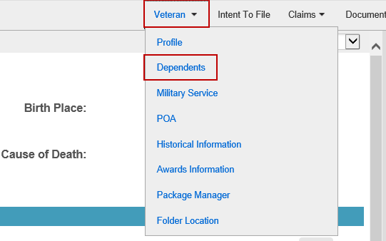

1. Select **Create New Dependent**.

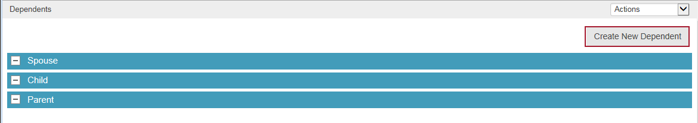

1. Enter *all required information*, then select the **Save** icon.

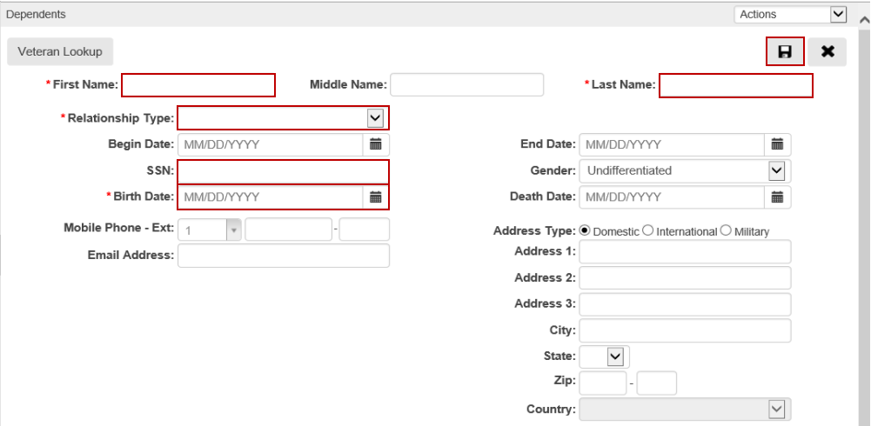

**Adding Dependents in Share**

The following information about establishing dependents in Share is provided for supplemental purposes. Whenever possible, dependents should be established in VBMS Core.

1. Check the Veteran’s corporate record to determine if the dependent in question is already associated. Select **Search All in List** from the *Available Processes* list on the VBA Ready Screen, enter the **File Number/SSN**, and click **Submit**. From the screen below, click on **Corporate**.

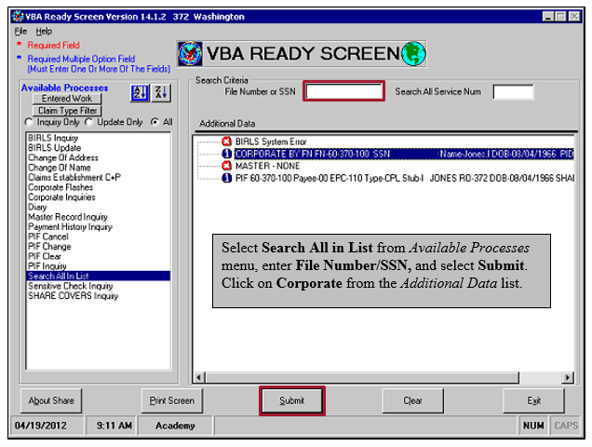

Select **Person**, then click on **All Relationships**. All associated dependents on file will be displayed, regardless of whether the Veteran is receiving additional benefits for them or not. To return to the VBA Ready Screen, click **Ready**.

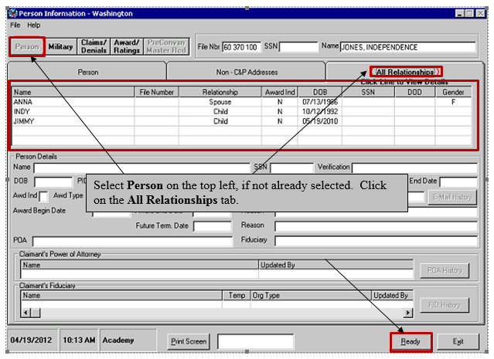

1. To add/edit dependents, begin by selecting **Dependents** from the *Available Processes* menu found on the Share – VBA Ready Screen. Enter the Veteran’s file number and payee number and click **Submi**t.

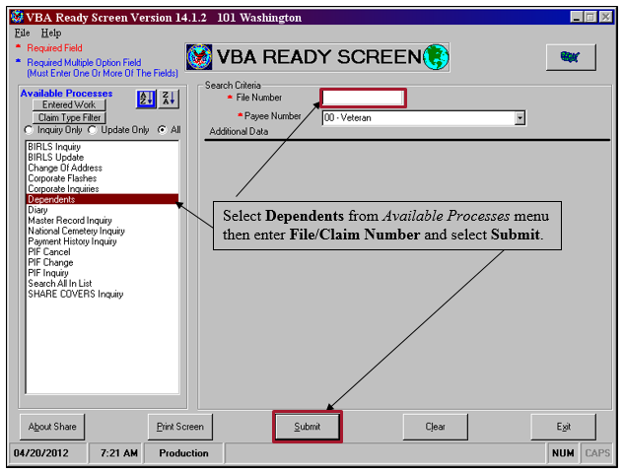

1. Select **Add** to continue.

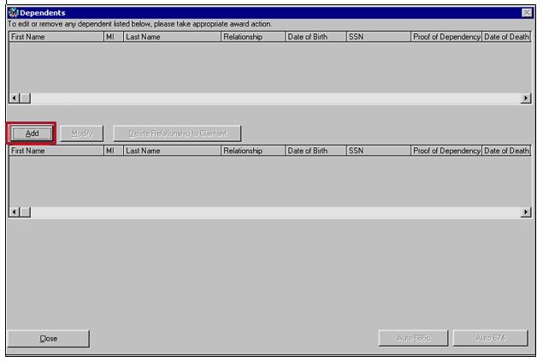

1. Input the required information for the dependent, then select **Update**.

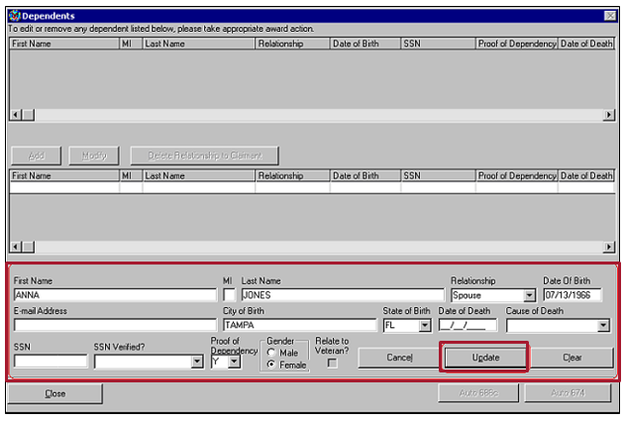

1. You will receive a message upon the successful addition of the dependent. Select **OK.** Repeat previous steps for each dependent. Once all dependents are added, select **Close**.

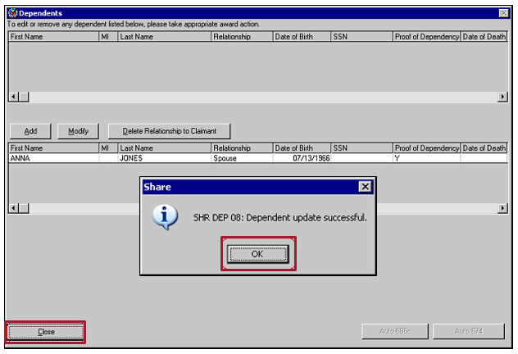

Topic 3: Entering Dependency Decisions in VBMS-A

In VBMS-A, to add any dependent, you must first enter the **Record Decisions** screen, then select **Dependency** from the decisions list on the left of the screen.

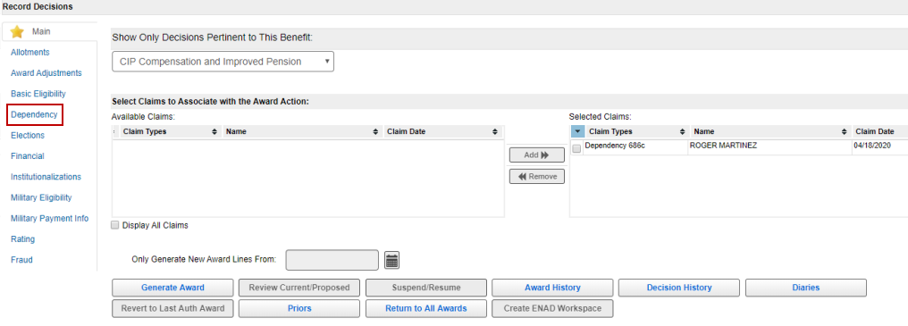

*Note: the information above was created in a Demo environment and is not an actual Veteran*

The *Dependency* screen fields are shown below with an explanation of what information to enter in each field:

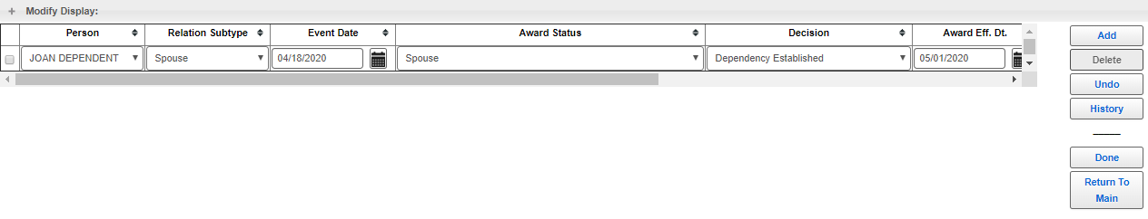

* *Person* – the name of the dependent based upon whom a decision is being made. Only dependents that have been added to the Veteran’s corporate record will show in this list.
* *Relation Subtype –* if it is a spouse, the field will auto-populate; if it is a minor child, the user must select Adopted, Biological or Stepchild.
* *Event Date* – the ***effective date*** for VA purposes.
* *Award Status* – allows the selection of the award status as a regular *Spouse* or *A&A Spouse*.
* *Decision* – allows the selection of the decision.
* *Award Eff. Dt*. – the ***payment date/payment start date*** for VA purposes. The Award Eff. Dt. field often auto-populates; however, *it is the user’s responsibility to ensure it is correct*.
* *Relation, SSN, Date of Birth fields, File Number and Decision Date fields* – auto-populates based on the information entered in the corporate record.

**Adding a Spouse in VBMS-A**



* Begin by selecting the spouse’s name from the **Person** drop-down. If this is not available, click **Add** and the fields should become available for editing.
* The **Relation Subtype** will auto populate as *Spouse.*
* Enter the **Event Date** – the ***effective date*** for VA purposes.
* Enter the **Award Status** as *Spouse* or *A&A Spouse.*
* Enter the **Decision** as *Dependency Established.*
* The **Award Eff. Dt.** – ***payment date/payment start date*** will populate based on the *Event Date* entered. Review for accuracy and update if necessary.
* Click **Add** to add more dependents or **Done** to save and return to the Record Decisions screen.

**Adding a Minor Child in VBMS-A**

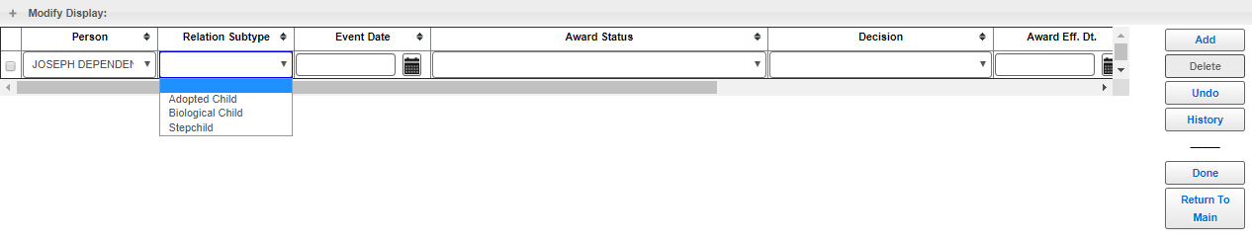

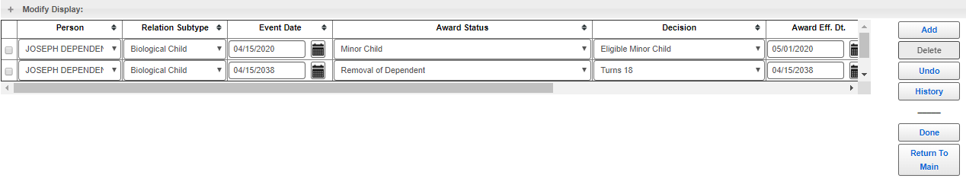

*Example (above): The Veteran’s biological child was born on April 15, 2020. The Veteran, who is currently evaluated at 30% or greater disabled for VA purposes, submitted* VA Form 21-686c *within a year of his child’s birth. The event date entered into VBMS-A is April 15, 2020. The Award Effective Date is automatically populated to May 1, 2020. VBMS-A also establishes a line to remove the dependent from the Veteran’s award effective April 15, 2038, the date of the child’s 18th birthday.*

* Begin by selecting the minor child’s name from the **Person** drop-down. If this is not available, click **Add** and the fields should become available for editing.
* **Relation Subtype** – the user must select either *Adopted, Biological, or Stepchild.*
* Enter the **Event Date** – the ***effective date*** for VA purposes.
* Enter the **Award Status** as *Minor Child.*
* Enter the **Decision** as *Eligible Minor Child*.
* the **Award Eff. Dt.**– payment date/payment start date will populate based on the *Event Date* entered.
* VBMS-A will automatically establish a line to remove the minor child effective his or her 18th birthday. *It is the VSR’s responsibility to ensure this information is correct.*
* Click **Add** to add more dependents or **Done** to save and return to the Record Decisions screen.

**Denying Entitlement to Additional Benefits for Dependents**

On August 23, 2017, the Veterans Appeals Modernization Act (AMA), Public Law 115-55, was signed into law, creating a new decision review process that allows VA to improve the delivery of benefits and service to Veterans and their families.

Regarding dependency claims, if we deny entitlement to additional benefits for a dependent, we must provide the Veteran with the reason for the denial – and the favorable findings in our decision.

A favorable finding is a determination of fact, based on applicable laws and regulations, made by the adjudicator on an issue under review. Favorable findings should relate to a material element that would be required to grant the benefit sought.

Favorable findings only apply when *denying* entitlement to additional benefits for a dependent.

**Denying Dependents in VBMS-A**

When a Veteran claims a dependent for which VA cannot pay additional benefits, you must generate and award in VBMS-A. Doing so provides an official record that the claim has been addressed. It also allows you to generate a Redesigned Automated Decision Letter (RADL) for notification.

To deny entitlement to additional benefits for a dependent in VBMS-A:

* Select **Add.**
* Select the dependent’s name from the **Person** drop-down menu.
* Relation Subtype – Select **type** of dependent.
* Event Date – Actual date of the event affecting the dependency.
* Select the **Award Status** of *Not an Award Dependent*.
* Under Decision, Select **Edit**, which will list the **favorable findings,** and select the decision elements as “met” or “not met.”
* Enter or update the **Award Effective Date** or leave blank.
* Select **Done** to save the decision and close the screen.

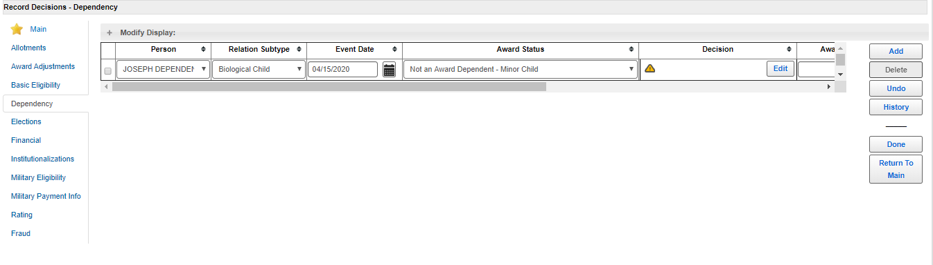

Select each decision element as “Met” or “Not Met,” as applies to the claim and dependent. A decision must be entered in every element category:

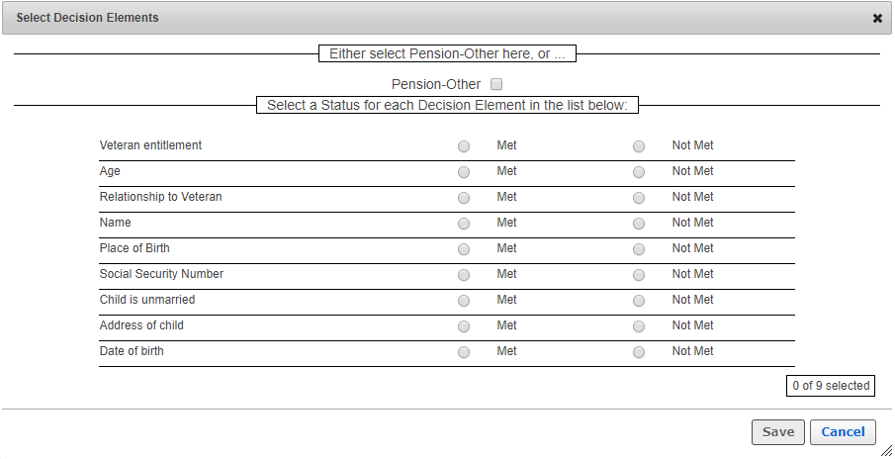

*Note*: Favorable finding options will vary depending on the Relationship Subtype of the dependent.

**Removing Dependents in VBMS-A**

If a dependent must be removed from the Veteran’s award, take the following actions:

* Enter a new decision, or edit the existing removal decision, with an Award Status of ***Removal of Dependent*** with the applicable event date and award effective date of removal.
* There are NO favorable findings for a removal of a dependent.

It is possible to “delete” the historical decision that established the dependent; however, this is only used when the dependent never should have been established to begin with (lacked the status of dependent at establishment). In addition, deleting the original decision line that established a dependent will remove him/her from the entire award, as if he/she never existed, and will create a large overpayment of benefits. This option is *rarely used* because the Veteran is usually entitled to payment for a certain period for that dependent.

For award-processing purposes, when removing a dependent, the *Event Date* will be the actual date of the event that resulted in loss of the dependent, even if the *Award Eff. Dt.* (payment date) is the end-of-month, because of the way the written explanation generates in the RADL.

*Note:* If removing a dependent due to death, you must also update the corporate record in VBMS Core to add the date of death for the deceased dependent. Ensure you ***update the existing dependent***. ***Do not*** add the dependent to the record again.

**Removing a Spouse *After* Initial Establishment**

To remove a dependent spouse *after* the initial eligibility date for the dependency:

* Select **Add.**
* Person – Select the person.
* Relation Subtype (auto populate).
* Enter the **Event Date -** Actual date of the event affecting the dependency.
* Select the **Award Status** of ***Removal of Dependent.***
* Select the **Decision** reason that supports removing the dependent.
* Enter the **Award Effective Date** - will auto populate to the 1st of the following month. Always verify this is correct.
* Select **Done** to save the decision and close the screen.

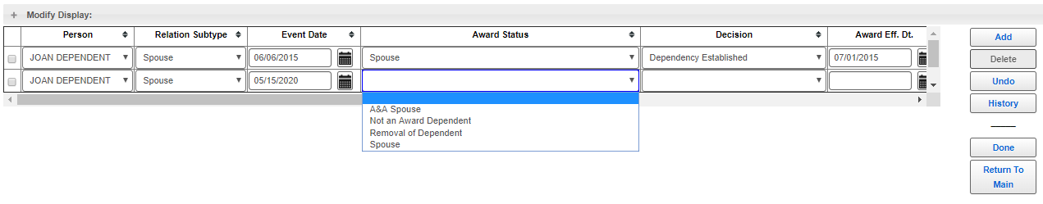

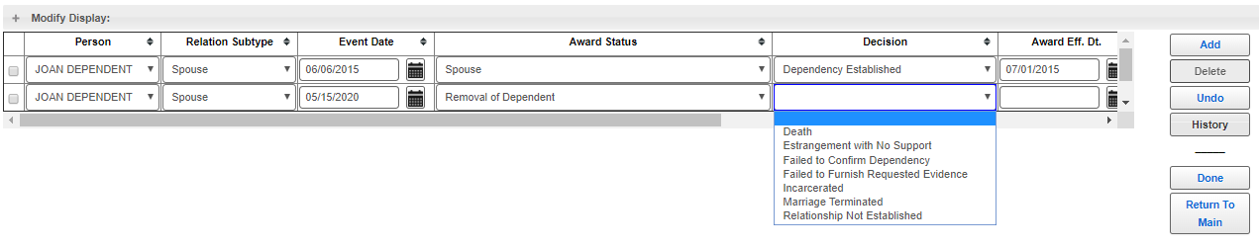

*Example (above) – eligible for a period*:

A Veteran, rated 60% disabled effective March 8, 2010, was married on June 6, 2015, and filed his dependency claim within one year of the marriage. The Veteran’s spouse was established on his award with an effective date of June 6, 2015, and a payment date of July 1, 2015. The Veteran reported that he divorced his spouse on May 15, 2020. Since the Veteran is entitled to benefits for his spouse through the end of the month of the divorce, we *would not* delete the original spouse decision, but *add a new line* to remove the spouse.

**Removing a Minor Child *Prior to* 18th Birthday**

To remove a minor child from a date earlier than the 18th birthday:

* Select the line on the screen that *removes* the minor child on his/her 18th birthday.
* Edit the **Event Date.**
* Update the **Award Status** – ***Removal of Dependent.***
* Select the **Decision** reason that supports removing the minor child.
* Enter the new **Award Effective Date** or verify if auto populated.
* Select **Done** to save the decision and close the screen.

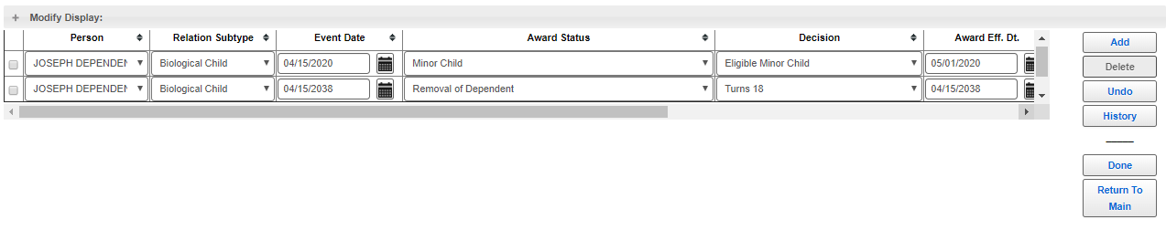

***Important:*** Since the Event Date and Award Effective Dates for removing a minor child may vary depending on the reason for the removal, you should always verify these dates are entered and auto-populate correctly.

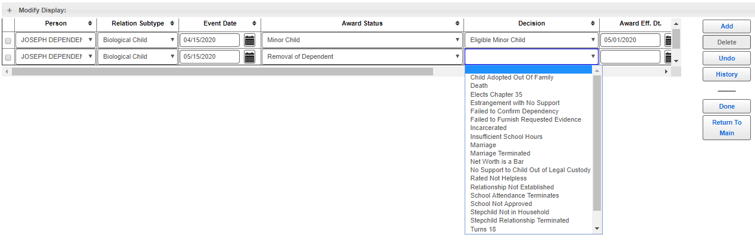

**Generate the Award in VBMS-A**

Once all decisions have been entered, click **Generate Award**.

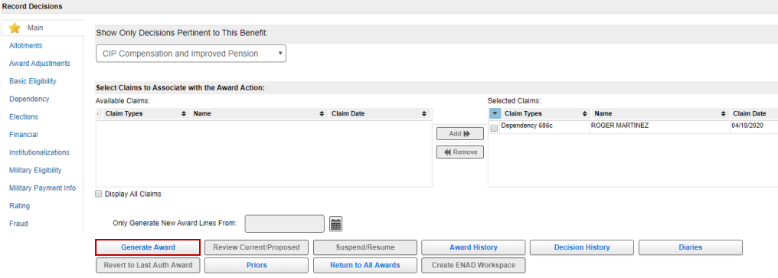

*Note: the information above was created in a Demo environment and is not an actual Veteran.*

Topic 4: Dependency Decision Notices

**Creating the RADL for Dependency Decision Notices**

After generating the award in VBMS-A, the user will be on the *Current/Proposed* Screen. To create the RADL, click **Gen Letter** at the bottom of the screen, which takes the user to the *Award Letter Interview* screen to complete the decision notice.

The process for using RADL to generate a decision notice regarding dependents is the same as the process for generating a decision notice for a rating decision; however, the user must *always* *list evidence* when generating a decision notice regarding dependents.

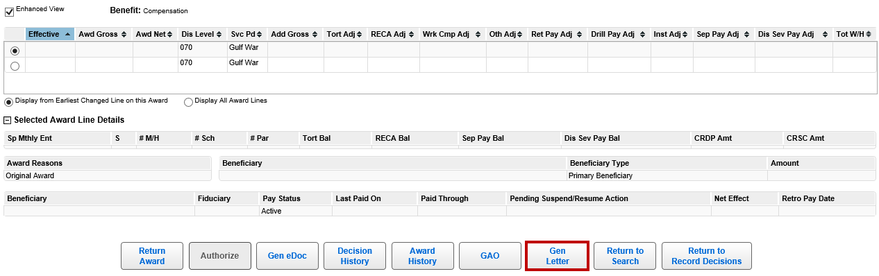

Refer to the prior lesson entitled *Award Processing for Ratings (VBMS-A/RADL)* located in the VBA Learning Catalog for a refresher on the specific *Award Letter Interview* screens in VBMS-A.

**Adding/Modifying Evidence**

Use either the *Import Evidence List* or *Evidence List* tabs in the VBMS-A Award Letter Interview pane to list the evidence considered.

The *Import Evidence List* tab will contain a catalog of the VBMS eFolder documents from which the user may select. Select documents from the VBMS eFolder to add to the evidence list:

1. Select the eFolder document on the left.
2. Click **Add** to move the document to the *Available Evidence* pane on the right.

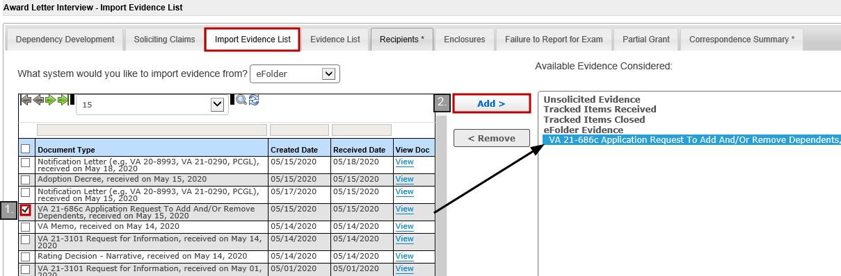

*Note:* If documents are incorrectly labeled in the VBMS eFolder, they will be labeled incorrectly in the *Import Evidence List* tab on the Letter Interview screen in VBMS-A. Always ensure documents are identified correctly in the eFolder prior to processing awards in VBMS-A.

If evidence cannot be accurately added from the *Import Evidence* List tab, use the *Evidence List* tab to manually enter the evidence considered, or modify or delete evidence imported from VBMS via the *Import Evidence List* tab:

1. Select existing evidence, then click **Edit** or **Delete**; or click **Add** to add new evidence.
2. Enter/edit the **Evidence Type**.
3. Choose *Received on* or *Dated* – enter the corresponding date.
4. Add any necessary Free-Text.
5. Click **Accept**.

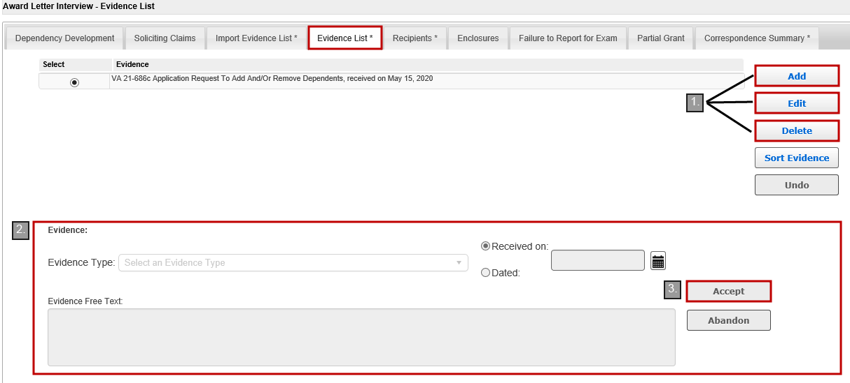

**Required Elements of Dependency Decision Notice**

If a Veteran is entitled to additional benefits for a dependent, written notification must be provided to the Veteran for each dependent claimed. Decision notices may address only dependency issues or both rating issues and dependency issues at the same time.

Since dependency is an authorization (i.e. non-rating) issue, the decision notice serves as the entire legal document of the entitlement determination and must include *all* the required elements of notification pertaining to the dependency claim.

You must create the decision notice using the RADL functionality in VBMS-A, or use PCGL if the RADL fails, is incorrect, or is insufficient beyond the addition of minor free text.

VA decision notices addressing authorization issues, such as dependency, must include all the following elements:

* inform the claimant of the issues adjudicated,
* Summarize the
  + evidence VA considered,
  + laws and regulations applicable to the claim, and
  + applicable review options the claimant may use to seek further review of the decision,
* explain how to obtain or access evidence used in making the decision,
* identify for denied claims:
  + the element(s) required to grant the claim that were not met, and
  + a listing of findings that are favorable to the claimant under *38 CFR 3.104(c)*, if any.

If granting entitlement to dependency for one or more dependent, or otherwise adjusting the Veteran’s running award, the decision notice must *also* notify the Veteran of:

* the monthly rate of payment,
* the effective dates of entitlement and payment, and
* the amount of any benefits VA is withholding and the reason for withholding.

Finally, if the enactment of the dependency decision results in the creation of an overpayment to the Veteran’s account, notify the Veteran of his/her right to request:

* a waiver of the overpayment, and/or
* a repayment plan.

**Favorable Findings Requirement**

Each notice of a decision affecting benefits must address any findings made by the adjudicator that are favorable to the claimant. When granting dependency claims all applicable regulations will be summarized in the decision notice. If we are denying a claim for additional benefits for a dependent, the favorable findings will be displayed in list format in the decision notice.

*Note*:

* Not all claims will have favorable findings.
* Element selection generates favorable finding language in the RADL.
* Elements are specific to dependent type, for example:
  + spouse,
  + minor child (biological child, stepchild and adopted child), or
  + school child.

**Example of a Dependency Grant**

The following language will be in the decision notice regarding a grant of entitlement to additional benefits for a dependent (this example is for a grant of entitlement to additional benefits for a spouse):

*“< Dependent’s Name> has been added to your award effective <Event Date>, because you submitted all the required information and meet the eligibility requirements for the dependency allowance. (38 CFR 3.4, 38 CFR 3.50, 38 CFR 3.57, 38 CFR 3.204, 38 CFR 3.205, 38 CFR 3.216)”*

*Note*: There will be different regulations (CFRs) for different dependent subtypes.

**Example of a Dependency Denial**

The below example is for a denial of entitlement to additional benefits for a spouse based on the Veteran’s failure to provide the date and place of marriage.

If we denied a claim to add a dependent spouse, the decision notice identifies the element(s) not met with a summary of applicable laws and regulations. We must then list the element(s) met that are favorable to the Veteran. The decision notice will state:

*“We couldn’t pay for <Dependent’s Name> as a dependent, because not all required elements were met. The following list contains an explanation of the elements required to establish entitlement to additional compensation for your dependent:*

* *You failed to provide the date and place of the marriage. (38 CFR 3.204).*

*Even though we aren’t able to pay additional compensation for your dependent, the following findings were favorable to your claim:*

* *You are rated 30% or greater service connected.*
* *Your relationship with <Dependent’s Name> has been established.*
* *You provided your spouse's name.*
* *You provided <Dependent's Name> social security number.*
* *You provided marital history, as requested.*
* *You provided your spouse’s date of birth.”*

*Note:* Favorable findings will be displayed in a list format in the decision notice.

**Example of the Removal of a Dependent**

The following language will be in the decision notice for removal of a dependent (this example is for removal of a spouse due to a divorce):

*“We have removed <Dependent’s Name> effective <Award Effective Date> for the following reason:*

* *You and <Dependent’s Name> divorced on < Event Date>.”*

Favorable findings are *not* required for removal of a dependent.

**Using PCGL to Generate a Decision Notice**

If the RADL in VBMS-A does not generate correctly and cannot be corrected using the Free-Text feature, or RADL fails to generate, PCGL must be used to generate the decision notice.

The primary PCGL template compensation service employees use to address dependency is **CG4 RFW Comp Grant/Denial**.

The **CG4 PCGL** template allows for input of withholding and offsets in the payment chart and language selection, such as for military retirement pay. This template can be used for notifying a claimant of a rating decision, both a rating decision and a decision regarding a Veteran’s dependent(s), or by selecting *Authorization Only* when prompted a decision that only addresses a Veteran’s entitlement to additional benefits for his/her dependent(s).

When using this template, the you must always free-text an explanation of the decision regarding the Veteran’s dependents, including the name of each dependent claimed, the effective date to add or remove the dependent (if applicable), favorable findings (if denying entitlement to additional benefits for a dependent) and a list of each piece of evidence relevant to the decision.

*Note:* When using the CG4 template for a decision notice that only addresses a Veteran’s entitlement to additional benefits for a dependent, you must *also* remove language and paragraphs that are not required or relevant to this category of decision, such as reference to a rating decision, VA Form 21-8764, and/or additional benefit information.

**PCGL/Letter Templates**

For examples of PCGL decision notice paragraphs for dependency decisions, please refer to the job aid “Approved Language for Favorable Findings – Dependency” attached to this lesson. In addition, the following paragraphs must be amended when providing notice using PCGL:

* **“What We Decided”**
  + Include any favorable findings, if applicable, for each issue decided.
  + Include applicable laws and regulations for each issue decided.
* **“Evidence Used to Decide Your Claim”**
  + List any documents from the Veteran’s eFolder used to help decide the claim.
* **“What You Should Do If You Disagree with Our Decision”**
  + Include approved text that explains AMA review options.
  + Include text that explains how to access or obtain evidence.
* **“Enclosures”**
  + Include *VA Form 20-0998,* *Your Rights to Seek Further Review of Our Decision.*
  + Delete *VA Form 21-8764* and Rating Decision (if only addressing dependency).

*Note: Refer to the Sample Letter on page 26 of this handout*

Attachment A - Dependency Decision Notice - PCGL Example

**Department of Veterans Affairs**

**\*\*\*This is a sample PCGL letter for dependency for training purposes only\*\*\***

In Reply Refer To:

STATION#/UNIT/INITIALS

CSS XXX XX XXXX

VETERAN, Joe

JOE VETERAN

11 NOWHERE DR

WHEREVER USA XXXXX

Dear Mr. Veteran:

We made a decision on your claim for additional benefits for dependents received on

May 15, 2020.

This letter tells you about your entitlement amount and payment start date and what we decided. We have also included information about what to do if you disagree with our decision, and who to contact if you have questions or need assistance.

**Your Award Amount and Payment Start Date**

Your monthly entitlement amount is shown below:

|  |  |  |
| --- | --- | --- |
| **Monthly Entitlement Amount** | **Payment Start Date** | **Reason for Change** |
| $1,311.68 | Jun 1, 2020 | Change in Spouse Status, Minor Child Adjustment |
| 1,234.68 | Oct 2, 2036 | Minor Child Adjustment (Child turns 18 and comes off the award) |

We are paying you as a veteran with 2 dependents. Your payment includes an additional amount for your spouse, <Free Text Spouse’s Name> and your minor child <Free Text Child’s Name>. *Let us know right away if there is any change in the status of your dependents.*

**You Can Expect Payment**

Your payment begins the first day of the month following your effective date. You will receive a payment covering the initial amount due under this award, minus any withholdings. Thereafter, payment will be made at the beginning of each month for the prior month. For example, benefits due for May are paid on or about June 1.

**Your payment will be directed to the financial institution and account number that you specified. To confirm when your payment was deposited, please contact that financial institution.**

***If this account is no longer open,***

please notify us immediately.

**What We Decided *(Refer to the job aid “Approved Language for Favorable Findings – Dependency” for paragraphs that needed to be added for dependency grants, denials and/or removals)***

**GRANTS**

<Dependent’s Name (Spouse)> has been added to your award effective <Event Date>, because you submitted all the required information and meet the eligibility requirements for the dependency allowance. (38 CFR 3.4, 38 CFR 3.50, 38 CFR 3.57, 38 CFR 3.204, 38 CFR 3.205, 38 CFR 3.216) (this paragraph is for a grant of entitlement to additional benefits for a spouse)

<Dependent’s Name (Child)> has been added to your award effective < Event Date>, because you submitted all the required information and meet the eligibility requirements for the dependency allowance. (38 CFR 3.4, 38 CFR 3.57, 38 CFR 3.204, 38 CFR 3.209, 38 CFR 3.210, 38 CFR 3.216) (this paragraph is for a grant of a minor biological child)

***(You MUST add a separate paragraph for every dependent that was added to the Veteran’s award)***

**DENIALS – This paragraph is an example denying entitlement to additional benefits for a biological minor child due to absent place of birth and social security number. Refer to the job aid for additional examples**

We couldn’t pay for < Dependent’s Name> as a dependent, because not all required elements were met. The following list contains an explanation of the elements required to establish entitlement to additional compensation for your dependent:

* You did not provide evidence showing < Dependent’s Name> place of birth, as requested. (38 CFR 3.204, 38 CFR 3.209, 38 CFR 3.210)
* You did not provide <Dependent’s Name> social security number, as requested. (39 CFR 3.204, 38 CFR 3.216)

Even though we aren't able to pay additional compensation for your dependent, the following

findings were favorable to your claim:

* You are rated 30% or greater service connected.
* You provided <Dependent’s Name> age.
* Your relationship with <Dependent’s Name> has been established.
* You provided your child’s name.
* < Dependent’s Name> is unmarried.
* You provided <Dependent’s Name> address.
* You provided <Dependent’s Name> date of birth.

***(You MUST add a separate paragraph and favorable findings for every dependent for whom entitlement to additional benefits were denied)***

**Evidence Used to Decide Your Claim**

In making our decision, we used the following evidence:

* VA Form 21-686c, Application Request to Add and/or Remove Dependents, received May 15, 2020

***(You MUST add any other evidence that was used to decide the dependency claim)***

**What You Should Do If You Disagree with Our Decision** (Replace generated template language with this language manually)

If you do not agree with our decision, you have one year from the date of this letter to select a review option in order to protect your initial filing date for effective date purposes. You must file your request on the required application form for the review option desired. The table below represents the review options and their respective required application form.

|  |  |
| --- | --- |
| **Review Option** | **Required Application Form** |
| **Supplemental Claim** | VA Form 20-0995, *Decision Review Request: Supplemental Claim* |
| **Higher-Level Review** | VA Form 20-0996, Decision Review Request: Higher-Level Review |
| **Appeal to the Board of**  **Veterans’ Appeals** | VA Form 10182, Decision Review Request: Board Appeal (Notice of Disagreement) |

***Please note:*** You **may not** request a higher-level review of a higher-level review decision issued by VA.

The enclosed VA Form 20-0998, *Your Rights to Seek Further Review of Our Decision*, explains your options in greater detail and provides instructions on how to request further review. You may download a copy of any of the required application forms noted above by visiting www.va.gov/vaforms/ or you may contact us by telephone at 1-800-827-1000 and we will mail you any form you need.

You can visit www.va.gov/decision-reviews to learn more about how the disagreement process works.

If you would like to obtain or access evidence used in making this decision, please contact us by telephone, email, or letter as noted below letting us know what you would like to obtain. Some evidence may be obtained online by visiting VA.gov.

**What Is eBenefits?**

eBenefits provides electronic resources in a self-service environment to Service members, Veterans, and their families. Use of these resources often helps us serve you faster! Through the eBenefits website you can:

* Submit claims for benefits and/or upload documents directly to the VA
* Request to add or change your dependents
* Update your contract and direct deposit information and view payment history
* Request a Veterans Service Officer to represent you
* Track the status of your claim or appeal
* Obtain verification of your military service, civil service preference, or VA benefits
* And much more!

Enrolling in eBenefits is easy. Just visit www.eBenefits.va.gov for more information. If you submit a claim in the future, consider filing through eBenefits. Filing electronically, especially if you participate in our fully developed claim program, may result in faster decision than if you submit your claim through the mail.

**If You Have Questions or Need Assistance**

If you have any questions, you may contact us by telephone, e-mail, or letter.

|  |  |
| --- | --- |
| **If you** | **Here is what to do.** |
| Telephone | Call us at 1‑800‑827‑1000. If you use a Telecommunications Device for the Deaf (TDD), the Federal number is 711. |
| Use the Internet | Send electronic inquiries through the Internet at https://iris.custhelp.va.gov. |
| Write | VA now uses a centralized mail system. For all written communications, put your full name and VA file number on the letter. Please mail or fax all written correspondence to the appropriate address listed on the attached Where to Send Your Written Correspondence. |

In all cases, be sure to refer to your VA file number XXX XX XXXX.

If you are looking for general information about benefits and eligibility, you should visit our website at https://www.va.gov, or search the Frequently Asked Questions (FAQs) at https://iris.custhelp.va.gov.

[**Veteran has a POA**]

We sent a copy of this letter to your representative, [POA], whom you can also contact if you have questions or need assistance.

[**Veteran does not have a POA**]

We have no record of you appointing a service organization or representative to assist you with your claim. You can contact us for a listing of the recognized veterans' service organizations and/or representatives. Veterans' service organizations, which are recognized or approved to provide services to the veteran community, can also help you with any questions.

Sincerely yours,

RO Director

VA Regional Office

Enclosure(s): VA Form 20-0998 (this is the ONLY form to attach)

Where to Send Your Written Correspondence

cc: [POA]

Practical Exercise

**Please answer the following questions:**

1. Which VA systems *can* be used to associate dependent profiles to the Veteran’s corporate record? Which one should be attempted first?
2. Which decision screen in VBMS-A is used to establish dependents on a Veteran’s award?
3. Favorable Findings apply which of the following decisions for dependency?
4. Granting
5. Denying
6. Removing
7. Which 2 tabs on the Award Letter Interview screen in VBMS-A can be used to add evidence to the RADL?

1. The Veteran submitted an *initial claim* on March 21, 2020. Rating decision dated   
   May 16, 2020, granted a combined evaluation of 30% service-connected compensation, effective March 21, 2020, the date of claim. The Veteran was notified of the decision on May 19, 2020. VA receives a *complete VA Form 21-686c,* *Application Request to Add and/or Remove Dependents,* on June 23, 2020. The form shows the Veteran has been married to Susan since June 10, 2018, and he has a biological child named Benjamin, born on June 1, 2020. What is the effective date and payment date to add each dependent?

Susan (spouse)

Effective Date:

Payment Date:

Benjamin (child)

Effective Date:

Payment Date: