Monthly Benefits Delivery at Discharge (BDD) and

Integrated Disability Evaluation System (IDES) Conference Call Notes

Compensation Service

BDD/IDES/Military Pay Staff (212A)

October 9, 2018—2 PM ET

The Compensation Service BDD/IDES/Mil Pay Staff hosts this monthly conference call to announce updates and address issues and questions related to the BDD and IDES Programs. All Military Services Coordinators (MSCs), Disability Rating Activity Sites (DRAS), Regional Offices and other VA personnel supporting BDD and IDES are invited to participate.

The Call Notes are provided as a wrap-up and to answer questions received on the conference call. The meeting Call Notes are posted on the [IDES](https://vbaw.vba.va.gov/vbadod/IDES.asp) and [Pre-Discharge](https://vbaw.vba.va.gov/vbadod/predischarge.asp) intranet sites under **2018 Monthly Conference Call Schedule & Notes.** The call notes, PowerPoint presentation and Lync recording will also be available in TMS.

VA 4484820 has been created to provide training credit for the October 2018 BDD/IDES Conference Call. To receive the credit, you must sign into TMS and self-assign the course. The evaluation must be completed to receive credit for today’s call.

Please sign–up for the [C&P Calendar Subscription Service](http://vbacodmoint1.vba.va.gov/bl/21/calendar/cal_Subscribe.asp) to receive notification that the read-ahead is available and for notification when the TMS number is active.

Call in numbers: 844-358-7954, 844-210-0201, 844-894-0415; Conference ID: 26520195

[Join online meeting](https://meet.RTC.VA.GOV/andrew.reese/84K5ZZFM)

<https://meet.RTC.VA.GOV/andrew.reese/84K5ZZFM>

**Topics for Discussion**

**EMS Job Aid Update**

The Office of Field Operations (OFO) released the Job Aid regarding Exam Management Issues (EMS) on September 25, 2018. OFO in partnership with Compensation Service, the Office of Business Process Integration (OBPI), and the EMS developers continue to make improvements to address all EMS issues impacting the field. The updated version added or changed the following guidance to the topics in the job aid released, September 11, 2018: Missing Exam results, Rework Requests, clarification requests requiring DBQ changes, exam scheduling requests with 11 contentions, and possible scenario requiring trouble tickets. Questions regarding this job aid should be sent to the OFO POC [Thor Wold](mailto:aragorn.wold@va.gov), as well as the [Contract Exam Mailbox](mailto:ContractExam.VBAVACO@va.gov).

**OFO Comment:** Please see all the latest guidance, as the EMS system changes rapidly. Always check the most recent job aide for updated functionality information. For instance, all rework should be functional at this point.

**Missing Entrance Physicals and Final Attempt Letter in IDES and BDD Claims**

A question was raised during the July IDES/BDD call regarding the need for final attempt letters in IDES/BDD cases--specifically, whether final attempt letters were required in cases involving missing entrance physicals. IDES and BDD claims are subject to the same requirement for final attempt letters as all other Veteran’s claims. The are no program-specific or special requirements for the final attempt requirement in IDES and BDD claims above those specified in M21-1 for general VA claims. [M21-1 III.iii.1.C.1.e](https://vaww.vrm.km.va.gov/system/templates/selfservice/va_kanew/help/agent/locale/en-US/portal/554400000001034/content/554400000014156/M21-1,-Part-III,-Subpart-iii,-Chapter-1,-Section-C---Requesting-Evidence-From-Federal-Record-Custodians) requires claims processors to prepare a “final notification letter,” when STRs (or other federal records) are deemed unavailable. However, [M21-1, III.iii. 2.A.1.f](https://vaww.vrm.km.va.gov/system/templates/selfservice/va_kanew/help/agent/locale/en-US/portal/554400000001034/content/554400000014154/M21-1-Part-III-Subpart-iii-Chapter-2-Section-A-General-Information-on-Service-Records#1e) indicates that when the STR includes at least one of the documents listed in [M21-1, III.iii. 2.A.1.e](https://vaww.vrm.km.va.gov/system/templates/selfservice/va_kanew/help/agent/locale/en-US/portal/554400000001034/content/554400000014154/M21-1-Part-III-Subpart-iii-Chapter-2-Section-A-General-Information-on-Service-Records#1e) for each period of service (POS), the STR should be considered “substantially complete for development purposes.”  Therefore, it is not necessary to complete a final notification letter for missing entrance physicals, when the STR is otherwise complete.

In IDES cases, the entrance physical is a required part of the referral package and must be provided by the PEBLO, or have been deemed unavailable and noted as such on the PEBLO’s STR memo (IDES referral should be returned to the PEBLO if the entrance physical is missing but not noted on the STR memo). However, if the entrance physical is noted as unavailable on the STR memo, but the rest of the STR was provided, the MSC/DRAS does not need to complete a final notification letter.  DRAS should not delay decisions or initiate development for missing entrance physicals when the STR memo states the entrance physical is unavailable.

Similarly, If the STRs provided in BDD cases do not include the entrance physical, but are otherwise complete, it is not necessary to complete a final notification letter.

However, a final notification letter is required when the STRs for an *entire POS* are missing (or when the available STRs are inconsistent with the circumstances of the Veteran’s service—e.g., lacking records over an extended period).  In these circumstances, MSCs processing IDES cases must prepare the final notification letter before transferring the claim to DRAS.

**VA Form 21-0845 vs VA Form 5571**

We have received several questions regarding the use of VA Form 5571 during interviews. VA Form 5571 is not required for interviews. MSCs should use VA Form 21-0845 which allows the National Call Centers (NCCs) and regional offices (ROs) to release specified information normally protected under privacy provisions to family members or other designated persons who are not POAs, agents, or fiduciaries (III.ii.3.C.3.a., use of VA Form 21-0845).

**TMS Course for MSC Rebuttal’s on Errors**

TMS course VA 4450993 (QMS Error Corrections for Floor Employee and Coaches) covers how to use the system for the non-QRT user and provides information on notification of errors, accepting errors, rebuttals, etc.

**IDES Specific Topics**

**IDES Checklist Update**

The IDES checklist was updated September 2018. You can find the September 2018 version on the [IDES Homepage](https://vbaw.vba.va.gov/vbadod/IDES.asp). As changes in the manual occur, Compensation Service will continue to update the IDES Checklist.

**Can the IDES MSC Checklist and the MSC Standards Checklist be synced up?**

We will work with OFO and the Quality Staff to see if revisions are needed to both checklists. Please provide feedback/ideas to the [IDES Mailbox](mailto:DESPILOT.VBACO@VA.GOV) and the [Pre-Discharge BDD Mailbox](mailto:VAVBAWAS/CO/PREDISCHARGE%20%3cPredischarge.VBACO@va.gov%3e).

**Acceptable Diagnostic Language on VA Rating Code Sheets**

M21-1 III.iv.6.C.3 permits only the VA-recognized diagnostic language to appear on VA rating code-sheets. Any indication of different diagnostic language (such as the terminology used by the Veteran on the application, typically indicated as “claimed as…”) may be shown on the rating narrative, to help explain the decision to the claimant; however, this language must not be entered on the code-sheet.

The purpose of this restriction is to standardize the information in VA’s corporate record. The information on the code-sheet populates the VA record and should indicate only the specific issues/diagnoses decided by VA.

There is one allowable exception in IDES cases: When a discrepancy exists between the VA diagnosis of a referred condition and the DoD diagnosis indicated on the referral, it would be acceptable to indicate “referred as…” on the code-sheet of the proposed rating.

**Handling an IDES Participant’s Request to Reschedule a Pending VA Examination**

IDES participants with pending appointments for VA examinations are expected to report for appointments as scheduled; these appointments cannot be changed unless the participant’s PEBLO determines that it is necessary to reschedule.  As such, MSCs must advise participants who wish to reschedule VA examinations to first consult with their PEBLO. MSCs may act to reschedule IDES examinations only after receiving a request (or approval) from the participant’s PEBLO.  MSCs must ensure that the PEBLOs request/approval is noted in VTA.

**Brokering IDES Claims**

MSCs are reminded of the requirement in III.i.2.D.7.d. (Actions MSCs Must Take Once All Examination Reports Are Deemed Complete) to broker the EP 689 to the DRAS. We have recently seen an increase of EP689’s not being brokered timely which leads to delays in the case. Two ROs alone had over 300 cases that had not been brokered timely. To broker a claim, a VBMS user must have the **Intake Analyst** role.

**VTA Reminders**

**Improper Use of Other Exam Fields**

The Other Exam fields are used when the SHA Examiner is not performing all exams. We are seeing numerous cases in which the MSC is incorrectly populating the Other Exam Fields.

1. The same provider and dates should not be in the SHA and Other Exam fields.

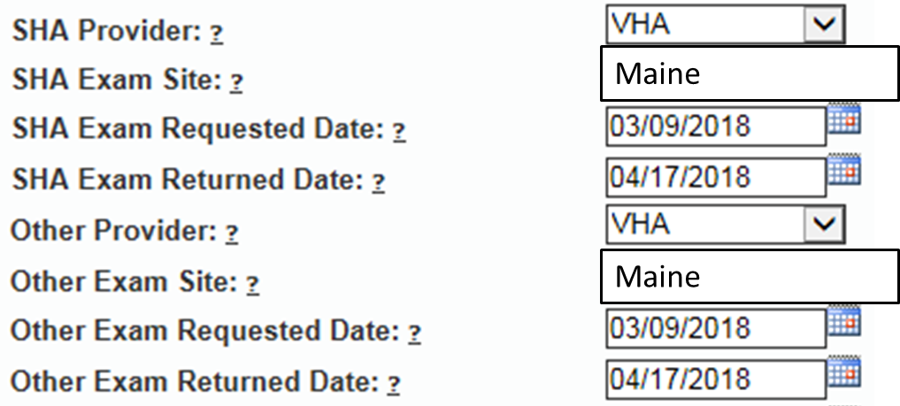

1. The Other Exam fields will **not** be used when the MSC must re-order exams from the SHA Provider.

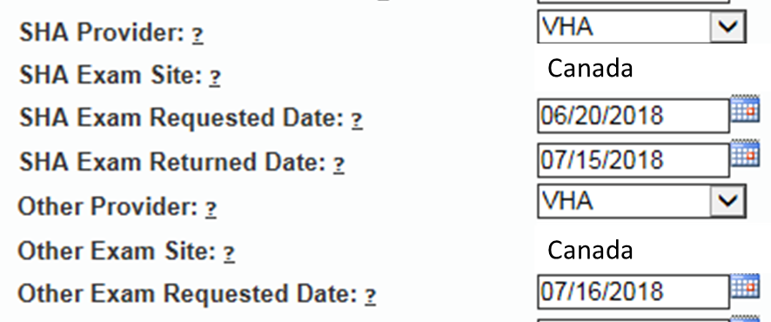

The definition of the data field is shown when you hover over the question mark (?). Questions: Contact Michelle Collins or Andy Reese.

**Timely Input of Exam Returned Dates**

MSCs are reminded of the importance of entering the SHA Exam Returned Date and the Other Exam Returned Date (if applicable) when exams are complete. In cases where SHA and Other exams are requested, MSCs should not wait for both providers to complete the exams before updating VTA. Ex: Exams are split and being performed by VHA and QTC. VHA has completed the SHA exams on the 22nd, but the other QTC exams are still pending. MSCs must update the VHA (SHA Exam Returned Date) in VTA upon notification that VHA exams are complete. Once the QTC exams are complete the Other Exam Returned Date must be entered. Questions contact Michelle Collins or Andy Reese.

**VTA Training**

VTA Training is October 16, 2018 (9:00 AM EDT) and 17, 2018 (1:00 PM EDT). Information is listed on the VTA Homepage under Calendar of Events.

**BDD Specific Topics**

**Electronic Transfer of STRs**

Over the last several years we have been working with DoD and IT to develop a method to transfer STRs electronically for BDD claimants. Functionality was released to VBMS in March 2018 to enable this capability and we have been working with DoD since that time to refine the process. DoD is now moving closer towards implementing the electronic transfer of the STRs for BDD cases. BDD claims processors should be aware that, as a result of this testing, you may see STR records electronically transferred into the VBMS eFolder along with the STRs provided by the Servicemember that were scanned by the scanning vendor.

**BDD claims processors must continue to require STRs to be submitted when filing a BDD claim until official notice is provided that the requirement has been removed.** If you notice any issues with the electronic transfer of the STRs (such as duplicate or missing records) please let us know through the Pre-Discharge mailbox, along with the information on the claim, so that we can work with DoD to resolve these issues. We will provide additional information on this process as it becomes available.

**Benefits Delivery at Discharge (BDD) Claims in the Centralized Mail Portal**

Since implementing the revised Benefits Delivery at Discharge (BDD) program last year, Regional Offices (RO) nationwide have been processing BDD claims to include establishment/development, in-service ratings and authorization. Intake sites and ROs are responsible for completing all initial development for BDD claims received at their locations; however, it was recently noted that some ROs are receiving BDD claims from intake sites outside of their jurisdiction through redistribution of mail in the Centralized Mail (CM) Portal. This inventory has the potential to create workload management challenges for ROs who happen to receive many BDD claims from other ROs CM queues.

BDD claims received from other ROs/intake sites through the CM portal should have the 336 – *BDD* EP established (be sure to select the appropriate intake site where the claim was received during establishment), and that EP should be brokered back to the RO with jurisdiction over that intake site for initial development.

As a reminder, ROs and intake sites should not be sending hardcopy BDD claims to the CM portal. Hardcopy BDD claims and all related evidence should be sent to the scanning vendor using a Document Control Sheet (DCS) after they have been established in VBMS by the receiving location. If you have any questions regarding Pre-Discharge claim processing, please send them to the [Pre-Discharge mailbox](mailto:Predischarge.VBACO@va.gov). We appreciate your continued support of the BDD program.

**Intake Sites in VBMS**

A new default intake site functionality has been added to VBMS for Pre-Discharge claims received externally (eBenefits). “Other – Not On List” will automatically populate as the intake site in VBMS for Pre-Discharge claims received electronically when a location is not available. This new feature will allow end users to successfully request examinations for Pre-Discharge claims in EMS without receiving an error message. End users are reminded that this selection is only for claims that are received externally and should **not** be used when manually establishing a Pre-Discharge claim in VBMS. Users must continue to include the intake site for manually established Pre-Discharge claims to prevent error messages when requesting examinations. If your intake site location is not listed in VBMS, use your Regional Office as the intake site and send a request to our [Pre-Discharge mailbox](mailto:Predischarge.VBACO@va.gov) to have your intake site added to VBMS.

**Examination Availability for BDD Claimants**

It is important to remind BDD claimants, as part of the criteria for participating in the BDD program, they must be available for examinations for 45 days following the date of claim submission. If the Servicemember is not available during this time, be sure to advise them of their exclusion from the BDD program and answer any questions regarding processing. In rare circumstances, if a Servicemember is excluded from the BDD program and later becomes available for exams and still meets all other BDD criteria (including still having 90 or more days remaining on active duty), update the claim type to BDD and process accordingly.

**Current Program Timeliness**

As outreach specialists and VA’s frontline contact with SMs and Veterans, it is vital that we are realistic in our communications regarding claims processing times. Below is the current program timeliness data as of September 30, 2018.

|  |  |
| --- | --- |
| **September 30, 2018** | **BDD** |
| **Completed FYTD** | 36,281 |
| **Receipts FYTD** | 36,184 |
| **Pending** | 5,367 |
| **% Pending >125 Days** | 17.7% |
| **# Pending >125 Days** | 949 |
| **Average Days Pending** | 82.2 |
| **Avg. Days to Complete FYTD** | 64.5 |

**Source:** PA&I Daily Output Reports, 10/1/18

**From the Pre-Discharge BDD Mailbox**

**Question:** Is it still appropriate to verbally communicate exclusions to BDD excluded claimants?

**Answer:** Yes. For MSCs who meet with Servicemembers in person, verbal communication is appropriate; however, a note must be placed in VBMS that reflects your verbal notification. This topic was discussed in our December 2017 monthly call and manual updates are currently pending publishing.

**Open Floor**

**When will MSCs be able to see their quality?**

MSCs can see their quality by logging into their Employee Performance Report (EPR).

**What is the proper procedure for MSC's when we get an email of exam cancellation and the EP has already been changed to a rating EP?**

There are no email notifications provided when exams are cancelled in EMS. Exam cancellations for EMS are re-routed by NWQ upon cancellation by the vendor. For emails received regarding VHA cancellations users should check the reason for cancellation immediately and decide if an examination request should be resubmitted. Request the claim from NWQ if necessary and follow the guidance provided in [M21-1, III.i.2.B.2.d](https://vaww.vrm.km.va.gov/system/templates/selfservice/va_kanew/help/agent/locale/en-US/portal/554400000001034/content/554400000014101/M21-1-Part-III-Subpart-i-Chapter-2-Section-B-Division-of-Responsibilities-for-Processing-Benefits-Delivery-at-Discharge-BDD-and-BDD-Excluded-Claims) **to reinput the request.** VHA cancellations are only re-routed by NWQ upon expiration of the suspense in VBMS, which may delay processing.

**For the mail portal claims, are we only cesting? Do you want us to put in contentions?**

**Where does the cest procedures stop?**

Cesting procedures can be found in M21-1, III.ii.3.D.2.c. Cesting should include adding contentions. Supervisors should be sure the EP 336 is assigned to the proper claims processor for action after establishment has occurred. If the claim needs to be brokered back to the receiving RO, please follow the guidance in the call topic above.

**Is there a regulation on service verification that if the DD 214 of record is over a month old but final we have to go out for a new DD214?**

There is no regulation that requires processors to go out for a new DD 214 if it’s over a month old.

**Next Teleconference**

The next call is scheduled for Tuesday, November 13, 2018 at 2PM ET. Please submit IDES questions and proposed topics for discussion to the [IDES Mailbox](mailto:DESPILOT.VBACO@VA.GOV), and BDD questions and proposed topics for discussion to the [Pre-Discharge BDD Mailbox](mailto:VAVBAWAS/CO/PREDISCHARGE%20%3cPredischarge.VBACO@va.gov%3e) no later than COB, Thursday, November 1, 2018.