(VSR VIP Pre-D) Introduction to Reviewing
Service Treatment Records (STRs)
Trainee Handout

Table of Contents

Objectives 2
References 3
Topic 1: Review of Service Treatment Records 4
Topic 2: Components and Variations of SOAP 6
Practical Exercise 1: Review of STRs and Other Medical Evidence 7
Practical Exercise 2: Components and Variations of SOAP 8

Objectives

- Define Service Treatment Records (STRs)
- Explain the organization of STRs
- Know how to locate x-rays, medical history forms, and other parts of STRs
- Identify the entrance and separation physical examinations and annotate/bookmark them for future reference
- Review STRs efficiently to establish if the claimed condition or symptoms occurred during service
- Describe the Subjective Objective Assessment Plan (SOAP) format

References

M21-1, Part III, Subpart iii, 2.A, General Information on Service Records

M21-1, Part III, Subpart iii, 2.B, Migration of Service Records and the
Procedures for Obtaining Them

M21-1, Part IV, Subpart ii, 2.A, Deciding Claims for Disability Compensation

M21-1, Part III, Subpart iv, 3.A.8.d, Requirement to Identify Relevant Evidence for the Examiner’s Review

M21-1, Part III, Subpart iv, 3.A.8.e, Bookmarking Documents for Examiner Review

M21-1 Part III. Subpart iv, 3.A.8.f, Annotating Documents for Examiner Review

Topic 1: Review of Service Treatment Records

Definition
Service Treatment Records (STRs) are the chronological records (electronic or paper) documenting the medical and/or dental care and treatment received primarily outside of a hospital (i.e. – outpatient) during service for each service member. For many years, they were referred to as Service Medical Records (SMRs)

Note: STRs of service members, that obtain treatment at a civilian facility on their own, will not contain those medical or mental health records. These records are not associated with the military records unless referred from a military treatment facility. The records are not sent to a storage facility such as NPRC or HAIMS and usually destroyed within a defined period of inactivity (usually 5 years for mental health records).

Obtaining STRs
STRs are uploaded into Veteran Benefits Management System (VBMS) from: National Personnel Records Center (NPRC) via Personnel Information Exchange System (PIES), Records Management Center (RMC) -RMC Source Material Tracking System (SMTS) Portal and Healthcare Artifact and Image Management Solution (HAIMS)

On January 1, 2013 individual service departments included a letter of certification of completeness of a member’s STRs. On June 25, 2013, DOD included a DD Form 2963, STR Certification. By August 1, 2013, all service departments were using this form.

General Information Found in STRs
- Physical examination reports, including reports from entrance and discharge physical examinations, if performed
- Service member’s medical history
- All dental examination reports and records
- Clinical record cover sheets and summaries
- Outpatient medical and dental treatment records
- Physical profiles and medical board proceedings
- Prescriptions for eyeglasses and orthopedic footwear

STRs received from a service department or records facility are considered substantially complete for records development purposes if they contain
- at least one of the documents listed in M21-1, Part III, Subpart iii, 2.A.1.e for each period of qualifying service, or
- the certification letter/DD Form 2963, Service Treatment Record (STR) Certification.
Note: On January 1, 2013, individual service departments began issuing their own version of a letter that certified the completeness of a service member’s STRs. Prior to this date, no requirement for certification existed. On June 25, 2013, DOD replaced the letters with DD Form 2963, Service Treatment Record (STR) Certification. By August 1, 2013, all service departments were using the new form.

General Information Not Found in STRs
- Inpatient treatment records (clinical records)
- Finance records
- Mental health records, or
- The Military Personnel Record Jacket (MPRJ), which may contain physical profiles and medical board proceedings

Reviewing STRs
To review Service Treatment Records efficiently you should:
- Review the STRs for claimed conditions or symptoms
- Annotate/bookmark the entrance and separation physical exams in the STRs
- Annotate/bookmark necessary in instances where the claimed condition was diagnosed or noted in the STRs
- STRs received from HAIMS are often typed and contain a Table of Contents to make STR review easier
It is required to annotate/bookmark these records per M21-1 III.iv.3. A.8. d.

Enlistment and Separation Exams
To identify the entrance and separation physical exams in the STRs, you will need to know the dates the Veteran entered and separated from service.
When reviewing the STRs, the entrance and separation physical exams can be noted by the status of the Veteran. Often the status of the Veteran or type of exam is noted as “Civilian” on the entrance examination or “Separation Exam” for a separation physical exam. Other commonly seen exam types are “Annual”, “Periodical”, or “School”.
- While reviewing STRs you will find that the form is now changed from Form SF-88 to a DD Form 2808, depending on the period that the veteran served. These forms are very similar.
- In the Separation SF 88, the purpose of examination can be found in section 16.
- Purpose of examination can be found in section 15C of DD Form 2808: enlistment, separation, retirement, medical board, etc.

Topic 2: Components and Variations of SOAP
The SOAP format found in treatment records came into use by the military in the late 1970’s and early 1980’s. Generally, you would only look at the S and the A parts and not read the full note. You will also notice that many treatment records will use different abbreviations to signify each section. Some of these variations are included below:
S Subjective summary or history of the patient’s reason for seeking medical advice/help or symptoms experienced
O Objective finding by the treatment provider during the examination
A Assessment (the diagnosis, or in some cases the provisional diagnosis pending further tests)
P Plan for treatment or medication prescribed

See below for an example of a treatment record in SOAP format.

Sample Treatment Report
Gorgas Army Hospital

Wilber C. Fuegot

S: Past hx R knee injury in 1995. Arthroscopic surgery showed torn medical meniscus. Pt underwent medial meniscectomy, physical therapy, then limited duty. Sx continued. MEB completed 9/95. That exam showed marked lateral laxity, some tenderness at medial aspect, no edema, no locking. Pt discharged from service w/disability severance pay. Today, C/O R knee buckling, pain w/standing, sitting, stair climbing.

O: Flexion to 110, extension to 5. + tenderness to patellar compression. + varus/valgus stress test. Marked lateral laxity. Negative drawer sign. No edema. X-ray: slight joint space narrowing, early arthritic changes.

Dx: s/p R medial meniscectomy w/residual laxity, DJD.

P: MRI, orthopedics consult

Practical Exercise 1: Review of STRs and Other Medical Evidence

Instructions: In the following scenarios, please provide the correct SOAP component for each.

- “Diagnosis: Left knee strain”
__________________________________________________________________

- “Patient complains of sore throat. Patient says that redness and swelling of throat causes painful swallowing. Took 2 Aleve in past 1 hour.”
__________________________________________________________________

- “Patient should continue back exercises to alleviate lower back pain. Patient should alternate ice & heat when pain occurs at nighttime. 800mg Motrin prescribed up to 3 x day.”
__________________________________________________________________

- “S/P ACL reconstruction. Dry & intact. No mottling of lower leg. Toes warm to touch, no discoloration of nail beds. Full mobility of toes.”
__________________________________________________________________

- “Patient says he cannot lift left arm above shoulder. Prognosis is: left shoulder rotator cuff syndrome.”
__________________________________________________________________

Practical Exercise 2: Components and Variations of SOAP

Please fill out the components of SOAP as discussed in classroom. Also, list their variations usually found in service treatment records (STRs):

S: ____________________________________

O: ____________________________________

A: _____________________________________

P: _____________________________________

What is the main difference between “Subjective” and “Objective” portions of a treatment report?

SOAP Exercise
- Please “translate” abbreviations and acronyms in the SOAP note and column on the left side.
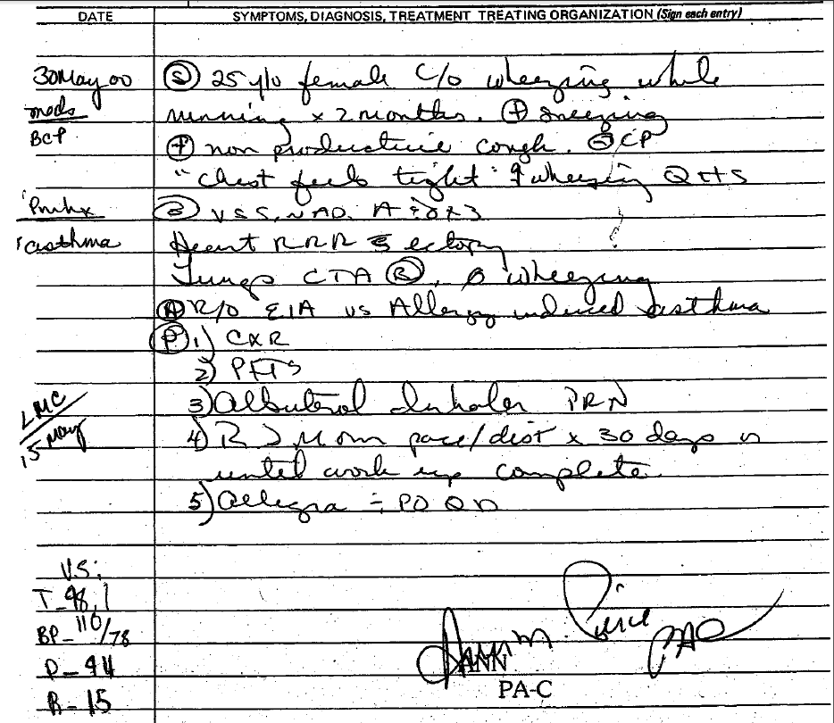
S:

O:

A:

P:

Left side:
- Please “translate” abbreviations and acronyms in the SOAP note below.
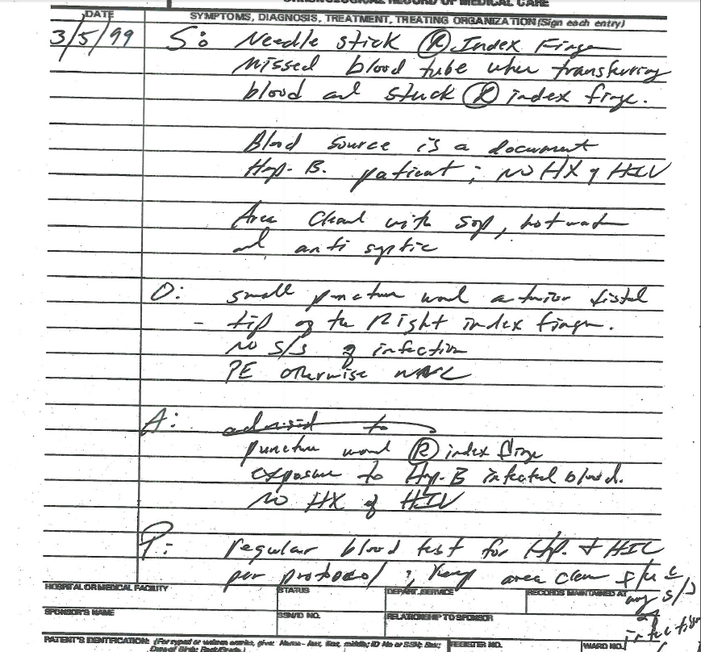

S:

O:

A:

P:

- Please “translate” abbreviations and acronyms in the SOAP note below.
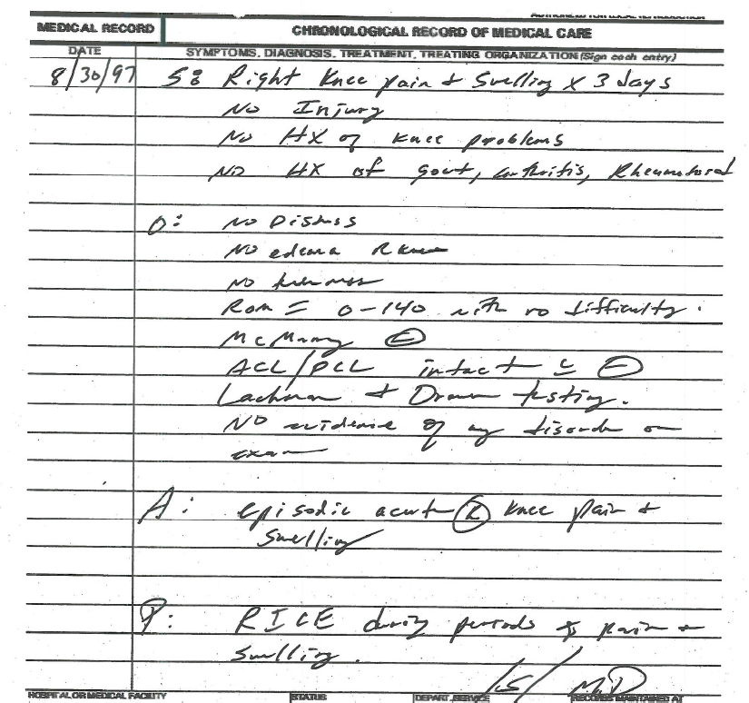
S:

O:

A:

P:

