Codesheet Compliance

Trainee Handout

**Table of Contents**

Objectives 2

References 3

Topic 1: Codesheet Compliance 4

Objectives

* Understand the anatomy of a rating codesheet.
* Identify the required elements of a rating codesheet.

References

* [38 CFR Part 4, Schedule for Rating Disabilities](https://www.ecfr.gov/cgi-bin/text-idx?SID=ad275643432556b9dda942343fb89296&mc=true&node=pt38.1.4&rgn=div5)
* [M21-1, Part III, Subpart iv, Chapter 6, D – Codesheet Section](https://vaww.vrm.km.va.gov/system/templates/selfservice/va_kanew/help/agent/locale/en-US/portal/554400000001034/content/554400000014207/M21-1-Part-III-Subpart-iv-Chapter-6-Section-D-Codesheet-Section#4)
* [M21-1, Part III, Subpart iv, Chapter 6, E – Coded Conclusion](https://vaww.vrm.km.va.gov/system/templates/selfservice/va_kanew/help/agent/locale/en-US/portal/554400000001034/content/554400000014208/M21-1-Part-III-Subpart-iv-Chapter-6-Section-E-Coded-Conclusion)
* [M21-1, Part III, Subpart iv, Chapter 6, Section A - Partial Rating Decisions and Deferred Issues](https://vaww.vrm.km.va.gov/system/templates/selfservice/va_kanew/help/agent/locale/en-US/portal/554400000001034/content/554400000014204/M21-1-Part-III-Subpart-iv-Chapter-6-Section-A-Partial-Rating-Decisions-and-Deferred-Issues)

All M21-1 references are found in the [Live Manual Website](https://vaww.compensation.pension.km.va.gov/).

Topic 1: Codesheet Compliance

**Anatomy of a Rating Codesheet**

The rating codesheet includes the following sections:

* Data table
* Jurisdiction
* Associated claim(s)
* Coded conclusions
* Special notations and template fields
* Signature(s)

**Data Table**

The *data table* includes the following information:

* Veteran’s name
* Veteran’s file number
* Veteran’s Social Security number
* Period(s) of service (POS) information
* Power of attorney (POA) information
* Date of rating
* Any future exam dates
* Special Monthly Compensation (SMC) codes
* Combat status code
* Additional service code

**Power of Attorney**

It is extremely important that the POA in VA systems indicate the most recent POA election. Although the POA information should be entered into VA systems before the claim is made ready for decision, the decision maker also has the ability to update VA systems using SHARE. The steps to do so are provided in [M21-1 III.ii.3.C.5.b](https://vaww.vrm.km.va.gov/system/templates/selfservice/va_kanew/help/agent/locale/en-US/portal/554400000001034/content/554400000014125/M21-1-Part-III-Subpart-ii-Chapter-3-Section-C-System-Updates#5).

**Period of Service**

It is also extremely important that the POS(s) are correct and updated in VA systems. Although all verified and pertinent periods of service should be in the system before a claim is made ready for decision, the individual drafting the Rating still needs to verify this information prior to drafting the Rating. Military service can be updated and verified using SHARE and Participant Profile ([M21-1, III.ii.3.C.7.a](https://vaww.vrm.km.va.gov/system/templates/selfservice/va_kanew/help/agent/locale/en-US/portal/554400000001034/content/554400000014125/M21-1-Part-III-Subpart-ii-Chapter-3-Section-C-System-Updates#7)).

Exception: RVSR may determine an injury incurred during ADT so that period of service will not be updated in SHARE prior to the rating being completed - this action is completed after the rating is finalized per [M21-1 III.ii.6.A.2.k](https://vaww.vrm.km.va.gov/system/templates/selfservice/va_kanew/help/agent/locale/en-US/portal/554400000001034/content/554400000014143/M21-1-Part-III-Subpart-ii-Chapter-6-Section-A-Establishing-Veteran-Status#2k).

**Jurisdiction**

The *jurisdiction* of the *codesheet*

* appears below the heading section
* explains why the case is before the rating activity
* refers to the claim at issue, and
* cites the pertinent jurisdictional date.

**Associated Claim(s)**

The *associated claim(s)* section

* appears below the *jurisdiction*
* includes all end product(s) (EP) associated with the contentions/claims be processed along with the date of claim(s) (DOC) of the claim(s)
* cites the type of claim(s)

**Coded Conclusions**

The *coded conclusions* section provides the list of conditons that are service connected or not service connected, or for pension purposes only. This section must include all rated conditions **both past and present**.

38 CFR Part 4, Rating Schedule for Disabilities, is used to determine disability codes and percentages of evaluation.

If a condition is service connected, it must include

* the current percentage evaluation,
* the effective date of the grant (for each assigned evaluation for that condition),
* the era in which the disability was incurred,
* whether the condition is a disability severance condition **(extremely important)**,
* whether the disability is static or not,
* basis for a decision (i.e. aggravated, presumptive, direct)
* special issue (Agent Orange, Asbestos)
* any future exam(s) that may be warranted for that particular condition,
* future percentage evaluation and future effective date, if applicable

At the end of the service connected conditions must be the

* combined combined evaluation
* historical combined evaluation, and
* the effective date(s) for each combined evaluation.

All denials for service connection must include the date of the original denial along with the reason and era. If the Veteran has ever claimed pension, each non-service connected condition must include a disability percentage for pension purposes. Furthermore, the *codesheet* must include the combined evaluation of all service connected and non-service connected conditions for pension purposes.

***Please note*** that in order to identify a condition that received disability severance pay, one must select “Disability Severance” from the “Withholding Information” drop down under the “Diagnosis Information” chevron under the “Disability Decisions” tab in VBMS-R.

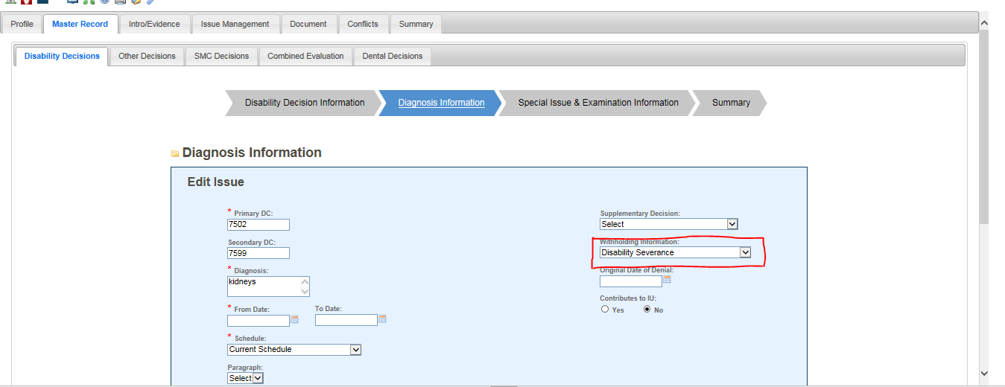

Conditions that need further development before a proper decision can be made will be listed under the heading “Deferred Issues.” It is extremely important that when a final decision for a deferred issue is made that the condition is removed from the “Deferred Issues” subsection.

Additionally, a condition cannot be listed simultaneously under the Service Connected subsection and the Not Service Connected subsection. This is duplicate and non-compliant with properly updated VA systems.

**Special Notations and Template Fields**

The primary purposes of notations made in the *special notation* and the notification *template* fields on the *codesheet* are to

* record special remarks or approvals applicable to the rating decision, and
* communicate an instruction or administrative message to the authorization activity.

For instance, for Rating Narratives that propose to reduce and/or sever a service connected condition, the proposed combined evaluation will be included in this section ([M21-1, IV.ii.3.A.3.a](https://vaww.vrm.km.va.gov/system/templates/selfservice/va_kanew/help/agent/locale/en-US/portal/554400000001034/content/554400000014588/M21-1,-Part-IV,-Subpart-ii,-Chapter-3,-Section-A---General-Authorization-and-Claimant-Notification-Issues#3) and [III.iv.8.B.1.b](https://vaww.vrm.km.va.gov/system/templates/selfservice/va_kanew/help/agent/locale/en-US/portal/554400000001034/content/554400000014212/M21-1-Part-III-Subpart-iv-Chapter-8-Section-B-Proposed-Rating-Decisions#1)).

***Note***:  All *special notations* and *templates* are generated through input in the ISSUE MANAGEMENT tab of VBMS-R.

Use the SPECIAL NOTATION field, accessible from VBMS-R's PROFILE tab, to communicate an instruction or administrative message to the VSR. Clarify if the message is solely administrative (for example, *Cancel the erroneously established EP 930*) or to be shared with the Veteran (for example, *Tell the Veteran that the evaluation of his nephrolithiasis is currently under appeal and will be addressed in a future decision*).

***Note***:  The special notation text appears at the bottom of the *codesheet* above the signature(s) (unless the Rating is for a clear and unmistakable error (CUE). In that case, the special notation text appears at the top of the codesheet).

***Reference***:  For further information on the ISSUE MANAGEMENT tab or SPECIAL NOTATION field, see the [VBMS-R User Guide](http://vbaw.vba.va.gov/VBMS/Resources_Technical_Information.asp).

**Signature**

Rating decisions must contain the decision maker’s standard digital signature on the bottom of the last page of the *codesheet*. “wet signatures” are no longer required.

A rating decision ***signature*** is defined as

* an electronic signature certification statement, and
* the user’s
  + Local Area Network identification (LAN ID), and
  + job title.

To establish the standardized digital signature, users should navigate to the SIGNATURE/DOCUMENT TITLE tab, and populate the AUTHOR SIGNATURE LINE field as follows:

*eSign: certified by [decision maker’s LAN ID, job title]*

***Example****:  eSign: certified by VSCJSMIT, RVSR*

***Exception***:  If a rating decision requires more than one signature, the rating decision *codesheet* must display the required additional signature fields, but the digital signatures of the additional reviewers must be documented on [VA Form 21-0961, Electronic Signatures](http://vbaw.vba.va.gov/bl/20/cio/20s5/forms/VBA-21-0961-ARE.pdf).

***Important***:  The signature of the decision maker(s) certifies that the claims folder was reviewed and all phases of the claims process leading to the decision were correctly handled.

***Single or Multiple Signatures***

Single-signature authority is restricted to RVSRs whose ability to produce quality work independently without additional oversight has been demonstrated by review.

All rating decisions require the signatures of two decision makers, unless approved as single-signature ratings by the Veterans Service Center Manager (VSCM) or Pension Maintenance Center Manager (PMCM).

***Exception***:  The VSCM/PMCM does not have authority to grant single-signature authority in all cases. Please refer to the table in [M21-1, Part III, Subpart iv, 6.D.7.d](https://vaww.vrm.km.va.gov/system/templates/selfservice/va_kanew/help/agent/locale/en-US/portal/554400000001034/content/554400000014207/M21-1-Part-III-Subpart-iv-Chapter-6-Section-D-Codesheet-Section#7) for information on when second signatures are warranted.