System Compliance Training
Instructor Lesson Plan
Time Required: 2 Hours

Table of Contents

Lesson Description 2
Introduction to System Compliance Errors 4
Topic 1: History of System Compliance Errors 6
Topic 2: What is Considered a System Compliance Error 9
Topic 3: Importance of System Compliance 15
Topic 4: How to Avoid System Compliance Errors 17
Lesson Review, Assessment, and Wrap-up 18

Lesson Description
The information below provides the instructor with an overview of the lesson and the materials that are required to effectively present this instruction.
TMS # | 4483941
Prerequisites | Prior to this lesson, the Veteran Service Representatives (VSRs), Rating Veteran Service Representatives (RVSRs), Decision Review Officers (DROs), and Quality Review Specialists (QRSs) should have completed Challenge/WARTAC training. Claims Assistants should be within his or her position for at least one month.
target audience | The target audience for System Compliance training is for VSRs and RVSRs who have completed Challenge/WARTAC training, DROs, and QRSs. Although in most instances the Claims Assistants and VSR will be undertaking the necessary actions, an RVSR/DRO must also know what information is required before they can appropriately decide a claim. The A/RQRSs must also know this information in order to properly review claims for quality.
Time Required | 2 hours
Materials/  TRAINING AIDS | Lesson materials:  - System Compliance Training PowerPoint Presentation  - System Compliance Training Trainee Handouts  - System Compliance Training Answer Key
Training Area/Tools | The following are required to ensure the trainees are able to meet the lesson objectives:  - Classroom or private area suitable for participatory discussions  - Seating, writing materials, and writing surfaces for trainee note taking and participation  - Handouts  - Large writing surface (easel pad, chalkboard, dry erase board, overhead projector, etc.) with appropriate writing materials  - Computer with PowerPoint software to present the lesson material  Trainees require access to the following tools:  - VA TMS to complete the assessment  - Internet access for Live Manual Website.

Pre-Planning | - Become familiar with all training materials by reading the Instructor Lesson Plan while simultaneously reviewing the corresponding PowerPoint slides. This will provide you the opportunity to see the connection between the Lesson Plan and the slides, which will allow for a more structured presentation during the training session.  - Become familiar with the content of the trainee handouts and their association to the Lesson Plan.  - Practice is the best guarantee of providing a quality presentation. At a minimum, do a complete walkthrough of the presentation to practice coordination between this Lesson Plan, the trainee handouts, and the PowerPoint slides and ensure your timing is on track with the length of the lesson.  - Ensure that there are copies of all handouts before the training session.  - When required, reserve the training room.  - Arrange for equipment such as flip charts, an overhead projector, and any other equipment (as needed).  - Talk to people in your office who are most familiar with this topic to collect experiences that you can include as examples in the lesson.  - This lesson plan belongs to you. Feel free to highlight headings, key phrases, or other information to help the instruction flow smoothly. Feel free to add any notes or information that you need in the margins.
Training Day | - Arrive as early as possible to ensure access to the facility and computers.  - Become familiar with the location of restrooms and other facilities that the trainees will require.  - Test the computer and projector to ensure they are working properly.  - Before class begins, open the PowerPoint presentation to the first slide. This will help to ensure the presentation is functioning properly.  - Make sure that a whiteboard or flip chart and the associated markers are available.  - The instructor completes a roll call attendance sheet or provides a sign-in sheet to the students. The attendance records are forwarded to the Regional Office Training Managers.

Introduction to System Compliance Errors
INSTRUCTOR INTRODUCTION |  | Complete the following:  - Introduce yourself  - Orient learners to the facilities  - Ensure that all learners have the required handouts
time required |  | 0.25 hours
Purpose of Lesson  Explain the following: |  | This lesson is intended to reinforce the importance of proper systems compliance. This lesson will contain discussions and exercises that will allow you to gain a better understanding of:  - System Compliance Checklist  - Importance of System Compliance and adverse impacts of non-compliance  - National Data regarding System Compliance errors
Lesson Objectives  Discuss the following:  Slide 2  Handout 2 | In order to accomplish the purpose of this lesson, the VSR, RVSR, DRO, QRS, or Claims Assistant will be required to accomplish the following lesson objectives.  The VSR, RVSR, DRO, QRS, or Claims Assistant will be able to:  - Review the history of System Compliance errors  - Identify the different System Compliance errors  - List different ways to prevent a System Compliance error  - Summarize the importance of proper systems compliance  - Properly identify if an System Compliance error exists
Explain the following: | Each learning objective is covered in the associated topic. At the conclusion of the lesson, the learning objectives will be reviewed.
Motivation | Provide students with a history of VETSNET business rules and the compliance standards derived from these rules. Non-compliance of these rules creates delays in claims processing delays, increased workload, and waste of resources which all negatively impact the service to Veterans.
STAR Error code(s) | S1

References  Slide 3  Handout 3 | Explain where these references are located in the workplace.  All M21-1 references are found in the Live Manual Website.  - M21-1, Part I, Chapter 3 - Power of Attorney  - M21-1, Part III, Subpart ii, Chapter 2, D through F - Reopen, Claims for Increase, Reconsideration  - M21-1, Part III, Subpart ii, Chapter 3, Section C - Systems Updates  - M21-1, Part III, Subpart iii, Chapter 1, Section F - Record Maintenance During the Development and Dependency Issues  - M21-4, Appendix A - Regional Office Station Numbers and Payee Codes  - M21-4, Appendix B - End Product Codes and Work-Rate Standards for Quantitative Measurements  - M21-4, Appendix C - Index of Claim Attributes  - M21-4, Appendix D - Index of Claim Stage Indicators  - M21-4, Chapter 6, Appendix A, B, and C - Task Based Quality Review Checklists

Topic 1: History of System Compliance Errors
Introduction | This topic will allow the trainee to understand the history regarding system compliance errors.
Time Required | 0.25 hours
OBJECTIVES/  Teaching Points | Topic objectives:  - Review the history of System Compliance errors  The following topic teaching points support the topic objectives:  - Explain the progression of system compliance  - Fast Letter (FL) 03-10  - Fast Letter (FL) 06-11  - Fast Letter (FL) 12-03  - M21-4, Chapter 6
Development of VETSNET Business Rules  Slide 4  Handout 4 | VETSNET Business Rules were originally developed April 3, 2003 under Fast Letter (FL) 03-10. FL 03-10, Distribution of standardized data input rules for Modern Award Processing – Development (MAP-D) clearly defined MAP-D functions and functionality.  Rollout of the MAP-D application began in November 2002 to field stations. Data was able to be collected through Inventory Management System and was designed to replace the BDN WIPP reports.  Fast Letter 03-10 defined eight general segments of a claim cycle. The rules for each segment explain the actual data being input or the action being accomplished, who has responsibility for the input and when, and where it is input into MAP-D.  Process Segment Action Specifications Typical Responsibility  Claims control Use SHARE to establish claims control Actual date claim received Triage  Development Initiated First development action taken Actual date evidence is requested Pre-D Post-D  Development- Interim actions Some requested evidence is received or additional evidence is developed Evidence is recorded using the actual date received or date additional evidence is requested Triage Pre-D Post-D  All evidence received All requested items received or controls expired Date last requested evidence is received or date assessed for non-response Triage Pre-D Post-D  Claim determined ready for decision Assessed as ready for decision Date assessed as ready for decision Pre-D Post-D  Decision complete Claim decided - ready to move on to award/notification or POA review Date decision action is complete, after any second signature approval Rating Post-D (non-rating issues)  Decision Processed - pending authorization Claim has been GAP’d Date of GAP Post-D  Award action authorized - decision notification released Claim has been authorized or finalized and notification has been released Date of CAUT or PCLR with release of decision notification letter Post-D  Explain April 2003 was when VA defined eight categories of cycles throughout the claims process which are around today. This was the start of gaining uniformed business processes throughout the nation.
VETSNET Business Rules  Slide 4  Handout 5 | FL 06-11, VETSNET Business Rules, was issued July 17, 2006. It defined standardized rules and claims cycles. Updates completed to MAP-D enhanced functionality and defined status options as the following:  - Use of MAP-D notes  - Explanation of MAP-D status indicators  - Clarification of “received” versus “closed” tracked items  - All open tracked items must be closed (if there are no other pending issues and response time has expired) prior to “ready-for-decision” status
VETSNET Business Rules Progression  Slide 4  Handout 5 | FL 12-03, Revised VETSNET Business Rules, was issued February 13, 2012. It defined standardized rules and stressed MAP-D compliance. Enhanced business requirements included the following:  Entering contentions  Entering unsolicited evidenced received with the claim  Tracking all development actions via tracked items  Tracking all development letters  Entering notes  Explain that MAP-D was designed because there was variation in claims and needed to standardize VA’s business practices.
February 2014 Compensation Service Bulletin  Slide 4  Handout 5 | February 2014 Compensation Bulletin stated Quality Review Specialists (QRSs) are required to cite System Compliance errors on an individual quality review for the following:  - Is the payee’s addresses (to include direct deposit) updated, correct, and verified?  - Is the date of claim correct?  - Were the contentions and classifications entered into VBMS or MAP-D? Were they entered correctly?  - Were special issues and flashes entered and correct?  - Were tracked items entered and updated as necessary?  - Was the claim status (Ready for Decision (RFD), Rating Decision Complete (RDC), OPEN) updated appropriately?  - Were the suspense dates (tracked item or claim level) updated?  - Was the Power of Attorney (POA) information/access updated in all systems and correspondence?  - Are the documents in VBMS indexed correctly? Are the dates of receipt for each document correct?  - Is service information in SHARE verified and complete?  - Was Control of Veterans Records System (COVERS) updated to reflect the correct and current location?
M21-4 Chapter 6  Slides 5-6  Handout 6 | M21-4 Chapter 6 was created in December 2015 to assist QRSs improve quality and timeliness of claims processing. QRSs must call System Compliance errors for oversights such as the following:  - Is the date of claim and end product correct?  - Are all the payees’ address (including direct deposit) correct?  - Are all periods of service for the Veteran verified and updated in all systems?  - Was the Power of Attorney (POA) information/access updated in all systems and correspondence?  - Were special issues and flashes entered correctly?  - Were contentions and classifications entered correctly?  - Were tracked items entered and updated as necessary?  - Was the claim cycle (Ready for Decision (RFD), Rating Decision Complete (RDC), Open) updated appropriately?  - Were the suspense dates (tracked item or claim level) updated and correct?

Topic 2: What is Considered a System Compliance Error
Introduction | This topic will allow the trainee to see what is considered a System Compliance Error
Time Required | 0.75 hours
OBJECTIVES/  Teaching Points | Topic objectives:  - Identify the different System Compliance errors  - Properly identify if a System Compliance error exists  The following topic teaching points support the topic objectives:  - Systems Compliance Checklist  - Explain each of the elements included in system compliance
System Compliance Checklist  Slide 7  Handout 7 | M21-4 Chapter 6, Appendices A and B provide the VSR and RVSR Task Based Quality Review Checklists, respectively. Section 11 of each checklist covers System Compliance Specific Questions. Questions on the Qualtiy Review Checklists include:  - Date of claim incorrect  - End product correct  - Payees’ address (including direct deposit information) incorrect  - All periods of active duty or other service related to claimed issues not verified and updated in all systems (BIRLs/Participant Profile) (EOD, RAD, Branch, Char SVC, Sep Reason VADS and/or VERIFIED)
Date of Claim (DOC)  Slide 8  Handout 7 | Explain the date of claim (DOC) is the earliest date any Department of Veterans Affairs (VA) facility received the claim. (III.ii.2.B.3.c) Clarify that the DOC for a pre-discharge claim is the first day following the anticipated date of release from active duty (RAD), regardless of the date VA received the claim. (III.i.2.A.2.b)  Example Scenario:  - A VA medical center (VAMC) receives VA Form 21-526EZ on October 14, 2017.  - The VAMC forwards the application to the regional office (RO) on November 1, 2017.  - The RO does not receive the application in its mailroom until November 5, 2017.  Result: When the RO places the claim under EP control, it must use October 14, 2017, as the DOC.
End Product  Slide 9  Handout 7 | Explain the end product (EP) is the primary workload monitoring and management tool for the Veterans Service Center (VSC)/Pension Management Center (PMC). It is imperative that the correct EP is associated with the claim.  - Correct use of the EP system facilitates proper control of pending workloads and appropriate work measurement credit.  - Correct work measurement is essential to substantiate proper staffing requirements and determine productive capacity.  M21-4, Appendix B
Period of Service  Slides 10-11  Handout 8-9 | Emphasize that Regional Offices (ROs) are responsible for ensuring service is updated in both BIRLS (Beneficiary Identification and Records Locator Subsystem) and the Veteran’s corporate record through Participant Profile (M21-1 III.ii.3.C.7.a). Stress that all periods of ACTIVE service must be verified and updated in VA systems.  Verified service is shown by  - a Y or D in the VADS (Veterans Assistance Discharge System) field of the BIRLS VET’S IDENTIFICATION DATA tab in Share, or  - the claims processor  - entering Y in the VERIFIED field, if using BIRLS, and  - checking the SERVICE VERIFIED box in Participant Profile.  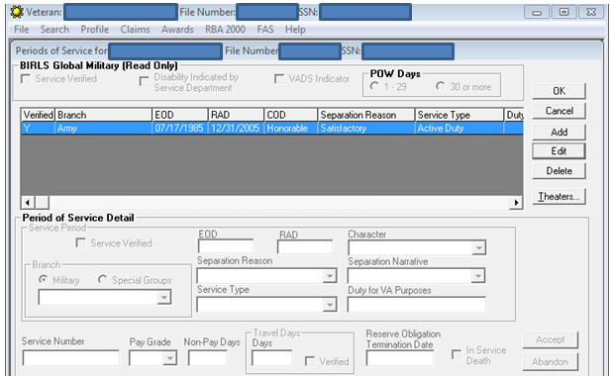  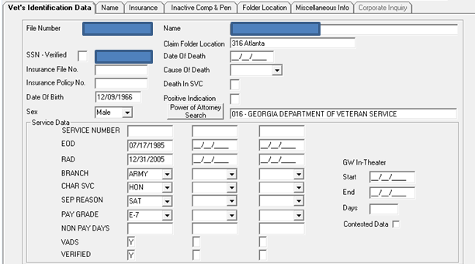  In some situations, service connection (SC) is awarded for a death, disease, or injury incurred or aggravated during a period of duty other than full-time active duty in the Armed Forces. In these situations, the period of duty during which the death, disease, or injury occurred is considered active military service for VA compensation purposes. These instances warrant ADT and.or IADT be entered into systems.  Example: SC may be awarded for an injury incurred in the line of duty (LOD) during inactive duty for training (IADT). Once it is determined that SC is in order for that injury, the period of IADT is considered active military service for VA compensation purposes.  Clarify when SC for disability or death has been established based on a single day of ADT or IADT, the authorization activity will update BIRLS and Participant Profile to reflect that the period of service identified by the RVSR is active service. The RVSR will utilize the day following as the end date of service but clearly annotate VA Form 21-6789, Deferred Rating Decision, (as directed in M21-1, Part III, Subpart ii, 6.A.2.k) to reflect that the service was actually only one single day of service.  Stress that ADT and IADT should not be inputted to BIRLS and Participant Profile unless the SC disability was incurred during such a period.
Payee’s Address(es)  Slide 12  Handout 9 | Demonstrate where to change the address in SHARE under the Change of Address function (M21-1 III.ii.3.C.1.c). Also encourage that all contact information, save direct deposit, must be updated through the EDIT VETERAN function under the claimant’s PROFILE in VBMS (M21-1 III.ii.3.C.1.b). Explain that direct deposit can be updated in SHARE or VBMS-A at awards promulgation.  Educate on the proper business mail delivery address per the United States Postal Service Business Mail 101 instructions. Important items to keep in mind for Mailing Addresses are:  - No punctuation  - If you can't fit the suite or apartment number on the same line as the delivery address, put it on the line ABOVE the delivery address, NOT on the line below
Power of Attorney  Slides 13-14  Handout 9-10 | The Department of Veterans Affairs’ (VA’s) policy is that all claimants have the right to representation before the department in claims affecting the payment of benefits or relief. VA representation means broadly that an individual has completed legal formalities to authorize a VSO, attorney, agent, or individual to perform functions on his or her behalf in business before VA.  VA Form 21-22, Appointment of Veterans Service Organization as Claimant’s Representative, or VA Form 21-22a, Appointment of Individual as Claimant’s Representative,are declaration of represetations by the claimant.  Explain employees are to follow directions in M21-1 III.ii.3.C.4.g when an outdated VA Form 21-22 or VA Form 21-22a is received. For information on acceptable versions of VA Form 21-22, please see M21-1 III.ii.1.C.8.a. Be cognitive the VA can accept older versions of VA Form 21-22 until depletion of existing stock.  Employees must check the form for compliance with M21-1 I.3.B.2.d. This is extremely important as VA must comply with 38 U.S.C 7332. To prevent inadvertent disclosure of records protected by 38 U.S.C 7332, a claimant’s representative may only access VA electronic systems pertaining to the claimant where there is a valid claimant authorization in effect permitting disclosure to all protected records (M21-1 I.3.B.2.g).  Explain if VA Form 21-22 does not permit release of 38 U.S.C 7332, then send the claimant the Failure to Elect 38 U.S.C. 7332 letter through Letter Creator.  Also, share the importance of handling requests to revoke or change POA per III.ii.3.C.4.f when such evidence is received.
Verify POA Access  Slides 15-16  Handout 10 | Demonstrate the steps provided in M21-1 III.ii.3.C.5.b and explain how Box 12 of the VA Form 21-22 correlates to Auth’d POA Access in the Corporate record. If Box 12 is checked, then the Auth’d POA Access box should state “Yes.”  Make sure to explain how box 14 of the VA Form 21-22 correlates with the CADD Auth’d box. If Box 14 of the VA Form 21-22 is checked, then the box should state “Yes”. 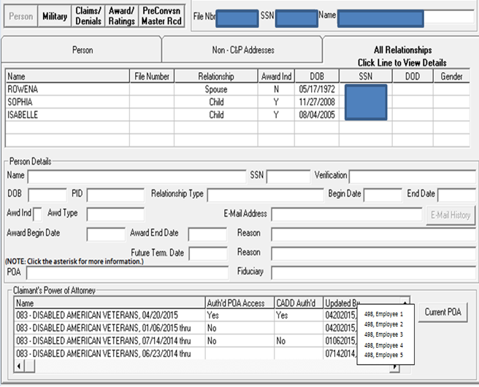
Special Issues and Corporate Flashes  Slide 17  Handout 11 | Show and explain list of corporate flashes and special issues as defined in M21-4, Appendix A.d and e.  Special Issues and Corporate Flashes help track certain cases and measure types of conditions claimed. This data assists with balancing staff and assigning work.
Contentions  Slide  Handout 11 | Use of contentions for each claim is mandatory and should be entered as soon as they are identified (M21-1 III.iii.1.F.2.a). Make sure you express the required language for dependency contentions.  Remind the audience that each contention must be entered separately, easy to understand, and in the claimant’s own words, as appropriate. If the Veteran misspells a condition, you can input the correct spelling. If the condition claimed is “Diabetes due to Agent Orange Exposure,” you only need to input “diabetes,” not “due to Agent Orange Exposure.” Agent Orange exposure will be identified using a special issue and/or corporate flash.
Tracked Items  Slide  Handout 11 | The purpose of tracked item is to control receipt or non-receipt of information requested from the claimant, beneficiary, or other information provider. Status of individual tracked items will be visible through eBenefits (M21-1 III.iii.1.F.3.a).  It is the responsibility of the claims processor reviewing or taking action on a claim to ensure that  - the necessary tracked items have been generated  - all suspense dates are accurate, and  - the dispositions of all tracked items have been accurately managed, to include any automated tracked item actions. M21-1 III.iii.1.F.3.e  Remind custom tracked items can be manually established by the claims processor; however, custom tracked items should not be used if a standard tracked item for the claim action already exists.

Topic 3: Importance of System Compliance
Introduction | This topic will allow the trainee to understand why system compliance is important and learn some implications of non-compliance.
Time Required | 0.25 hours
OBJECTIVES/  Teaching Points | Topic objectives:  - Explain reasons why System Compliance is important  The following topic teaching points support the topic objectives:  - Transparency of Detailed Claims Data
Importance of System Compliance  Slide  Handout 12 | The Department of Veterans Affairs has worked tirelessly over the past few years to reduce the number of pending compensation claims. VA has also adopted creating transparency with the public. Your individual actions influence data which is given to the public through this web site: Veterans Benefits Administration Reports  Every claim you work impacts a Veteran and their family!
Creating a Better Veteran’s Experience  Slide 20  Handout 12 | Explain: The President’s Commission on Care for America’s Returning Wounded Warriors established by Executive Order 13426 in March 2007, recommended the creation of a web portal to provide wounded, ill, and injured service members, Veterans, their family members, and care providers a single transparent access point to online benefits, as well as related contact and services.  On April 5, 2010, eBenefits launched version 2.3 which allowed service members and Veterans to check the status of C&P claims, review payment history, obtain home loan certificates of eligibility, and access My HealtheVet through a single sign on.  Various data points are exchanged with eBenefits and directly impact the information the Veteran is able to view through eBenefits. Every employee who enters data possesses the ability to influence updates which are given to the Veteran.
Creating a Better Work Experience  Slides 21-22  Handout 12 | Question: Have you ever received a claim where development already occurred yet the systems were not properly updated? How did receiving this type of workload make you feel?  Various feelings probably occurred when it was identified you received a less than 100% accurate piece of workload within your work queue.  Proper systems compliance eliminates extra workload. Here are some examples:  - Manually reassigning claims occurs because proper flashes or special issues are not initially added correctly.  - Prevents missed development.  - Eliminates misrouting of claims.
National Impacts throughout VA  Slide 23  Handout 13 | Systems Compliance impacts the National Work Queue’s (NWQ) ability to properly disseminate workload to employees for processing based on special issues and flashes.  Incorrect tracked items added to a claim or not closing out track items could cause delays in claims processing timeliness.  Wrong date of claim could lead to a wrong effective date applied.  Incorrect address could implicate a Personally Identifiable Information (PII) violation.  Incorrect contentions entered could confuse the Veteran and the next employee who processes the claim.  Department of Veterans of Office of Inspector General has published various reports which are related to VA’s compliance and non-compliance with established system procedures.  Ask what other issues could arise from system non-compliance?

Topic 4: How to Avoid System Compliance Errors
Introduction | This topic will allow the trainee to gain different ideas to assist in reducing system non-compliance.
Time Required | 0.25 hours
OBJECTIVES/  Teaching Points | Topic objectives:  - List different ways to prevent a System Compliance error  The following topic teaching points support the topic objectives:  - System Compliance Checklist
Recommendations to Avoid System Compliance Errors  Slides 24-25  Handout 14 | Create a routine of verifying accuracy of system compliance while working a claim.  Explain that performing steps in the same order will make employees less likely to miss one of the system compliance categories. Creating a habit of going in the same order will become routine after the same process is implemented.  Post the systems compliance checklist in a visible sight within your work area.  Double check your work. Triple check your work! Especially Periods of Sevices and POA information are updated, verified, and entered.  Learn from errors or recommendations provided to you from the QRT, whether it would be an in-process review or a quality review.  Keep in mind you are influencing a Clamaint’s eBenefits record and think about if you were a claimant how you would like your claim to be processed. Keep in mind your co-workers - the better system compliance each individual satisfies, the higher the quality and lower average days pending fr eac claim. Tracked items are designed for employees to quickly identify which life cycle the claim currently meets and assists in determining what next action is required.  Remind the Code of Federal Regulations and Manual are great resources to avoiding system compliance oversights. Additional resources are the VBA Learning Catalog and VSR/RVSR Assistant  Ask the audience of any other ways to avoid a system compliance error. Allow for open discussion and time for all employees to express any other helpful examples of what his or she does to improve the quality.

Lesson Review, Assessment, and Wrap-up
Introduction  Discuss the following: | The System Compliance Training lesson is complete.  Review each lesson objective and ask the trainees for any questions or comments.
Time Required | 0.25 hours
Lesson Objectives | You have completed the System Compliance Training lesson.  The trainee should be able to:  - Review the history of System Compliance errors  - Distinguish the nine different System Compliance errors  - List different ways to prevent a System Compliance error  - Summarize the importance of proper systems compliance  - Properly identify if an System Compliance error exists
Assessment | Remind the trainees to complete the online assessment in TMS to receive credit for completion of the course.  The assessment will allow the participants to demonstrate their understanding of the information presented in this lesson.

