Slide 1 - Accounting Audit (Core)
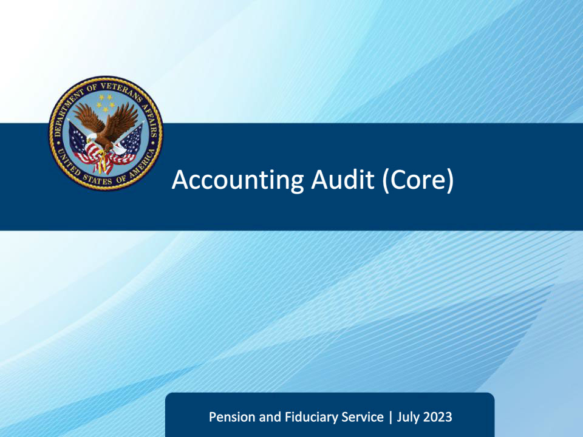
Slide notes

Course Description:

This course teaches fiduciary personnel the accounting audit process, including verifying accounting documents, income, expenses, fiduciary fees, investments, funds protection, and red flags.

Slide 2 - Navigation
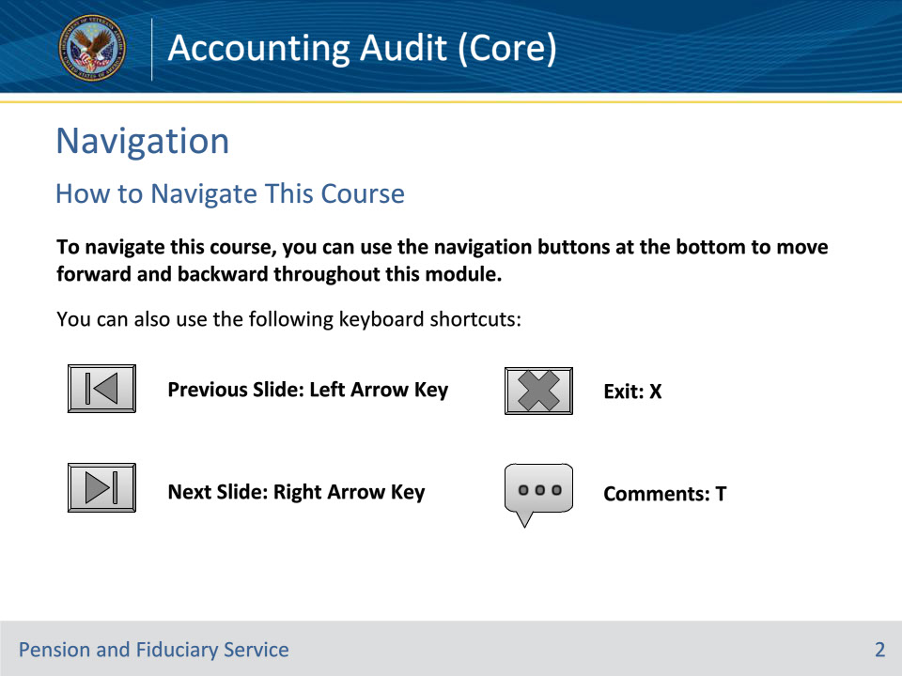
Slide notes

To navigate this course, you can use the navigation buttons at the bottom to move forward and backward throughout this module.

You can also use the following keyboard shortcuts:

• Previous Slide: Left Arrow Key

• Next Slide: Right Arrow Key

• Exit: X

• Comments: T

Slide 3 - Objectives
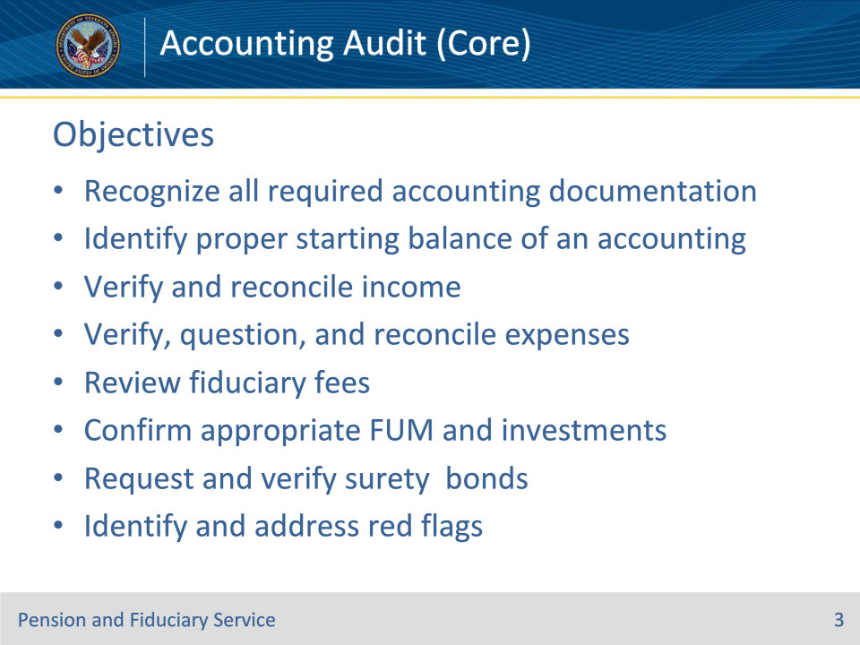
Slide notes

Instructor Notes:

At the end of this lesson, given the training and corresponding references, the learner will be able to:

• Recognize all required accounting documentation

• Identify proper starting balance of an accounting

• Verify and reconcile income

• Verify, question, and reconcile expenses

• Review fiduciary fees

• Confirm appropriate FUM and investments

• Request and verify surety bonds

• Identify and address red flags

Slide 4 - References
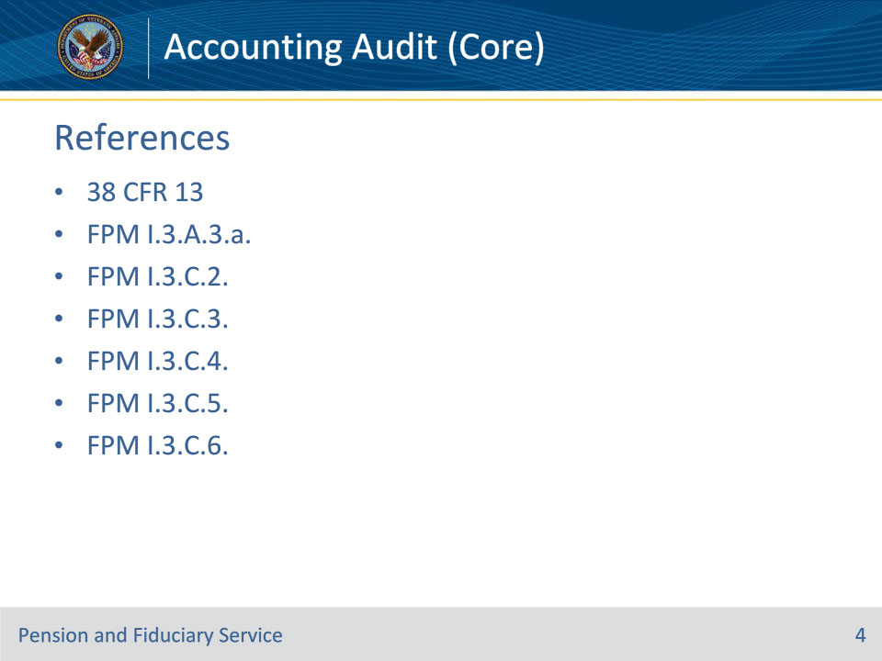
Slide notes

Instructor Notes:

These are our references for today’s training:

• 38 CFR 13, Fiduciary Activities

• FPM I.3.A.3.a. Elements of a Complete Accounting

• FPM I.3.C.2. Accounting Review

• FPM I.3.C.3. Verifying Income and Expenses

• FPM I.3.C.4. Examining VA-Appointed Fiduciary Fees

• FPM I.3.C.5. Review of Investments, Surety Bonds, and Administration of VA and Other FUM

• FPM I.3.C.6. Red Flag Indicators of Misuse, Fraud, or Improper Use

Slide 5 - Accounting Documents
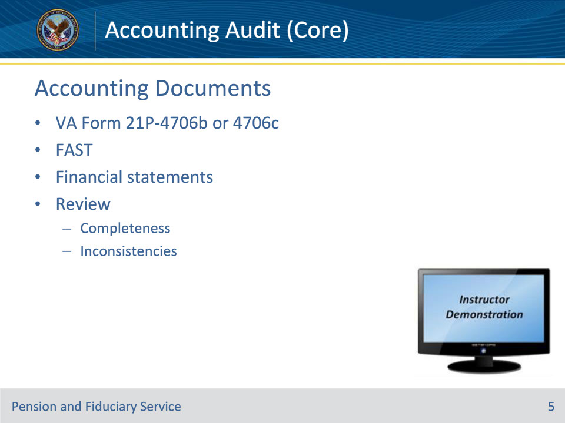
Slide notes

Policy Reference(s): FPM I.3.A.3.a., FPM I.3.C.2.d.

Instructor Notes:

Hubs must review all documents the fiduciary submits in response to a VA request for an annual accounting. The hub must determine if the accounting submission is complete before auditing an accounting submission by the fiduciary.

A complete accounting means that the accounting contains enough information for VA to review all income and expenditures during the accounting period.

An accounting report submission by a fiduciary is considered complete and ready for audit if all the conditions below are met:

• the VA Form 21P-4706b, VA Fiduciary’s Account, VA Form 21P-4706c, Court Appointed Fiduciary’s Account, or an accounting submitted via FAST contains the

• name of the beneficiary

• VA file number associated with the beneficiary

• expenses, and

• income, and

• the fiduciary

• completes the background information, and

• provides financial statements detailing account transactions during the entire accounting period.

During the accounting audit, examine all accounting report documents closely for inconsistencies in type face, print quality, website addresses, or color. The LIE must question any documents that show signs of alteration.

Instructor Actions: Open VBMS, share your screen and show the students example(s) of VA Forms 21P-4706b and 4706c, eFolder, FAST.

Slide 6 - Properly Titled Account
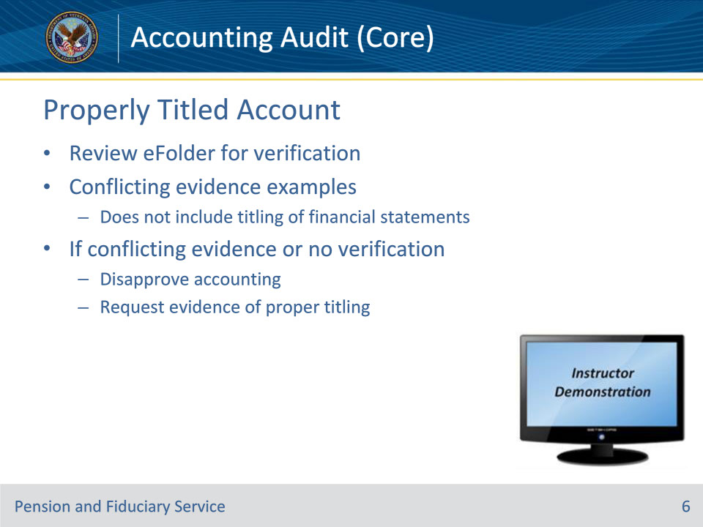
Slide notes

Policy Reference(s): FPM I.3.C.2.h.

Instructor Notes:

Hub personnel will review the eFolder for existing properly titled account verification. The hub will accept previously submitted evidence verifying a properly titled account as long as the evidence met the verification requirements in place at the time of initial verification and the accounting documents do not contain conflicting information.

Examples of conflicting evidence include the following:

• The fiduciary provided an acceptable voided check that appropriately verified the establishment of a properly titled investment account for transfer of VA FUM from the prior fiduciary upon appointment. However, the financial statements submitted with the accounting contain either a different account number or banking institution name when compared to the voided check of record, and the eFolder does not reveal acceptable verification that the investment account is properly titled per FPM, Part II, 2.A.2.d.

• A review of the eFolder reveals that the fiduciary provided a Standard Form 1199A, Direct Deposit Sign-Up Form, that appropriately verified the initial establishment of a properly titled direct deposit account for VA benefit payments. However, the documentation submitted with the accounting contains copies of checks from the same account which do not reflect the fiduciary relationship.

Financial statements are not a reliable source for verifying that an account is or is not properly titled due to varying bank procedures. The full account title, to include the fiduciary relationship, may not be reflected on the financial statement. While the lack of full account titling on the financial statement is not considered conflicting information, the financial statements must still be utilized to review for other conflicting information, as described in the examples above.

If there is no existing properly titled account verification of record in the eFolder, or the accounting documents show conflicting information to the evidence previously submitted, the hub employee must disapprove the accounting and request evidence that the fiduciary has established a properly titled account. The hub must specifically request that the fiduciary provide evidence of an update on all accounts for which the fiduciary manages VA benefit funds. Disapprove the accounting.

Instructor Actions: Open VBMS and demonstrate examples of various financial statements/account titles

Slide 7 - Pooled and Commingled Accounts
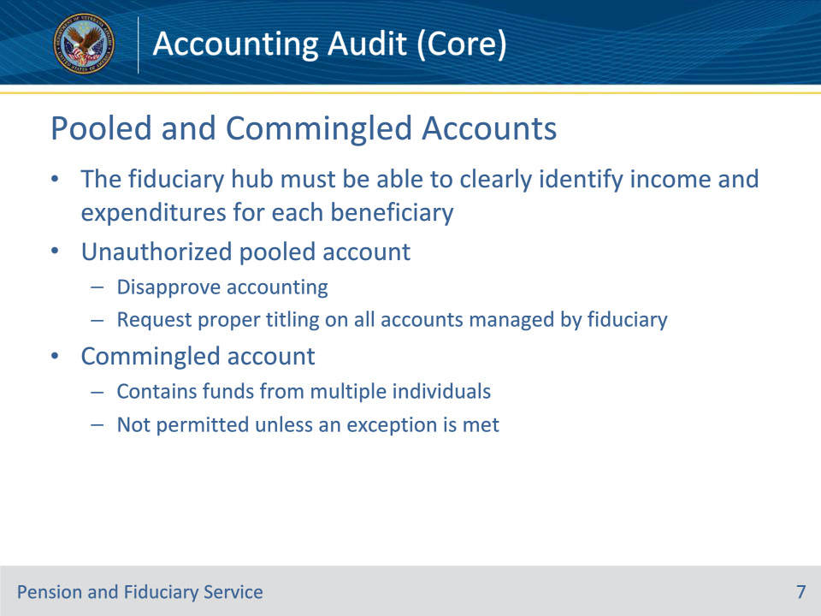
Slide notes

Policy Reference(s): FPM I.3.C.2.f., g.

Instructor Notes:

Hub personnel must be able to clearly identify income and expenditures for each beneficiary.

If a review of the accounting documents shows that the fiduciary use of a pooled account is restricted, disapprove the accounting.

Request evidence that the fiduciary has established a properly titled account. The hub must specifically request that the fiduciary provide evidence of an update on all accounts for which the fiduciary manages VA benefit funds.

For VA purposes, a commingled financial account, whether custodial, personal or business, contains funds from multiple individuals. Generally, a fiduciary must not commingle funds. The exceptions to this requirement are addressed in the Fiduciary Accounts and Investments training.

• A financial account containing multiple source funds (e.g., VA and Social Security Administration (SSA)) for the same beneficiary is not considered a commingled financial account and is acceptable. When multiple source funds for the same beneficiary are in the same beneficiary-fiduciary account, the fiduciary shall provide an accounting report that addresses all source funds.

• Regarding spouses, it is VA’s policy to minimize the government’s intrusion into the marital relationship and avoid dictating requirements for property that is jointly owned by a beneficiary and spouse. Therefore, a beneficiary’s spouse may commingle funds in the same financial accounts.

The fiduciary must submit sufficient financial documentation such that the LIE is able to identify the income and expenditures for the specified beneficiary. This may be satisfied through the use of a ledger containing all transactions for the beneficiary.

Slide 8 - Starting Balance
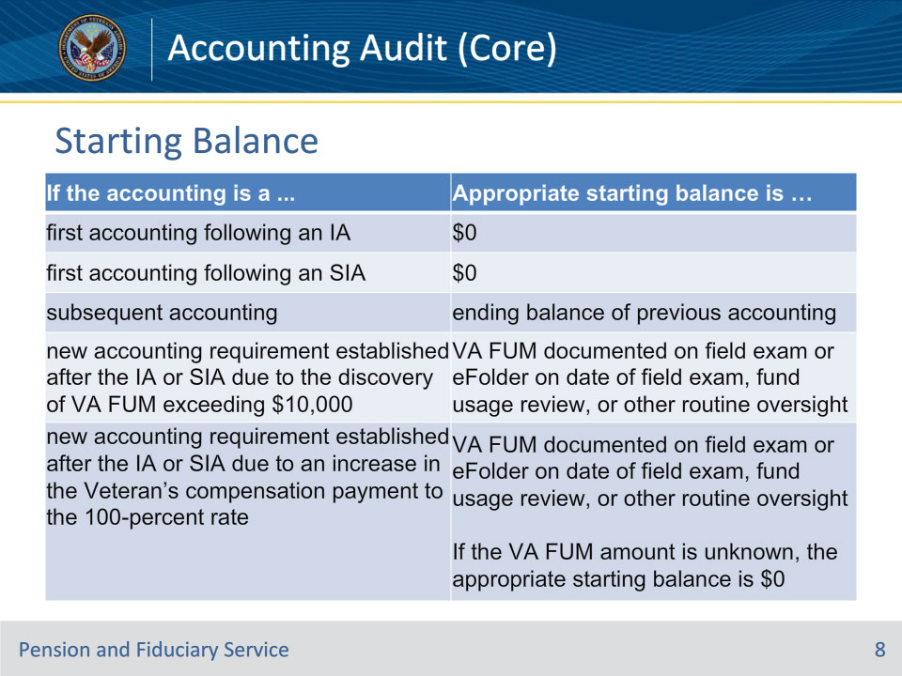
Slide notes

Policy Reference(s): FPM I.3.C.3.a.

Instructor Notes:

The hub must verify the starting balance on accounting reports. The starting balance of the accounting period is referred to as the

• TOTAL ESTATE AT BEGINNING OF PERIOD on a VA Form 21P-4706b, and

• CASH BALANCE FROM LAST ACCOUNTING on a VA Form 21P-4706c.

The above fields are applicable regardless to whether the accounting is received via mail or within FAST.

The following describes the appropriate starting balance for the accounting type:

• First accounting following an IA—Starting Balance $0

• First accounting following a SIA—Starting Balance $0

• Subsequent accounting—Starting balance of this accounting is the ending balance as indicated in the previously approved accounting

• New accounting requirement established after the IA or SIA due to the discovery of VA FUM exceeding $10,000 or a determination under 38 CFR 13.280(a)(4)—Starting balance is the verified VA FUM amount documented on the field examination or in the eFolder on the date of the field examination, fund usage review, or other routine oversight.

• New accounting requirement established after the IA or SIA due to an increase in the Veterans compensation payment to the 100% rate—Starting balance is the verified VA FUM amount documented on the field examination or in the eFolder on the date of the field examination, fund usage review, or other routine oversight, if known. If the VA FUM amount is unknown, the appropriate starting balance is $0.

VBMS uses the accounting period starting balance in conjunction with the previous VA FUM amount and other FUM to automatically calculate the total FUM.

Slide 9 - Starting Balance Continued
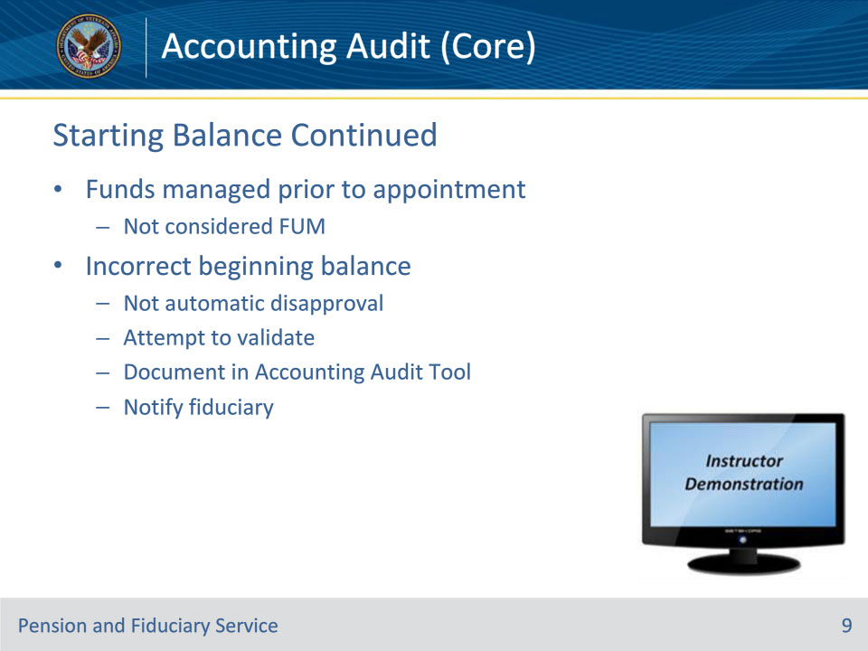
Slide notes

Policy Reference(s): FPM I.3.C.3.a.

Instructor Notes:

Any funds an individual managed prior to being appointed as a VA fiduciary are not considered FUM.

Hub personnel should not disapprove the accounting when the beginning balance on the accounting form is incorrect if the LIE can validate the correct starting balance based on financial documentation provided with the accounting.

In any situation where the fiduciary’s accounting form starting balance does not match the correct starting balance:

• do not immediately disapprove the accounting

• utilize the financial institution statements and the previously approved accounting to validate the actual starting balance

• list the correct starting balance in the VBMS Accounting Audit Tool

• document the discrepancy in the NOTES section in the VBMS Accounting Audit Tool, and

• notify the fiduciary of the discrepancy.

Document any starting balance discrepancies in the NOTES section of the VBMS Accounting Audit Tool. The note must detail the varying amounts between the accounting form balance and financial institution statement and indicate that the financial statement balance was validated as the actual amount.

Instructor Actions: Open VBMS and demonstrate the guidance on this slide and the previous slide, including where beginning balance can be found on VA Form 4706b and 4706c, where verified VA FUM amounts can be found in VBMS-Fiduciary, and how discrepancies are documented in the AAT.

Slide 10 - Income Types
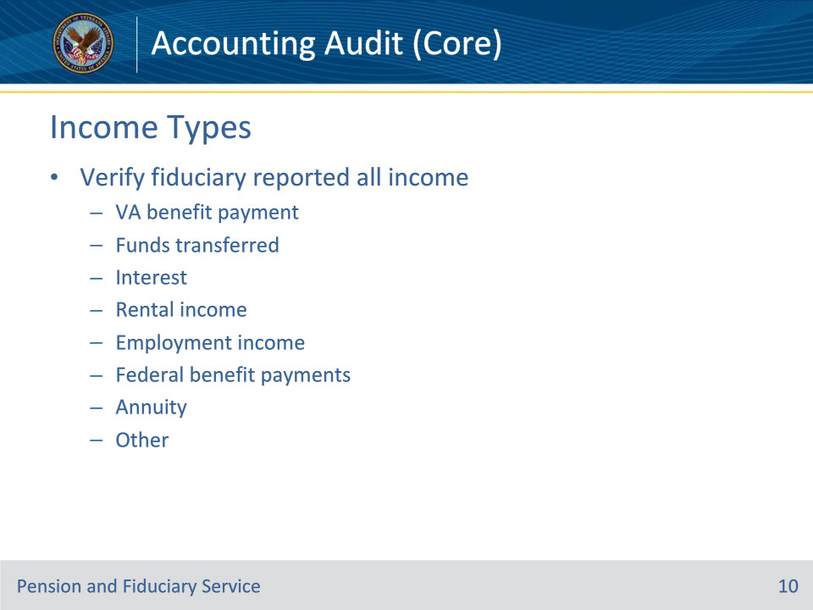
Slide notes

Policy Reference(s): FPM I.3.C.3.b.

Instructor Notes:

Income refers to cash or cash-equivalents the fiduciary receives on behalf of the beneficiary for which the fiduciary manages.

The auditing hub personnel must verify that the fiduciary reported all regular and one-time income received on behalf of the beneficiary including, but not limited to

• VA benefit payment deposit

• funds transferred from previous fiduciary

• savings of VA benefit funds including interest

• interest income resulting from the investment or saving

• rental income

• employment income

• Federal benefit payments (retirement, Social Security, etc.), and

• annuity.

Slide 11 - Income Verification
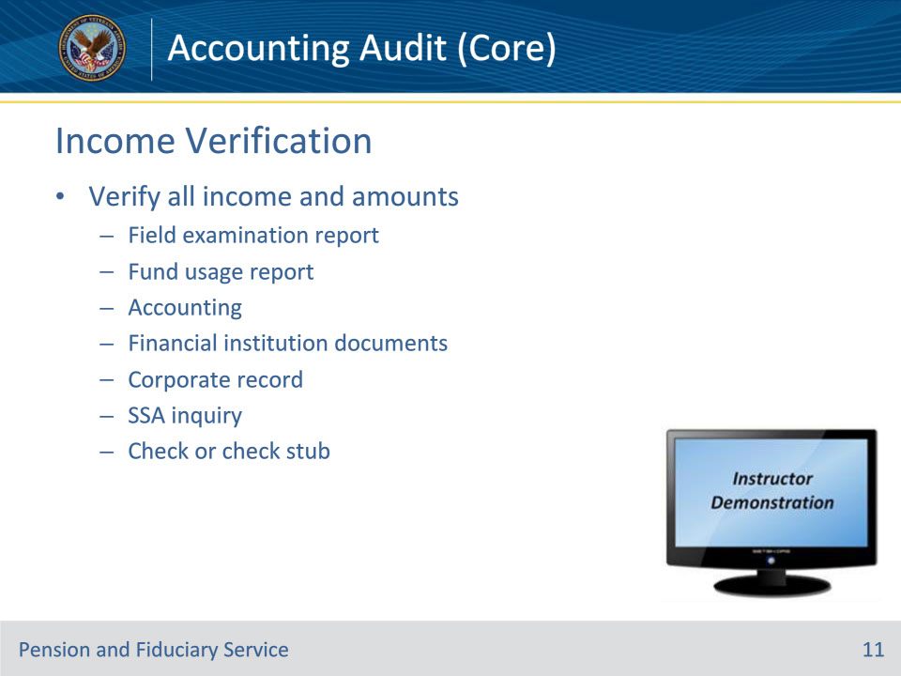
Slide notes

Policy Reference(s): FPM I.3.C.3.b.

Instructor Notes:

To verify that the fiduciary has reported all income for which they manage, the hub must review the

• most recent field examination, fund usage report, and/or accounting to identify all income and identify all accounts and the amounts in those accounts

• financial institution documents

• Share corporate record, and

• SSA inquiry.

Any funds an individual managed prior to being appointed as a VA fiduciary are not considered FUM and are not considered in the calculation of income.

Additionally, the LIE must verify that the amount reported was the amount received by the fiduciary. Generally, the amount of income a fiduciary receives and manages on behalf of the beneficiary is a factual finding that the LIE may verify by

• viewing an original, photocopied, or computer-generated financial institution document, which does not show any signs of alteration

• viewing a check or check stub, or

• using VA corporate record payment information (e.g. Share, payment screens).

If the Social Security or VA payment amount shown on the corporate record differs from the amount that was shown as a deposit on the financial institution statement, accept the amount shown on the financial institution statement as the net income amount for verification of the actual payment amount.

Instructor Actions: Open VBMS, share your screen and show the students how to verify income via the methods listed on this slide.

Slide 12 - Documenting in VBMS
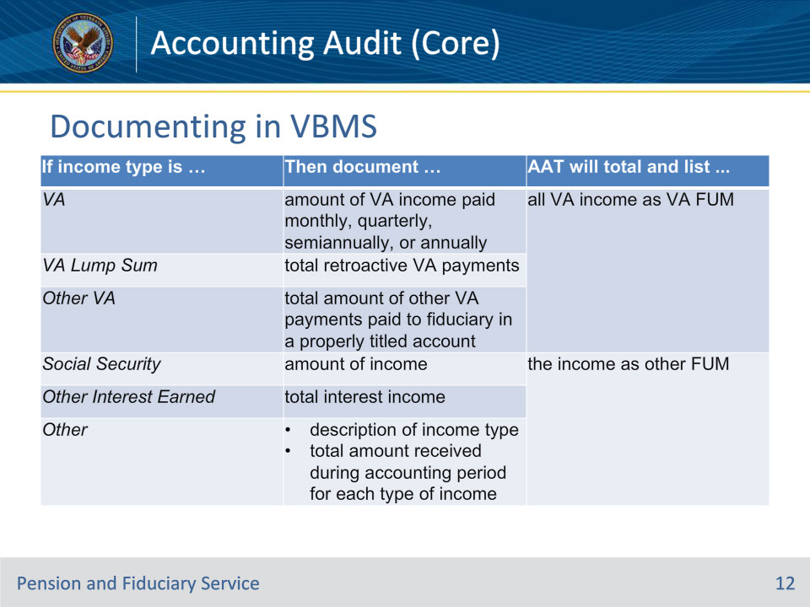
Slide notes

Policy Reference(s): FPM I.3.C.3.d.

Instructor Notes:

Following verification of income, the hub must document income information in the VBMS Accounting Audit Tool INCOMES section.

Use the table on this slide to determine the information required for the following types of income.

If the income type in VBMS is VA, Then the LIE must document the amount of VA compensation or pension income paid monthly, quarterly, semiannually, or annually And the Accounting Audit Tool will total income inputs and list all VA income as VA FUM.

If the income type in VBMS is VA lump sum, then the LIE must document the total retroactive VA payments and the accounting audit tool will total income inputs and list all VA income as VA FUM

If the income type in VBMS is Other VA, then the LIE must document the total amount of any other VA payments paid on a regular or irregular basis directly to the fiduciary in a properly titled account (e.g., VA insurance, clothing allowance, education, specially adapted housing/special home adaptation grants, etc.) and the accounting audit tool will total income inputs and list all VA income as VA FUM

If the income type in VBMS is Social Security, then the LIE must document the amount of income and the AAT will total income inputs and list the income as other FUM.

If the income type in VBMS is Other Interest Earned, then the LIE must document the total interest income and the AAT will total income inputs and list the income as other FUM.

If the income type in VBMS is Other, then the LIE must document the description of the income type (e.g., military retired pay, rental income), and total amount received during the accounting period for each different type of income, and the AAT will total income inputs and list the income as other FUM.

Slide 13 - Reconciliation
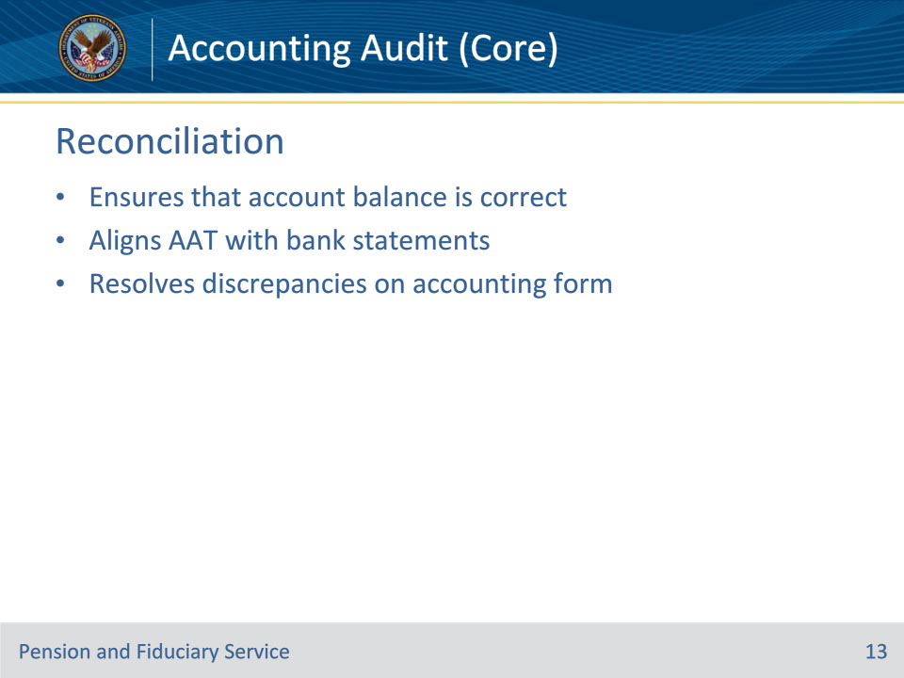
Slide notes

Policy Reference(s): FPM I.3.C.3.k.

Instructor Notes:

Generally, reconciling an accounting requires the hub to document that an account balance is correct and aligns with the account balances following audit in the VBMS Accounting Audit Tool. The hub may use the amounts shown on financial documents and in VA systems to identify actual amounts of receipts and the financial documents to determine expenditures.

Reconciliation ensures that bank account balances shown on the bank statement when considering expenditures, are equal to those shown in the VBMS Accounting Audit Tool.

There are two ways to reconcile an accounting:

• the balance in the financial account and VA accounting form exactly match the total of the amounts in the VBMS Accounting Audit Tool, or

• the actual amounts found on the financial account statements and VA systems can be justified despite inconsistent information on the accounting form.

If the account reconciliation reveals that an account balance in VA systems is not supported by the accounting form, adjust the expenses and receipts to match the supporting detail in the financial institution documents and VA systems. By doing so, you can justify and document the account balances through evidence.

Slide 14 - Reconciling Income
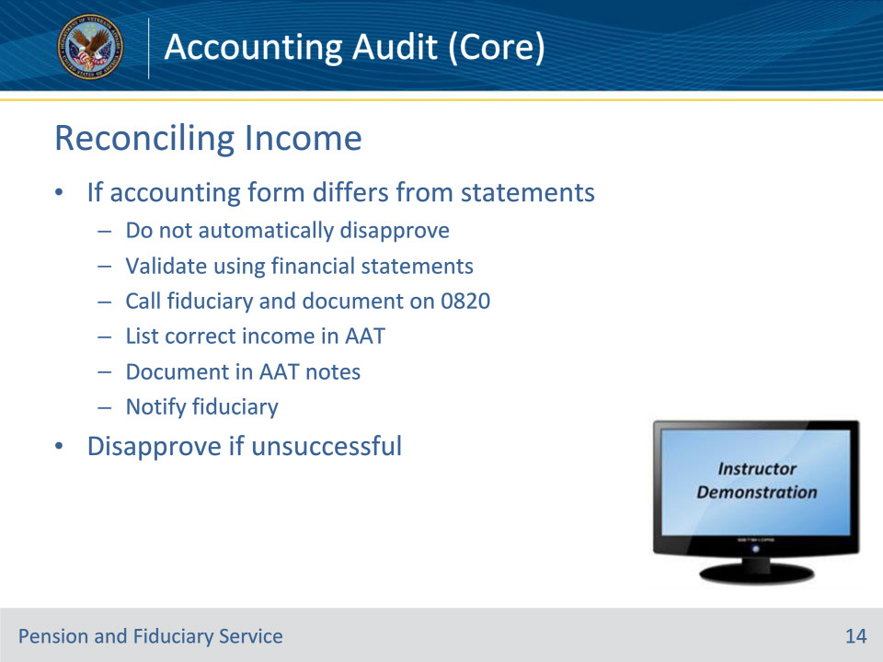
Slide notes

Policy Reference(s): FPM I.3.C.3.c.

Instructor Notes:

If the amount reported on the accounting form is different from the amount received as shown by financial institution statements, the hub must attempt to reconcile the reported amount by comparing financial documents to

• previous

• field examinations

• fund usage reports, and/or

• accountings

• the accounting form

• correspondence from the fiduciary, and

• receipts, when required.

In any situation where the fiduciary’s accounting form income does not match the income as shown on financial statements

• do not immediately disapprove the accounting

• utilize the financial institution statements to validate the actual income received

• contact the fiduciary telephonically if the income cannot be reconciled through a review of VA systems and/or financial statements, document on a VA Form 27-0820, and upload to the eFolder

• list the correct income in the VBMS Accounting Audit Tool

• document the discrepancy in the NOTES section in the VBMS Accounting Audit Tool, and

• notify the fiduciary of the discrepancy.

The discrepancy note must detail the varying amounts between the accounting form income and financial institution statement and indicate that the financial statement balance was validated as the actual amount.

If the LIE is unable to resolve the discrepancy, disapprove the accounting and request the information VA needs to resolve the issue via official VA notification. Allow the fiduciary 14 days from the date of the official VA notification to respond to the request. The LIE must ensure the official notification has been uploaded to the eFolder.

Instructor Actions: Open VBMS, share your screen and show the students example(s) of how to document a discrepancy in the AAT Notes section, notify a fiduciary of a discrepancy, and disapproval process if reconciliation is not possible.

Slide 15 - Expenses
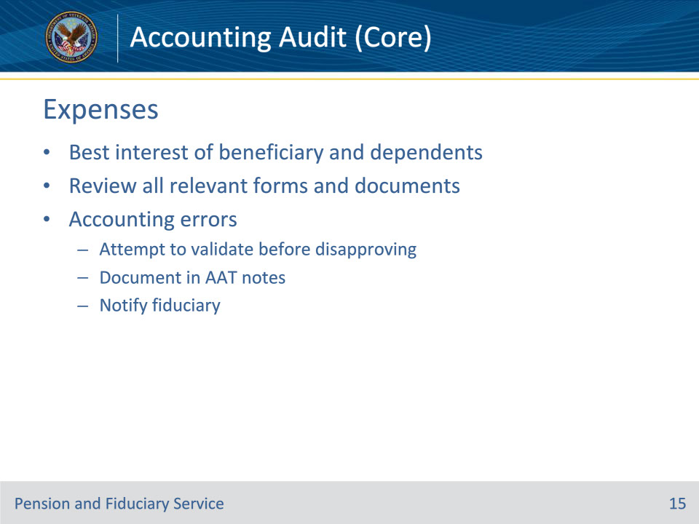
Slide notes

Policy Reference(s): FPM I.3.C.3.e.

Instructor Notes:

The hub must take into consideration the fiduciaries responsibilities to the beneficiary when reviewing expenses. In all cases, the fiduciary must disburse or otherwise manage funds according to the best interests of the beneficiary and the beneficiary’s dependents while considering the beneficiary’s unique circumstances, needs, desires, beliefs, and values.

Hub employees should be mindful that most fiduciaries spend beneficiary funds in the best interest of the beneficiary and their dependents and do so without a fee. Fairness and courtesy must always be shown to fiduciaries by all employees reviewing fiduciary expenditures regardless of the hub employee’s personal feeling or attitudes concerning fund usage.

Hub personnel must review expenses on the accounting form, financial institution documents, ledgers, documents, and statements that the fiduciary submits to VA and determine if beneficiary’s funds were spent for beneficiary and their dependents.

Hub personnel should not disapprove accounting errors, such as the incorrect expense amounts reported on the accounting form when unaltered financial institution statements or check stubs are available and the hub can document a reasonable explanation, including notice of the error to the fiduciary.

Document any discrepancies in the NOTES section of the VBMS Accounting Audit Tool. The note must detail the varying amounts between the accounting form expenses and financial institution statement and indicate that the financial statement balance was validated as the actual amount.

Contact the fiduciary telephonically, in any situation where the income cannot be reconciled through a review of VA systems and/or financial statements. LIEs must disapprove the accounting for fiduciaries who are unable to resolve the unreconcilable discrepancy and request the information VA needs to resolve the issue via official VA notification.

Slide 16 - Gifts
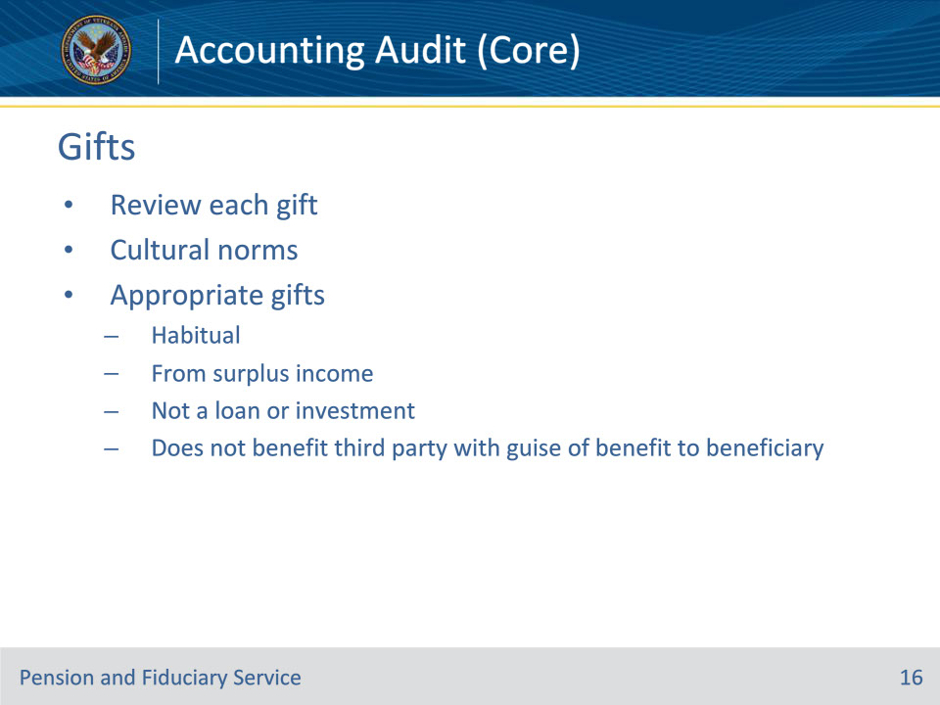
Slide notes

Policy Reference(s): FPM I.3.C.3.g.

Instructor Notes:

The hub must review each gift and consider the cultural norms of the beneficiary when determining if the gift is appropriate. A gift is considered appropriate if it:

• is one that the beneficiary had been in the habit of giving or is one that he or she probably would have given had he or she been able to manage VA benefits, including gifts to family members

• is made from surplus income, (i.e., income more than the amount required for the care, support, and maintenance of the beneficiary and his or her dependents)

• is not held under the guise as a loan or for investment purposes, and

• does not benefit a third party, with the guise of a benefit to the beneficiary; such as remodeling a family member residence to care for the beneficiary with continued room charges.

Slide 17 - Non-Questionable Expenses
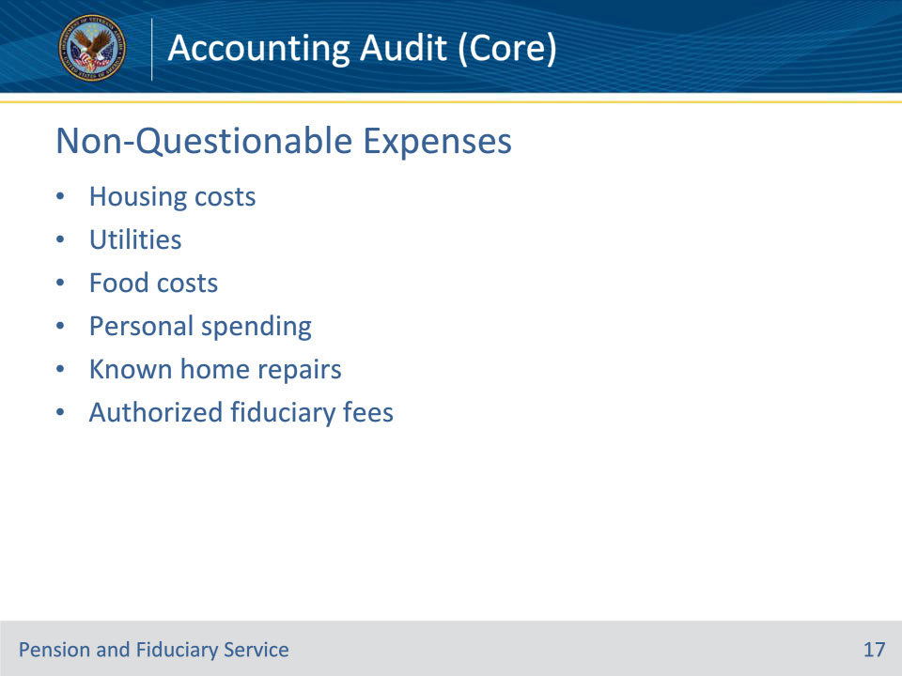
Slide notes

Policy Reference(s): FPM I.3.C.3.e.; j.

Instructor Notes:

Generally, the LIE will not consider the following expenses questionable:

• housing costs, such as

• mortgage

• facility cost

• taxes, and

• renter’s insurance

• utilities and routine home maintenance, such as

• cable

• internet, and

• phone

• food costs, such as

• groceries, and

• dining out

• miscellaneous personal spending

• known upcoming home repairs, and

• authorized fees for fiduciary service.

Do not request receipts or invoices for home repairs/improvements or other large purchases if the most recent field examination projected the purchase.

Home repair cost may vary greatly by geographic area, the size of the home, and type of improvement. Therefore, the hub should only request receipts for home improvements when the hub cannot determine that the home improvements were for the beneficiary or their dependent’s benefit.

Slide 18 - Questioning Expenses
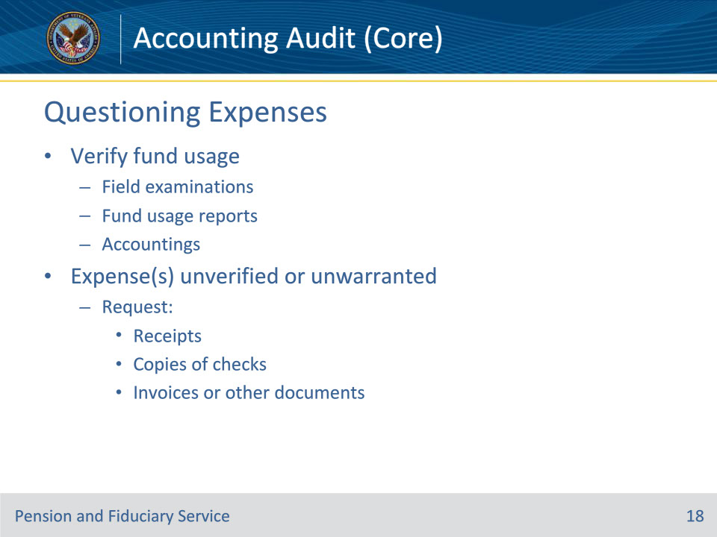
Slide notes

Policy Reference(s): FPM I.3.C.3.f.

Instructor Notes:

The LIE must utilize previous field examinations, fund usage reports, and/or accountings when attempting to verify fund usage. If the LIE cannot determine for what purpose the beneficiary’s funds were spent or the beneficiary’s situation does not warrant the expense, the LIE may request

• receipts

• copies of checks, or

• invoices or other documents.

If the most recent field examination or other oversight documentation establishes that the fiduciary plans to use VA funds for the beneficiary and their dependents, do not request receipts.

Example: If the field examination indicates that the beneficiary needs a new washer and dryer, do not request receipts for the washer and dryer purchase shown on the accounting. The LIE must ensure use of VA funds is consistent with VA policy, which recognizes the fiduciary should spend beneficiary funds consistent with the beneficiary’s unique circumstances, needs, desires, beliefs, and values.

Slide 19 - Questioning Expenses
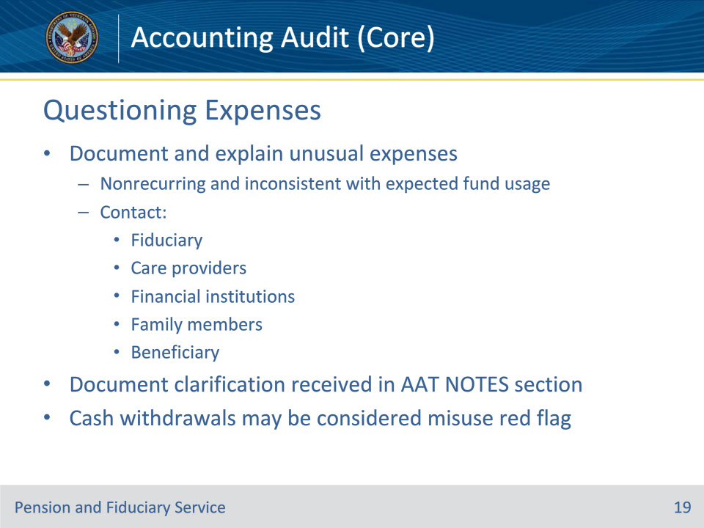
Slide notes

Policy Reference(s): FPM I.3.C.3.f.

Instructor Notes:

Unusual expenses are those that are generally nonrecurring and not considered consistent with previous or expected fund usage.

The LIE must document and satisfactorily explain unusual expenses by contacting the fiduciary, care providers, financial institutions, family members, and/or beneficiary for additional information or obtain additional evidence to justify a questioned expense.

Any clarification received must be documented in the Accounting Audit Tool NOTES section.

Important: ATM withdrawals, counter withdrawals, and checks made payable to cash are prohibited and may be considered a red flag indicator of misuse. If the fiduciary completed a cash withdrawal, and the use of those funds cannot be associated to a legitimate expense, establish a misuse allegation.

Slide 20 - Questioning Expenses
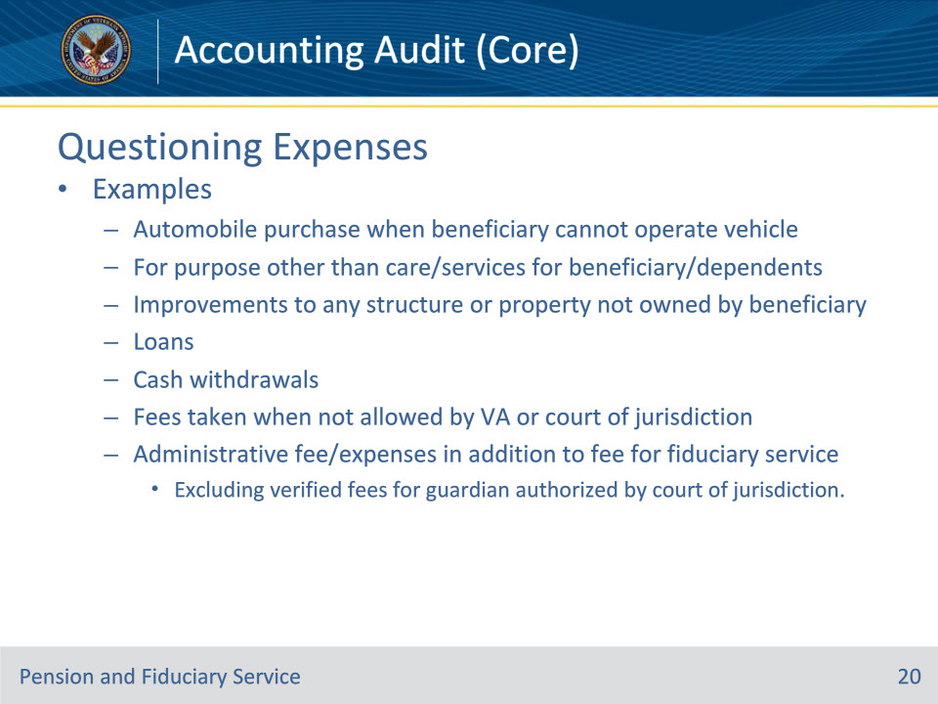
Slide notes

Policy Reference(s): FPM I.3.C.3.f.

Instructor Notes:

Examples of unusual expenses requiring clarification include

• purchase of an automobile for a beneficiary when the previous field examination or medical evidence in the eFolder suggest that the beneficiary may not be able to operate a vehicle

• expenses or funds distributed for a purpose other than the care or services for the beneficiary and their dependents

• expenses for improvements to any structure or other property not owned by the beneficiary

• loans

• cash withdrawals, such as

• automated teller machine (ATM) withdrawals

• counter withdrawals, and/or

• checks made payable to cash

• fees taken when not allowed by VA or a court of jurisdiction, and

• administrative fee/expenses in addition to the fee for fiduciary services, excluding verified fees for guardian of the person authorized by a State court of jurisdiction.

Slide 21 - Documenting Expenses
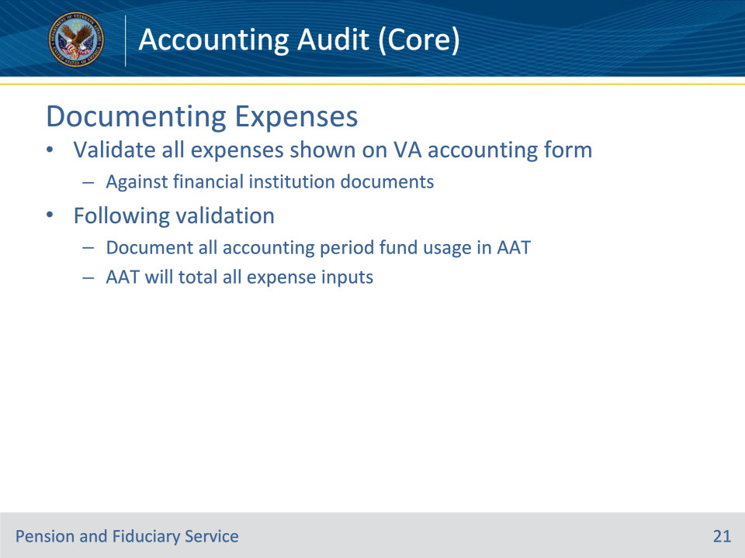
Slide notes

Policy Reference(s): FPM I.3.C.3.h.

Instructor Notes:

The auditing hub personnel must validate all expenses shown on the VA Form 21P-4706b or VA Form 21P-4706c, submitted electronically via FAST or through the mail, against financial institution documents.

Following validation, document all the fiduciary’s use of the beneficiary’s funds during the accounting period in the VBMS Accounting Audit Tool.

The VBMS Accounting Audit Tool will total all expense inputs.

Slide 22 - Reconciling Expenses
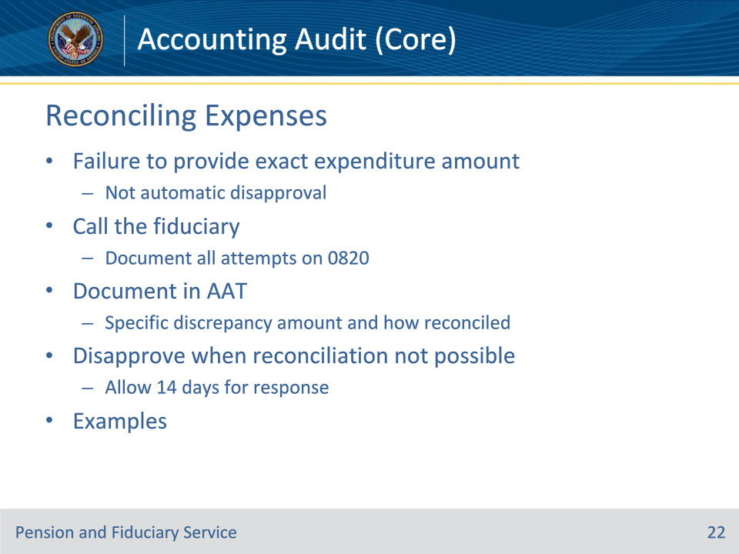
Slide notes

Policy Reference(s): FPM I.3.C.3.l.

Instructor Notes:

The fiduciary’s failure to provide the exact amount or total of an expenditure on a VA Form 21P-4706b or VA Form 21P-4706c as shown on the financial institution statement, invoice, receipt, or copy of a check, does not warrant an immediate disapproval of an accounting.

The hub must attempt to contact the fiduciary telephonically to resolve questions, when expense discrepancies may be clarified over the phone and without additional documents. Both successful and unsuccessful telephone contact attempts must be documented on a VA Form 27-0820 and uploaded in the beneficiary’s eFolder.

Hub personnel must document in the Accounting Audit Tool the specific expense amount discrepancy and how the expense was reconciled.

Disapprove the accounting and allow the fiduciary 14 days to provide clarification or missing information when the hub cannot reconcile expenses because documents or information is unavailable for review to reconcile the income discrepancy.

Examples of documents or information that would allow the LIE to reconcile information may include

• financial institution document(s) for the entire accounting period

• copies of checks

• receipts, or

• statements of clarification.

Slide 23 - Potential Misuse Identified
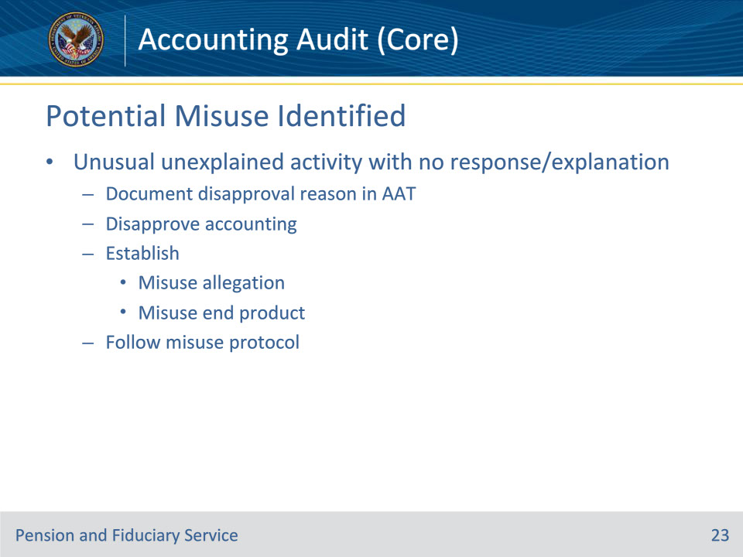
Slide notes

Policy Reference(s): FPM I.3.C.3.i.

Instructor Notes:

In any instance where a fiduciary’s accounting contains unusual unexplained activity and the fiduciary does not explain in the response to the VA inquiry, the hub must:

• document the reason for disapproval in the Accounting Audit Tool

• immediately disapprove the accounting

• establish a misuse

• allegation on the day of discovery, and

• EP, and

• follow the misuse protocol.

Slide 24 - Fiduciary Fees
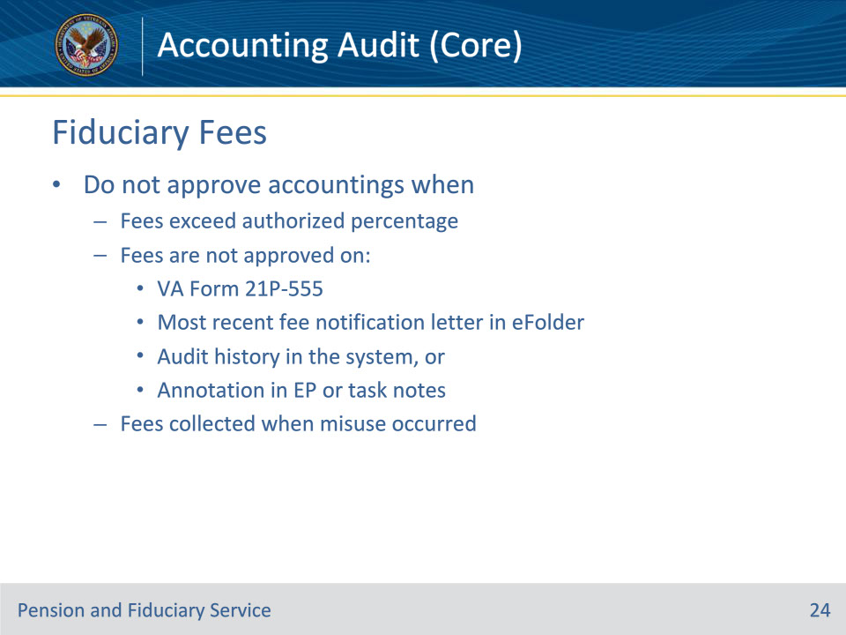
Slide notes

Policy Reference(s): FPM I.3.C.4.a.

Instructor Notes:

The hub must verify whether fees taken during an accounting period were properly authorized.

Following review if fees have been properly authorized, the hub must review all fiduciary fees charged by a VA-appointed fiduciary to ensure the charges do not exceed the amount authorized by the Fiduciary Hub Manager (FHM).

Do not approve an accounting for a VA-appointed fiduciary if the

• fee amount exceeds the percentage authorized by the FHM for fiduciary services

• fee is not approved

• on a VA Form 21P-555

• on the most recent fee notification letter within the eFolder

• within the audit history in the system, or

• with an annotation in the EP or task notes in VBMS

• fees were collected for a period when the hub or court of jurisdiction determined that the fiduciary misused all or part of the beneficiary’s VA benefits, or

• total fees taken during the accounting period exceed the total amount allowed based upon a calculation of total income received and the percent allowed, unless satisfactory evidence is of record and fully documented that the fiduciary earned the fee in the previous accounting period or was not authorized the fee by VA, until the following accounting period.

Slide 25 - Fiduciary Fees
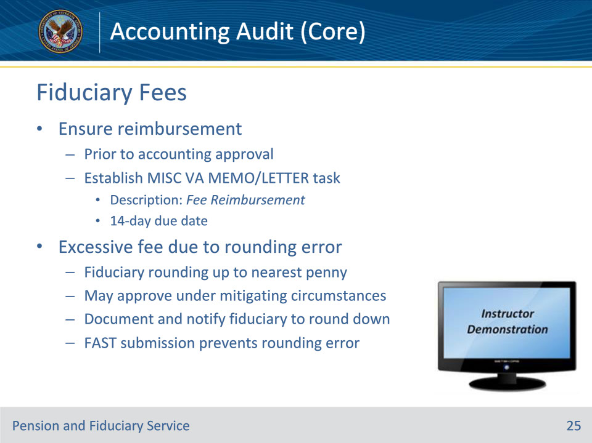
Slide notes

Policy Reference(s): FPM I.3.C.4.a.

Instructor Notes:

The hub must take action to ensure reimbursement of fees/charges in excess of the approved amount to the beneficiary’s account. The hub must verify the fiduciary reimbursed the beneficiary’s FUM prior to accounting approval. To control this action, the LIE must establish the appropriate development activity with a 14-day due date.

• If the hub discovers a fiduciary fee exceeds the authorized percentage because the fiduciary fee was calculated by rounding the monthly award up to the nearest penny, the hub may approve the accounting under mitigating circumstances. The hub must document the mitigating circumstance and notify the fiduciary to round fiduciary fees down to nearest penny in the future.

• If the fiduciary is submitting their accounting within FAST, the system requires the fiduciary correct the rounding error prior to submission.

Instructor Actions: Open VBMS, share your screen and show the students example(s) of a fiduciary fee being authorized (555, VBMS-Fid, Notification letter), how you would verify appropriate fees and ensure reimbursement.

Slide 26 - Court Authorized Fees
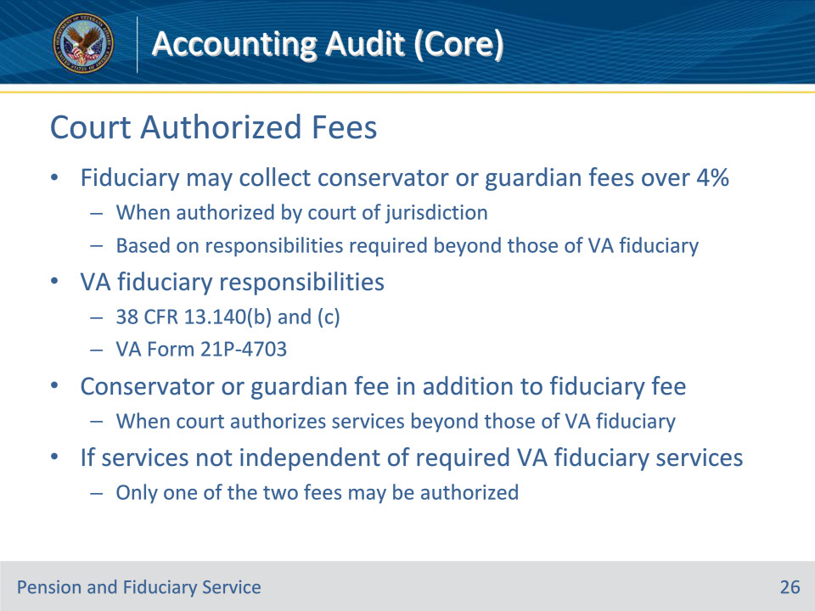
Slide notes

Policy Reference(s): FPM I.3.C.4.b.

Instructor Notes:

A VA-appointed fiduciary may collect conservator or guardian fees exceeding 4 percent of the VA FUM when authorized by the court of jurisdiction, based on responsibilities required beyond those of a VA-appointed fiduciary.

For listings of the responsibilities a fiduciary must provide in the VA as part of the VA Fiduciary Program, see 38 CFR 13.140(b) and (c), or a VA Form 21P-4703, Fiduciary Agreement.

A conservator or guardian fee may be paid from VA FUM in addition to a VA authorized fiduciary fee when a court authorizes services beyond those of a VA-appointed fiduciary. If the services provided are not independent of required VA fiduciary services, only one of the two fees may be authorized.

Slide 27 - Court Authorized Fees
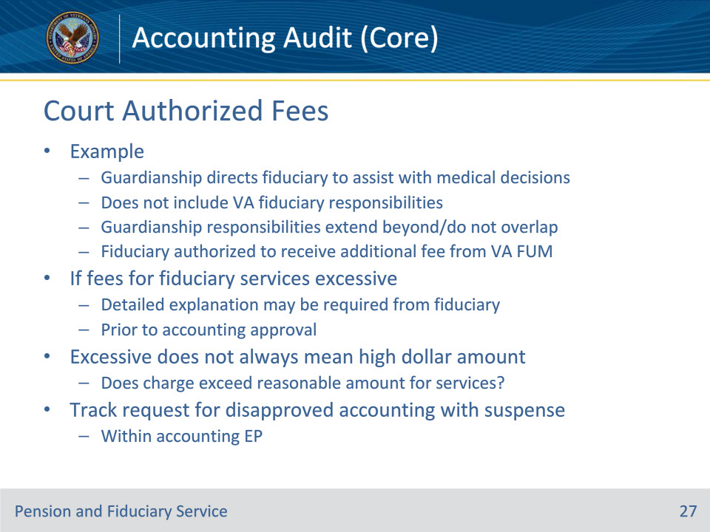
Slide notes

Policy Reference(s): FPM I.3.C.4.b.

Instructor Notes:

Example: A VA-appointed fiduciary who collects a 4 percent fiduciary fee is also the court-appointed guardian of the beneficiary. The guardianship directs that the fiduciary assists the beneficiary in making medical decisions and end of life decisions on their behalf but does not include responsibilities a VA fiduciary must provide. Since the guardianship responsibilities extend beyond and do not overlap the responsibilities listed in 38 CFR 13.140(b) and (c), the fiduciary is authorized to receive an additional fee from VA FUM.

If the hub determines the fees for fiduciary services exceed the authorized amount or are excessive based on the service performed, a detailed explanation may be required from the fiduciary prior to accounting approval. Excessive does not always mean a high dollar amount, but rather does the charge exceed a reasonable amount for the services performed in an area of service.

The hub must track any request for a disapproved accounting with an appropriate suspense within the accounting EP.

Slide 28 - Fee Analysis
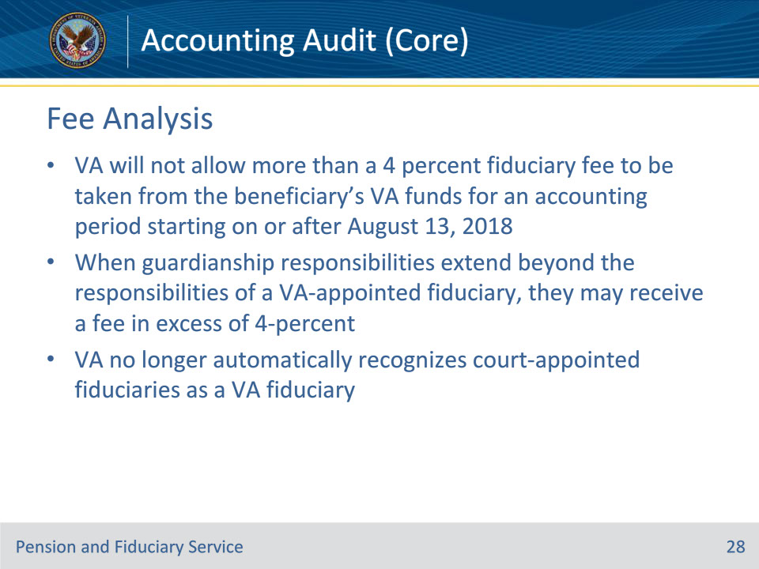
Slide notes

Policy Reference(s): FPM I.3.C.4.c.

Instructor Notes:

Effective August 13, 2018, 38 CFR 13.220 provides that VA will not allow more than a 4 percent fiduciary fee to be taken from the beneficiary’s VA funds for an accounting period starting on or after August 13, 2018. For all cases in which VA previously allowed a fee greater than 4 percent due to a court authorization, VA must notify the fiduciary and the court of jurisdiction that a fee more than 4 percent of the VA benefits is not authorized.

When guardianship or conservatorship responsibilities extend beyond the responsibilities of a VA-appointed fiduciary, they may be authorized to receive a fee in excess of the 4-percent fee outlined in the table on the next slide.

Effective August 13, 2018, VA no longer automatically recognizes court-appointed fiduciaries as a VA fiduciary.

Slide 29 - Fee Analysis
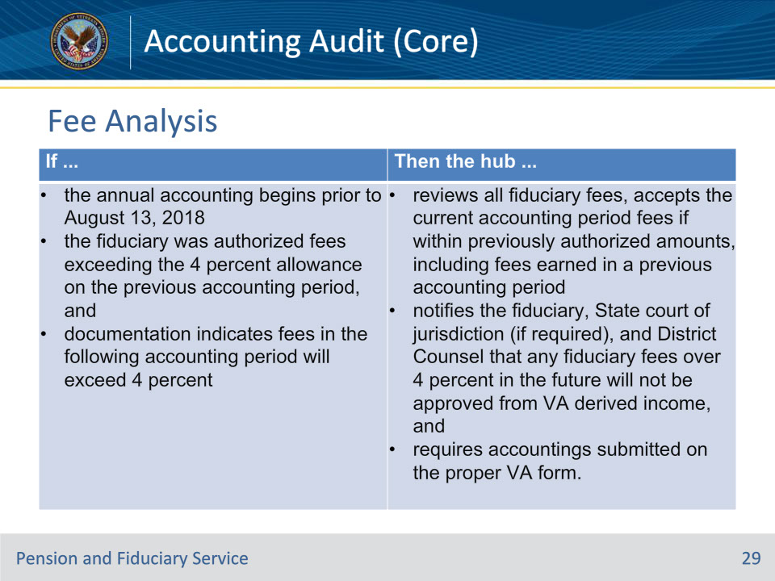
Slide notes

Policy Reference(s): FPM I.3.C.4.c.

Instructor Notes:

Use this table to determine the actions to take for fiduciary fees earned prior to and after the effective date of August 13, 2018.

Slide 30 - Fee Analysis
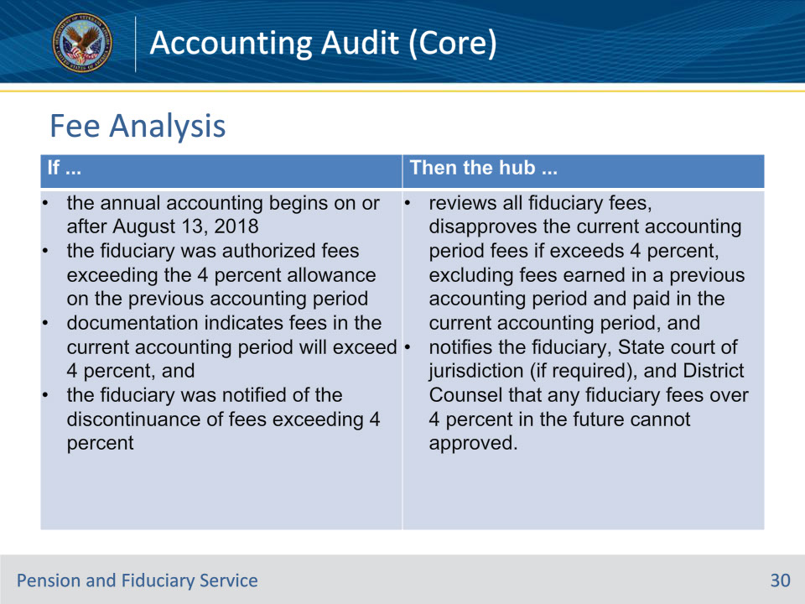
Slide notes

Policy Reference(s): FPM I.3.C.4.d.

Instructor Notes:

Use this table to determine the actions to take for fiduciary fees earned prior to and after the effective date of August 13, 2018.

Slide 31 - Attorney Fiduciaries
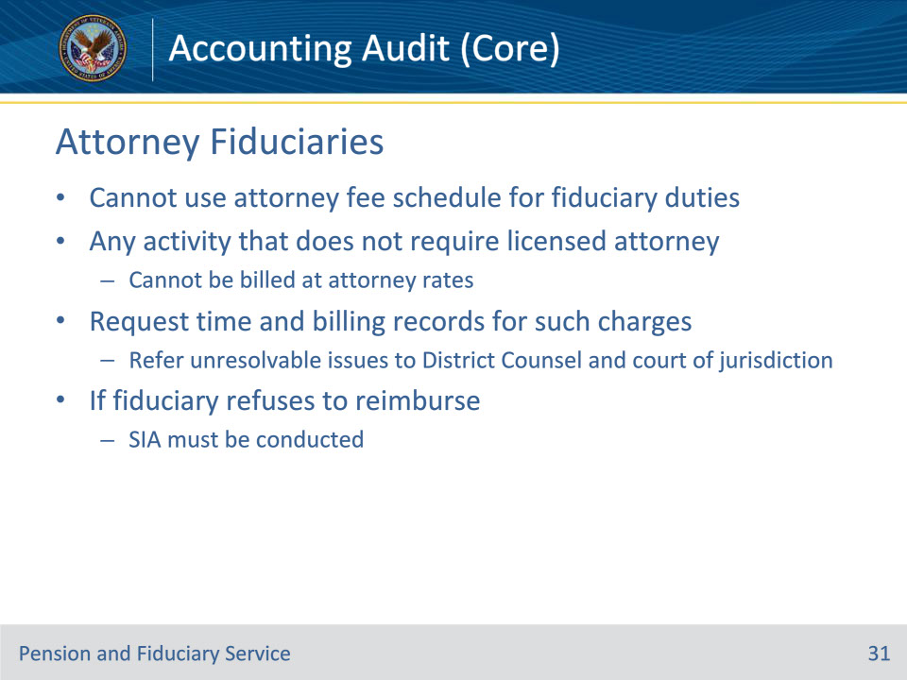
Slide notes

Policy Reference(s): FPM I.3.C.4.d.

Instructor Notes:

VA-appointed fiduciaries who are attorneys and who may serve in a dual capacity cannot use their attorney fee schedule when charging for duties performed as a fiduciary, such as paying the monthly bills of the beneficiary. Any activity that does not require a licensed attorney cannot be billed at attorney rates.

The hub must question and request time and billing records for such charges and refer issues that cannot be resolved to the District Counsel and the court of jurisdiction. Hubs must follow the guidance to reconcile expenses.

A successor fiduciary must be appointed in all cases in which an attorney serving as a VA-appointed fiduciary charges a fiduciary fee to the beneficiary from VA benefits and refuses to reimburse the amount charged in excess of the VA or court ordered authorized percentage or amount.

Slide 32 - Attorney Fees
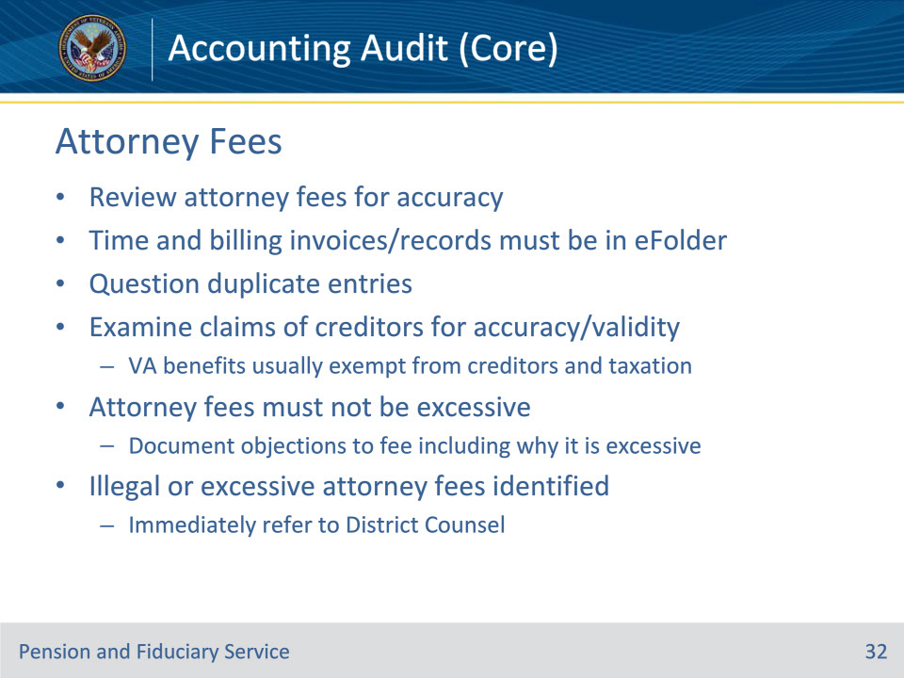
Slide notes

Policy Reference(s): FPM I.3.C.4.e.

Instructor Notes:

The hub must review attorney fees for accuracy. Time and billing invoices/records for any charges associated with legal fees must be in the eFolder. Hubs must question duplicate entries for the same service annotated on time and billing records.

Examine attorney fees associated with claims of creditors for accuracy and validity. VA benefit payments are exempt, both before and after receipt by the beneficiary, from the claims of creditors and taxation. The hub must notify and instruct the fiduciary to invoke this defense in applicable circumstances. This does not preclude a just debt owed by the beneficiary, and a fiduciary or beneficiary cannot arbitrarily invoke this protection to avoid payment of a just debt. If the fiduciary does not do so, the FHM may refer the matter to District Counsel for evaluation and appropriate legal action.

Attorney fees must not be excessive, meaning not exceeding a normal, usual, reasonable, or proper limit. Excessive does not always equal a high dollar amount, but rather attorney fees not exceeding a reasonable limit for the services rendered. The hub must document objections to a fee and/or charges to include why the fees are considered excessive for the services performed.

Immediately upon detection of cases involving apparent illegal or excessive attorney fees, the FHM must refer the matter to District Counsel to take any action that may be appropriate to affect the reduction or recovery of the amount in question.

Slide 33 - Investments
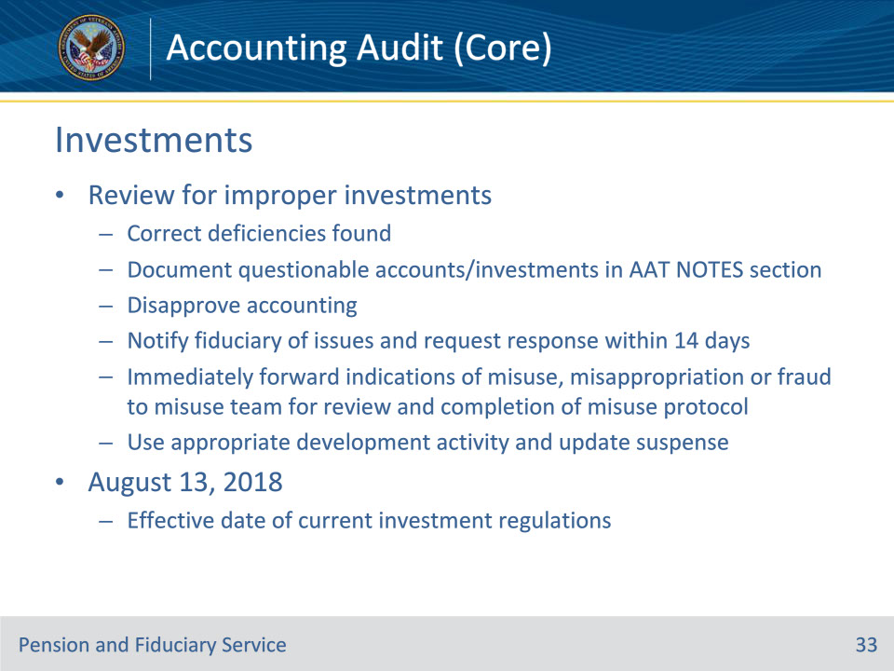
Slide notes

Policy Reference(s): FPM I.3.C.5.a.

Instructor Notes:

The hub must review the accounting for indications of improper investments. The hub must determine if the fiduciary established accounts and invested FUM appropriately. If the hub discovers indications of improper accounts or investments, the hub must act to

• correct the deficiencies found

• document questionable accounts and or investments in the NOTES section of the VBMS Accounting Audit Tool

• disapprove the accounting

• notify the fiduciary of the issues and request a response within 14 days, and

• immediately forward indications of misuse, misappropriation or fraud to the misuse team for review and completion of the misuse protocol.

Hubs must use the most appropriate development activity and update the suspense date to control for the receipt of the corrected information.

Effective August 13, 2018, the effective date of new fiduciary regulations, all future investments must adhere to VA policy. Previously recognized court-appointed (VA recognized) fiduciaries may have existing investments that do not adhere to current VA policy. VA recognizes the risks that may be involved in any liquidation or changes and VA will not require the fiduciary to disturb investments in existence prior to August 13, 2018.

Slide 34 - FUM Requirements
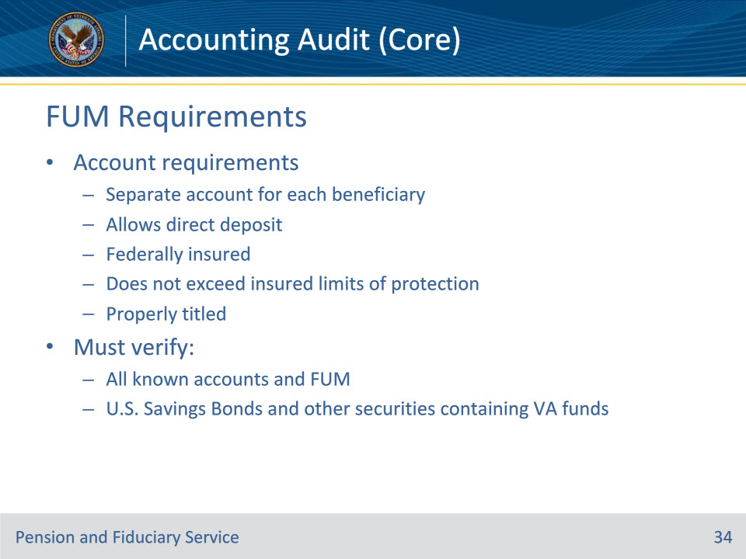
Slide notes

Policy Reference(s): FPM I.3.C.5.b.

Instructor Notes:

The LIE must ensure that all VA and other FUM by the fiduciary are deposited and meet all of the requirements listed below, unless exempt:

• The fiduciary must establish and maintain a separate financial institution account for each VA beneficiary served, unless otherwise exempt.

• The account must be

• established to allow for the direct deposit of VA benefits

• Federally insured and not exceed current insured limits of protection, and

• properly titled in the beneficiary’s and fiduciary’s names and note the existence of the fiduciary relationship, unless otherwise exempt.

The LIE must verify

• all known accounts and FUM, and

• U.S. Savings Bonds and other allowable securities purchased with or containing VA funds. This review should include verification in the VBMS Accounting Audit Tool of the savings bond and values via the TreasuryDirect website.

Slide 35 - FUM and Account Verification
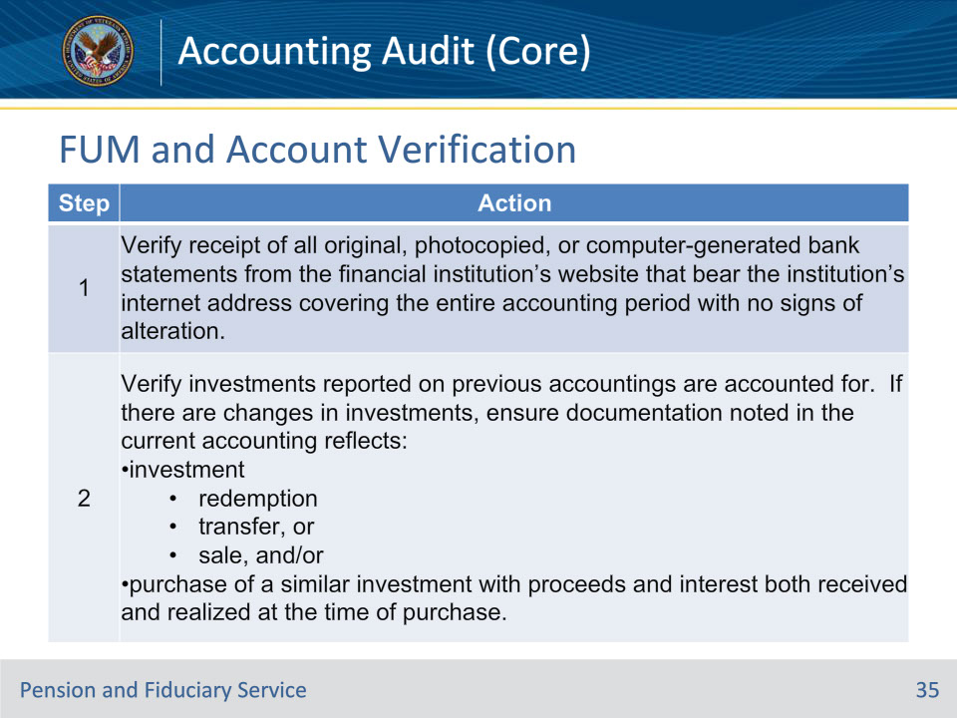
Slide notes

Policy Reference(s): FPM I.3.C.5.b.

Instructor Notes:

Follow the steps in this table when verifying all known accounts and FUM.

Slide 36 - FUM and Account Verification
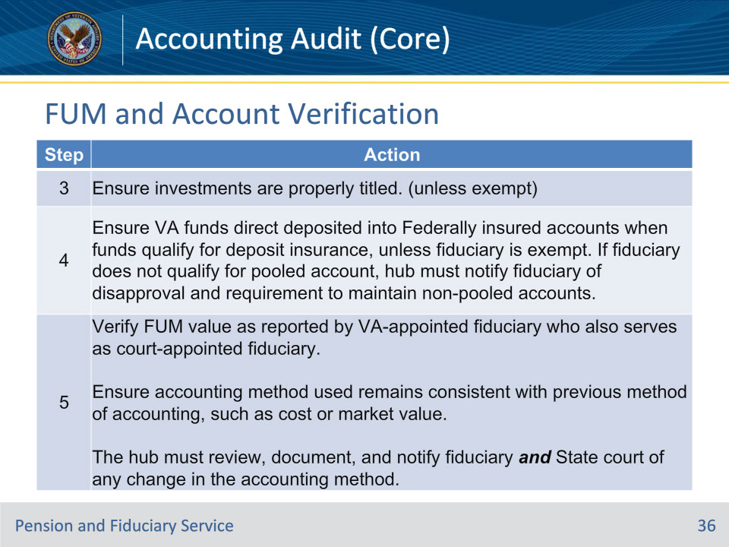
Slide notes

Policy Reference(s): FPM I.3.C.5.b.

Instructor Notes:

Follow the steps in this table when verifying all known accounts and FUM.

Slide 37 - FUM and Account Verification
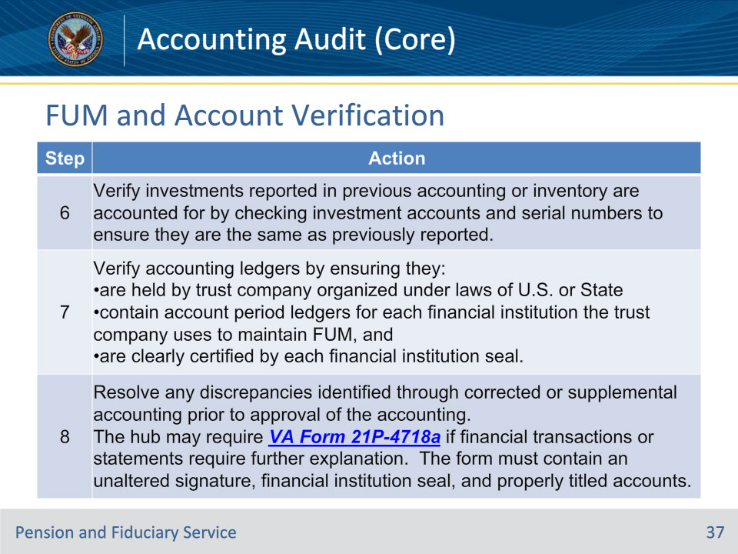
Slide notes

Policy Reference(s): FPM I.3.C.5.b.

Instructor Notes:

Follow the steps in this table when verifying all known accounts and FUM.

Important: The trust officer cannot certify as the financial institution.

Slide 38 - Surety Bonds
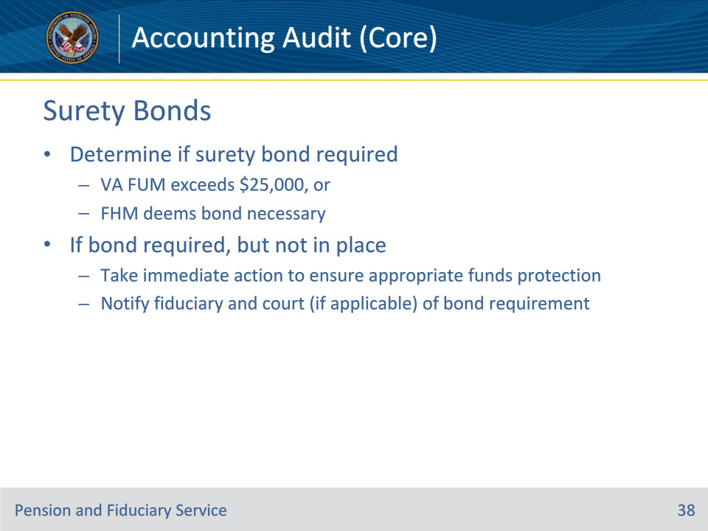
Slide notes

Policy Reference(s): FPM I.3.C.5.c.

Instructor Notes:

The LIE must review the FUM at the time of each accounting audit to determine if a corporate surety bond is required.

Unless the fiduciary is exempted, a corporate surety bond is required when

• VA FUM exceeds $25,000, or

• the FHM determines obtaining a surety bond is in the best interest of the beneficiary, without regard to the amount of VA benefit FUM.

If a corporate surety bond is required but is not in place, the hub must take immediate action to ensure appropriate protection of VA FUM.

The hub must notify the fiduciary and State court of jurisdiction (if applicable) of the corporate surety bond requirement.

Slide 39 - Bond Requirements
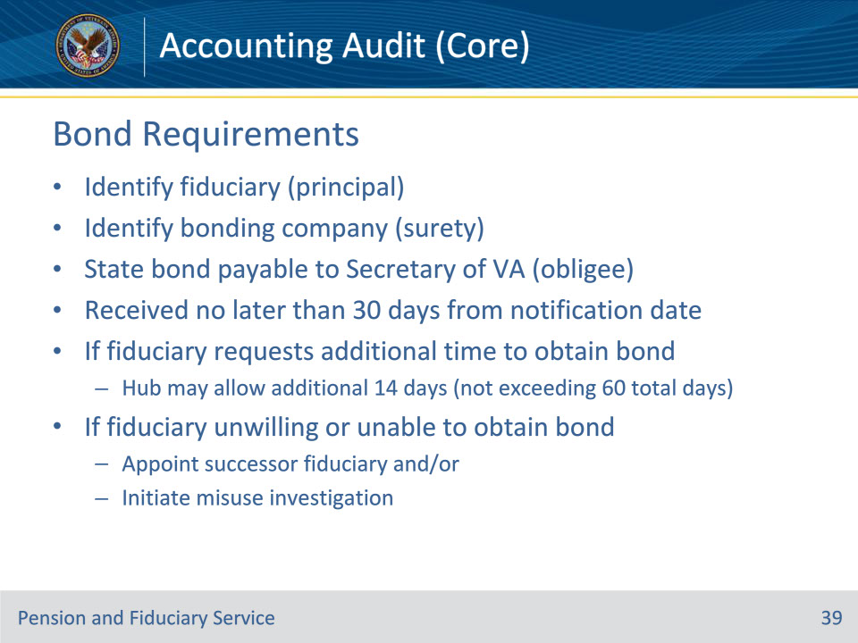
Slide notes

Policy Reference(s): FPM I.3.C.5.c.

Instructor Notes:

The corporate surety bond must

• identify the

• fiduciary (principal), and

• bonding company (surety)

• contain a statement that the bond is payable to the Secretary of VA (obligee), and

• be received no later than 30 days from the date of notification to the fiduciary.

If the fiduciary requests additional time to obtain the corporate surety bond, the hub may allow an additional 14 days, not to exceed 60 days from the first date of notification to the fiduciary.

If the fiduciary is unwilling or cannot obtain a corporate surety bond, the hub must appoint a successor fiduciary and/or initiate a misuse investigation.

Slide 40 - Court Bonds
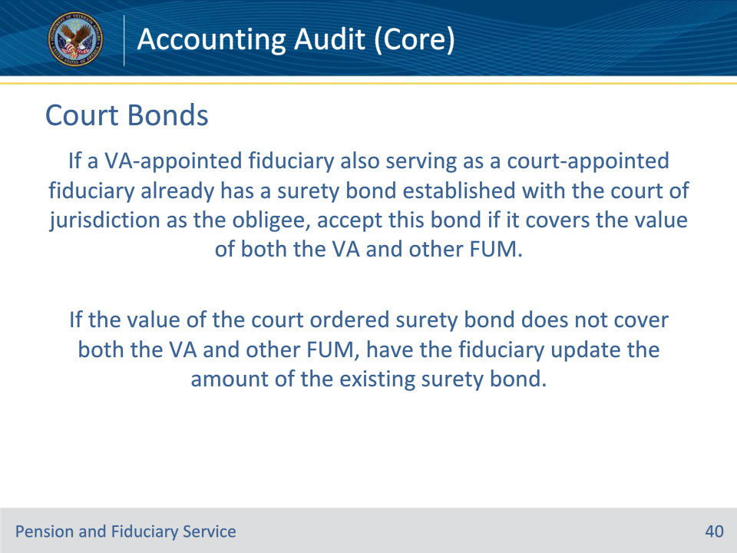
Slide notes

Policy Reference(s): FPM I.3.C.5.c.

Instructor Notes:

Exception: If a VA-appointed fiduciary also serving as a court-appointed fiduciary already has a surety bond established with the court of jurisdiction as the obligee, accept this bond if it covers the value of both the VA and other FUM. If the value of the court ordered surety bond does not cover both the VA and other FUM, have the fiduciary update the amount of the existing surety bond.

Slide 41 - Bond Notifications
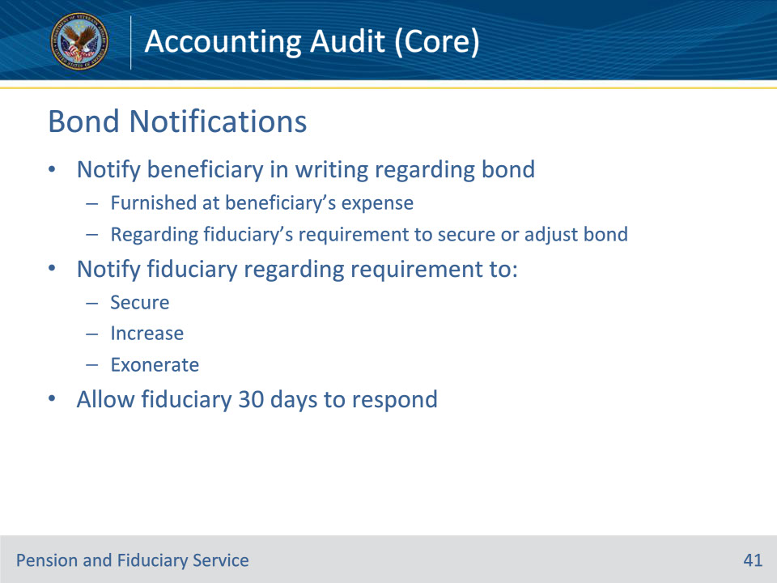
Slide notes

Policy Reference(s): FPM I.3.C.5.d.

Instructor Notes:

The hub must notify the beneficiary in writing regarding the corporate surety bond furnished at the beneficiary’s expense. The notice must be sent regarding their fiduciary’s requirement to secure or adjust a surety bond.

The hub must also notify the fiduciary regarding their requirement to secure, increase, or exonerate a surety bond.

Allow 30 days for the fiduciary to provide required documentation in response to these requests.

Slide 42 - Verifying Funds Protection
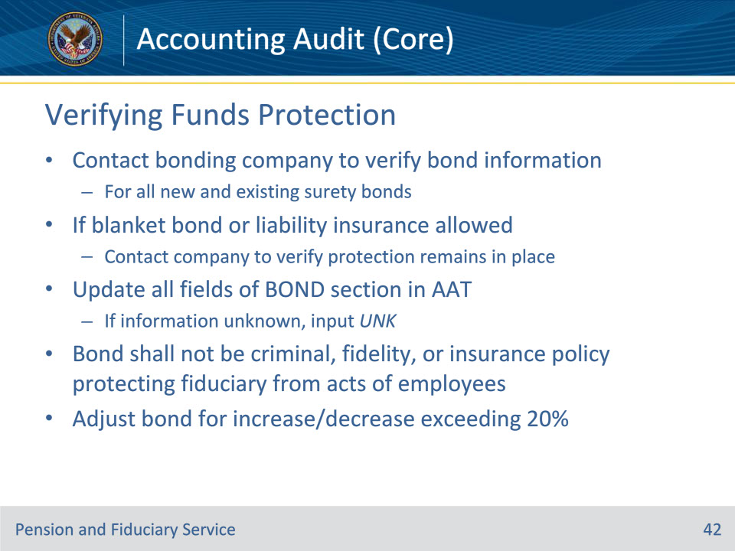
Slide notes

Policy Reference(s): FPM I.3.C.5.e.

Instructor Notes:A fiduciary must furnish proof of adequate bonding at any time the hub requests proof of protection.

The hub must contact the bonding company to verify the corporate surety bond information for all new and existing surety bonds. If there is an existing allowable blanket bond or liability insurance, the hub must contact the bond or insurance company to verify that the protection remains in place. The hub must update all fields of the BOND section of the Accounting Audit Tool with any information received from the bond or insurance company. If information is not known, input UNK.

With the exception for blanket bonds held by State agencies, the bond shall not be a criminal, fidelity or insurance policy protecting the policy holder (fiduciary) from theft or fraudulent acts of employees.

A VA-appointed fiduciary must adjust a corporate surety bond for any increase or decrease of more than 20 percent between the corporate surety bond and the current VA FUM.

The hub must review for VA withdrawal agreements, VA Form 21-8473, Withdrawal Agreement, or restricted or blocked accounts. If a withdrawal agreement or restricted or blocked account is existing, refer to FPM, Part II, 2.B.3 for policy guidance.

If the bond cannot be verified, contact the fiduciary and follow the steps in the table found in FPM, Part II, 2.B.2.e.

Slide 43 - Red Flags
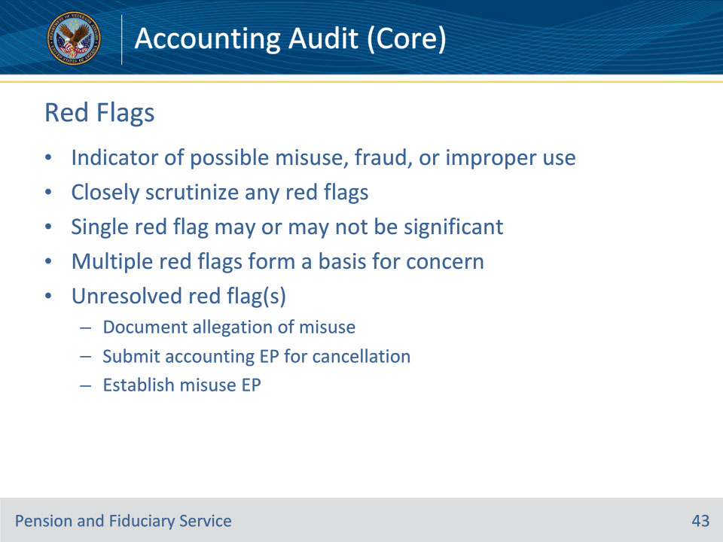
Slide notes

Policy Reference(s): FPM I.3.C.6.a.

Instructor Notes:

A red flag is an indicator of possible misuse, fraud, or improper use of FUM by a fiduciary. The hub must closely scrutinize any red flags. A single red flag may or may not be of significance whereas multiple red flags form a basis for concern.

The hub must document an allegation of misuse for any instances where a fiduciary’s accounting contains one or more red flags that cannot be resolved.

Submit the accounting EP for cancellation. Upon cancellation of the accounting EP, establish a misuse EP.

Slide 44 - Red Flags
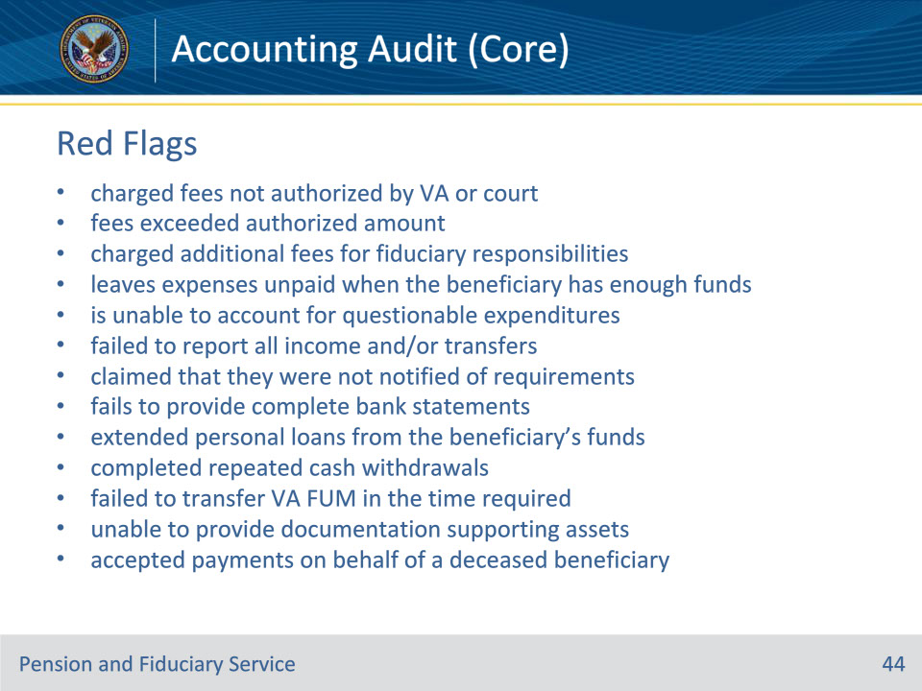
Slide notes

Policy Reference(s): FPM I.3.C.6.a.

Instructor Notes:

The LIE may discover the following red flags of misuse while auditing an accounting, such as the fiduciary

• charged fees not authorized by VA or court

• fees exceeded authorized amount/percentage

• charged additional fees for service already agreed to as one of the basic responsibilities of the fiduciary

• leaves expenses unpaid when the beneficiary has enough funds to pay the expenses

• is unable to account for questionable expenditures

• failed to report all income and/or transfers from a previous fiduciary

• claimed that they were not notified of accounting, surety bond, and/or proper account registration requirements

• fails to provide complete bank financial statements that match the appropriate VA accounting form

• extended personal loans from the beneficiary’s funds

• completed repeated cash withdrawals

• falied to transfer VA FUM in the time required

• is unable to provide documentation supporting assets previously documented in a field examination, fund usage report, or accounting, and/or

• accepted payments on behalf of a deceased beneficiary.

Slide 45 - Evasive Fiduciary
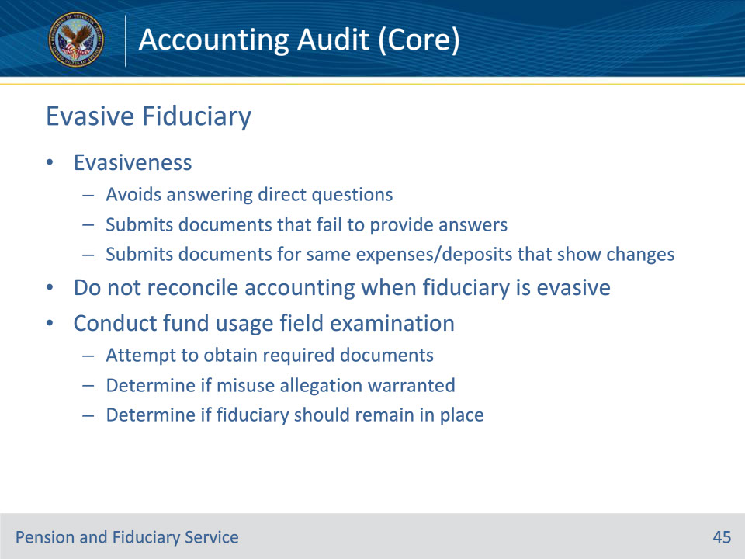
Slide notes

Policy Reference(s): FPM I.3.C.6.b.

Instructor Notes:

Fiduciaries who are evasive in the accounting review process avoid answering direct questions regarding funds usage or submit documents that fail to provide answers to VA’s inquiry. Evasiveness is also shown when the fiduciary submits the same documents for the same expense or deposits that show changes in information.

Do not reconcile an accounting when the fiduciary shows signs of evasiveness.

If a fiduciary shows signs of evasiveness, the hub must conduct a fund usage field examination. The field examination is conducted to

• attempt to obtain the required documents, and

• determine if

• an allegation of misuse is warranted, and

• the fiduciary should remain in place.

Slide 46 - Fund Usage Field Exam
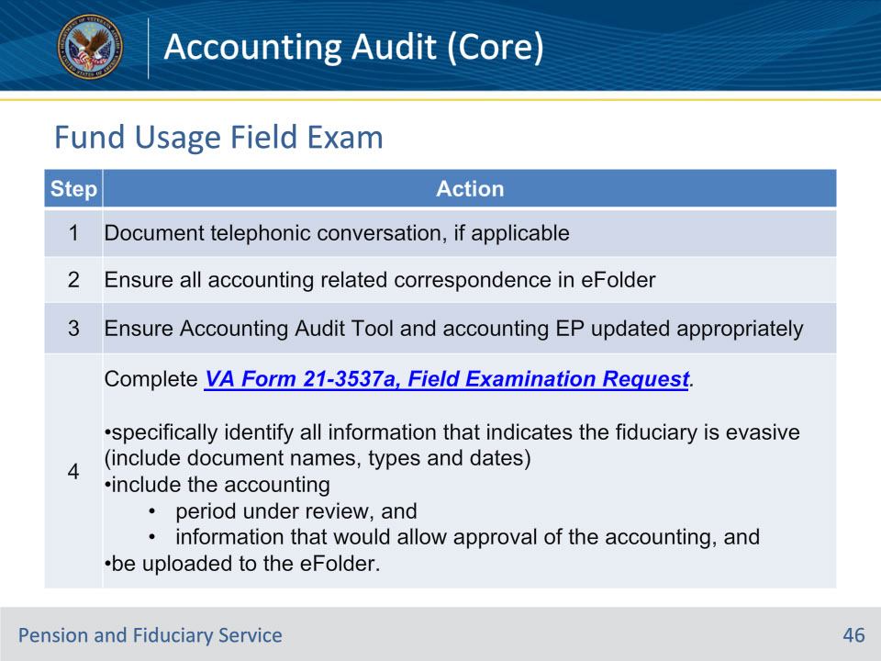
Slide notes

Policy Reference(s): FPM I.3.C.6.b.

Instructor Notes:

Follow the steps in this table to complete the fund usage field examination.

Slide 47 - Fund Usage Field Exam
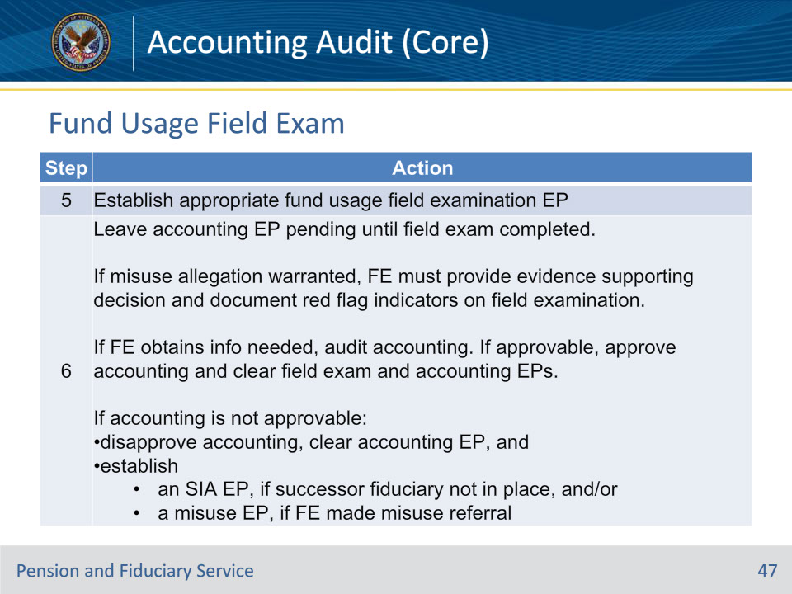
Slide notes

Policy Reference(s): FPM I.3.C.6.b.

Instructor Notes:

Follow the steps in this table to complete the fund usage field examination.

Important for Step 6:

Leave the accounting EP pending until the field examination is completed and either an accounting is available for audit and the FE determines that a misuse allegation is not warranted, or a misuse allegation is warranted.

The date of claim for the SIA EP is the date on which VA identifies or documents the fiduciary’s evasiveness.

Slide 48 - Questions?
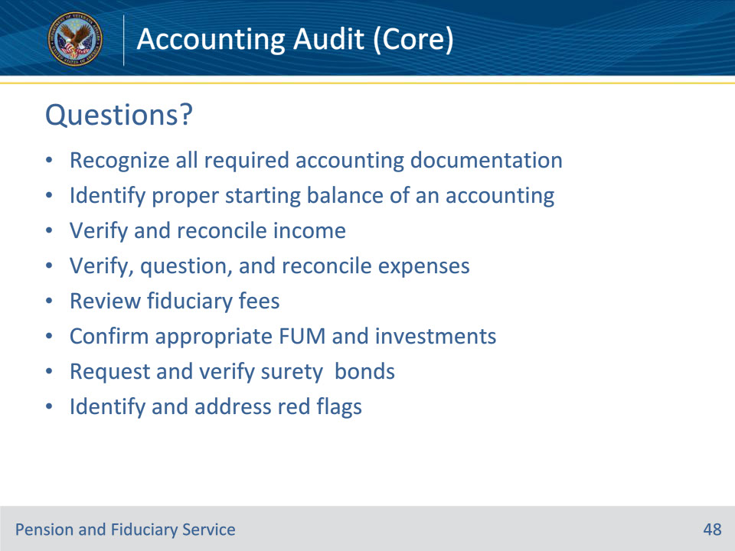
Slide notes

Instructor Notes:

(Recall) These are our learning objectives as stated from the beginning of the training:

• Recognize all required accounting documentation

• Identify proper starting balance of an accounting

• Verify and reconcile income

• Verify, question, and reconcile expenses

• Review fiduciary fees

• Confirm appropriate FUM and investments

• Request and verify surety bonds

• Identify and address red flags

Are there any questions?

Slide 49 - TMS Survey
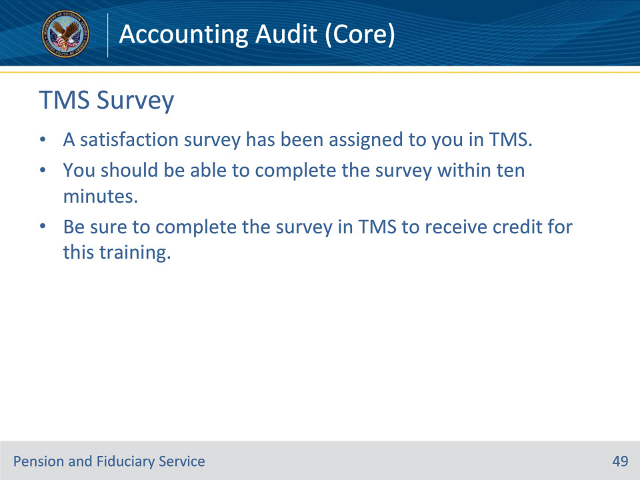
Slide notes

Instructor Notes:

A satisfaction survey has been assigned to you in TMS. You should be able to complete the survey within ten minutes. Completing the survey will allow you to receive credit for this training.

