Compensation Pension Knowledge Management Portal

for Claims Assistants

Trainee Handout

**Table of Contents**

Objectives 2

References 2

Topic 1: Introduction to the Compensation Pension Knowledge Management Portal 3

Topic 2: Searching the CPKM 4

Topic 3: Changes to the CPKM 8

CPKM Scavenger Hunt 10

Objectives

At the end of this lesson, the claims assistant will be able to:

* Recognize the Compensation Pension Knowledge Management (CPKM) Portal
* List characteristics of the CPKM
* Identify effective search strategies
* Explain how to find a list of changes by date, change date, and audience
* Demonstrate use of the manual for research

References

* [Compensation Service Homepage](https://vbaw.vba.va.gov/bl/21/index.htm)
* [Compensation & Pension Knowledge Management (CPKM)](https://vaww.vrm.km.va.gov/system/templates/selfservice/va_kanew/help/agent/locale/en-US/portal/554400000001034)
* [KnowVA](https://www.knowva.ebenefits.va.gov/system/templates/selfservice/va_ssnew/help/customer/locale/en-US/portal/554400000001018)

**Note:** KnowVa is an external-facing Web platform that provides Veterans, their families, survivors and Veteran advocates with access to the same information claims processors use to process and make decisions on benefit claims. Should the CPKM go down for any reason, you can access most information through KnowVA.

Topic 1: Introduction to the Compensation Pension Knowledge Management (CPKM) Portal

The Compensation Pension (CPKM) Portal was established in 2015, replacing the M21-1 MR (now labeled M21-1 Archive on the Compensation Service Homepage). With the transformation, it made searching for published guidance easier by putting everything in one location, rather than multiple. All existing published guidance has been incorporated in the M21-1, as applicable, making it easier to navigate through the information.

The CPKM is listed under the Publications subsection in the Miscellaneous Section on the Compensation Website (<https://vbaw.vba.va.gov/bl/21/index.htm>).

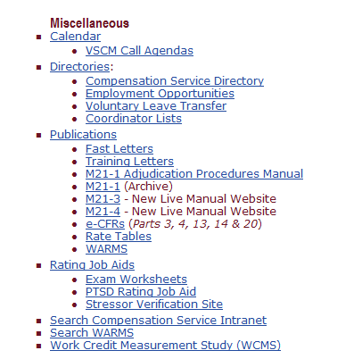

Selecting M21-1 Adjudication Procedures Manual will open the main page of the CPKM.

The main page of the CPKM contains:

* Breaking News links
* Recently Changed Articles
* Most Popular links that you visit
* Search bar
* Browse Topics
* Additional links and drop downs

Once you enter the CPKM, if you move your mouse over the “Browse Topics” header, you will see 16 topics, each with their own separate pull outs of information. These 16 topics used to be housed in various locations on the Compensation Website; however, the transformation to CPKM made it so that they were more easily accessible. **Note:** This is where you will find the Knowledge Management Portal, formally known as the Live Manual.

Topic 2: Searching the CPKM

The most effective way to find information in the CPKM is by using the search function; however, if you are looking for a general area to search, or know which section of the portal you are looking for, you can use the “Browse Topics” drop down to find information as well.

The “Browse Topics” drop down contains 16 topics, each with their own separate drop downs of information. These can be found from the main page of the CPKM, or at any time while working in the manual, via the drop down in the top left corner of the page. Once you select one of these options, you will be routed to the publication displayed.

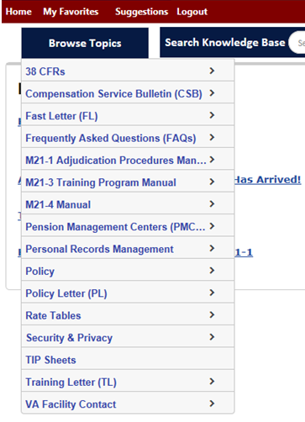

The “Browse Topics” header contains access to all 16 publication topics within the CPKM.

Next to this, is the option to *Search Knowledge Base*. This area is helpful if you are unsure of the exact location of the material needed, but know the general basis of what you are seeking. (For example, “unidentifiable mail”)

When entering keywords (such as “unidentifiable mail”) into the *Search Knowledge Base*, the CPKM does a search of **all** publications located within the portal and grants immediate access to any regulation or reference applicable to the search. By using this feature, you can get the most updated information pertinent to what you are looking searching.

Remember: When completing a search of the Knowledge Base,

* Use terms that are
* specific (relate to your actual topic)
* sensitive (aren’t included in every topic like “rating” or “decision”), and
* unique, if possible.
* Don’t use a long phrase because it will generate many topics unrelated to your search.

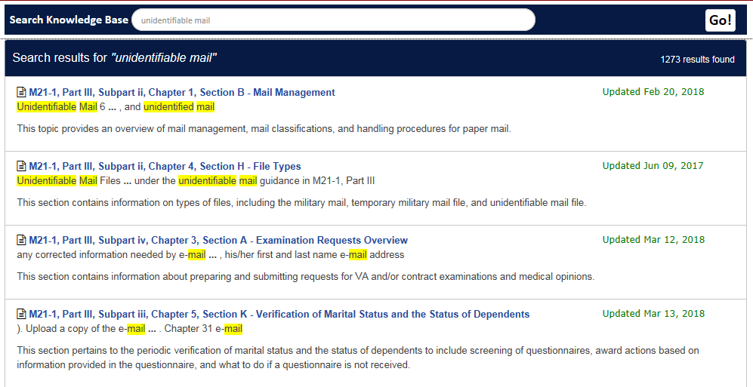

**Note:** When completing a search, depending on your keywords used, you could have a large number of results found. Some of these may not be relevant to what you are seeking. Should this happen, there are ways to refine your search.

First, you could consider trying a Boolean search. A Boolean search is a type of search that allows you to combine keywords with modifiers such as AND, NOT and OR. (For example: if the results for “unidentifiable mail” does not pull what you are looking for, you could broaden the topic by adjusting it to “unidentifiable mail AND new claim” if you are specifically look at what to do with new claims.)

You could also try alternate words. For example: use “FDC” instead of “fully developed claim”.

Notice that inputting the keywords “fully developed claim” generates 2755 results

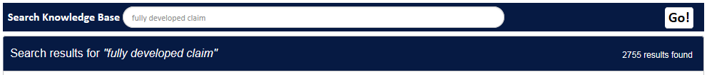

while “FDC” generates only 80.

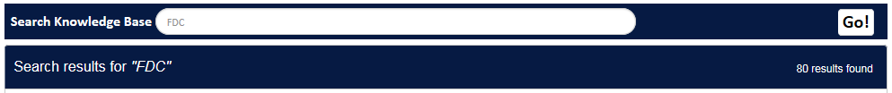

If you still cannot find what you’re seeking, or there are too many results found, you can refine your search by using the drop down options on the left side of the screen, under the “Browse Topics” selection. **Note:** This option only appears after you have input your keywords into the *Search Knowledge Base*.

In refining your search, you can narrow the results to a content type, a special benefit group, a target audience, or the process stage.

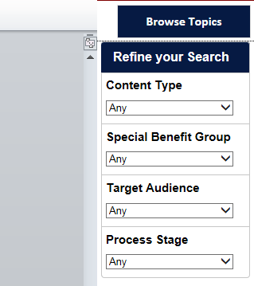

By selecting any of these drop downs, the CPKM will narrow the results provided based on the keywords input into your search bar.

The final option you have narrows down your search to one publication topic specifically. If you select a publication from the “Browse Topics” menu, directly below the *Search Knowledge Base*, a new search appears that reads *Search within this topic*.

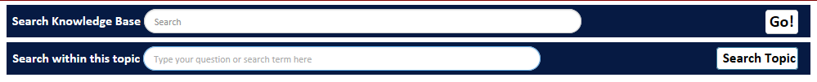

This option will help you narrow your search from all 16 topics in the CPKM to only the one applicable to your request.

Notice, when selecting the M21-1 Adjudication Procedures Manual, and inputting “unidentifiable mail” into the *Search within this Topic* option, your search results narrow from the 1273 results found above, to 219.

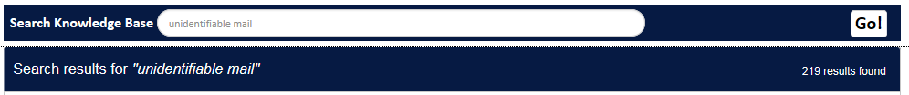

If you would like to search the manual through the “Browse Topics” option, note that the following layout is how each reference or regulation is read:

**Reading M21-1 Manual References**

Start with M21-1 III.iv.6.C.10.a:

* + **M21-1** (The Manual)
    - Part **III** (Which Part of the Manual)
      * Subpart **iv** (The Subpart of Part III)
        + Chapter **6** (The Chapter of the Subpart)

Section **C** (The Section of the Chapter)

Topic **10** (The Specific Topic of the Section)

Block **a** (The Specific Block of Information for the Topic)

***See the*** [***M21-1 Website Quick Reference User Guide***](https://vaww.compensation.pension.km.va.gov/system/templates/selfservice/va_ka/portal.html?encodedHash=%23!agent%2Fportal%2F554400000001034%2Ftopic%2F554400000003061%2FM21-1-Adjudication-Procedures-Manual) ***for additional information.***

**Reading CFR References**

Start with 38 CFR §3.309(a):

* + Title **38** (What Part of the CFR)
    - **CFR** (Code of Federal Regulations)
      * **§3.309** (What Regulation in CFR)
        + **(a)** (Specific Paragraph in Regulation)

Topic 3: Changes to the CPKM

Because the CPKM is a running collection of VA publications, it is constantly updated with new additions and changes.

There are several places that will show the change as well as the date of the change. When you actually go into the manual, you will see the date of the last change before each section. However, if you are looking for specific changes, you can go to the Calendar on the Compensation Homepage, the main page of the CPKM, or the “Changes by Date” pullout in the Browse Topics dropdown.

If you are looking for the overall changes that have taken place since the CPKM’s creation, the easiest way is to go into the main page of the CPKM, then go to “VA Changes By Date”.

To get here you will move your mouse over “Browse Topics” 🡪 M21-1 Adjudication Procedures Manual 🡪 VA Changes By Date.

This section will break the changes down by year, followed by month, then date. In addition to listing the date of the change, it will inform you of the change, but will also identify the target audience. While it is helpful to browse over the changes, this section will help notify you of the changes that are pertinent to you as claims processors.

For example:

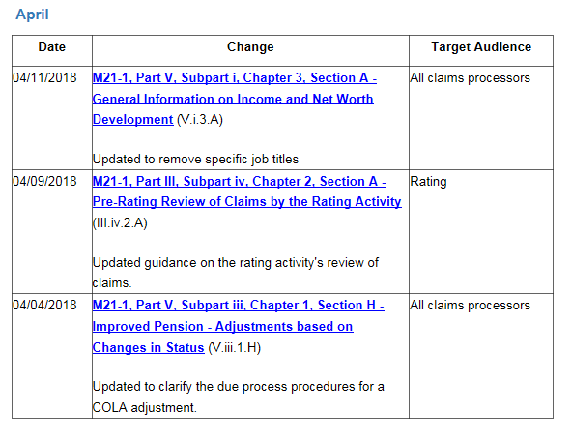

Does not apply to you as claims assistants

May apply to you as claims assistants

May apply to you as claims assistants

**Note:** The changes with a target audience of “Intake” and “All claims processors” apply to you, and should be read when updates occur.

If you are in the manual, looking for references, you will also notice a “change date” for each section. This date correlates with the date listed in the “VA Changes By Date” portion of the manual, so that you know the last time this section was updated. This information will fall directly below the introduction to the section.

For example, this shows you that the last update made to the reference regarding handling unidentifiable mail was on April 17, 2017.

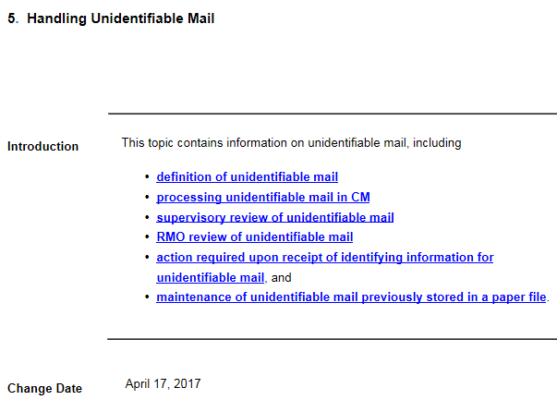

While it is good practice to know where these changes are, and keep informed, the CPKM has created a link within the calendar so that any time a change is made, you will receive an email at your VA account.

To set this up, you will select *Calendar* under the Miscellaneous section from the main page of the Compensation Intranet.

Once in the Calendar, you will notice there are several options to navigate through the information, from the main screen that identifies daily events, to the tabs on the left side of the screen that range from a search option to various calls and prior calendars.

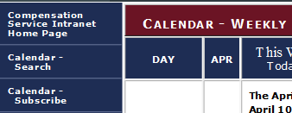

Select this option to input your VA email address and receive updates.

The third option on the toolbar on the left is titled “Calendar – Subscribe”. This is where you will enter your **VA email address** and your organization (Regional Office), then select *submit.*

After you submit this information, the changes that are listed in the “VA Changes By Date” screen will be automatically emailed to you when they occur.

CPKM Scavenger Hunt

Using the PowerPoint, Handout, and your notes, navigate through the CPKM and Compensation Intranet Homepage, in order to answer the following questions:

1. List the Web Address for the Compensation Service Intranet Home Page:
2. How do you access the M21-1 Adjudication Procedures Manual website?
3. How many parts of the manual are there? What are they?

1. What are the two methods for searching the CPKM?

1.

2.

1. Within the M21-1 Adjudication Procedures Manual, what are the 16 topics listed within “Browse Topics”?

1.

2.

3.

4.

5.

6.

7.

8.

9.

10.

11.

12.

13.

14.

15.

16.

1. What is the manual reference that provides guidance for processing Fully Developed Claims?
2. What are three types of claims that require priority processing?
3. Where would you find the Index of Claim Attributes?
4. What is the purpose of special issues?
5. What manual reference discusses the PMR Retrieval Program?
6. What special issue does the code AOIV stand for? What is it used for?

1. What is the end product used for initial disability compensation claims with seven issues or less?
2. What manual reference shows the step by step process for establishing claims in VBMS?
3. What is the manual reference that provides the criteria for substantially complete applications?
4. What is the 3-digit number that identifies the Roanoke Regional Office?
5. What manual reference identifies the steps taken to update contact information in VBMS?
6. Which Regional Office (RO) is responsible for processing of Radiation exposure claims?
7. Which Regional Office (RO) is responsible for processing of Chapter 18, Spina Bifida claims?
8. What is the manual reference that discusses notification requirements for special issues? What is the date that it was last updated?
9. What are the four classes of mail that Veterans Service Centers (VSCs) and pension management centers (PMCs) routinely handle?