Intent To File (ITF)

Trainee Handout

**Table of Contents**

Objectives 2

References 2

Topic 1: ITF 3

Topic 2: ITFs in VBMS 6

Topic 3: Duplicate ITFs 10

Practical Exercise 11

Objectives

* Understand the importance of **March 24, 2015**, as it relates to the communication of an ITF
* Recognize what kind of claims ITFs apply to and how they can be communicated
* Know required elements of an ITF and development actions needed for an inadequate communication of an ITF
* Locate list of ITFs in VBMS and determine their status
* Identify possible duplicate ITFs

References

* [38 CFR 3.155(b), Intent to File a claim](http://www.ecfr.gov/cgi-bin/text-idx?SID=b12a2641b53d64328cb803138210d8ea&node=se38.1.3_1155&rgn=div8)
* [M21-1 Part III, Subpart ii, 2.C, Informal Claims Received prior to March 24, 2015, Communication of an Intent to File (ITF), and Requests for Application](https://vaww.compensation.pension.km.va.gov/system/templates/selfservice/va_ka/portal.html?encodedHash=%23!agent%2Fportal%2F554400000001034%2Farticle%2F554400000014115%2FM21-1-Part-III-Subpart-ii-Chapter-2-Section-C-Informal-Claims-Received-Prior-to-March-24-2015-Communication-of-an-Intent-to-File-ITF-and-Requests-for-an-Application%3FfromQuery%3Ditf)

Topic 1: Intent to File (ITF)

**March 24, 2015**

Informal claims were important prior to March 24, 2015, because VA could possibly grant entitlement to benefits as early as the date of receipt of an informal claim, as long as VA received a formal claim within one year of the date VA sent the claimant an application.

VA stopped accepting informal claims on March 24, 2015. Claimants desiring an “effective date placeholder” must now communicate to VA a formal “intent to file” a claim. What we mean by “effective date placeholder” is that VA may grant entitlement to benefits from an effective date prior to the formal date of claim (DOC) as long as the claimant submits a complete claim within one year of the date VA received the ITF.

**Status of ITFs:**

The status of each communication of an ITF that VA receives is displayed in Share and VBMS.  The table below provides the meaning behind each status the system may assign.

| **Status** | **Meaning** |
| --- | --- |
| *Active* | VA received a communication of an ITF that contains the required elements set forth in [M21-1, Part III, Subpart ii, 2.C](https://vaww.compensation.pension.km.va.gov/system/templates/selfservice/va_ka/#2b)    A communication of an ITF remains in this status until the ***earlier*** of the following occur:   * VA receives a substantially complete application for benefits, or * the one-year period following VA’s receipt of the communication ends.   ***Note***:  No more than one communication of an intent to file a claim for a general benefit may be in an active status at any given period of time. |
| *Duplicate* | While a communication of an intent to file a claim for a general benefit is in an active status, VA receives another communication of an intent to file a claim for the same benefit. |
| *Incomplete* | VA received a communication of an ITF that did ***not*** contain the required elements set forth in [M21-1, Part III, Subpart ii, 2.C](https://vaww.compensation.pension.km.va.gov/system/templates/selfservice/va_ka/#2b) |
| *Expired* | The claimant failed to submit a substantially complete application within one year of the date VA received a communication of an ITF from the claimant. |
| *Claim Received* | VA received a substantially complete application for a benefit from a claimant within one year of the date VA received a communication of an intent to file a claim for the same general benefit from the claimant. |
| *Canceled* | An ITF was established erroneously and subsequently canceled by a VA employee with an associated cancellation reason, such as *Incorrect Received Date*. |

**Benefits ITF Does and Does Not Apply to:**

ITF applies to claims for:

* Compensation
* Pension
* Survivors Pension, and
* DIC.

An ITF is specific to the benefit sought. When the claim received is not for the same type of benefit identified on the ITF, the ITF may not be applied to the claim for purposes of effective date assignment. For example, an ITF identifying pension as the benefit sought cannot be applied to a subsequent claim for compensation.

The following are examples of benefits or types of claims to which ITF does not apply:

* requests for dependency
* ancillary benefits
* requests for reconsideration
* duplicate claims
* requests for review based on clear and unmistakable error.

**Required Elements of an ITF:**

A claimant’s communication of an ITF is adequate for VA purposes if, in the communication, the claimant:

1. provides VA with enough information to identify the Veteran (***and*** the claimant, if the claimant is *not* the Veteran), and
2. specifies the general benefit he/she is seeking (compensation and/or pension, or Survivors Pension and/or Dependency and Indemnity Compensation (DIC))

***Notes***:

* The ***initiation*** of an application for benefits via eBenefits/VDC or SEP constitutes an acceptable communication of an ITF.
* When an ITF is submitted in writing, it must be submitted on[*VA Form 21-0966*](http://vbaw.vba.va.gov/bl/20/cio/20s5/forms/VBA-21-0966-ARE.pdf)*.*  [*VA Form 21-0966*](http://vbaw.vba.va.gov/bl/20/cio/20s5/forms/VBA-21-0966-ARE.pdf) must be signed by
  + the claimant
  + the claimant’s Veterans service organization (VSO), or
  + a VA-recognized power of attorney (POA).
* As long as VA can identify the claimant via information included on *VA Form 21-0966* or other information submitted with the form, the only sections of *VA Form 21-0966* a claimant must complete are the sections titled *General Benefit Election* and *Declaration of Intent* (Sections II and III on the July 2015 version of the form). Assume the claimant is the Veteran if he/she leaves the *Claimant/Veteran Identification* (Section I) of the form blank.
* If a claimant communicates his/her ITF by contacting a VA call center, and the claimant does not have a corporate record, a call center employee must complete, sign, and submit [*VA Form 21-0966*](http://vbaw.vba.va.gov/bl/20/cio/20s5/forms/VBA-21-0966-ARE.pdf) on the claimant's behalf.
* A claimant may communicate his or her ITF to a Field Examiner as directed in the [Fiduciary Program Manual (FPM) 2.D](https://vbaw.vba.va.gov/PENSIONANDFIDUCIARY/fiduciary/Fiduciary_Manual.asp).

**6 Ways to Communicate an ITF:**

1. a claimant initiates an application for benefits via eBenefits/VDC, or a VSO, claim agent, or private attorney initiates a claim through SEP
2. a VSO submits *VA Form 21-0966* on a claimant’s behalf via D2D
3. a claimant communicates an ITF to a VA call center
4. a claimant submits a completed *VA Form 21-0966* to VA
5. a claimant communicates an ITF to a VSC/PMC employee
6. a claimant communicates an ITF to a Field Examiner

Topic 2: ITFs in VBMS

An ITF is automatically established when:

* The VSO submits via SEP or D2D.
* The claimant communicates an intent to file a claim to the National Call Center (NCC) and a corporate record exists
* The claimant initiates a claim in eBenefits.

An ITF is manually established when the claimant or POA:

* communicates an intent to file a claim to a VBA employee (i.e. VSR or RVSR)
* The claimant communicates an intent to file a claim to the National Call Center (NCC) and a corporate record ***does not*** exist
* submits the paper copy of VA Form 21-0966 and Claims Analysts/Intake Analysts enter it through Share/VBMS

**Accessing ITF Information in VBMS**

ITF information can be found on the “Intent To File” screen under the “Veteran” tab in VBMS.

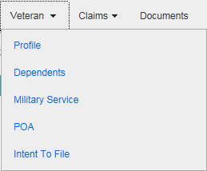

**Select a Status**

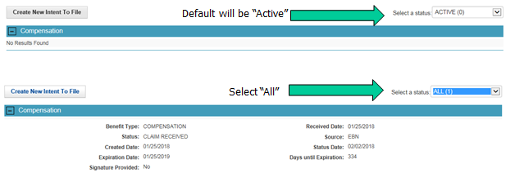

Ensure the status you have selected is on “All” as this box will default to “Active” which may not show all the pertinent information regarding this claim.

**Entering an ITF in VBMS**

ITFs can be manually entered on the “Intent To File” screen using the “Create New Intent To File” button.

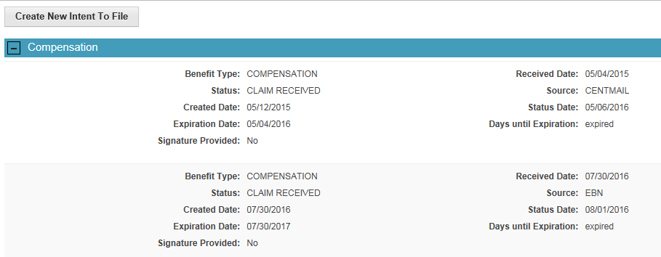

**Incomplete VA Form 21-0966**

If VA Form 21-0966 is missing a required element, **and VA has not received a subsequent claim**, telephone development should be attempted to obtain the missing information. If telephone development is unsuccessful, an “Incomplete ITF” letter must be sent to the claimant. This letter is automatically generated by entering an “Incomplete” ITF in VBMS (selecting the benefit is unidentified and/or the signature is missing).

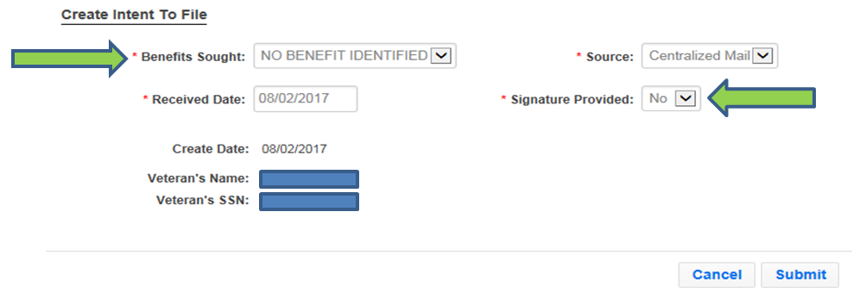

If a subsequent claim has been received an “Incomplete ITF – Claim Received” letter should be sent using the Letter Creator program, so that the automatic VBMS letter is not sent.

**ITF Acknowledgement Letter**

When a valid ITF is communicated online or entered in VBMS, and a substantially complete claim is NOT submitted online the same day, an automatically generated letter is sent to the claimant acknowledging receipt of the ITF. This letter informs the claimant when we received the ITF and what they need to do to submit a claim.

Historically a copy of this letter was placed into the “Legacy Content Manager Documents” in VBMS. Currently the letter is placed into the eFolder.



**Incomplete VA Form 21-0966**

If VA Form 21-0966 is missing a required element, **and VA has not received a subsequent claim**, telephone development should be attempted to obtain the missing information. If telephone development is unsuccessful, an “Incomplete ITF” letter must be sent to the claimant. This letter is sent automatically when an incomplete ITF is entered in VBMS.

**If a subsequent claim has been received** an “Incomplete ITF – Claim Received” letter should be sent using the Letter Creator program, so that the automatic VBMS letter is not sent.

**VA Form 21-0966 in VBMS?**

A VA Form 21-0966 historically have NOT appeared in the Documents list if the ITF was communicated by initiating an application online, calling the NCC or NPCC, or spoken to a VSC or PMC employee who has immediate access to VBMS (to enter the ITF). In these situations, ITF information can be found on the ITF screen in VBMS (see the ITF VBMS video for more information).

Note: If a claimant does not have a corporate record, a call center employee must complete, sign, and submit [*VA Form 21-0966*](http://www.vba.va.gov/pubs/forms/VBA-21-0966-ARE.pdf) on the claimant's behalf.

**Request for Application**

Consider a request for benefits which was ***not*** filed on an appropriate prescribed form on or after March 24, 2015, a Request for Application (RFA). A RFA letter should be sent to the claimant informing them what they need to do to submit an ITF and/or formal claim. It should be generated in VBMS using the process described below.

Follow the steps in the table below to provide the claimant notice of receipt of a request for application and the need for submission of a claim on a proper form.

|  |  |
| --- | --- |
| **Step** | **Action** |
| 1 | Ensure the request for application is associated with the Veteran’s claims folder. |
| 2 | Establish EP 400 with the date of claim (DOC) as the date the request for application was received.  Apply the appropriate claim label, including   * Request for Application (compensation), or * PMC Request for Application (pension/DIC). |
| 3 | The *RFA Letter Information* pop-up screen will appear, as shown below.  ***Example***:  RFA Letter Information pop-up screen.   * If the address information is incorrect, select BACK to edit address information. * If the address information is correct, select CONTINUE to proceed with generation of the notice letter. |
| 4 | Review the generated letter for accuracy. The EP 400 will be automatically cleared during this process. No additional user action is required to complete the process of notifying the claimant on receipt of a request for application and need to submit a claim on the proper form. |

Topic 3: Identify Possible Duplicate ITFs

An ITF remains active for one year or until a claim is received, whichever occurs earlier. Any subsequent duplicate ITF submitted for the same benefit during the active period will have no effect on benefit entitlement.

***Notes:***

* Only one ITF can be active at a time. If another ITF is received while an active ITF exists, it is a “Duplicate” ITF.
* Search the Documents in VBMS for current “active” ITF.
* If there is a current ITF, mark the subsequent ITF as “Duplicate”.

**ITF VBMS Video**

**Please watch the ITF VBMS Video:** [ITF Video](http://media.ttande.org/video/Comp_Svc/4203116.html)

Please note Virtual VA was the historic name of Legacy Content Manager and this video provides information for how an effective date is determined by a Rating Veteran Service Representative. Please focus on the different areas to locate information and how the information is coded in VBMS.

Practical Exercise

1. What is the date that determines if communication indicating a desire for benefits is considered an informal claim or Intent to File (ITF)?
2. What are the four ways a claimant may communicate an ITF?

1.

2.

3.

4.

1. What are the three possible required elements of an ITF?

1.

2.

3.

1. Does ITF apply to a claim for additional benefits for dependents?

1. Once an ITF is entered into the system it will contain a status that will be displayed in Share and VBMS. What are the six possible statuses?

1. 4.

2. 5.

3. 6.