Complete Application and Payee Codes
Instructor Lesson Plan
Time Required: 2.25 Hours

Table of Contents

Lesson Description 2
Introduction to a Complete Application 4
Topic 1: Substantially Complete Application 6
Topic 2: Payee Codes 10
Practical Exercise 13
Lesson Review, Assessment, and Wrap-up 14

Lesson Description
The information below provides the instructor with an overview of the lesson and the materials that are required to effectively present this instruction.
TMS # | 4456250
Prerequisites | Prior to this lesson, the Claims Assistant (CA). Trainees should also have completed the Introduction to Standard forms lesson first.
target audience | The target audience for Complete Application and Payee Code is Entry Level Claims Assistants (CA).  Although this lesson is targeted to teach the CA, it may be taught to other VA personnel as mandatory or refresher type training.
Time Required | 2.25 hours
Materials/  TRAINING AIDS | Lesson materials:  - Complete Application and Payee Code PowerPoint Presentation  - Complete Application and Payee Code Trainee Handouts  - Complete Application and Payee Code Answer Key
Training Area/Tools | The following are required to ensure the trainees are able to meet the lesson objectives:  - Classroom or private area suitable for participatory discussions  - Seating, writing materials, and writing surfaces for trainee note taking and participation  - Handouts, which include a practical exercise  - Large writing surface (easel pad, chalkboard, dry erase board, overhead projector, etc.) with appropriate writing materials  - Computer with PowerPoint software to present the lesson material  Trainees require access to the following tools:  - VA TMS to complete the assessment
Pre-Planning | - Become familiar with all training materials by reading the Instructor Lesson Plan while simultaneously reviewing the corresponding PowerPoint slides. This will provide you the opportunity to see the connection between the Lesson Plan and the slides, which will allow for a more structured presentation during the training session.  - Become familiar with the content of the trainee handouts and their association to the Lesson Plan.  - Practice is the best guarantee of providing a quality presentation. At a minimum, do a complete walkthrough of the presentation to practice coordination between this Lesson Plan, the trainee handouts, and the PowerPoint slides and ensure your timing is on track with the length of the lesson.  - Ensure that there are copies of all handouts before the training session.  - When required, reserve the training room.  - Arrange for equipment such as flip charts, an overhead projector, and any other equipment (as needed).  - Talk to people in your office who are most familiar with this topic to collect experiences that you can include as examples in the lesson.  - This lesson plan belongs to you. Feel free to highlight headings, key phrases, or other information to help the instruction flow smoothly. Feel free to add any notes or information that you need in the margins.
Training Day | - Arrive as early as possible to ensure access to the facility and computers.  - Become familiar with the location of restrooms and other facilities that the trainees will require.  - Test the computer and projector to ensure they are working properly.  - Before class begins, open the PowerPoint presentation to the first slide. This will help to ensure the presentation is functioning properly.  - Make sure that a whiteboard or flip chart and the associated markers are available.  - The instructor completes a roll call attendance sheet or provides a sign-in sheet to the students. The attendance records are forwarded to the Regional Office Training Managers.

Introduction to a Complete Application
INSTRUCTOR INTRODUCTION |  | Complete the following:  - Introduce yourself  - Orient learners to the facilities  - Ensure that all learners have the required handouts
time required |  | 0.25 hours
Purpose of Lesson  Explain the following: |  | This lesson is intended to explain the criteria for a substantially complete application and proper action to take for incomplete applications. This lesson will contain discussions and exercises that will allow you to gain a better understanding of:  - Identify a substantially complete application.  - Identify an incomplete application.  - Select proper actions when an incomplete application is received.  - Select proper actions when a claim is based on allegation of exposure.  - Identify when a Payee Code is required.  - Determine the correct Payee Code to apply during Claims Establishment.
Lesson Objectives  Discuss the following:  Slide 2  Handout 2 | In order to accomplish the purpose of this lesson, the CA will be required to accomplish the following lesson objectives.  The CA will be able to:  - Identify a substantially complete application.  - Identify an incomplete application.  - Select proper actions when an incomplete application is received.  - Select proper actions when a claim is based on allegation of exposure.  - Identify when a Payee Code is required.  - Determine the correct Payee Code to apply during Claims Establishment.
Explain the following: | Each learning objective is covered in the associated topic. At the conclusion of the lesson, the learning objectives will be reviewed.
Motivation | Trainees will be able to differentiate between a complete and incomplete application.
References  Slide 3  Handout 3 | Explain where these references are located in the workplace.  All M21-1 references are found in the CPKM.  - M21-1, Part I, Section B, 1, Criteria for Substantially Complete Applications  - M21-1, Part III, Subpart ii, Chapter 2, Section B, What Constitutes a Substantially Complete Application  - 38 CFR 3.160 (a)  - 38 CFR 3.159 (a)(3)  - M21-4, Appendix A, Section II, Payee Codes  - M21-4, Appendix B, Section 1, End Products

Topic 1: Substantially Complete Application
Introduction | This topic will allow the trainee to recognize a complete application.
Time Required | 1 hour
OBJECTIVES/  Teaching Points | Topic objectives:  - Identify a substantially complete application.  - Identify an incomplete application.  - Select proper actions when an incomplete application is received.  - Select proper actions when a claim is based on allegation of exposure.
Criteria for Substantially Complete Applications  Slide 4  Handout 4 | A substantially complete application must include the following:  - claimant’s name and relationship to the veteran, if applicable  - sufficient service information for the VA to verify the Veteran’s service, if applicable  - benefit claimed  - disability(ies) on which the claim for benefits is based  - signature of the claimant or another legally authorized individual, and  - statement of income for Veterans pension, Survivors pension, or Parents' Dependency and Indemnity Compensation (DIC), if claimed.
Criteria for Substantially Complete Applications  Slide 5  Handout 4 | Upon receipt of an application for benefits, VA must determine the claim is substantially complete.  Note: If the claim was received on an EZ form, then in most instances requirements regarding Section 5103 notice has been fulfilled.  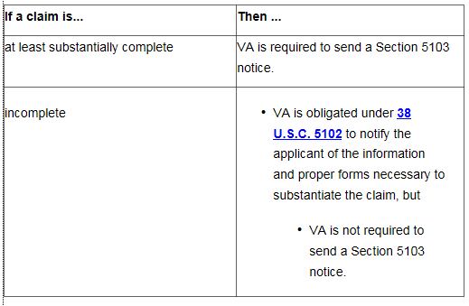
Acceptable Signature  Slide 6  Handout 4 | Faxed or photocopied versions of original wet signatures are acceptable for VA purposes.  Accept any electronic or digital signature or other image of a signature on a claim or appeal for benefits, or associated form, unless there are clear indications of fraud.  Accept signatures by X mark or thumbprint only if any one of the following individuals (or group of individuals) witness the mark or thumbprint:  - two persons who give their addresses  - a VA employee  - a Veterans service organization (VSO) representative  - an attorney  - an accredited agent  - a notary public, or  - a person having the authority to administer oaths for general purposes.
Incomplete Application  Slide 7-10  Handout 5-6 | In absence of any of the required information, the application is considered incomplete. Follow the steps in the table below to notify the claimant of the information necessary to complete the claim.  Step Action  1 Whenever possible, contact the claimant first by telephone to obtain the information needed to complete the application.  2 If the information necessary to complete the application cannot be obtained by telephone - establish an EP 400 to control the correspondence, or - change the erroneously established EP to an EP 400 - with an Incomplete Application claim label, and - use the date the application was received as the control date.  3 Cancel any other erroneously established EP associated with the incomplete claim.  4 Notate the incomplete application in the claims folder by changing the document’s subject to Incomplete Application.  5 Print a copy of the incomplete application.  6 Mark the blocks on the application in red that require the claimant’s attention.  7 Use the Incomplete Application letter included in the Letter Creator tool or equivalent letter from Personal Computer Generated Letters (PCGL) to return the incomplete application to the claimant and claimant’s representative, if any. Include notice - of the information VA needs to consider the application complete, and - that failure to submit a substantially complete application within one year will result in no benefit being paid or furnished by reason of that application.  8 Add a copy of the Incomplete Application letter to the claims folder.  9 Clear the EP 400.  Note: If a complete claim is submitted within one year of the date of receipt of an incomplete application,  - consider the complete application filed as of the date the incomplete application form was received, but  - use the date of receipt of the complete claim as the date of claim.
Incomplete Applications  Slide 11  Handout 6 | Example: The Veteran submits a VA Form 21-526EZ, Application for Disability Compensation Benefits, which includes the following:  -Veteran’s name - Signature  -Social Security number - Disability listed: right leg condition  Multiple searches were completed with the information provided but no record was able to be retrieved via SHARE, VBMS, or CAPRI. What is the next step with this claim?  Answer: Insufficient service information for the VA to verify the Veteran’s service was provided. Telephone development to the Veteran should be attempted. If contact attempt is unsuccessful, then follow steps in slides 7 through 9.
Incomplete Application based on Exposure Allegation  Slide 12  Handout 6-7 | An allegation of exposure to a potentially hazardous substance during service without an associated claim for SC for a specific disability resulting from the exposure is not a substantially complete claim. In these cases, follow the procedures in M21-1, Part I, 1.B. In the notification letter, also  - inform the Veteran that exposure, in and of itself, is not a disability, and  - ask the Veteran to identify the disability(ies) that resulted from exposure during service.
Incomplete Application based on Exposure Allegation  Slide 13  Handout 7 | Important: Do not  - Process the claim as a denial, or  - Establish EP control for the incomplete claim unless there are other complete claims also submitted.  Examples:  - Radiation  - Agent Orange  - Mustard Gas  - Herbicides  - Asbestos  - Environmental hazards during service in Southwest Asia  - Other hazards  The Veteran may attest these issues occurred when a disability is claimed, but these issues may be solely be raised without name a specific disability.
Exercise | Have students review the four VA Form 21-526EZs found within the training materials. Please have them review his/her handouts for questions which will need to be answered. Answers will be found within Answer Key.

Topic 2: Payee Codes
Introduction | This topic will allow the trainee to identify the correct payee code to be used for the claim to be established.
Time Required  objectives/  teaching points | 0.25 hours  Topic objectives:  - Identify when a Payee Code is required.  - Determine the correct Payee Code to apply during Claims Establishment.
Payee Code  Slide 15  Handout 8 | Payee code is a mandatory field needed during the claims establishment process. VBMS will provide a list of options from a drop down menu.  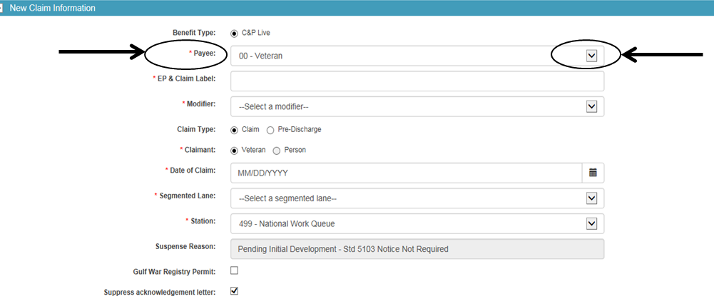
Payee Code  Slide 16  Handout 9 | 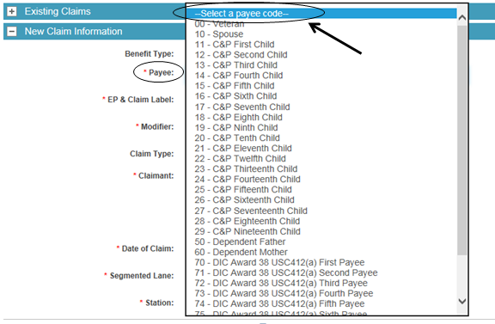
Payee Code  Slide 17-20  Handout 9-11 | The appropriate payee code is assigned by the user during claims establishment:  Payee Payee Code  Veteran 00  First Payee Recipient 01  Second Payee Recipient 02  Third Payee Recipient 03  Fourth Payee Recipient 04  Fifth Payee Recipient 05  Sixth Payee Recipient 06  Seventh Payee Recipient 07  Eighth Payee Recipient 08  Ninth Payee Recipient 09  Spouse 10  C&P First Child 11  C&P Second Child 12  C&P Third Child 13  C&P Fourth Child 14  C&P Fifth Child 15  C&P Sixth Child 16  C&P Seventh Child 17  C&P Eighth Child 18  C&P Ninth Child 19  C&P Tenth Child 20  C&P Eleventh Child 21  C&P Twelfth Child 22  C&P Thirteenth Child 23  C&P Fourteenth Child 24  C&P Fifteenth Child 25  C&P Sixteenth Child 26  C&P Seventeenth Child 27  C&P Eighteenth Child 28  C&P Nineteenth Child 29  Vendor 30  Consolidated Payee 1st group of children 31  Consolidated Payee 2nd group of children 32  Consolidated Payee 3rd group of children 33  Consolidated Payee 4th group of children 34  Consolidated Payee 5th group of children 35  Consolidated Payee 6th group of children 36  Consolidated Payee 7th group of children 37  Consolidated Payee 8th group of children 38  Consolidated Payee 9th group of children 39  CH35 First Child 41  CH35 Second Child 42  CH35 Third Child 43  CH35 Fourth Child 44  CH35 Fifth Child 45  CH35 Sixth Child 46  CH35 Seventh Child 47  CH35 Eighth Child 48  CH35 Ninth Child 49  Dependent Father 50  Dependent Mother 60  DIC Award 38 USC412(a) First Payee 70  DIC Award 38 USC412(a) Second Payee 71  DIC Award 38 USC412(a) Third Payee 72  DIC Award 38 USC412(a) Fourth Payee 73  DIC Award 38 USC412(a) Fifth Payee 74  DIC Award 38 USC412(a) Sixth Payee 75  DIC Award 38 USC412(a) Seventh Payee 76  DIC Award 38 USC412(a) Eighth Payee 77  DIC Award 38 USC412(a) Ninth Payee 78  First Claimant Burial/Accrued 80  Second Claimant Burial/Accrued 81  Third Claimant Burial/Accrued 82  Fourth Claimant Burial/Accrued 83  Fifth Claimant Burial/Accrued 84  Sixth Claimant Burial/Accrued 85  Seventh Claimant Burial/Accrued 86  Eighth Claimant Burial/Accrued 87  Ninth Claimant Burial/Accrued 88  Tenth Claimant Burial/Accrued 89  Institutional Veteran CFR3.852 99
Payee Code – Practice Exercise  Slides 21-23  Handout 11 | Instructor: Answers for these are found within the Answer Key.  Example 1: Veteran submits a VA Form 21P-527EZ, Application for Pension, on January 26, 2018. Which payee code would be utilized in this situation?  Example 2: Surviving spouse submits a VA Form 21P-524EZ, Application for DIC, Death Pension and/or Accrued Benefits, on December 14, 2017. Which payee code would be utilized in this situation?  Example 3: Veteran’s name is Michelle. Veteran’s spouse, Roger, submits a claim for apportionment for daughter Clara. Which payee code would be utilized in this situation?  Example 4: Veteran’s name is Samuel. Veteran’s daughter, Emily, submits a claim for apportionment. Which payee code would be utilized in this situation?  Example 5: Veteran’s name is Lauren. Veteran submits a VA Form 21-526, Veterans Application for Compensation and/or Pension. Which payee code would be utilized in this situation?  Example 6: Veteran’s name is Eric. Veteran submits a VA Form 21-526EZ, Application for Disability Compensation and Related Compensation Benefits. Which payee code would be utilized in this situation?  Note: Example 6 is the most common form received when Veterans apply for Compensation.

Practical Exercise
Time Required | 0.5 hours
EXERCISE | Have the Claims Assistants complete the exercise independently or in small groups.  Ask if there are any questions about the information presented in the exercise, and then proceed to the Review.

Lesson Review, Assessment, and Wrap-up
Introduction  Discuss the following: | The How to Identify a Complete Application, Payee Codes, and End Products lesson is complete.  Review each lesson objective and ask the trainees for any questions or comments.
Time Required | 0.25 hours
Lesson Objectives | You have completed the How to Identify a Complete Application, Payee Codes, and End Products lesson.  The trainee should be able to:  - Identify a complete application  - Identify the correct Payee Code to use  - Use the correct End Product
Assessment | Remind the trainees to complete the on-line assessment in TMS to receive credit for completion of the course.  The assessment will allow the participants to demonstrate their understanding of the information presented in this lesson.

