Complete Application and Payee Codes

Trainee Handout

**Table of Contents**

Objectives 2

References 3

Topic 1: Substantially Complete Application 4

Practical Exercise 8

Topic 2: Payee Codes 9

Practical Exercise 12

Objectives

In order to accomplish the purpose of this lesson, the CA will be required to accomplish the following lesson objectives.

The CA will be able to:

* Identify a substantially complete application.
* Identify an incomplete application.
* Select proper actions when an incomplete application is received.
* Select proper actions when a claim is based on allegation of exposure.
* Identify when a Payee Code is required.
* Determine the correct Payee Code to apply during Claims Establishment.

References

All M21-1 references are found in the [CPKM](https://vaww.compensation.pension.km.va.gov/).

* M21-1, Part I, Section B, 1, Criteria for Substantially Complete Applications
* M21-1, Part III, Subpart ii, Chapter 2, Section B, What Constitutes a Substantially Complete Application
* 38 CFR 3.160 (a)
* 38 CFR 3.159 (a)(3)
* M21-4, Appendix A, Section II, Payee Codes
* M21-4, Appendix B, Section 1, End Products

# Topic 1: Substantially Complete Application

**Criteria for Substantially Complete Applications**

A substantially complete application must include the following:

* claimant’s name and relationship to the Veteran, if applicable
* sufficient service information for the VA to verify the Veteran’s service, if applicable
* benefit claimed
* disability(ies) on which the claim for benefits is based
* signature of the claimant or another legally authorized individual, and
* statement of income for Veterans pension, Survivors pension, or Parents' Dependency and Indemnity Compensation (DIC), if claimed.

Upon receipt of an application for benefits, VA must determine the claim is substantially complete.

Note: If the claim was received on an EZ form, then in most instances requirements regarding Section 5103 notice has been fulfilled.

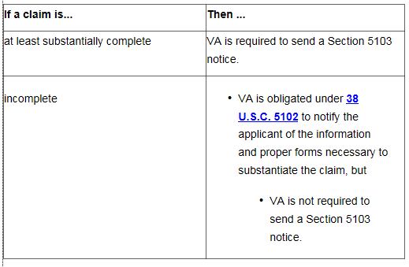

**Acceptable Signature**

Faxed or photocopied versions of original wet signatures are acceptable for VA purposes.

Accept any electronic or digital signature or other image of a signature on a claim or appeal for benefits, or associated form, unless there are clear indications of fraud. 

Accept signatures by *X* mark or thumbprint ***only*** if any one of the following individuals (or group of individuals) witness the mark or thumbprint:

* two persons who give their addresses
* a VA employee
* a Veterans service organization (VSO) representative
* an attorney
* an accredited agent
* a notary public, or
* a person having the authority to administer oaths for general purposes.

**Incomplete Application**

In absence of any of the required information, the application is considered incomplete. Follow the steps in the table below to notify the claimant of the information necessary to complete the claim.

| **Step** | **Action** |
| --- | --- |
| 1 | Whenever possible, contact the claimant first by telephone to obtain the information needed to complete the application. |
| 2 | If the information necessary to complete the application cannot be obtained by telephone   * establish an EP 400 to control the correspondence, or * change the erroneously established EP to an EP 400   + with an Incomplete Application claim label, and   + use the date the application was received as the control date. |
| 3 | Cancel any other erroneously established EP associated with the incomplete claim. |
| 4 | Notate the incomplete application in the claims folder by changing the document’s subject to Incomplete Application. |
| 5 | Print a copy of the incomplete application. |
| 6 | Mark the blocks on the application in red that require the claimant’s attention. |
| 7 | Use the Incomplete Application letter included in the [Letter Creator](http://vbacodmoint1.vba.va.gov/bl/21/LetterGenerator/LG.asp) tool or equivalent letter from Personal Computer Generated Letters (PCGL) to return the incomplete application to the claimant and claimant’s representative, if any.  Include notice   * of the information VA needs to consider the application complete, and * that failure to submit a substantially complete application within one year will result in no benefit being paid or furnished by reason of that application. |
| 8 | Add a copy of the Incomplete Application letter to the claims folder. |
| 9 | Clear the EP 400. |

***Note***:  If a complete claim is submitted within one year of the date of receipt of an incomplete application,

* consider the complete application filed as of the date the incomplete application form was received, but
* use the date of receipt of the complete claim as the date of claim.

***Example:*** The Veteran submits a VA Form 21-526EZ, Application for Disability Compensation Benefits, which includes the following:

-Veteran’s name - Signature

-Social Security number - Disability listed: right leg condition

Multiple searches were completed with the information provided but no record was able to be retrieved via SHARE, VBMS, or CAPRI. What is the next step with this claim? *(Instructor will provide answer.)*

Incomplete Application based on Exposure Allegation

An allegation of exposure to a potentially hazardous substance during service without an associated claim for SC for a specific disability resulting from the exposure is not a substantially complete claim. In these cases, follow the procedures in [M21-1, Part I, 1.B](https://vaww.vrm.km.va.gov/system/templates/selfservice/va_kanew/help/agent/locale/en-US/portal/554400000001034/content/554400000014065/M21-1,-Part-I,-Chapter-1,-Section-B---Duty-to-Notify-Under-38-U.S.C.-5102-and-5103). In the notification letter, also

* inform the Veteran that exposure, in and of itself, is not a disability, and
* ask the Veteran to identify the disability(ies) that resulted from exposure during service.

***Important***:  Do not

* Process the claim as a denial, or
* Establish EP control for the incomplete claim unless there are other complete claims also submitted.

Examples:

* Radiation
* Agent Orange
* Mustard Gas
* Herbicides
* Asbestos
* Environmental hazards during service in Southwest Asia
* Other hazards

The Veteran may attest these issues occurred when a disability is claimed, but these issues may be solely be raised without name a specific disability.

Practical Exercise

For the following scenarios please review the below VA Form 21-526EZ, Application for Disability Compensation and Related Compensation Benefits. These four examples will be found within the training materials catalog.

**Practical Exercise #1:**

Name: Kenneth Davis

1. Is this a substantially Complete Application?
2. What is the next step in the process?

**Practical Exercise #2:**

Name: Molly Burns

1. Is this a substantially Complete Application?
2. What is the next step in the process?

**Practical Exercise #3:**

Name: Tirone Reynolds

1. Is this a substantially Complete Application?
2. What is the next step in the process?

**Practical Exercise #4:**

Name: Janet Baysigner

1. Is this a substantially Complete Application?
2. What is the next step in the process?

# Topic 2: Payee Codes

**Payee Code**

Payee code is a mandatory field needed during the claims establishment process. VBMS will provide a list of options from a drop down menu.

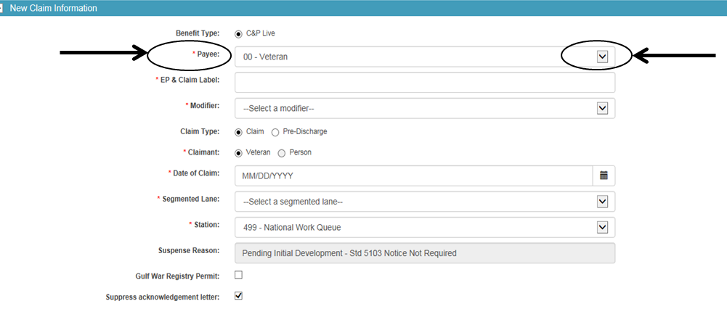

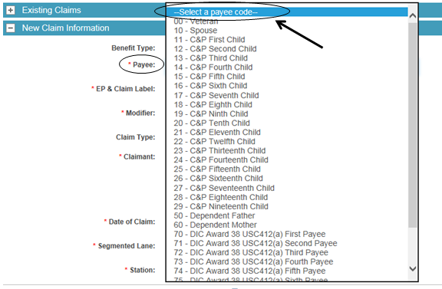

The appropriate payee code is assigned by the user during claims establishment:

|  |  |
| --- | --- |
| **Payee** | **Payee Code** |
| Veteran | 00 |
| First Payee Recipient | 01 |
| Second Payee Recipient | 02 |
| Third Payee Recipient | 03 |
| Fourth Payee Recipient | 04 |
| Fifth Payee Recipient | 05 |
| Sixth Payee Recipient | 06 |
| Seventh Payee Recipient | 07 |
| Eighth Payee Recipient | 08 |
| Ninth Payee Recipient | 09 |
| Spouse | 10 |
| C&P First Child | 11 |
| C&P Second Child | 12 |
| C&P Third Child | 13 |
| C&P Fourth Child | 14 |
| C&P Fifth Child | 15 |
| C&P Sixth Child | 16 |
| C&P Seventh Child | 17 |
| C&P Eighth Child | 18 |
| C&P Ninth Child | 19 |
| C&P Tenth Child | 20 |
| C&P Eleventh Child | 21 |
| C&P Twelfth Child | 22 |
| C&P Thirteenth Child | 23 |
| C&P Fourteenth Child | 24 |
| C&P Fifteenth Child | 25 |
| C&P Sixteenth Child | 26 |
| C&P Seventeenth Child | 27 |
| C&P Eighteenth Child | 28 |
| C&P Nineteenth Child | 29 |
| Vendor | 30 |
| Consolidated Payee 1st group of children | 31 |
| Consolidated Payee 2nd group of children | 32 |
| Consolidated Payee 3rd group of children | 33 |
| Consolidated Payee 4th group of children | 34 |
| Consolidated Payee 5th group of children | 35 |
| Consolidated Payee 6th group of children | 36 |
| Consolidated Payee 7th group of children | 37 |
| Consolidated Payee 8th group of children | 38 |
| Consolidated Payee 9th group of children | 39 |
| CH35 First Child | 41 |
| CH35 Second Child | 42 |
| CH35 Third Child | 43 |
| CH35 Fourth Child | 44 |
| CH35 Fifth Child | 45 |
| CH35 Sixth Child | 46 |
| CH35 Seventh Child | 47 |
| CH35 Eighth Child | 48 |
| CH35 Ninth Child | 49 |
| Dependent Father | 50 |
| Dependent Mother | 60 |
| DIC Award 38 USC412(a) First Payee | 70 |
| DIC Award 38 USC412(a) Second Payee | 71 |
| DIC Award 38 USC412(a) Third Payee | 72 |
| DIC Award 38 USC412(a) Fourth Payee | 73 |
| DIC Award 38 USC412(a) Fifth Payee | 74 |
| DIC Award 38 USC412(a) Sixth Payee | 75 |
| DIC Award 38 USC412(a) Seventh Payee | 76 |
| DIC Award 38 USC412(a) Eighth Payee | 77 |
| DIC Award 38 USC412(a) Ninth Payee | 78 |
| First Claimant Burial/Accrued | 80 |
| Second Claimant Burial/Accrued | 81 |
| Third Claimant Burial/Accrued | 82 |
| Fourth Claimant Burial/Accrued | 83 |
| Fifth Claimant Burial/Accrued | 84 |
| Sixth Claimant Burial/Accrued | 85 |
| Seventh Claimant Burial/Accrued | 86 |
| Eighth Claimant Burial/Accrued | 87 |
| Ninth Claimant Burial/Accrued | 88 |
| Tenth Claimant Burial/Accrued | 89 |
| Institutional Veteran CFR3.852 | 99 |

Practical Exercise

Directions: Circle the correct answer to the questions listed. Please work independently and the instructor will review the answers.

1. VA Form 21-526, Veterans Application for Compensation and/or Pension, was submitted electronically, the Veteran has completed the entire form with all requested information, to include the contentions for the claim. Is this considered a complete form?
   1. Yes
   2. No
2. A Veteran submitted VA form 21P-527, Income, Net Worth, and Employment Statement. He did not include his income information. Is this considered a complete application?
   1. Yes
   2. No
3. A POA signs a reopen claim. Veteran’s data is able to be verified via the Social Security number provided. Is this considered a complete application?
   1. Yes
   2. No
4. The Veteran submitted a claim and he signed it with a “X”, it had two witnesses who provided their addresses. Is this a complete application?
   1. Yes
   2. No
5. VA Form 21-526EZ, Application for Disability Compensation and Related Compensation Benefits, was submitted by a Disabled American Veterans (DAV) (Power of Attorney). A review of the file shows there is a valid VA Form 21-22, Appointment of Veterans Service Organization as Claimant’s Representative, from the DAV and this is the Veteran’s third claim. The Veteran provided his Social Security number, date of birth, and claimed hearing loss as a contention. A SHARE inquiry of the Veteran’s Social Security number reflect his BIRLS record, Corporate record, and shown the Veteran was service connected. Is this considered a complete form? If not, please explain why.
6. VA Form 21-526EZ, Application for Disability Compensation and Related Compensation Benefits, was submitted by the Veteran. The Veteran provided his Social Security number, date of birth, and claimed hearing loss as a contention. No signature was on the VA Form 21-526EZ. A SHARE inquiry of the Veteran’s Social Security number reflect his BIRLs record, Corporate record, and shown the Veteran was service connected. Is this considered a complete form? If not, please explain why.
7. The Veteran filed a claim. What is the correct Payee code to use for this case?
8. 00
9. 10
10. 11
11. None of the above
12. The estranged spouse of a Veteran filed for an apportionment. What is the correct Payee code to use for this case?
    1. 00
    2. 10
    3. 11
    4. None of the above
13. The first child of a Veteran filed for an apportionment. What is the correct Payee code to use for this case?
    1. 10
    2. 11
    3. 12
    4. None of the above
14. The second child of a Veteran filed for an apportionment. What is the correct Payee code to use for this case?
    1. 10
    2. 11
    3. 12
    4. None of the above