Letter Creator

Trainee Handout

**Table of Contents**

Objectives 2

References 2

Topic 1: Locating Letter Creator 3

Topic 2: Creating a Letter 5

Topic 3: Uploading a Letter 11

Attachment A: Types of Letters 12

Practical Exercise 13

Objectives

* Locate the Letter Creator program and initial Setup
* Recognize what types of letters are used in IPC
* Demonstrate how to create a letter using Letter Creator
* Know how to Print VA Forms in Letter Creator

References

* Letter Creator User Guide
* [M21-1, Part I, Chapter 1, Section B, Notification Requirements for an Incomplete Application](https://vaww.vrm.km.va.gov/system/templates/selfservice/va_kanew/help/agent/locale/en-US/portal/554400000001034/content/554400000014065/M21-1-Part-I-Chapter-1-Section-B-Duty-to-Notify-Under-38-USC-5102-and-5103?query=letter%20creator)
* [M21-1, Part III, Subpart ii, Chapter 3, Section E, Handling a Disagreement with a Decision Not Submitted on VA Form 21-0958, When Required](https://vaww.vrm.km.va.gov/system/templates/selfservice/va_kanew/help/agent/locale/en-US/portal/554400000001034/content/554400000033133/M21-1-Part-III-Subpart-ii-Chapter-3-Section-E-Establishing-an-Appellate-Record?query=letter%20creator)
* [M21-1, Part I, Chapter 3, Section B, Notification Requirement Where Appointment Forms Lack 38 USC 7332 Election](https://vaww.vrm.km.va.gov/system/templates/selfservice/va_kanew/help/agent/locale/en-US/portal/554400000001034/content/554400000014077/M21-1-Part-I-Chapter-3-Section-B-A-Representatives-Right-to-Notification-and-Review-of-Records?query=letter%20creator)
* [M21-1, Part III, Subpart ii, Chapter 1, Section C, Handling a Form or Application With an Alternate Signature](https://vaww.vrm.km.va.gov/system/templates/selfservice/va_kanew/help/agent/locale/en-US/portal/554400000001034/content/554400000014112/M21-1-Part-III-Subpart-ii-Chapter-1-Section-C-Initial-Screening-Policies?query=letter%20creator)
* [M21-1, Part III, Subpart ii, Chapter 1, Section C, Rejecting an Outdated Version of VA Form](https://vaww.vrm.km.va.gov/system/templates/selfservice/va_kanew/help/agent/locale/en-US/portal/554400000001034/content/554400000014112/M21-1-Part-III-Subpart-ii-Chapter-1-Section-C-Initial-Screening-Policies?query=letter%20creator)
* [M21-1, Part III, Subpart ii, Chapter 1, Section B, Processing Unidentifiable Mail in CM](https://vaww.vrm.km.va.gov/system/templates/selfservice/va_kanew/help/agent/locale/en-US/portal/554400000001034/content/554400000014111/M21-1-Part-III-Subpart-ii-Chapter-1-Section-B-Mail-Management?query=unidentifiable)
* [M21-1, Part III, Subpart ii, Chapter 1, Section B, Final Attempt to Obtain an Updated Address for Undeliverable Claimant Notification and Essential Mail](https://vaww.vrm.km.va.gov/system/templates/selfservice/va_kanew/help/agent/locale/en-US/portal/554400000001034/content/554400000014111/M21-1-Part-III-Subpart-ii-Chapter-1-Section-B-Mail-Management?query=return%20mail#6)

Topic 1: Locating Letter Creator

Veterans Benefits Management System (VBMS) is the primary system for eFolder storage, strongly utilized for workload management, and the development process.

Letter Creator is an additional system utilized for letters to the Veteran which are not available within VBMS.

Go to the Compensation Services Intranet site: [Compensation Service Intranet](https://vbaw.vba.va.gov/bl/21/index.htm)

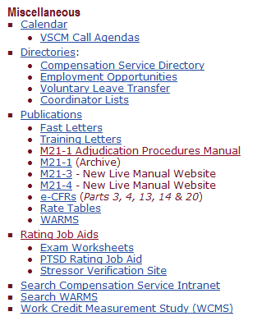

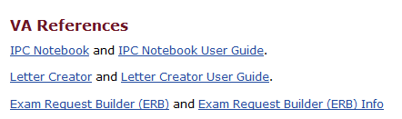

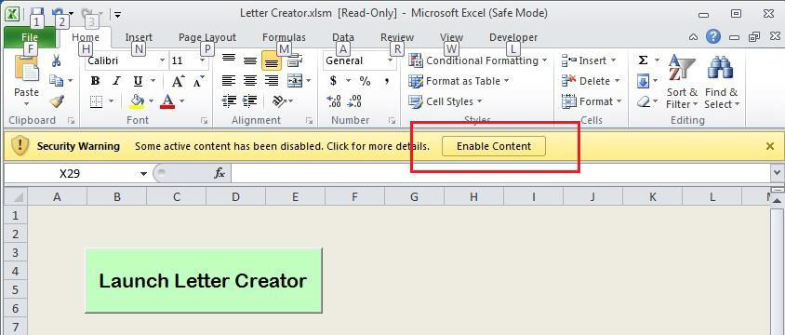

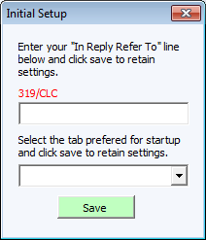

The first time the tool is opened, the above screen should appear. Please enter your station ID/your department code (if applicable)/your Initials.

For example, the “In Reply Refer To:” line should appear like this: **319/CLC.**

The drop down menu allows for the user to set a default tab in which the tool will start each time it is opened.

Topic 2: Creating a Letter

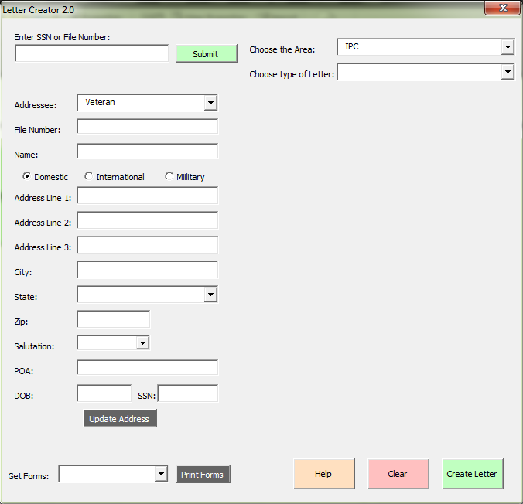

First, ensure VBMS is open to the proper Veteran. Enter the Veteran’s Social Security number or File number into the field and click the green Submit button. Letter Creator will populate the name, address, salutation, and POA (if one is of record) from VBMS.

It will also extract other points of data not seen on the screen above that is stored in the tool for use in certain letters.

* This data includes DOD and Periods of Service.

If a letter is needed where there is no Veteran record or address then the address can be manually entered into the tool.

If an address is entered manually where a Veteran record does exist, the tool can be used to update the Veteran record with the address entered into the tool.

To begin, enter the Veteran’s file number in the SSN or File Number Field as shown below:

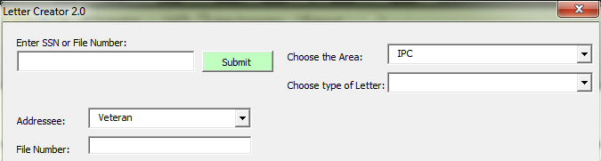

Once the “Submit” button is clicked this will pull the Veteran’s profile information from VBMS and populate it into the tool as shown below. A loading screen will appear and go away once the tool is finished loading.

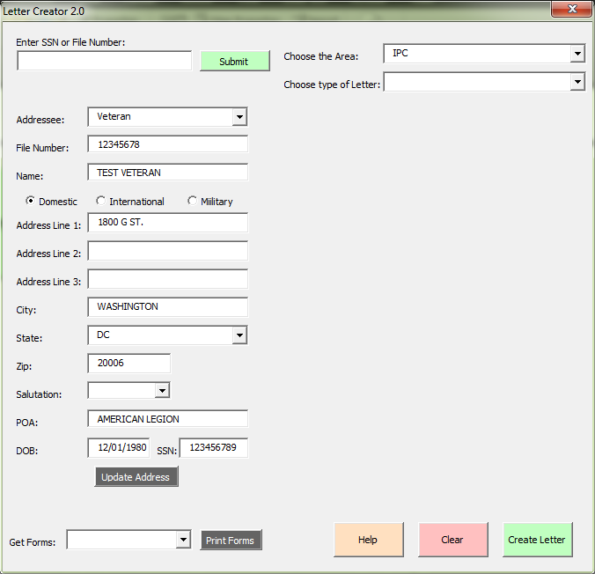

Select the appropriate drop down from “Choose the Area”. Then, select the type of letter that needs to be sent to the Veteran/claimant.

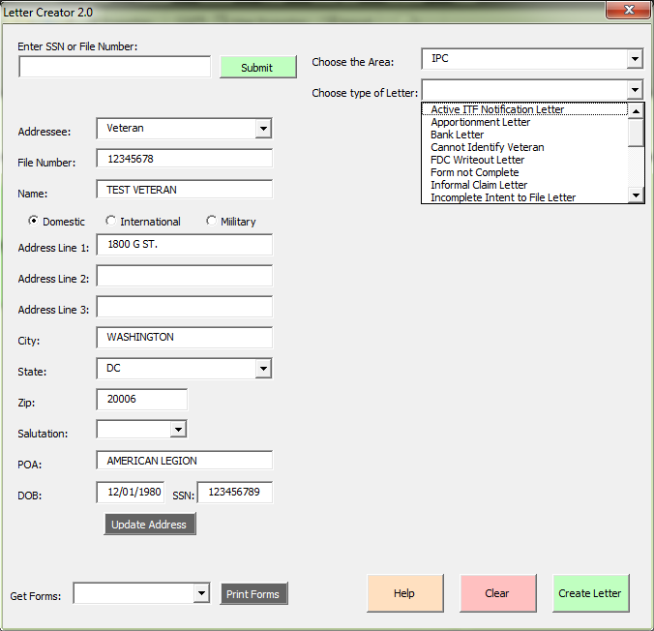

As shown below there is a field for a date. Throughout the tool there are various areas where a date needs to be entered. Where a date should be entered, there will be a little calendar next to the field. Clicking the picture of the calendar will bring up a full calendar where the date can be selected by clicking on the date.

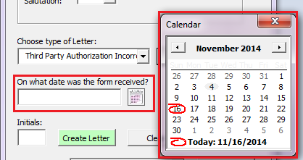

When all options and entries are made, click the “Create Letter” button. This will create the letter in a word document that may not appear instantly on screen but will be running on the desktop. Find it on the taskbar and click on the letter to maximize it.



The letter should appear as shown and be complete.

Do not save the letter at this point.

Do not close the letter.

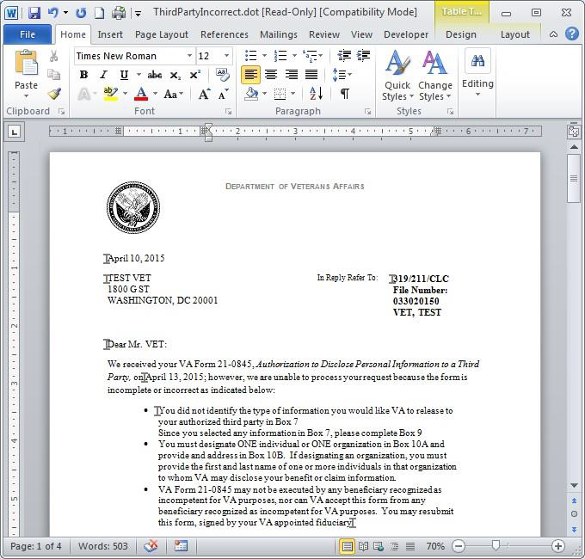

After reviewing the letter and making any necessary changes, go back to the tool in excel. It should be blinking on the taskbar in Windows.

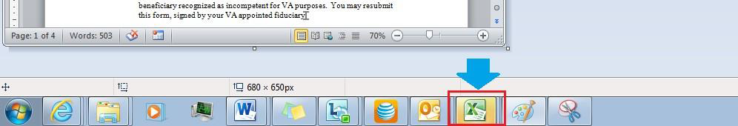

Once back in the tool, a popup message will appear that says, “Click OK when you are finished making changes and are ready to upload the letter to VBMS.” Click OK

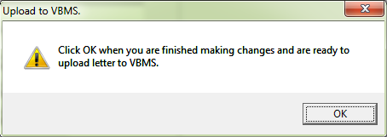

Note: At this point the tool will save the letter as a PDF to a specific location. The tool will save the letter to your desktop in a folder called “LetterBank”. The tool will create the folder automatically if it does not already exist.

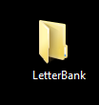

A pop up will appear that will notify you of the location to which the PDF was saved.

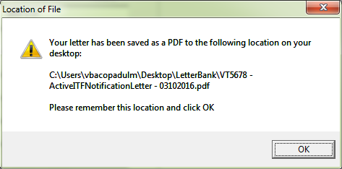

Topic 3: Uploading a Letter

Once the “OK” button is clicked the tool will cause VBMS to navigate to the Upload Document screen. The tool will also fill out everything on that screen except for the File Location. The file field will need to be manually completed by the user.

The Letter Creator will automatically update the “category – type” field to “Correspondence: Correspondence”.

The user can manually edit this field if necessary.

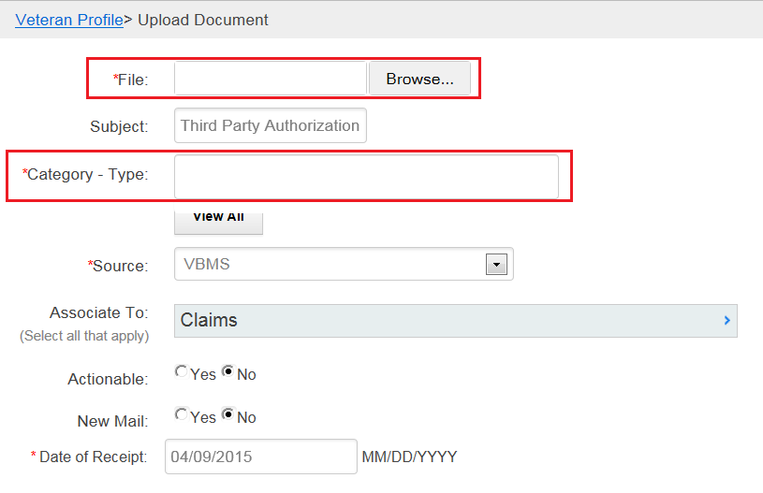

To further assist please watch the following Video:

[Uploading a Document](http://vbaw.vba.va.gov/vbms/videos/Upload_Document_VBMS_Minute.wmv)

Note: This video can be found on the [VBMS Training](https://vbaw.vba.va.gov/VBMS/multimedia.asp) page by searching “Uploading a Document”.

Topic 4: Letters Available

Attachment A lists the available letters within the IPC section of Letter Creator.

Instructor will provide at least one demonstration of how to create a letter. Please review the list of the letters available and the references provided at the beginning of this lesson.

Opportunity to experience Letter Creator is provided in Practical Application questions 5-14.

Practical Exercise

Directions: Answer the following questions by using the materials provided in lesson and Letter Creator application.

1. In what section of the Compensation Service Intranet Site do you find the link to the Letter Creator?

_______________________________________

1. What is the Category Type for a letter, from Letter Creator, being uploaded to VBMS?

­­­­­­­­­­­­­­­­­­_______________________________________

1. What information is needed to pull a Veteran/Claimant’s profile from VBMS?

_______________________________________

1. Name 3 types of letters Letter Creator has available for IPC.

1.__________________________

2.__________________________

3.__________________________

Questions 5 through 10 relate with the **IPC section** of Letter Creator.

1. Which letter generates the language “form is being returned to you because it was incomplete”?
2. If a piece of mail is received within the Centralized Mail Portal and it was not complete, which letter would be utilized in Letter Creator?
3. Which letter generates the language “We received your correspondence indicating that you would like to file a claim for benefits. VA regulations now require all claims to be submitted on a standardized form.”?
4. The Request for Application for NOD requests two pieces of information prior to generating the letter. What two pieces of information does it request?
5. Which letter selection prompts “What document was returned to the VA USPS” at the top of the page? What other information is listed as an additional prompt at the bottom of the page?
6. Which letter selection prompts “POA of Record” at the top of the page? How many fields are required to be completed by the user prior to creating the letter?

Questions 11 through 14 relate with the **Appeals section** of Letter Creator.

1. What language populates under the “What Do We Need From You?” if you were to select notification of NOD letter and use the following information:

Date of receipt of NOD: 01/01/2018 and

Date of Notification Letter: 12/01/2017

1. What language populates under the salutation if you were to select Appeals Process Explanation Letter and use the following information:

Date of notification letter: 01/31/2018

1. What three prompts populate when the user selects the Local Appeal Hearing Letter?
2. What language populates under the “What We Decided” if you were to select NOD Not Timely letter and use the following information:

Enter Date of Rating: 01/26/2017

Date of receipt of NOD: 02/01/2018 and

Date of Notification Letter: 01/31/2017

Attachment A: Types of Letters

These are the types of letters in Letter Creator listed under IPC:

|  |  |  |  |
| --- | --- | --- | --- |
| **Letter Name** | **Letter Name** | **Letter Name** |  |
| **Active ITF Notification Letter** | **Informal Claim Letter** | **Return Mail** |  |
| **Apportionment Letter** | **ITF Cancellation Letter** | **Return of Documents** |  |
| **Bank Letter** | **Outdated Form - Non-Claim Letter** | **Return of X-rays** |  |
| **Cannot Identify Veteran** | **POA Not of Record Letter** | **Special Media Return Letter** |  |
| **Claim Already on Appeal** | **Receipt of Unsolicited Evidence** | **Third Party Authorization Incorrect** |  |
| **Claims Acknowledgement Letter** | **Recently Employed IU Recipient Letter** | **Untimely Claim Withdrawal Letter** |  |
| **FDC Writeout Letter** | **Recognition of Custodian** | **Withdrawal of Claim Letter** |  |
| **Form not Complete** | **Request for Application Apportionment** |  |  |
| **Incomplete Application Letter** | **Request for Application for Compensation, Pension, or DIC** |  |  |
| **Incomplete Intent to File Letter** | **Request for Application for Dependency** |  |  |
| **Incomplete ITF – Claim Received Letter** | **Request for Application for NOD** |  |  |
| **Incomplete NOD** | **Request for Application Helpless Child** |  |  |
|  |  |  |