Claim Attributes
Instructor Lesson Plan
Time Required: 1.75 Hours

Table of Contents

Lesson Description 2
Introduction to Claim Attributes 4
Topic 1: Claim Attributes and Agency Goals 5
Topic 2: Claim Labels 7
Topic 3: Corporate Flashes 10
Topic 4: Special Issues 14
Practical Exercise 18
Lesson Review, Assessment, and Wrap-up 19

Lesson Description
The information below provides the instructor with an overview of the lesson and the materials that are required to effectively present this instruction.
TMS # | 4420798
Prerequisites | There are no required prerequisites to this class.
target audience | The target audience for Claims Assistants at all levels. This course could be utilized for additional training for Veteran Service Representatives or Rating Veteran Service Representatives.
Time Required | 1.75 hours
Materials/  TRAINING AIDS | Lesson materials:  - Claim Attributes- Rating PowerPoint Presentation  - Claim Attributes- Rating Trainee Handouts
Training Area/Tools | The following are required to ensure the trainees are able to meet the lesson objectives:  - Classroom or private area suitable for participatory discussions  - Seating, writing materials, and writing surfaces for trainee note taking and participation  - Handouts, which include a practical exercise  - Large writing surface (easel pad, chalkboard, dry erase board, overhead projector, etc.) with appropriate writing materials  - Computer with PowerPoint software to present the lesson material  Trainees require access to the following tools:  - VA TMS to complete the assessment  - Compensation Pension (CPKM) Portal
Pre-Planning | - Become familiar with all training materials by reading the Instructor Lesson Plan while simultaneously reviewing the corresponding PowerPoint slides. This will provide you the opportunity to see the connection between the Lesson Plan and the slides, which will allow for a more structured presentation during the training session.  - Become familiar with the content of the trainee handouts and their association to the Lesson Plan.  - Practice is the best guarantee of providing a quality presentation. At a minimum, do a complete walkthrough of the presentation to practice coordination between this Lesson Plan, the trainee handouts, and the PowerPoint slides and ensure your timing is on track with the length of the lesson.  - Ensure that there are copies of all handouts before the training session.  - When required, reserve the training room.  - Arrange for equipment such as flip charts, an overhead projector, and any other equipment (as needed).  - Talk to people in your office who are most familiar with this topic to collect experiences that you can include as examples in the lesson.  - This lesson plan belongs to you. Feel free to highlight headings, key phrases, or other information to help the instruction flow smoothly. Feel free to add any notes or information that you need in the margins.
Training Day | - Arrive as early as possible to ensure access to the facility and computers.  - Become familiar with the location of restrooms and other facilities that the trainees will require.  - Test the computer and projector to ensure they are working properly.  - Before class begins, open the PowerPoint presentation to the first slide. This will help to ensure the presentation is functioning properly.  - Make sure that a whiteboard or flip chart and the associated markers are available.  - The instructor completes a roll call attendance sheet or provides a sign-in sheet to the students. The attendance records are forwarded to the Regional Office Training Managers.

Introduction to Claim Attributes
INSTRUCTOR INTRODUCTION |  | Complete the following:  - Introduce yourself  - Orient learners to the facilities  - Ensure that all learners have the required handouts
time required |  | 0.25 hours
Purpose of Lesson  Explain the following: |  | This lesson is intended to provide the Claim Assistants detailed training on claim attributes which should be utilized at claims establishment. This lesson will contain discussions and exercises that will allow you to gain a better understanding of:  - Claim Labels  - Corporate Flashes  - Special Issues
Lesson Objectives  Discuss the following:  Slide 2  Handout 2 | In order to accomplish the purpose of this lesson, the Claim Assistants will be required to accomplish the following lesson objectives.  The Claim Assistants will be able to:  - Identify Priority Processing claims  - Determine the most accurate Claim Label  - Recognize when Corporate Flash should be applied to a claim  - Determine all Corporate Flashes applicable to a claim  - Recognize when a Special Issue is applicable to a claim  - Determine all Special Issues applicable to a claim
Explain the following: | Each learning objective is covered in the associated topic. At the conclusion of the lesson, the learning objectives will be reviewed.
Motivation | With the inception of the National Work Queue (NWQ) claim attributes have become one of the most essential and important components for workload management and claims routing nationally.
References  Slide 3  Handout 3 | Explain where these references are located in the workplace.  All M21-1 references are found in the CPKM.  - M21-1, Part III, Subpart i, Chapter 3, Section A, Forms Claimants Must Use When Submitting an FDC  - M21-1, Part III, Subpart iii, Chapter 1, Section F, Corporate Flashes  - M21-1, Part III, Subpart ii, Chapter 1, Section D, Claims that Require Priority Processing  - M21-4, Appendix C, Index of Claim Attributes  - M21-4, Chapter 6, Appendix A: VSR Task Based Quality Review Checklist

Topic 1: Claim Attributes and Agency Goals
Introduction | With the inception of NWQ, uniformed claims establishment is essential and an important component of uniform claims processing are claim attributes. Claim attributes impact workload and routing nationally. The application of claim attributes is extremely important for the purpose of data consistency and data integrity. All processors must enter all applicable attributes throughout the claims process accurately and completely as possible.
Time Required | 0.25 hours
OBJECTIVES/  Teaching Points | Topic objectives:  - The overall purpose of claim attributes and agency goals.  - Identify Priority Processing claims.  The following topic teaching points support the topic objectives:  - Claim attributes required at establishment.  - Pay attention to details within the claim and claimant.  - Priority Processing
Claim Attributes and Agency Goals  Slide 4-5  Handout 4 | With the inception of NWQ, uniformed claims establishment is essential and an important “component” of uniform claims are claim attributes, which impact workload and routing nationally.  The application of claim attributes is extremely important for the purpose of data consistency and data integrity. All processors must enter all applicable attributes throughout the claims process accurately and completely as possible.  There are a variety of claims attributes required at establishment, all of them serve their specific importance towards the claim or the claimant; however, there are a few that are specifically important as they directly impact workload and reporting at the national level.
Required Claim Attributes at Establishment  Slide 6  Handout 4 | The following Claim Attributes are Required at Establishment:  - Address  - Claim Label  - Claim Level Suspense Reason  - Claim Status  - Corporate Flashes  - Date of Claim  - End Product  - Military Service Data  - Power of Attorney  - Special Issues  The bolded claim attributes impact workload management and routing.  Today we will focus our efforts discussing proper claim labels, corporate flashes and special issues as is related to the Veterans Benefits Administration (VBA) workload management and routing.  During claims establishment it is important to pay close attention to several details.  - Does the Veteran qualify for priority processing?  - Claimed conditions or exposure need special issue or corporate flash added?
Priority Processing  Slide 7-8  Handout 5 | The agency has identified several categories of claimants in which require priority processing. These can be found at M21-1 III.ii.1.D, Claims That Require Priority Processing. These categories describe some of our agency’s most sensitive claimant situations. You will need to pay close attention to the claim attributes regarding these types of claims throughout this lesson.  Instructors: Please navigate to the manual and discuss with trainees several categories of claimants that require priority processing.

Topic 2: Claim Labels
Introduction | The purpose of a claim label is to provide a more specific description of the claim type that a corresponding end product (EP) represents. The most accurate claim label must be selected when establishing a claim, and reviewed for any potential updates throughout the life of the claim.
Time Required | 0.25 hours
OBJECTIVES/  Teaching Points | Topic objectives:  - Determine the most accurate Claim Label.  The following topic teaching points support the topic objectives:  - Claim Label Options.
Claim Labels  Slide 9  Handout 6 | A claim label pertains to the EP of the claim. They describe the type of benefit claimed. Since there are multiple claims with the same EP number, claim labels help distinguish these types of claims.  The claim label is first added at establishment; however, everyone in the regional office (RO) is responsible for ensuring that appropriate claim labels are applied and should make any necessary changes to address any deficiencies.  The claim label that best describes the situation and provides information vital to proper tracking should be used.  Instructor: The purpose of a claim label is to provide a more specific description of the claim type that a corresponding EP represents. The most accurate claim label must be selected when establishing a claim, and reviewed for any potential updates throughout the life of the claim.  There is a full index of claim labels which can be found at M21-4, Appendix C, Index of Claim Attributes. There are currently over 700 different claim label options between all types of claims worked by VBA. Of those just over 10% are rating inventory related. Therefore, it is extremely important to pay close attention at claims establishment.  Instructor: Navigate to M21-4 and identify claim labels relevant to the changes brough about by the Appeals Modernization Act.
How is a claim label applied?  Slide 10  Handout 6  Segmented Lane as part of claims establishment  Slide 11  Handout 6  Discuss with CA’s:  How is a claim label applied?  Slide 12  Handout 6 | The claim label is applied at claims establishment, here is an example of the claims establishment area in VBMS:  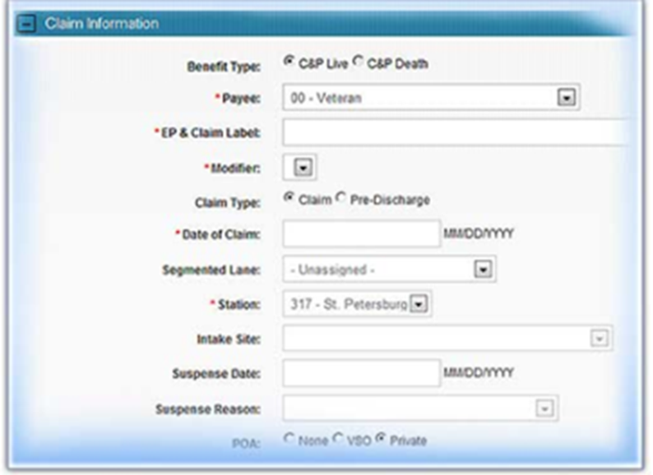  VBMS requires completion of the SEGMENTED LANE field when establishing a claim, however, the lane assignment does not affect claims routing in the NWQ. Select Core (National) when assigning the segmented lane, unless otherwise directed by specific Manual guidance  Segmented lanes are no longer used; however, it remains a required field when establishing a claim in VBMS.  Once established this information is available for viewing under the “claim tab” in VBMS. The EP system is critical to workload monitoring, routing and work credit measurement for VBA staff.  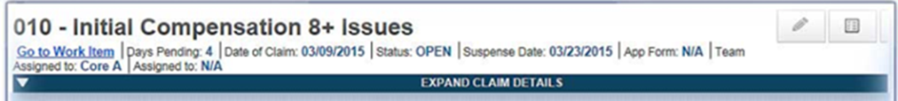
Appropriate Claim Label Selection  Slide 13-14  Handout 6  DEMONSTRATION | A full list of all claim labels can be found a M21-4 Appendix C. Let’s discuss the purpose of these claim labels in detail. Many EPs contain multiple claim labels. It is very important to pay close attention to the details surrounding the claim you are establishing.  The instructor should navigate to the M21-4, Appendix C and review all of the available options with the learners. They should spend time reviewing the different options and discussing the reasons to use them.

Topic 3: Corporate Flashes
Introduction | The corporate flash is a claimant-specific indicator which represents an attribute, fact, or status that is unlikely to change. A corporate flash can either be automatically generated by the system, or managed manually by a user. Some available corporate flashes are generated by the system but others must be identified by a user.
Time Required | 0.25 hours
OBJECTIVES/  Teaching Points | Topic objectives:  - Recognize when Corporate Flash should be applied to a claim  - Determine all Corporate Flashes applicable to a claim  The following topic teaching points support the topic objectives:  - Who is responsible for adding the corporate flash.  - How to add the corporate flash.  - Available corporate flashes options.
Corporate Flashes  Slide 15-16  Handout 7-10 | There are just over 100 available corporate flashes, therefore, it is imperative for the claim establisher to pay close attention to details about the claim/claimant during the establishment phase.  Corporate flashes are claimant-specific indicators which represent an attribute, fact, or status that is unlikely to change. A corporate flash can either be automatically generated by the system, or managed manually by a user. There may be more than one (1) corporate flash that is applicable.  Claimant flashes are claimant-specific indicators that represent an attribute, fact, or status that may occasionally change (e.g. Former Prisoner of War, blind Veteran, homeless, etc.). ROs are responsible for  - identifying claimant’s records that require flashes  - inputting the flashes when required, and  - promptly removing the flash when it no longer applies.  Claimant flashes must be entered in the corporate record once the need is identified. Most flashes are added by the end user, but some are generated by the system. Flashes will exist on a claimant’s record until the flash is manually removed.  Once the scenario no longer applies, the flash will be removed by any authorized end user. The new scenario may result in another flash being applicable. ROs are responsible for identifying and updating flashes when applicable.  They are either entered automatically by the system or are manually added by a user. Available corporate flashes not generated by the system must be identified and updated when applicable. We will primarily discuss those added manually.  All users are responsible for validating and updating corporate flashes when applicable.  Below you will find some of the most common corporate flashes that can be identified at claims establishment.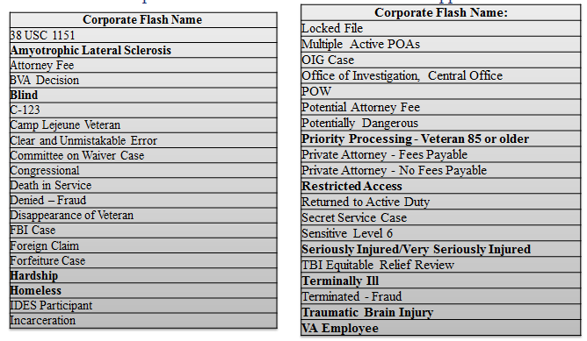A full list of all available corporate flashes can be found at M21-4, Appendix C, Index of Claim Attributes. There is a separate list specific for quality assurance that can be found at M21-4, Chapter 6, Appendix A, VSR Task Based Quality Review Checklist – Task 11.
Corporate Flashes  Slide 17  Handout 9 | Corporate Flashes are added through SHARE and are available for viewing and tracking in all systems.  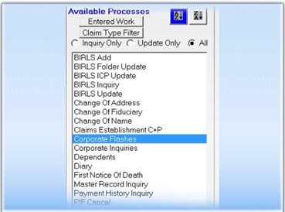  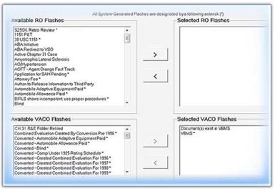
Adding a Corporate Flash  Slide 18-19  Handout 10 | 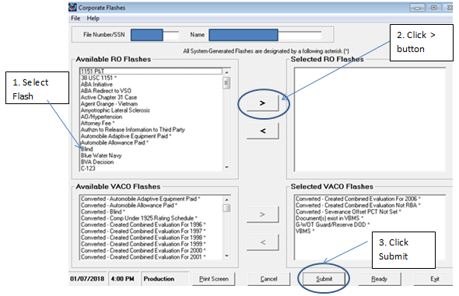  Step 1: Select the appropriate Flash.  Step 2: Click the carrot over button ( “>”).  Step 3: Click “Submit”.  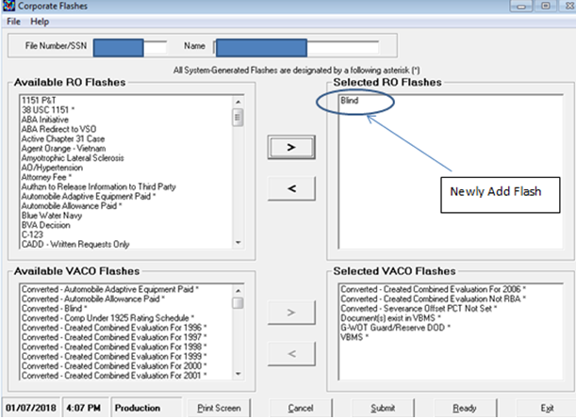
DEMONSTRATION | The instructor should spend time reviewing how to add a corporate flash in SHARE and how to view it in VBMS. The instructor should navigate to the M21-4, Appendix C, Index of Corporate Flashes and review all of the available options with the learners. They should spend time reviewing the different options and discussing the reasons to use them.

Topic 4: Special Issues
Introduction | Special issues are claim-specific indicators and can represent a certain claim type, disability or disease, or other special notation that is only relevant to a particular claim. Special issues must be identified and inputted when applicable.
Time Required | 0.25 hours
OBJECTIVES/  Teaching Points | Topic objectives:  - Recognize when a Special Issue is applicable to a claim  - Determine all Special Issues applicable to a claim  The following topic teaching points support the topic objectives:  - Who is responsible for adding the corporate flash.  - How to add the corporate flash.  - Available corporate flash options.
Special Issues  Slide 20  Handout 11 | Special Issues are related to a contention.  Claim specific indicators typically pertaining to certain contentions which represent a claim type, disability or disease, or other special notation that is only relevant to a current pending claim.  Special issues stay on for the duration of the claim and no longer exist when the claim has ended.  Mandatory with every case.
Special Issues  Slide 21  Handout 11 | Why does VA need special tracking requirements?  - Easy identification  - Priority processing  - NWQ routing rules  Instructor: Please feel free to elaborate on other reasons why special issues assist in VA claims adjudication.

Fully Developed Claim - Special Issue  Slide 22  Handout 11 | The Department of Veterans Affairs (VA) designed the Fully Developed Claim (FDC) Program for the purpose of  - Reducing its backlog of pending claims, and  - Improving claims-processing timeliness.  VA must receive one of the following forms in order to participate in the FDC program:  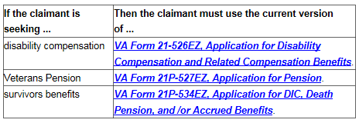

Special Issues  Slide 23  Handout 12 | If a special issue exists and applies to the claim, it is required. Claims may require both a corporate flash and a similar special issue. Currently, there are over 90 available special issues, and attention to detail at establishment phase is a must.  A full list of all available special issues can be found at M21-4, Appendix C, Special Issue. There is a separate list specific for quality assurance that can be found at M21-4, Chapter 6, Appendix A, VSR Task Based Quality Revie Checklist – Task 11.  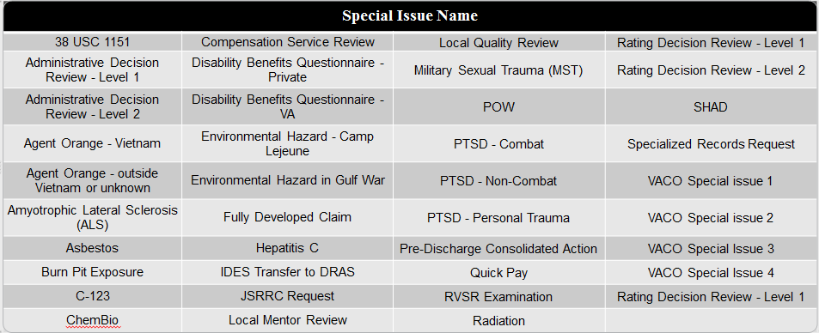  Claims establishment entails a multiple step process. One of the steps is entering the contentions the Veteran is claimed. A subpart of entering the contention is adding any appropriate special issues.  Instructor note: Student handout lists specific references for certain special issues. (Agent Orange, PTSD, Gulf War/Environment Hazards, etc.)
Entering Special Issue in VBMS  Slide 24-26  Handout 14-15 | Step 1: Under the CONTENTION tab, select the SPECIAL ISSUES down arrow.  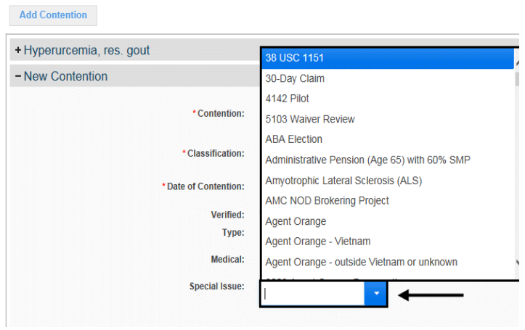  Step 2: Select the appropriate special issue to be associated to the contention.  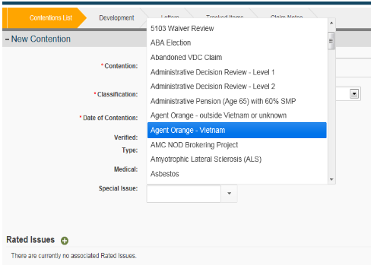  Step 3: Select the SAVE button to save the special issue or the CANCEL button to discard the changes.  Note: If you finish adding special issues and want to add another contention select the SAVE and ADD button.

DEMONSTRATION | The instructor should spend time reviewing how to add a special issue in VBMS. The instructor should navigate to the M21-4, Appendix C, Special Issue and review all of the available options with the learners. They should spend time reviewing the different options and discussing the reasons to use them.
Regional Office Specific Topics | At this time add any information pertaining to:  - Station quality issues with this lesson  - Additional State specific programs/guidance on this lesson

Practical Exercise
Time Required | 0.25 hours
EXERCISE  Practical Exercise  Handout 18 | You will need to help the learners log into the Compensation and Pension Knowledge Management (CPKM) Portal and locate the applicable references covered to complete the practical exercise.  Ask if there are any questions about the information presented in the exercise, and then proceed to the Review.  Directions: You will need to log into the CPKM Portal. Read the practical exercise scenarios below, use the list of claim labels, corporate flashes and special issues available in M21-4, Appendix C, Index of Claim to answer the questions below.  Scenarios can be found in the Student Handout.

Lesson Review, Assessment, and Wrap-up
Introduction  Discuss the following: | The Claim Attributes lesson is complete.  Review each lesson objective and ask the trainees for any questions or comments.
Time Required | 0.25 hours
Lesson Objectives | You have completed the claim attributes lesson.  The trainee should be able to:  - Identify Priority Processing claims.  - Determine the most accurate Claim Label  - Recognize when Corporate Flash should be applied to a claim  - Determine all Corporate Flashes applicable to a claim  - Recognize when a Special Issue is applicable to a claim  - Determine all Special Issues applicable to a claim
Evaluation | Remind the trainees to complete the on-line evaluation in TMS to receive credit for completion of the course.

