Claim Attributes

Trainee Handout

**Table of Contents**

Objectives 2

References 3

Topic 1: Attributes and Agency Goals 4

Topic 2: Claim Labels 6

Topic 3: Corporate Flashes 7

Topic 4: Special Issues 11

Attachment A: Systems Compliance Errors: Corporate Flashes 16

Attachment B: Systems Compliance Errors: Special Issues 17

Practical Exercise 18

Objectives

Upon completion of this lesson, you will be able to determine the Claim Labels, Corporate Flashes and Special Issues that should be applied to a claim by:

* Identify Priority Processing claims.
* Determine the most accurate Claim Label
* Recognize when Corporate Flash should be applied to a claim
* Determine all Corporate Flashes applicable to a claim
* Recognize when a Special Issue is applicable to a claim
* Determine all Special Issues applicable to a claim

References

All M21-1 references are found in the [CPKM](https://vaww.compensation.pension.km.va.gov/).

* [M21-1, Part III, Subpart i, Chapter 3, Section A, Forms Claimants Must Use When Submitting an FDC](https://vaww.vrm.km.va.gov/system/templates/selfservice/va_kanew/help/agent/locale/en-US/portal/554400000001034/content/554400000014109/M21-1-Part-III-Subpart-i-Chapter-3-Section-A-General-Information-About-the-Fully-Developed-Claim-FDC-Program)
* [M21-1, Part III, Subpart iii, Chapter 1, Section F, Coporate Flashes](https://vaww.vrm.km.va.gov/system/templates/selfservice/va_kanew/help/agent/locale/en-US/portal/554400000001034/content/554400000071983/M21-1-Part-III-Subpart-iii-Chapter-1-Section-F-Record-Maintenance-During-the-Development-Process)
* [M21-1, Part III, Subpart ii, Chapter 1, Section D, Claims that Require Priority Processing](https://vaww.vrm.km.va.gov/system/templates/selfservice/va_kanew/help/agent/locale/en-US/portal/554400000001034/content/554400000020037/M21-1-Part-III-Subpart-ii-Chapter-1-Section-D-Claims-That-Require-Priority-Processing)
* [M21-4, Appendix C, Index of Claim Attributes](https://vaww.vrm.km.va.gov/system/templates/selfservice/va_kanew/help/agent/locale/en-US/portal/554400000001034/content/554400000036570/Appendix%20C.%20Index%20of%20Claim%20Attributes)
* [M21-4, Chapter 6, Appendix A: VSR Task Based Quality Review Checklist](https://vaww.vrm.km.va.gov/system/templates/selfservice/va_kanew/help/agent/locale/en-US/portal/554400000001034/content/554400000037939/Chapter%206.%20%20Quality%20Review%20Team%20(QRT)#AppA)

Topic 1: Claim Attributes and Agency Goals

With the inception of National Work Queue (NWQ), uniformed claims establishment is essential and an important “component” of uniform claims are claim attributes, which impact workload and routing nationally. The application of claim attributes is extremely important for the purpose of data consistency and data integrity. All processors must enter all applicable attributes throughout the claims process accurately and completely as possible.

There are a variety of claims attributes required at establishment, all of them serve their specific importance towards the claim or the claimant; however, there are a few that are specifically important as they directly impact workload and reporting at the national level.

**Required Claim Attributes at Establishment:**

* Address
* Claim Label
* Claim Level Suspense Reason
* Claim Status
* Corporate Flashes
* Date of Claim
* End Product
* Military Service Data
* Power of Attorney
* Special Issues

The bolded claim attributes impact workload management and routing. The bolded and underlined attributes will be discussed within this training packet.

During this lesson we will discuss proper end products (EP) and claim labels, corporate flashes and special issues as is related to the Veterans Benefits Administration (VBA) workload management and routing.

During claims establishment it is important to pay close attention to several details.

* Does the Veteran qualify for priority processing?
* Are they claiming a condition or exposure that needs a special attribute?

**Priority Processing**

The agency has identified several categories of claimants in which require priority processing. These can be found at [M21-1 III.ii.1.D, Claims That Require Priority Processing](https://vaww.vrm.km.va.gov/system/templates/selfservice/va_kanew/help/agent/locale/en-US/portal/554400000001034/content/554400000020037/M21-1-Part-III-Subpart-ii-Chapter-1-Section-D-Claims-That-Require-Priority-Processing). These categories describe some of our agency’s most sensitive claimant situations. You will need to pay close attention to the claim attributes regarding these types of claims throughout this lesson.

|  |  |  |
| --- | --- | --- |
| **III.ii.1.D Types of Claims That Require Priority Processing** |  | Listed below are the types of claims that require priority processing:   * claims from *any* claimant who is   + a participant in the Fully Developed Claim Program   + homeless or experiencing extreme financial hardship   + terminally ill   + more than 85 years old, or   + a survivor of a former prisoner of war (FPOW). * claims from any current or former member of the Armed Forces who   + became very seriously ill or injured/seriously ill or injured (VSI/SI) during service and is *not* already receiving Department of Veterans Affairs (VA) disability benefits   + is diagnosed with Amyotrophic Lateral Sclerosis (ALS) or Lou Gehrig's Disease   + is an FPOW, or   + received the Medal of Honor, or * the following types of claims from any current or former member of the Armed Forces or a claimant whose claim is based on the death of a service member or former service member who received the Purple Heart:   + original compensation or pension claims, or   + an original claim for Dependency and Indemnity Compensation (DIC). |

Topic 2: Claim Labels

A claim label pertains to the EP of the claim. They describe the type of benefit claimed. Since there are multiple claims with the same EP number, claim labels help distinguish these types of claims.

The claim label is first added at establishment; however, everyone in the RO is responsible for ensuring that appropriate claim labels are applied and should make any necessary changes to address any deficiencies.

The claim label that best describes the situation and provides information vital to proper tracking should be used.

**How is a claim label applied?**

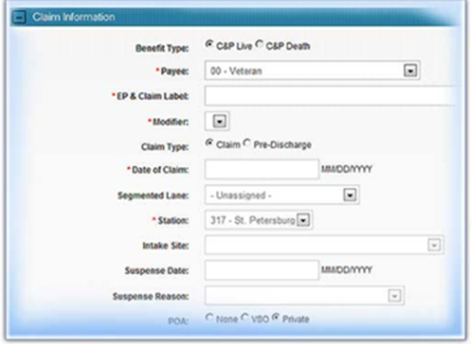The claim label is applied at claims establishment. Here is an example of the claims establishment area in VBMS:

**Note:** VBMS requires completion of the

Segmented Lane field when establishing a

Claim, however, the lane assignment does

not affect NWQ routing.

Select Core (National) when assigning

the Segmented lane.

Once established this information is available for viewing under the “claim tab” in VBMS. The EP system is critical to workload monitoring, routing and work credit measurement for VBA staff.

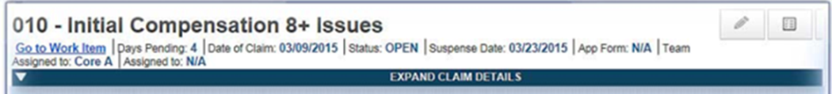

**Appropriate Claim Label Selection**

A full list of all claim labels can be found a M21-4 Appendix C. Let’s discuss the purpose of these claim labels in detail. Many End Products (EPs) contain multiple claim labels.

It is very important to pay close attention to the details surrounding the claim you are establishing.

Topic 3: Corporate Flashes

There are just over 100 available corporate flashes, therefore, it is imperative for the claim establisher to pay close attention to details about the claim/claimant during the establishment phase.

Corporate flashes are ***claimant***-specific indicators which represent an attribute, fact, or status that is unlikely to change. A corporate flash can either be automatically generated by the system, or managed manually by a user. There may be more than one (1) corporate flash that is applicable.

Claimant flashes are claimant-specific indicators that represent an attribute, fact, or status that may occasionally change (e.g. Former Prisoner of War, blind Veteran, homeless, etc.).  Regional offices (ROs) are responsible for

* identifying claimant’s records that require flashes
* inputting the flashes when required, and
* promptly removing the flash when it no longer applies.

Claimant flashes must be entered in the corporate record once the need is identified. Most flashes are added by the end user, but some are generated by the system. Flashes will exist on a claimant’s record until the flash is manually removed.

Once the scenario no longer applies, the flash will be removed by any authorized end user.  The new scenario may result in another flash being applicable. ROs are responsible for identifying and updating flashes when applicable.

They are either entered automatically by the system or are manually added by a user. Available corporate flashes not generated by the system must be identified and updated when applicable. We will primarily discuss those added manually.

All users are responsible for validating and updating corporate flashes when applicable.

Below you will find some of the most common corporate flashes that can be identified at claims establishment.

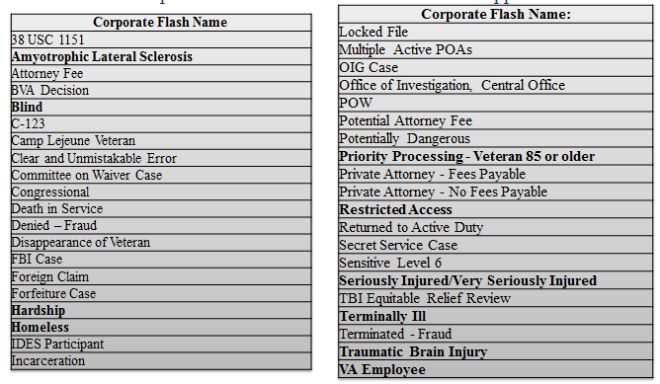

A full list of all available corporate flashes can be found at [M21-4, Appendix C, Index of Claim Attributes](https://vaww.vrm.km.va.gov/system/templates/selfservice/va_kanew/help/agent/locale/en-US/portal/554400000001034/content/554400000036570/Appendix%20C.%20Index%20of%20Claim%20Attributes). There is a separate list specific for quality assurance can be found at [M21-4, Chapter 6, Appendix A, VSR Task Based Quality Revie Checklist – Task 11](https://vaww.vrm.km.va.gov/system/templates/selfservice/va_kanew/help/agent/locale/en-US/portal/554400000001034/content/554400000037939/Chapter%206.%20%20Quality%20Review%20Team%20(QRT)#AppA).

Corporate Flashes

Corporate Flashes are added through SHARE and are available for viewing and tracking in all systems.

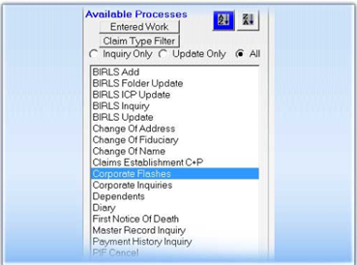

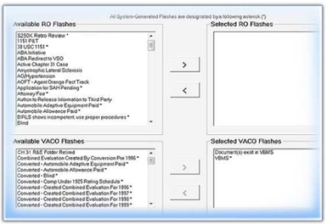

**Adding a Corporate Flash**

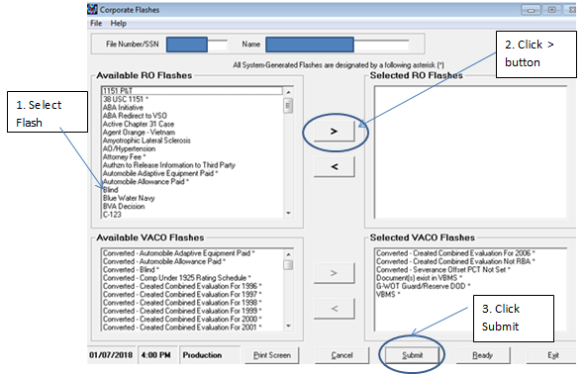

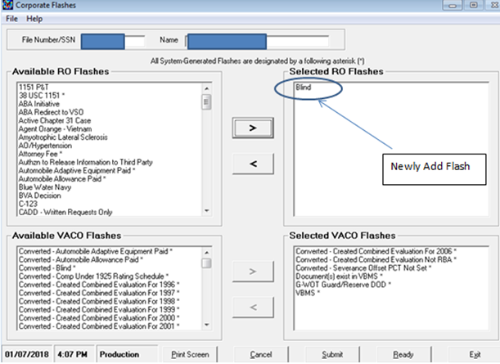

Topic 4: Special Issues

Special issues are claim-specific indicators and can represent a certain claim type, disability or disease, or other special notation that is only relevant to a particular claim. Special issues must be identified and inputted when applicable. If a special issue exists and applies to the claim, it is required. Oftentimes claims require both a corporate flash and a similar special issue. Currently, there are just over 90 available special issues, and attention to detail at establishment phase is a must.

Special Issues are related to a contention.

Claim specific indicators typically pertain to certain contentions which represent a claim type, disability or disease, or other special notation that is only relevant to a current pending claim.

Special issues stay on for the duration of the claim and no longer exist when the claim has ended.

Mandatory with every case.

Why does VA need special tracking requirements?

* Easy identification
* Priority processing
* National Work Queue (NWQ) routing rules

**Fully Developed Claim - Special Issue**

The Department of Veterans Affairs (VA) designed the Fully Developed Claim (FDC) Program for the purpose of

* Reducing its backlog of pending claims, and
* Improving claims-processing timeliness.

VA must receive one of the following forms in order to participate in the FDC program:

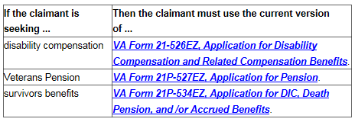

**Special Issues**

If a special issue exists and applies to the claim, it is required. Claims may require both a corporate flash and a similar special issue.

A full list of all available special issues can be found at [M21-4, Appendix C, Special Issue](https://vaww.vrm.km.va.gov/system/templates/selfservice/va_kanew/help/agent/locale/en-US/portal/554400000001034/content/554400000036570/Appendix-C-Index-of-Claim-Attributes?query=claim%20label#II). There is a separate list specific for quality assurance that can be found at [M21-4, Chapter 6, Appendix A, VSR Task Based Quality Revie Checklist – Task 11](https://vaww.vrm.km.va.gov/system/templates/selfservice/va_kanew/help/agent/locale/en-US/portal/554400000001034/content/554400000037939/Chapter%206.%20%20Quality%20Review%20Team%20(QRT)#AppA).

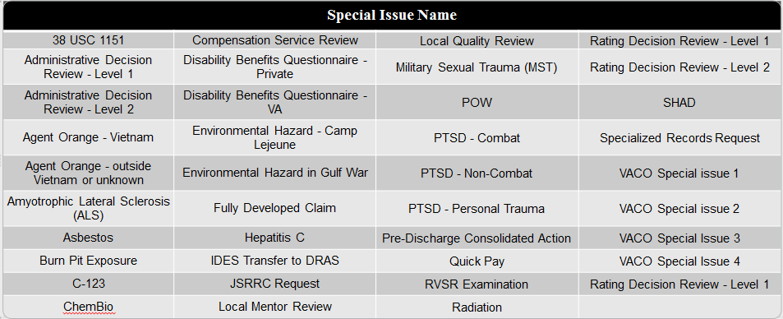

Claims establishment entails multiple step process. One of the steps is entering the contentions the Veteran is claimed. A subpart of entering the contention is add any appropriate special issues.

There are three commonly used special issues which are related to **Agent Orange Exposure**:

1. Agent Orange – Vietnam - Use for all SC claims for disabilities resulting from exposure to Agent Orange during military service in Vietnam not previously granted.
2. Agent Orange - outside Vietnam or unknown - Use for all SC claims for disabilities resulting from exposure to Agent Orange during military service outside of Vietnam not previously granted.
3. C-123 - Apply to contentions for SC disability or death associated with Agent Orange exposure through regular and repeated duties flying on, or maintaining, contaminated former Operation Ranch Hand (ORH) C-123 aircraft. ***Reference***: For more information, see [M21-1, IV.ii.1.H.3.a](https://vaww.vrm.km.va.gov/system/templates/selfservice/va_kanew/help/agent/locale/en-US/portal/554400000001034/content/554400000014940/M21-1,-Part-IV,-Subpart-ii,-Chapter-1,-Section-H---Developing-Claims-for-Service-Connection-(SC)-Based-on-Herbicide-Exposure).

There are four special issues which are related to **PTSD**:

1. PTSD – Combat -- Use for SC claims of PTSD resulting from combat experience, or when the nature of the stressor is not expressly stated but the Veteran is in receipt of a requisite combat decoration, and entitlement has not been previously established. ***Reference***: For more information, see [M21-1, IV.ii.1.D.1](https://vaww.vrm.km.va.gov/system/templates/selfservice/va_kanew/help/agent/locale/en-US/portal/554400000001034/content/554400000014906/M21-1,-Part-IV,-Subpart-ii,-Chapter-1,-Section-D---Claims-for-Service-Connection-(SC)-for-Post-Traumatic-Stress-Disorder-(PTSD)).
2. PTSD - Non-Combat -- Use for claims of PTSD resulting from a non-combat stressor (other than personal trauma or MST) when entitlement has not been previously established.
3. PTSD - Personal Trauma -- Use for claims of PTSD resulting from a non-sexual personal trauma and entitlement has not been previously established. ***Reference***: For more information, see [M21-1, IV.ii.1.D.5.k](https://vaww.vrm.km.va.gov/system/templates/selfservice/va_kanew/help/agent/locale/en-US/portal/554400000001034/content/554400000014906/M21-1,-Part-IV,-Subpart-ii,-Chapter-1,-Section-D---Claims-for-Service-Connection-(SC)-for-Post-Traumatic-Stress-Disorder-(PTSD)).

**Other Commonly used Special Issues:**

* Military Sexual Trauma (MST) - Use for any claimed condition, mental or physical, resulting from MST when entitlement has not been previously established. ***Reference***: For more information, see [M21-1, IV.ii.1.D.5.k](https://vaww.vrm.km.va.gov/system/templates/selfservice/va_kanew/help/agent/locale/en-US/portal/554400000001034/content/554400000014906/M21-1,-Part-IV,-Subpart-ii,-Chapter-1,-Section-D---Claims-for-Service-Connection-(SC)-for-Post-Traumatic-Stress-Disorder-(PTSD)).
* Burn Pit Exposure - Use for all SC claims for disabilities resulting from burn pit exposure not previously granted.
* Environmental Hazard in Gulf War - Use for all SC claims for disabilities resulting from an environmental hazard due to Gulf War military service in Southwest Asia not previously granted. ***Reference***: For more information, see [M21-1, IV.ii.1.I.6.b](https://vaww.vrm.km.va.gov/system/templates/selfservice/va_kanew/help/agent/locale/en-US/portal/554400000001034/content/554400000033326/M21-1,-Part-IV,-Subpart-ii,-Chapter-1,-Section-I---Developing-Claims-for-Service-Connection-(SC)-Based-on-Other-Exposure-Types).
* Gulf War Presumptive - Use for all SC claims for presumptive disabilities listed in [38 CFR 3.317(c)](http://www.ecfr.gov/cgi-bin/text-idx?SID=e363ee2ac85a74e6c173385b12844379&mc=true&node=pt38.1.3&rgn=div5) not previously granted.
* Environmental Hazard - Camp Lejeune - Use for all SC claims for disabilities resulting from Camp Lejeune Environmental Hazard not previously granted. ***Reference***: For more information, see [M21-1, IV.ii.1.I.](https://vaww.vrm.km.va.gov/system/templates/selfservice/va_kanew/help/agent/locale/en-US/portal/554400000001034/content/554400000033326/M21-1,-Part-IV,-Subpart-ii,-Chapter-1,-Section-I---Developing-Claims-for-Service-Connection-(SC)-Based-on-Other-Exposure-Types)7.
* Mustard Gas - Use for all SC claims for disabilities resulting from exposure to mustard agents or lewisite not previously granted. ***Reference***: For more information, see [M21-1, IV.ii.1.F.3.a](https://vaww.vrm.km.va.gov/system/templates/selfservice/va_kanew/help/agent/locale/en-US/portal/554400000001034/content/554400000014322/M21-1,-Part-IV,-Subpart-ii,-Chapter-1,-Section-F---Developing-Claims-for-Service-Connection-(SC)-for-Disabilities-Resulting-From-Exposure-to-Mustard-Gas-or-Lewisite).
* Disability Benefits Questionnaire – Private- Apply to any compensation contention when a DBQ is received from any non-VA source.
* VONAPP Direct Connect – Automatically affixed to the first contention when a claim is submitted through the Veterans Online Application (VONAPP) Direct Connect (VDC). ***Reference***: For more information, see [M21-1, III.i.4.A.1](https://vaww.vrm.km.va.gov/system/templates/selfservice/va_kanew/help/agent/locale/en-US/portal/554400000001034/content/554400000031039/M21-1,-Part-III,-Subpart-i,-Chapter-4,-Section-A---The-Veterans-Online-Application-(VONAPP)-Direct-Connect-(VDC)-Program-and-www.Vets.gov-(Vets.gov)).

Additional Special Issues:

* Claim filed within 1 year of RAD
* POW
* 38 US 1151
* Asbestos
* Amyotrophic Lateral Sclerosis (ALS)
* Hepatitis C
* HIV
* Local Mentor Review

Special issues must be applied or updated once they are identified. Use the table below to determine how special issues should be applied to contentions.



**Entering Special Issue in VBMS**

Step 1: Under the CONTENTION tab, select the SPECIAL ISSUES down arrow.

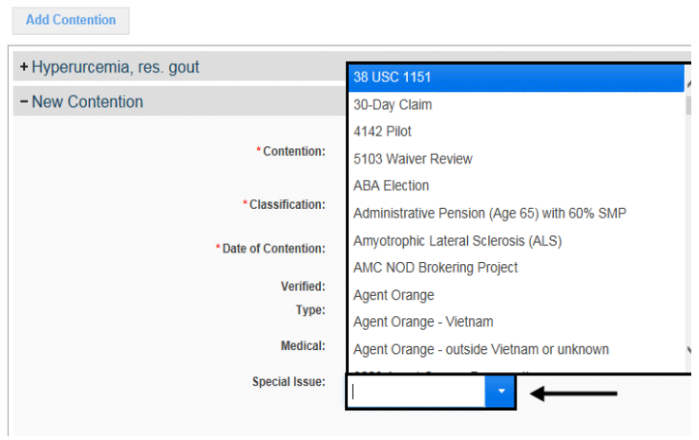

Step 2: Select the appropriate special issue to be associated to the contention.

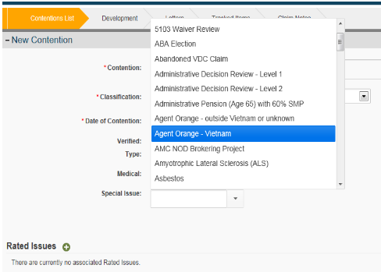

Step 3: Select the SAVE button to save the special issue or the CANCEL button to discard the changes.

**Note:** If you finish adding special issues and want to add another contention select the SAVE and ADD button.

Attachment A: [M21-4, Appendix C, Index of Claim Attributes - Corporate Flashes](https://vaww.vrm.km.va.gov/system/templates/selfservice/va_kanew/help/agent/locale/en-US/portal/554400000001034/content/554400000036570/Appendix%20C.%20Index%20of%20Claim%20Attributes)

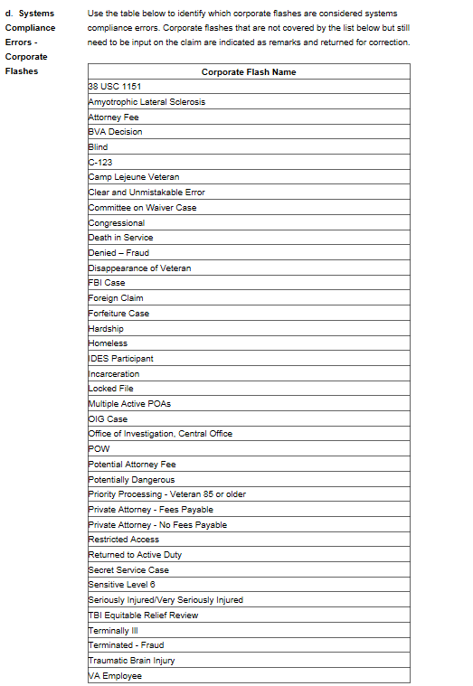Attachment B: [M21-4, Appendix C, Index of Claim Attributes - Special Issues](https://vaww.vrm.km.va.gov/system/templates/selfservice/va_kanew/help/agent/locale/en-US/portal/554400000001034/content/554400000036570/Appendix%20C.%20Index%20of%20Claim%20Attributes)

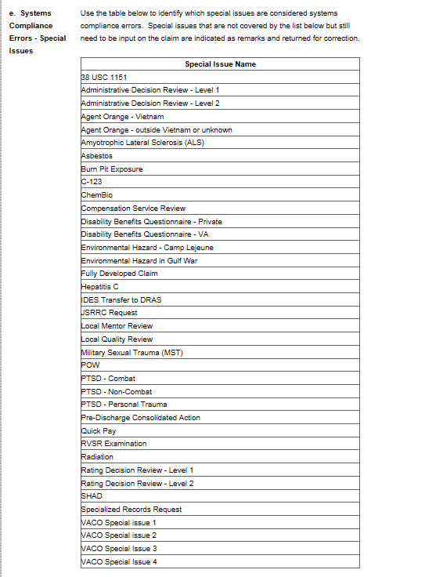

Practical Exercise

**Directions:** You will need to log into the Compensation and Pension Knowledge Management ([CPKM](https://vaww.vrm.km.va.gov/system/templates/selfservice/va_kanew/help/agent/locale/en-US/portal/554400000001034)) Portal. Read the practical exercise scenarios below, use the list of claim labels, corporate flashes and special issues available in M21-4 Appendix C Index of Claim Attributes to answer the questions below.

**Scenario 1:**

Julie Fairley, a Veteran, submitted a VA Form 21-526ez claiming service connection for tinnitus, bronchitis related to environmental hazards in Gulf War, traumatic brain injury due to IED exposure and unemployability related to the brain injury. She has never filed a claim before. In addition to the VA Form 21-526ez, she submitted a copy of her DD214, multiple unpaid utility bills and private medical evidence related to her claim. She did not submit a VA Form 21-8940 with her claim.

**What EP and claim label is appropriate for this case?**

**What flash(es) is/are appropriate for this case?**

**What special issue(s) is/are appropriate for this case?**

**Scenario 2:**

You have just received a non-original claim for benefits from Dane Lambert. He submitted a VA Form 21-526ez, VA Form 21-0781 and a DD214. Additionally, he submitted private medical evidence claiming Non-Hodgkin’s Lymphoma and diabetes due to Agent Orange Exposure. He is also claiming PTSD and submitted a note indicating it was related to his service in Republic of Vietnam. The evidence indicates that Mr. Lambert is terminal and he is currently service connected for diabetes, only.

**What claim label is appropriate for this case?**

**What flash(es) is/are appropriate for this case?**

**What special issue(s) is/are appropriate for this case?**