Completing an Exam Scheduling Request

for Individual Unemployability

**Identifying Contentions and Contention Classification**

Use of contentions for each claim is mandatory. Each claimed issue, including non-rating issues, must be entered as a separate contention. A claim for total disability due to individual unemployability is treated as a claim for increase in the service-connected (SC) disabilities that the Veteran identifies as causing unemployability. Therefore, the identified SC disabilities should be entered as individual contentions. (M21-1.III.iii.1.F)

The CLASSIFICATION and MEDICAL fields are required components when entering a contention. (M21-1.III.iii.1.F)

1. For each medical contention, use the appropriate medical verbiage that corresponds to the claimed medical condition and select the appropriate classification.

Select ‘Yes’ in the MEDICAL field if the contention requires an examination or medical opinion to make a determination.

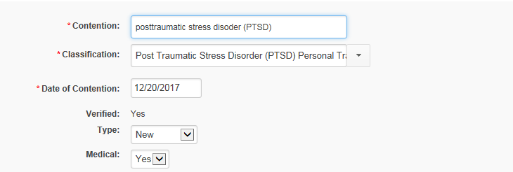

1. For the contention of ‘Unemployability’, select ‘Unemployability’ as the classification and select ‘Yes’ in the MEDICAL field.

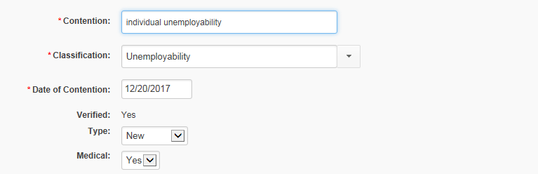

**Completing an Exam Scheduling Request for Individual Unemployability**

Remember, a claim for IU may not be freestanding, but must be part of a claim for increased evaluation or original service connection. (M21-1.IV.ii.2.F)

**Scenario 1**: A Veteran has filed an original claim for posttraumatic stress disorder (PTSD), low back strain, and right ankle strain on a VA Form 21-526EZ. At the same time, the Veteran submitted a VA Form 21-8940, which identified unemployability due to PTSD and low back strain. The evidence of record establishes service connection on a direct basis is warranted for all three contentions and that the Veteran is no longer working. However, exams are needed to determine the severity of these conditions and for a comment on unemployability related to the PTSD and low back strain.

1. When a VA Form 21-8940 is received for a claim of Individual Unemployability, as part of an original claim, a claim for an increase or a new contention(s), you will establish a separate contention for claim of unemployability and classify it as ‘Unemployability’.

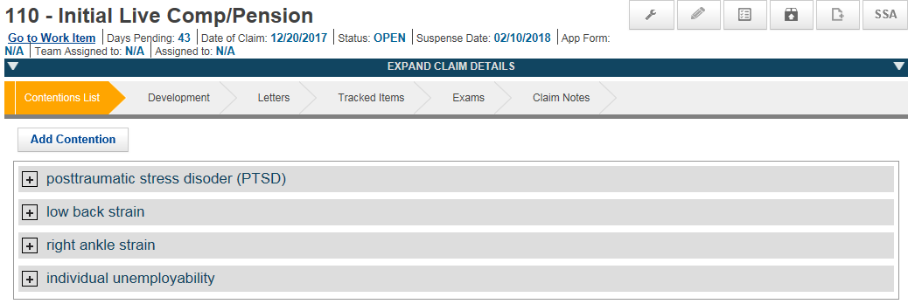

1. Select the ‘**Exams**’ chevron; then, select the ‘**Create New Request**’ button.

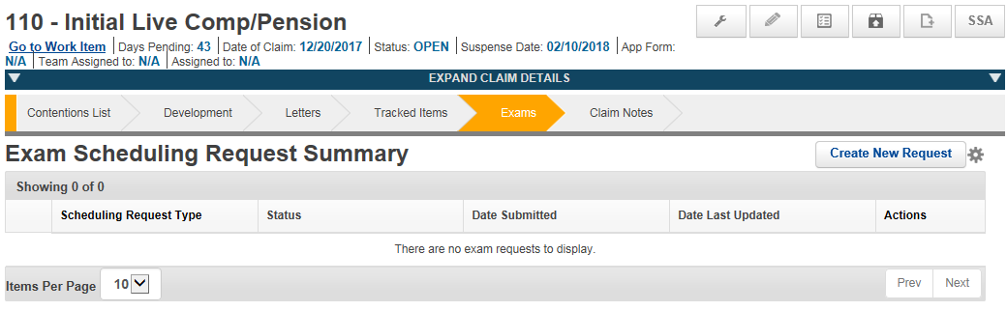

1. Under the ‘**Select Contentions**’ tab, select the medical contentions that require examinations, to include the disabilities the Veteran states and/or the evidence indicates prevent(s) substantially gainful employment.

**Do not select the ‘Unemployability’ contention.** *For guidance on when to select the ‘Unemployability’ contention for exam scheduling request, see Page 6 for ‘When an Unemployability Comment Only is Needed’.*

**NOTE:** In addition to those contentions associated with the claim for unemployability, you will also select any additional contentions that may require an examination.

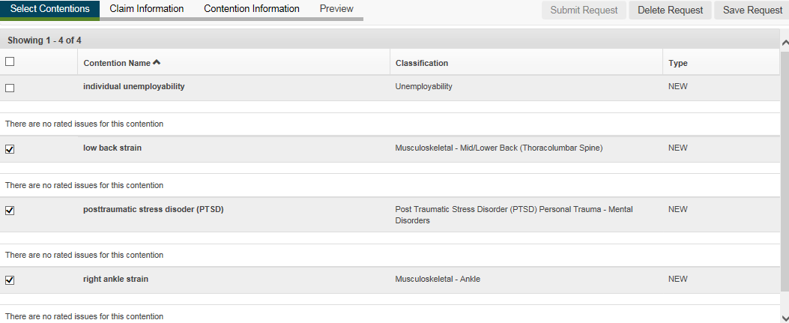

1. Complete the required information in the ‘**Claim Information**’ tab. Select the VBA Contractor, Era(s) of Service information, and whether the Veteran has a Preferred Geographic Location. If an alternate phone number, power of attorney, or special issue needs to be address, complete the information as necessary.

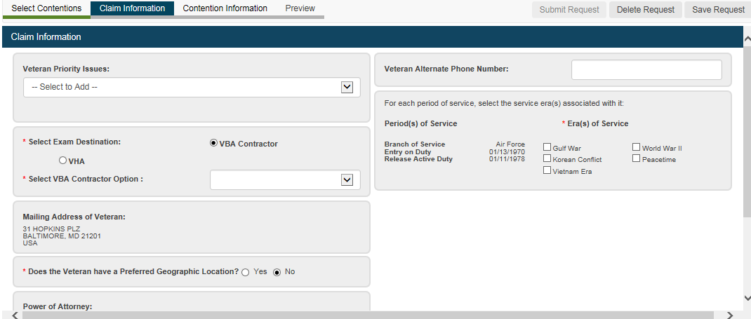

1. Under the ‘**Contention Information**’ tab, you will expand each contention to complete the required information needed for the examination and/or medical opinion.

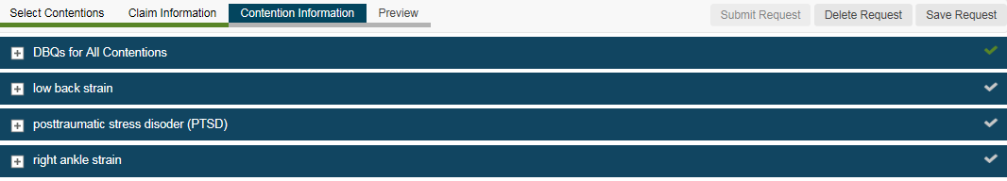

1. You will complete the exam scheduling request field selections as you would normally for each contention.

**However**, for the contentions that are included in the claim for ‘Unemployability’ you will also, select the ‘Employment Impact Assessment Requested’ field.

* 1. **ACE Eligible**: This should not be selected when the Veteran must report for an examination.
  2. **Veteran Must Report to Exam**: This should be selected when the Veteran must report for an examination.
  3. **Employment Impact Assessment Requested**: Select to enable, when the contention is part of the claim for ‘Unemployability’; otherwise, skip this question.
  4. **Need for Employment Impact Assessment**: If there is any specific information or evidence of record that the clinician needs to review, it should be identified here. (You can also add information to the ‘Special Instructions’ box beneath the ‘Available DBQs/Selected DBQs’.)
  5. **Is Specialty Language Needed?**: For medical contentions, if medical opinions are needed, please complete this section.

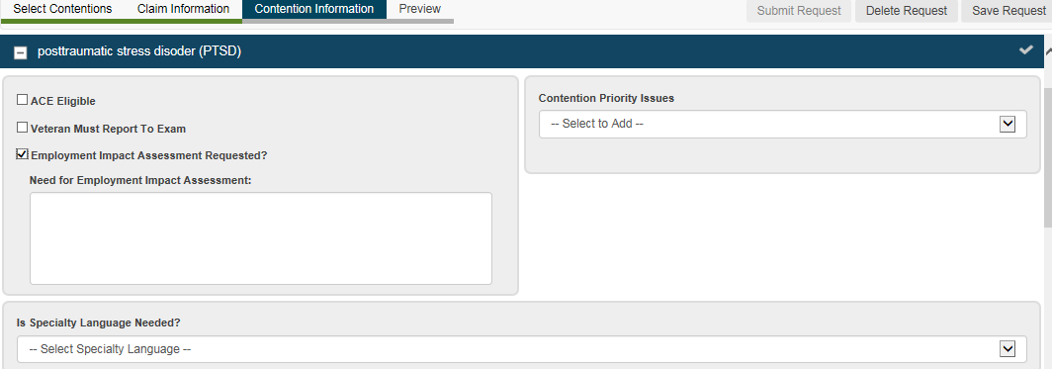

* 1. **Available DBQs/Selected DBQs**: Select the appropriate disability DBQ(s) and advance to the Selected DBQs box.

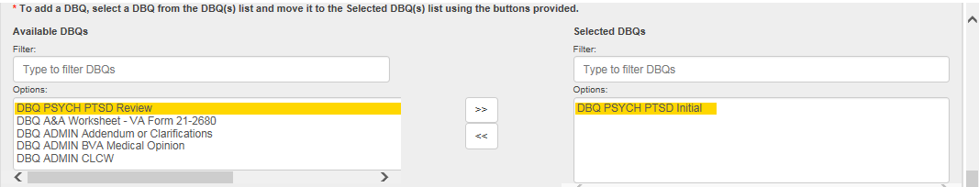

* 1. Each tab above the exam contentions and the checkmarks to the right will be green, when the required information has been completed for each contention.

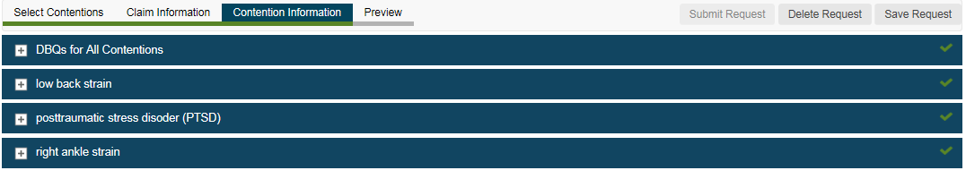

* 1. Select ‘**Preview**’, once each contention that needs an exam scheduling request has been completed. A new tab will open to display the exam scheduling request.
  2. Following your review of the exam scheduling request, you can select ‘**Submit Request**’, if there are no changes that need to be made. If you need to make edits, you can go back through each of the tabs (Select Contentions, Claim Information, Contention Information, Preview).

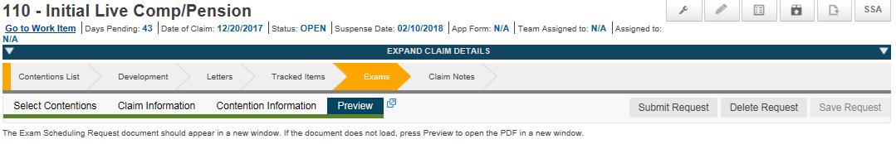

**When an Unemployability Comment Only is Needed**

On occasion, a comment regarding ‘Unemployability’ is needed although an examination has recently been completed (late-flowing claim). No new exams are necessary to evaluate the severity of service connected disability(ies), only a comment related to ‘Unemployability’ is needed.

**Scenario 2**: A Veteran files a claim for increase of the service connected posttraumatic stress disorder (PTSD), currently evaluated as 30 percent disabling. The completed examination is received and the RVSR determines an increased evaluation is warranted to 70 percent disabling. During the pendency of the claim, the Veteran submits VA Form 21-8940 identifying PTSD contributes to unemployability. *No new exam is necessary, just a comment related to unemployability*.

**If only an ‘Unemployability’ comment is needed, please complete Steps 1 thru 4 as described on Pages 1 and 2. Then proceed as follows.**

1. Under the ‘**Select Contentions’** tab, select the ‘**Unemployability**’contention **only**.

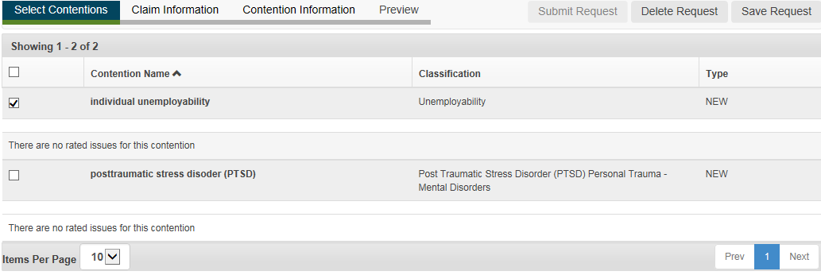

1. Complete the required information in the ‘**Claim Information tab’**, as shown in **Step 6 on Page 3**.
2. Under the ‘**Contention Information’** tab, you will expand the ‘**Unemployability**’ contention to complete the required information needed.
   1. **ACE Eligible**: This should not be selected when the Veteran must report for an examination.
   2. **Veteran Must Report to Exam**: This should be selected when the Veteran must report for an examination.
   3. **Employment Impact Assessment Requested**: This is *selected by default*, since the contention was classified as ‘Unemployability’.
   4. **Need for Employment Impact Assessment**: If there is any specific evidence in the record that the clinician needs to review, it should be identified here. (You can also add information to the ‘Special Instructions’ box beneath the ‘Available DBQs/Selected DBQs’.)
   5. **Available Unemployability Contentions**: Select the contentions identified for the ‘Unemployability’ claim and advance to the **Selected Unemployability Contentions**.

The ‘Available Service Connected Disabilities’ section will identify the conditions for which the Veteran is already service connected and will allow you to select a check box if these conditions need to be identified for the examiner..

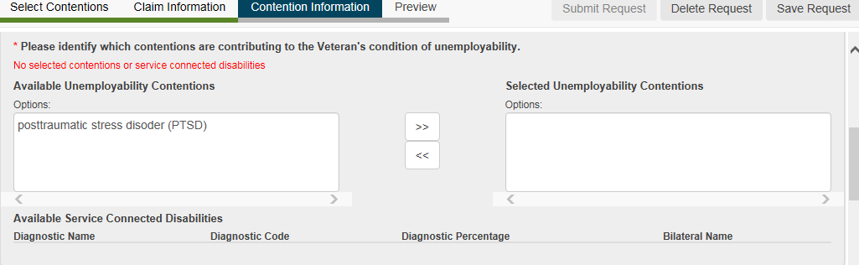

* 1. **Is Specialty Language Needed**: For the contention of ‘Unemployability’ **skip** this and move on to ‘Available DBQs’.
  2. **Available DBQs/Selected DBQs:** Select the ‘DBQ Medical Opinion (Examiner’s Version)’ and advance to the Selected DBQs box.

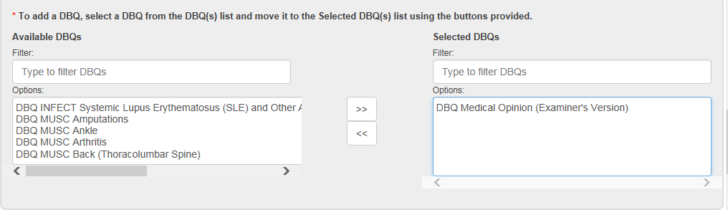

* 1. See Steps 8g to 8i on how to **Preview** and **Submit** the exam scheduling request.

**References**:

M21-1, Part III, Subpart iii, 1.B, Evidence Requested from the Claimant

M21-1, Part III, Subpart iii, 1.F, Record Maintenance During the Development Process

M21-1, Part III, Subpart iv, 3.A, Examination Requests Overview

M21-1, Part IV, Subpart ii, 2.F, Compensation Based on Individual Unemployability (IU)