Introduction to End Product Controls and Claims Establishment
Lesson plan
Time Required: 2.5 Hours

Table of Contents

Lesson Description 2
Introduction to End Product (EP) Controls and Claims Establishment (CEST) 4
Topic 1: End Products 6
Topic 2: Duplciate Record Prevention 9
Topic 3: Claims Establishment 11
Review Exercise 21
Practical Exercise 21
Lesson Review, Assessment, and Wrap-up 22

Lesson Description
The information below provides the instructor with an overview of the lesson and the materials that are required to effectively present this instruction.
TMS # | 4415893
Prerequisites | None
target audience | The target audience for Introduction to Establish Claim Procedures and EP Controls VBMS and adding flashes in SHARE is VSR Entry Level.  Although this lesson is targeted to teach the VSR Entry Level employee, it may be taught to other VA personnel as mandatory or refresher type training.
Time Required | 2.5 hours
Materials/  TRAINING AIDS | Lesson materials:  - Introduction To Claim Establishment and End Product Controls Power Point Presentation  - Introduction To Claim Establishment and End Product Controls Handout Packet  - Attachment A: End Product Codes  - Introduction To Claim Establishment and End Product Controls Practical Exercise
Training Area/Tools | The following are required to ensure the trainees are able to meet the lesson objectives:  - Classroom or private area suitable for participatory discussions  - Seating, writing materials, and writing surfaces for trainee note taking and participation  - Trainee Handout Packet, which includes a practical exercise  - Large writing surface (easel pad, chalkboard, dry erase board, overhead projector, etc.) with appropriate writing materials  - Computer with PowerPoint software to present the lesson material  Trainees require access to the following tools:  - Compensation Intranet Home Page  - M21-4, Appendix B  - VBMS demo environment and SHARE Academy mode  - VBA Virtual Schoolhouse
Pre-Planning | - Become familiar with all training materials by reading the Instructor Lesson Plan while simultaneously reviewing the corresponding PowerPoint slides. This will provide you the opportunity to see the connection between the Lesson Plan and the slides, which will allow for a more structured presentation during the training session.  - Become familiar with the content of the trainee handouts and their association to the Lesson Plan.  - Practice is the best guarantee of providing a quality presentation. At a minimum, do a complete walkthrough of the presentation to practice coordination between this Lesson Plan, the trainee handouts, and the PowerPoint slides and ensure your timing is on track with the length of the lesson.  - Ensure that there are copies of all handouts before the training session.  - When required, reserve the training room.  - Arrange for equipment such as flip charts, an overhead projector, and any other equipment (as needed).  - Talk to people in your office who are most familiar with this topic to collect experiences that you can include as examples in the lesson.  - This lesson plan belongs to you. Feel free to highlight headings, key phrases, or other information to help the instruction flow smoothly. Feel free to add any notes or information that you need in the margins.
Training Day | - Arrive as early as possible to ensure access to the facility and computers.  - Become familiar with the location of restrooms and other facilities that the trainees will require.  - Test the computer and projector to ensure they are working properly.  - Before class begins, open the PowerPoint presentation to the first slide. This will help to ensure the presentation is functioning properly.  - Make sure that a whiteboard or flip chart and the associated markers are available.  - Provide a sign in sheet and at the conclusion of the session, ensure that all trainees sign in.

Introduction to End Product (EP) Controls and Claims Establishment (CEST)
INSTRUCTOR INTRODUCTION |  | Complete the following:  - Introduce yourself  - Orient learners to the facilities  - Ensure that all learners have the required handouts
time required |  | 0.15 hours
Purpose of Lesson  Explain the following: |  | This lesson is intended to introduce the trainee to the initial claims establishment process and EP control system. This lesson will contain discussions and exercises that will allow the trainee to gain a better understanding of:  - End Prodcut (EP) and Claims Establishment (CEST)  - CEST Demonstration
Lesson Objectives  Discuss the following:  Slide 2  Handout 2 | At the end of the lesson, the VSR will be required to complete an assessment that tests whether the following lesson objectives have been accomplished:  The VSR should be able to:  - Identify how End Product (EP) control affect claim management, productivity and staffing  - Identify a duplicate claims folder number and avoid creation of a duplicate claims folder  - Establish a claim using Veteran Benefits Management System (VBMS)  - Describe procedures for adding contentions and special issues into VBMS  - Define procedures for creating a Corporate or Regional Office Flashes
Explain the following: | Each learning objective is covered in the associated topic. At the conclusion of the lesson, the learning objectives will be reviewed.
Motivation | Understanding using the correct EP and CESTing is the first step in establishing a claim and is essential for controlling and monitoring a claim as well as evaluating station productivity. Failure to establish a claim under the correct EP could result in delaying the Veteran’s claim.
STAR Error code(s) | The Systematic Technical Accuracy Review (STAR) Program reviews cases and considers them either “accurate” or “in error” for the purpose of measuring technical accuracy.  System Compliance Errors should be discussed.
References  Slide 3  Handout 3 | Explain where these references are located in the workplace.  All M21-1 references are found in the CKPM.  - M21-1, Part III, Subpart ii, 1.C, Initial Screening Policies  - M21-1, Part III, Subpart ii, 3.A, Assignment of Claims Folder Numbers  - M21-1, Part III, Subpart ii, 4.E, Consolidation of Duplicate Beneficiary Identification and Records Locator Subsystem (BIRLS) Records and Corporate Records  - M21-1, Part III, Subpart ii, 3.D, Claims Establishment  - M21-1, Part III, Subpart iii,1.F, Record Maintenance During the Development Process  - M21-1, Part III, Subpart iii, 5, General Information on Relationship and Dependency  - M21-4, Appendix B, End Product Classification Codes and Work Rate Standards for Quantitative Measurement  - SHARE User’s Guide  - VBMS User Guide  - VBMS Online Help

Topic 1: End Products

INTRODUCTION | This topic will introduce the trainee to End Products
TIME REQUIRED | 0.75 hours
OBJECTIVES/  TEACHING POINTS | Topic objectives:  - Given the trainee handout packet, identify how end product (EP) controls affect claim management, productivity, and staffing.  The following topic teaching points support the topic objectives:  - End Products  - Productivity and Staffing  - Determining the EP for Original and Supplemental Rating EPs
End Products  Slide 4  Handout 13 | Explain to the trainne that the End Product (EP) system is the primary Service Center workload monitoring and management tool.  - Correct use of the EP system facilitates proper control of pending workloads and appropriate work measurement credit.  - Correct work measurement is essential to substantiate proper staffing requirements and determine productive capacity.  - Received and completed EPs are also used to formulate the annual budget submission to the Secretary, Office of Management and Budget (OMB), the President, and Congress.
Establishing and Maintaining EP Controls  Slide 5  Handout 13 | A claim should be placed under EP control within seven days of receipt.  The EP should remain pending until all required actions on that claim have been completed.
Examples of EPs  Slide 6  Handout 13,14 | EP codes 010 and 110 are used for original claims, based on the number of disabilities claimed:  - EP 010 is limited to initial disability compensation or concurrent initial disability compensation and pension claims containing eight issues or more.  - EP 110 is limited to initial disability compensation or concurrent initial disability compensation and pension claims containing seven issues or less.  EP codes 020 are used for non-original claims regardless of the number of disabilities claimed.  EP codes 130 are used for dependency claims.  If a claim for dependents accompanies an original claim do not establish another End Product (EP). If the claim is not an original claim then establish a 130 for tracking purposes.  If a Veteran with at least one service-connected disability and a combined disability evaluation that is less than 30 percent files a claim for additional compensation for a dependent, administratively deny the Veteran’s claim. This action will require an EP 130 to be established.  Important: If a claim that might result in the assignment of a combined disability evaluation of at least 30 percent is concurrently pending, postpone a decision on the claim for additional compensation for a dependent until after the rating activity decides the disability claim..  - An original claim will never have an accompanying 130.  - Generally, only one EP (not including dependent claim accompanying disability claim) is proper even though the casework may involve multiple actions that could have resulted in separate EPs had they been received and/or worked at different times.  - The EP should not be cleared until all issues have been adjudicated.  Only one EP 110, 010, representing an original claim can be established for a Veteran in the Veteran’s life time.
Determining the EP for Original and  Slide 6  Handout 5,6 | To administer proper EP control for rating-related claims, determine if the claimant  - previously filed for benefits (making the current claim supplemental), or  - is filing an initial (original) claim.  Follow the steps in the table below to determine if a claim should be controlled with an original or supplemental EP. If a determination has been made or entries exist then a supplemental EP is needed:  - Perform a Corporate Inquiry  - Click on the AWARD/RATING tab, navigate to the RATING INFORMATION tab and check for a previous determination.  - If no information is found, complet a BIRLS INQUIRY and select the INACTIVE COMP & PEN tab and determine if entries exist in the :  - DIAGNOSTIC table  - ENTITLEMENT CODE field, or  - Reason for Termination or Disallowance field.

Topic 2: Duplciate Record Prevention
Introduction | This topic will introduce the trainee to Duplicate Claims Folders
Time Required | 0.5 hours
OBJECTIVES/  Teaching Points | Topic objectives:  Given the trainee handout packet, identify procedures to identify and avoid creation of duplicate clqaims folder number using the step by step process outlined in the manual.  The following topic teaching points support the topic objectives:  - When to assign a claims folder number  - Actions necessary to check for the existence of a previously established claims folder number.
When to Assign a Claims Folder Number  Slide 8  Handout 7 | Associate the records for all claimants and beneficiaries to a claims folder number. There are two types of claims folder numbers used by the Veterans Benefits Administration (VBA) based on  - the Veteran’s Social Security number (SSN), or  - an eight-digit claims folder number assigned through the Beneficiary Identification and Records Locator Subsystem (BIRLS).  Use the table located in M21-1.III.ii.3.A to determine the claims folder number to assign.  All documents received by VBA with identifying personal information require association with a claims folder number regardless of the need for claims establishment or confirmation of Veteran status.  Important: To avoid duplicate claim (DUPC) processing, conduct a thorough search of all systems for a previously established claims folder number as outlined in M21-1, Part III, Subpart ii, 3.A.
Preventing Duplication of BIRLS Records  Slide 9  Handout 7 | Commands used to check for a duplicate claim folder number are as follows:  - Using SHARE, complete BIRLS INQUIRY using provided information:  - File number  - Social Security Number  - Service Number  - First name/last name  - First name/middle initial/last name  - Using SHARE, complete COPORATE INQUIRY and conduct a PERSON SEARCH using claimant’s information.  - Using Participant Profile conduct a NUMBER SEARCH as applicable if correspondence includes:  - insurance file number  - current domestic phone number  - home loan number, or  - tax identification number  - Using COVERS, select NAME/SSN INQ command to search by claimant’s name  - Is minimum information available to establish a corporate record?  - SSN and/or claims folder number  - First name  - Last name, and  - DOB  - If information is unavailable complete search procedures outlined.  - Using SHARE, complete a SEARCH ALL IN LIST command to ensure the claimant has both a BIRLS and corporate record.  - If BIRLS record exists, complete a BIRLS UPDATE to create a corporate record.  - If no BIRLS exists complete a BIRLS ADD to create a BIRLS and corporate record.  An Alternative Search includes:  Using the Veterans Benefits Management System (VBMS), select the More Search Options hyperlink to do an advanced search based on the Veteran’s first and last name. Sort the results by date of birth and analyze for a match.  Important: Use of this method to look for a previously established claims folder number is expedient. However, it is not a conclusive search. Before conducting a BIRLS ADD in Share, follow all search guidance in M21-1, Part III, Subpart ii, 3.A to avoid creating a DUPC.
NOTE(S) | Refer trainees to the M21-1, Part III, Subpart ii, Chapter 3, Section A and/or M21-1, Part III, Subpart ii, Chapter 4, Section E for step by step instructions of the process outlined above which also includes the attachment Preventing Duplicate Records.

Topic 3: Claims Establishment
Introduction | This topic will introduce the trainee to Claims Establishment (CEST).
Time Required | 0.5 hours
OBJECTIVES/  Teaching Points | Topic objectives:  - Given the trainee handout packet, identify procedures to establish a claim using VBMS and enter Flashes into SHARE  The following topic teaching points support the topic objectives:  - Preparing for Claims Establishment  - Establishing Claim Procedures VBMS  - Date of Claim Information  - Creating Flashes in SHARE for Claim
Preparing for Claims Establishment (CEST)  Slide 10  Handout 10 | The table below describes the steps of claims establishment and the references for guidance on these actions.  - Review the VBMS exclusions to determine the system in which to place the claim under control.  - Check for a previously established claims folder number.  - Determine the current claims folder format and request scanning of paper claims folders.  - Establish a claims folder in VA systems (if necessary).  Important:  - Establish EP control only upon receipt of a substantially completed form.  - Most pension and survivor claims should now be established in VBMS, as indicated in M21-1, Part III, Subpart ii, 3.D.
Claims Establishment in VBMS vs SHARE  Slide 10  Handout 9 | Veterans Benefits Management System (VBMS) is the system used to review the Veteran’s profile, establish claims, add contentions to include dependents and develop claims. VBMS is the primary source to establish claims for:  - Pension and survivor claims, and  - most claim types for which a VBMS record already exists  VBMS is used to established almost all claims however SHARE is still used in some cases for Claims Establishment and for adding flashes.  Exceptions to CESTING in VBMS: The following claims should be established using SHARE:  - any claim where the claimant is an organization  - appeals where the appellant is not a child, spouse, or parent of the Veteran  - accrued claims upon the death of a surviving spouse or child, as listed in M21-1, Part VIII, 1.5  - pending paper claims, including any new claim filed while a paper claim is pending, and  - a claim or Work Item for which the claimant has a Department of Veterans Affairs (VA) appointed fiduciary
Establishing a New End Product in VBMS  Slide 12  Handout 10 | Inform the trainees that you will now discuss the New Claims Procedure Process for VBMS.  What is done during New Claim Establishment in VBMS:  - Verify Veteran’s contact information on the Veteran’s Profile  - Complete the entries on New Claim Screen  - Add Contentions  *Explain that Veteran’s service information should be verified prior to establishing the new claim.  *Explain that if Veteran’s service needs to be updated the action will need to be completed in SHARE (BIRLS Update) and participant which will be discussed in a future class.
Date of Claim (DOC)  Slide 13  Handout 9 | The Date of Claim is a required entry on the VBMS New claim and serves as the basis for determining processing timeliness. For CEST purposes, it is the earliest date the claim was actually received by any VA facility. The term “VA facility” includes, but is not limited to:  - eBenefits  - VA Regional Office  - VA Centralized Mail Facility  - VA employee at an outreach event  - VA Public Contact team  - VA Call Center  - VA Medical Center  VA requires this date stamp received by Intake Processing Center (IPC) or an electronic date stamp on all information received, including claims, applications, and associated evidence.
Veteran’s Profile Screen  Slide 14  Handout 10 | Prior to establishing a new claim, verification of the Veterans profile must be completed. Once the decision is made to establish a new claim you must pull up the Veteran’s record by entering a search term and clicking “Open Profile”.  From the search bar, enter information in the text box. You can enter:  - A file number  - First and last name separated by a space, such as first_name last_name  - Last and first name, separated by a comma, such as last_name, first_name  - Participant name  - SSN, without dashes, such as xxxxxxxxx  The Veteran Profile includes the following information:  - Demographic information: SSN, birth date, birth place, gender, death date, and station  - Contact information: mailing address, payment address, home phone, work  - phone, and email address  - Flashes: Veteran flashes and systems of update
Establishing a New Claim  Slide 15  Handout 11 | After verifying the Veteran’s personal information and ensuring this is the Veteran for which the claim is being established. Click Actions and then select New Claim from the profile screen. The Claim Establishment page opens to the New Claim Information section.  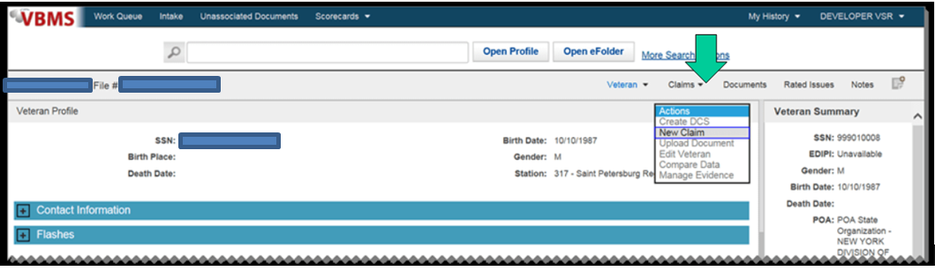
New Claim Information Screen  Slide 16  Handout 12  The trainee handout packet includes a screenshot from VBMS New Claim Screen, to demonstrate New claim procedures. | Once all pertinent information has been verified proceed to the New Claim Information Screen.  - Complete all the entries required noted by the red asterisk.  - Payee code  - EP & Claim Label  - Modifier (on demo environment this function is not operational)  - Date of Claim  - Segmented Lane  - Station  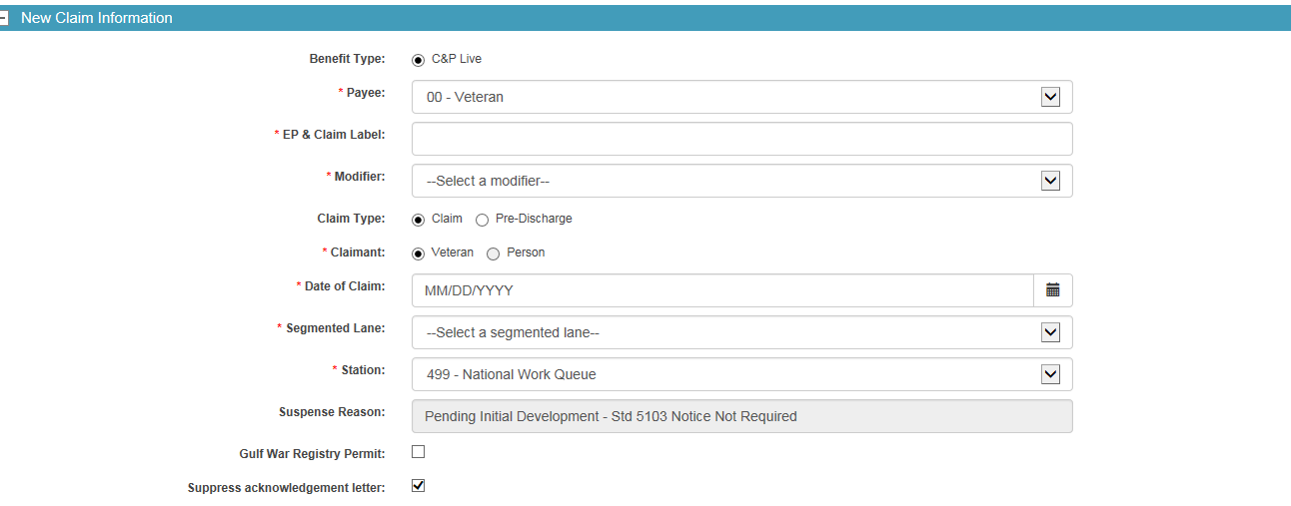  - Choose appropriate Power Of Attorney selection  - None-The claimant has not identified a POA or POA information is not available  - VSO: The Veterans Service organization or Officer acts as POA for the claimant  - Private: The claimant retains a private attorney to act as POA  - Select of clear the “allow POA access to Documents check box to indicate if the claimant has authorized the VSO or other POA to view e folder documents.  - Check Suppress Letter
Claimant Contact Information  Slide 17  Handout 12 | 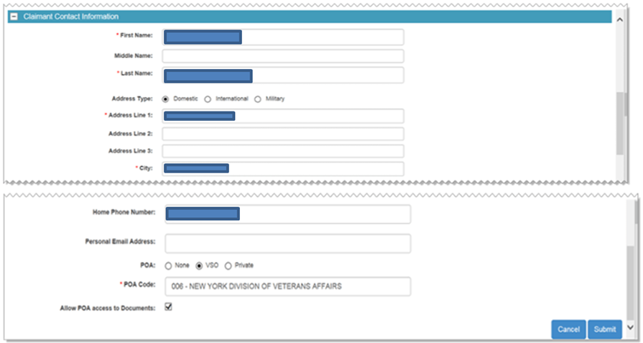
Adding Contentions  Slide 18-20  Handout 13 | Upon completion of the establishment of the claim in VBMS the system automatically routes the VSR to the contentions development task bar.  Use of contentions for each claim is mandatory and should be entered as soon as they are identified. All claimed issues must be entered as contentions as they are claimed by the Veteran on the application for benefits. Each claimed issue, including non-rating issues, must be entered as a separate contention. Click Add Contention from the Development task bar  - Click Add Contention and enter a contention description. As you type, contentions that might apply will be suggested.  - Click Classification and choose from the classification list.  - The contentions date will be set to the date of claim by default. If needed (in the case of additional claims after the first is established) and select date from calendar. The contentions date can not be before the date of claim.  - The Verified box is automatically populated with a yes or no value, once you save the contention. The Verified box indicates that the contention has been reviewed and it is correct.  - Contentions that have been manually entered will always show Yes.  - Scanned contentions will show No until verified.  - Click Type and choose the type from the list New; Reopen, Increase, Secondary or Request for Examination (RFE).  - Click Medical and select Yes or No.  - Click Medical and Select Yes or No  Stress that Non-rating contentions should relate to the specific benefit being sought and appropriate naming conventions must be adhered to. Stress the importance of naming the contentions in the manner that were presented by the Veteran. Stress that when adding dependents as contentions they must indicate the dependents name as well.
Example of Appropriate Naming  Slide 21  Handout 14 | A Veteran submits a claim to add a spouse and a child along with a claim for hearing loss due to acoustic trauma and tinnitus. Create separate contentions for the spouse and child as well as each medical contention as follows:  - Dependency claim for [name of spouse]  - Dependency claim for [name of child]  - Hearing loss due to acoustic trauma (exactly how Veteran stated)  - Tinnitus  Instructor should note the importance of entering the contentions as they are identified by the Veteran and ensure to stress the naming conventions for dependents.
Special Issues  Slide 22  Handout 14 | Click Special Issue and select an issue from the drop down list. There will be a special issue that needs to be entered in all cases because all cases must be assigned to a team such as Core, Special Operations, Non-Rating or Express.  - A special issue helps to identify a potential variance in the manner in which the case is being developed  Multiple special issues may be added to a contention but the same same special issue more than once.  - When each special issue is identified, it appears in the area below the Special Issue box. Click the [X] to remove a special issue from the list.
Rated Issues  Slide 23  Handout 15 | Contentions with a type that is secondary or increase are often associated with issues that have been previously determined. When working with these types of contentions view any previously rated issues an associate them to the contention. If there are no rated issues that apply to the specific claim being worked, no action is needed.  - Click the green add Icon next to the Rated Issues. The Associate Rated Issues dialog opens.  - Select the check boxes next to the Associate Rated Issues you want to associate to the contention and click the Add button.  - The issues that have been selected to associate are listed in the Rated Issues list.  - Click Save to save the contention and click Save and Add to save the contention and to add another.  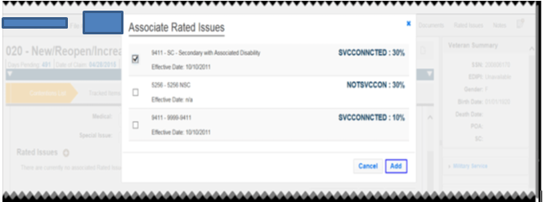  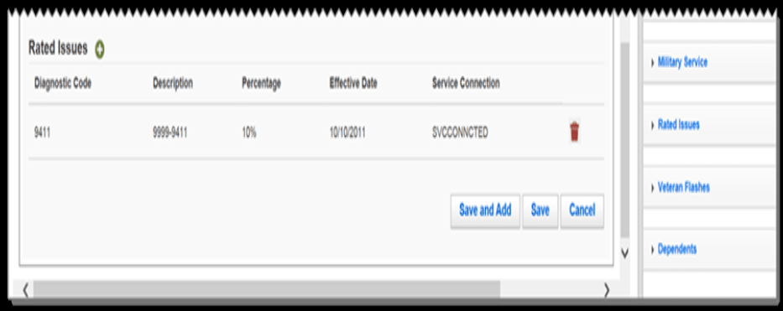
Reviewing Established Contentions  Slide 24  Handout 16 | Contentions that have been entered electronically or have not yet been verified in the system by a a VSR will be marked with a yellow alert icon in the contentions list. In order for the contentions to be accurate and complete, the VSR must take appropriate action to review and correct the contention. After it is completed and verified the yellow alert icon will disappear.  If a yellow alert icon is noticed have the VSR:  - Click the plus sign [+] next to the contention to view or edit the contentions.  - Follow Adding Contention procedures 7-16.
Adding Flashes in Share  Slide 25  Handout 17 | For the purposes of this training share will only be utilized to add flashes to the record. If more detail is required please refer to the Share User Guide. Claims are not to be established in SHARE.  Claimant flashes are claimant-specific indicators that represent an attribute, fact, or status that may occasionally change (e.g. Former Prisoner of War (FPOW), blind Veteran, homeless, etc.). Regional offices (ROs) are responsible for:  - identifying claimant’s records that require flashes  - inputting the flashes when required, and  Claimant flashes must be entered in the corporate record once the need is identified. Most flashes are added by the end user, but some are generated by the system. Flashes will exist on a claimant’s record until the flash is manually removed.  Note: Claimant flashes may only be reviewed on the VBMS profile screen, they must be added and updated in SHARE.
How to Add a Flash in SHARE  Slide 26,27  Handout 17 | Adding Flashes  - Open Share from your Start menu  - Under Search Criteria, enter the File Number.  - Select the Submit button.  - Select Corporate Flash from the Available Processes list on the Ready Screen.  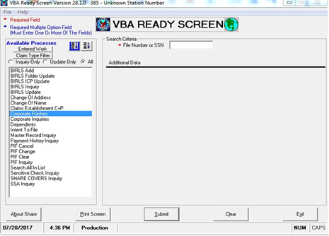  - Select desired flashes from the Available RO Flashes or Available VACO Flashes. Use the > button to add the flashes to the Selected boxes. When all flashes are selected, click the Submit button. A message will be displayed stating the updates are complete.  Inform student that the information that has been provided in SHARE is is not complete because it is a Legacy program and use of the program is limited.  Additional Guidance on the use of SHARE can be found in the SHARE user guide.

Review Exercise
Time Required | 0.25 hours
EXERCISE  Handout 16,17 | Refer trainees to Attachment C: CEST and EP Control Review Exercise in the trainee packet handout.  - Allow 15 minutes for the trainees complete the exercise individually.  - Review and discuss answers to reinforce trainee understanding.

Practical Exercise
Time Required | 0.25 hours
EXERCISE  Handout 16,17 | This practical exercise is an opportunity for the trainees to use the information learned in this lesson using e-cases and the academy database/demo environment. This exercise will help the trainees become comfortable with “doing” the work.  - Refer trainees to the Practical Exercise in the trainee packet handout.  - Establish a claim within the VBMS Demo System  - Monitor the trainees as they complete the practical exercise.  - Check trainees’ work once they have established the claim.  - Give feedback as needed.  - If you feel a trainee has not established a claim to your satisfaction, give appropriate remediation and ask him/her to try again with a new case file.  - Ask if there are any questions about the information presented in the exercise, and then proceed to the Review.

Lesson Review, Assessment, and Wrap-up
Introduction  Discuss the following: | The CEST and EP Controls lesson is complete.  Review each lesson objective and ask the trainees for any questions or comments.
Time Required | 0.1 hours
Lesson Objectives | You have completed the CEST and EP Controls lesson.  The trainee should be able to:  - Identify procedures to establish a claim using VBMS and flashes in SHARE.  - Identify a duplicate claims folder number and avoid creation of a duplicate claims folder  - Identify how end product (EP) controls affect claim management, productivity, and staffing.  - Establish a claim in VBMS and a flash in SHARE to instructor satisfaction.  - Establish an end product (EP) control in VBMS to instructor satisfaction.
Assessment | The assessment will allow the participants to demonstrate their understanding of the information presented in this lesson.

