Introduction to End Product Controls and Claims Establishment

Trainee Handout

**Table of Contents**

Objectives 2

References 3

Topic 1: End Products 4

Topic 2: Duplicate Record Prevention 7

Topic 3: Claims Establishment (CEST) in VBMS 9

Attachment A: End Product Codes 19

Attachment B: VBMS Claims Establishment Flowchart M21-1.III.II.3.DVB 20

Attachment C: CEST and EP Control Review Exercise 21

Practical Exercise 22

Objectives

* Identify how end product (EP) controls affect claim management, productivity, and staffing
* Identify a duplicate claims folder number and avoid creation of a duplicate claims folder
* Establish a claim using Veteran Benefits Management System (VBMS)
* Describe procedures for adding contentions and special issues into VBMS
* Define procedures for creating Corporate or Regional Office Flashes

References

* [M21-1, Part III, Subpart ii, 1.C, Initial Screening Policies](https://vaww.compensation.pension.km.va.gov/system/templates/selfservice/va_ka/portal.html?encodedHash=%23!agent%2Fportal%2F554400000001034%2Farticle%2F554400000014112%2FM21-1-Part-III-Subpart-ii-Chapter-1-Section-C-Initial-Screening-Policies)
* [M21-1, Part III, Subpart ii, 3.A, Assignment of Claims Folder Numbers](https://vaww.vrm.km.va.gov/system/templates/selfservice/va_kanew/help/agent/locale/en-US/portal/554400000001034/content/554400000014122/M21-1-Part-III-Subpart-ii-Chapter-3-Section-A-Assignment-of-Claims-Folder-Numbers)
* [M21-1, Part III, Subpart ii, 4.E, Consolidation of Duplicate Beneficiary Identification and Records Locator Subsystem (BIRLS) Records and Corporate Records](https://vaww.vrm.km.va.gov/system/templates/selfservice/va_kanew/help/agent/locale/en-US/portal/554400000001034/content/554400000014130/M21-1-Part-III-Subpart-ii-Chapter-4-Section-E-Consolidation-of-Duplicate-Beneficiary-Identification-and-Records-Locator-Subsystem-BIRLS-Records-and-Corporate-Records)
* [M21-1, Part III, Subpart ii, 3.D, Claims Establishment](https://vaww.compensation.pension.km.va.gov/system/templates/selfservice/va_ka/portal.html?encodedHash=%23!agent%2Fportal%2F554400000001034%2Farticle%2F554400000031819%2FM21-1-Part-III-Subpart-ii-Chapter-3-Section-D-Claims-Establishment)
* [M21-1, Part III, Subpart iii,1.F, Record Maintenance During the Development Process](https://vaww.vrm.km.va.gov/system/templates/selfservice/va_kanew/help/agent/locale/en-US/portal/554400000001034/content/554400000071983/M21-1-Part-III-Subpart-iii-Chapter-1-Section-F-Record-Maintenance-During-the-Development-Process)
* [M21-1, Part III, Subpart iii, 5, General Information on Relationship and Dependency](https://vaww.compensation.pension.km.va.gov/system/templates/selfservice/va_ka/portal.html?encodedHash=%23!agent%2Fportal%2F554400000001034%2Ftopic%2F554400000003089%2FChapter-05-Relationship-and-Dependency)
* [M21-4, Appendix B, End Product Classification Codes and Work Rate Standards for Quantitative Measurement](https://vaww.compensation.pension.km.va.gov/system/templates/selfservice/va_ka/portal.html?encodedHash=%23!agent%2Fportal%2F554400000001034%2Farticle%2F554400000011474%2FAppendix-B-End-Product-Codes-and-Work-Rate-Standards-for-Quantitative-Measurements)
* [SHARE User’s Guide](http://css.vba.va.gov/SHARE/)
* [VBMS User Guide](http://vbaw.vba.va.gov/VBMS/Resources_Technical_Information.asp)
* [VBMS Online Help](https://www.vbms.vba.va.gov/vbmsp2/resources_p4/webhelp/index.htm)

Topic 1: End Products

**End Products**

* The End Product (EP) system is the primary Service Center workload monitoring and management tool.
* Correct use of the EP system facilitates proper control of pending workloads and appropriate work measurement credit.
* Correct work measurement is also essential to substantiate proper staffing requirements and determine productive capacity.
* Received and completed EPs are also used to formulate the annual budget submission to the Secretary, Office of Management and Budget OMB, the President, and Congress.

EP Controls

A claim should be placed under EP control within seven days of receipt. The EP should remain pending until all required actions on that claim have been completed.

EP codes 010 and 110 are used for **original claims**, based on the number of disabilities claimed:

* EP code 010 is limited to initial disability compensation or concurrent initial disability compensation and pension claims containing *eight issues or more*.
* EP code 110 is limited to initial disability compensation or concurrent initial disability compensation and pension claims containing *seven issues or less*.
* EP code 130 is used for dependency.
* EP code 020 is used for non-original claims regardless of the number of contentions.

EP codes 020 are used for non-original claims regardless of the number of disabilities claimed.

Generally, only one EP is proper even though the casework may involve multiple actions that could have resulted in separate EPs had they been received and/or worked at different times. The EP should not be cleared until all issues have been adjudicated.

* An original claim will **never** have an accompanying 130.
* Generally, only one EP (not including dependent claim accompanying disability claim) is proper even though the casework may involve multiple actions that could have resulted in separate EPs had they been received and/or worked at different times.
* The EP should not be cleared until all issues have been adjudicated.

*If a claim for dependents accompanies an original claim do not establish another End Product (EP). If the claim is not an original claim then establish a 130 for tracking purposes.*

*If a Veteran with at least one service-connected disability and a combined disability evaluation that is less than 30 percent files a claim for additional compensation for a dependent, administratively deny the Veteran’s claim. This action will require an EP 130 to be established.*

***Important****:  If a claim that might result in the assignment of a combined disability evaluation of at least 30 percent is concurrently pending, postpone a decision on the claim for additional compensation for a dependent until after the rating activity decides the disability claim.*

***Only one EP 110, 010, representing an original claim can be established for a Veteran in the Veteran’s life time.***

See Attachment A for a list of commonly used EPs. A more thorough list of EPs can be found at M21-4, Appendix B.

**Determining the EP for Original and Supplemental Rating-Related Claims**

To administer proper EP control for rating-related claims, determine if the claimant

* previously filed for benefits (making the current claim supplemental), or
* is filing an initial (original) claim.

Follow the steps in the table below to determine if a claim should be controlled with an original or supplemental EP.

| **Step** | **Action** |
| --- | --- |
| 1 | Open Share and select the CORPORATE INQUIRY command. |
| 2 | Enter the claimant’s Social Security number (SSN) or claims folder number into the FILE NUMBER OR SSN field and click the SUBMIT button. |
| 3 | Click on the AWARD/RATING box in the menu bar and navigate to the RATING INFORMATION tab.  Determine if the claimant has previously received a rating determination.     | **If a determination has ...** | **Then ...** | | --- | --- | | been previously made | use a supplemental rating EP from the 020 series.  No further action in this table is required. | | not been made | proceed to the next step. |     ***Note***:  For more information on establishing a request for reconsideration, see [M21-1, Part III, Subpart ii, 2.F](https://vaww.vrm.km.va.gov/system/templates/selfservice/va_kanew/help/agent/locale/en-US/portal/554400000001034/content/554400000032429/M21-1,-Part-III,-Subpart-ii,-Chapter-2,-Section-F---Requests-for-Reconsideration). |
| 4 | * Click the READY button to return to the main Share screen. * Select the Beneficiary Identification & Records Locator Subsystem (BIRLS) INQUIRY command and click the SUBMIT button. |
| 5 | Select the INACTIVE COMP & PEN tab.    Determine if there any entries in the   * DIAGNOSTIC table * ENTITLEMENT CODE field, or * Reason for Termination or Disallowance field.   ***Example***:  http://vaww.vrm.km.va.gov/img/M21-1_III_ii_3_SecD_Termination.png     | **If entries ...** | **Then use ...** | | --- | --- | | exist | a supplemental rating EP from the 020 series. | | do not exist | an original rating EP from the   * 110 series, if there are seven or fewer claimed contentions, or * 010 series, if there are eight or more claimed contentions. | |

***References***:  For more information on

* establishing and maintaining EP control, see [M21-4, Appendix B, Section I](https://vaww.vrm.km.va.gov/system/templates/selfservice/va_kanew/help/agent/locale/en-US/portal/554400000001034/content/554400000011474/Appendix-B.-End-Product-Codes-and-Work-Rate-Standards-for-Quantitative-Measurements), and
* available EP codes for compensation, pension, and fiduciary operations, see [M21-4, Appendix B, Section II](https://vaww.vrm.km.va.gov/system/templates/selfservice/va_kanew/help/agent/locale/en-US/portal/554400000001034/content/554400000011474/Appendix-B.-End-Product-Codes-and-Work-Rate-Standards-for-Quantitative-Measurements).

Topic 2: Duplicate Record Prevention

**When to assign a Claims Folder Number**

Associate the records for all claimants and beneficiaries to a claims folder number.  There are two types of claims folder numbers used by the Veterans Benefits Administration (VBA) based on

* the Veteran’s Social Security number (SSN), or
* an eight-digit claims folder number assigned through the Beneficiary Identification and Records Locator Subsystem (BIRLS).

Use the table located in M21-1.III.ii.3.A to determine the claims folder number to assign.

All documents received by VBA with identifying personal information require association with a claims folder number regardless of the need for claims establishment or confirmation of Veteran status.

***Important***:  To avoid duplicate claim (DUPC) processing, conduct a thorough search of all systems for a previously established claims folder number as outlined in [M21-1, Part III, Subpart ii, 3.A](https://vaww.vrm.km.va.gov/system/templates/selfservice/va_kanew/help/agent/locale/en-US/portal/554400000001034/content/554400000014122/M21-1,-Part-III,-Subpart-ii,-Chapter-3,-Section-A---Assignment-of-Claims-Folder-Numbers#1d).

**Preventing Duplication of BIRLS Records**

Prior to the addition of any new Beneficiary Identification and Records Locator Subsystem (BIRLS) record, the following ***must*** be completed to avoid the creation of a duplicate corporate record:

* select BIRLS INQUIRY in the Veterans Benefits Administration (VBA) application Share
* input the file number for the Veteran, and
* follow the instruction in the table below.

| **If ...** | **Then ...** |
| --- | --- |
| a record is found under a file number with no Social Security number (SSN) | select BIRLS INQUIRY in Share and input the Veteran’s SSN. |
| a record is found under the SSN and there is another record under the file number | the BIRLS records must be consolidated using the duplicate claim (DUPC) process in the Benefits Delivery Network (BDN). |
| no records are found under the file number | select BIRLS INQUIRY in Share and input the Veteran’s SSN. |
| no records are found under the SSN | select BIRLS INQUIRY in Share and input the Veteran’s service number.    ***Note***:  Remove the SSN and/or file number from the search fields because the system will only search the service number if the SSN and file number search fields are blank. |
|  |  |
| no records are found under the service number | no BIRLS record exists and a CORPORATE RECORD INQUIRY is required. |
| no BIRLS records are found under the   * file number * SSN, or * service number | select CORPORATE INQUIRY in Share and input the Veteran’s file number. |
| no corporate record is found under the file number | select CORPORATE INQUIRY in Share and input the Veteran’s SSN. |
|  |  |
| no corporate record is found under the file number or SSN | follow the steps below.     | **Step** | **Action** | | --- | --- | | 1 | Select CORPORATE INQUIRY in Share to determine if a corporate record exists for the Veteran. | | 2 | Select the PERSON SEARCH tab and input the Veteran’s   * first name * last name, and * date of birth (DOB). | | 3 | Review   * records that match the information provided by the Veteran * records with transposed digits, and * records that are one or two digits off the SSN provided. | |
| **If …** | **Then …** |
| * any record found matches the name, and * *closely* matches the file number or SSN and DOB of the Veteran | follow the steps below.     | **Step** | **Action** | | --- | --- | | 1 | Compare the record(s) found with the information provided by the Veteran. | | 2 | Repeat the BIRLS inquiry using the file number and/or SSN found in the corporate database. | | 3 | Determine if the SSN or file number needs correction in BIRLS or the corporate database. | |
| none of the records are determined to belong to the Veteran | a new BIRLS record may be added. |

***Note***:  If the Veteran reports that his/her SSN has been changed, a search using the old SSN must be completed.

**Alternative Search**

Using the Veterans Benefits Management System (VBMS), select the More Search Options hyperlink to do an advanced search based on the Veteran’s first and last name.  Sort the results by date of birth and analyze for a match.

***Important***:  Use of this method to look for a previously established claims folder number is expedient.  However, it is *not* a conclusive search.  Before conducting a BIRLS ADD in Share, follow all search guidance in [M21-1, Part III, Subpart ii, 3.A](https://vaww.vrm.km.va.gov/system/templates/selfservice/va_kanew/help/agent/locale/en-US/portal/554400000001034/content/554400000031819/M21-1-Part-III-Subpart-ii-Chapter-3-Section-D-Claims-Establishment#1d) to avoid creating a DUPC.

Topic 3: Claims Establishment (CEST) in VBMS

**Common Terms**

**VBMS**

Veterans Benefits Management System (VBMS) is the system used to review the Veteran’s profile, establish claims, add contentions to include dependents and develop claims. VBMS is the primary source to establish claims for:

* Pension and survivor claims, and
* most claim types for which a VBMS record already exists

VBMS is used to establish almost all claims; however SHARE is still used in some cases for Claims Establishment and for adding flashes.

**SHARE**

Note: Although SHARE will be discussed for supplemental purposes, claims establishment in SHARE will not be a topic of this class. For more information on claims establishment in SHARE, please review the SHARE User Guide

***Exceptions to CESTING in VBMS***:  The following claims should be established using Share:

* any claim where the claimant is an organization
* appeals where the appellant is not a child, spouse, or parent of the Veteran
* accrued claims upon the death of a surviving spouse or child, as listed in [M21-1, Part VIII, 1.5](https://vaww.compensation.pension.km.va.gov/system/templates/selfservice/va_ka/#!agent/portal/554400000001034/article/554400000015017/M21-1, Part VIII, Chapter 1 - Entitlement to Accrued Benefits Under 38 U.S.C. 5121)
* pending paper claims, including any new claim filed while a paper claim is pending, and
* a claim or Work Item for which the claimant has a Department of Veterans Affairs (VA) appointed fiduciary

**The Date of Claim** is a required entry when establishing a claim and serves as the basis for determining processing timeliness. For CEST purposes, it is the earliest date the claim was actually received by the VA. The term “VA” includes, but is not limited to:

* eBenefits
* VA Regional Office
* VA Centralized Mail Facility
* VA employee at an outreach event
* VA Public Contact team
* VA Call Center
* VA Medical Center

VA requires a date stamp received by Intake Processing Center (IPC) or an electronic date stamp on all information received, including claims, applications, and associated evidence.

**Preparing for Claims Establishment**

The table below describes the steps of claims establishment and the references for guidance on these actions.

| Step | Action | Reference |
| --- | --- | --- |
| 1 | Review the VBMS exclusions to determine the system in which to place the claim under control. | [M21-1, Part III, Subpart ii, 3.D](https://vaww.vrm.km.va.gov/system/templates/selfservice/va_kanew/help/agent/locale/en-US/portal/554400000001034/content/554400000031819/M21-1-Part-III-Subpart-ii-Chapter-3-Section-D-Claims-Establishment#1a). |
| 2 | Check for a previously established claims folder number. | [M21-1, Part III, Subpart ii, 3.A](https://vaww.vrm.km.va.gov/system/templates/selfservice/va_kanew/help/agent/locale/en-US/portal/554400000001034/content/554400000014122/M21-1,-Part-III,-Subpart-ii,-Chapter-3,-Section-A---Assignment-of-Claims-Folder-Numbers). |
| 3 | Determine the current claims folder format and request scanning of paper claims folders. | * [M21-1, Part III, Subpart ii, 3.B](https://vaww.vrm.km.va.gov/system/templates/selfservice/va_kanew/help/agent/locale/en-US/portal/554400000001034/content/554400000014123/M21-1,-Part-III,-Subpart-ii,-Chapter-3,-Section-B---Paper-and-Electronic-Claims-Folders), and * [M21-1, Part III, Subpart ii, 3.B](https://vaww.vrm.km.va.gov/system/templates/selfservice/va_kanew/help/agent/locale/en-US/portal/554400000001034/content/554400000014123/M21-1,-Part-III,-Subpart-ii,-Chapter-3,-Section-B---Paper-and-Electronic-Claims-Folders). |
| 4 | Establish a claims folder in VA systems (if necessary). | [M21-1, Part III, Subpart ii, 3.B](https://vaww.vrm.km.va.gov/system/templates/selfservice/va_kanew/help/agent/locale/en-US/portal/554400000001034/content/554400000014123/M21-1,-Part-III,-Subpart-ii,-Chapter-3,-Section-B---Paper-and-Electronic-Claims-Folders). |

*Important*:

* Establish EP control only upon receipt of a substantially completed form.
* Most pension and survivor claims should now be established in VBMS, as indicated in [M21-1, Part III, Subpart ii, 3.D](https://vaww.vrm.km.va.gov/system/templates/selfservice/va_kanew/help/agent/locale/en-US/portal/554400000001034/content/554400000031819/M21-1-Part-III-Subpart-ii-Chapter-3-Section-D-Claims-Establishment#1a).

**Establishing New End Product in VBMS**

Attachment B shows a diagram of the VBMS Claim Establishment Process.

* Verify Veteran’s contact information on the Veteran’s Profile
* Complete the entries beginning with the New Claim Screen
* Add Contentions

Veteran’s service information should be verified prior to establishing the new claim. If Veteran’s service needs to be updated the action will need to be completed in Participant Profile and BIRLS. Participant Profile is the only system that interacts with VBMS when it pertains to Veteran’s service.

**Veteran’s Profile Screen**

Prior to establishing a new claim, verification of the Veterans profile must be completed. Once the decision is made to establish a new claim you must pull up the Veteran’s record by entering a claim number or social security number in the search box.

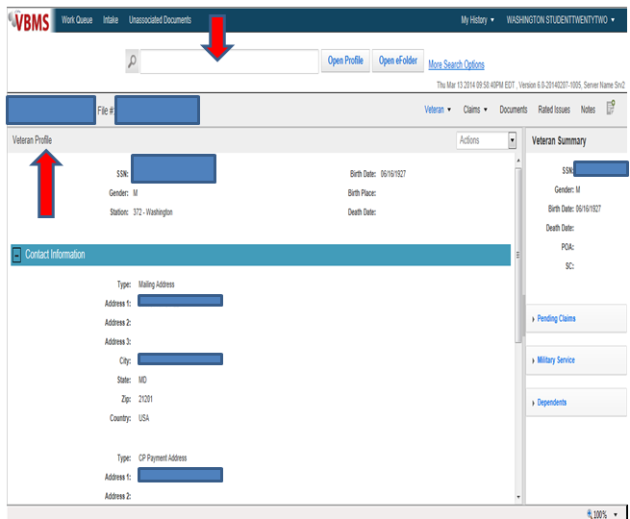

**Establishing a New Claim**

After verifying the Veteran’s personal information and ensuring this is the Veteran for which the claim is being established. Click **Actions** and then select **New Claim**. The Claim Establishment page opens to the New Claim Information section.

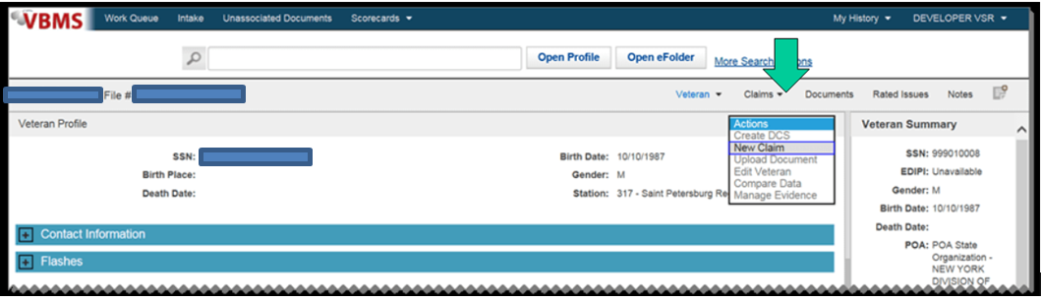

Veteran’s Information Screen- Verify Veteran’s Contact Information screen or fill out address as needed.

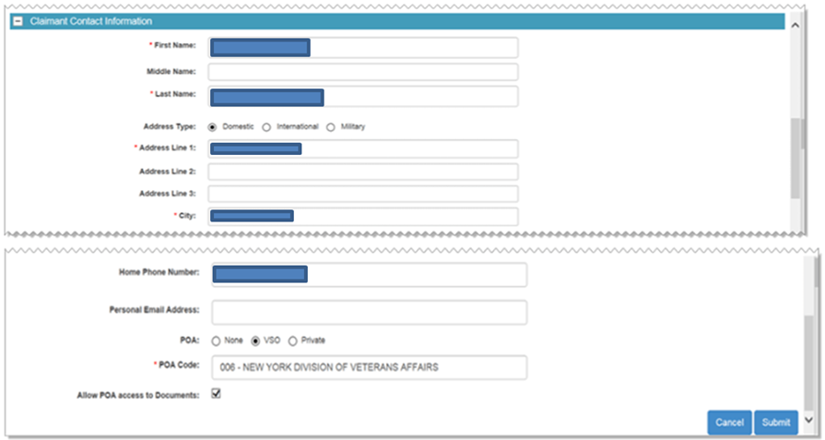

**New Claim Information Screen**

Once all pertinent information has been verified proceed to the New Claim Information Screen.

1. Complete all the entries required noted by the red asterisk in VBMS.
   * Payee Code
   * EP & Claim Label
   * Modifier
   * Date of Claim
   * Segmented Lane
   * Station

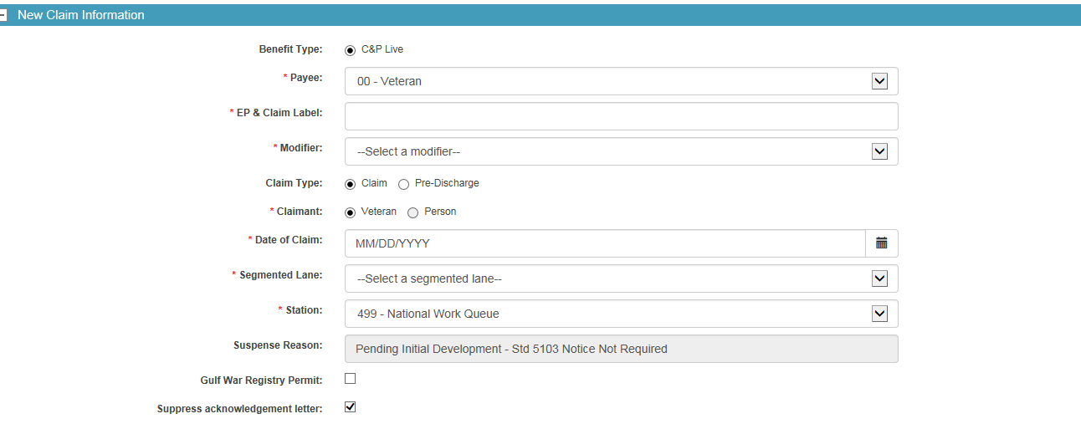

1. Choose appropriate Power Of Attorney selection

* None-The claimant has not identified a POA or POA information is not available
* VSO: The Veterans Service organization or Officer acts as POA for the claimant
* Private: The claimant retains a private attorney to act as POA

1. Select of clear the “allow POA access to Documents check box to indicate if the claimant has authorized the VSO or other POA to view e folder documents.

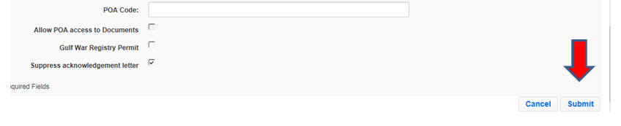

1. Check Suppress Letter
2. Select “Submit”

The process of establishing a New EP in VBMS is complete. The system will now direct the VSR automatically to the contention development task bar.

**Adding Contentions**

Use of contentions for each claim is mandatory and should be entered as soon as they are identified.  All claimed issues must be entered as contentions **as they are claimed** by the Veteran on the application for benefits.  Each claimed issue, including non-rating issues, must be entered as a separate contention.  Non-rating contentions should relate to the specific benefit being sought.

1. Click Add Contention from the Development task bar

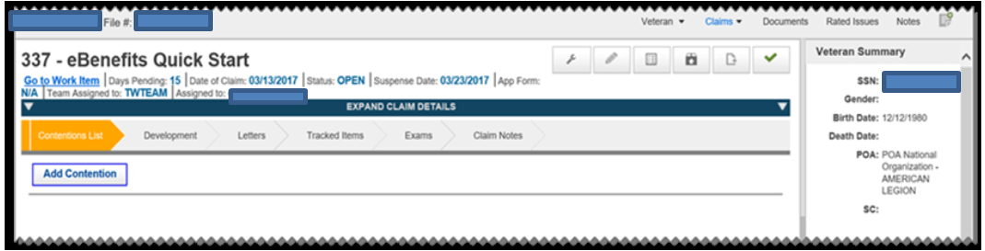

1. Click **Classification** and choose from the classification list.
2. The contentions date will be set to the date of claim by default. If needed (in the case of additional claims after the first is established) and select date from calendar. The contentions date cannot be before the date of claim.
3. The **Verified box** is automatically populated with a yes or no value, once you save the contention. The Verified box indicates that the contention has been reviewed and it is correct.
   1. Contentions that have been manually entered will always show *Yes*.
   2. Scanned contentions will show *No* until a classification and type are entered.



1. Click **Type** and choose the type from the list New; Reopen, Increase, Secondary or Request for Examination (RFE).
2. Click **Medical** and select *Yes* or *No.*

Non-rating contentions should relate to the specific benefit being sought and appropriate naming conventions must be adhered to. *See below for an example.*

**Example of Appropriate Naming**

*A Veteran submits a claim to add a spouse and a child along with a claim for hearing loss due to acoustic trauma and tinnitus.  Create separate contentions for the spouse and child as well as each medical contention as follows:*

* *Dependency claim for* **[*name of spouse*]**
* *Dependency claim for* **[*name of child*]**
* *Hearing loss due to acoustic trauma (exactly how Veteran stated)*
* *Tinnitus*

Instructor should note the importance of entering the contentions as they are identified by the Veteran and ensure to stress the naming conventions for dependents.

**Special Issues**

Click ***Special Issue*** and select an issue from the drop down list. There will be a special issue that needs to be entered in all cases because all cases must be assigned to a team such as Core, Special Operations, Non-Rating or Express.

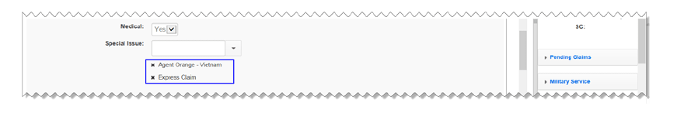

**Rated Issues**

Contentions with a type that is secondary or increase are often associated with issues that have been previously determined. When working with these types of contentions view any previously rated issues an associate them to the contention. If there are no rated issues that apply to the specific claim being worked, no action is needed.

1. Click the green add Icon next to the Rated Issues. The Associate Rated Issues dialog opens.



1. Select the check boxes next to the Associate Rated Issues you want to associate to the contention and click the **Add** button.

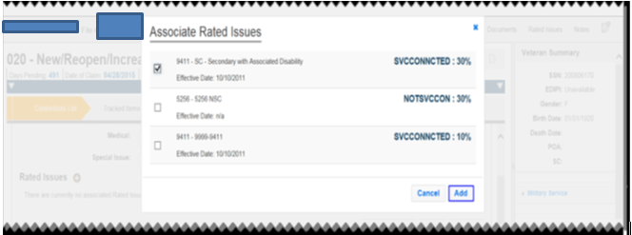

1. The issues that have been selected to associate are listed in the **Rated Issues** list.



1. Click **Save** to save the contention and click **Save and Add t**o save the contention and to add another.

**Reviewing Established Contentions**

* Contentions that have been entered into the system automatically must be verified upon review and are marked with a yellow alert icon in the Contentions List.*

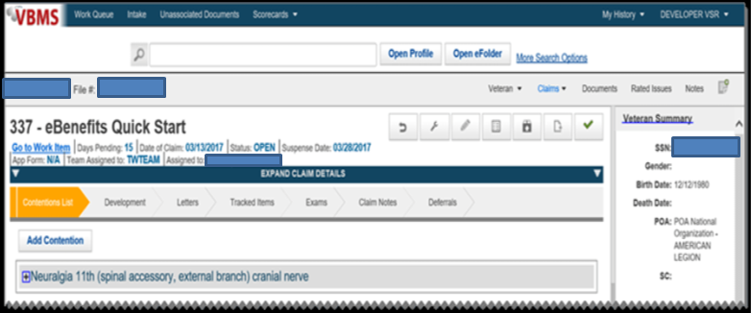

1. Click the plus sign [+] next to the contention to view or edit the contentions.
2. Follow **Adding Contention** procedures 7-16.

**Adding Flashes in Share**

*For the purposes of this training share will only be utilized to add flashes to the record. If more detail is required please refer to the Share User Guide. Claims are not to be established in SHARE.*

Claimant flashes are claimant-specific indicators that represent an attribute, fact, or status that may occasionally change (e.g. Former Prisoner of War (FPOW), blind Veteran, homeless, etc.).  Regional offices (ROs) are responsible for:

* identifying claimant’s records that require flashes
* inputting the flashes when required, and

Claimant flashes must be entered in the corporate record once the need is identified.  Most flashes are added by the end user, but some are generated by the system.  Flashes will exist on a claimant’s record until the flash is manually removed.

Note: Claimant flashes may only be reviewed on the VBMS profile screen; they must be added and updated in SHARE.

**How to Add a Flash in SHARE**

1. Open Share from your Start menu
2. Under *Search Criteria*, enter the File Number.
3. Select the **Submit** button.
4. Select *Corporate Flash* from the *Available Processes* list on the Ready Screen.

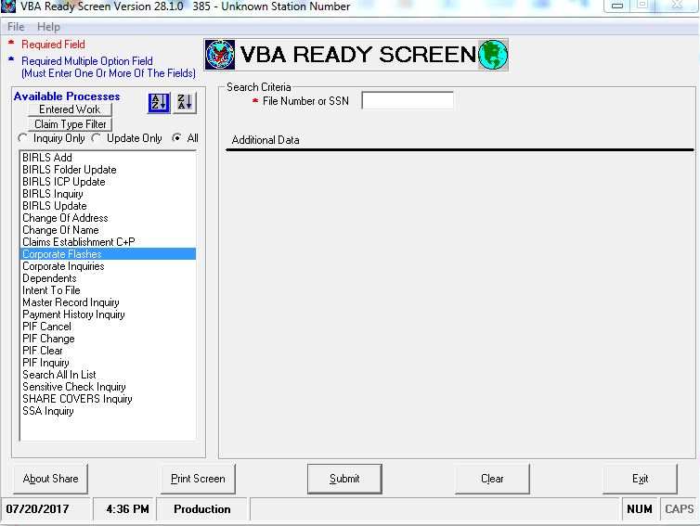

1. Select desired flashes from the Available RO Flashes or Available VACO Flashes.  Use the **>** button to add the flashes to the Selected boxes. When all flashes are selected, click the **Submit** button.  A message will be displayed stating the updates are complete.

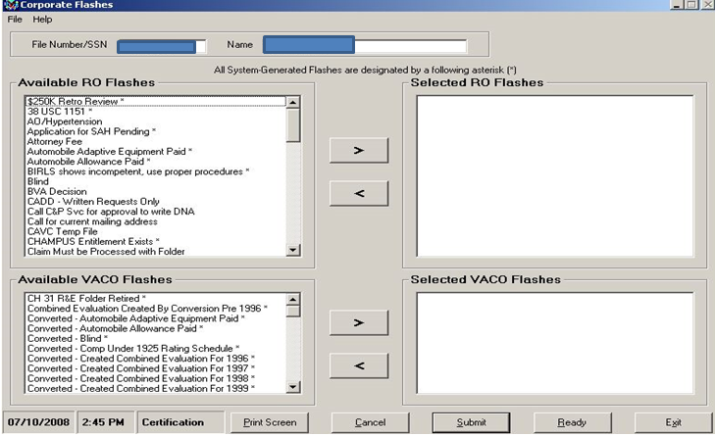

Additional Guidance on the use of SHARE can be found in the SHARE user guide.

Attachment A: End Product Codes

|  |  |
| --- | --- |
| 010 Original comp or C&P, 8 issues or more  020 Supplemental compensation  050 EVR without further referral  070 SSOC, Appeal certification  095 Vocational-rehab eligibility, memo rating  110 Original comp or C&P, 7 issues or less  120 Reopened pension  130 Dependency issues  135 Hospital/NH/Medicaid adjustments  140 Original DIC  150 Income, Estate, Election issues  154 IVM  155 EVR with further referral  160 Burial claim  165 Accrued claim  170 Appeals control – No work credit  172 Statement of the Case  173 Hearing – Other than Hearing Officer  174 Hearing Officer hearing  180 Original pension | 190 Original death pension  290 Miscellaneous eligibility determinations  293 COWC decisions  295 Vocational-rehab eligibility, no rating  310 Review exams, unemployability, no rating  314 IVM-Comp employability issue  320 Hospital reviews, Para 29 and 30  400 Miscellaneous actions-no work credit  410 Original spina bifida claim  420 Reopened claims for spina bifida  450 Claim for increase – spina bifida  470 Notices of Disagreement – spina bifida  500 Controlled correspondence   1. FOIA/PA release of information 2. Due Process 3. Special projects without rating action (e.g., PGW, tobacco)   690 Special projects without rating action   1. Reviews, referrals   960 Administrative error |

Reference M21-4, Appendix B

**Attachment B: VBMS Claims Establishment Flowchart M21-1.III.ii.3.D**

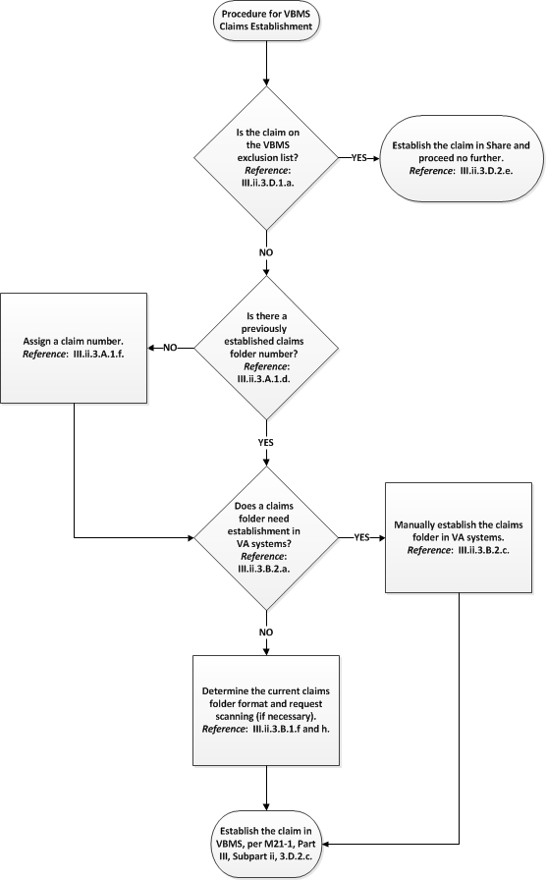

Share Claims Establishment Flowchart provided in M21-1.III.ii.3.D

Attachment C: CEST and EP Control Review Exercise

**Review Exercise**

**Instructions:** Use all references that are available to complete the following:

1. What is an end product (EP) and why is it important?
2. What is the difference between EP 010 and EP 110?
3. What EP is used for dependency claims?
4. What are the four steps to prepare for claims establishment?
5. What is CEST and when is it used?
6. How is the date of claim established?
7. Define the steps necessary to establish a new claim in VBMS
8. How should contentions be entered into VBMS?
9. What is the proper way to enter a “dependency” contention?
10. What are flashes and how are they added to the system
11. What does the icon mean?

Practical Exercise

This practical exercise will give you an opportunity to practice establishing a claim. Once the instructor has provided you with an e-case, complete the following:

1. Review the case.
2. Access the VBMS Demo System.
3. Complete New claim procedures to establish the claim.