Shipping/Veterans Claim Intake Program (VCIP) Review and Centralized Mail (CM) Routing to Other Business Lines
Time Required: 2.5 Hours

Table of Contents

Lesson Description 2
Shipping/Veterans Claim Intake Program (VCIP) Review and Centralized Mail (CM) Routing to Other Business Lines 4
Topic 1: Centralized Mail 6
Topic 2: Veterans Claims Intake Program (VCIP) Shipping 12
Practical Exercise 14
Lesson Review, Assessment, and Wrap-up 15

Lesson Description
The information below provides the instructor with an overview of the lesson and the materials that are required to effectively present this instruction.
TMS # | 4411839
Prerequisites | Prior to this lesson, the Claims Assistant should be able to navigate VBMS and the Centralized Mail portal (CM).
target audience | The target audience for Shipping/Veterans Claim Intake Program (VCIP) Review and Centralized Mail (CM) Routing to other Business Lines is Claims Assistance with any level of experience.
Time Required | 2.5 hours
Materials/  TRAINING AIDS | Lesson materials:  - Shipping/Veterans Claim Intake Program (VCIP) Review and Centralized Mail (CM) Routing to Other Business Lines PowerPoint Presentation  - Shipping/Veterans Claim Intake Program (VCIP) Review and Centralized Mail (CM) Routing to Other Business Lines Trainee Handout
Training Area/Tools | The following are required to ensure the trainees are able to meet the lesson objectives:  - Classroom or private area suitable for participatory discussions  - Seating, writing materials, and writing surfaces for trainee note taking and participation  - Handouts, which include a practical exercise  - Large writing surface (easel pad, chalkboard, dry erase board, overhead projector, etc.) with appropriate writing materials  - Computer with PowerPoint software to present the lesson material  Trainees require access to the following tools:  - VA TMS to complete the assessment

Pre-Planning | - Become familiar with all training materials by reading the Instructor Lesson Plan while simultaneously reviewing the corresponding PowerPoint slides. This will provide you the opportunity to see the connection between the Lesson Plan and the slides, which will allow for a more structured presentation during the training session.  - Become familiar with the content of the trainee handouts and their association to the Lesson Plan.  - Practice is the best guarantee of providing a quality presentation. At a minimum, do a complete walkthrough of the presentation to practice coordination between this Lesson Plan, the trainee handouts, and the PowerPoint slides and ensure your timing is on track with the length of the lesson.  - Ensure that there are copies of all handouts before the training session.  - When required, reserve the training room.  - Arrange for equipment such as flip charts, an overhead projector, and any other equipment (as needed).  - Talk to people in your office who are most familiar with this topic to collect experiences that you can include as examples in the lesson.  - This lesson plan belongs to you. Feel free to highlight headings, key phrases, or other information to help the instruction flow smoothly. Feel free to add any notes or information that you need in the margins.
Training Day | - Arrive as early as possible to ensure access to the facility and computers.  - Become familiar with the location of restrooms and other facilities that the trainees will require.  - Test the computer and projector to ensure they are working properly.  - Before class begins, open the PowerPoint presentation to the first slide. This will help to ensure the presentation is functioning properly.  - Make sure that a whiteboard or flip chart and the associated markers are available.  - The instructor completes a roll call attendance sheet or provides a sign-in sheet to the students. The attendance records are forwarded to the Regional Office Training Managers.

Shipping/Veterans Claim Intake Program (VCIP) Review and Centralized Mail (CM) Routing to Other Business Lines
INSTRUCTOR INTRODUCTION |  | Complete the following:  - Introduce yourself  - Orient learners to the facilities  - Ensure that all learners have the required handouts
time required |  | 20 minutes
Purpose of Lesson  Explain the following: |  | This lesson is intended to provide an overview of the VCIP and CM processing functions. This lesson will contain discussions and exercises that will allow you to gain a better understanding of:  - The Centralized Mail portal  - Routing of mail in the mailroom and Centralized Mail portal.  - Shipping to scanning vendors  - Requesting rescan of records already sent to a scanning vendor
Lesson Objectives  Discuss the following:  Slide 2  Handout 2 | In order to accomplish the purpose of this lesson, the Claims Assistant will be required to complete an assessment that covers the following lesson objectives:  The CA will be able to:  - Understand and explain the roles and responsibilities in the centralized mail process.  - Understand and explain the procedures for Record Management Number (RMN)/Document Control Sheet (DCS) Shipping.
Explain the following: | Each learning objective is covered in the associated topic. At the conclusion of the lesson, the learning objectives will be reviewed.
Motivation | This training will provide the knowledge to understand the routing of mail in the mail room and centralized mail portal. This training will cover procedures for shipping documents to the scanning vendors and how to request a rescan of materials previously sent to a scanning vendor.

STAR Error code(s) | The Systematic Technical Accuracy Review (STAR) Program does not review VCIP shipping but may review mail processed in the CM.
References  Slide 3 - 4  Handout 2 | Explain where these references are located.  - M21-1, Part III, Subpart ii, Chapter 1, Section E, Centralized Mail (CM) Intake  - M21-1, Part III, Subpart ii, Chapter 1, Section F, Veterans Claims Intake Program (VCIP) Shipping  - M21-1, Part III, Subpart i, Chapter 1, IPC  - Centralized Mail Intranet  - OBPI-VCIP Issue Tracker  - ICMHS Tracking Portal

Topic 1: Centralized Mail
Introduction | This topic will allow the trainee to understand the processes of working mail in the Centralized Mail (CM).
Time Required | 45 minutes
OBJECTIVES/  Teaching Points | Topic objectives:  The following topic teaching points support the topic objectives:  - Understand the intent of CM  - Define the roles and responsibilities in the CM process  - Understand the receipt, separation, and routing of physical mail in the mailroom
Intent of the CM  Slide 4  Handout 2 | Centralizing conversion of incoming paper to an electronic medium in the Centralized Mail (CM) process is intended to  - eliminate paper handling by the Department of Veterans Affairs (VA) personnel at regional offices (ROs)  - reduce the number of times mail is handled in any medium  - expedite uploading of claims, evidence, and other mail to electronic claims folders in the Veterans Benefits Management System (VBMS)  - improve customer service and claims processing timeliness through improved mail control processes, and  - implement first in, first out (FIFO) workflow for all mail received.
Roles and Responsibilities in the CM Process  Slide 5  Handout 3 | Discuss each positions role and responsibilities in the CM:  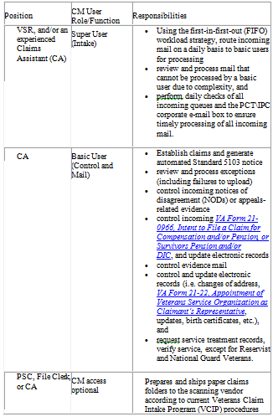
Receipt, Separation, and Routing of Physical Mail in the Mailroom  Slide 6  Handout 4-5 | Explain: The different business lines in the VA and how to properly route CM and physical mail received in the mailroom.  The USPS automatically sends mail to the scanning vendor when the claimant uses the centralized mail address provided in all development letters.  When physical mail is received by the RO, the mail clerk opens, date stamps and separates the mail by VA business lines and/or addresses.  Routing mail for:  - VSC, PMC, ARC, or BVA  - Other business lines  - undeliverable mail containing Federal tax information (FTI)  Explain: Please see table on page 4-5 of handout and explain examples within the table.
Shipping Mail to Scanning Vendors  Slide 7-8  Handout 5-6 | Explain the steps involved in sorting the mail received in the mailroom and how to ship mail for the CM to the scanning vendor.  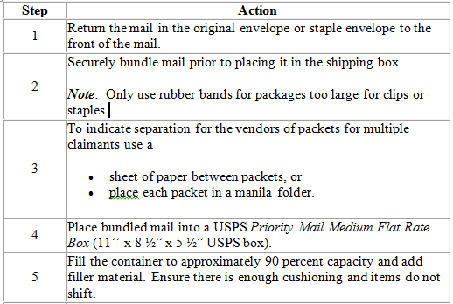  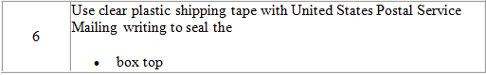  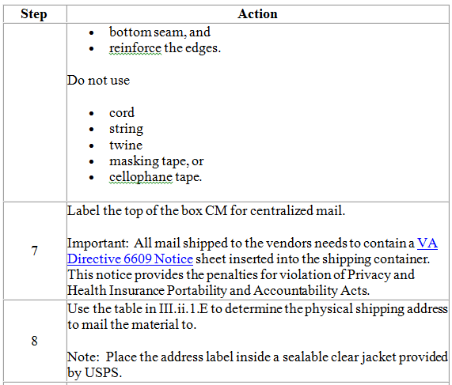  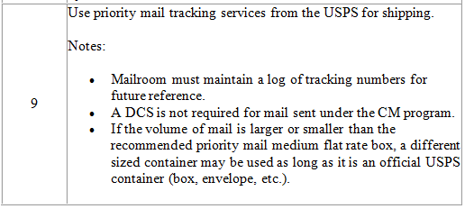
FOIA and PA Request Process  Slide 9  Handout 6-7 | Explain the routing of FOIA /PA requests to the RMC.  Routing of FOIA and PA requests to the Records Management Center (RMC) is required when received through the CM portal. Follow the steps in the table below for RO FOIA/PA procedures.  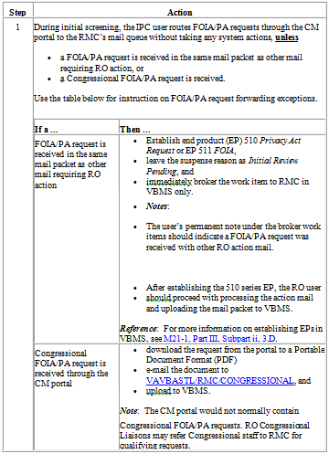
Basic User Mail Role in the CM Portal  Slide 10  Handout 8 | Instructor note: Detailed processes and charts start on Page 8 of employee Handout. Please see additional reference if needed.  Explain the basic user role in the CM portal.  - When FTI is discovered in the CM portal.  - Establishing new claims or appeals  - Updating pending claims  - Updating claimant information  - Uploading mail or rerouting to appropriate business lines.  - Updating direct deposit
Processing CM Packages  Slide 11-12  Handout 8-12 | Explain the procedures for processing a mail packet in the CM portal.  - Check VBMS and VACOLS for a pending EP or appeal  - Does the claim fall under the jurisdiction of the RACC  - Does the claim fall under the jurisdiction of a PMC  - Will the RO that received the mail retain jurisdiction  - Is the mail for another business line  - Does a claims folder exist
Rerouting Mail by E-Mail to Other Business Lines  Slide 11-12  Handout 12-15 | Explain the procedures for processing mail in the CM portal for other business lines.  - Downloading mail to PDF format  - Sending documents via encrypted email to appropriate business line  - Business lines not in the CM  - Email addresses for other business lines
Processing Solicited and Unsolicited Mail Slide 13 Handout 11-16 Explain the difference between solicited and unsolicited mail and the procedures for processing solicited or unsolicited mail. - Does the solicited or unsolicited mail pertain to a pending EP - Is there a tracked item - Managing evidence for unsolicited mail | Explain the difference between solicited and unsolicited mail and the procedures for processing solicited or unsolicited mail.  - Does the solicited or unsolicited mail pertain to a pending EP  - Is there a tracked item  - Managing evidence for unsolicited mail
 | Instructor note: Detailed processes and charts start on Page 13 of employee Handout. Please see additional reference if needed.
Rerouting Mail by E-Mail to other Business Lines Slide 14 Handout 16 Explain the difference between solicited and unsolicited mail and the procedures for processing solicited or unsolicited mail. - Does the solicited or unsolicited mail pertain to a pending EP - Is there a tracked item - Managing evidence for unsolicited mail | Explain the manual reference with email addresses for each different business line.  If the Basic User identifies mail for business lines not in CM, he/she  - uses the functionality within the portal to download the mail image(s) to PDF format, and  - sends the document(s), via encrypted e-mail, to the appropriate business line.  Business lines not in the CM:  - Education  - Insurance  - Loan Guaranty  - VR&E  - Fiduciary Hub (Do not re-route Fiduciary Hub mail to the co-located RO)  - Support Services Division (SSD)/finance activity  - VHA  - NCA
Exercise | Run a few scenarios by the audience to determine if they can properly identify where and how they would route various mail in the CM or mailroom.
note(s) | Ensure the student knows Fiduciary Hub mail is not rerouted in the mail portal but downloaded and mailed to the appropriate Fiduciary hub. Review M21-1 III.ii.1.E where emails can be sent for other business lines.

Topic 2: Veterans Claims Intake Program (VCIP) Shipping

Introduction | This topic will allow the trainee to understand the VCIP shipping procedures and how to request a file rescan.
Time Required | 45 minutes
OBJECTIVES/  Teaching Points | The following topic teaching points support the topic objectives:  - Understand the procedures for Record Management Number (RMN)/Document Control Sheet (DCS) Shipping  - Review the VCIP Shipping Procedures  - Understand the RMC/DCS shipping process  - Understand Requesting a folder rescan
Overview of VCIP Shipping Procedures for Claims Folders, Service Treatment Records (STRs), and Personnel Records  Slide 15  Handout 16-17 | The Veterans Claims Intake Program’s (VCIP's) mission is to  - provide direct support to the Veterans Benefits Administration (VBA) claims process by providing procedures for intake of  - source material  - documentation  - electronic records, and  - data  - work collaboratively with all stakeholders to manage VBA’s digital operating environment, and  - provide procedures relating to intake capabilities and the execution/management of document conversion services contracts.  Source materials not eligible for CM processing will be shipped to the scanning vendors using the Record Management Number (RMN)/Document Control Sheet (DCS) shipping process, a regional office’s (RO’s) Intake Processing Center (IPC) or mailroom personnel ship source materials for document conversion, including  - claims folders  - service treatment records (STRs), and  - personnel records.
Record Management Number (RMN)/Document Control Sheet (DCS) Shipping Process  Slide 16  Handout 17 | CSRA portal access is required to ship documents to the scanning vendor via the RMN/DCS process. There are limited CSRA portal access accounts available. Instructions on how to obtain access and shipping requirements are outlined in M21-1 III.ii.1.F
Requesting a Folder Rescan and Other Scanning Inquiries  Slide 17-18  Handout 17 | If documents are missing from VBMS the source folder or shipment must be located before a rescan request can be submitted.  - If looking for the Claims file first check COVERS. When the claims folder is shipped from an RO or RMC to the scanning vendor it should have been COVERED to one of the locations in M21-1 III.ii.3.B. The most common are:  - DCSC1 - CSRA Newnan, GA  - DCSC2 - Mt Vernon, KY  - DCSS1 - Janesville, WI  - DCSS2 - Janesville, WI  - ICMHS - Converted as part of the File Bank Extraction program.  - Check the VBMS Intake tab. Select “All Stations, enter the file number, and remove the date.  Once you have a list of all RMN/DCS shipments for that file number you can determine which DCS was shipped on the same day that matches the date shown as shipped in COVERS. Click on the box number for additional information on that shipment that is needed to submit a ticket to the scanning vendor.  Rescan requests for shipments to DCSS1, DCSS2, and ICMHS (SMS) can be submitted through the OBPI-VCIP Issue Tracker.  Instructor note: There may be one office point of contact to submit OBPI-VCIP tickets. Please clearly define expectations.  Rescan requests for shipments to DCSC1 and DCSC2 (CACI) can be submitted through the ICMHS Tracking Portal.  Additional information on how to check the status of an RMN or DCS in the vendor portals can be found at the VBA Centralized Mail Intranet and the document How to Check the Status of an RMN or DCS in the Vendor Portals found at the bottom of the on the OBPI-VCIP Issue Tracker.
DEMONSTRATION | Demonstrate how to search for a RMN using the intake tab in VBMS.

Practical Exercise
Time Required | 20 minutes
EXERCISE | Have the students answer the questions on page 18 of the handout.  Refer to the answer key to assist with answering questions.

Lesson Review, Assessment, and Wrap-up
Introduction  Discuss the following: | The Shipping/Veterans Claim Intake Program (VCIP) Review and Centralized Mail (CM) Routing to Other Business Lines is complete.  Review each lesson objective and ask the trainees for any questions or comments.
Time Required | 20 minutes
Lesson Objectives | You have completed the Shipping/Veterans Claim Intake Program (VCIP) Review and Centralized Mail (CM) Routing to other Business Lines lesson.  The trainee should be able to:  - Understand and explain the roles and responsibilities in the centralized mail process.  - Understand and explain the procedures for Record Management Number (RMN)/Document Control Sheet (DCS) Shipping.
Assessment | Remind the trainees to complete the on-line assessment in TMS to receive credit for completion of the course. The assessment will allow participants to demonstrate understanding of information presented.

