**Pension and Fiduciary Service Instructor-led Training Guide**

|  |  |
| --- | --- |
| **Lesson Title** | Fiduciary Agreement (VA Form 21P-4703) Updates (Feb 2018) |
| **TMS Item Number** | VA 4411513 |
| **Learning Hours** | 1.0 |
| **Target Audience** | Mandatory:  Legal Instruments Examiners  Field Examiners  QRT  Station-Selected:  All Other Fiduciary Personnel |

Table of Contents

Lesson Description 2

Lesson Objectives 2

Lesson References 2

Materials and Aids 2

Training Area and Tools 2

Pre-Planning 3

Printing PowerPoint Instructor Notes 3

Training Day 4

Survey and Assessment 4

Questions and Comments 5

# Lesson Description

This course teaches fiduciary hub personnel about the changes made to the VA Form 21P-4703, *Fiduciary Agreement,* effective February 7, 2018, and how to utilize the form for fiduciary instruction.

# Lesson Objectives

By the end of this lesson, the learner will be able to do the following:

* State the purpose of the changes
* Explain the major changes to the VA Form 21P-4703
* Identify the fiduciary’s responsibilities to the beneficiary
* Identify the fiduciary’s responsibilities to VA
* Understand corresponding changes to FElux

# Lesson References

* Regulations (CFR) 13*, Fiduciary Activities*
* Fiduciary Program Manual (FPM) 2*, Field Examinations*

# Materials and Aids

Lesson materials available in the [VBA Learning Catalog](https://vba-tpi.vbatraining.org/lc/):

* Fiduciary Agreement (VA Form 21P-4703) PowerPoint Presentation
* Fiduciary Agreement (VA Form 21P-4703) Instructor Guide

# Training Area and Tools

The following are required to ensure the trainees are able to meet the lesson objectives:

* Classroom or private area suitable for participatory discussions
* Seating, writing materials, and writing surfaces for trainee note taking and participation
* VA Form 21P-4703, *Fiduciary Agreement*
* Computer with BFFS access and PowerPoint software to present the lesson material

Trainees require access to the following tools:

* VA [Talent Management System (TMS)](https://www.tms.va.gov/learning/user/login.jsp) to complete the assessment and survey
* Pension and Fiduciary Service – [Fiduciary Knowledge Management Site](https://vaww.fiduciary.km.va.gov/)
* Beneficiary Fiduciary Field System - <https://internalcrm.crm15.xrm.va.gov/BFFS/>
* Beneficiary eFolder
* Internal VA Forms website - <http://vaww.va.gov/vaforms/>

# Pre-Planning

* Become familiar with all training materials by reading the Instructor-led Training Guide, PowerPoint slides (including the instructor speaking notes in the notes area below each slide. Preparation will provide you the opportunity to see the connection between all lesson materials, which will allow for a more structured presentation during the training session.
* Practice is the best guarantee of providing a quality presentation. At a minimum, do a complete walkthrough of the presentation to practice coordination between the lesson materials, demonstration, and to ensure your timing is on track with the length of the lesson.
* Make appropriate training room reservations and accommodations.
* Ensure the instructor computer and overhead projector work properly.
* Talk to people in your office who are most familiar with this topic to collect experiences that you can include as examples in the lesson.
* This lesson plan belongs to you. Feel free to highlight headings, key phrases, or other information to help the instruction flow smoothly. Feel free to add any notes or information that you need in the margins.

# Printing PowerPoint Instructor Notes

Print the PowerPoint and instructor notes to prepare for instruction by selecting **File, Print,** and **Notes Page**. Select **Print on Both Sides** if your printer has the capability.

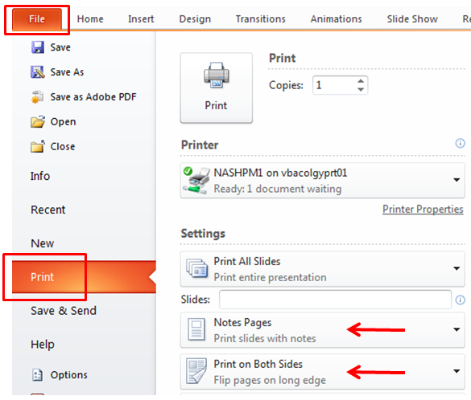

# Training Day

* Arrive as early as possible to ensure access to the facility and computers.
* Become familiar with the location of restrooms and other facilities that the trainees will require.
* Test the computer and projector to ensure they are working properly.
* Before class begins, open the PowerPoint presentation to the first slide. This will help to ensure the presentation is functioning properly.
* Make sure that the instructor has login access to any other necessary programs and VBA systems for any demonstration(s).
* The instructor completes a roll call attendance sheet or provides a sign-in sheet to the students. Forward the attendance record to the Regional Office Training Manager when complete.

# Survey and Assessment

Remind trainees to complete the assessment and survey in TMS to receive credit for completion of the course. The assessment allows the participants to demonstrate their understanding of the information presented in this lesson and the survey provides Pension and Fiduciary Service with feedback and satisfaction on the lesson.

# Questions and Comments

Please contact the Pension and Fiduciary Service – Fiduciary Training Staff with any questions or comments on this Instructor-led Training Guide or the other materials associated with the lesson at [FFE.VBACO@va.gov](mailto:FFE.VBACO@va.gov).