System Updates and Compliance
Instructor Lesson Plan
Time Required: 1.5 Hours

Table of Contents

Lesson Description 2
Introduction to System Updates and Compliance 4
Topic 1: Updating Contact Information and Direct Deposit Porcessing 5
Topic 2: Change of Name Processing 11
Topic 3: Processing Third Party information Requests 13
Topic 4: Updating Military Service Information 15
Practical Exercise 17
Lesson Review, Assessment, and Wrap-up 18

Lesson Description
The information below provides the instructor with an overview of the lesson and the materials that are required to effectively present this instruction.
TMS # | 4411257
Prerequisites | There are no prerequisites for this lesson.
target audience | The target audience for this lesson is those assigned to the Intake Processing Center (IPC). Although this lesson is targeted to teach those assigned to the IPC, it may be taught to other VA personnel as mandatory or refresher type training.
Time Required | 1.5 hours
Materials/  TRAINING AIDS | Lesson materials:  - System Updates and Compliance PowerPoint Presentation  - System Updates and Compliance Trainee Handouts
Training Area/Tools | The following are required to ensure the trainees are able to meet the lesson objectives:  - Classroom or private area suitable for participatory discussions  - Seating, writing materials, and writing surfaces for trainee note taking and participation  - Handouts, which include a practical exercise  - Computer with PowerPoint software to present the lesson material  Trainees require access to the following tools:  - VA TMS to complete the assessment  - Access to the VBA intranet
Pre-Planning | - Become familiar with all training materials by reading the Instructor Lesson Plan while simultaneously reviewing the corresponding PowerPoint slides. This will provide you the opportunity to see the connection between the Lesson Plan and the slides, which will allow for a more structured presentation during the training session.  - Become familiar with the content of the trainee handouts and their association to the Lesson Plan.  - Practice is the best guarantee of providing a quality presentation. At a minimum, do a complete walkthrough of the presentation to practice coordination between this Lesson Plan, the trainee handouts, and the PowerPoint slides and ensure your timing is on track with the length of the lesson.  - Ensure that there are copies of all handouts before the training session.  - When required, reserve the training room.  - Arrange for equipment such as flip charts, an overhead projector, and any other equipment (as needed).  - Talk to people in your office who are most familiar with this topic to collect experiences that you can include as examples in the lesson.  - This lesson plan belongs to you. Feel free to highlight headings, key phrases, or other information to help the instruction flow smoothly. Feel free to add any notes or information that you need in the margins.
Training Day | - Arrive as early as possible to ensure access to the facility and computers.  - Become familiar with the location of restrooms and other facilities that the trainees will require.  - Test the computer and projector to ensure they are working properly.  - Before class begins, open the PowerPoint presentation to the first slide. This will help to ensure the presentation is functioning properly.  - Make sure that a whiteboard or flip chart and the associated markers are available.  - The instructor completes a roll call attendance sheet or provides a sign-in sheet to the students. The attendance records are forwarded to the Regional Office Training Managers.

Introduction to System Updates and Compliance
INSTRUCTOR INTRODUCTION |  | Complete the following:  - Introduce yourself  - Orient learners to the facilities  - Ensure that all learners have the required handouts
time required |  | 0.25 hours
Purpose of Lesson |  | This lesson is intended to teach students the proper procedures for updating information in several VA systems.
Lesson Objectives  Discuss the following:  Slide 2  Handout Page 1 | In order to accomplish the purpose of this lesson, the trainee will be required to accomplish the following lesson objectives.  The trainee will be able to:  - Understand the requirements for updating Contact Information and Direct Deposit Processing  - Understand the requirements for Change of Name Processing  - Understand the requirements for Processing Third Party Information Requests  - Understand the requirements for Updating Military Service Information
Explain the following: | Each learning objective is covered in the associated topic. At the conclusion of the lesson, the learning objectives will be reviewed.
Motivation | Inform trainees of the impact that updating systems with information is crucial to proper claims development.
STAR Error code(s) | The Systematic Technical Accuracy Review (STAR) Program reviews cases and considers them either “accurate” or “in error” for the purpose of measuring technical accuracy.  Currently there are no STAR code errors for system updates that this lesson will prevent. However, this does not make this lesson inconsequential or unimportant.
References  Slide 3  Handout Page 1 | Explain where these references are located in the workplace.  All M21-1 references are found in the Live Manual Website.  Explain where these references are located in the workplace.  - M21-1, Part III, Subpart ii, Chapter 3, Section C, System Updates  - M21-1, Part III, Subpart ii, Chapter 1, Section E, Centralized Mail (CM) Intake  - M21-1, Part III, Subpart v, Chapter 9, Section A, Fiduciary Hub Jurisdictions and Contact Information

Topic 1: Updating Contact Information and Direct Deposit Processing
Introduction |  |  |  | This topic will allow the trainee to update contact and Direct Deposit Information.
Time Required |  |  |  | 0.25 hours
OBJECTIVES/  Teaching Points |  |  |  | Topic objectives:  - Understand the requirements for Updating Contact Information and Direct Deposit Processing  The following topic teaching points support the topic objectives:  - Understand Notification formats  - Understand where to update direct deposit information  - Understand who must sign for direct deposit enrollment  - Understand handling information for claimants with a fiduciary  - Updating contact information in VBMS  - Updating contact information in SHARE
Updating Contact Information and Direct Deposit Processing  Slide 4-8  Handout Pages 2-6 |  |  |  | Change of contact information or direct deposit notification may come in multiple formats including:  - A signed statement from the claimant,  - telephone contact with the claimant, after identity has been verified,  - undeliverable mail with the United States Post Office (USPS) forwarding address sticker affixed to the envelope,  - VA Form 20-572, Request for Change of Address/Cancellation of Direct Deposit, and  - other Department of Veterans Affairs (VA) forms that contain the information.  Important notes for updating direct deposit or contact information  - Update direct deposit information only in Share.  - Direct deposit currently cannot be updated in VBMS.  - VA Form 24-0296, Direct Deposit Enrollment, must be signed by the payee, either the Veteran or the beneficiary.  - An appointed Veterans service organization (VSO), agent, or attorney has the legal authority to change a claimant’s address in person, by telephone, or by letter when annotated on the VA Form 21-22 or VA Form 21-22a .  Important: Verify the claimant does not have a fiduciary prior to making a change of address in the Veterans Benefits Management System (VBMS). The FID CATEGORY box on the GENERAL INFORMATION tab in Share will show Incompetent if the claimant has a VA-appointed fiduciary.  - For any claimant assigned a fiduciary do not  - change the address  - establish a direct deposit account, or  - change a direct deposit account.  - An address change request is to be sent to the Fiduciary Hub of jurisdiction. Contact and jurisdiction information for the Fiduciary hubs can be found at M21-1, Part III, Subpart v, Chapter 9, Section A.  Updating Contact Information in VBMS  Follow the steps in the table below to update the address in VBMS.  - Open VBMS and enter the claimant’s claims folder number in the search box and open profile.  - On the profile screen to the right of the “Veteran Profile” or “Contact Information” click on the pencil edit icon.  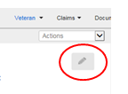  - Now you can edit any field with a box around the field. Once information is completed click on the save icon to make the changes or the X icon to cancel your changes.  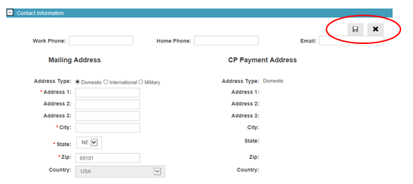
 | Step |  |  |  | Action
 | 1 |  |  |  | Open VBMS and enter the claimant’s claims folder number in the search box.
 | 2 |  |  |  | Select OPEN PROFILE.
 | 3 |  |  |  | Select EDIT VETERAN from the ACTIONS drop down menu.  Example:  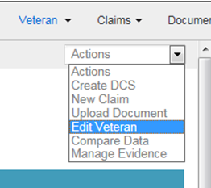
 | 4 |  |  |  | Update address and contact information on the UPDATE VETERAN PROFILE screen.  Example:  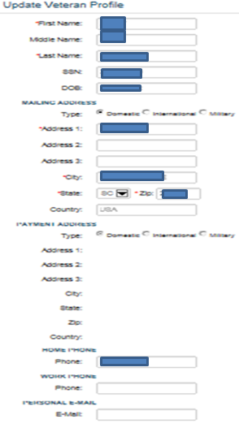
 | 5 |  |  |  | Once updates are complete select SUBMIT to save the information.

Updating Contact Information in SHARE
Share allows a user to update the claimant’s contact and/or direct deposit information when VA receives notice as described in M21-1, Part III, Subpart ii, Chatper 3, Section C. Follow the steps in the table below when an update to information in VA systems is required.

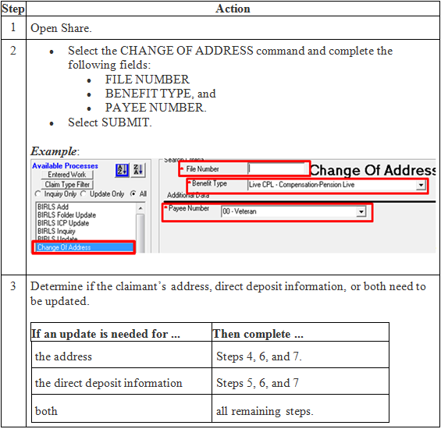

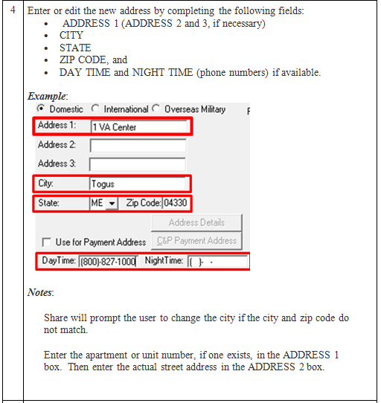

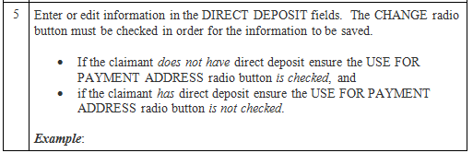

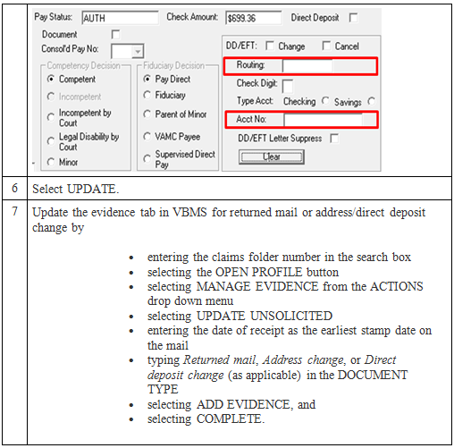

Topic 2: Change of Name Processing
Introduction |  |  |  | This topic will allow the trainee to update contact and Direct Deposit Information.
Time Required |  |  |  | 0.25 hours
OBJECTIVES/  Teaching Points |  |  |  | Topic objectives:  - Understand how to update a claimant’s name.  - Understand how to update Direct Deposit information.
Change of Name Processing  Slide 10  Handout 6-8 | Change of contact information or direct deposit notification may come in multiple formats. VA requires the claimant or appointed VSO, agent, or attorney representing the claimant, to submit a signed request and sufficient evidence of a legal name change before the claimant’s name can be changed in VA systems unless otherwise noted in M21-1, Part III, Subpart iii, Chapter 8.  To change a veteran or claimant’s name in SHARE the BIRLS Update command is used.  Follow the steps in the table below to change the Veteran or claimant’s name, once adequate evidence has been received.  Step Action  1 Open Share.  2 - Select the BIRLS UPDATE command and complete the following fields: - FILE NUMBER - FIRST NAME, and - LAST NAME. - Select SUBMIT. Example:  3 Select the second tab labeled NAME on the BIRLS UPDATE screen. Example:  4 Select the CHANGE (RETAINS OLD AND NEW NAME) radio button.  5 Enter the new name in the UPDATE NAME fields at the bottom of the screen.  6 Select UPDATE.  7 Upload the document to VBMS and add a permanent VBMS note.

Topic 3: Processing Third Party Information Requests

Introduction |  |  |  | This topic will allow the trainee to update contact and Direct Deposit Information.
Time Required |  |  |  | 0.25 hours
OBJECTIVES/  Teaching Points |  |  |  | Topic objectives:  - Understand how to process third party requests.
Slide 11-12  Handout Pages 8-9 |  |  | VA Form 21-0845, Authorization to Disclose Personal Information to a Third Party, allows the National Call Centers (NCCs) and regional offices (ROs) to release specified information normally protected under privacy provisions to family members or other designated persons who are not POAs, agents, or fiduciaries.  Notes:  - A Veteran may only designate one person or one organization on the form. In addition, only one form may be valid at a time.  - If the veteran has a previous 21-0845 on file you will need to revoke it and add a note in VBMS that the previous 21-0845 has been revoked.  VA Form 21-0845 Required Criteria Checklist  To be valid, the VA Form 21-0845 must contain or meet the following criteria to be considered substantially complete:  - the signature of Veteran/claimant and date  - the name and claims folder number of the Veteran/claimant  - the contact information (address, daytime or cell phone number, or e-mail address)  - the type of information authorized for release  - the length of time authorization is valid, if applicable  - a security question and answer  - the form date stamped by the VA  - the form designates only one person or organization, and  - if the Veteran has a fiduciary, the signature of the fiduciary.  Important: The signature cannot be someone other than Veteran/claimant except in cases where the Veteran/claimant is incompetent. When the Veteran/claimant is found incompetent, the VA Form must be signed by a VA appointed fiduciary.  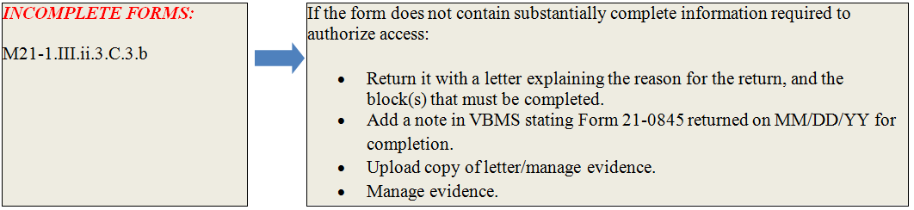  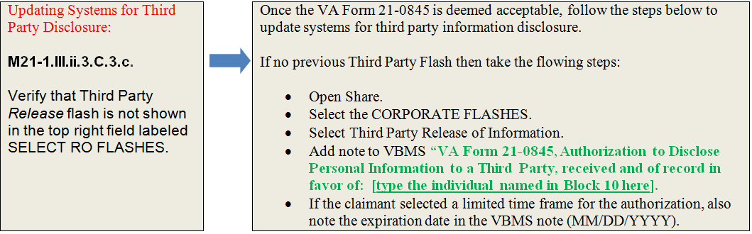  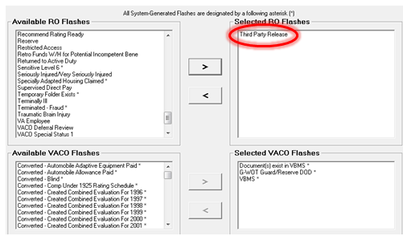
 |  | Topic 4: Updating Military Service Information
Introduction |  |  |  | This topic will allow the trainee to update Military Service Information in BIRLS and Participant Profile.
Time Required |  |  |  | 0.25 hours
OBJECTIVES/  Teaching Points |  |  |  | Topic objectives:  - Update Military service information in BIRLS.  - Update Military service information in Participant Profile.
Slide 13  Handout Pages 9-11 |  | Claims processors are responsible for ensuring that any unverified period of active duty is entered into VA systems as soon as VA is notified of the (unverified) period of active duty. Many times this is at initial claims establishment when a DD214 or other documentation is received indicating the veteran’s service. The service can initially be unverified to enter the information. The service will be marked as verified after VA receives all information required to verify military service.  Update a period of active duty in BIRLS by performing a BIRLS Update.  To properly verify active military service, the following information must be available:  - entered on date (EOD)  - date of release from active duty (RAD)  - branch of service  - character of service, and  - separation reason.  Notes:  - Once all information necessary to verify service is obtained per M21-1, Part III, Subpart ii, Chapter 3, Section C, users should indicate that service is verified by  - entering Y in the VERIFIED field, if using BIRLS, and  - checking the SERVICE VERIFIED box in Participant Profile.  - When available, include the claimant's service number when entering service information in VA claims systems.  References: For more information on  - verifying military service in  - BIRLS, see the Share User’s Guide, and  - Participant Profile, see the Participant Profile User’s Guide, and  - updating multiple periods of active duty military service, see M21-1, Part III, Subpart ii, Chapter 3, Section C.

Practical Exercise
Answer the following questions:
- True or False. If you edit a claimant’s contact information when establishing a claim it also updates the claimant’s profile at the same time.

- True or False. An appointed Veterans service organization (VSO), agent, or attorney has the legal authority to change a claimant’s address (CADD access) can update the claimant’s direct deposit information.

- True or False. Direct Deposit information can be updated in VBMS.

- True or False. A VA Form 21-0845, Authorization to Disclose Personal Information to a Third Party can be signed by a fiduciary if the veteran has been found in competent.

- What two VBA systems can be used to update military service information?

Lesson Review, Assessment, and Wrap-up
Introduction | The System Update and Compliance lesson is complete.  Review each lesson objective and ask the trainees for any questions or comments.
Time Required | 15 minutes
Lesson Objectives | You have completed the System Update and Compliance lesson.  The trainee should be able to:  - Understand the requirements for updating Contact Information and Direct Deposit Processing  - Understand the requirements for Change of Name Processing  - Understand the requirements for Processing Third Party Information Requests  - Understand the requirements for Updating Military Service Information
Assessment | Remind the trainees to complete the on-line assessment in TMS to receive credit for completion of the course.  The assessment will allow the participants to demonstrate their understanding of the information presented in this lesson.

