System Updates and Compliance

Trainee Handout

**Table of Contents**

**Objectives:**

* Understand the requirements for Updating Contact Information and Direct Deposit Processing
* Understand the requirements for Change of Name Processing
* Understand the requirements for Processing Third Party Information Requests
* Understand the requirements for Updating Military Service Information

**References:**

* [M21-1, Part III, Subpart ii, Chapter 3, Section C, System Updates](https://vaww.vrm.km.va.gov/system/templates/selfservice/va_kanew/help/agent/locale/en-US/portal/554400000001034/content/554400000014125/M21-1-Part-III-Subpart-ii-Chapter-3-Section-C-System-Updates)
* [M21-1, Part III, Subpart ii, Chapter 1, Section E, Centralized Mail (CM) Intake](https://vaww.vrm.km.va.gov/system/templates/selfservice/va_kanew/help/agent/locale/en-US/portal/554400000001034/content/554400000032384/M21-1-Part-III-Subpart-ii-Chapter-1-Section-E-Centralized-Mail-CM-Intake)
* [M21-1, Part III, Subpart v, Chapter 9, Section A, Fiduciary Hub Jurisdictions and Contact Information](https://vaww.vrm.km.va.gov/system/templates/selfservice/va_kanew/help/agent/locale/en-US/portal/554400000001034/content/554400000014275/M21-1-Part-III-Subpart-v-Chapter-9-Section-A-General-Information-on-Incompetency-and-Fiduciary-Cases)

**Topic 1: Updating Contact Information and Direct Deposit Information**

**Topic 2: Change of Name Processing**

**Topic 3: Processing Third Party Information Requests**

**Topic 4: Updating Military Service Information**

**Practical Exercise**

Topic 1: Updating Contact Information and Direct Deposit Processing

Change of contact information or direct deposit notification may come in multiple formats including

* A signed statement from the claimant,
* telephone contact with the claimant, after identity has been verified,
* undeliverable mail with the United States Post Office (USPS) forwarding address sticker affixed to the envelope,
* [***VA Form 20-572, Request for Change of Address/Cancellation of Direct Deposit***](http://www.vba.va.gov/pubs/forms/VBA-20-572-ARE.pdf), and
* other Department of Veterans Affairs (VA) forms that contain the information.

**Important notes for updating direct deposit or contact information**

* Update direct deposit information only in Share.
* Direct deposit currently cannot be updated in VBMS.
* [***VA Form 24-0296, Direct Deposit Enrollment***](https://www.vba.va.gov/pubs/forms/VBA-24-0296-ARE.pdf), must be signed by the payee, either the Veteran or the beneficiary.
* An appointed Veterans service organization (VSO), agent, or attorney has the legal authority to change a claimant’s **address** in person, by telephone, or by letter when annotated on the [***VA Form 21-22***](https://www.vba.va.gov/pubs/forms/VBA-21-22-ARE.pdf) or [***VA Form 21-22a***](https://www.vba.va.gov/pubs/forms/VBA-21-22A-ARE.pdf) .
* ***Important***: Verify the claimant does not have a fiduciary prior to making a change of address in the Veterans Benefits Management System (VBMS). The FID CATEGORY box on the GENERAL INFORMATION tab in Share will show *Incompetent* if the claimant has a VA-appointed fiduciary.

For any claimant assigned a fiduciary ***do*** ***not***

* change the address
* establish a direct deposit account, or
* change a direct deposit account.
* An address change request is to be sent to the Fiduciary Hub of jurisdiction. Contact and jurisdiction information for the Fiduciary hubs can be found at [M21-1, Part III, Subpart v, Chapter 9, Section A](https://vaww.vrm.km.va.gov/system/templates/selfservice/va_kanew/help/agent/locale/en-US/portal/554400000001034/content/554400000014275/M21-1-Part-III-Subpart-v-Chapter-9-Section-A-General-Information-on-Incompetency-and-Fiduciary-Cases).

**Updating Contact Information in VBMS**

Follow the steps in the table below to update the address in VBMS.

1. Open VBMS and enter the claimant’s claims folder number in the search box and open profile.
2. On the profile screen to the right of the “Veteran Profile” or “Contact Information” click on the pencil edit icon.

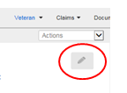

1. Now you can edit any field with a box around the field. Once information is completed click on the save icon to make the changes or the X icon to cancel your changes.

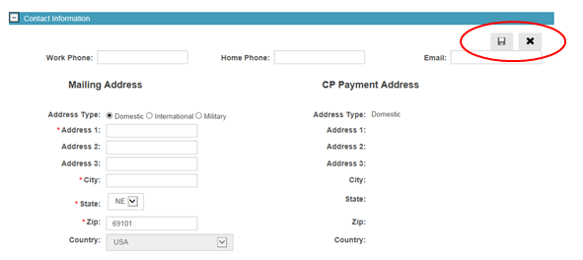

Updating Contact Information in SHARE

Share allows a user to update the claimant’s contact and/or direct deposit information when VA receives notice as described in [M21-1, Part III, Subpart ii, Chatper 3, Section C](https://vaww.vrm.km.va.gov/system/templates/selfservice/va_kanew/help/agent/locale/en-US/portal/554400000001034/topic/554400000003078/Chapter-03-System-Updates). Follow the steps in the table below when an update to information in VA systems is required.

| **Step** | **Action** |
| --- | --- |
| 1 | Open Share. |
| 2 | * Select the CHANGE OF ADDRESS command and complete the following fields:   + FILE NUMBER   + BENEFIT TYPE, and   + PAYEE NUMBER. * Select SUBMIT.   ***Example***:  selecting change of address from the dropdown also depicts fields to update |
| 3 | Determine if the claimant’s address, direct deposit information, or both need to be updated.     | **If an update is needed for ...** | **Then complete ...** | | --- | --- | | the address | Steps 4, 6, and 7. | | the direct deposit information | Steps 5, 6, and 7 | | both | all remaining steps. | |

|  |  |
| --- | --- |
| 4 | Enter or edit the new address by completing the following fields:   * ADDRESS 1 (ADDRESS 2 and 3, if necessary) * CITY * STATE * ZIP CODE, and * DAY TIME and NIGHT TIME (phone numbers) if available.   ***Example***:  closeup of required fields to complete an address    ***Notes***:  Share will prompt the user to change the city if the city and zip code do not match.  Enter the apartment or unit number, if one exists, in the ADDRESS 1 box.  Then enter the actual street address in the ADDRESS 2 box. |
| 5 | Enter or edit information in the DIRECT DEPOSIT fields. The CHANGE radio button must be checked in order for the information to be saved.   * If the claimant *does not have* direct deposit ensure the USE FOR PAYMENT ADDRESS radio button *is checked*, and * if the claimant *has* direct deposit ensure the USE FOR PAYMENT ADDRESS radio button *is not checked*.   ***Example***:  closeup of routing and acct number fields to complete for direct deposit |
| 6 | Select UPDATE. |
| 7 | Update the evidence tab in VBMS for returned mail or address/direct deposit change by   * entering the claims folder number in the search box * selecting the OPEN PROFILE button * selecting MANAGE EVIDENCE from the ACTIONS drop down menu * selecting UPDATE UNSOLICITED * entering the date of receipt as the earliest stamp date on the mail * typing *Returned mail*, *Address change*, or *Direct deposit change* (as applicable) in the DOCUMENT TYPE * selecting ADD EVIDENCE, and * selecting COMPLETE. |

Note: It is required that Direct Deposit Information be updated anytime it is received from the veteran to include when establishing an initial claim.

Topic 2: Change of Name Processing

VA requires the claimant or appointed VSO, agent, or attorney representing the claimant, to submit a signed request and sufficient evidence of a legal name change before the claimant’s name can be changed in VA systems unless otherwise noted in [M21-1, Part III, Subpart iii, Chapter 8](https://vaww.vrm.km.va.gov/system/templates/selfservice/va_kanew/help/agent/locale/en-US/portal/554400000001034/content/554400000028396/M21-1,-Part-III,-Subpart-iii,-Chapter-8---Evidence-Required-to-Change-or-Correct-Existing-Vital-Information-About-a-Beneficiary).

To change a veteran or claimant’s name in SHARE the BIRLS Update command is used.

Follow the steps in the table below to change the Veteran or claimant’s name, once adequate evidence has been received.

| **Step** | **Action** |
| --- | --- |
| 1 | Open Share. |
| 2 | * Select the BIRLS UPDATE command and complete the following fields:   + FILE NUMBER   + FIRST NAME, and   + LAST NAME. * Select SUBMIT.   ***Example***:  dropdown of available processes showing BIRLS Update selection |
| 3 | Select the second tab labeled NAME on the BIRLS UPDATE screen.    ***Example***:  closeup of fields required to complete a name change |
| 4 | Select the CHANGE (RETAINS OLD AND NEW NAME) radio button. |
| 5 | Enter the new name in the UPDATE NAME fields at the bottom of the screen. |
| 6 | Select UPDATE. |
| 7 | Upload the document to VBMS and add a permanent VBMS note. |

Topic 3: Processing Third Party Information Requests

[***VA Form 21-0845, Authorization to Disclose Personal Information to a Third Party***](http://www.vba.va.gov/pubs/forms/VBA-21-0845-ARE.pdf), allows the National Call Centers (NCCs) and regional offices (ROs) to release specified information normally protected under privacy provisions to family members or other designated persons who are not POAs, agents, or fiduciaries.

*Notes*:

* A Veteran may only designate one person or one organization on the form.  In addition, only one form may be valid at a time.
* If the veteran has a previous 21-0845 on file you will need to revoke it and add a note in VBMS that the previous 21-0845 has been revoked)

**VA Form 21-0845 Required Criteria Checklist**

To be valid, the VA Form 21-0845 must contain or meet the following criteria to be considered substantially complete:

* the signature of Veteran/claimant and date
* the name and claims folder number of the Veteran/claimant
* the contact information (address, daytime or cell phone number, or e-mail address)
* the type of information authorized for release
* the length of time authorization is valid, if applicable
  + a security question and answer
  + the form date stamped by the VA
  + the form designates only one person or organization, and
  + if the Veteran has a fiduciary, the signature of the fiduciary.

***Important***:  The signature cannot be someone other than Veteran/claimant except in cases where the Veteran/claimant is incompetent. When the Veteran/claimant is found incompetent, the VA Form must be signed by a VA appointed fiduciary.

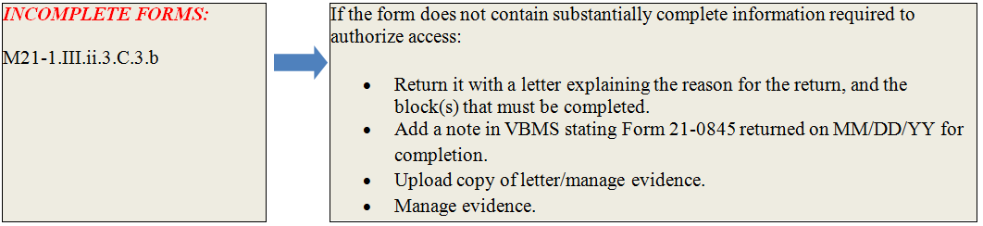

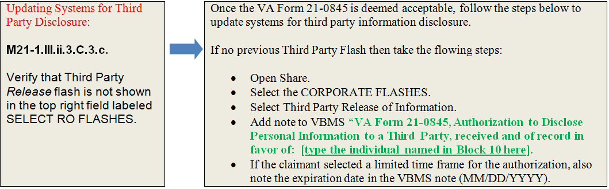

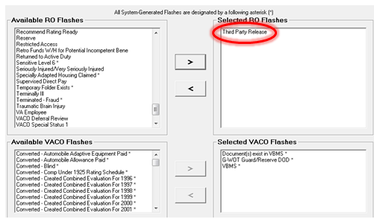

# Topic 4: Updating Military Service Information

Claims processors are responsible for ensuring any unverified period of active duty is entered into VA systems as soon as VA is notified of the (unverified) period of active duty. Many times this is at initial claims establishment when a DD214 or other documentation is received indicating the veteran’s service. The service can initially be unverified to enter the information. The service will be marked as verified after VA receives all information required to verify military service.

Update a period of active duty in BIRLS by performing a BIRLS Update.

To properly verify active military service, the following information must be available:

* entered on date (EOD)
* date of release from active duty (RAD)
* branch of service
* character of service, and
* separation reason.

***Notes***:

* Once all information necessary to verify service is obtained per [M21-1, Part III, Subpart ii, Chapter 3, Section C](https://vaww.vrm.km.va.gov/system/templates/selfservice/va_kanew/help/agent/locale/en-US/portal/554400000001034/content/554400000014125/M21-1-Part-III-Subpart-ii-Chapter-3-Section-C-System-Updates), users should indicate service is verified by
  + entering *Y* in the VERIFIED field, if using BIRLS, and
  + checking the SERVICE VERIFIED box in Participant Profile.
* When available, include the claimant's service number when entering service information in VA claims systems.

***References***:  For more information on

* verifying military service in
* BIRLS, see the [***Share User’s Guide***](http://css.vba.va.gov/SHARE/), and
* Participant Profile, see the [***Participant Profile User’s Guide***](http://vbaw.vba.va.gov/VetsNet/SPP_Docs/Webhelp/Participant_Profile.htm), and
* updating multiple periods of active duty military service, see [M21-1, Part III, Subpart ii, Chapter 3, Section C](https://vaww.vrm.km.va.gov/system/templates/selfservice/va_kanew/help/agent/locale/en-US/portal/554400000001034/content/554400000014125/M21-1-Part-III-Subpart-ii-Chapter-3-Section-C-System-Updates),

BIRLS Update screen.

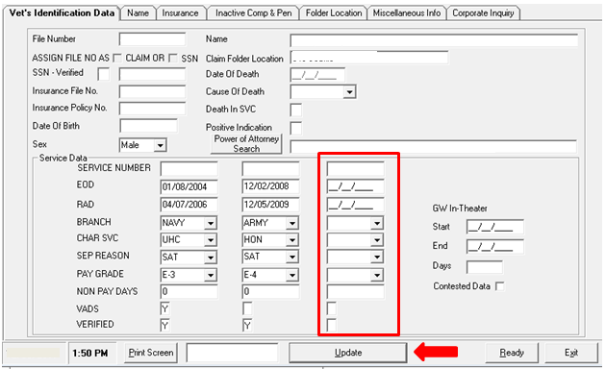

Participant Profile Update screen.

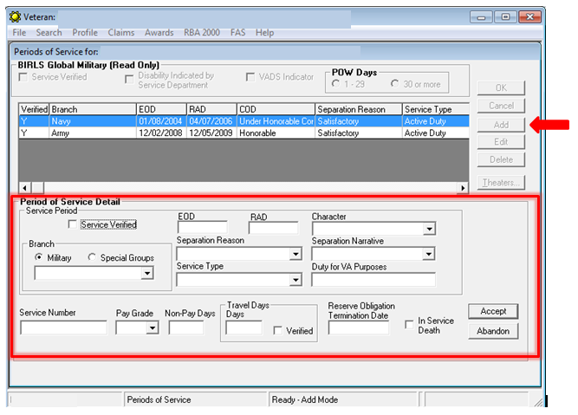

# Practical Exercise

1. **True or False**. If you edit a claimant’s contact information when establishing a claim it also updates the claimant’s profile at the same time.
2. **True or False**. An appointed Veterans service organization (VSO), agent, or attorney has the legal authority to change a claimant’s address (CADD access) can update the claimant’s direct deposit information.
3. **True or False**. Direct Deposit information can be updated in VBMS.
4. **True or False**. A *VA Form 21-0845, Authorization to Disclose Personal Information to a Third Party* can be signed by a fiduciary if the veteran has been found in competent.
5. What two VBA systems can be used to update military service information?