Pension and Fiduciary Service
PMC VSR Advanced Core Course Phase 6: Processing Claims
Lesson 17: Process 850 Series Work Items (Manual Payment Adjustments)
Trainee Guide
August 21, 2017
Version 1.0

Process 850 Series Work Items (Manual Payment Adjustments)

Lesson Overview
Topic | Description
Time Estimate: | 3 hours
Purpose of the Lesson: | This lesson is part of the entry-level course for PMC VSRs. The purpose of this lesson is to train PMC VSRs to process 850 series work items through demonstration, practice, and feedback.
Prerequisite Training Requirements: | Prior to taking the Process 850 Series Work Items lesson, you must complete the entry-level course Phases 1–5 and Phase 6, lessons 1–16. (Refer to the Master Course Map learning aid for a list of lessons.)
Target Audience: | This lesson is for entry-level PMC VSRs.
Lesson References: | - Master Course Map learning aid  - M21-1 III.ii.1.B.2.c (Placing Claims and 800 Series Work Items Under EP Control)  - M21-1 III.v.3.B.1.k (Handling Allegations of Hardship When an Apportionment Is Already in Place)  - M21-1 III.v.10.A.1.i (850WI Claim Label)  - M21-1 III.v.10.A.2 (Processing 800 Series Work Items)  - M21-1 III.v.10.A.3.a (Adjusting an Award to Reflect a COLA)  - M21-1 V.iii.1.A.5.l (Example 1: Handling a MAPR and Income Change Effective the Same Date)  - M21-1 V.iii.1.H.2.c (Reduction in Rate of Current-Law Pension Due to SS’s COLA)  - M21-4 Appendix C, Section I.b (Index of Claim Labels)  - Processing an Award Adjustment job aid  - See Lesson 17: Appendix A for references introduced in earlier lessons.
Technical Competencies: | - Program Benefits and Eligibility (PMC VSR)  - Processing Claims (PMC VSR)  - VBA Applications (PMC VSR)  - Income Counting and Net Worth
Knowledge Check: | Phase 6, Lesson 17 Knowledge Check: Process 850 Series Work Items
Lesson Objectives: | - Process 850 series work items.  - Determine which 800 series work item was received.  - Determine the reason for the 850 series work item.  - Determine the appropriate steps to take to process the 850 series work item.  - Perform the required actions to process the 850 series work item.  - Submit the outcomes of the 850 series work item to the Authorizer.
What You Need: | - Trainee Guide  - Master Course Map learning aid  - Access to Appendix B: Activity Worksheet  - Access to the Processing an Award Adjustment job aid from VSR Assistant  - See Lesson 17: Appendix A for other job aids  - Applicable VBA applications used in job aids and references listed in Appendix A

PowerPoint Slides | Notes
Lesson 17: Process 850 Series Work Items
You Are Here
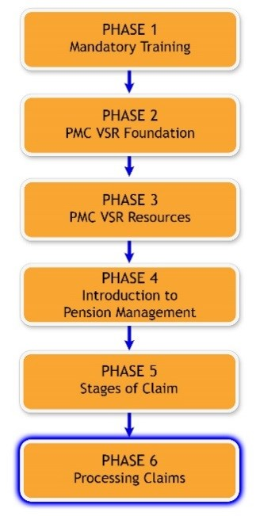
Scenario—850 Series Work Item
PMC VSR Miranda Smith receives notice from her Coach that an 850A work item is pending for Veteran Don Beckett. Miranda determines, based on changes from SSA indicating that social security income and Medicare Part B increased for 2017, that the award requires a manual adjustment for COLA. Miranda then CESTs an EP 696 and an EP 150/157 to perform the necessary actions to update the award. Once the claim has been authorized, the system will automatically clear the 850A since it cannot be cleared manually.
Why It Matters!
It is important to know how to process 850 series work items because certain award adjustments or benefits might not be made automatically. They are adjusted manually to ensure beneficiaries receive the correct award amount.
Lesson Objectives
- Process 850 series work items:
  - Determine which 800 series work item was received
  - Determine the reason for the 850 series work item
  - Determine the appropriate steps to take to process the 850 series work item
  - Perform the required actions to process the 850 series work item
  - Submit the outcomes of the 850 series work item to the Authorizer
Knowledge Check
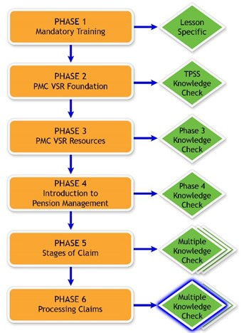
800 Series Work Items Review Activity—Part A
- Instructions:
  - Complete Appendix B: Part A—Match the Title to the Correct Work Series Status Category.
  - Given the title description, select the correct status category.
  - Use the references listed in Appendix B, Part A.
  - Be prepared to share your answers with the class.
- Time allowed: 5–7 minutes
800 Series Work Items Review Activity—Part A Answers
- Explanation of Audit Messages/Notice of Death
- Bureau of Federal Prison
- Manual Payment Adjustments
- Notice of Benefit Payment Transaction
800 Series Work Items Review Activity—Part B
- Instructions:
  - Divide into pairs.
  - Complete Appendix B: Part B—Which Status Category and Claim Label Is It? Worksheet.
  - Read the scenarios and identify the status category and claim label for each scenario.
  - Confer with your partner and write your answers in the worksheet.
  - Use the references listed in Appendix B, Part B.
  - Be prepared to share your finished activity with other groups.
- Time allowed: 15 minutes
800 Series Work Items Review Activity—Part B Answers
- Scenario 1
- Scenario 2
- Scenario 3
- Scenario 4
- Scenario 5
Characteristics of Processing 850 Series Work Items
- System-generated notifications requiring a manual payment adjustment
- Involve manual adjustment for changes in COLA
Common Reasons a COLA may not Automatically Generate
- Veterans and survivor's pension benefits when the income reported from SSA would cause a decrease to VA benefits
- DIC benefits when an apportionment is being paid
- Veterans pension benefits when an apportionment is being paid
- Any award with a future award line (e.g. dependent is removed from an award on his/her 18th birthday)
850 Series Work Items Claim Label
- 850A: Legislative Rate Adjustment
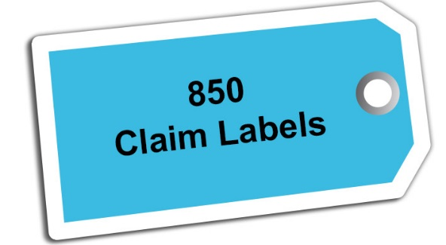
850A: Legislative Rate Adjustment (1 of 3)
- Reason: this work item generates when a cost of living adjustment (COLA) is not automatically given to a beneficiary.
- Actions:
  - CEST an EP 696 to control the 850A work item.
  - Review beneficiary's award information in SHARE for year working in to ensure there was a change for the COLA that corresponds to the date of the 850A work item (no December line–no financial rate change).
  - If the Corporate award shows a 12-01-YYYY line, no further action is necessary.
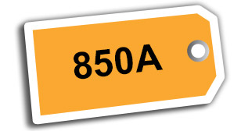
850A: Legislative Rate Adjustment (2 of 3)
- Actions:
  - If there is not a 12-01-YYYY line for the current year, further action is needed.
  - If there is no additional EP pending, CEST one.
  - Determine whether income is being counted.
  - If the income or medical expenses need to be updated, CEST a companion EP 150/157 in addition to the EP 696 and process both concurrently to adjust the award.
850A: Legislative Rate Adjustment (3 of 3)
- Actions:
  - After entering the information—if the change causes a decrease in benefits—clear the EP 150/157 and CEST an EP 607 to apply due process provisions.
  - The final award must be processed under the EP 696 in order to clear the 850A work item.
COLA and Effective Dates
- If COLA creates a decrease to an award in December, “protect the rate” by deferring the adjustment until January.
- If medical expenses will cause an increase, apply Omnibus also and defer the adjustment until February instead of January.
Demonstration and Guided Practice
- Demonstration—Instructor processes a claim from start to finish with opportunities for questions.
- Guided Practice—Trainees process a claim with questions and feedback/remediation.
Demonstration Work Item—850 Series Work Items

- Demonstration—
  - {Work item}
  - {Other information}
Demonstration Work Item—Determine Which 800 Series Work Item Was Received
Demonstration Work Item—Determine the Reason for the 850 Series Work Item
- Work item was not cleared previously, but no update is needed
- An update is needed in the system
- An award adjustment is needed
Demonstration Work Item—Determine the Appropriate Steps to Take to Process the 850 Series Work Items
Demonstration Work Item—Perform the Required Actions to Process the 850 Series Work Item
Demonstration Work Item—Submit the Outcomes of the 850 Series Work Item to the Authorizer
Guided Practice Exercise Overview—850 Series Work Items (1 of 2)
- Instructions:
  - Process 850 series work item from beginning to end.
  - Use the job aids, references, and systems available.
  - Select a partner before beginning the exercise to confer with after completing each step individually.
  - Consult with instructors for assistance.
  - Be prepared to discuss your results with the class.
  - Take credit in ASPEN as directed at the completion of the exercise.
Guided Practice Exercise Overview—850 Series Work Items (2 of 2)
- This exercise includes the following parts of the work items process:
  - Determine which 800 series work item was received.
  - Determine the reason for the 850 series work item.
  - Determine the appropriate steps to take to process the 850 series work item.
  - Perform the required actions to process the 850 series work item.
  - Submit the outcomes of the 850 series work item to the Authorizer.
Guided Practice Exercise—850 Series Work Items
- Guided Practice Exercise Example:
  - {Work item}
  - {Other information}
Guided Practice Exercise—Determine Which 800 Series Work Item Was Received
- Instructions:
  - Determine which 800 series work item was received.
  - Confer with your partner.
  - Be prepared to discuss your results with the class.
- Time allowed: 5 minutes
Guided Practice Exercise—Determine the Reason for the 850 Series Work Item
- Instructions:
  - Determine the reason for the work item.
  - Confer with your partner.
  - Be prepared to discuss your results with the class.
- Time allowed: 15 minutes
Guided Practice Exercise—Determine the Appropriate Steps to Take to Process the 850 Series Work Item
- Instructions:
  - Determine the steps to take to process the 850 series work item.
  - Use the job aids, references, and systems available.
  - Confer with your partner.
  - Be prepared to discuss your results with the class.
- Time allowed: 15 minutes
Guided Practice Exercise—Perform the Required Actions to Process the 850 Series Work Item
- Instructions:
  - Perform the required actions to process the specific claim label for the 850 series work item.
  - Use the job aids, references, and systems available.
  - Confer with your partner to asses each other’s steps to process the work item.
  - Ask for guidance from the instructor if you identify discrepancies.
- Time allowed: 40 minutes
Guided Practice Exercise—Submit the Outcomes of the 850 Series Work Item to the Authorizer
- Instructions:
  - Finalize notes for work items and save completed work in appropriate locations for review by Authorizer.
  - Use the job aids, references, and systems available.
- Time allowed: 10 minutes
Questions?

Lesson Summary (1 of 2)
What are the main tasks a PMC VSR must accomplish to process 850 series work items?
Lesson Summary (2 of 2)
What are the main tasks a PMC VSR must accomplish to process 850 series work items?
What’s Next?
Knowledge Check: Process 850 Series Work Items

