PENSION AND FIDUCIARY Service
PMC VSR Advanced Core Course
Phase 6: Processing Claims
Lesson 16: Process 820 Series Work Items (Notice of Death)
Trainee Guide
August 21, 2017
Version 1.0

Process 820 Series Work Items (Notice of Death)

Lesson Overview
Topic | Description
Time Estimate: | 3 hours
Purpose of the Lesson: | This lesson is part of the entry-level course for PMC VSRs. The purpose of this lesson is to train PMC VSRs on how to process 820 series work items (notice of death) through demonstration and practice. This lesson also includes instruction on how to use the systems for processing 820 series work items (notice of death).
Prerequisite Training Requirements: | Prior to taking the Process 820 Series Work Items (Notice of Death) lesson, you must complete entry-level:  - Phases 1–5  - Phase 6, Lessons 1-15. (Refer to the Master Course Map learning aid for a list of lessons.)
Target Audience: | This lesson is for entry-level PMC VSRs.
Lesson References: | - Master Course Map learning aid  - VA Form 10-7132 (Status Change Form)  - VA Form 21-534 (Application for Dependency and Indemnity Compensation, Survivors Pension and Accrued Benefits by a Surviving Spouse or Child [including Death Compensation if Applicable])  - VA Form 21-534EZ (Application for DIC, Survivors Pension, and/or Accrued Benefits)  - VA Form 21-0537 (Marital Status Questionnaire)  - VA Form 21P-601 (Application for Accrued Amounts Due a Deceased Beneficiary)  - M21-1 I.2.D.1.g (Contemporaneous Notice and Report of Death)  - M21-1 III.ii.1.B.2.c (Placing Claims and 800 Series Work Items Under EP Control)  - M21-1 III.ii.2.B.1.c (Benefit Requests Not Requiring a Prescribed Form)  - M21-1 III.ii.8 (First Notice of Death [FNOD] Processing)  - M21-1 III.ii.8.A.1.d (Notice Requirements Associated With Veteran FNOD Processing)  - M21-1 III.ii.8.A.1.h (Guidelines for Specific Veteran NOD Situations)  - M21-1 III.v.10.A.1 (800 Series Work Items)  - M21-1 III.v.10.A.1.a (Definition: 800 Series Work Items)  - M21-1 III.v.10.A.1.g (820WI Claim Labels)  - M21-1 III.v.10.A.2 (Processing 800 Series Work Items)  - M21-1 V.iii.1.E.3.a (Combined Rate Payable to Veterans Married to Each Other)  - M21-1 V.iii.4.2 (Making Payments in Veteran-Married-to-Veteran Improved Pension Cases)  - M21-1 X.5 (Social Security Death Master File)  - M21-1 X.5.1.b (Message Code 833 Work Items)  - M21-1 X.5.1.c (Automated Actions Based on Death Match)  - M21-1 X.5.2.a (Reviewing the Master Record on DMF Matches)  - M21-1 X.5.4.c (Uploading Match Listing in the eFolder)  - M21-4 Appendix C, Section I.b (Index of Claim Labels)  - 38 CFR 3.700(a)(4) (Veterans—Improved pension)  - Processing an Award Adjustment job aid  - See Lesson 16: Appendix A for references introduced in earlier lessons
Technical Competencies: | - Program Benefits and Eligibility (PMC VSR)  - VBA Applications (PMC VSR)
Knowledge Check: | Phase 6, Lesson 16 Knowledge Check: Process 820 Series Work Items (Notice of Death)
Lesson Objectives: | - Process 820 series work items.  - Determine which 820 series work item was received.  - Determine the appropriate steps to process the 820 series work item.  - Perform the required actions to process the 820 series work item.  - Create notification letter, if applicable.  - Submit the outcomes of the 820 series work item to the Authorizer.
What You Need: | - Trainee Guide  - Master Course Map learning aid  - Whiteboard/flip chart with different colored markers  - Access to the Processing an Award Adjustment job aid from VSR Assistant  - See Lesson 16: Appendix A for other job aids  - Applicable VBA applications used in job aids and references listed in Lesson 16: Appendix A

PowerPoint Slides | Notes
Lesson 16: Process 820 Series Work Items (Notice of Death)
You Are Here
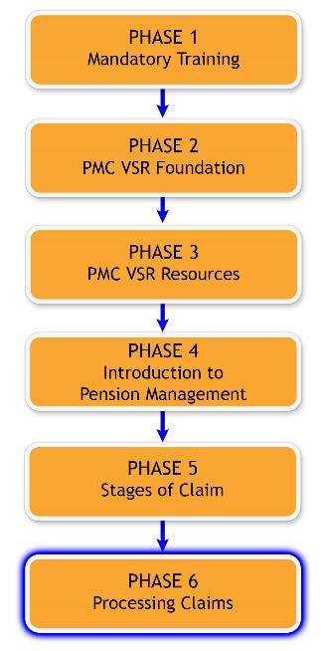
Definition Reminder: 800 Series Work Items
- An 800 Series Work Item is a system-generated message issued through the Veterans Service Network (VETSNET) that is designed to assist Veterans Service Centers (VSCs) and Pension Management Centers (PMCs) in identifying and tracking cases that require follow-up action. 800 series work items replace paper work items.
- M21-1 III.v.10.A.1.a (Definition: 800 Series Work Items)
Scenario—820 Series Work Item
PMC VSR April Boston receives notice from her Coach that an 820 work item is pending for Veteran Adam Johnson. PMC VSR will then go through the steps to verify the Veteran’s death and terminate his running award.
Characteristics of 820 Series Work Item Processing
- 820 series work items:
  - Are system-generated notifications from the Matching Program with the Social Security Administration (SSA).
  - Are not generated by a claim submitted to VA.
  - Indicate to a PMC VSR that a deceased beneficiary’s benefits should be terminated.
- FNOD action for a Veteran or CESTed: EP 137 for a non-Veteran
820 Series Work Item Claim Labels
- 738: FNOD Vet Married to Vet: Spouse award needs adjustment
- 833A: SSA Death DOB Mismatch: Master record date of birth does not match the SSA date of birth
- 833B: SSA Death Name Mismatch: Master record last name or first initial of the first name do not match the SSA last name and/or first initial of the first name
- 833C: SSA Death C&P Matched: The master record and the SSA DMF match on SSN, DOB, and name
Why It Matters!

- Helps prevent VBA from making overpayments to deceased beneficiaries that VBA cannot recover
- Provides cost-saving input into Omnibus Budget Reconciliation Act of 1990 (OBRA) reporting for the PMC
Lesson Objectives
- Process an 820 series work item.
  - Determine which 820 series work item was received.
  - Determine the appropriate steps to process the 820 series work item.
  - Perform the required actions to process the 820 series work item.
  - Create notification letter, if applicable.
  - Submit the outcomes of the 820 series work item to the Authorizer.
Knowledge Check
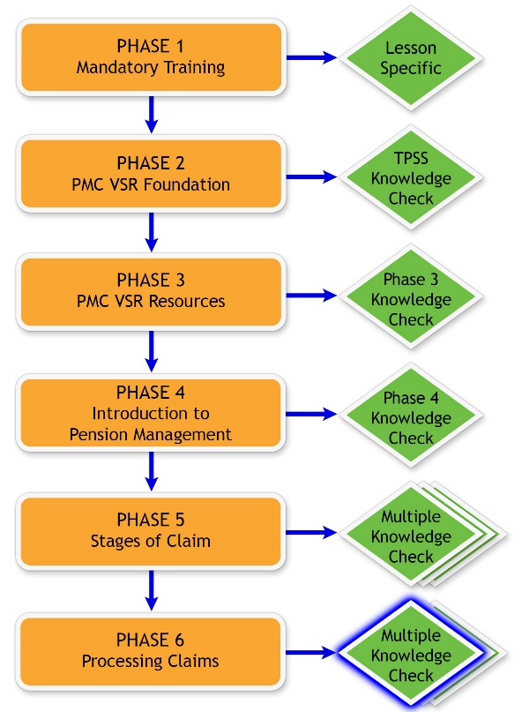
Lesson Overview
- Demonstration: Instructor processes various 820 series work items from start to finish with opportunities for questions.
- Guided Practice Exercise: Trainees process an 820 series work item with questions and feedback/remediation.
Demonstration Example Work Item 1—Process an 820-833C SSA Death C&P Matched
Example Work Item 1:
- {Name}
- {Other information}
Example Work Item 1—Determine Which 820 Series Work Item Was Received

- Receive notice by Coach of 820-833C system-generated notification from SSA regarding death of beneficiary.
- Confirm the claim label on the inquiry.
Example Work Item 1—Determine the Appropriate Steps to Process the 820-833C Work Item
- Determine if there is a match between the corporate record and SSA inquiry to verify death of beneficiary.
- Is the deceased a Veteran or a survivor?
Example Work Item 1—Perform the Required Actions to Process the 820-833C Work Item
- Process FNOD for a Veteran.
  - Confirm spouse is still living.
  - Confirm spouse is proper recipient of automated burial payment, MOD, and potential DIC.
  - If spouse is incorrect in system, then go to Participant Profile to correct.
- Clear 820 work item for a non-Veteran, if not already completed.
- Process EP 137 for a non-Veteran.
- Determine if there are accrued benefits.
Example Work Item 1—Process the FNOD
- Determine the date of termination of entitlement based on the first of the month of the date of death of the beneficiary.
- Complete the FNOD for the Veteran.
Example Work Item 1—Prepare Contemporaneous Notice
- Prepare contemporaneous notice to the estate if accrued benefits are payable or there was a claim pending at death and enclose VA Form 21-601.
- If there is possible eligibility for survivor’s benefits, include VA Form 21-534 or VA Form 21-534EZ.
Demonstration Example Work Item 2—Process an 820-833A SSA Death DOB Mismatch
Example Work Item 2:
- {Name}
- {Other information}
Example Work Item 2—Determine Which 820 Series Work Item Was Received
- Receive notice by Coach of 820-833A system-generated notification from SSA regarding death of beneficiary.
- Confirm the claim label on the inquiry.
Example Work Item 2—Determine the Appropriate Steps to Process the 820-833A Work Item
- Determine if there is a match between the corporate record and SSA inquiry to verify death of beneficiary.
- Review eFolder to determine correct date of birth.
- Is the deceased a Veteran or a survivor?
Example Work Item 2—Perform the Required Actions to Process the 820-833A Work Item
- Clear 820 work item, if not already completed.
- Process EP 137 for a non-Veteran.
- Determine if there are accrued benefits to consider.
Example Work Item 2—Generate Award Adjustment
- Determine the date of termination of entitlement based on the date of death of the beneficiary.
- Generate award adjustment.
Example Work Item 2—Prepare Contemporaneous Notice
- Prepare contemporaneous notice to be sent to the deceased beneficiary’s estate based on required 820-833A work item actions taken.
- The letter must inform the estate that accrued benefits may be available if there was a claim pending at death or money was owed to the beneficiary at death.
Example Work Item 2—Submit the Outcomes of the 820-833A Work Item to the Authorizer
- Submit the generated EP 137, including the contemporaneous notice to the estate, to the Authorizer for review according to local procedures.
Demonstration Example Work Item 3—Process an 820-738 FNOD Vet Married to Vet
Example Work Item 3:
- {Name}
- {Other information}
Example Work Item 3—Determine Which 820 Series Work Item Was Received
- Receive notice by Coach of 820-738 system-generated notification from SSA regarding death of Veteran spouse.
- Confirm the claim label on the inquiry.
Example Work Item 3—Determine the Appropriate Steps to Process the 820-738 Work Item
Determine if there is a match between the corporate record and SSA inquiry to verify death of Veteran.
Example Work Item 3—Perform the Required Actions to Process the 820-738 Work Item
- For deceased Veteran:
  - Go to the deceased Veteran’s file number in SHARE.
  - Process FNOD for a Veteran.
  - Determine if there are accrued benefits to consider.
- For surviving Veteran:
  - Go to the surviving Veteran’s file number in VBMS.
  - CEST EP 137 to remove Veteran’s spouse.
  - Clear 820 work item, if not already completed.
Example Work Item 3—Generate Award Adjustment
- Determine the date of removal of dependent based on the date of death of deceased Veteran spouse.
- If award is:
  - Increasing, generate award adjustment.
  - Decreasing, but Veteran notified VA of death of spouse, generate award adjustment.
  - Decreasing, but Veteran did not notify VA of death of spouse, issue due process.
Example Work Item 3—Submit the Outcomes of the 820-738 Work Item to the Authorizer
- Create the letter.
- Submit the outcomes, including the letter, to the Authorizer for review according to local procedures.
820 Series (Notice of Death) Work Items—Document for OBRA Reporting
Guided Practice Exercise Overview (1 of 2)
- Instructions:
  - Process Example Work Item 4 from beginning to end.
  - Use the job aids, references, and systems available.
  - Select a partner before beginning the exercise to confer with after completing each step individually.
  - Consult with instructors for assistance.
  - Be prepared to discuss your results with the class.
Guided Practice Exercise Overview (2 of 2)
- This exercise includes the following parts of the 820 series work item process:
  - Determine which 820 series work item was received.
  - Determine the appropriate steps to process the 820 series work item.
  - Perform the required actions to process the 820 series work item.
  - Create notification letter, if applicable.
  - Submit the outcomes of the 820 series work item to the Authorizer.
Guided Practice Exercise Example Work Item 4—Process 820-833C Work Item
Guided Practice Exercise Example Work Item 4:
- {Name}
- {Other information}
Example Work Item 4—Determine Which 820 Series Work Item Was Received
- Instructions:
  - Perform the steps to determine which 820 series work item was received for Example Work Item 4.
  - Use the job aids, references, and systems available.
  - Confer with your partner.
  - Be prepared to discuss your results with the class.
- Time allowed: 5 minutes
Example Work Item 4—Determine the Appropriate Steps to Process the 820-833C Work Item (1 of 2)
- Instructions:
  - Perform the steps to determine the appropriate steps to process the 820-833C work item for Example Work Item 4.
  - Use the job aids, references, and systems available.
  - Confer with your partner.
  - Be prepared to discuss your results with the class.
- Time allowed: 10 minutes
Example Work Item 4—Determine the Appropriate Steps to Process the 820-833C Work Item (2 of 2)
- Is there a match between the corporate record and SSA inquiry to verify death of beneficiary?
- Is the deceased a Veteran or a survivor?
Example Work Item 4—Perform the Required Actions to Process the 820-833C Work Item
- Instructions:
  - Perform the required actions to process the 820 series work item for Example Work Item 4.
  - Use the job aids, references, and systems available.
  - Confer with your partner.
  - Be prepared to discuss your results with the class.
- Time allowed: 20 minutes
Example Work Item 4—Prepare Contemporaneous Notice
- Instructions:
  - Perform the steps to prepare the contemporaneous notice to the deceased beneficiary’s estate for Example Work Item 4.
  - Use the job aids, references, and systems available.
  - Confer with your partner to assess each other’s notices.
  - Discuss differences in the notices.
  - Ask for guidance from the instructor if you identify discrepancies.
- Time allowed: 15 minutes
Example Work Item 4—Submit the Outcomes of the 820-833C Work Item to the Authorizer
- Instructions:
  - Perform the steps according to local procedures to submit the Outcomes of the 820-833C Work Item to the Authorizer for Example Work Item 4.
  - Use the job aids, references, and systems available.
  - Confer with your partner.
  - Be prepared to discuss your results with the class.
- Time allowed: 5 minutes
Questions?

Lesson Summary (1 of 2)
What are the main tasks a PMC VSR must accomplish to process an 820 series work item correctly?
Lesson Summary (2 of 2)

What’s Next?
Knowledge Check: Process 820 Series Work Items (Notice of Death)

