**Learning Catalog: Item Detail QA Checklist**

TMS #: 4407809

Lesson Title: *Endocrine System Refresher*

Reviewer: Sarah Gilbert

Review Date: 12/5/17

Global Review Notes:

VBA Learning Catalog Website: <https://hvnc.gdit.com/lc/Default.aspx>

Enter the TMS # into the search box in the upper right hand corning of the home page of the Learning Catalog and click on the hour glass to begin your review.

| **Review Item** | **Complete** | | **Notes** | |
| --- | --- | --- | --- | --- |
| **User View of Catalog Item** | | | | |
| **Item Cover Page** | | | | |
| **Lesson Title** | X | |  | |
| **TMS #** | X | |  | |
| **Learning Hours** | X | |  | |
| **Last Updated** | X | |  | |
| **Audience** | X | |  | |
| **Design/Delivery** | X | |  | |
| **Item Details Page** | | | | |
| **Lesson Title** | X | |  | |
| **TMS #** | X | |  | |
| **Learning Hours** | X | |  | |
| **Last Updated** | X | |  | |
| **Description** | X | |  | |
| **Prerequisites** | n/a | |  | |
| **Objectives** |  | | 1st bullet: add “the” after “Review” | |
| **Other Information** – may include item completion detail instruction, special delivery method notes, additional audience details, etc. *Confirm if the item has a Level II or not. Review for correct notation. | X | |  | |
| **Audience** | X | |  | |
| **Curriculum** | X | |  | |
| **Category** | X | |  | |
| **Related Links** – click on each related link to ensure that it launches without error. | X | |  | |
| Handouts, Lesson Plans, Additional References, etc., do not show any Track Changes. |  | | LP has incorrect metadata under Summary, Company. Says “Veteran Affairs” instead of “Veterans Benefits Administration” | |
| Item Category Population | | | | |
| Item can be searched and located under the **Audience** drop down tile on the User side of the LC. | | X | |  |
| Item can be searched and located under the **Curriculum** drop down tile on the User side of the LC. (if applicable)  *Challenge has been added as a Curriculum as of February 2016. | | X | |  |
| Item can be searched and located under the **Category** drop down tile on the User side of the LC. (if applicable) | | X | |  |
| Item can be searched and located under the **Design/Delivery** drop down tile on the User side of the LC. | | X | |  |
| Item can be searched and located under the **Competency** drop down tile on the User side of the LC. | |  | | *Competency is not linked to the VBA Learning Catalog at this time. N/A |

**Item Cover Page Sample: (QA auditor may replace with actual item)**

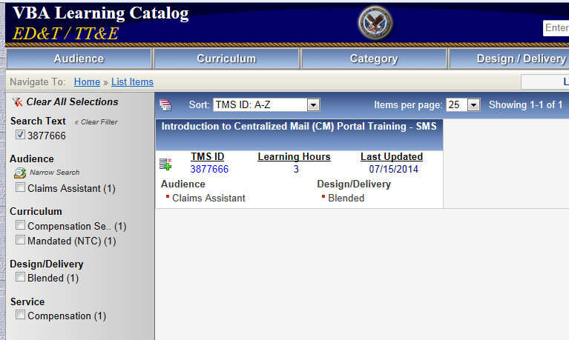

**Item Detail Page Sample: (QA auditor may replace with actual item)**

