Claims Establishment for Character of Discharge Determinations
Instructor Lesson Plan
Time Required: 1.25 Hours

Table of Contents

Lesson Description 2
Introduction to Claims Establishment for Character of Discharge Determination 4
Topic 1: VA Form 20-0986 5
Topic 2: Establishing Control 11
Topic 3: Proper Routing 12
Lesson Review, Assessment, and Wrap-up 17

Lesson Description
The information below provides the instructor with an overview of the lesson and the materials that are required to effectively present this instruction.
TMS # | 4300970
Prerequisites | Prior to this lesson, the Claims Assistant should be within his or her position for a week. Trainees should also have an understanding of how to establish a claim.
target audience | The target audience for Claims Establishment for Character of Discharge is Claim Assistant.
Time Required | 1.25 hours
Materials/  TRAINING AIDS | Lesson materials:  - Claims Establishment for Character of Discharge Determination PowerPoint Presentation  - Claims Establishment for Character of Discharge Determination Trainee Handouts
Training Area/Tools | The following are required to ensure the trainees are able to meet the lesson objectives:  - Classroom or private area suitable for participatory discussions  - Seating, writing materials, and writing surfaces for trainee note taking and participation  - Handouts, which include a practical exercise  - Large writing surface (easel pad, chalkboard, dry erase board, overhead projector, etc.) with appropriate writing materials  - Computer with PowerPoint software to present the lesson material  Trainees require access to the following tools:  - VA TMS to complete the assessment
Pre-Planning | - Become familiar with all training materials by reading the Instructor Lesson Plan while simultaneously reviewing the corresponding PowerPoint slides. This will provide you the opportunity to see the connection between the Lesson Plan and the slides, which will allow for a more structured presentation during the training session.  - Become familiar with the content of the trainee handouts and their association to the Lesson Plan.  - Practice is the best guarantee of providing a quality presentation. At a minimum, do a complete walkthrough of the presentation to practice coordination between this Lesson Plan, the trainee handouts, and the PowerPoint slides and ensure your timing is on track with the length of the lesson.  - Ensure that there are copies of all handouts before the training session.  - When required, reserve the training room.  - Arrange for equipment such as flip charts, an overhead projector, and any other equipment (as needed).  - Talk to people in your office who are most familiar with this topic to collect experiences that you can include as examples in the lesson.  - This lesson plan belongs to you. Feel free to highlight headings, key phrases, or other information to help the instruction flow smoothly. Feel free to add any notes or information that you need in the margins.
Training Day | - Arrive as early as possible to ensure access to the facility and computers.  - Become familiar with the location of restrooms and other facilities that the trainees will require.  - Test the computer and projector to ensure they are working properly.  - Before class begins, open the PowerPoint presentation to the first slide. This will help to ensure the presentation is functioning properly.  - Make sure that a whiteboard or flip chart and the associated markers are available.  - The instructor completes a roll call attendance sheet or provides a sign-in sheet to the students. The attendance records are forwarded to the Regional Office Training Managers.

Introduction to Claims Establishment for Character of Discharge Determination
INSTRUCTOR INTRODUCTION |  | Complete the following:  - Introduce yourself  - Orient learners to the facilities  - Ensure that all learners have the required handouts
time required |  | 0.25 hours
Purpose of Lesson  Explain the following: |  | This lesson is intended to explain how to properly establish a Character of Discharge Determination request from the Veteran’s Health Administration. This lesson will contain discussions and exercises that will allow you to gain a better understanding of:  - Properly identifying a VA Form 20-0986, Eligibility Determination for Character of Discharge (COD) Request Form  - Establishing proper control of determination requests received  - Ensure Proper Routing of these claims determination occurs
Lesson Objectives  Discuss the following:  Slide 2  Handout 2 | In order to accomplish the purpose of this lesson, the Claims Assistant will be required to accomplish the following lesson objectives.  The Claims Assistant will be able to:  - Identify a Character of Discharge determination for health care eligibility claim  - Convert forms received for health care eligibility into a controlling End Product (EP)  - Classify the Character of Discharge with proper special issue to ensure accurate routing occurs
Explain the following: | Each learning objective is covered in the associated topic. At the conclusion of the lesson, the learning objectives will be reviewed.
Motivation | The Secretary has identified a need for Veterans with discharges which are less than honorable to gain access to the Veterans Health Administration (VHA) system. However, United States Code 3.12(d) states Veterans Benefits Administration is required to make the determination if the Veteran qualifies for this benefits on a case-by-case basis.
National Error trend | During a recent review it was noted 37% of VA Form 10-7131 requests from VHA were incorrectly controlled. This problem identified a need to create a form which clearly communicates the need for Veterans Benefits Administration (VBA) action.
References  Slide 3  Handout 3 | Explain where these references are located in the workplace.  All M21-1 references are found in the CPKM.  - Public Law 95-126  - 38 U.S.C. 3.12(d), Character of Discharge  - M21-4, Appendix B, End Product (EP) Codes and Work-Rate Standards for Quantitative Measurements  - M21-1, Part III, Subpart v, 1.B.4, Character of Discharge/Statutory Bar Determinations and Health Care Eligibility  - M21-1, Part III, Subpart v, 7.A.7.c, EP Control Over Eligibility Determination Requests

Topic 1: VA Form 20-0968
Introduction | This topic will allow the trainee to properly identify the VA Form 20-0986, Eligibility Determination for Character of Discharge (COD) Request Form.
Time Required | 0.25 hours
OBJECTIVES/  Teaching Points | Topic objectives:  - Identify a Character of Discharge determination for health care eligibility claim  - Review each section of the VA Form 20-0986  - Understand each section of the VA Form 20-0986
VA Form 20-0986  Slide 4  Handout 4 | VA Form 20-0986, Eligibility Determination for Character of Discharge (COD) Request Form is the form which Veterans Health Administration (VHA) will submit to Veterans Benefits Administration (VBA) when a Veteran’s discharge determination is needed. VHA will submit this form if the discharge is unknown, or instances outside of an honorable or general discharge.  According to 38 U.S.C. 3.12(d) VBA must make the eligibility determination prior to the Veteran receiving health care treatment.  VA Form 10-7131 was previously used to exchange information between VBA and VHA prior to the use of computers. It the form previously used to request eligibility determinations prior to the VA Form 20-0986.
VA Form 20-0986  Slide 5-7  Handout 4 | This is the full view of the VA Form 20-0986, Eligibility Determination for Character of Discharge (COD) Request Form.  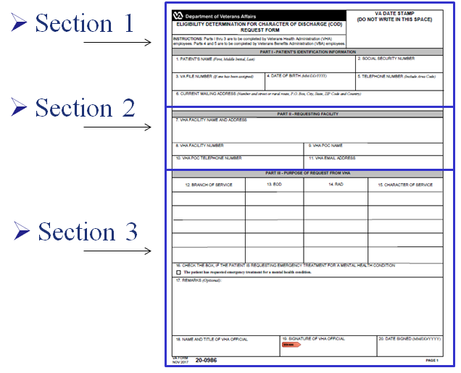  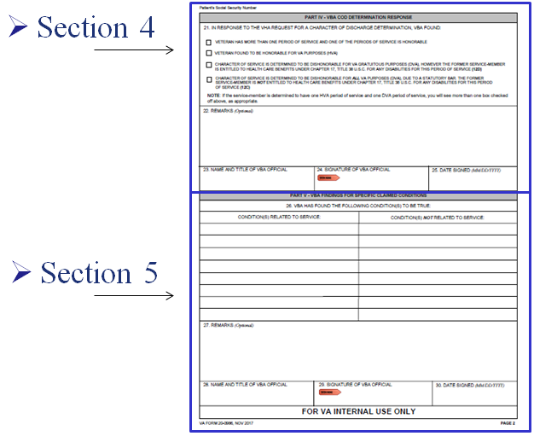
VA Form 20-0986, Section 1  Slide 8  Handout 5 | We will divide page one of this form into Sections one through three, and page two of this form into Sections four and five.  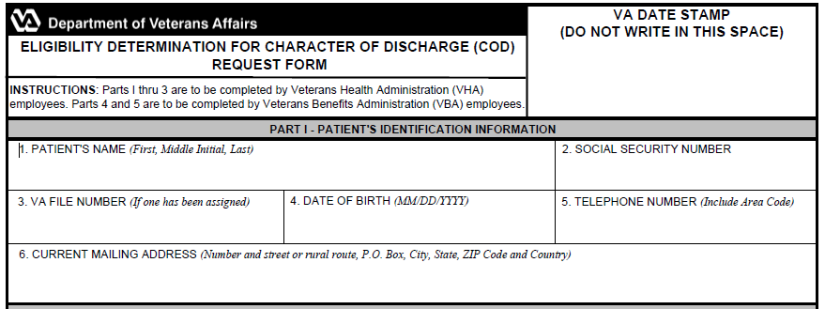  Section 1 will contain the VA date stamp in the upper right corner, similar to othe standardized VA forms.  This section will also show the Veteran’s name, Social Security number, VA file number, date of birth, and telephone number.  It will also show the Veteran’s current mailing address.
VA Form 20-0986, Section 2  Slide 9  Handout 5 | 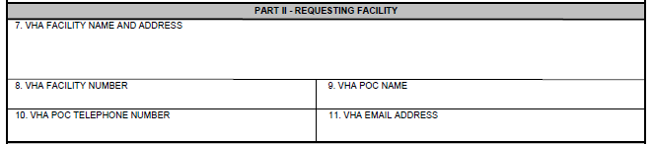  Section 2 will have the requesting facilities information to include the VHA facility’s name and address. The VHA requesting facility will also list its telephone number along with a VHA representative as a Point of Contact (POC).
VA Form 20-0986, Section 3  Slide 10  Handout 6  VA Form 20-0986, Section 4  Slide 11  Handout 7 | 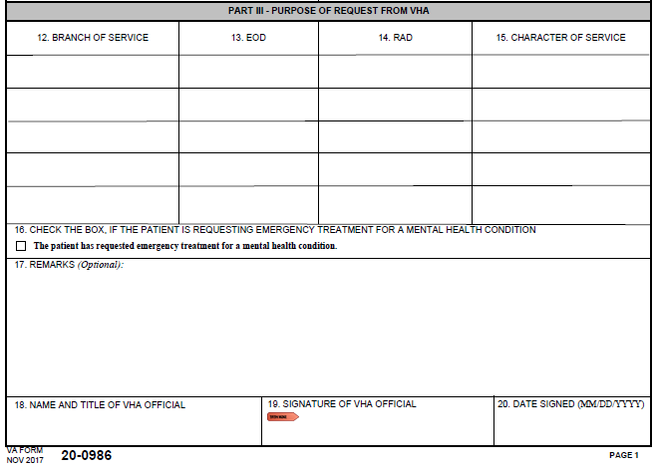  Section 3 is where VHA will indicate the Veteran’s service information. This section does not need to be completed fully as VHA may not know the Veteran’s character of discharge.  Box 16 is extremely important as this indicate the Veteran is in need to emergency treatment for a mental health condition. Later in this lesson we will identify additional steps to ensure this Veteran receives priority processing based on urgent need for treatment.  The remarks section may be utilized by VHA when service is unknown or for any other information.  This form does not have to be fully complete in order for VBA to accept the claim. This form does need explain a determination is needed for health care eligibility.  Boxes 18 through 20 should be completed by VHA but are not required fields. If these fields are blank we will continue to place the claim under control and VBA will continue with the Character of Discharge Determination.  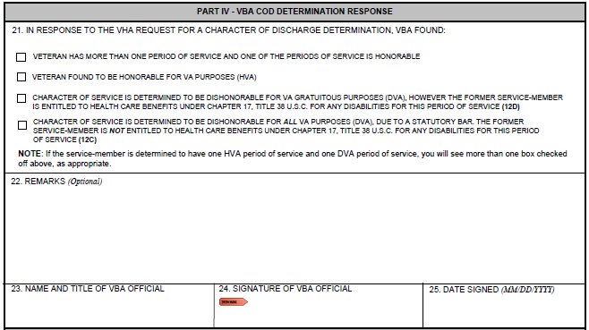  Section 4 will be completed by a Veterans Service Representative after a determination has been rendered. Box 21 will have one of the four boxes checked reflecting what VBA has decided. This section should be fully completed to include signature of the VSR prior to returning this form to the requesting facility. These actions will occur after the claim has been esatlibshed and processed.
VA Form 20-0986, Section 5  Slide 12  Handout 7 | 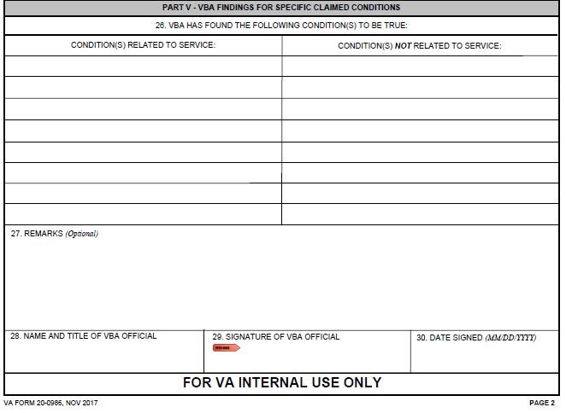
 | Section 5 will be completed by the VSR prior to sending the form back to VHA. VBA will clearly indicate which disabilities are related to service and which disabilities are not releated to service within Box 26. If a Veteran has never applied for beneftis through VBA or the claim is pending decisoin this will be indicated within Box 27.
VA Form 20-0986 – Communication from VHA  Slide 13  Handout 8 | It is extremely important to review the entire VA Form 20-0986. VA will accept the standardized form from VHA indicating a Character of Discharge determination is needed.  VA Form 20-0986 will indicate a Character of Discharge determination is needed, and VA must establish proper control.

Topic 2: Establishing Control
Introduction | This topic will allow the trainee to understand which End Product (EP) is required during the claims establishment process.
Time Required | 0.25 hours
OBJECTIVES/  Teaching Points | Topic objectives:  - Convert forms received for health care eligibility into a controlling End Product (EP)  - End Product (EP) to establish when a rating claim is pending
Establishing Control  Slide 14  Handout 8 | Once a VA Form 20-0986 is received requesting a determination regarding eligibility for health care, then VBA will always establish an EP 290 with the claim label Character of Discharge.  In all instances an Administrative Decision for Character of Discharge determination to be completed by VBA personnel and the EP 290 will continue pending until a determination is rendered.  Establish an EP 290 even if a Character of Discharge decision was previously processed. Since VHA is requesting updated information, it is VBA’s duty to ensure our counterparts receive the most updated and accurate information. The VSR will need to properly respond to VHA’s request.
Establishing Control  Slide 15  Handout 8 | If an application for disability compensation is received after having established the EP 290 from VHA, then VBA will establish the appropriate rating EP using the date of receipt of the disability compensation claim as the date of claim (DOC).  -If the sole contention the Veteran is claiming on a disability compensation claim is a Character of Discharge Determination, and an EP 290 is already pending for Character of Discharge, then the mail would be associated to the pending EP 290.
Establishing Control – Examples  Slide 16  Handout 8  Establishing Control - VBMS  Slide 17  Handout 9 | Example 1: A single inquiry shows an EP 020 is pending with a DOC of November 21, 2017. A VA Form 20-0986 is received from VHA on November 23, 2017 which shows the Veteran’s complete service information and is signed by a VHA employee. What action is needed?  Answer: An EP 290 – Character of Discharge should be established with a date of claim of November 23, 2017  Example 2: A single inquiry shows an EP 290 is pending for Character of Discharge due to a VA Form 20-0986 from VHA received November 30, 2017. A VA Form 21-526EZ from the Veteran is received on December 2, 2017 which solely requests a Character of Discharge determination. What action is needed?  Answer: Add the VA Form 21-526EZ as unsolicited evidence under the manage evidence screen in VBMS.  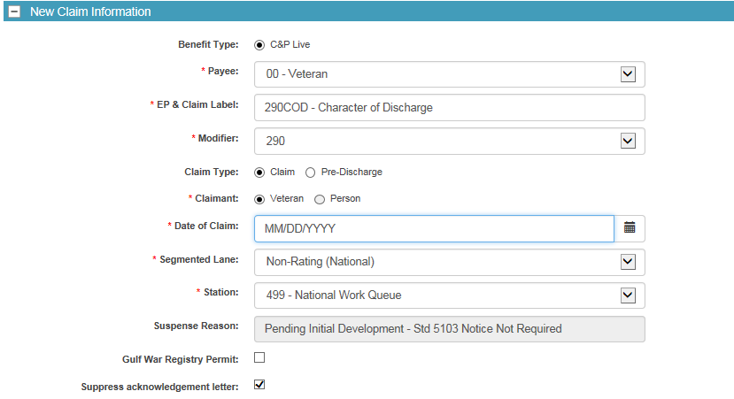  Once a VA Form 20-0986 is received requesting a determination regarding eligibility for health care, then VBA should establish an End Product (EP) 290 – Character of Discharge with the exception of the rating EP pending.  Use the EP 290 – COD – Character of Discharge claim label.  Since the claim is generated from VHA, for claims establishment purposes, the date of claim (DOC) will be VBA’s earliest date stamp.

Topic 3: Proper Routing
Introduction | This topic will allow the trainee to ensure a proper special issue is added to each claim establish to ensure proper routing by the National Work Queue. In addition, in some instances a corporate flash may be required.
Time Required | 0.25 hours
OBJECTIVES/  Teaching Points | Topic objectives:  - Classify the Character of Discharge with proper special issue to ensure accurate routing occurs  - Learn which special issue should be added to each claim  - Understand the VA Central Office’s corporate flash and when it should be applied to a claim
Special Issue  Slide 18  Handout 9 | 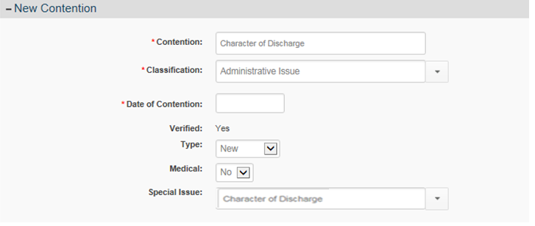  Contention should be listed as “Character of Discharge”.  Classification should be listed as Administrative Issue.  Medical should be listed as “No”.  Special Issue should be identified as “Character of Discharge”.
Corporate Record – Regional Office Flash  Slide 19  Handout 10 | As part of the Secretary’s initiatives it is imperative VBA properly handles these Veteran’s claims. It is important to notes this initiative is for providing emergency mental health coverage to former service members with other-than-honorable (OTH) administrative discharges.  Weekly Veteran Affairs Central Office (VACO) will add corporate flash named “Emergency Care – CH17 Determiation” to Mental Health Initiative (MHI) claims when VHA notifies Central Office a request for Character of Discharge determination is needed.  When processing aVA Form 20-0986 ensure a thorough review of Box 16 occurs. If Box 16 is checked, then VBA will add an additional corporate flash and special issue. The corporate flash and additional special issue will ensure these claims are properly routed and receive priority processing.  VBA has defined a timeliness goal to process these claims within 90 days of receipt.
VA Form 20-0986 -Box 16  Slide 20  Handout 10 | 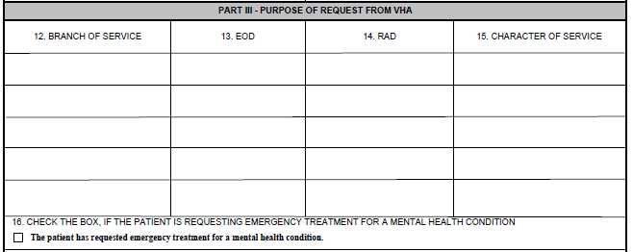  Look at Box 16 for the indication of a request for emergency treatment for mental health condition.  If the emergency treatment for mental health condition (Box 16) is checked, then two additional steps which must be taken during claims establishment process. The first step is to add a corporate flash to the claim.
Corporate Record – Regional Office Flash  Slide 21  Handout 11  Step 1  Corporate Record – Regional Office Flash  Slide 22  Handout 11 | 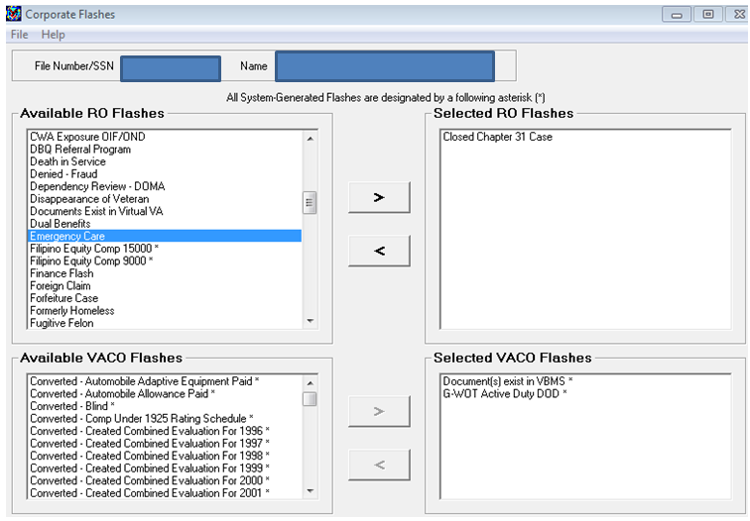  Step 2  Step 3  Step 1: Click the Emergency Care RO Flash to highlight the flash.  Step 2: Click the right arrow button.  Step 3: Click the Submit button to finalize the action.  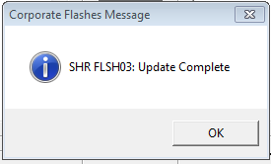  The SHR FLSH03: Update Complete pop up window should appear once the Corporate Flash has been updated.
Corporate Record – Regional Office Flash  Slide 22  Handout 12 | 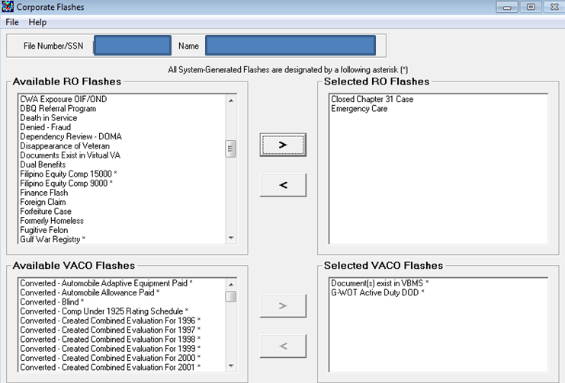  Ensure this corporate flash is added to the Corporate Record when VA Form 20-0986 indicates Emergency treatment for a mental health condition is requested.
Corporate Record – Regional Office Flash  Slide 23  Handout 12 | Claims Assistants should not remove the Emergency Care corporate flash.  Corporate flash is designed for National Work Queue priority routing purposes and is extremely important to be included on these claims.  The flash is important to ensure proper routing of these claims.
Special Issue - Emergency Care  Slide 24  Handout 13 | 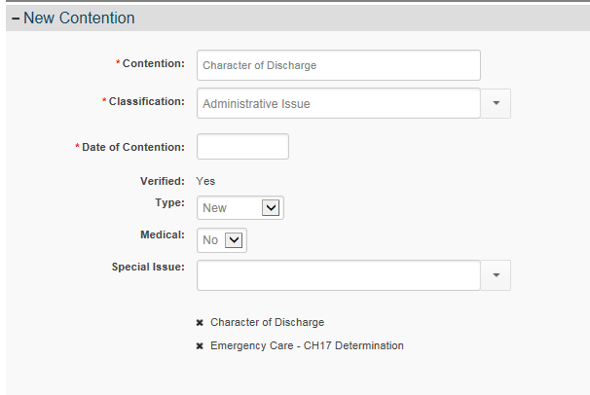 The second additional step is to add another special issue. The “Emergency Care – CH17 Determination” special issue should be added to the EP 290 when Box 16 is checked.  When entering information into VBMS, the  -Contention should be listed as “Character of Discharge”.  -Classification should be listed as Administrative Issue.  -Medical drop down box should be listed as “No”.  -Special Issues should be identified as “Emergency Care – CH17 Determination” and “Character of Discharge”.  This special issue will be in addition to the Character of Discharge special issue, so both special issues should be present.
Summary  Slide 25 | Reviewed how to properly identify a VA Form 20-0986.  Reviewed how to properly establish an EP.  Reviewed which corporate flash and special issue should be added to ensure proper routing and prioritization by National Work Queue.
Regional Office Specific Topics | At this time add any information pertaining to:  - Station quality issues with this lesson  - Additional State specific programs/guidance on this lesson

Lesson Review, Assessment, and Wrap-up
Introduction  Discuss the following: | The Claims Establishment for Character of Discharge Determination lesson is complete.  Review each lesson objective and ask the trainees for any questions or comments.
Time Required | 0.25 hours
Lesson Objectives | You have completed the Claims Establishment for Character of Discharge Determination lesson.  The trainee should be able to:  - Identify a Character of Discharge determination for health care eligibility claim  - Convert forms received for health care eligibility into a controlling End Product (EP)  - Classify the Character of Discharge with proper special issues
Assessment | Remind the trainees to complete the on-line assessment in TMS to receive credit for completion of the course.  The assessment will allow the participants to demonstrate their understanding of the information presented in this lesson.

