Claims Establishment for Character of Discharge Determinations

Trainee Handout

**Table of Contents**

Objectives 2

References 3

Topic 1: VA Form 20-0986 4

Topic 2: Establishing Control 8

Topic 3: Proper Routing 9

Objectives

* Identify a Character of Discharge determination for health care eligibility claim
* Convert forms received for health care eligibility into a controlling End Product (EP)
* Classify the Character of Discharge with proper special issue to ensure accurate routing occurs

References

All M21-1 references are found in the [CPKM](https://vaww.compensation.pension.km.va.gov/).

* Public Law95-126
* 38 U.S.C. 3.12(d), Character of Discharge
* M21-4, Appendix B, End Product (EP) Codes and Work-Rate Standards for Quantitative Measurements
* M21-1, Part III, Subpart v, 1.B.4, Character of Discharge/Statutory Bar Determinations and Health Care Eligibility
* M21-1, Part III, Subpart v, 7.A.7.c, EP Control Over Eligibility Determination Requests

Topic 1: VA Form 20-0968

VA Form 20-0986, Eligibility Determination for Character of Discharge (COD) Request Form is the form which Veterans Health Administration (VHA) will submit to Veterans Benefits Administration (VBA) when a Veteran’s discharge determination is needed. VHA will submit this form if the discharge is unknown, or instances outside of an honorable or general discharge.

According to 38 U.S.C. 3.12(d) VBA must make the eligibility determination prior to the Veteran receiving health care treatment.

VA Form 10-7131 was previously used to exchange information between VBA and VHA prior to the use of computers. It the form previously used to request eligibility determinations prior to the VA Form 20-0986.

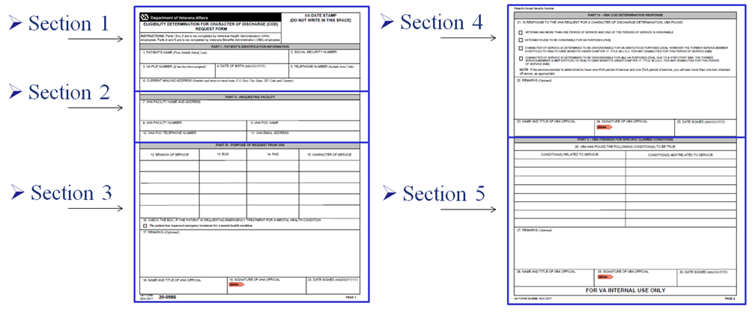

This is the full view of the VA Form 20-0986, Eligibility Determination for Character of Discharge (COD) Request Form.

We will divide page one of this form into Sections one through three, and page two of this form into Sections four and five.

**VA Form 20-0986, Section 1**

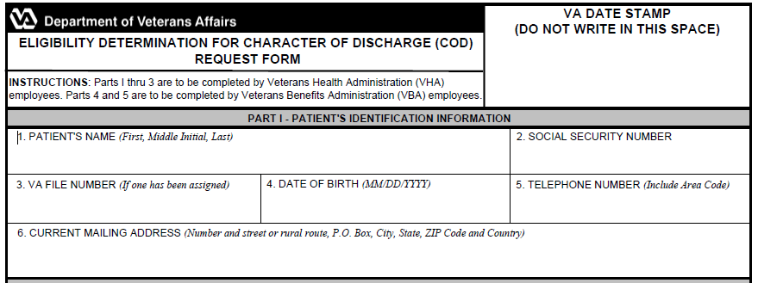

Section 1 will contain the VA date stamp in the upper right corner, similar to othe standardized VA forms.

This section will also show the Veteran’s name, Social Security number, VA file number, date of birth, and telephone number.

It will also show the Veteran’s current mailing address.

**VA Form 20-0986, Section 2**

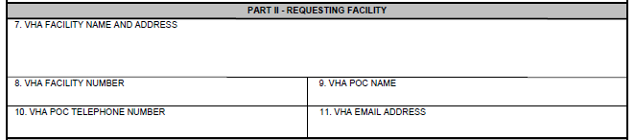

Section 2 will have the requesting facilities information to include the VHA facility’s name and address. The VHA requesting facility will also list its telephone number along with a VHA representative as a Point of Contact (POC).

**VA Form 20-0986, Section 3**

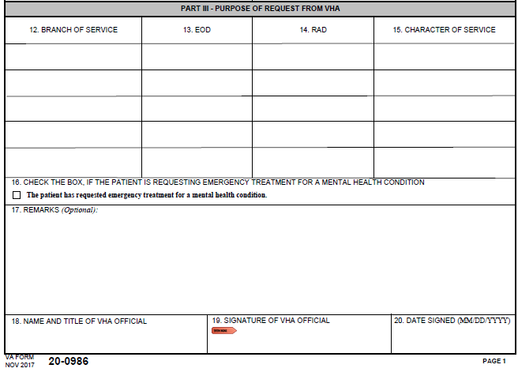

Section 3 is where VHA will indicate the Veteran’s service information. This section does not need to be completed fully as VHA may not know the Veteran’s character of discharge.

Box 16 is extremely important as this indicate the Veteran is in need to emergency treatment for a mental health condition. Later in this lesson we will identify additional steps to ensure this Veteran receives priority processing based on urgent need for treatment.

The remarks section may be utilized by VHA when service is unknown or for any other information.

This form **does not** have to be fully complete in order for VBA to accept the claim.

This form **does** need explain a determination is needed for health care eligibility.

Boxes 18 through 20 should be completed by VHA but are not required fields. If these fields are blank we will continue to place the claim under control and VBA will continue with the Character of Discharge Determination.

**VA Form 20-0986, Section 4**

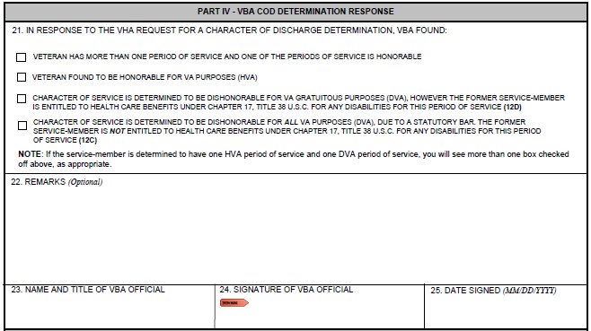

Section 4 will be completed by a Veterans Service Representative after a determination has been rendered. Box 21 will have one of the four boxes checked reflecting what VBA has decided. This section should be fully completed to include signature of the VSR prior to returning this form to the requesting facility. These actions will occur after the claim has been esatlibshed and processed.

**VA Form 20-0986, Section 5**

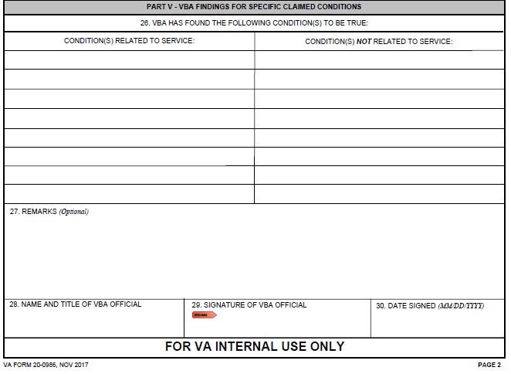

Section 5 will be completed by the VSR prior to sending the form back to VHA. VBA will clearly indicate which disabilities are related to service and which disabilities are not releated to service within Box 24. If a Veteran has never applied for beneftis through VBA or the claim is pending decisoin this will be indicated within Box 27.

**VA Form 20-0986 – Communication from VHA**

It is extremely important to review the entire VA Form 20-0986. VA will accept the standardized form from VHA indicating a Character of Discharge determination is needed.

VA Form 20-0986 will indicate a Character of Discharge determination is needed, and VA must establish proper control.

Topic 2: Establishing Control

Once a VA Form 20-0986 is received requesting a determination regarding eligibility for health care, then VBA will always establish an EP 290 with the claim label Character of Discharge.

In all instances an Administrative Decision for Character of Discharge determination to be completed by VBA personnel and the EP 290 will continue pending until a determination is rendered.

Establish an EP 290 even if a Character of Discharge decision was previously processed. Since VHA is requesting updated information, it is VBA’s duty to ensure our counterparts receive the most updated and accurate information. The VSR will need to properly respond to VHA’s request.

**Establishing Control**

If an application for disability compensation is received *after* having established the EP 290 from VHA, then VBA will establish the appropriate rating EP using the date of receipt of the disability compensation claim as the date of claim (DOC).

-If If the sole contention the Veteran is claiming on a disability compensation claim is a Character of Discharge Determination, **and** an EP 290 is already pending for Character of Discharge, then the mail would be associated to the pending EP 290.

**Establishing Control – Examples**

Example 1: A single inquiry shows an EP 020 is pending with a DOC of November 21, 2017. A VA Form 20-0986 is received from VHA on November 23, 2017 which shows the Veteran’s complete service information and is signed by a VHA employee. What action is needed? *(Instructor will provide answer.)*

Example 2: A single inquiry shows an EP 290 is pending for Character of Discharge due to a VA Form 20-0986 from VHA received November 30, 2017. A VA Form 21-526EZ from the Veteran is received on December 2, 2017 which solely requests a Character of Discharge determination. What action is needed? *(Instructor will provide answer.)*

**Establishing Control – VBMS**

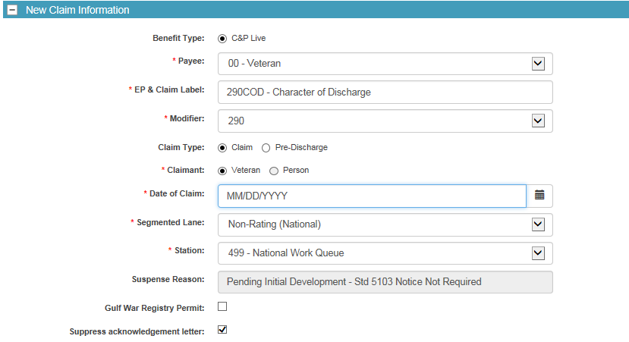

Once a VA Form 20-0986 is received requesting a determination regarding eligibility for health care, then VBA should establish an End Product (EP) 290 – Character of Discharge with the exception of the rating EP pending.

Use the EP 290 – COD – Character of Discharge claim label.

Since the claim is generated from VHA, for claims establishment purposes, the date of claim (DOC) will be VBA’s earliest date stamp.

Topic 3: Proper Routing

**Special Issue**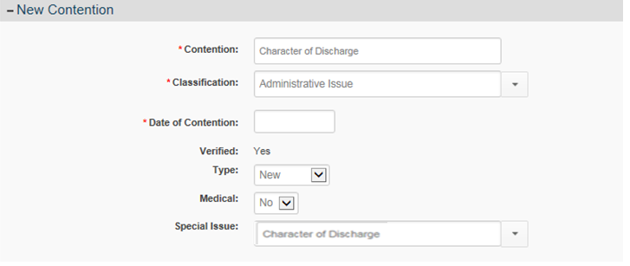

Contention should be listed as “Character of Discharge”.

Classification should be listed as Administrative Issue.

Medical should be listed as “No”.

Special Issue should be identified as “Character of Discharge”.

**Corporate Record – Regional Office Flash**

As part of the Secretary’s initiatives it is imperative VBA properly handles these Veteran’s claims. It is important to notes this initiative is for providing emergency mental health coverage to former service members with other-than-honorable (OTH) administrative discharges.

Weekly Veteran Affairs Central Office (VACO) will add corporate flash named “Emergency Care – CH17 Determination” to Mental Health Initiative (MHI) claims when VHA notifies Central Office a request for Character of Discharge determination is needed.

When processing aVA Form 20-0986 ensure a thorough review of Box 16 occurs. If Box 16 is checked, then VBA will add an additional corporate flash and special issue. The corporate flash and additional special issue will ensure these claims are properly routed and receive priority processing.

VBA has defined a timeliness goal to process these claims within 90 days of receipt.

**VA Form 20-0986 – Box 16**

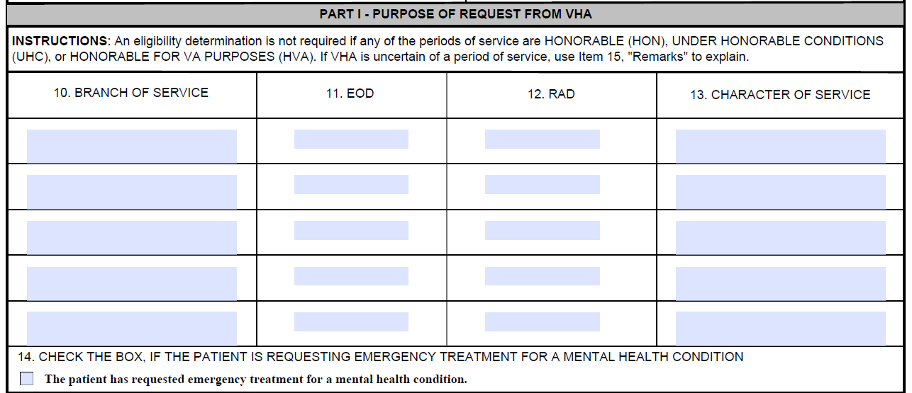

Look at Box 16 for the indication of a request for emergency treatment for mental health condition.

If Box 16 is checked, then two additional steps should be taken at the time of the Claims Establishment. The first step is to add a corporate flash to the claim.

**Corporate Record – Regional Office Flash**

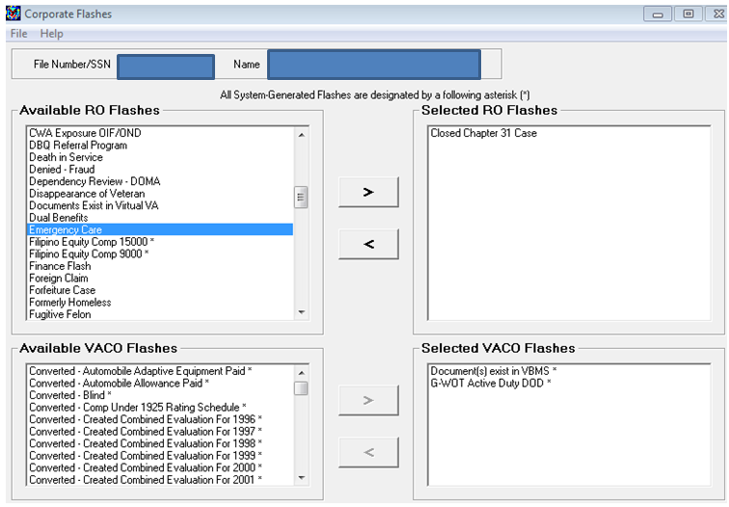

Step 2

Step 1

Step 3



Step 1: Click the Emergency Care RO Flash to highlight the flash.

Step 2: Click the right arrow button.

Step 3: Click the Submit button to finalize the action.

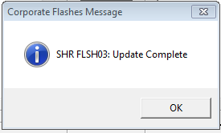

The SHR FLSH03: Update Complete pop-up window should appear once the Corporate Flash has been updated.

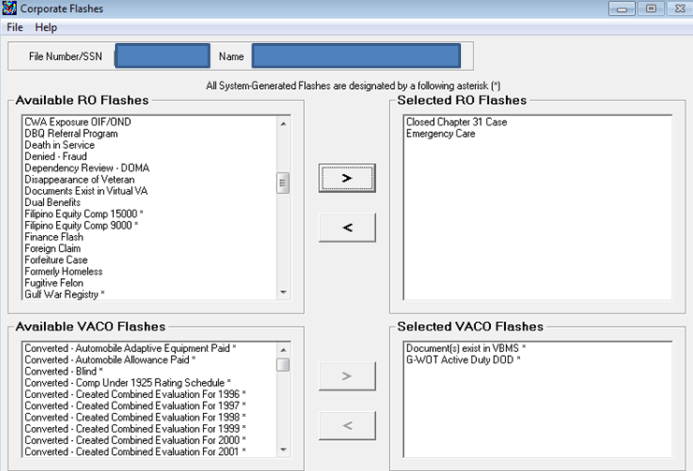

Ensure this corporate flash is added to the Corporate Record when VA Form 20-0986 indicates Emergency treatment for a mental health condition is requested.

Claims Assistants should **not** remove the Emergency Care corporate flash.

Corporate flash is designed for National Work Queue priority routing purposes and is extremely important to be included on these claims.

The flash is important to ensure proper routing of these claims.

**Special Issue – Emergency Care**

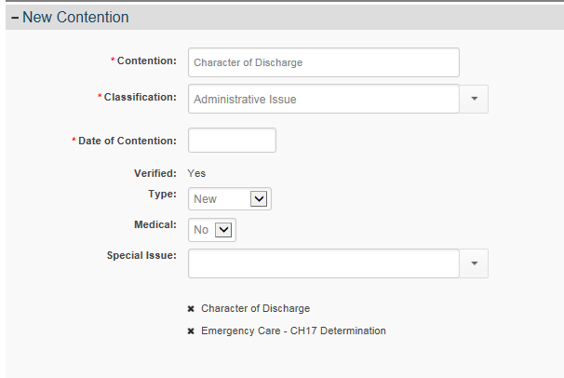

The second additional step is to add another special issue. The “Emergency Care – CH17 Determination” special issue should be added to the EP 290 when Box 16 is checked.

When entering information into VBMS, the

-Contention should be listed as “Character of Discharge”.

-Classification should be listed as Administrative Issue.

-Medical drop down box should be listed as “No”.

-Special Issues should be identified as “Emergency Care – CH17 Determination” and “Character of Discharge”.

This special issue will be in addition to the Character of Discharge special issue, so both special issues should be present.