Schedule of Operations
Lesson Plan
June 2017
Version 1.0

Lesson Overview
Topic | Description
Time Estimate: | 2.0 hrs
Purpose of the Lesson: | The purpose of this lesson is to provide Education employees with the knowledge to understand, identify and answer questions regarding specific payment and special processing dates according to the schedule of operations.
Prerequisite Training Requirements: | General knowledge of various Education benefits to include Chapter 30, 1606, 1607, Chapter 35 and Chapter 33. General Knowledge of BDN and Share screens.
Target Audience: | The target audience for this lesson is:  - VA Education Veteans Claims Examiners  - VA Education Call Center Technicians  VA Education employees with a need to verify payment dates for education benefits
Lesson References: | - BDN Schedule of Operations located at the following website: https://vaww.vba.esp.va.gov/sites/HIN-282Ops/ProdAnal/  - M22-4 Part II, Chapter 1, Subchapter 2 1.13  - M22-4 Part IV, Chapter 10, 10.10
Lesson Objectives: | At the end of this lesson, you will be able to:  - Identify features of the Schedule of Operations  - Identify specific payment release dates associated with authorized transactions in BDN  - Identify frequency/timeframe of special processing actions within the Schedule of Operations
What You Need: | The instructor should have:  - Access to a computer and overhead projector  - Copy of the Schedule of Operations PowerPoint
Post Training Requirements: | Upon completion of the classroom portion of the lesson, participants are required to complete an online lesson assessment and survey in Talent Management System (TMS).  To demonstrate successful completion of the lesson participants must pass the assessment with a score of at least 80%.  Participants must also complete the online survey to earn credit for completion of the lesson.

Instructor Notes
The purpose of this lesson is to provide Education employees with the knowledge to understand, identify and answer questions regarding specific payment and special processing dates according to the schedule of operations.
PowerPoint Slides | Instructor Activities
Schedule of Operations | DISPLAY slide 1 “Schedule of Operations”  INTRODUCE yourself as the instructor  INTRODUCE the lesson.
Overview of Today’s Training  The purpose of this lesson is to provide Education employees with the knowledge to understand, identify and answer questions regarding specific payment and special processing dates according to the Schedule of Operations. | DISPLAY slide 2 “Overview of Today’s Training”  PROVIDE an overview of the lesson  DISCUSS the importance of the lesson:  - This lesson will give you the knowledge to answer questions about payment dates and to be able to identify when payments are processed and released.
Lesson Objectives  At the end of this lesson, you will be able to:  - Identify features of the Schedule of Operations  - Identify specific payment release dates associated with authorized transactions in BDN  - Identify frequency/timeframe of special processing actions within the Schedule of Operations | DISPLAY slide 3 “Lesson Objectives”  REVIEW the lesson objectives  EMPHASIZE that the post-lesson assessment will align with the content and these objectives.
Terminology | DISPLAY slide 4 “Terminology”
Schedule of Operations (Terms)  Hines - Most education processing is done through the Benefits Delivery Network (BDN). BDN is maintained at the BDC (Benefits Delivery Center) in Hines, Illinois. Hines is simply the location of the VA office that manages BDC.  Benefit Run - Is when the BDN system updates. This is generally scheduled daily, at the end of the processing day indicated on the schedule. It uses the daily transaction processing results to identify cases requiring letters, reports, certifications of attendance and payments. | DISPLAY slide 5.  - Read definition thoroughly to class to ensure they understand meaning.
Schedule of Operations (Terms), Cont.  Julian Day – A Julian Date is an individual number assigned to each day of the year (1–365; or 1-366 during Leap Years). The Julian Date is the number for a specific day of the year that corresponds with the Benefit activity processing on that date.  FFP (Full File Pass) – A term used on the monthly Schedule of Operations to indicate when certain processing action occurs. Examples: automated certification, processing delinquent certifications, generation of collection letters and report production. | DISPLAY slide 6.  - Read definition thoroughly to class to ensure they understand meaning.
Schedule of Operations (Terms), Cont.  NOES (Notice of Exception) – System generated messages which indicate such things as new information from DOD, award input errors, returned checks or delinquent certifications.  DMDC (Defense Management Data Center) – This organization updates eligibility records for Chapter 30 and Chapter 1606 master records. This information is processed in batches.  CARS (Centralized Accounts Receivable System) – System used to collect type B accounts receivable. | DISPLAY slide 7.  - Read definition thoroughly to class to ensure they understand meaning.  - Explain that type “B” accounts receivable is simply the account and balance transactions when applying funds to a debt.
Comprehension Check  When do Benefit Runs generally occur?  What is the term used on the Schedule of Operations to indicate when certain processing actions occur, such as letter and report production?  What does NOES stand for on the Schedule of Operations?  Where is Hines located?  Which system is used to collect type B accounts receivable? | DISPLAY slide 8.  - Provide answers to the Comprehension Check.  Answers to Comprehension Check:  Q: When do Benefit Runs generally occur?  A: Benefit Runs “generally” occur each business day. There are a few exceptions, such as Ch35 which has approximately 6 Benefit Runs per month and Ch1606 and 1607 which have Benefit Runs every other business day.  Q: What is the term used on the Schedule of operations to indicate when certain processing actions occur, such as letter and report production?  A: Benefit Run  Q: What does NOES stand for on the Schedule of Operations?  A: Notice of Exception Processing – these are system generated messages that indicate new information from DoD.  Q: Where is Hines located?  A: Hines, Illinois  Q: Which system is used to collect type B accounts receivable?  A: CARS – Centralized Accounts Receivable System
Background: How locate the S of O.  The Schedule of Operations is a schedule of when certain actions will be processed within the Benefits Delivery Network (BDN).  You can locate the Schedule of Operations at the following website:  - https://vaww.vba.esp.va.gov/sites/HIN-282Ops/ProdAnal/  - OR, from the homepage of the ECC Index SharePoint site. It can be launched by clicking on the following icon:  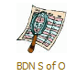  Next, select the production schedule from the list of available months in order to view transactions for that particular month. | DISPLAY slide 9.  - Instructor on the overhead projector should follow the listed pathways to demonstrate how to locate the Schedule of Operations.
Reading the Schedule | DISPLAY slide 10 “Reading the Schedule”.
Columns on Each Schedule  - Columns information includes:  Column 1 = Processing Activities (what type of transaction)  Column 2 = Julian Day Number (the exact date of the transaction)  Column 3 = Daily Processing 2100 Military Time ,  (dates BDN transactions are processed by HINES; transactions will be processed at 9:00pm Central Time on these dates)  Column 4 = Letters Reports (date when corresponding letters/reports are sent)  Column 5 = Transmit to Treasury (date information is sent to US Treasury)  Column 6 = Anticipated Date of Payment (Release date of payment)  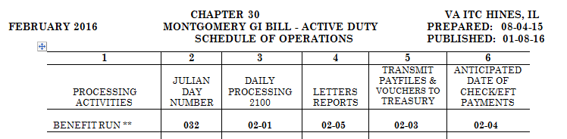 | DISPLAY slide 11.  - Instructor should demonstration how to scroll to the appropriate benefit type on the Schedule of Operations.  - Instructor should show class how to locate and identify each column on the Schedule of Operations.  - Show graphic that is provided on PowerPoint.
Benefit Run Example  - Chapter 30 has eight benefit runs from February 1st until February 10th of 2016  - The first benefit run of the month will occur on February 1st at 2100 (9:00pm Central Time)  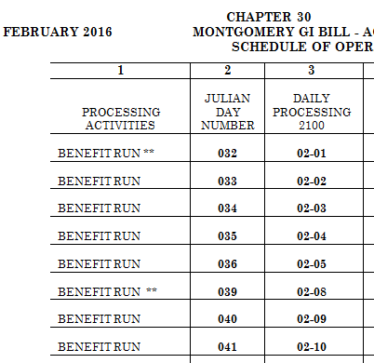 | DISPLAY slide 12.  - Instructor should use graphic provided to show class the different benefit runs between Feb. 1st and Feb.10th.
Comprehension Check  Which column shows the date the payment should be released?  What does the Letter Reports column indicate on the Schedule of Operations?  What does the number 2100 mean in the Daily Processing Column? | DISPLAY slide 13.  - Provide answers to the Comprehension Check.  Answers to Comprehension Check:  Q: Which column shows the date the payment should be released?  A: Anticipated Date of Check/EFT Payments  Q: What does the Letter Reports column indicate on the Schedule of operations?  A: The date that letters and/or reports are sent.  Q: What does the number 2100 mean in the Daily Processing Column?  A: This is the time that the benefit run will occur for each date in the column (9:00pm Central Time)
Payment Release Dates | DISPLAY slide 14 “Payment Release Dates”.
Determining Payment Date  In order to determine when an authorized payment in BDN will be released:  - First locate the authorization date of the payment in question on the BDN M22 screen:  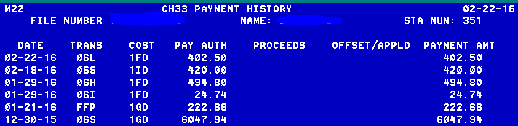 | DISPLAY slide 15.  - Instructor should use graphic provided to show class how to locate the authorization date of the payment in question on the BDN M22 screen.
Determining Payment Date, Cont.  2. Locate the correct Production Schedule for the month in which the payment was authorized in BDN.  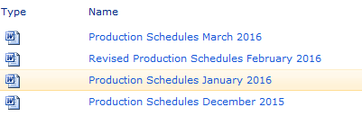  3. Scroll down to the correct Education Benefit table (in this example, Ch33). | DISPLAY slide 16.  - Instructor should use graphic provided to show class how to locate the correct Production schedule for the month in which the payment was authorizated in BDN.  - Then demonstration how to select the correct education benefit table.
Determining Payment Date, Cont.  4. Locate the BDN authorization date in the “Daily Processing” column.  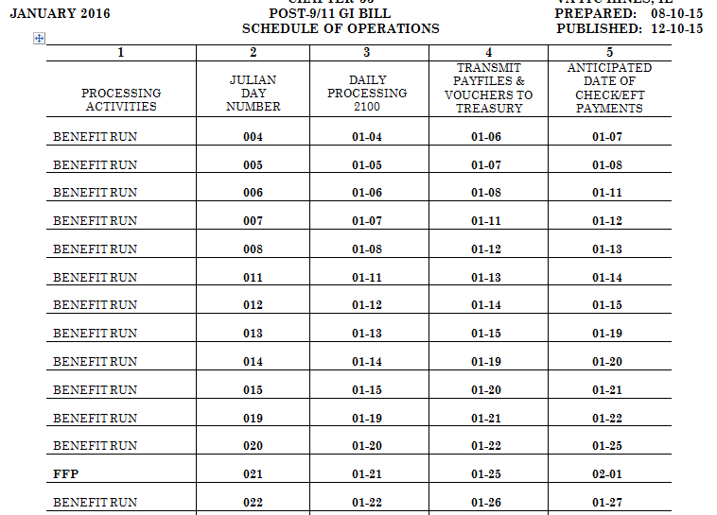 | DISPLAY slide 17.  - Instructor should use graphic provided to show class how to locate the BDN authorization date in the “Daily Processing” column.
Determining Payment Date, Cont.  5. The payment release date is the “Anticipated Date of Check/EFT Payments” that corresponds with the “Daily Processing” date. | DISPLAY slide 18.  - Instructor should use graphic provided to show class The payment release date is the “Anticipated Date of Check/EFT Payments” that corresponds with the “Daily Processing” date.
Pay Date in SHARE  Confirm in SHARE that the payment was released on the “Anticipated Date of Check/EFT Payments” date.  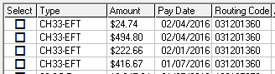 | DISPLAY slide 19.  - Instructor should use graphic provided to show class how to confirm in SHARE that the payment was released on the “Anticipated Date of Check/EFT Payments” date.
Comprehension Check  1. Where do you find the payment authorization date?  2. What is the anticipated payment date of the Ch33 Book Payment in the amount of $818.93?  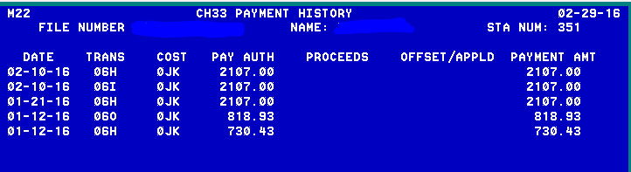  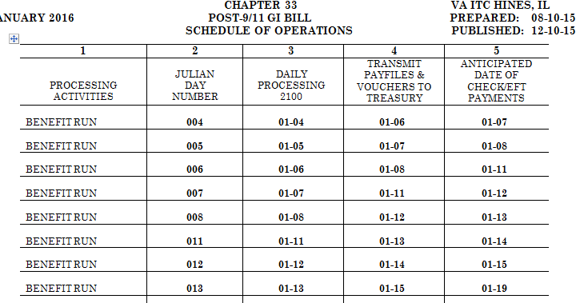 | DISPLAY slide 20.  - Provide answers to the Comprehension Check.  Answers to Comprehension Check:  Q: Where do you find the payment authorization date?  A: This date will be on the M22 screen in BDN and correspond to the “Daily Processing 2100” column on the Schedule of Operations.  Q: What is the anticipated payment date of the Ch33 Book Payment in the amount of $818.93?  A: January 15, 2016
Special Processing Dates | DISPLAY slide 21 “Special Processing Dates”.
Special Payments – Advanced Pay  The Schedule of Operations uses asterisks(*) to indicate special processing dates such as: Advance Pays, Certificate of Delivery (COD) of Advance Pays, Full File Pass (FFP) and End of the Month (EOM) Accounting.  - Advance Pays and COD of Advance Pays are indicated by two astericks (**) on the Schedule of Operations  - Advanced payments will cycle during the first Advance Pay cycle dated after the authorization date in BDN | DISPLAY slide 22.  - Instructor should explain the meaning/purpose of the two asterisks used on the Schedule of Operations.
End of Month Accounting (EOM)  The No Benefit Run indicated by (***) on the Schedule of Operations will process during the last two workdays of the month due to End of the Month Accounting. BDN transactions authorized on this date will be held until the first “Daily Processing” date of the next month.  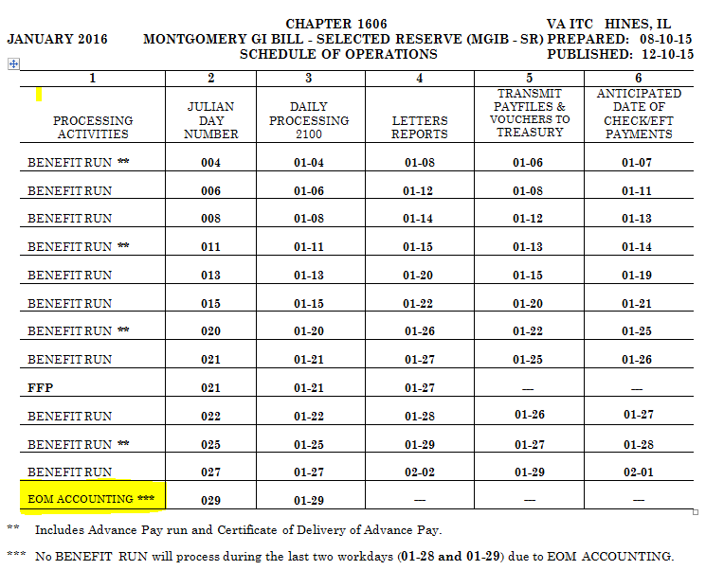 | DISPLAY slide 23.  - Instructor should use the graphic provided to explain the meaning/purpose of the three asterisks used on the Schedule of Operations.
Full File Pass (FFP)  The Full File Pass occurs once each month for Chapters 30, 1606, 1607 and Chapter 33. This usually occurs around the 21st of each month.  Note: This is also the date that regular monthly housing stipends are authorized in BDN for Chapter 33. Any changes made to Direct Deposit accounts will need to be made by this date in order for the housing stipend to go to the correct account. | DISPLAY slide 24.  - Instructor should explain to the class the importance of the Full File Pass for Chapter 33, in regards to the claimants monthly BAH payment.  - Look at M22-4 for other benefits.
Other Special Processing  Notice of Exceptions (NOES) processing occurs each Thursday night for Chapter 30 and Chapter 1606, and each Friday night for Chapter 1607.  Centralized Accounts Receivable System (CARS) processing occurs every Tuesday and Thursday during the month, but not during the EOM Accounting (for Chapters 1606 and 1607). | DISPLAY slide 25.  - Insturctor should let the class know when NOES and CARS processing occurs during the month.
Comprehension Check  How many asterisks indicates an Advance Pay was processed?  How many asterisks indicates the EOM Accounting occurred on the Schedule of Operations?  Which payment is released with a Chapter 33 FFP?  When does NOES processing occur according to the Schedule of Operations? | DISPLAY slide 26.  - Provide answers to the Comprehension Check.  Answers to Comprehension Check:  Q: How many asterisks indicate an Advance Pay was processed?  A: Two  Q: How many asterisks indicate the EOM Accounting occurred on the Schedule of Operations?  A: Three  Q: Which payment is released with a Chapter 33 FFP?  A: The Chapter 33 housing payment  Q: When does NOES processing occur according to the Schedule of Operations?  A: processing occurs each Thursday night for Chapter 30 and Chapter 1606, and each Friday night for Chapter 1607.
S of O for Comprehension Check  - 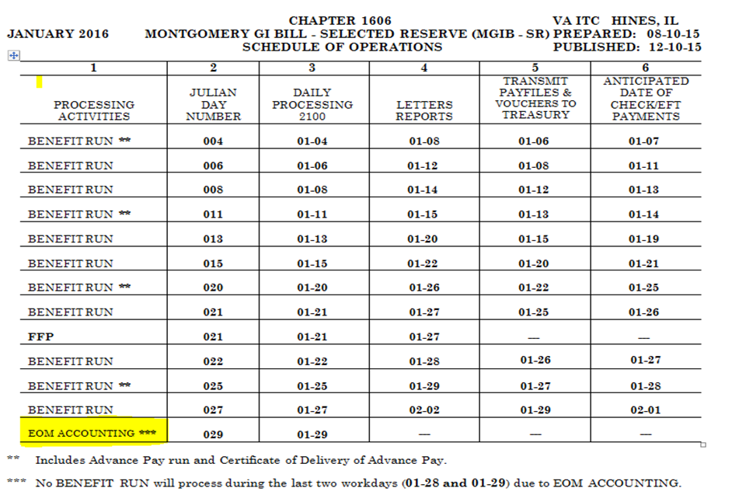 | DISPLAY slide 27.  - Instructor should use graphic to help in answering Comprehension Check from Slide 26.  Answers to Comprehension Check:  Q: How many asterisks indicate an Advance Pay was processed?  A: Two  Q: How many asterisks indicate the EOM Accounting occurred on the Schedule of Operations?  A: Three  Q: Which payment is released with a Chapter 33 FFP?  A: The Chapter 33 housing payment  Q: When does NOES processing occur according to the Schedule of Operations?  A: processing occurs each Thursday night for Chapter 30 and Chapter 1606, and each Friday night for Chapter 1607.
Summary  You have completed the Schedule of Operations lesson. You should be able to:  - List features of the Schedule of Operations  - Identify specific payment release dates associated with authorized transactions in BDN  - Identify frequency/timeframe of special processing actions within the Schedule of Operations | Display slide 28.  - Instructor should read and summarize the ojectives on slide 28.
References  - BDN Schedule of Operations located at the following website: https://vaww.vba.esp.va.gov/sites/HIN-282Ops/ProdAnal/  - M22-4 Part II, Chapter 1, Subchapter 2 1.13  - M22-4 Part IV, Chapter 10, 10.10 | DISPLAY slide 29.  - The instructor should answer any question the class may have from the information provided.
Questions  What questions do you have? | DISPLAY slide 30.  - The instructor should answer any question the class may have from the information provided.
TMS Assessment and Survey  - The assessment and survey have been assigned to you in TMS  - The assessment is comprised of multiple choice questions  - The questions are based on the information presented in this lesson  - The assessment should take you approximately 30 minutes  - Be sure to complete both the assessment and the survey in TMS to receive credit for this training | DISPLAY slide 31.  - Instructor should remind class of the assessment in TMS and the timframe allowed for the completion of the assessment.

