VBMS Release 13.0 New Functionality Updates

VBMS Release 13.0 offers a variety of system improvements including updates to the Automated Decision Letter language, new behavior regarding tracked item updates and deferral resolution, and more. Please see your VBMS Superuser or Change Management Agent for details and training on these new features. The list below describes a variety of additional VBMS Release 13.0 improvements not included in the New Functionality Training presentation materials.

VBMS Core

* The Work Queue now includes a Deferral Type column (hidden by default) that lists if a deferral was avoidable or unavoidable. Additionally, you can filter by Deferral Type in the Narrow Results pane.

Figure 1: Work Queue Deferral Type Filtering Capability and Column

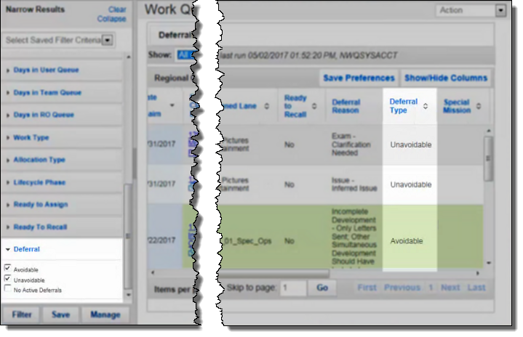

* The Release from Active Duty (RAD) date requirement to request Service Treatment Records (STRs) within VBMS has been updated to September 1, 2013 or later. Previously the RAD date requirement was January 1, 2014 or later.
* The Veteran’s Date of Birth no longer displays in the reference line of third party letters.
* VBMS 13.0 now includes the following development actions:

Table 1: New Development Actions in VBMS R13.0

|  |  |  |
| --- | --- | --- |
| **Development Action** | Development Action |  |
| 21-4142/21-4142a | Special Monthly Pension | Liberalizing Law |
| 21-4142a | Medical Evidence for Pension | Liberalizing Law SMP |
| Medical Evidence for housebound | Claim based on another agency disability grant | Claim Based on nursing home residency |
| Nursing home patient- need 21-8416 | Nursing home patient- need statement from official |  |

* A new visual indicator and notification was added to indicate document movement between Veterans’ eFolders, including for unassociated documents.
  + NOTE: Documents that have completed the document deletion process will be inaccessible.

Figure 2: Notification of eFolder Document Movement

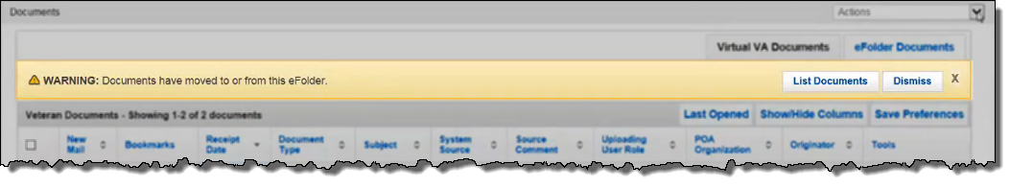

* During claim establishment, the date of birth field is now optional for new claimants when no relationship to the Veteran is indicated. The ability to select no relationship is only available when the Benefit Type is C&P Death and Payee code is selected as 00.
* For EP Code and Claim Labels, including Burial and Accrued, users can establish a CPD claim with a Claimant who is not related to the Veteran. In this situation, Social Security Number and Date of Birth are not system-required fields.
* From the RO Scorecard the Percentage to Threshold tile will now show data for claims of the selected work type.

VBMS Awards

* VBMS now recognizes and prevents the authorization of mutually exclusive CPD awards (e.g. a claimant cannot receive benefits as both a CPD spouse and CPD child under the same Veteran).
* ADL Letters were updated to display the name of each dependent for which the Veteran will be paid. The dates when each dependent is added/removed from a veteran’s payment calculation are also included.
* ADL letters now include automated decision text for Automobile and Adaptive Equipment Decisions.
* For CPD Parent awards, the following changes were made to the Income Type field.

Table 2: Income Type Changes for CPD Parent Awards

|  |  |
| --- | --- |
| **Options Added** | Options Removed |
| Gifts of Property | Gift/Inheritance Cash Annual |
| Gifts of Money | Gift/Inheritance Property Annual |
| Inheritance of Money | Social Security Lump Sum Death Benefit |
| Inheritance of Money, Joint Bank Account |  |

* Chapter 18 awards can now be authorized at any point during the month.
* VBMS Awards was updated to use the correct reimbursement mileage rates for medical expenses for calendar year 2017.

VBMS Rating

* DDI screen now features a checkbox for a non-compensable rating for diagnostic codes 8007-8009

Figure 3: Non-Compensable Rating Checkbox

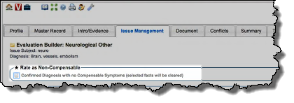

* New Basic Codes 16, 40, 41, 64, 65, 74-78, 80-85 were added to allow a user to select the appropriate basic code when a Veteran is entitled to multiple SMC(k)’s. The corresponding hospitalization codes have also been added and will be available based the selection of Basic Codes.