Exams: Who, When, and How

Trainee Handout

**Table of Contents**

Objectives 2

References 3

Topic 1: Who Is Responsible 4

Topic 2: When It Is Most Advantageous to Order Exams 6

Topic 3: How to Draft a Sufficient Examination 9

Review Exercise 18

Practical Exercise 2 20

Exams: Who, When, and How Assessment in TMS#4245283 23

Objectives

Given all available resources to include the live manual, development activity personnel will be required to accomplish the following lesson objectives.

* Determine who is responsible for ordering examinations and/or medical opinions.
* Identifywhen it ismost advantageous to order a VA examination.
* Demonstrate the ability to order a sufficient examination utilizing job aid resources.

References

All M21-1 references are found in the [Live Manual Website](https://vaww.compensation.pension.km.va.gov/).

* [38 CFR §3.159, Department of Veterans Affairs assistance in developing claims.](http://www.ecfr.gov/cgi-bin/text-idx?SID=4a418d89e8365fe8930972d91d1319fd&mc=true&node=se38.1.3_1159&rgn=div8)
* [38 CFR §3.303, Principles relating to service connection.](http://www.ecfr.gov/cgi-bin/text-idx?SID=4a418d89e8365fe8930972d91d1319fd&mc=true&node=se38.1.3_1303&rgn=div8)
* [38 CFR 3.304, Direct service connection; wartime and peacetime.](https://www.ecfr.gov/cgi-bin/retrieveECFR?gp=&SID=b0d257a834092e5dd716d82aa98dc5d2&mc=true&r=SECTION&n=se38.1.3_1304)
* [38 CFR §3.309, Disease subject to presumptive service connection.](http://www.ecfr.gov/cgi-bin/text-idx?SID=4a418d89e8365fe8930972d91d1319fd&mc=true&node=se38.1.3_1309&rgn=div8)
* [38 CFR§3.317(a), Compensation for certain disabilities due to undiagnosed illness and medically unexplained chronic multisymptom illnesses](https://www.ecfr.gov/cgi-bin/retrieveECFR?gp=&SID=852664962208764818fb0aaf15ba2851&mc=true&r=SECTION&n=se38.1.3_1317)
* [38 CFR §3.326, Examinations](https://www.ecfr.gov/cgi-bin/retrieveECFR?gp=&SID=8b2c4851d03c22d3d614f522eb8ecd72&mc=true&r=SECTION&n=se38.1.3_1326)
* [M21-1 Part 1, Chapter 1, Duty to Notify and Duty to Assist](https://vaww.vrm.km.va.gov/system/templates/selfservice/va_kanew/help/agent/locale/en-US/portal/554400000001034/topic/554400000003063/Chapter-01-Duty-to-Notify-and-Duty-to-Assist)
* [M21-1 Part III, Subpart iv, 3.A. Examination Requests Overview](https://vaww.vrm.km.va.gov/system/templates/selfservice/va_kanew/help/agent/locale/en-US/portal/554400000001034/content/554400000015809/M21-1-Part-III-Subpart-iv-Chapter-3-Section-A-Examination-Requests-Overview)
* [Exam Request Builder (ERB](http://vbaw.vba.va.gov/bl/21/rating/rat00.htm))
* [Examination Request Routing Assistant (ERRA) tool](http://vbacoweb02.vba.va.gov/bl/21/DEMO/ZIP/default.asp)
* [Disability Benefit Questionnaire (DBQ) Index](http://vbacodmoint1.vba.va.gov/bl/21/DBQ/DBQByDisab.asp)
* [National Work Queue Phase 1&2 Playbook](https://vaww.vashare.vba.va.gov/sites/OFOPlaybooks/Shared%20Documents/NWQ_phase_1and2_playbook.pdf)
* [VBMS User Guide](http://vbaw.vba.va.gov/VBMS/docs/12.1.130_VBMS_UserGuide.pdf)
* [VBMS Job Aids](http://vbaw.vba.va.gov/VBMS/Resources_Job_Aids.asp)
* [Compensation Service Novel Coronavirus (COVID-19) Operational Information Page](https://vbaw.vba.va.gov/bl/21/corona.htm)

Topic 1: Who Is Responsible

**Exam Responsibility:**

**Development Activity**

#### Development activity personnel have the primary responsibility for requesting examinations.

#### 

#### Typical examinations that development activity personnel are responsible requesting include:

#### posttraumatic stress disorder (PTSD) (combat and/or fear-based)

#### audio

#### presumptive issues

#### general medical examinations for Veterans within one year of discharge

#### increase examinations

#### 

Medical opinions are built into the PTSD and hearing loss DBQs and are within the scope of the development activity personnel to request. Each of these examinations will be discussed later in this lesson.

Rationale: Development personnel can order PTSD examinations for Combat (when conceded) and/or fear-based, as well as Audio exams (Hearing Loss & Tinnitus), as the etiology opinion is built into the examination. In these situations, there is no need for a written opinion from the VSR.

**Development Activity roles**

Development activity personnel and Military Service Coordinators (MSCs) who have completed training specified by Central Office (CO) are authorized to prepare basic or straightforward medical opinion requests without rating activity review.

Specially, they are responsible for ordering:

* direct service-connection opinions, and
* secondary service-connection opinions

**Critical Information**

As the COVID-19 pandemic has continued, it is essential before requesting and rescheduling examinations that all claims adjudicators review the information posted on the [Compensation Service Novel Coronavirus (COVID-19) Operational Information Page](https://vbaw.vba.va.gov/bl/21/corona.htm) for any changes/updates to the examination process.

**Rating Activity**

#### A Veterans Service Center Manager (VSCM), Pension Management Center Manager (PMCM), or designee may authorize an examination or medical opinion if he/she believes it is warranted.

#### Subject to the exceptions below, the VSCM, PMCM, or designee will designate categories of opinions that are sufficiently basic or straightforward.

#### Exception:  Only RVSRs or DROs may prepare complex medical opinion requests involving:

#### compensation under [38 U.S.C. 1151](http://www.law.cornell.edu/uscode/text/38/1151)

#### aggravation (including Allen aggravation)

#### diagnostic variation or conflicting medical evidence

#### questions of credibility of evidence presented to the examiner, or

#### any other matters specified by the VSCM or PMCM, such as

#### rare disorders/rare etiologies, or

#### sensitive or high priority claims

Guidance from rating activity personnel (RVSR/DRO) can come in two forms, **informal** and **formal**.

**Informal**: If development activity personnel need/desire clarification or justification before requesting an exam and/or medical opinion. The development activity contacts the rating activity to receive informal guidance that is sufficient to continue requesting the exam.

**Formal:** The development activity appends the “RVSR Examination” special issue to at least one contention requiring complex medical opinion review. Add the “Review Complex Exam” tracked item and follow local procedures to ensure assignment to the rating activity for review. This tracked item is required when the exam and/or medical opinion is outside the scope of development activity personnel, e.g., aggravation or diagnostic variation.

Topic 2: When It Is Most Advantageous to Order Exams

**Identify When to Request a VA Examination**

**Elements of Service-Connection**

All three elements of service-connection must be met before ordering an examination. (M21-1 I.1.C.)

Element 1: a current disability or persistent or recurrent symptoms of disability. This may be shown by medical or lay evidence of current symptoms.

Element 2: an event, injury, or disease that began in or was made permanently worse during service.

Element 3: an indication that the diagnosis or symptoms may be associated with the established event, injury or disease in service. This may be shown by medical records or medical opinions or lay evidence.

**Relevant and Sufficient Evidence**

**On an issue-by-issue basis**

* After the development of all ***relevant*** evidence, assess whether an examination or opinion is necessary pursuant to our duty to assist.
* Do not wait for receipt of requested evidence if the current evidence is sufficient to warrant the scheduling of an examination.

**Reminder:** All pertinent evidence (to include STRs when their review is relevant to the underlying request), must be scanned into the eFolder prior to requesting an examination.

STRs are not always **relevant** with regards to whether an exam is warranted. If an exam can be ordered, do so and make a note in the examination stating that “STRs are not pertinent to exam. Do not cancel.” STRs must still be requested and the RVSR must review the entire file.

***Relevant records*** for the purpose of VA’s statutory and regulatory duty to assist are those records that

* relate to the disability or injury for which the claimant is seeking benefits, and
* have a reasonable possibility of helping to substantiate the claim.

For the purpose of 38 U.S.C. 5103A, the Court of Appeals for Veterans Claims (CAVC), in [*Golz v. Shinseki*](https://vaww.compensation.pension.km.va.gov/system/templates/selfservice/va_ka/), 590 F.3d 1317 (Fed. Cir. 2010) held that not all medical records have a reasonable possibility of helping substantiate a pending claim and that VA’s duty to assist applies only to ***relevant*** records.

Because each case presents unique circumstances, relevance of records shall be determined on a case-by-case basis. It is not possible to offer “one-size fits all” guidance on the issue of determining whether an identified piece of evidence is relevant to the issue being adjudicated.

Here is a checklist for reviewing records for relevancy:

* *Can I determine relevance without review of the actual records?*
* *Can an earlier effective date be established by obtaining the identified records?*
* *Can a higher evaluation be assigned?*

**Tracked Items**

Tracked items are crucial in the exam process. When a tracked item is not created, the status of the claim change from Open to Ready For Decision (RFD). If the claim status is prematurely changed to RFD, this creates a delay in the claims process.

After ordering an examination, create specific DBQ tracked items for each exam.

When routing a claim to an RVSR for a review of complex exams or medical opinions:

#### Add the tracked item “Review Complex Exam.”

#### Add the special issue “RVSR examination” to one contention.

#### Add “Secondary Action Required” if an exam is warranted but unable to enter the request.

#### Add a permanent claim level note to accurately reflect the status of any outstanding contentions requiring examination review.

**Option 1:** Maintain the SECONDARY ACTION REQUIRED tracked item until examination review has been completed for all contentions to prevent the claim from reverting to RFD status before examination review is complete.

**Option 2:** Routes to a RVSR for exams within their scope such as when formal guidance is needed

The “RVSR Examination” special issue will ensure claims requiring RVSR review remain within a Regional Office’s (RO’s) work queue until completion of the RVSR examination review and removal of the “RVSR Examination” special issue.

**VBMS Notes**

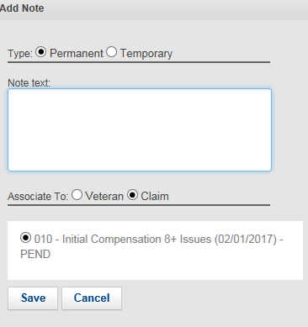

When the tracked item “Secondary Action Required” is used in VBMS, a permanent claim-level note shall be placed regarding any outstanding contentions requiring development and/or examination review.

For example, an examination for jungle rot is not being requested at this time because we are pending a character of discharge determination.

This note will be a placeholder and reminder for subsequent development.

Topic 3: How to Draft a Sufficient Examination

**ERRA Tool**

Sufficient examination request begins with the use of the ERRA tool, which can be found on the Compensation Service Intranet page.

Examination facilities designated to conduct exams are found in the [ERRA tool](http://vbacodmoint1.vba.va.gov/bl/21/DEMO/ZIP/default.asp).

The ERRA tool’s search results include:

* facility routing location
* the routing location and exam list comments
* exam type details, and
* approximate distance (from the ZIP code entered, including driving distance and estimated time).

**Important**:  This tool is designed as a guide to assist in the routing of C&P examination requests. Its usage in the development of SC compensation claims is mandatory. When routing an examination request, consider:

* claimant preferences, and
* topography/driving concerns.

**Notes:**

* The ERRA tool identifies whether a VA facility has capacity to complete examinations timely and suggests a contract vendor if necessary.
* Any justifiable deviation from the ERRA tool’s recommendations must be explained as a remark in the body of the examination request.

**Important**: The ERRA tool’s data is refreshed daily. Therefore, it is imperative to check ZIP codes daily, as the availability of VA or contract examination facilities may vary in response to demand. Routing locations and exam type comments may also be subject to daily updates.

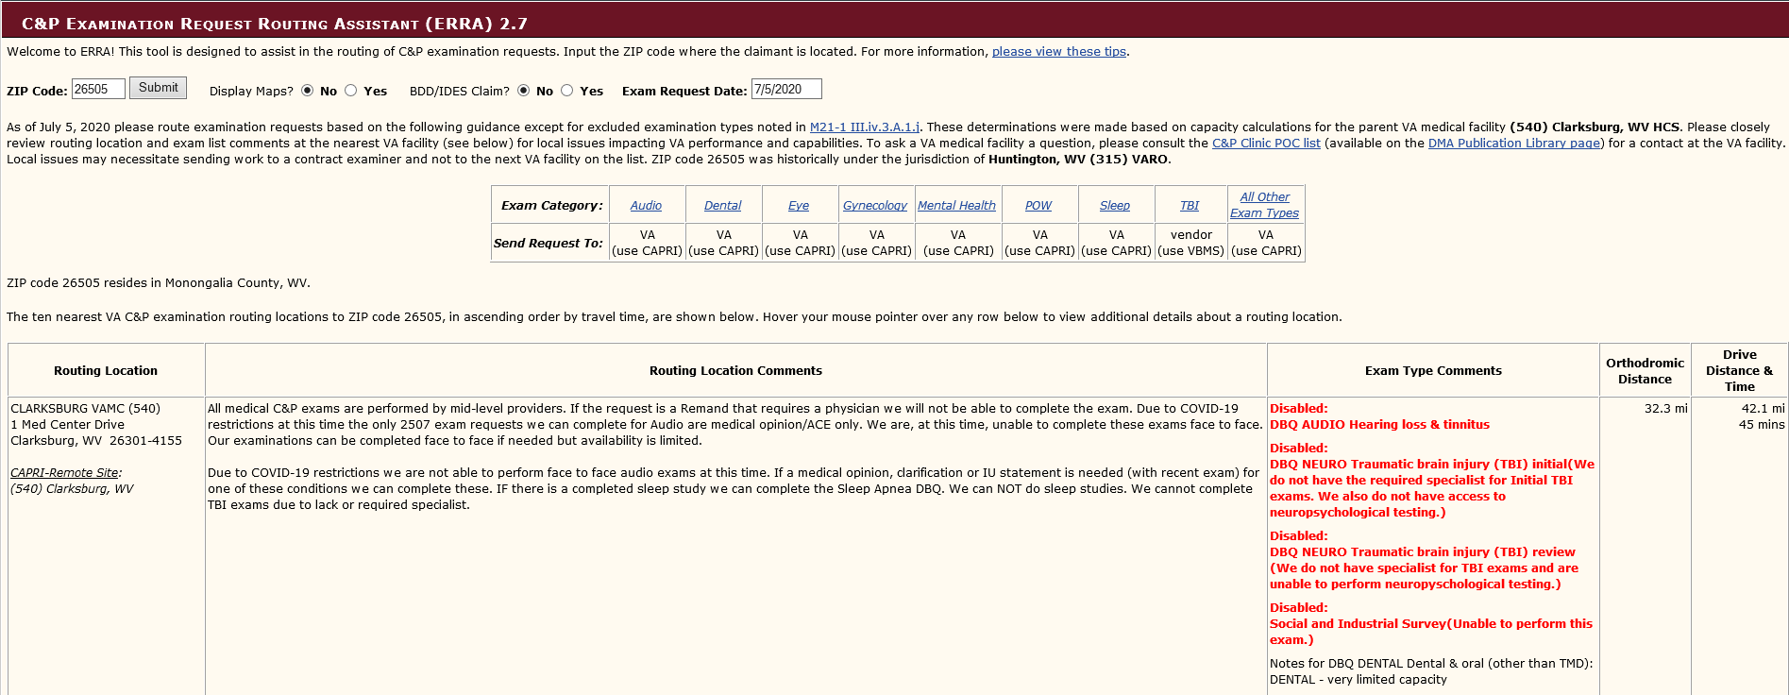Type the Veteran’s zip code and hit Submit.

**Block 1**: represents the Veteran’s zip code.

**Block 2**: represents the exam category by body system and the associated exam location, specifically the VA Medical Centers (VAMC) vs. contract examiners

**Block 3**: represents the Routing Location, reflecting the nearest VAMC to Veteran’s zip code.

**Note**: Examinations should not be requested from contract examiners under certain circumstances. Those circumstances under which contract examinations should not be requested include those listed in M21-1 III.iv.3 for the Contract Examination Exclusions List

**Important**:  Annotate in the CAPRI REMARKS section when an examination cannot be performed by a contract examiner.

*Example*: “Veteran has filed a claim for undiagnosed illness – cannot submit to VBA contract exam provider.”

When routing work to the closest VA facility capable of conducting the examination, be aware that ERRA:

* is usually correct, and
* might not put the claimant's needs or best interests first.

Uploading a screenshot of the ERRA results is mandatory.

[**Index of DBQ by Disability**](http://vbacodmoint1.vba.va.gov/bl/21/DBQ/DBQByDisab.asp)

Selecting the correct DBQ is vital.

#### The Index of DBQ by Disability allows users to search a particular word, phrase, or diagnostic code (DC).





Input information in the SEARCH CRITERIA text box, and the tool will generate suggested DBQs, DCs, and relevant legacy examination worksheets.

#### ERB

#### The purpose of the ERB tool is to standardize exam requests formats.

#### Use of the ERB tool is mandatory when creating an examination or medical opinion request in CAPRI.

From the Job Aids Screen, select Exam Request Builder (ERB) under VA References.

#### Users must ensure suggested language and examinations are adequate before inputting the requests.

#### Important: Examination requests submitted through CAPRI must include the primary requestor’s contact information, to include:

#### first and last name

#### e-mail address, and

#### 10-digit telephone number (which must be accessible during authorized periods of telework)

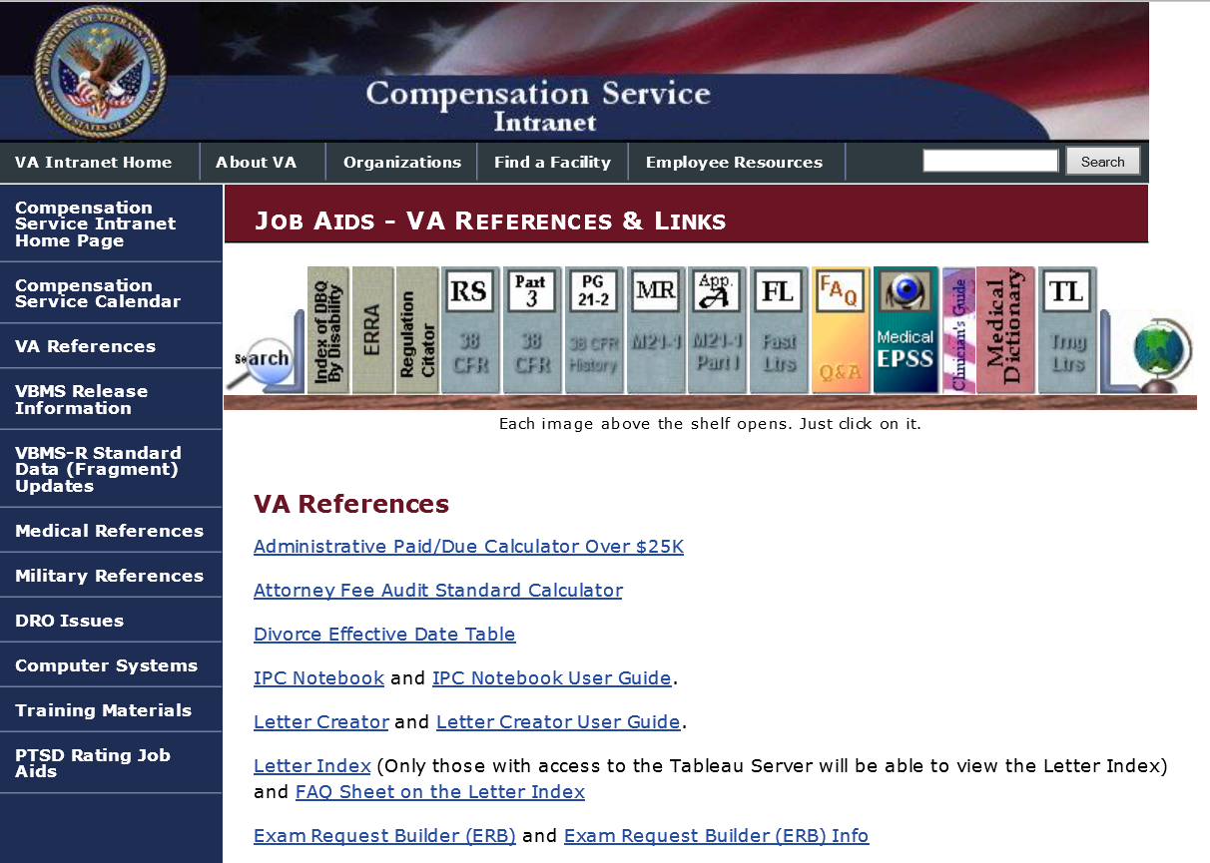

**Helpful Reminders When Ordering Exams**

#### List any pertinent evidence the examiner needs to review.

#### Tabs, annotations, and/or bookmarks are required. The eFolder is either bookmarked or annotated following the standardized procedures outlined in M21-1.III.iv.3.A.

List contentions to be examined, to include notifying examiner of any potential secondary complaints (if addressed by the Veteran) M21-1 III.iv.3.A.

**Information on Specific Exams**

**PTSD** exams must be requested by a VSR in these situations:

* Confirmed combat (combat-related)
* Confirmed in a combat area (fear-based)
* Conceded stressor (research or JSRRC response)
* In-service diagnosis

**Important**: Enter the rationale for ordering the exam in the exam request. Tab VBMS records that the examiner must review, e.g., DD-214, personnel file, lay statements, relevant medical records

**Hearing Loss and Tinnitus** exams must be requested in these situations:

* confirmed noise exposure due to MOS
* combat service indicated by receipt of a combat medal
* threshold shift shown in service

**Important:** Confirmed noise exposure must be specifically noted in the exam request.

The *Duty Military Occupational Specialty (MOS) Noise Exposure Listing*, which has been reviewed and endorsed by each branch of service, is available at <http://vbaw.vba.va.gov/bl/21/rating/docs/dutymosnoise.xls>.

The Duty MOS Chart can also be located from Jobs Aides, Military References, Duty MOS Noise Exposure Listing.

Based on the Veteran’s records, review each duty MOS, Air Force Specialty Code, rating, or duty assignment documented on the *Duty MOS Noise Exposure Listing* to determine the probability of exposure to hazardous noise. If the duty position is shown to have a “Highly Probable” or “Moderate” probability of hazardous noise exposure, concede exposure to hazardous noise for the purposes of establishing an event in service.

In addition, review the Veteran’s records for evidence that the Veteran engaged in combat with the enemy during a period of war, campaign, or expedition. If the evidence establishes that the Veteran was engaged in combat, concede exposure to hazardous noise for the purposes of establishing an event in service.

**Notes**

* If noise exposure is conceded based on the *Duty MOS Noise Exposure Listing*, include the level of probability conceded in the body of the examination request.
* If noise exposure is conceded based on engagement in combat with the enemy, include this in the body of the examination request.
* If noise exposure is not conceded but an examination and/or opinion is otherwise necessary based on another event, injury, or disease, provide the probable level of exposure to hazardous noise associated with the Veteran’s documented duty position in the examination request remarks.
* If the evidentiary threshold for finding a VA examination necessary under [38 CFR 3.159(c)(4)](http://www.ecfr.gov/cgi-bin/text-idx?SID=33d9334e8ca962940e6f920431bd3246&node=se38.1.3_1159&rgn=div8) has been met, a duty MOS consistent with a lower probability of hazardous noise exposure than “Highly Probable” or “Moderate” does not preclude a VA examination. M21-1 **III.iv.4.D**

**Presumptive Conditions**

Determining whether examinations are required in presumptive SC claims still warrants application of the three-element standard (although Elements 2 and 3 are satisfied differently). 38 CFR 3.159(c)(4)(ii) provides that in claims for presumptive SC, part of the standard for determining whether an examination or opinion is necessary is the establishment of:

* required service or triggering event qualifying for the presumption (which substitutes for the in-service injury, event, or disease), and
* manifestation during the presumptive period (which substitutes for the indication of an association) of either
  + a disease listed in a regulatory presumptive provision, or
  + symptoms of a disease listed in a regulatory presumptive period.

Notwithstanding, the evidence in support of the claim must still include lay or medical evidence of a current disability or symptoms to warrant an examination.

Confirmation of a diagnosis within the presumptive period is required. Presumptive issues can be found in 38 CFR 3.309

**General Medical Examination**

A general medical examination containing a full report of complaints and functional impairments is the preferred type of examination in original compensation claims within one year of discharge.

Request a general medical examination if:

* an original claim is received within one year of discharge, or
* an intent to file (ITF) is received within one year of discharge, and a substantially complete application is received within one year of the ITF.

It may also be appropriate to request a general medical examination to obtain evidence in claims for

* individual unemployability (IU)
* service connection (SC) under [38 CFR 3.317](http://www.ecfr.gov/cgi-bin/retrieveECFR?gp=1&SID=4f37eddd401a23753883deb8ce72d226&ty=HTML&h=L&r=SECTION&n=se38.1.3_1317) (GW Gen Med), or
* Veterans Pension.

When the medical examiner conducts the examination, he/she should confirm the existence of and evaluate

* all disabilities listed in the examination request, and
* any other disabilities the Veteran identifies during the examination.

The examination request for a general medical examination should clearly cite the conditions or particular diagnoses that require attention.

**Note:** Opinions addressing etiology and relationship to service are not typically provided by general medical examinations.

**Important:**  When requesting a general medical examination to evaluate an original compensation claim received within one year of discharge, do not specify that the examiner also complete specialty examinations for each claimed disability. However, consider whether specialist examinations are required by virtue of the specific claims. This policy applies to examinations requested from VHA, as well as from private providers under VA contract.  M21-1 III.iv.3.A.5.a

**Example 1:** An original claim is received within one year of the Veteran’s release from active duty. The claimed issues are the right knee, left elbow, scar on left ankle, asthma, and migraines.

**Results 1:** Request only the DBQ General Medical

**Example 2:** An original claim is received within one year of release from active duty. The claimed issues are for right knee, left elbow, scar on left ankle, asthma, migraines, hearing loss, tinnitus, and PTSD

**Results 2:** Request the DBQ General Medical, DBQ Audio, and DBQ Initial PTSD

**Note:**  A fully sufficient general medical examination is usually of greater value than a number of uncorrelated specialty examinations.

* If a subsequent claim is received within the initial year following discharge, but after a general medical examination has been conducted, do not order an additional general medical examination to evaluate the disability(ies) contended. In this case, you will need to order the individual DBQ.
* In addition, if the Veteran has multiple periods of service a general medical examination can be requested multiple times as long as the Veteran submits a claim within one year of the release from service.

**Increase Exams**

In a claim for increase in the evaluation of an SC condition, do not apply the 38 CFR 3.159(c)(4) standard. There is no prescribed standard for evidence that must be present prior to requesting an examination in a typical claim for increase. Obtain an examination when the medical evidence is not adequate for rating purposes.

If a claim for increase is received, regardless of whether a statement of worsening is received or whether an examination for the claimed condition was completed within the last year, request an examination for the claimed condition. (**see M21-1.I.1.C for exceptions**)

**Important:** A claim for increase is a new claim. Therefore, there is no regulatory hurdle to overcome before ordering an examination.

Do not request examinations for disabilities currently evaluated at the schedular maximum, as this is the jurisdiction of the RVSR.

**Exam Circle**

The exam request process should flow in a uniform manner and should be completed one step at a time. Every step is described in the manual and should be routine. By following this circle, exams will be requested sufficiently using appropriate tools.

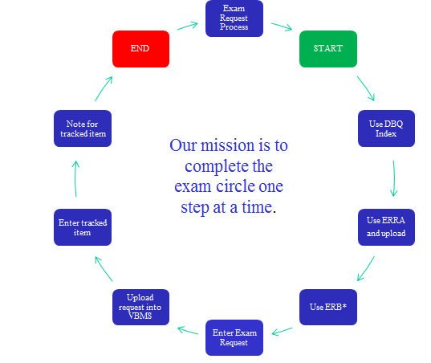

Skipping steps will cause errors.

* Example: if the claim status is changed to RFD due to failure to order a necessary examination, the claim process is delayed.
* Example: An exam is not requested due to a pending character of discharge determination, and the required “Secondary Action Required” tracked item is not entered. This results in the claim being sent auto-RFD by VBMS. Again, the claim process is delayed, potentially adding 120 days to the claim.

Actions matter and can result in untimely claims processing. A review of cases has shown a high number of avoidable deferrals can be corrected by entering a correct exam at the earliest point recognized, entering tracked items, and using VA exam tools such as ERRA, ERB, and the Index of DBQs.

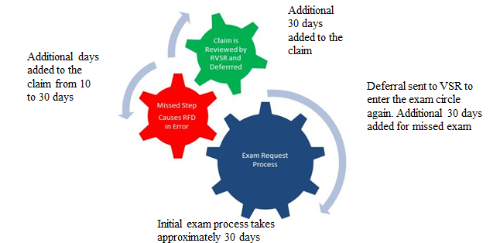

This is an example of how the exam becomes dysfunction and no longer movers in a streamline manner. Skipping steps will create unnecessary deferrals and untimely delays for the Veteran.

Review Exercise

Directions: Read the scenario and discuss the results as a class. Your response should include what exams you are ordering or waiting to order and the rationale.

SCENARIO: A Vietnam Veteran with verification of in-country service in the Republic of Vietnam who is SC @ 40% for diabetes mellitus type II submits a claim for ischemic heart disease. The veteran is also claiming a right knee condition. In-country Vietnam service is shown on the DD Form 214 and treatment records showing a diagnosis of ischemic heart disease and complications are associated with the claim upon submission. There is no evidence of a current medical diagnosis or lay statement regarding the right knee condition. STRs are not yet of record but development has been initiated. In addition, there is no evidence of combat service.

Practical Exercise

Directions: Read the scenario and write your response in the space provided. Your response should include what exams you are ordering or waiting to order and the rationale.

SCENARIO: A Vietnam Veteran with combat service claims SC for hearing loss, PTSD with symptoms of sleep impairment, back pain due to a back injury in service, and GERD with reflux and stomach upset due to medication taken for his back condition. STRs are not yet of record but development has been initiated. Combat service as an infantryman is shown on the DD214. Development has been initiated for private treatment records pertaining to PTSD and the back condition.

RESPONSE:

Practical Exercise 2

Please read the scenario and answer the questions that follow:

A Vietnam Veteran with combat service claims SC for hearing loss, PTSD with symptoms of sleep impairment, back pain due to a back injury in service, and GERD with reflux and stomach upset due to medication taken for his back condition. Combat service as an infantryman is shown on the DD214.

What action(s) would you take? (Select all that apply)

Develop for STRs

Develop for private treatment records

Order an initial PTSD exam

Order a medical opinion for the PTSD due to combat

Order an auditory exam

Order a medical opinion for hearing loss due to combat

Order a digestive exam

Order a medical opinion for GERD due to combat

Order a medical opinion for GERD due to medication for the back

Order a back exam

Order a medical opinion for back due to combat

Order a medical opinion for the back due to injury in service

Add a tracked item for each exam ordered

Add a tracked item Secondary Action Required

Add a VBMS Exam Review Note documenting the status

Private treatment records are received. They show ongoing treatment for PTSD, degenerative disc disease, and GERD. STRs are received. Review of STRs does not show evidence of treatment for any digestive issues, and treatment on only one occasion for a back injury.

What action(s) would you take? (Select all that apply)

Develop for STRs

Develop for private treatment records

Order an Initial PTSD exam

Order a medical opinion for the PTSD due to combat

Order an auditory exam

Order a medical opinion for hearing loss due to combat

Order a digestive exam

Order a medical opinion for GERD due to combat

Order a medical opinion for GERD due to medication for the back

Order a back exam

Order a medical opinion for back due to combat

Order a medical opinion for the back due to injury in service

Add a tracked item for each exam ordered

Add a tracked item for the exams not ordered

Add a VBMS Exam Review Note documenting the status

A continuance of the previous scenario but a different outcome was received regarding the medical evidence:

Private treatment records are received showing ongoing treatment for PTSD, degenerative disc disease, and GERD. STRs are received. Review of them does not show evidence of a back injury or digestive issues in service.

What action(s) would you take? (Select all that apply)

Develop for STRs

Develop for private treatment records

Order an Initial PTSD exam

Order a medical opinion for the PTSD due to combat

Order an auditory exam

Order a medical opinion for hearing loss due to combat

Order a digestive exam

Order a medical opinion for GERD due to combat

Order a medical opinion for GERD due to medication for the back

Order a back exam

Order a medical opinion for back due to combat

Order a medical opinion for the back due to injury in service

Add a tracked item for each exam ordered

Add a tracked item for the exams not ordered

Add a VBMS Exam Review Note documenting the status

Exams: Who, When, and How Assessment - TMS #4245283

You have completed the instructional part of training on Exams: Who, When and How. You must log in to TMS and enter ID#4245283 to complete the online assessment and survey to receive credit for this training. The assessment requires a score of 85% or greater to pass. Any available resource can be utilized to complete the assessment. This includes but not limited to lesson handout, internet/intranet web sites, job aides, PowerPoint and any applicable reference materials. You will have unlimited attempts to pass this assessment.