Contaminants in Water Supply: Camp Lejeune
Presumptive Regulation (RVSR)
Instructor Lesson Plan
Time Required: 2 Hours

Table of Contents

Lesson Description 2
Introduction to Camp Lejeune Presumptive Regulation 4
Topic 1: Background and Regulation 7
Topic 2: Claim Processing 10
Topic 3: Presumptive Disabilities – Schedule of Ratings 18
Topic 4: Effective Date 27
Topic 5: Rating Requirements 29
Lesson Review, Assessment, and Wrap-up 32

Lesson Description
The information below provides the instructor with an overview of the lesson and the materials that are required to effectively present this instruction.
TMS # | 4212554
Prerequisites | Prior to this lesson, the Rating Veteran Service Representatives (RVSRs), Decision Review Office (DRO), or Rating Quality Review Specialist (RQRS) should have completed RVSR Challenge curriculum.
target audience | The target audience for the Camp Lejeune Presumptive Regulation course is all RVSRs, DROs, and RQRSs.
Time Required | 2 hours
Materials/  TRAINING AIDS | Lesson materials:  - Camp Lejeune Presumptive Regulation PowerPoint Presentation  - Camp Lejeune Presumptive Regulation Student Handout
Training Area/Tools | The following are required to ensure the trainees are able to meet the lesson objectives:  - Classroom or private area suitable for participatory discussions  - Seating, writing materials, and writing surfaces for trainee note taking and participation  - Handouts, which include a practical exercise  - Large writing surface (easel pad, chalkboard, dry erase board, overhead projector, etc.) with appropriate writing materials  - Computer with PowerPoint software to present the lesson material  Trainees require access to the following tools:  - VA TMS to complete the assessment  - Internet access for Compensation Pension Knowledge Management (CPKM)
Pre-Planning | - Become familiar with all training materials by reading the Instructor Lesson Plan while simultaneously reviewing the corresponding PowerPoint slides. This will provide you the opportunity to see the connection between the Lesson Plan and the slides, which will allow for a more structured presentation during the training session.  - To avoid blanket reading from the power point slides, optional discussion bullet points have been provided for the instructor. Keep in mind the power point presentation is only a shell of the lesson and vital information is often provided in the discussion bullet points.  - Become familiar with the content of the trainee handouts and their association to the Lesson Plan.  - Practice is the best guarantee of providing a quality presentation. At a minimum, do a complete walkthrough of the presentation to practice coordination between this Lesson Plan, the trainee handouts, and the PowerPoint slides and ensure your timing is on track with the length of the lesson.  - Ensure that there are copies of all handouts before the training session.  - When required, reserve the training room.  - Arrange for equipment such as flip charts, an overhead projector, and any other equipment (as needed).  - Talk to people in your office who are most familiar with this topic to collect experiences that you can include as examples in the lesson.  - This lesson plan belongs to you. Feel free to highlight headings, key phrases, or other information to help the instruction flow smoothly. Feel free to add any notes or information that you need in the margins.
Training Day | - Arrive as early as possible to ensure access to the facility and computers.  - Become familiar with the location of restrooms and other facilities that the trainees will require.  - Test the computer and projector to ensure they are working properly.  - Before class begins, open the PowerPoint presentation to the first slide. This will help to ensure the presentation is functioning properly.  The instructor completes a roll call attendance sheet or provides a sign-in sheet to the students. The attendance records are forwarded to the Regional Office Training Managers.

Introduction to Camp Lejeune Presumptive Regulation
INSTRUCTOR INTRODUCTION |  | Complete the following:  - perform audio check and introduce yourself  - ensure that all learners have the required handouts
time required |  | 0.25 hours
Purpose of Lesson  Contaminants in Water Supply: Camp Lejeune Presumptive Regulation  Title slide 1 |  | Discuss: This lesson is intended to expose decision makers to the presumptive regulation regarding diseases associated with exposure to contaminants in the water supply at Camp Lejeune.  We will refer to the acronym CLCW, which for our purposes will be defined as Camp Lejeune Contaminated Water.  This lesson was developed as part of the National Training Curriculum so it involves instruction for those in Louisville and other centralized locations, as well as instruction for the decision makers at the Regional Office of Jurisdiction(s), as decided by the National Work Queue.
Motivation | Discuss: Understanding how to adjudicate CLCW presumptive service connection claims is imperative to ensuring accurate and consistent rating decisions not only for our individual quality, but more importantly for our Veterans.
Lesson Objectives  Discuss the following:  Slide 2 | Discuss: After discussion and presentation of today’s lesson, you will be required to accomplish the following lesson objectives:  - Demonstrate a comprehension of the requirements for presumptive service connection (Diseases associated with exposure to contaminants in the water supply at Camp Lejeune)  Discuss: We will discuss the service and presumptive requirements which have been codified at 38 CFR 3.307(a)(7) and 38 CFR 3.309(f)  - Understand the Regional Office and Centralized claims processing requirements  Discuss: It is imperative to understand what actions the Regional Office must and can take in developing and addressing CLCW claims. For the centralized claims processers, it is imperative to understand the unique development requirements that must be completed prior to a favorable or non-favorable decision being rendered.  - Identify rating considerations and criteria for the eight presumptive disabilities  Discuss: We will also identify and discuss the 8 new presumptive disabilities associated with CLCW, to include some general rating considerations and reminders.  - Apply the liberalizing legislation effective date regulation  Discuss: 38 CFR 3.114 will be discussed to ensure comprehension.  For the next year, we will in most cases, be granting the effective date of regulation if we are granting on the basis of presumption.  For centralized claims, special rules will be discussed for consideration of granting CLCW claims on a direct basis.  - Recognize and understand the rating decision and notification letter requirements  Discuss: All CLCW rating decisions and notification letters will require the inclusion of approved language. We will discuss same and show where to access the information in the M21, pending coding into VBMS-R.
References  Slides 3 and 4 | Explain where these references are located in the workplace.  All CFR references are found in the eCFR Website for Part 3 ; Part 4 ; and Part 17.  All M21-1 references are found in the Live Manual Website.  - 38 CFR 3.307(a)(7): Diseases associated with exposure to contaminants in the water supply at Camp Lejeune  - 38 CFR 3.309(f): Diseases associated with contaminated water supply at Camp Lejeune  - 38 CFR 3.114: Change of law or Department of Veterans Affairs issue  - 38 CFR 3.383: Special consideration for paired organs  - 38 CFR Part 4: Schedule for Rating Disabilities  - 38 CFR 17.400 – Hospital care and medical services for Camp Lejeune Veterans  - M21-1 Part III, Subpart iv, 4 – Rating specific disabilities  - M21-1 Part IV, Subpart ii, 1.I.7 – Developing claims based on exposure to contaminants in the water supply at Camp Lejeune  - M21-1 Part IV, Subpart ii, 2.C.6 - Disabilities resulting from exposure to contaminants in the water supply at Camp Lejeune

Topic 1: Background and Regulation
Introduction |  | This topic will allow the trainee to understand the presumptive regulations of 38 CFR 3.307(a)(7) and 38 CFR 3.309(f)
Time Required |  | 0.25 hours
OBJECTIVES/  Teaching Points  Presumptive Regulation  Slide 5 |  | Topic objectives and teaching points to support the topic objective:  - The trainee will be able to identify the date the CLCW disabilities were added as presumptive disabilities under 38 CFR 3.309(f)  - The trainee will be able to identify the CLCW service requirements under 38 CFR 3.307(a)(7)  - The trainee will be able to identify the 8 CLCW presumptive disabilities.  Discuss: One objective for this first topic is to identify the date CLCW disabilities were added as presumptive disabilities. We also want to talk about regulatory requirements and identify the eight CLCW presumptive disabilities.
Background  Slide 6 |  | In September 2016, VA published a rule proposing to create a presumption of service connection for eight diseases associated with contaminants present in the base water supply at U.S. Marine Corps Base Camp Lejeune, North Carolina.
38 CFR 3.307(a)(7)  Slide 7 |  | Emphasize: March 14, 2017 is an important date and a date to remember. This date will be prove to be vital in determining the appropriate effective date for a grant.  Effective March 14, 2017, eight presumptive diseases were added to 38 CFR 3.309(f), for  - service members, former reservists, National Guard members on official orders , who served  - 30 days (consecutive or nonconsecutive) at Camp Lejeune, between  - August 1, 1953 to December 31, 1987  Discuss: Note that official orders includes any official service department records that confirm no less than 30 days at Camp Lejeune. We want to emphasize that the 30 days can be consecutive or non-consecutive.  Example: A Reservist could have performed their two week active duty for training period in 1979, 1980, and 1985. Although the service is non-consecutive, the cumulative amount of time (6 weeks) satisfies the 30 day requirement.  Discuss: For centralized processors, note that while the presumption attaches to National Guardsman and Reservists who otherwise meet the requirements, a grant of service connection on a direct basis via VHA SME opinion is not applicable for periods of active duty for training or inactive duty for training.  Unless there is evidence of being called to active duty with requisite service, service connection prior to March 14, 2017 under 38 CFR 3.303 cannot be established for Guardsman and Reservists.  Show and Discuss: M21-1 IV.ii.2.C.6.b – Service at Camp Lejeune.  Note that Camp Lejeune includes the Marine Corps Air Station New River.  Military records may show service in the following areas which are also considered within the borders of Camp Lejeune:  - Camp Geiger  - Camp Johnson  - Naval Hospital Camp Lejeune  - Tarawa Terrace  - Camp Knox  - Montford Point  - Stone Bay / Rifle Range  - Holcomb Boulevard, and  - Hadnot Point  Emphasize: Camp Lejeune service does not include service at MCAS Cherry Point.  Important, Discuss: If service treatment records (STRs) document an official visit for medical treatment within the defined borders of Camp Lejeune, the episode of treatment counts as one day at Camp Lejeune. For example, if a Veteran’s official service personnel records listed his/her official duty station as Marine Corps Air Station Cherry Point, NC, but STRs indicate he/she received medical treatment at Camp Lejeune, each date of treatment should be counted as a day served at Camp Lejeune for the purposes of processing a claim for service connection based on exposure to contaminants in the water supply at Camp Lejeune.
38 CFR 3.309(f)  Slide 8 |  | If a veteran was exposed to contaminated drinking water at Camp Lejeune, the following diseases shall be service-connected if the requirements of §3.307(a)(7) are met:  - Kidney Cancer  - Liver Cancer  - Non-Hodgkin’s Lymphoma  - Adult Leukemia  - Multiple Myeloma  - Parkinson’s Disease  - Bladder Cancer  - Aplastic Anemia and other Myelodysplastic Syndromes  Discuss: The disability must have manifested to a compensable degree anytime after service. Note that the condition does not have to be compensable at the time of the presumptive grant, only that it was compensable at some point following service.  Instructor Note: By the very nature of the presumptive disabilities which become compensable solely based on confirmed diagnosis, a denial based on “not manifesting to a compensable degree” is not possible with the exception of aplastic anemia and other myelodyspastic sydnromes. Although, that will be rare because medication or treatment will most likely have occurred once diagnosed.
TOPIC POLL QUESTION |  | Question:  A Veteran who served honorably in the Marine Corps filed a claim for service connection for multiple myeloma due to CLCW on April 1, 2017.  Service department records showed service at Camp Geiger for a period in excess of 30 days from June 2010 through September 2013.  Treatment records confirm a diagnosis of multiple myeloma.  Is presumptive service connection warranted?  - Yes  - No  Answer:  No, while the Veteran has a diagnosis of a CLCW presumptive disability and served at least 30 days at Camp Geiger (an area within the border of Camp Lejeune), the Veteran did not serve there between August 1, 1953 to December 31, 1987.

Topic 2: Claim Processing
Introduction | This topic will allow the trainee to understand centralized and ROJ processing of CLCW claims.
Time Required | 0.25 hours
OBJECTIVES/  Teaching Points  Claim Processing  Slide 9 | Topic objectives and teaching points to support the topic objective:  - The trainee will be able to understand what processing actions are taken at the ROJ.  - The trainee will be able to identify what is considered a Camp Lejeune issue.  - The trainee will be able to understand what processing actions are taken at the centralized location.  - The trainee will demonstrate a working knowledge of the requirements for a VHA SME review.  Discuss: For purposes of this topic, when we discuss the ROJ, we are referring to any regional office that does not have jurisdiction of CLCW claims which require centralized processing.  We will discuss what decisions the ROJs can render and briefly show the actions which must be taken prior to transferring the claim for centralized processing. Transferring a CLCW claim is accomplished via a corporate flash that the NWQ will recognize and route.  Identifying what a “Camp Lejeune issue” is, will be critical when deciding the appropriate jurisdiction.  When we discuss centralized processing, we are referring not only to the Louisville RO, but also other centralized processing sites involving Veterans residing in foreign territories, original pre-discharge claims, and restricted access claims. We will discuss these locations in a few minutes.  For the centralized locations, we will discuss the stages of claim processing and talk about the VHA SME review.
ROJ Processing  Slide 10 | The ROJ will retain jurisdiction of a Camp Lejeune claim when:  - the Veteran did not serve at Camp Lejeune between August 1, 1953, and December 31, 1987  - the claim is for a disability recognized under 38 CFR 3.309(f) and  - the Veteran had at least 30 days of service at Camp Lejeune during the contamination period, or  - the evidence does not establish a diagnosis of the claimed condition  - no disability is specifically claimed as a result of exposure, such as claims stating “Camp Lejeune” or “exposure at Camp Lejeune”  - Veteran status needs to be established, such as a character of discharge determination, or  - the only claim is for a disability of a dependent, including birth defects.  Discuss: All ROJs are responsible for verifying Veteran status and any service at Camp Lejeune during the contamination period between August 1, 1953 and December 31, 1987. ROJs are also responsible for developing for a diagnosis, to include medical evidence, and sending a subsequent development letter identified in M21-1 IV.ii.1.I.7.j  At the regional office level, decision makers will be involved in three types of decisions.  First, when presumptive service connection can be granted. (for claims received after March 14, 2017)  Second, rating decision denials when the requisite service requirements are not met. So, the evidence fails to show any service at Camp Lejeune between August 1, 1953 and December 31, 1987.  Finally, rating decision denials when there is no diagnosis of the claimed presumptive disability shown be the evidence of record. This is regardless whether the Veteran served at Camp Lejeune or not.  Explain that presumptive grants for claims received after March 14, 2017, denials based on not meeting service requirements; or, having no diagnosis will be routed to the next available ROJ indicated by normal NWQ routing processes.  Important: If initial review of the claim does not establish any service at Camp Lejeune between August 1, 1953 and December 31, 1987, ensure a subsequent development letter was sent to the claimant prior to any denial at the ROJ. This is required even if the disability claimed is not one of the presumptive conditions.  If no specific disability is claimed development will be undertaken.  If Veteran status needs to be established, same will be accomplished at the ROJ and flashed for the appropriate centralized location or NWQ.  If Veteran status is not obtained; or, if the only claim is for a disability of a dependent, including birth defects, the ROJ will complete the administrative decision and/or administrative denial.  Show and Discuss: Both M21-1 IV.ii.1.I.7.b – Centralized Processing of Camp Lejeune Claims and M21-1 IV.ii.1.I.7.d – Initial actions to take on Camp Lejeune Claims  Instructor Note: Emphasize the special issue indicator, corporate flashes, and the locations where centralized processing occurs depending on the specifics of the claim.
Centralized Processing  Slide 11 | The ROJ will route the following Camp Lejeune claims for centralized processing at Louisville:  - a diagnosed disability recognized under 38 CFR 3.309(f) with at least one, but less than 30 days of service at Camp Lejeune, OR  - a condition recognized under 38 CFR 17.400, with at least one day of Camp Lejeune service, OR  - any other disability specifically claimed as due to exposure at Camp Lejeune with at least one day of service during the contamination period.  Note: If a claimed condition is listed at either 38 CFR 3.309(f) or at 38 CFR 17.400, service at Camp Lejeune during the contamination period does not have to be expressly claimed and may otherwise be established by the evidence of record.  Discuss: In addition to the presumptive disabilities codified at 38 CFR 3.309(f), if one of the conditions listed at 38 CFR 17.400 is claimed, the claim will be forwarded for centralized processing so long as the Veteran served at least one day at Camp Lejeune. This is regardless of whether the Veteran identified the claimed disability as due to contaminated water at Camp Lejeune or not.  Show and discuss: 38 CFR 17.400 – Hospital care and medical services for Camp Lejeune Veterans.
Centralized Processing  Slide 12 | Discuss: Once a claim has been flashed and routed for centralized processing by the NWQ, the centralized processing site is responsible for all additional development, rating, authorization, and appeal activity.  Stages of claims processing handled by the centralized RO:  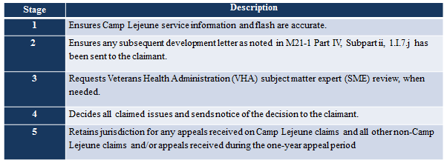  Instructor talking points:  Stage 1: Service must have been completed by the ROJ. Once transferred, the centralized location will confirm service and procedural system compliance.  Stage 2: Prior to any denial, centralized decision makers must ensure subsequent development letters were sent when required.  Stage 3: Examination requests will not be requested by the ROJ prior to transfer for centralized processing. VHA SME reviews are requested through the Office of Disability and Medical Assessment (DMA). Do not follow normal examination request procedures. We will discuss VHA SME review in a few minutes.  Stage 4: Note that all claimed issues, not just those claimed as due to CLCW will be decided by the centralized location.  Stage 5: Emphasize that the centralized location has jurisdiction for any appeals received on Camp Lejeune claims and all other non-Camp Lejeune claims and/or appeals received during the one year appeal period.
VHA SME Review  Slide 13 | Prior to finalizing the regulations allowing for presumptive SC, VBA referred CLCW claims to VHA for a subject matter expert (SME) review. These opinions must be weighed to determine if  - SC can be established on a direct basis prior to the date the final presumptive regulation became effective, or  - if the opinion sufficiently rebuts the presumption as discussed in 38 CFR 3.307(d).  Discuss: For the centralized locations where claims for CLCW presumptive disabilities are pending on March 14, 2017, consideration must still be given to service connection on a direct basis under 38 CFR 3.303.  Effective March 14, 2017, if otherwise qualified, these claims can be granted presumptive service connection effective the date of change of law. This will provide interim benefits until the VHA SME opinion can be obtained for direct service connection which may allow for an earlier effective date prior to the date of law.  Example: Veteran with confirmed Camp Lejeune service requirements who is objectively diagnosed with Parkinson’s disease claimed service connection on November 5, 2016 for PD due to CLCW. Rating decision grants presumptive service connection effective March 14, 2017. VHA SME opinion is then obtained which provides an opinion that the Parkinson’s disease was as least as likely as not incurred during military service. A second rating decision grants entitlement to an earlier effective date on a direct basis effective November 5, 2016.  Discuss: Tell the decision makers we will discuss rebutting the presumption of service connection in a few minutes.
VHA SME Review - Requirements  Slide 14 | VHA SME review is required in the following claims:  - 38 CFR 3.309(f) disability with less than 30 days Camp Lejeune service  - any disability claim with  - at least one day of verified service at Camp Lejeune service during the contamination period, and  - evidence sufficient to warrant an examination under 38 CFR 3.159, OR  Explain: While a presumption of SC based on exposure to contaminants in the water supply at Camp Lejeune is not warranted for any condition other than those codified at 38 CFR 3.309(f), SC may still be established on a direct basis, if warranted by the facts of the case.  Discuss: If the only service at Camp Lejeune was with a National Guard or reserve unit while on active duty for training or inactive duty for training, do not request a SME review. Reemphasize that unless there is evidence of being called to active duty with requisite service, service connection prior to March 14, 2017 under 38 CFR 3.303 cannot be established for Guardsman and Reservists.  - chronic disability recognized for healthcare under 38 CFR 17.400 with at least one day of verified service at Camp Lejeune service during the contamination period  Explain: These opinions remain required to establish eligibility for treatment.
VHA SME Review – 3.307(d)  Slide 15 | - A negative VHA SME opinion may be sufficient to deny direct service connection, but it is not necessarily sufficient to rebut a presumption for an otherwise qualified claim under 38 CFR 3.307(a)(7).  Discuss: The presumption of SC may not be rebutted using an opinion that does not:  - consider the entire record, and/or  - consider relevant evidence that post-dates the opinion  - has a negative finding of causation with respect to in-service exposure by itself (unaccompanied by medical evidence and sound medical reasoning to support the opinion)  - identifies an intercurrent cause but does not establish that the intercurrent cause is the sole cause of the disease, to the exclusion of in-service exposure as a contributory cause  - explain why a potentially intercurrent cause makes the presumptive cause of the disability medically unlikely  - relies on the “preponderance of the evidence” to rebut the presumption, as this level of proof is not sufficient to establish affirmative evidence contrary to the presumption.  Example: A Veteran files a claim for bladder cancer. Service records establish service at Camp Lejeune. The RO obtains a SME opinion which discusses the National Research Council's 2009 report and the Veteran’s other risk factors. The SME concludes that the weight of scientific and medical evidence supports that it is less likely than not that exposure to contaminated water at Camp Lejeune was causative of the development of the Veteran’s bladder cancer, and that his subsequent occupational exposure and cigarette smoking would be more likely the contributor to his bladder cancer.  Result: The decision maker finds the presumption is not rebutted and awards SC for bladder cancer under 38 CFR 3.307. In the decision, the decision maker explains the opinion fails to consider all relevant evidence and does not account for changed medical understandings as it did not consider other relevant studies that were the basis of the new presumptive rulemaking.  Additionally, the opinion does not discuss whether the other risk factors were the sole cause of the condition. Finally, the opinion switches between statements of causation and contribution. Therefore, the opinion applies an incorrect standard and only provides a negative opinion regarding in service exposures, which is arguably insufficient by itself to rebut the presumption of service connection.  Explain: In this example, if the claim was pending at the time of the change in law, service connection could not be established on a direct basis under 38 CFR 3.303 prior to March 14, 2017, as there would be no presumptive basis in law and no evidence the claimed condition was related to military service. The presumption is not rebutted; however, so service connection for bladder cancer would be granted effective March 14, 2017.  - To rebut the presumption of service connection, a burden of proof must be present and the opinion must meet a higher standard.  Discuss: Presumptive SC can be rebutted under 38 CFR 3.307(d). The medical evidence to rebut the presumption of SC need not be conclusive, but must include:  - affirmative evidence of an intercurrent cause, and  - sound medical reasoning, and  - be based on consideration of all evidence of record.  Example: A Veteran files a claim for chronic myeloid leukemia (CML). Service records establish service at Camp Lejeune. The RO obtains a SME opinion that identifies a chromosomal abnormality as the intercurrent cause of the Veteran’s disease and specifically states it is less likely than not that the diagnosis of CML is related to contamination in the ground water at Camp Lejeune.  Result: The decision maker determines the evidence is sufficient to rebut the presumption of SC under 38 CFR 3.307 and denies the claim. In the decision, the decision maker explains the opinion sufficiently and affirmatively identifies an intercurrent cause of the Veteran’s disease, in this case an abnormal chromosome, and also provides a specific negative finding of causation with respect to in service exposures.
TOPIC POLL QUESTION | Question:  A Veteran who served honorably in the Marine Corps filed a claim for service connection for breast cancer on March 21, 2017. Breast cancer is not a presumptive disability codified at 38 CFR 3.309(f) and the Veteran did not claim exposure to CLCW.  Service department records showed service at Camp Lejeune for a period 7 days in 1973.  Should this claim be processed by the ROJ or sent for centralized processing.  - ROJ  - Centralized  Answer:  Centralized. While this condition was not claimed as due to exposure to CLCW and same is not a disability subject to presumptive service connection under 38 CFR 3.309(f), the Veteran did serve at least one day at Camp Lejeune and breast cancer is a condition listed under 38 CFR 17.400. Consideration to eligibility for treatment is at issue and must be processed at the centralized location.

Topic 3: Presumptive Disabilities – Schedule of Ratings
Introduction | This topic will introduce the trainee to rating criteria and considerations for the eight CLCW presumptive disabilities.
Time Required | 0.5 hours
OBJECTIVES/  Teaching Points | Topic objectives and teaching points to support the topic objective:  - The trainee will be able to identify the appropriate diagnostic code and evaluation criteria for the eight CLCW presumptive disabilities.  - The trainee will be able to recognize special rating considerations for the eight CLCW presumptive disabilities.  - The trainee will be able to understand how to code Parkinson’s disease and related conditions in VBMS-R.
Genitourinary: Kidney Cancer  Slide 17 | Discuss: Prognosis for kidney cancer is good for single kidney cancer without lymphatic system involvement. When lymph involvement is present, the survival rate is less than 15% at the five year mark.  Testing for kidney cancer includes abdominal ultrasound, CT, MRI, aortography, and selective renal angiography  Treatment for kidney cancer may include nephrectomy, removing the tumor from the kidney, freezing the cancer cells (cryoablation), burning the cancer cells (radiofrequency ablation), immunotherapy, and radiation therapy.  - Kidney cancer is evaluated under DC 7528  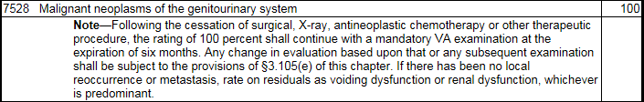  Discuss: Kidney cancer is evaluated under the same criteria we use to evaluate prostate cancer as both are malignant neoplasms of the genitourinary system. Following cessation of treatment, we will rate on voiding dysfunction or renal dysfunction, whichever is predominant.  - Single kidney cancer may be treated with radiation or nephrectomy:  Discuss: If a single service connected kidney is removed (nephrectomy), the minimum evaluation will be 30 percent. However, a higher evaluation under renal dysfunction may be warranted.
Genitourinary: Kidney Cancer  Slide 18 | - If both kidneys are diseased, long-term dialysis may be required.  - Regular dialysis is evaluated under renal dysfunction and warrants a 100 percent evaluation  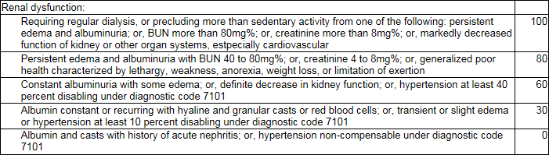  Discuss: Briefly discuss the evaluation criteria, note that we will talk more about dialysis, the BUN, and creatinine next.
Genitourinary: Kidney Cancer  Slide 19 | - Rating considerations for rating under renal dysfunction:  - Evaluating renal conditions using Blood Urea Nitrogen (BUN)  Discuss: Because BUN values can vary due to many factors, do not use elevated blood urea nitrogen (BUN) levels between 20mg% and 40mg% to support a finding of definite decrease in kidney function for assignment of a 60-percent disability evaluation for a renal disability.  Elevated BUN of 40mg% or greater can be used to support an evaluation of 80 or 100 percent for renal disease as described in 38 CFR 4.115a.  When the BUN is elevated at greater than 20mg% but less than 40mg%, do not enter the BUN value in the Evaluation Builder or use this value alone to support a finding of definite decrease in kidney function.  - Evaluating renal conditions using creatinine  Discuss: Creatinine levels above normal but less than 4mg% are abnormal and indicate decreased renal function that would warrant a 60-percent evaluation.  Normal creatinine levels vary between men and women and by laboratory. The lab report should note the normal level used by that particular laboratory for the patient.  Example: A Veteran files for an increased evaluation of his SC renal disease, evaluated as renal dysfunction. He submits a lab report, which notes the lab’s highest normal level is 1.2mg%. The Veteran’s results show a creatinine level of 1.4mg%.  Result: Assign a 60-percent evaluation for renal dysfunction under 38 CFR 4.115b.  - Limits on separate evaluation of nephritis and cardiovascular conditions with exceptions of kidney removal and regular dialysis  Show and Discuss: 38 CFR 4.115 – Nephritis  Show and Discuss: M21-1 III.iv.4.I.3.p – Limits on Separate Evaluation of Nephritis and Cardiovascular Conditions. Emphasize that unless regulatory exceptions are met, hypertension and nephritis cannot be separately evaluated. Note that it is a common error in the field to assign separate evaluations when hypertension was not used to support the evaluation under renal dysfunction; however, 38 CFR 4.115 prohibits such action.  - Annual review of evaluations based on hemodialysis  Discuss: Each year RO’s must review 100 percent evaluations that are based on the need for regular hemodialysis to determine whether the Veteran has discontinued hemodialysis because of kidney transplant surgery.  Note that the M21 provides a “Step and Action” chart. Emphasize the RO will automatically receive a work item for cases that contain a single 100 percent genitourinary evaluation.
Genitourinary: Kidney Cancer  Slide 20 | - Paired organs: Loss of loss of use of one kidney as a result of SC disability and involvement of the other kidney as a result of NSC disability.  - Kidney transplant may be required for treatment: (Note the minimum evaluation)  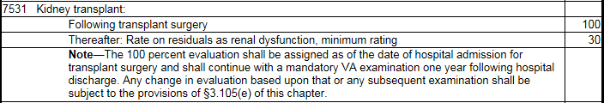
Genitourinary: Bladder Cancer  Slide 21 | Discuss: The majority of bladder cancers are diagnosed at an early stage, when the cancer is highly treatable. Early-stage bladder cancer is likely to recur, however.  Testing for bladder cancer includes cystoscopy, biopsy, urine cytology, and imaging tests.  Treatment for bladder cancer may include surgery to remove the tumor, immunotherapy, chemotherapy, radiation therapy, removal of the entire bladder (radical cystectomy), or suprapubic cystostomy.  Note that if a radical cystectomy occurs, the prostate and seminal vesicles are also typically removed. Decision makers should review the evidence to determine if a radical prostatectomy, in fact, occurred as part of the surgery to treat the SC bladder cancer. Entitlement to special monthly compensation (k) based on loss of use of a creative organ may be warranted.  Note that complications and treatment may involve the surgical opening of the bladder with insertion of a catheter to drain urine out of the body through the skin (suprapubic cystostomy). Postoperative cystostomy warrants a 100 percent evaluation.  - Bladder cancer is evaluated under DC 7528. Residuals will likely involve voiding dysfunction (urine leakage, frequency, obstructed voiding).  - Suprapubic cystostomy (DC 7516):
Digestive: Liver Cancer  Slide 22 | Discuss: Cancer that spreads to the liver (metastatic) is more common than cancer that begins in the liver cells. Decision makers should review the evidence to determine if the diagnosed liver cancer is that of a primary cancer before granting.  Testing for liver cancer includes blood tests, imaging, and liver biopsy.  Treatment for liver cancer may involve removal of the tumor, liver transplant, radiation, and chemotherapy.  Note that it is likely that the treatment for liver cancer is palliative in nature. Liver transplant may not be a viable treatment option. Decision makers should review the evidence to determine if a permanent and total evaluation should be awarded  - Liver cancer is evaluated under DC 7343:  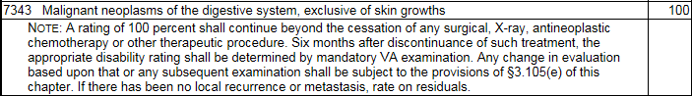  - Residuals of injury to the liver (DC 7311):  Show and Discuss: 38 CFR 4.114 - Schedule of Ratings for the Digestive System. Note that residual disability may involve any number of potential diagnostic codes. Starting with DC 7311 is a good option to direct decision makers to potential diagnostic codes.
Digestive: Liver Cancer  Slide 23 | - Rating considerations for rating under the digestive system:  - 38 CFR 4.113 – Coexisting abdominal conditions  - 38 CFR 4.114 – Single evaluation under predominant disability  Show and Discuss: M21-1 III.iv.4.I.1.b.  Remind decision makers that there is a prohibition of separate evaluations for certain co-existing digestive disabilities, so a comprehensive review of previously SC disabilities should be accomplished prior to establishing residual disability based on liver cancer that is in remission.  Briefly show the “Step and Action” chart at M21-1 III.iv.4.I.1.c. Remind the decision makers to review this reference when co-existing digestive disabilities exist to ensure the appropriate predominant disability and evaluation is assigned.
Digestive: Liver Cancer  Slide 24 | - Liver transplant may be required for treatment: (Note the minimum evaluation)  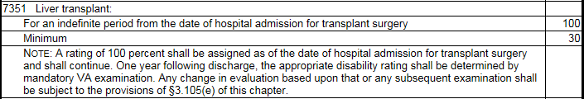  - If not already at a total evaluation, lengthy hospitalization may be required while waiting for a liver transplant. 38 CFR 4.29  Discuss: Veterans with liver cancer may require lengthy hospitalization due to advanced illness and liver failure. Review for periods of hospitalization in excess of 21 days.
Hemic: Adult Leukemia  Slide 25 | Discuss: There are four main types of leukemia: Acute myeloid leukemia (AML); Chronic myeloid leukemia (CML); Acute Lypmhocytic Leukemia (ALL); and Chronic Lymphocytic Leukemia (CLL).  Advise decision makers that all forms of leukemia are subject to presumptive service connection under 38 CFR 3.309(f). It does not matter what type of leukemia is diagnosed or the fact the word “adult” is included in the regulation.  Remind decision makers about the permanency of CLL. Advise that certain types of leukemia are chronic by their very nature and would also warrant a permanent evaluation. If not shown by the evidence of record, a medical opinion may be needed to determine if a certain type of leukemia is considered an incurable malignancy.  Note that following cessation of treatment, residual disability is evaluated as either anemia or aplastic anemia.  - Leukemia is evaluated under DC 7703:  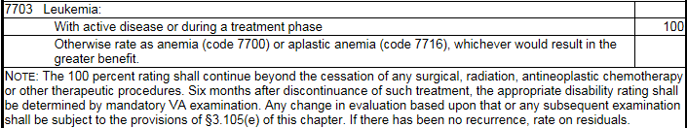  - Chronic Lymphocytic Leukemia (CLL): Assign a P&T evaluation for CLL. CLL is considered an incurable malignancy.
Hemic: Aplastic Anemia  Slide 26 | - Aplastic anemia is evaluated under DC 7716:  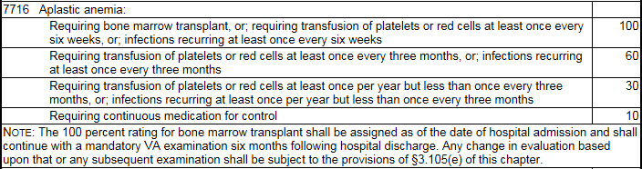  Discuss: Aplastic anemia is a condition that occurs when the body stops producing enough new blood cells. Aplastic anemia carries a higher risk of infections.  Treatment for aplastic anemia may include medications, blood transfusions or a stem cell transplant, also known as a bone marrow transplant.  As noted in the rating schedule, a review of all evidence to determine instances of recurrent infections and frequency of transfusions will be requried to provide an accurate evaluation. Note and discuss the temporary 100 percent evaluation for bone marrow transplant.
Hemic: Myelodysplastic Syndrome  Slide 27 | - Myelodysplastic syndromes (MDS) are a group of closely related diseases in which the bone marrow produces too few functioning:  - red blood cells  - white blood cells  - platelets, or  - any combination of the three.  - MDS will be rated as aplastic anemia under DC 7716, if the MDS progresses to leukemia, evaluate as leukemia under DC 7703.
Lymphatic: Non-Hodgkin’s Lymphoma  Slide 28 | - Non-Hodgkin’s lymphoma (NHL) is evaluated under DC 7715:  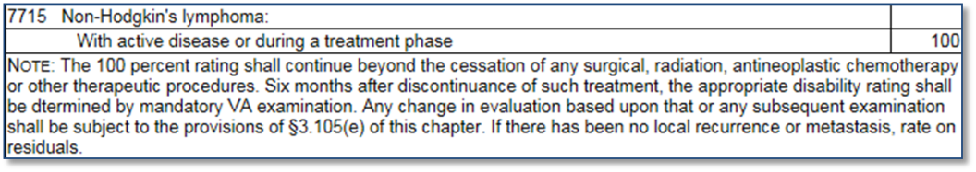  - If the disease has actively persisted for several years, thoroughly examine the medical record to determine whether the disease is:  - actually in remission  - still active and being regularly treated over extended periods of time.  Show and Discuss: M21-1 IV.ii.2.C.3.p – Subcategories of NHL Qualifying for Presumptive SC.  Note that presumptive service connection is warranted if the evidence shows a diagnosis of any of the subcategories of low, intermediate, or high-grade lymphona listed in the table.
Lymphatic: Mutiple Myeloma  Slide 29 | Discuss: Multiple myeloma causes cancer cells to accumulate in the bone marrow, where they crowd out healthy blood cells. Rather than produce helpful antibodies, the cancer cells produce abnormal proteins that can cause kidney problems.  - Multiple myeloma is evaluated analogous to Hodgkin’s disease under DC 7799-7709:  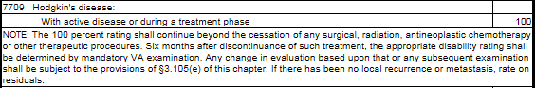  - Multiple myeloma is considered an incurable malignancy and generally requires a permanent and total evaluation.  - There may be rare exceptions when the evidence clearly shows the multiple myeloma is no longer active.
Neurological: Parkinson’s Disease  Slide 30 | Discuss: Parkinson’s disease is a chronic, slowly progressive central nervous system disorder characterized by muscular rigidity, a tremor of resting muscles, slow and decreased voluntary movements and positional instability. An outdated term for Parkinson’s disease is paralysis agitans.  - Parkinson’s disease is evaluated under paralysis agitans - DC 8004:  - The 30 percent evaluation will be assigned until complications can be separately evaluated and provide an evaluation of higher than 30 percent.  Discuss: Complications and symptoms may include:  - muscular aches and fatigue  - mask-like expression with open mouth  - drooling  - stooped posture  - gait characterized by involuntary, short, accelerating steps  - difficulty in walking  - loss of postural reflexes (tendency to fall forward or backward with respective shift in center of gravity)  - speech manifestations – specifically low speech volume with stuttering or slurred speech, or uniformity of tone and high pitch, and  - dysphagia.  A whole range of body systems are often involved in the evaluation as Parkinson’s disease progresses. (Neurological, Musculoskeletal, Organs of Special Sense, Genitourinary, Mental). Give careful consideration to SMC in cases of Parkinson’s disease, particularly losses of use and A&A.  Show and discuss: Parkinson’s Disease Disability Benefits Questionnaire.  Remind decision makers that when dealing with cranial nerves, same are evaluated unilaterally. SC may be warranted for a right fifth cranial nerve and a left fifth cranial nerve.
Neurological: Parkinson’s Disease  Slide 31 | - Evaluate residual disability similar to MS:  - Evaluate each affected body system or body part separately  - Show the DC for Parkinson’s only once by listing with the most severely affected function  - Code involvement of other manifestations under their specific DC and show as secondary to PD.  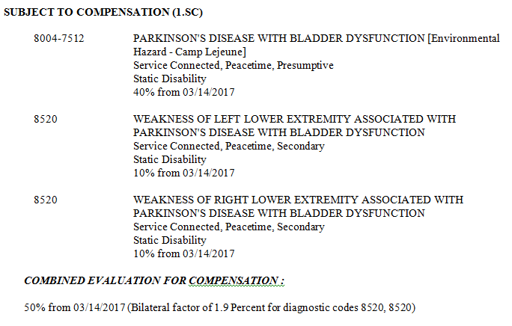  Note: Tell decision makers that we will demonstrate how to evaluate residual disability of Parkinson’s disease at the end of the lesson. At that time, we will tie in the effective date and other language requirements.

Topic 4: Effective Date
Introduction | This topic will discuss applicable effective dates for the grant of CLCW presumptive service connection under 38 CFR 3.309(f).
Time Required | 0.25 hours
OBJECTIVES/  Teaching Points  Effective Date: March 14, 2017  Slide 32 | Topic objectives and teaching points to support the topic objective:  - The trainee will be able to apply 38 CFR 3.114 to determine the applicable effective date for CLCW presumptive disabilities.  Discuss: As we have mentioned, consideration for direct service connection may still be warranted for pending claims received prior to the change in law.  Claims received March 14, 2017 and after, will be subject to consideration under liberalizing legislation for effective date puposes.
38 CFR 3.114: Liberalizing Law  Slide 33 | - If criteria for eligibility for the liberalized benefit were met from the date of the law change, and  - reviewed by VA or claimed by Veteran within one year of law change, effective date is date of law change.  - reviewed by VA or claimed by Veteran more than one year after law change, effective date is one year prior to date of VA review/date of claim.
Scenario  Slide 34 | The Veteran submits a claim for liver cancer on January 30, 2018. His DD-214 shows that he served honorably in the Marine Corps from 3/13/65 to 5/26/67. Personnel records show the Veteran was stationed at Camp Lejeune from April 1965 to September 1965.  In support of his claim he submits private treatment records that include laboratory tests confirming a diagnosis of liver cancer on August 9, 2014. Current treatment includes palliative chemotherapy. The Veteran is considered terminal.  What rating action should be taken?
Answer  Slide 35 | Grant service connection for liver cancer with an evaluation of 100% Effective March 14, 2017, the date of law change. The claim was received within one year of March 14, 2017 and the Veteran was diagnosed with liver cancer at the time of the change in law. DEA is warranted.  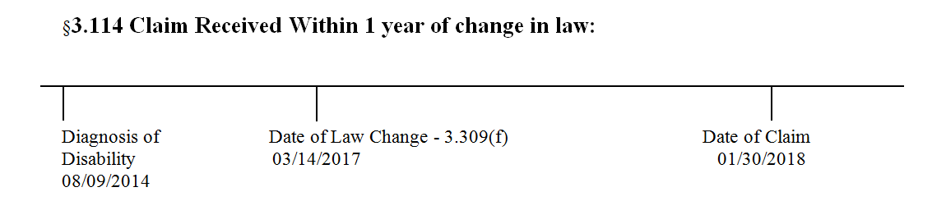  Instructor Note: Give an example of a future claim more than one year after the date of law change where we will grant effective one year prior to the date of claim based on 38 CFR 3.114(a)(3).

Topic 5: Rating Requirements
Introduction | This topic will introduce the trainee to the required language that must be included in rating decision grants and denials.
Time Required | 0.25 hours
OBJECTIVES/  Teaching Points  Rating Requirements  Slide 36 | Topic objectives and teaching points to support the topic objective:  - The trainee will be able to identify the required language that must be included in rating decision grants and denials and where to access the text.  Discuss: All grants and denials require specially approved language to be inserted into the rating decision document; and, in some cases, the notification letter.  Note that the appropriate text is included in the M21 so knowing where to access the information is imperative.  The required language will not be coded as glossary text in VBMS-R until the next scheduled VBMS-R update in November 2017.
Rating Requirements  Slide 37 | - When awarding or denying a claim due to exposure to contaminants in the Camp Lejeune water supply users must:  - select the appropriate reason(s) for awarding or denying the claim in the DECISION BASIS  - affix the Environmental Hazard-Camp Lejeune special issue in VBMS-R, and  - insert the appropriate text as provided in M21-1 IV.ii.2.C.6.i or j.  Emphasize: The special issue in VBMS-R must be affixed for both grants and denials.
Rating Requirements: Grants  Slide 38 | - If awarding a Camp Lejeune claim on a presumptive basis, the following text must be included in both the RATING NARRATIVE and NOTIFICATION LETTER user text fields:  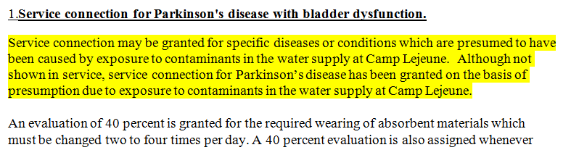  Emphasize: In addition to copying the text in the reasons for decision, decision makers must also place the text in Box 4 in order for same to be incorporated into the notification letter.
Rating Requirements: Denials  Slide 39 | - If denying a Camp Lejeune claim on a presumptive basis, the following text must be included in the RATING NARRATIVE field:  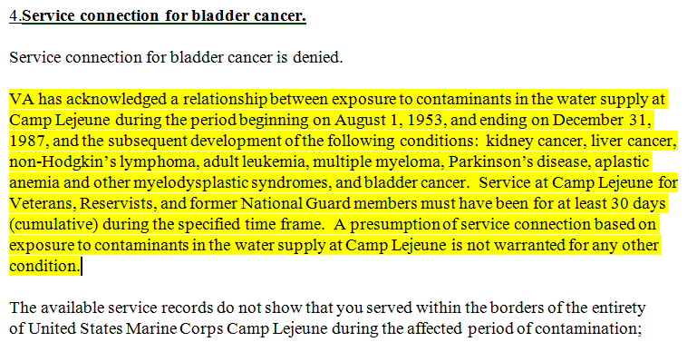
Rating Requirements: Denials  Slide 40 | - If denying a Camp Lejeune claim on a presumptive basis, all applicable denial reasons must be included in both the RATING NARRATIVE and NOTIFICATION LETTER user text fields:  - The claimed disability is not a condition associated with exposure to contaminants at Camp Lejeune.  - The Veteran did not serve at Camp Lejeune.  - VA received a negative SME medical opinion.  - The Veteran’s Camp Lejeune service was for less than 30 Days.  - There is no diagnosis of the claimed condition.  Show and Discuss: M21-1 IV.ii.2.C.6.j – Documenting Decisions to Deny Camp Lejeune Claims. Emphasize the “Notes” at the end of the block.  Emphasize the following: If the negative SME opinion is determined to rebut the presumption of SC as discussed in M21-1, Part IV, Subpart ii, 2.C.6.e, users must free text an explanation of how the evidence supports the decision.
VBMS-R Demonstration | Demonstrate: Replicate the above decision in VBMS-R Demo.  This will allow decision makers to observe how to establish the most severely affected function and other manifestations of PD appropriately.  In addition, this demonstration will show how to obtain the appropriate liberalizing legislation effective date language using the effective date builder; demonstration of Camp Lejeune special issue indicator; and, required narrative text.

Lesson Review, Assessment, and Wrap-up
Introduction | The Camp Lejeune Presumptive Regulation course is complete.
Time Required | 0.25 hours
Lesson Objectives | Review each lesson objective and ask the trainees for any questions or comments.  You have completed the Camp Lejeune Presumptive Regulation course.  You should be able to:  - Demonstrate a comprehension of the requirements for presumptive service connection (Diseases associated with exposure to contaminants in the water supply at Camp Lejeune)  - Understand the Regional Office and Centralized claims processing requirements  - Identify rating considerations and criteria for the eight presumptive disabilities  - Apply the liberalizing legislation effective date regulation  - Recognize and understand the rating decision and notification letter requirements
Assessment | Remind the trainees to complete the online assessment in TMS to receive credit for completion of the course.  The assessment will allow the participants to demonstrate their understanding of the information presented in this lesson.  The survey will allow participants to provide feedback on how Compensation Service can enhance the training course.

