Contaminants in Water Supply: Camp Lejeune Presumptive Regulation (RVSR)
Trainee Handout

Table of Contents

Objectives 2
References 2
Topic 1: Background and Regulation 3
Topic 2: Claim Processing 5
Topic 3: Presumptive Disabilities – Schedule of Ratings 10
Topic 4: Effective Date 20
Topic 5: Rating Requirements 21

Objectives
This lesson is intended to provide decision makers with instruction regarding the Camp Legeune contaminated water presumptive regulation. This lesson will contain discussions and exercises that will allow you to accomplish the following lesson objectives:

- Demonstrate comprehension of the requirements for presumptive service connection (Diseases associated with exposure to contaminants in the water supply at Camp Lejeune)

- Understand the Regional Office and Centralized claims processing requirements

- Identify rating considerations and criteria for the eight presumptive disabilities

- Apply the liberalizing legislation effective date regulation

- Recognize and understand the rating decision and notification letter requirements

References
All CFR references are found in the eCFR Website for Part 3; Part 4; and Part 17.
All M21-1 references are found in the Live Manual Website.

- 38 CFR 3.307(a)(7): Diseases associated with exposure to contaminants in the water supply at Camp Lejeune
- 38 CFR 3.309(f): Diseases associated with contaminated water supply at Camp Lejeune
- 38 CFR 3.114: Change of law or Department of Veterans Affairs issue
- 38 CFR 3.383: Special consideration for paired organs
- 38 CFR Part 4: Schedule for Rating Disabilities
- 38 CFR 17.400 – Hospital care and medical services for Camp Lejeune Veterans
- M21-1 Part III, Subpart iv, 4 – Rating specific disabilities
- M21-1 Part IV, Subpart ii, 1.I.7 – Developing claims based on exposure to contaminants in the water supply at Camp Lejeune
- M21-1 Part IV, Subpart ii, 2.C.6 – Disabilities resulting from exposure to contaminants in the water supply at Camp Lejeune

Topic 1: Background and Regulation
In September 2016, VA published a rule proposing to create a presumption of service connection for eight diseases associated with contaminants present in the base water supply at U.S. Marine Corps Base Camp Lejeune, North Carolina.
Effective March 14, 2017, eight presumptive diseases were added to 38 CFR 3.309(f), for
- service members, former reservists, National Guard members on official orders, who served
- 30 days (consecutive or nonconsecutive) at Camp Lejeune, between
- August 1, 1953 to December 31, 1987

Service Requirements:

Official orders include any official service department records that confirm no less than 30 days at Camp Lejeune.

Under 38 CFR 3.307(a)(7), former reservists and National Guard members are presumed to have been exposed to contaminants in the water supply between August 1, 1953, and December 31, 1987, if their official service department records includes orders or other records of no less than 30 days service (consecutive or nonconsecutive) at Camp Lejeune during the contamination period. This presumption applies even if the only qualifying service at Camp Lejeune occurred during a period of training. If the claimant’s National Guard or Reserve duty at Camp Lejeune does not meet the requirements under 38 CFR 3.307(a)(7)(iii), there is no presumption of exposure; and therefore, Veteran status is not conferred.

Camp Lejeune includes the Marine Corps Air Station New River. In addition, military records may also show service in the following areas which are also considered within the borders of Camp Lejeune:

- Camp Geiger
- Camp Johnson
- Naval Hospital Camp Lejeune
- Tarawa Terrace
- Camp Knox
- Montford Point
- Stone Bay / Rifle Range
- Holcomb Boulevard, and
- Hadnot Point

Camp Lejeune service does not include service at MCAS Cherry Point.

Important: If service treatment records (STRs) document an official visit for medical treatment within the defined borders of Camp Lejeune, the episode of treatment counts as one day at Camp Lejeune. For example, if a Veteran’s official service personnel records listed his/her official duty station as Marine Corps Air Station Cherry Point, NC, but STRs indicate he/she received medical treatment at Camp Lejeune, each date of treatment should be counted as a day served at Camp Lejeune for the purposes of processing a claim for service connection based on exposure to contaminants in the water supply at Camp Lejeune.
Presumptive Disabilities:

Under 38 CFR 3.309(f), VA acknowledges the following disabilities to have a relationship with exposure to contaminants in the Camp Lejeune water supply during the period beginning on August 1, 1953, and ending on December 31, 1987:

- kidney cancer
- liver cancer
- non-Hodgkin’s lymphoma
- adult leukemia
- multiple myeloma
- Parkinson’s disease
- aplastic anemia and other myelodysplastic syndromes, and
- bladder cancer.

A presumption of SC based on exposure to contaminants in the water supply at Camp Lejeune is not warranted for any other condition, but may be established on a direct basis, if warranted by the facts of the case.

Question:
A Veteran who served honorably in the Marine Corps filed a claim for service connection for multiple myeloma due to CLCW on April 1, 2017.
Service department records showed service at Camp Geiger for a period in excess of 30 days from June 2010 through September 2013.
Treatment records confirm a diagnosis of multiple myeloma.
Is presumptive service connection warranted?

- Yes
- No

Topic 2: Claim Processing
ROJ Jurisdiction

All ROJs are responsible for verifying Veteran status and any service at Camp Lejeune during the contamination period between August 1, 1953 and December 31, 1987. ROJs are also responsible for developing for a diagnosis, to include medical evidence, and sending a subsequent development letter identified in M21-1 IV.ii.1.I.7.j

The ROJ must retain jurisdiction of a Camp Lejeune claim when:
- the Veteran did not serve at Camp Lejeune between August 1, 1953, and December 31, 1987
- the claim is for a disability recognized under 38 CFR 3.309(f) and
  - the Veteran had at least 30 days of service at Camp Lejeune during the contamination period, or
  - the evidence does not establish a diagnosis of the claimed condition
- no disability is specifically claimed as a result of exposure, such as claims stating “Camp Lejeune” or “exposure at Camp Lejeune”
- Veteran status needs to be established, such as a character of discharge determination, or
- the only claim is for a disability of a dependent, including birth defects.

Centralized Jurisdiction

The ROJ will route the following Camp Lejeune claims for centralized processing at Louisville:
- a diagnosed disability recognized under 38 CFR 3.309(f) with at least one, but less than 30 days of service at Camp Lejeune, OR
- a condition recognized under 38 CFR 17.400, with at least one day of Camp Lejeune service, OR
- any other disability specifically claimed as due to exposure at Camp Lejeune with at least one day of service during the contamination period.
Note: If a claimed condition is listed at either 38 CFR 3.309(f) or at 38 CFR 17.400, service at Camp Lejeune during the contamination period does not have to be expressly claimed and may otherwise be established by the evidence of record.

If the claim is for … | And evidence shows … | And military records document during the contamination period … | Then the claim is decided by the …
a condition recognized under 38 CFR 3.309(f) | a diagnosis of a 3.309(f) condition | 30 days or more of service at Camp Lejeune | ROJ.
 |  | at least one, but less than 30 days of service at Camp Lejeune | Louisville RO.
 |  | no Camp Lejeune service. | ROJ.
 | no diagnosis | n/a | ROJ.
a condition not recognized under 38 CFR 3.309(f), but recognized for healthcare purposes under 38 CFR 17.400 | n/a | no Camp Lejeune service | ROJ.
 |  | at least one day of Camp Lejeune service | Louisville RO.
any other disability claimed specifically as due to exposure at Camp Lejeune | n/a | no Camp Lejeune service | ROJ.
 |  | at least one day of Camp Lejeune service | Louisville RO.

Once a claim has been flashed and routed for centralized processing by the NWQ, the centralized processing site is responsible for all additional development, rating, authorization, and appeal activity.

Other Centralized Sites
The following types of claims qualify for other specialized centralized processing and will not be processed by the Louisville RO:

- Veterans residing in foreign territories
- original pre-discharge claims
- restricted access claims, and
- other specific special mission claims, as needed.

Stages of claims processing handled by the centralized RO:

Stage | Description
1 | Ensures Camp Lejeune service information and flash are accurate.
2 | Ensures any subsequent development letter as noted in M21-1 Part IV, Subpart ii, 1.I.7.j has been sent to the claimant.
3 | Requests Veterans Health Administration (VHA) subject matter expert (SME) review, when needed
4 | Decides all claimed issues and sends notice of the decision to the claimant.
5 | Retains jurisdiction for any appeals received on Camp Lejeune claims and all other non-Camp Lejeune claims and/or appeals received during the one-year appeal period

VHA SME Review

Prior to finalizing the regulations allowing for presumptive SC, VBA referred CLCW claims to VHA for a subject matter expert (SME) review. These opinions must be weighed to determine if

- SC can be established on a direct basis prior to the date the final presumptive regulation became effective, or
- if the opinion sufficiently rebuts the presumption as discussed in 38 CFR 3.307(d).

VHA SME review is required in the following claims:

- 38 CFR 3.309(f) disability with less than 30 days Camp Lejeune service
- any disability claim with
  - at least one day of verified service at Camp Lejeune service during the contamination period, and
  - evidence sufficient to warrant an examination under 38 CFR 3.159.
- chronic disability recognized for healthcare under 38 CFR 17.400 with at least one day of verified service at Camp Lejeune service during the contamination period

Exception: If the only service at Camp Lejeune was with a National Guard or reserve unit while on active duty for training or inactive duty for training, do not request a SME review.

Rebutting the Presumption of Service Connection

A negative VHA SME opinion may be sufficient to deny direct service connection, but it is not necessarily sufficient to rebut a presumption for an otherwise qualified claim under 38 CFR 3.307(a)(7).

The presumption of SC may not be rebutted using an opinion that does not:

- consider the entire record, and/or
- consider relevant evidence that post-dates the opinion
- has a negative finding of causation with respect to in-service exposure by itself (unaccompanied by medical evidence and sound medical reasoning to support the opinion)
- identifies an intercurrent cause but does not establish that the intercurrent cause is the sole cause of the disease, to the exclusion of in-service exposure as a contributory cause
- explain why a potentially intercurrent cause makes the presumptive cause of the disability medically unlikely
- relies on the “preponderance of the evidence” to rebut the presumption, as this level of proof is not sufficient to establish affirmative evidence contrary to the presumption.

Example: A Veteran files a claim for bladder cancer. Service records establish service at Camp Lejeune. The RO obtains a SME opinion which discusses the National Research Council's 2009 report and the Veteran’s other risk factors. The SME concludes that the weight of scientific and medical evidence supports that it is less likely than not that exposure to contaminated water at Camp Lejeune was causative of the development of the Veteran’s bladder cancer, and that his subsequent occupational exposure and cigarette smoking would be more likely the contributor to his bladder cancer.
Result: The decision maker finds the presumption is not rebutted and awards SC for bladder cancer under 38 CFR 3.307. In the decision, the decision maker explains the opinion fails to consider all relevant evidence and does not account for changed medical understandings as it did not consider other relevant studies that were the basis of the new presumptive rulemaking.
Additionally, the opinion does not discuss whether the other risk factors were the sole cause of the condition. Finally, the opinion switches between statements of causation and contribution. Therefore, the opinion applies an incorrect standard and only provides a negative opinion regarding in service exposures, which is arguably insufficient by itself to rebut the presumption of service connection.

Presumptive SC can be rebutted under 38 CFR 3.307(d). The medical evidence to rebut the presumption of SC need not be conclusive, but must meet a higher standard and must include:

- affirmative evidence of an intercurrent cause, and
- sound medical reasoning, and
- be based on consideration of all evidence of record.

Example: A Veteran files a claim for chronic myeloid leukemia (CML). Service records establish service at Camp Lejeune. The RO obtains a SME opinion that identifies a chromosomal abnormality as the intercurrent cause of the Veteran’s disease and specifically states it is less likely than not that the diagnosis of CML is related to contamination in the ground water at Camp Lejeune.

Result: The decision maker determines the evidence is sufficient to rebut the presumption of SC under 38 CFR 3.307 and denies the claim. In the decision, the decision maker explains the opinion sufficiently and affirmatively identifies an intercurrent cause of the Veteran’s disease, in this case an abnormal chromosome, and also provides a specific negative finding of causation with respect to in service exposures.

Question:
A Veteran who served honorably in the Marine Corps filed a claim for service connection for breast cancer on March 21, 2017. Breast cancer is not a presumptive disability codified at 38 CFR 3.309(f) and the Veteran did not claim exposure to CLCW.
Service department records showed service at Camp Lejeune for a period 7 days in 1973.
Should this claim be processed by the ROJ or sent for centralized processing.
- ROJ
- Centralized

Topic 3: Presumptive Disabilities – Schedule of Ratings
Kidney Cancer

Kidney cancer is evaluated under DC 7528.
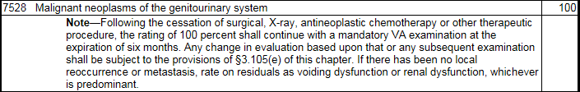
Single kidney cancer may be treated with nephrectomy.
When evaluating a single kidney cancer, consider 38 CFR 3.383, Special consideration for paired organs and extremities.
Compensation is payable for the combinations of service-connected and nonservice-connected disabilities as if both disabilities were service-connected, provided the nonservice-connected disability is not the result of the veteran's own willful misconduct.
If there is loss or loss of use of one kidney as a result of service-connected disability and involvement of the other kidney as a result of nonservice-connected disability, compensation is payable as if both were service-connected.

If both kidneys are diseased, long-term dialysis may be required. Regular dialysis is evaluated under renal dysfunction and warrants a 100 percent evaluation
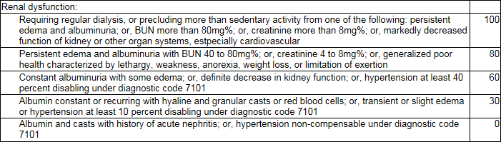
Each year regional offices (ROs) must review 100-percent evaluations that are based on the need for regular hemodialysis to determine whether the Veteran has discontinued hemodialysis because of kidney transplant surgery. Refer to M21-1 III.iv.4.I.3.t – Annual Review of Evaluations Based on Hemodialysis, for more information.

Evaluating renal conditions using Blood Urea Nitrogen (BUN):
Do not use elevated blood urea nitrogen (BUN) levels between 20mg% and 40mg% to support a finding of definite decrease in kidney function for assignment of a 60-percent disability evaluation for a renal disability. BUN values can vary due to many factors such as
- age and sex of the individual
- blood loss through the gastrointestinal tract
- use of steroids for treatment of other chronic diseases
- level of hydration in the body, and
- the prescription of too much protein for patients receiving intravenous nutrition in the hospital.
BUN testing is typically employed to screen for kidney disease or for a general assessment of the condition of the kidneys. BUN is analyzed with respect to the other laboratory values such as creatinine and the glomerular filtration rate (eGFR) to provide a better assessment of kidney function.
Important:
- Elevated BUN of 40mg% or greater can be used to support an evaluation of 80 or 100 percent for renal disease as described in 38 CFR 4.115a.
- When the BUN is elevated at greater than 20mg% but less than 40mg%, do not enter the BUN value in the Evaluation Builder or use this value alone to support a finding of definite decrease in kidney function.
Evaluating renal conditions using creatinine:
Creatinine is a normal breakdown product from muscle which the kidneys cleanse from blood. As the kidneys become impaired, the creatinine level in the blood will increase due to poor clearance of creatinine by the kidneys.
Creatinine levels above normal but less than 4mg% are abnormal and indicate decreased renal function that would warrant a 60-percent evaluation.
Important: Normal creatinine levels vary between men and women and by laboratory. The lab report should note the normal level used by that particular laboratory for the patient.
Example: A Veteran files for an increased evaluation of his SC renal disease, evaluated as renal dysfunction. He submits a lab report, which notes the lab’s highest normal level is 1.2mg%. The Veteran’s results show a creatinine level of 1.4mg%.
Result: Assign a 60-percent evaluation for renal dysfunction under 38 CFR 4.115b.

Limits on Separate Evaluation of Nephritis and Cardiovascular Conditions:
38 CFR 4.115 states that separate ratings cannot be assigned for disability from disease of the heart and any form of nephritis.
The rationale is that there is a close interrelationship between cardiovascular disabilities and nephritis.

Example:
7101 | Hypertension | 10
7502 | Nephritis | 60

This would not be permitted under 38 CFR 4.115 even if the nephritis evaluation was supportable based on definite decrease in renal function.
Exceptions: Separate ratings for any hypertension or heart disease are permitted in the following scenarios:
Chronic renal disease has progressed to the point where regular dialysis is required.
If absence of a kidney is the sole renal disability – even if removal was required because of nephritis.

Example:
7500 | Kidney – removal of one | 30
7101 | Hypertension | 20

Example:
7530 | Nephritis | 100
7101 | Hypertension | 10

Kidney transplant may be required for treatment.:
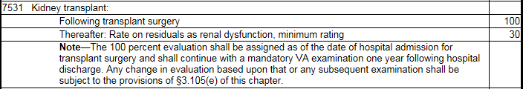
Bladder Cancer

Bladder cancer is evaluated under DC 7528. Residuals will likely involve voiding dysfunction (urine leakage, frequency, obstructed voiding).
Suprapubic cystostomy (DC 7516) may be performed as a complication of bladder cancer.

Liver Cancer
Liver cancer is evaluated under DC 7343.
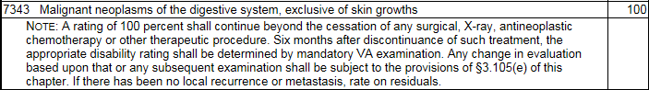
A number of diagnostic codes may be used to evaluate residuals of liver cancer that is in remission. Residuals of injury to the liver (DC 7311).
38 CFR 4.114 – Prohibition of Separate Evaluations for Certain Coexisting Digestive Disabilties
Evaluations of digestive conditions under certain diagnostic codes (DCs) will not be combined with each other or assigned separate evaluations. These are:
7301 to 7329, inclusive (meaning all the DCs from 7301 to 7329)
7331
7342, and
7345 to 7348, inclusive (meaning all the DCs from 7345 to 7348).

When there are coexisting digestive disabilities for which multiple evaluations cannot be assigned
- a single rating will be assigned under the DC which reflects the predominant disability, and
- that evaluation will be elevated to the next higher evaluation, when the severity of the overall disability warrants it.
The Veterans Benefits Management System – Rating (VBMS-R) Evaluation Builder is programmed to appropriately apply the provisions of 38 CFR 4.114 but it is critical that
- the user input the symptoms that support the elevation, and
- the symptoms coincide with the criteria listed in the rating schedule.
For instructions on proper application of the 38 CFR 4.114 provision on assigning an evaluation in cases of multiple qualifying coexisting digestive disabilities see the table below.

Step | Action
1 | Determine which of the coexisting digestive conditions is the predominant disability.  Important:  To determine the predominant disability, determine the evaluation each condition would support on its own. The condition that has the highest disability evaluation is the predominant disability.  If the same evaluation would be assigned to each, go through the analysis in the steps, alternatively treating each condition as the predominant one to see if one alternative provides a more advantageous outcome to the Veteran.
2 | Determine if there are symptoms of the non-predominant disability that do not overlap with those of the predominant disability.  If yes, go to Step 3.  If no, go to Step 4.
3 | Reevaluate the predominant disability but this time also consider the non-overlapping symptoms of the non-predominant disability.  Important: The non-overlapping symptoms must support a higher evaluation when applied to the DC criteria being utilized for the predominant disability.  Determine if the resultant evaluation is higher than the evaluation for the symptoms of the predominant disability alone (as derived in Step 1).  If yes, go to Step 5.  If no, go to Step 4.
4 | Rate the coexistent disabilities together under the rating criteria for the predominant disability without elevation to the next higher evaluation.  No further action necessary.
5 | Rate the coexistent disabilities together under the rating criteria for the predominant disability and elevate to the next higher evaluation.  No further action necessary.

Important: The “next higher level of evaluation” is the lowest evaluation specified in the DC for the predominant disability that provides greater compensation than the evaluation derived in Step 1 (the evaluation that would be supported by only the symptoms of the predominant disability without the symptoms of the lesser disability). Do not simply add 10 percent.

Liver transplant may be required for treatment (DC 7351).
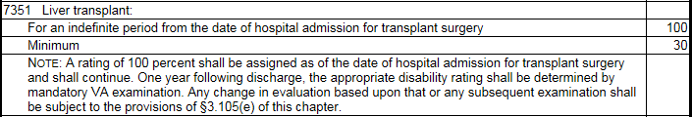
If not already at a total evaluation, lengthy hospitalization may be required while waiting for a liver transplant. Claims should be reviewed for consideration of a temporary total evaluation under 38 CFR 4.29:
§4.29 Ratings for service-connected disabilities requiring hospital treatment or observation.
A total disability rating (100 percent) will be assigned without regard to other provisions of the rating schedule when it is established that a service-connected disability has required hospital treatment in a Department of Veterans Affairs or an approved hospital for a period in excess of 21 days or hospital observation at Department of Veterans Affairs expense for a service-connected disability for a period in excess of 21 days.

Aplastic Anemia and other Myelodysplastic Syndromes
Aplastic anemia is evaluated under DC 7716:
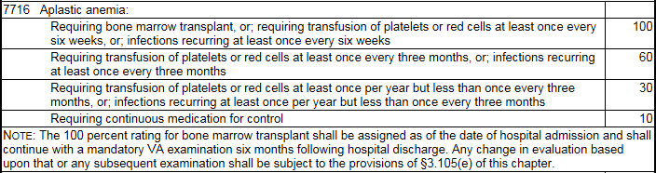
Myelodysplastic syndromes (MDS) are a group of closely related diseases in which the bone marrow produces too few functioning red blood cells, white blood cells, platelets, or any combination of the three. MDS is rated as aplastic anemia under DC 7716, if the MDS progresses to leukemia, evaluate as leukemia under DC 7703.

Non-Hodgkin’s Lymphoma (NHL)
Non-Hodgkin’s lymphoma (NHL) is evaluated under DC 7715:
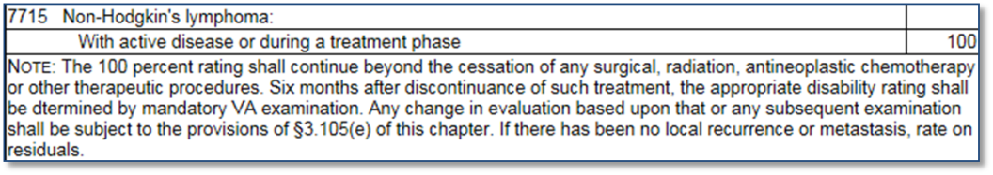
If the disease has actively persisted for several years, thoroughly examine the medical record to determine whether the disease is actually in remission or still active and being regularly treated over extended periods of time.
Presumptive service connection is warranted if the evidence shows a diagnosis of any of the subcategories of low, intermediate, or high-grade lymphona listed in the table.

Low Grade Lymphoma | Intermediate Grade Lymphoma | High Grade Lymphoma
Small lymphocytic with plasmacytoid features | Diffuse, small and large | Diffuse, small and large
Small lymphocytic lymphoma and B-cell CLL | Diffuse, small cleaved | Lymphoblastic
Intermediate cell | Diffuse, large cleaved | Immunoblastic
Follicular, mixed small and large | Diffuse, large non-cleaved | Burkitt’s
Mantle zone | Diffuse, large | ---
Follicular, small cleaved | Follicular, large | ---
Waldenstrom’s macroglobulinemia | --- | ---
Mycosis fungoides  Reference: For more information on considering claims for SC for mycosis fungoides, see M21-1, Part III, Subpart iv, 4.l.5.l. | --- | ---

Multiple Myeloma
Multiple myeloma is evaluated analogous to Hodgkin’s disease under DC 7799-7709:
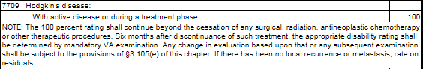

Assign a permanent and total evaluation (P&T) for multiple myeloma. Multiple myeloma is considered an incurable malignancy.
This is a general rule, and there may be rare exceptions based on the facts in a particular case. If the evidence clearly shows that the multiple myeloma is no longer active, then a P&T evaluation is not warranted.
Consider ancillary benefits associated with the award of a P&T disability evaluation.

Parkinson’s Disease

Parkinson’s disease is a chronic, slowly progressive central nervous system disorder characterized by muscular rigidity, a tremor of resting muscles, slow and decreased voluntary movements and positional instability. An outdated term for Parkinson’s disease is paralysis agitans.

Early signs and symptoms of the condition may include:
- infrequent blinking
- lack of facial expression
- decreased movement, and
- impaired postural reflexes.
The condition is characterized by muscle tremors at rest which diminish during movement and are absent during sleep. The tremors are enhanced by emotional tension or fatigue and the hands are most affected. Muscle rigidity may be present without tremors. As the muscle rigidity progresses, movement becomes slow (bradykinesia), decreased or diminished (hypokinesia), and difficult to initiate (akinesia). Other signs and symptoms may include:
- muscular aches and fatigue
- mask-like expression with open mouth
- drooling
- stooped posture
- gait characterized by involuntary, short, accelerating steps
- difficulty in walking
- loss of postural reflexes (tendency to fall forward or backward with respective shift in center of gravity)
- speech manifestations – specifically low speech volume with stuttering or slurred speech, or uniformity of tone and high pitch, and
- dysphagia.
Parkinson’s disease is evaluated under paralysis agitans – DC 8004:

The 30 percent evaluation will be assigned until complications can be separately evaluated and provide an evaluation of higher than 30 percent.

When evaluating residual disability and/or complications of Parkinson’s disease, ensure to:
- Evaluate each affected body system or body part separately
- Show the DC for Parkinson’s only once by listing with the most severely affected function
- Code involvement of other manifestations under their specific DC and show as secondary to PD.

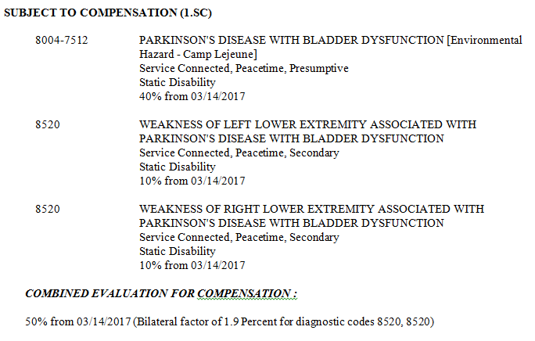

Topic 4: Effective Date

§3.114 Change of law or Department of Veterans Affairs issue.
(a) Effective date of award. Where pension, compensation, dependency and indemnity compensation, or a monetary allowance under 38 U.S.C. chapter 18 for an individual who is a child of a Vietnam veteran or child of a veteran with covered service in Korea is awarded or increased pursuant to a liberalizing law, or a liberalizing VA issue approved by the Secretary or by the Secretary's direction, the effective date of such award or increase shall be fixed in accordance with the facts found, but shall not be earlier than the effective date of the act or administrative issue. Where pension, compensation, dependency and indemnity compensation, or a monetary allowance under 38 U.S.C. chapter 18 for an individual who is a child of a Vietnam veteran or child of a veteran with covered service in Korea is awarded or increased pursuant to a liberalizing law or VA issue which became effective on or after the date of its enactment or issuance, in order for a claimant to be eligible for a retroactive payment under the provisions of this paragraph the evidence must show that the claimant met all eligibility criteria for the liberalized benefit on the effective date of the liberalizing law or VA issue and that such eligibility existed continuously from that date to the date of claim or administrative determination of entitlement. The provisions of this paragraph are applicable to original and reopened claims as well as claims for increase.
(1) If a claim is reviewed on the initiative of VA within 1 year from the effective date of the law or VA issue, or at the request of a claimant received within 1 year from that date, benefits may be authorized from the effective date of the law or VA issue.
(2) If a claim is reviewed on the initiative of VA more than 1 year after the effective date of the law or VA issue, benefits may be authorized for a period of 1 year prior to the date of administrative determination of entitlement.
(3) If a claim is reviewed at the request of the claimant more than 1 year after the effective date of the law or VA issue, benefits may be authorized for a period of 1 year prior to the date of receipt of such request.
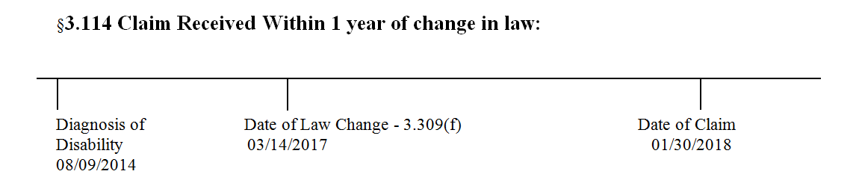
Scenario: The Veteran submits a claim for liver cancer on January 30, 2018. His DD-214 shows that he served honorably in the Marine Corps from 3/13/65 to 5/26/67. Personnel records show the Veteran was stationed at Camp Lejeune from April 1965 to September 1965.
In support of his claim he submits private treatment records that include laboratory tests confirming a diagnosis of liver cancer on August 9, 2014. Current treatment includes palliative chemotherapy. The Veteran is considered terminal. What rating action should be taken?

Topic 5: Rating Requirements
When awarding or denying a claim due to exposure to contaminants in the Camp Lejeune water supply users must:
- select the appropriate reason(s) for awarding or denying the claim in the DECISION BASIS
- affix the Environmental Hazard-Camp Lejeune special issue in VBMS-R, and
- insert the appropriate text as provided in M21-1 IV.ii.2.C.6.i or j.

The special issue in VBMS-R must be affixed for both grants and denials.
If awarding a Camp Lejeune claim on a presumptive basis, the following text must be included in both the RATING NARRATIVE and NOTIFICATION LETTER user text fields:

Service connection may be granted for specific diseases or conditions which are presumed to have been caused by exposure to contaminants in the water supply at Camp Lejeune. Although not shown in service, service connection for [insert condition] has been granted on the basis of presumption due to exposure to contaminants in the water supply at Camp Lejeune.

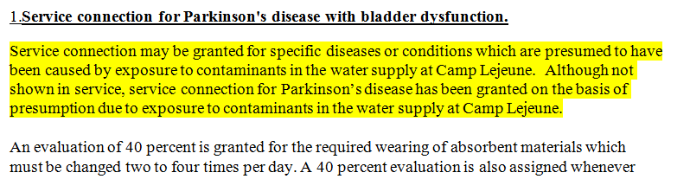

If denying a Camp Lejeune claim on a presumptive basis, the following text must be included in the RATING NARRATIVE field:

VA has acknowledged a relationship between exposure to contaminants in the water supply at Camp Lejeune during the period beginning on August 1, 1953, and ending on December 31, 1987, and the subsequent development of the following conditions: kidney cancer, liver cancer, non-Hodgkin’s lymphoma, adult leukemia, multiple myeloma, Parkinson’s disease, aplastic anemia and other myelodysplastic syndromes, and bladder cancer. Service at Camp Lejeune for Veterans, Reservists, and former National Guard members must have been for at least 30 days (cumulative) during the specified time frame. A presumption of service connection based on exposure to contaminants in the water supply at Camp Lejeune is not warranted for any other condition.

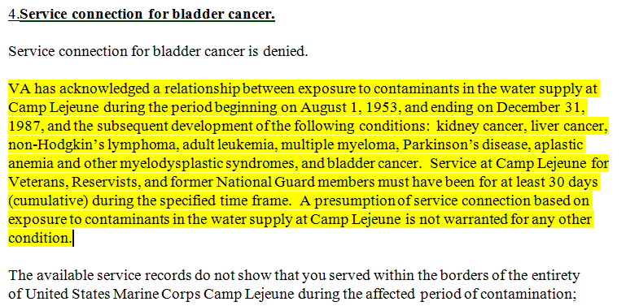

If denying a Camp Lejeune claim on a presumptive basis, all applicable denial reasons must be included in both the RATING NARRATIVE and NOTIFICATION LETTER user text fields:

- The claimed disability is not a condition associated with exposure to contaminants at Camp Lejeune:
A review of all of the objective medical evidence does not indicate that there is a reasonable possibility that your [insert condition] may be associated with your exposure to contaminants in the water supply at Camp Lejeune

- There is no diagnosis of the claimed condition:
Service connection based on exposure to contaminants in the water supply at Camp Lejeune is denied because the evidence does not show a diagnosis of a condition for which VA has acknowledged a relationship with exposure to contaminants in the water supply at Camp Lejeune.

- VA received a negative SME medical opinion:

You claimed [insert condition]. As this condition is not one of the presumptive conditions VA has acknowledged as related to exposure to contaminants in the water supply at Camp Lejeune, we requested a VA medical opinion. The examiner stated that the evidence of record and available medical and scientific research does not demonstrate a link between your [insert condition] and exposure to contaminants in the water supply at Camp Lejeune.

- The Veteran did not serve at Camp Lejeune:

The available service records do not show that you served within the borders of the entirety of United States Marine Corps Camp Lejeune during the affected period of contamination; therefore, we must deny your claim. If you are able to produce or provide information of supportive records showing official military orders or other official assignment within the borders of the entirety of United States Marine Corps Camp Lejeune, please submit that evidence within one year of notification of this decision.

- The Veteran’s Camp Lejeune service was for less than 30 days:

The available service records do not show that you served within the borders of the entirety of United States Marine Corps Camp Lejeune for at least 30 days during the affected period of contamination; therefore, we must deny your claim.

