VA Examination Requests
Integrated Disability Evaluation System (IDES)
Military Service Coordinator (MSC)
Trainee Handout
Table of Contents

Objectives 2
References 3
Topic 1: IDES Exam Request Procedures 4
Topic 2: IDES Post Exam Procedures 13
Attachment: Additional Medical Information 18

Objectives
- Identify VA IDES examination request procedures

- Identify VA IDES post examination request procedures
References
- M21-1, Part III, Subpart i, Chapter 2, Section D.6, Requesting Examinations for IDES Participants
- M21-1, Part III, Subpart I, Chapter 2, Section D.7, Handling IDES Examination Reports and Other Evidence
- M21-1, Part III, Subpart iv, Chapter 3, Section A.13.c. General Medical Examinations and the SHA
- M21-1, Part III, Subpart iv, Chapter 3, Section A.15.e, Bookmarking Documents for Examiner Review
- M21-1, Part III, Subpart i, 2, F - Special Situations Related to the Integrated Disability Evaluation System (IDES)

Topic 1: IDES Exam Request Procedures
Prerequisites
Prior to requesting a VA exam, the MSC must ensure the following have been completed:
• A referral from the Physical Evaluation Board Liaison Officer (PEBLO) has been received.
• The Service Treatment Records (STRs) are reviewed and tabbed.
• The Service member has been interviewed.
• VA Form 21-0819 has been completed.

VA Exam Requests
A VA exam must be requested for each potentially unfitting condition indicated in Section I of VA Form 21-0819, VA/DoD Joint Disability Evaluation Board Claim.

Appropriate exam location
Each IDEs location has a Memorandum of Agreement (MOA) which list whether the VHA to include VHA fee-basis-examiners (contract) or DoD facility is responsible for conducting IDES Examinations. Reminder: The requirement to use the Exam Request Routing Assistant (ERRA) tool does not currently supersede any local IDES agreement between DoD, VHA, and VBA that specifies responsibility for IDES exams. IDES sites must continue to send IDES exam requests to the provider specified in local agreements.
Once it is determined that VHA is responsible for the examinations it is mandatory that the MSC use the Examination Request Routing Assistant (ERRA) tool located in Compensation Service Intranet site under Rating Job Aids.
MSCs must use ERRA tool to identify the exam provider nearest the participant with capability to complete the required exam when
the participant is not physically located at or near the referring MTF, and/or
the provider specified in the local agreement is unable to conduct the necessary examination(s). See M21-1, Part III, Subpart iv, 3, A - Examination Requests Overview
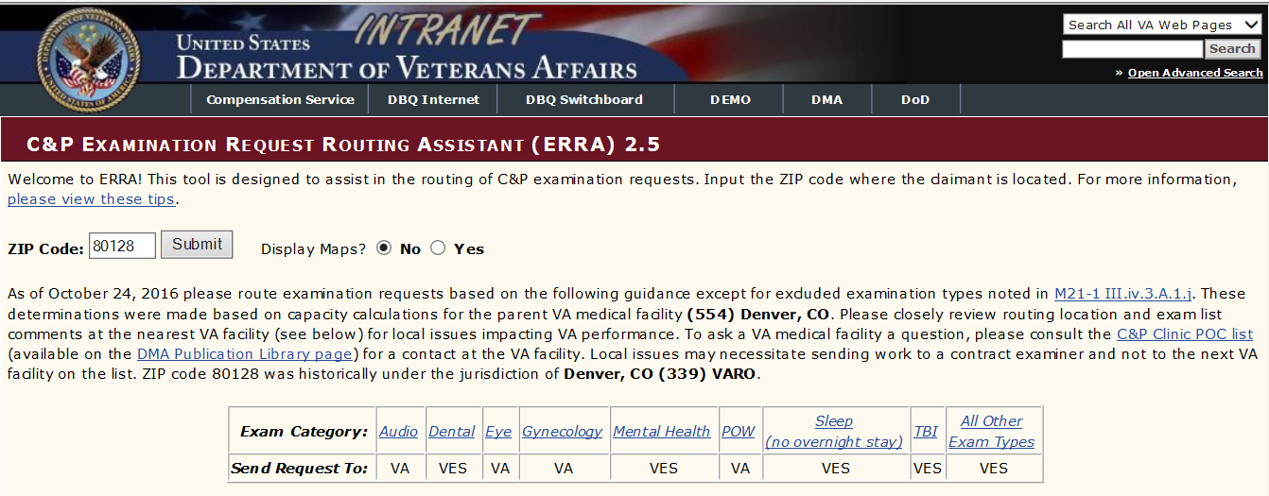

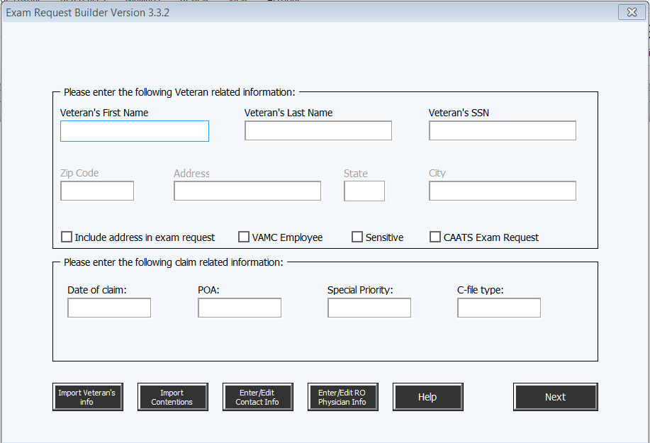
Exam Request Builder
Use of the ERB tool is mandatory when creating a(n) examination or medical opinion request in CAPRI for a compensation claim, or a medical opinion request for a claim based on combat experiences, or Military Sexual Trauma (MST).
Please ensure the suggested language and examinations are adequate before inputting the exam requests.
SHA Exam Categories
All eligible Pre-Discharge claimants receive a Separation Health Assessment (SHA) exam.
The SHA is a single separation examination which supports the VA disability compensation process and the DoD separation/retirement process. It includes the Separation History and Physical Examination Program (SHPE).
The SHA process provides service members with an improved general medical examination, which includes an audiogram, any specialty exams deemed necessary, and a full lab analysis, using VA’s examination protocols. The service member completes and provides the DD Form 2807-1, Report of Medical History, to the examiner. The examiners will complete their designated section of the DD Form 2807-1, and the completed form will be added to the service member’s service treatment records (STRs).
Note: The service member may elect to upload the completed DD Form 2807-1 into eBenefits with the Pre-Discharge claim(s) application instead of bringing the form to the SHA examination.
Specialty Exams
Specialty examinations, if warranted may include:
- Audio
  - Select the Hearing Loss and Tinnitus DBQ only if hearing loss is shown in the evidence of record. The SHA is a “screening” level, air conduction threshold audiogram and is not intended to be used for disability evaluation. If any 38 CFR 3.385 limits are met, a full Hearing loss and Tinnitus DBQ will be completed.
- Eye
- Mental disorders/initial Post Traumatic Stress Disorder (PTSD)
- Dental (trauma only)
- Traumatic Brain Injury (TBI)
- Gulf War General Medical
- Any other necessary specialty exam as determined by the examining physician

VA IDES Exam Request Format
When requesting a VA exam, the MSC needs to provide the following information in the remarks section of the exam request. Fill in the correct information in the highlighted areas.
Note: The examination request builder (ERB) provides the template to build the exam request. MSCs must fill in the yellow highlighted areas below.
INTEGRATED DISABILITY EVALUATION SYSTEM (IDES)
– Please expedite.
- Referred Disabilities: [list all referred disabilities]
- Claimed Disabilities: [list all claimed disabilities]
- Required Specialty Examinations of Referred Disabilities: [list all specialty examinations that are required to evaluate disabilities the participant’s service department referred to VA]
As soon as the examinations are scheduled, please notify the MSC and PEBLO of the dates and times.
- MSC: [provide name, title, complete mailing address, phone and fax number, and e-mail address of MSC], and
- PEBLO: [provide name, location, phone and fax number, and e-mail address of the participant’s PEBLO]

Important:
If VA is processing a participant’s case electronically, MSCs must also indicate in the REMARKS section of the request that
- the participant has an eFolder instead of a paper claims folder, and,
- the eFolder is accessible through Virtual VA or VBMS (whichever applies).
If the Separation Health Assessment (SHA) DBQ is not available in CAPRI or CAATS then,

- select the GEN MED DBQ, and
- add the following statement to the comments: IDES claim: SHA DBQ is requested.

Remarks to Avoid
When requesting a VA exam, avoid using the following remarks:
- “Condition” vs. diagnosis – Use a phrase like “right knee arthritis” rather than “knee condition”.
- Worksheet specifics – Exam requests do not need to duplicate information found on the exam worksheets.
- Insensitivity – Stick to the facts and do not include personal opinions or feelings in exam requests.
- VBA acronyms and abbreviations, such as IU, SMC, etc.

Examination of Pregnant IDES Participants
When holding the initial meeting with a pregnant IDES participant, MSCs must advise the participant of the following
- medical professionals that examine participants in connection with the IDES may, at their discretion, defer some or all examinations because the participant is pregnant
- without the medical evidence an examination provides, VA may have to defer a decision on some or all of the participant’s disabilities when preparing its proposed and final rating decisions
- deferral of a decision will not adversely affect the ultimate outcome of the participant’s claim
- the participant must notify VA of any changes in her address or telephone number, which will ensure VA can follow up with the participant on any deferred decisions after her anticipated delivery date, and
- the participant should contact VA if VA defers any decisions then fails to follow up with her within 90 days after her delivery date.
Special situations in IDES exam request:

Requesting Examinations for Pregnant Participants

MSCs must include the following remarks in any examination request for a pregnant IDES participant.

Please be advised that this individual has indicated that she is currently pregnant. If the examining physician determines that this examination (or any part of this examination) is medically contraindicated, please clearly indicate which parts of the examination were not completed due to the pregnancy.
Further, the examiner should indicate the earliest point (in days following delivery) that the examination may be safely completed.

Important: The contract with QTC Services (a company that conducts examinations for VBA) stipulates that its physicians will not examine pregnant claimants. Accordingly, IDES sites that QTC Services supports must coordinate with local VHA medical facilities to establish a contingency plan for examining pregnant IDES participants (when medically practicable).
Handling Examination Reports Involving Pregnant Participants
Once all examination reports that MSCs request for a pregnant IDES participant are available, MSCs must take the following actions, even if some or all of the reports indicate the participant could not be examined because of her pregnancy
- provide the examination reports to the participant’s PEBLO, and
- update the MEDICAL EVALUATION END DATE field on the MSC tab in VTA to reflect the date they provided the examination reports to the PEBLO.

PEBLO or MEB Requests for Examination After Pregnancy Ends
MSCs will make a second request for examination of an IDES participant after her pregnancy ends if
- the participant’s PEBLO or MEB requests the examination, and
- the time period has passed during which previous examiners indicated examination was contraindicated due to pregnancy.
Important: Under the circumstances described above, MSCs should
- not update any of the following fields in VTA unless a participant was disenrolled from the IDES due to pregnancy and reenrolled with a new case ID number
  - MEDICAL EVALUATION START DATE
  - EXAM END DATE, or
  - MEDICAL EVALUATION END DATE, and
- record as a note in VTA the date the MSCs
  - made the second request for examination, and
  - provided the corresponding examination report(s) to the participant’s PEBLO.
Examination involving Gulf War (GW) issues
The SHA DBQ will cover all Gulf War examination requirements. When IDES referral contain GW related contentions, there is no need to order the additional Gulf War examination

Examination of Severely Disabled IDES Participants
MSCs, PEBLOs, and physicians at MTFs are responsible for determining whether a participant is too disabled to travel to an examination.
The table below describes the process for handling cases involving a participant who is too disabled to travel to an examination.

Stage | Action
1 | The participant’s MSC  - notifies the DRAS of jurisdiction that the participant is too disabled to travel to an examination, and  - sends to the DRAS the participant’s  - STRs, and  - current inpatient/outpatient treatment records that refer to any claimed or referred disability.
2 | A DRAS Rating Veterans Service Representative (RVSR) reviews available medical records to determine whether the medical records contain the evidence necessary to make a rating decision.  Note: If the RVSR determines additional, relevant treatment records exist, he/she requests them from the MSC, who is responsible for obtaining them.
3 | The RVSR notifies the MSC of his/her findings within five days of the request.
4 | If the RVSR determined the available medical evidence is  - sufficient for rating purposes, the MSC  - notifies the participant’s PEBLO that examination of the participant is unnecessary, and  - enters the date of notification into the following fields on the MSC tab in VTA  - MEDICAL EVALUATION START DATE  - EXAM END DATE, and  - MEDICAL EVALUATION END DATE, or  - insufficient for rating purposes, the MSC  - notifies the Office of Transition, Employment, and Economic Impact (OTEEI) of the RVSR’s findings by sending an e-mail to VAVBAWAS/CO/DES, and  - awaits further guidance from OTEEI

Accuracy of Information
Before a request is considered complete, the MSC needs to be sure the information is accurate. Missed issues or incorrect exam requests will delay processing of the claim.
Prior to sending the request, and to ensure accuracy of the information, the MSC should:
- Review the exam request
- Match all referred and claimed conditions to the exam requests

Exam Request Builder sample

Veterans Name
SSN

IDES claim. Please expedite.

Date of claim: __/__/201_
Days pending: 1

If local MOU states exams are done by contractor, and one or more need exams are not conducted by contracting facility add the following:

“Attention C&P Services staff – This exam request was scheduled at your location because one or more exams in this request are excluded from the contract exam process under M21-1 III.iv.3.A.1.j.”

If SM is pregnant add

“Please be advised that this individual has indicated that she is currently pregnant. If the examining physician determines that this examination (or any part of this examination) is medically contraindicated, please clearly indicate which parts of the examination were not completed due to the pregnancy.
Further, the examiner should indicate the earliest point (in days following delivery) that the examination may be safely completed”.

An in-person examination is required for the following exam(s). ACE process must not be used to complete the DBQ.

DBQ Medical SHA:

Please review the Veteran's electronic folder in VBMS and state that it was reviewed in your report.

Referred conditions:

- Post-traumatic stress disorder ATTN - Specialty exam for referred condition!

Claimed Conditions:

- Asthma

If Gulf War issues are indicated the SHA exam will assess these issues. Include the “Notice to Examiners” shown in M21-1, Part IV, Subpart ii, 1.E.2.2.m. Notice to Examiners in Southwest Asia Claims
If National Guard or Reserve member and not on Active duty add the following:
“National Guard and/or Reserve member, please provide at least one week’s notification prior to the first appointment.”
As soon as the examinations are scheduled, please notify the MSC and PEBLO of the dates and times. Please direct any questions regarding this request to:

Exceptional MSC PEBLO Name, MEB/PEBLO Officer
Email: MSC@VBA.gov E-mail: PEBLO@ ______.Mil
Phone number: (___) -__-____ FAX: (___) -__-____
Fax: (___) -__-____ Duty Phone: (___) -__-____
VA Intake Site/ROJ address Unit/Duty Address

Topic 2: IDES Post Exam Procedures

Tracking Examination Requests in VTA
After an MSC requests all the examinations an IDES participant requires, he/she must make updates on the MSC tab in VTA by
- entering the date the MSC submitted the request(s) for examination in the MEDICAL EVALUATION START DATE field, and
- selecting the entity (VAMC, MTF, or QTC/Contract Provider) responsible for completing the SHA DBQ in the EXAM PROVIDER field.
The table below describes additional entries the MSC must make on the MSC tab.
If ... | Then the MSC must ...
a VAMC or MTF is responsible for completing the SHA DBQ | enter the name of the VAMC or MTF in the EXAM SITE field.
a contract examiner is responsible for completing the SHA DBQ | enter the name and address of the contract examiner in the CONTRACTOR DETAILS field.

VBMS Tracking
- Upload the examination request into VBMS.
- Add a tracked item to VBMS under the pending EP 689 for each type of examination submitted.
Requirements for Claim Folder Review
Any examination VHA or a VBA contractor conducts in connection with the IDES must include a review of the participant’s claims folder. Claims folders must be available to examiners far enough in advance to allow them sufficient time to review the folders prior to a scheduled examination.
Before shipping a claims folder to an examining facility, MSCs must
- write IDES on a green sheet of paper and attach it to the front of the claims folder, and
- update COVERS to reflect temporary transfer of the claims folder to the examining facility.
Important: If the participant has an eFolder instead of a paper claims folder, it is not necessary to print out the contents of his/her eFolder and send them to the examining facility.
- Both VHA and VBA contract examiners have access to participants’ eFolders.
- MSCs are responsible for notifying examiners (in the examination request) that
  - the participant has an eFolder instead of a paper claims folder, and
  - the eFolder is accessible through Virtual VA or VBMS (whichever applies).
Notes:
- MSCs must ship claims folders to examining facilities. They may not fax the contents of claims folders to an examining facility.
- If COVERS is unavailable to track a claims folder’s movement, MSCs must
  - record the tracking number for shipment of the claims folder in a note in VTA and VBMS, and
  - coordinate with the examining facility to ensure it
    - receives the claims folder, and
    - returns the claims folder to the correct location after completing the examination(s).
Medical Exam Requests Follow-Up
At least once each week, MSCs must
- run the Pending Exam Report in VTA, and
- follow up on any examination requests that the report shows have been pending more than 35 days.
Perform follow-up for incomplete medical exam requests. Communicate with your point of contact at your examination facility to address problems that may prevent the exams from being completed in a timely manner. Problems include:
- Service members not showing for appointments
- Inadequate exam reports follow-up
- Delay in setting exam appointments

Actions MSCs Must Take Once All Examination Reports Are Complete

MSCs must take the actions described in the table below as soon as all of an IDES participant’s examination reports are complete and have been uploaded into the participant’s eFolder.

Step | Action
1 | Update the EXAM END DATE field on the MSC tab in VTA to reflect the date when all of the participant’s examination reports became available to the participant’s MSC.
2 | Provide copies of examination reports for all claimed and referred disabilities to the participant’s PEBLO according to the instructions in M21-1, Part III, Subpart i, 2.D.7.f.  Important: If CAPRI contains records that are related to VHA’s examination of an IDES participant but are not included in his/her examination report (such as the results of a neuropsychological evaluation conducted in connection with an examination of a head injury), MSCs must provide a copy of these records to the participant’s PEBLO in addition to the corresponding examination report(s). These records are usually accessible by selecting Progress Notes on the VISTAWEB tab in CAPRI.
3 | Ensure that the entire examination is available in VBMS.  Note: Examinations completed by VHA or QTC should be automatically uploaded into Virtual VA or VBMS; however, MSCs must ensure the entire examination has been uploaded before proceeding to the next step.
4 | Update the MED EVAL END DATE field on the MSC tab in VTA to reflect the date the MSC sent the examination report(s) to the participant’s PEBLO.  Important: MSCs must complete Steps 2, 3, and 4 of this table on the same day.  Rationale: These actions are critical to ensure the timely identification of insufficient exams. VA has committed to notifying the MEB of exam insufficiencies within five days of the date exam results are provided to the PEBLO. In order for VA to meet this commitment, it is critical that MSCs ensure the exams are available in VBMS and update VTA on the day the exam is provided to the PEBLO.
5 | Are all necessary development actions complete?  - If yes, proceed to Step 7.  - If no, proceed to the next step.
6 | - Follow up on any outstanding development requests  - set appropriate suspense reasons and dates in VBMS to control development actions, and  - proceed to the next step when all development actions are complete.
7 | Ensure all tracked items are marked closed or received in VBMS.
8 | Ensure that the IDES Development Checklist has been completed and incorporated into the eFolder (or forwarded to the scanning vendor under a DCS).  Note: If the MSC uploads the checklist directly into the eFolder, he/she must use the indexing values specified on the checklist.  Reference: For more information on the use of the IDES Development Checklist, see M21-1, Part III, Subpart i, 2.D.3.a.
9 | Add the IDES Transfer to DRAS special issue indicator to one of the contentions in VBMS under EP 689.
10 | Broker the EP 689 to the DRAS per instructions in the VBMS Job Instruction Sheet – Broker Claim.

MSC Action Upon Return of Claims Folder From Exam Provider
If a paper claims folder exists, upon return from the examination provider, MSCs must:
- create a DCS in VBMS
- secure the DCS to the front of the top volume of the claims folder
- forward the claims folder to the appropriate scanning vendor according to current VCIP Shipping Procedures, and
- update the COVERS record to reflect appropriate scanning vendor location, according to the table below.
If the claims folder is sent to ... | Then the COVERS location should reflect ...
SMS in Janesville, WI | DCSS1
SMS in Clinton, IA | DCSS1
CACI in Newnan, GA | DCSC1
CACI in Mt. Vernon, KY | DCSC2

Note: MSCs must complete the actions above no later than the end of the first workday following the day the claims folder was returned from the exam facility.
Providing Examination Reports to PEBLOs
MSCs may print copies of examination reports and hand-deliver them to PEBLOs. It may be faster and more convenient, however, to save the reports in an electronic format and send them to PEBLOs using Safe Access File Exchange (SAFE) or encrypted e-mail.

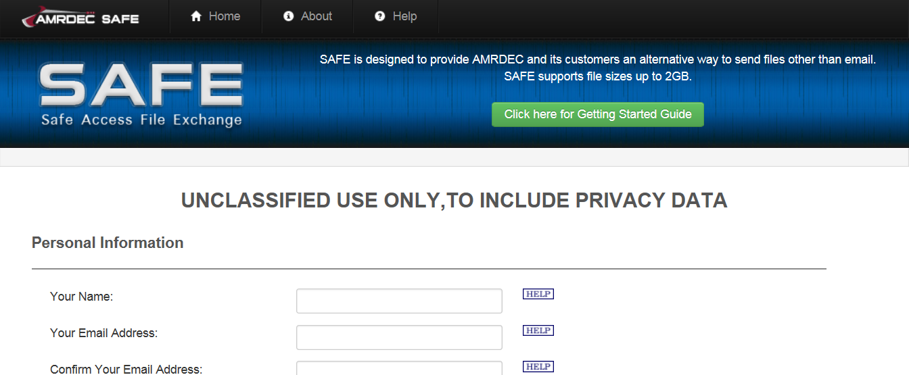
Reference: For information about using SAFE to send sensitive records, see M21-1, Part III, Subpart i, 2.D.20.a.

DRAS Review of Examination Reports for Sufficiency
Within five calendar days of the date an MSC notifies a DRASs that reports from requested examinations are available in an IDES participant’s eFolder, the DRASs must
- review the reports to determine whether they are sufficient for rating purposes, and
- e-mail the appropriate statement from those listed below to the MSC
  - The examinations for IDES case [enter the service member’s last name and VTA case ID number] have been reviewed and have been found to be sufficient for rating purposes, or
  - The examinations for IDES case [enter the service member’s last name and VTA case ID number] have been reviewed and have been found to be insufficient for rating purposes.
If a DRAS determines an examination report is insufficient, it must also include a description of the report’s deficiency(ies) in the e-mail to the MSC.
Important: Regardless of the sufficient of a participant’s examination reports, or whether a new examination or corrected examination report is necessary, an MSC may not
- postpone sending an examination report to a PEBLO pending completion of a DRAS’s review of the report, or
- change the date the MSC initially entered in the EXAM END DATE or MED EVAL END DATE fields in VTA.
Note: The DRAS will complete follow-up actions to the examination facility for insufficient examination reports.
MSC Actions If an Examination Report Is Insufficient
If a DRAS reports to an MSC that an IDES participant’s examination report is insufficient for rating purposes, the MSC must
- notify the participant’s PEBLO of the DRAS’s findings, and
- provide the PEBLO with a copy of the new or revised VA examination report that replaces the insufficient report.

Attachment: Additional Medical Information
Required Conditions
Requests for VA exams must be submitted for the following conditions, unless the disease process is still active or is immediately following surgery and the time period before a mandatory examination has not expired. For example, an exam would not be requested if the Service member’s cancer is still active or if the Service member recently completed treatment and the time period before a mandatory examination has not expired.
Required conditions include:
- Agranulocytosis, acute
- Aneurysm, any large artery
- Aortic aneurysm
- Aplastic anemia
- C-cell hyperplasia of the thyroid
- Cardiac transplantation
- Heart valve replacement (prosthesis)
- Hodgkin’s disease
- Joint replacement (prosthesis)
- Kidney transplant
- Leprosy (Hansen’s disease)
- Leukemia
- Liver transplant
- Malignant melanoma
- Malignant neoplasms of:
  - Digestive system, exclusive of skin growths
  - Ear (other than skin only)
  - Any specified part of the endocrine system
  - Genitourinary system
  - Gynecological system or breast
  - Muscle (excluding soft tissue sarcoma)
  - Any specified part of respiratory system
- Malignant skin neoplasms (other than malignant melanoma)
- Non-Hodgkin’s lymphoma
- Pulmonary tuberculosis, chronic, inactive
- Soft tissue sarcoma (of muscle, fat, or fibrous connective tissue)
- Soft tissue sarcoma (of vascular origin)
- Ventricular arrhythmias (sustained)
- Visceral leishmaniasis
Service-Connected Cancer
If the Veteran is service-connected for cancer and the evidence suggests the Veteran is terminal (or in a hospice), do not order an exam. If medical evidence is received showing the cancer is active, a 100% evaluation is warranted. For example, it is not necessary to request an exam for a Veteran who has lung cancer and is terminal.
Exclusions
Generally, VA exam requests are NOT submitted for the following conditions, to include laboratory findings, test results, congenital defects, or developmental defects:
- Abnormal laboratory tests followed by normal results
- Alcohol or drug abuse
- Cervical dysplasia, amenorrhea
- Elective surgery residuals (e.g. vasectomy, tubal ligation, PRK etc.)
- Elevated triglycerides
- Elevated prostate specific antigen (PSA), in the absence of a diagnosis of prostate cancer
- Fibrocystic breast disease
- High cholesterol (hypercholesterolemia, hyperlipidemia, etc.)
- Human Papilloma Virus (HPV)
- Obesity
- Premature ventricular contractions (PVCs)
- Personality disorders Positive PPD (TB Tine test)
- Refractive error, correctable vision, myopia, etc.
- Sinus bradycardia, abnormal EKG finding
- Uncomplicated pregnancy/childbirth
Exceptions
Occasionally, excluded conditions will be claimed as aggravated by service. When this occurs, an examination may need to be requested for the following cases:
- Alcohol and drug abuse
- Cervical dysplasia
  - Post-treatment residuals
  - Cancer
- Human Papilloma Virus (HPV)
  - Genital warts
  - Cancer
Alcohol and Drug Abuse
Some instances of alcohol or drug abuse may be service-connected secondary to PTSD or other medical conditions. The MSC may ask the examiner to address the substance abuse in the PTSD or mental exam.
Note: The following information is found on the Initial PTSD Exam Worksheet, so the examiner must address the issue:
VA is prohibited by statute, 38 U.S.C. 1110, from paying compensation for a disability that is a result of the veteran's own ALCOHOL OR DRUG ABUSE. However, when a veteran's alcohol or drug abuse disability is secondary to or is caused or aggravated by a primary service-connected disorder, the veteran may be entitled to compensation. See Allen v. Principi, 237 F.3d 1368, 1381 (Fed. Cir. 2001). Therefore, it is important to determine the relationship, if any, between a service-connected disorder and a disability resulting from the veteran's alcohol or drug abuse. Unless alcohol or drug abuse is secondary to or is caused or aggravated by another mental disorder, you should separate, to the extent possible, the effects of the alcohol or drug abuse from the effects of the other mental disorder(s). If it is not possible to separate the effects in such cases, please explain why.
Cervical Dysplasia, Amenorrhea
The more severe cases of cervical dysplasia may require treatment by cauterization, laser surgery, cryosurgery, or Loop Electrosurgical Excision Procedure (LEEP). When cervical dysplasia requires treatment, service connection might be in order if there are residuals as a result of the treatment. In such cases, an exam may be warranted.
Cervical dysplasia may also be a precursor to cancer. If a woman develops cervical dysplasia in service and cervical cancer after military service, a medical opinion would be warranted.
Human Papilloma Virus
In general, if the STRs show a laboratory finding of human papilloma virus (HPV), a VA exam is NOT needed because service connection would not be warranted.
However, certain types of HPV infections are associated with genital warts. Service connection may be appropriate in these cases because there is a chronic disability. Therefore, an exam would be warranted if the Service member had genital warts during military service. Also, an opinion would be required to determine the relationship between an in-service HPV infection and cancer that developed later.
Headaches, Gastritis, Earaches, Sinusitis, or Rhinitis
Do NOT request an examination for issues such as headaches, gastritis, earaches, sinusitis, or rhinitis unless specifically claimed by the Service member. If the Veteran was discharged more than a year ago, medical evidence which shows the event, injury, or disease occurred or is related to military service is required before requesting a VA exam or medical opinion.

