Amputation Rule, Pyramiding, and Muscle Injury
Instructor Lesson Plan
Time Required: 4.5 Hours

Table of Contents

Lesson Description 2
Introduction to Amputation Rule, Pyramiding, and Muscle Injury 4
Topic 1: Amputation Rule 7
Topic 2: Pyramiding 12
Topic 3: Muscles and Muscle Injuries 23
Lesson Review, Assessment, and Wrap-up 31

 | Lesson Description
 | The information below provides the instructor with an overview of the lesson and the materials that are required to effectively present this instruction.
 | TMS # |  | 4193687
 | Prerequisites |  | Prior to this lesson, the Rating Veteran Service Representatives (RVSRs), Decision Review Office (DRO), or Rating Quality Review Specialist (RQRS) should have completed RVSR Challenge curriculum.
 | target audience |  | The target audience for Amputation Rule, Pyramiding, and Muscle Injury is all RVSR, DRO, and RQRS.
 | Time Required |  | 4.5 hours
 | Materials/  TRAINING AIDS |  | Lesson materials:  - Amputation Rule, Pyramiding, and Muscle Injury PowerPoint Presentation  - Amputation Rule, Pyramiding, and Muscle Injury Trainee Handouts  - VMBS Job Aid – Amputation Rule for VBMS-R
 | Training Area/Tools |  | The following are required to ensure the trainees are able to meet the lesson objectives:  - Classroom or private area suitable for participatory discussions  - Seating, writing materials, and writing surfaces for trainee note taking and participation  - Handouts, which include a practical exercise  - Large writing surface (easel pad, chalkboard, dry erase board, overhead projector, etc.) with appropriate writing materials  - Computer with PowerPoint software to present the lesson material  Trainees require access to the following tools:  - VA TMS to complete the assessment  - Internet access for Compensation Pension Knowledge Management (CPKM)
 | Pre-Planning |  | - Become familiar with all training materials by reading the Instructor Lesson Plan while simultaneously reviewing the corresponding PowerPoint slides. This will provide you the opportunity to see the connection between the Lesson Plan and the slides, which will allow for a more structured presentation during the training session.  - Become familiar with the content of the trainee handouts and their association to the Lesson Plan.  - Practice is the best guarantee of providing a quality presentation. At a minimum, do a complete walkthrough of the presentation to practice coordination between this Lesson Plan, the trainee handouts, and the PowerPoint slides and ensure your timing is on track with the length of the lesson.  - Ensure that there are copies of all handouts before the training session.  - When required, reserve the training room.  - Arrange for equipment such as flip charts, an overhead projector, and any other equipment (as needed).  - Talk to people in your office who are most familiar with this topic to collect experiences that you can include as examples in the lesson.  - This lesson plan belongs to you. Feel free to highlight headings, key phrases, or other information to help the instruction flow smoothly. Feel free to add any notes or information that you need in the margins.
 | Training Day |  | - Arrive as early as possible to ensure access to the facility and computers.  - Become familiar with the location of restrooms and other facilities that the trainees will require.  - Test the computer and projector to ensure they are working properly.  - Before class begins, open the PowerPoint presentation to the first slide. This will help to ensure the presentation is functioning properly.  - The instructor completes a roll call attendance sheet or provides a sign-in sheet to the students. The attendance records are forwarded to the Regional Office Training Managers.

Introduction to Amputation Rule, Pyramiding, and Muscle Injury
INSTRUCTOR INTRODUCTION |  |  | Complete the following:  - introduce yourself  - orient learners to the facilities  - ensure that all learners have the required handouts
time required |  |  | 0.25 hours
Purpose of Lesson  Explain the following: |  |  | This lesson is intended to provide students with detailed instruction of the amputation rule, pyramiding, and how to evaluate muscle disabilities. This lesson will contain discussions and exercises that will allow the student to gain a better understanding of:  - what the amputation rule is  - exceptions to the amputation rule  - identifying the elective level of amputations  - how and when to apply the amputation rule  - how the amputation rule applies to evaluating osteomyelitis  - utilizing the amputation rule within VBMS-R  - how pyramiding is defined  - specific pyramiding principles applicable to body systems  - types of muscles, muscle groups, and muscle injuries  combining ratings for muscle injuries and the evaluation of muscle disabilities
Lesson Objectives  Discuss the following:  Slides 2-3  Handout 1 |  | In order to accomplish the purpose of this lesson, the VSR, RVSR, or DRO will be required to accomplish the following lesson objectives.  The VSR, RVSR, or DRO will be able to:  - define the amputation rule and understand exceptions to the rule  - identify the elective level of amputations and demonstrate application of the amputation rule  - recognize how the amputation rule applies to osteomyelitis  - obtain a working knowledge of how to apply the amputation rule in VBMS-R  - define pyramiding and understand the prohibition against pyramiding  - recognize specific pyramiding principles applicable to each of the body systems  - understand types of muscles, muscle groups, and muscle injuries  - demonstrate knowledge of combining ratings for muscle injuries (38 CFR 4.55)  - demonstrate knowledge of the evaluation of muscle disabilities (38 CFR 4.56)
Explain the following: |  | Each learning objective is covered in the associated topic. At the conclusion of the lesson, the learning objectives will be reviewed.
Motivation |  | Ask students if they have ever applied the amputation rule, considered the prohibition against pyramiding; or, had difficulty understanding the regulations while evaluating muscle disabilities. Tell students that an understanding of 38 CFR 4.14, 38 CFR 4.68, 38 CFR 4.55, and 38 CFR 4.56 is imperative to ensuring accurate and consistent rating decisions.
STAR Error code(s) |  | C2d: Violation of pyramiding under 38 CFR 4.14 (same symptomatology used for multiple disabilities)  C2g: Over-evaluation for failing to apply the amputation rule in accordance with 38 CFR 4.68  C2h: Under-evaluation for failing to recognize the minimum evaluations for muscle disabilities as defined in 38 CFR 4.56
References  Slides 4-6  Handout 1-2 |  | Explain where these references are located in the workplace.  All M21-1 references are found in the Live Manual Website.  - 38 CFR 4.68, Amputation Rule  - 38 CFR 4.14, Avoidance of Pyramiding  - 38 CFR 4.59, Painful Motion  - 38 CFR 4.71a, Schedule of Ratings-Musculoskeletal System, DC 5120-5126, Amputations: Upper Extremity; and, 5160-5173, Amputations: Lower Extremity  - 38 CFR 4.55, Principles of Combined Ratings for Muscle Injuries  - 38 CFR 4.56, Evaluation of Muscle Disabilities  - 38 CFR 4.73, Schedule of Ratings-Muscle Injuries  - 38 CFR 4.96, Special Provisions Regarding Evaluation of Respiratory Conditions  - 38 CFR 4.115, Nephritis  - 38 CFR 4.114, Schedule of Ratings – Digestive System  - 38 CFR 3.310(d), Traumatic Brain Injury  - 38 CFR 4.126, Evaluation of Disability from Mental Disorders  - 38 CFR 4.150, Dental and Oral Conditions  - M21-1 Part III, Subpart iv, 4.A, Musculoskeletal Conditions  - M21-1 Part III, Subpart iv, 4.B.2.b, Considering Impairments of Both Visual Acuity and Visual Field  - M21-1 Part III, Subpart iv, 4.G, Neurological Conditions and Convulsive Disorders  - M21-1 Part III, Subpart iv, 4.J, Skin Conditions  - M21-1 Part III, Subpart iv, 6.D.10.a, Sample Draft Code-sheet, Amputation Rule  - VBMS Job Aid, Amputation Rule and VBMS-R  - Compensation and Pension Medical EPSS

Topic 1: Amputation Rule
Introduction | This topic will allow the trainee to understand the amputation rule and when/how to apply the provisions 38 CFR 4.68.
Time Required | 1.25 hours
OBJECTIVES/  Teaching Points | Topic objectives and teaching points to support the topic objective:  - The trainee will be able to define the amputation rule and understand exceptions to the rule.  - The trainee will be able to identify the elective level for amputations and demonstrate application of the amputation rule.  - The trainee will be able to recognize how the amputation rule applies to osteomyelitis.  - The trainee will obtain a working knowledge of how to apply the amputation rule in VBMS-R.
38 CFR 4.68: Amputation Rule  Slide 8  Handout 2 | The combined evaluation for disabilities of an extremity shall not exceed the evaluation for the amputation at the elective level, were amputation to be performed.  For example, the combined evaluations for disabilities below the knee shall not exceed the 40 percent evaluation, diagnostic code 5165. This 40 percent rating may be further combined with evaluation for disabilities above the knee but not to exceed the above the knee amputation elective level.  Explain that this topic will be discussed in further detail during the presentation.  The amputation rule is included in the musculoskeletal section of the rating schedule and, consequently, applies only to musculoskeletal disabilities and not to disabilities affecting other body systems.  Example: Ankylosis of the right ankle evaluated at 40 percent disabling (DC 5270) combined with an evaluation of diabetic peripheral neuropathy of the right lower extremity affecting the posterior tibial nerve evaluated at 20 percent disabling (DC 8525) would not violate the amputation rule because different body systems are affected.  Emphasize that although the amputation rule may not be applicable, we would still consider whether the separate evaluation of disabilities are affected by the prohibition against pyramiding.
Exceptions  Slide 9  Handout 3 | Any peripheral nerve injury, associated with the musculoskeletal injury, applies to and counts towards the amputation rule.  Explain that evaluations of peripheral nerves of the extremities are not considered when applying the amputation rule unless the peripheral nerve injury is associated with a musculosketal injury. Discuss this scenario would be uncommon but most likely seen when evaluating a defective stump.  Actual amputation with associated neuroma will be evaluated at the next higher site of elective re-amputation.  Example: Amputation of a lower extremity, permitting prosthesis (DC 5165 – 40%) with associated neuroma, will be evaluated as an amputation not improvable by prosthesis controlled by natural knee action (DC 5164 – 60%)
Exceptions  Slide 10  Handout 3 | The amputation rule does not apply to bilateral evaluations under DCs 5276-5279.  Although the diagnostic code for bilateral flat feet provides for unilateral evaluations, when the disability affects both feet, it is rated bilaterally, and the evaluation accounts for both feet. It is not appropriate to evaluate each foot separately. Therefore, this diagnostic code is not subject to the amputation rule, except for comparison to a bilateral lower extremity amputation.  The amputation rule does not apply when temporary evaluations are assigned to an extremity, such as Paragraph 29 and 30.  Explain that approved hospitalization in excess of 21 days or for convalescence due to service connected disability is meant to compensate the Veteran at a temporary total evaluation. Applying the amputation rule and thus compensating the Veteran at less than 100 percent would contradict the specific instructions of 38 CFR 4.29 and 38 CFR 4.30.
Identifying the Elective Level of Amputations: Lower Extremity  Slide 11  Handout 3 | Demonstrate and explain how to determine the elective level of amputations of the lower extremity.  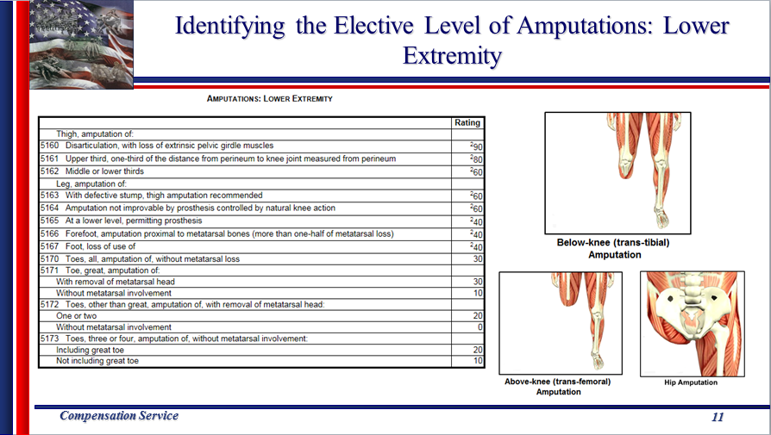
Identifying the Elective Level of Amputations: Upper Extremity  Slide 12  Handout 4 | Demonstrate and explain how to determine the elective level of amputations of the upper extremity.  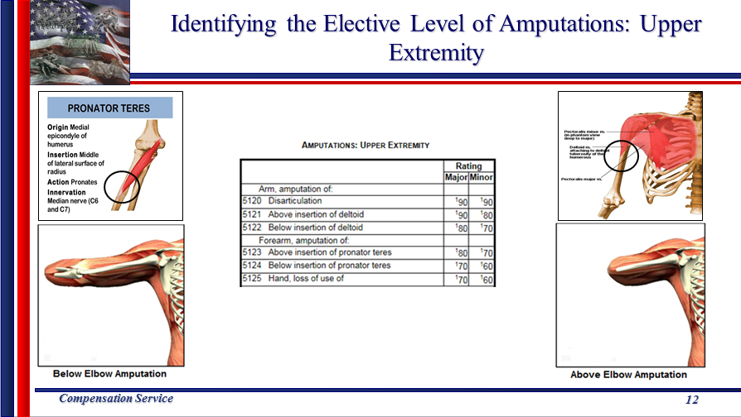
Applying the Amputation Rule  Slide 13  Handout 4 | Utilizing the graphic on slide 13, discuss the following scenario to demonstrate proper application of the amputation rule in the upper extremity. Emphasize that it is important to recognize the different evaluations for the major and minor extremities.  - If there is limitation of flexion of the left (minor) elbow evaluated at 40%, limitation of extension of the left elbow evaluated at 20%, prosthetic replacement of the left wrist evaluated as 30%, and three digits ankylosed in the left hand at 30%, the combined evaluation of the left extremity would be 80% disabling.  - Because amputation of the forearm above insertion of the pronator teres is evaluated as 70% disabling in the minor extremity, the amputation rule would be applied and a 70% combined evaluation would be assigned.  - If the disabilities were present in the major extremity, there would be no violation of the amputation rule, as amputation of the forearm above insertion of the pronator teres in the major extremity is evaluated as 80% disabling.
Applying the Amputation Rule  Slide 14  Handout 5 | Utilizing the graphic on slide 14, discuss the following scenario to demonstrate proper application of the amputation rule in the lower extremity. Note that the distinction between applying the amputation rule to DC 5276-5279 is dependent on whether the disability is rated unilaterally or bilaterally.  - If there is malunion of the right tibia and fibula with marked ankle disability rated 30% and right flat foot rated at 30%, the combined evaluation of the right leg below the knee would equal 50% disabling.  - Because the loss of use or amputation below the knee is evaluated as 40% disabling, the amputation rule would be applied and a 40% combined evaluation would be assigned.  - If the flat foot condition was rated as bilateral at 30%, then all the conditions could be combined. The amputation rule does not apply to bilateral evaluations under DCs 5276-5279. The combined overall rating of 60% would not be a violation of the amputation rule as only the 30% evaluation for the right tibia and fibula would be considered for the right lower extremity.
Amputation Rule and Osteomyelitis (DC 5000)  Slide 15  Handout 5-6 | Explain that osteomyelitis is an infection and inflammation of the bone and bone marrow. Display 38 CFR 4.71a (DC 5000) and discuss the specific amputation rule instructions of Note (1) that pertain to evaluating osteomyelitis.  The amputation rule DOES NOT apply if:  - the osteomyelitis evaluation is 10% based on active osteomyelitis of a body part where the evaluation would normally be 0 percent, or  - the osteomyelitis evaluation is 60% based on constitutional symptoms of osteomyelitis.  The amputation rule DOES apply if:  - the osteomyelitis evaluation is 10% based on active osteomyelitis of a body part where the evaluation would normally be 0 percent, or  - 30% or less under DC 5000, AND  - combined with evaluations for ankylosis, limited motion, nonunion or malunion, shortening, or other musculoskeletal impairment.
Amputation Rule within VBMS-R  Slide 16  Handout 6 | If the instructor has access to VBMS-R Demo, demonstrate how to create an amputation umbrella and apply the amputation rule within the system.  At a minimum, demonstrate how to access the VBMS Job Aid for applying the amputation rule and discuss the instructions contained in the document.  Important: Note that the example in the VBMS Job Aid for applying the amputation rule is not correct as same considers bilateral flat feet for application. Utilize the codesheet provided in Slide 16 during discussion.  **The VBMS Job Aid for applying the amputation rule is has been scheduled to be corrected; however, same has not been updated as of July 2016.  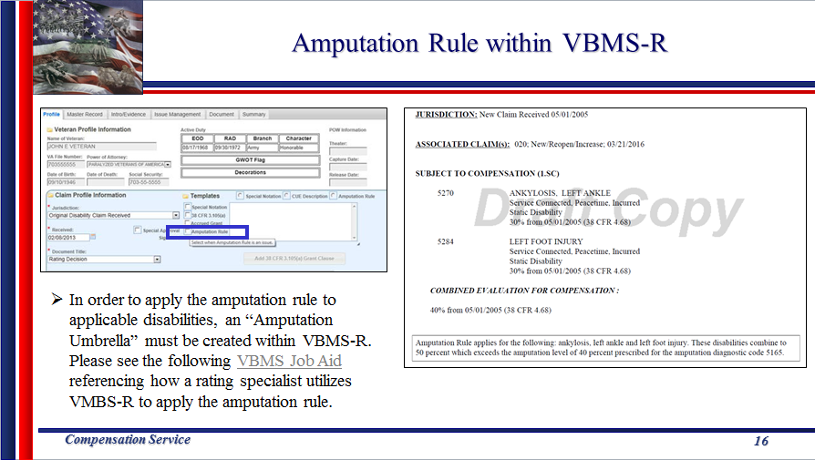

Topic 2: Pyramiding
Introduction | This topic will allow the trainee to understand the prohibition against pyramiding.
Time Required | 1.5 hours
OBJECTIVES/  Teaching Points | Topic objectives and teaching points to support the topic objectives:  - The trainee will be able to define pyramiding and understand the prohibition against pyramiding.  - The trainee will be able to recognize specific pyramiding principles applicable to each of the body systems.
38 CFR 4.14: Avoidance of Pyramiding  Slide 18  Handout 7 | Pyramiding is rating the same manifestations of a disability under two separate DCs.  Disabitlies from injuries to the muscles, nerves, and joints of an extremity may overlap to a great extent, so that special rules are included in the appropriate bodily system for their evaluation.  Emphasize that we should not only consider whether there is distinct functional impairment between two or more disabilities, but also whether the rating schedule expressly prohibits separate evaluations.  Separate disability ratings are appropriate when a single injury results in distinct functional impairments.
Pyramiding: Joints and Pain  Slide 19  Handout 7 | 38 CFR 4.59 does not permit separate compensable evaluations for each painful joint motion.  When each qualifying joint motion is painful but motion is not actually limited to a compensable degree under its applicable 52XX-series DC, only one compensable evaluation can be assigned.  Explain that 38 CFR 4.59 specifically refers to providing the minimum compensable evaluation for a particular “joint”, not the separate joint motions.  Example: A Veteran cannot receive a 10 percent under 38 CFR 4.59 for painful flexion of the knee under DC 5260 combined with 10 percent under 38 CFR 4.59 for painful extension of the knee under DC 5261.  When more than one qualifying joint motion is actually limited to a compensable degree and there is painful but otherwise non-compensable limitation of the complementary movement(s), only one compensable evaluation can be assigned.  Example: A Veteran in receipt of a 10 percent evaluation under DC 5260 for knee flexion limited to 45 degrees, cannot receive a 10 percent evaluation under 38 CFR 4.59 for painful extension under DC 5261.
Pyramiding: Musculoskeletal Conditions  Slide 20  Handout 7-8 | Degenerative Arthritis: Separate evaluations under diagnostic code 5003 with any other joint evaluation based on limitation of motion or painful motion, due to degenerative arthritis, is prohibited.  Provide the following opposite scenario to check comprehension: A compensable evaluation for degenerative arthritis of the shoulder under DC 5003 and a compensable evaluation for patellofemoral syndrome of a knee under DC 5260 or DC 5261 would not be pyramiding.  Forearm: Do not assign a compensable evaluation for both limitation of pronation and limitation of supination of the forearm in the same extremity.  Note that the rating schedule combines supination and pronation into one diagnostic code (DC 5213)  Fibromyalgia: The criteria for the evaluation of fibromyalgia does not exclude assignment of separate evaluations when secondary disabilities are diagnosed. The same signs and symptoms; however, cannot be used to assign separate evaluations under different DCs.  Discuss: This includes, but is not limited to, disability diagnoses for which symptoms are included in the evaluation criteria under Fibromyalgia such as depression, anxiety, headache, and irritable bowel syndrome.
Pyramiding: Musculoskeletal Conditions  Slide 21  Handout 7-8 | IVDS: If the evaluation of IVDS is based on incapacitating episodes, a separate evaluation may not be assigned for limitation of motion, radiculopathy, or any other associated objective neurological abnormality.  Note that if IVDS is evaluated under the General Formula for Diseases and Injuries of the Spine, Note (1) does allows for separate evaluations for objective neurological abnormalities.  Arthroplasty: Once joint replacement occurs, separate evaluations for range of motion and/or instability in the joint is prohibited.  The 30 percent and 100 percent evaluations under DC 5055 are minimum and maximum evaluations and, as such, encompass all identifiable residuals post knee replacement – including limitation of motion, instability, and functional impairment.  The 60 percent and intermediate evaluations by their plain text provide exclusive methods by which residuals can be evaluated at 40 or 50 percent and contemplate instability.  Note that the only way to obtain an evaluation in excess of 30 percent under DC 5262 (Tibia and Fibula Impairment) is if there is nonunion with loose motion and the need for a brace, which suggests instability is incorporated in the intermediate criteria.  Meniscus (semilunar cartilage): Do not assign separate evaluations for a meniscus disability (DC 5258/DC 5259) and limitation of motion in the same knee OR with subluxation/lateral instability.  Explain that limitation of motion of the knee is contemplated by the meniscus diagnostic codes. Dislocation, locking, and the broad terminology of “symptomatic under the meniscus DCs also contemplate instability.
Pyramiding: Musculoskeletal Conditions  Slide 22  Handout 7-8 | Shin Splints: If the evaluation of shin splints is based on impairment of the knee and/or ankle joint, do not assign separate evaluations for shin splints and the applicable joint(s).  Explain that shin splints is evaluated analogously to DC 5262 which includes criteria for knee and/or ankle disability. Show M21-1 Part III.iv.4.A.3.k for a step by step guide when evaluating shin splints.  Ankle Instability: Separate evaluations for limitation of motion and instability of the ankle are prohibited.  DCs for the ankle, including 38 CFR 4.71a, DC 5271 and 38 CFR 4.71a, DC 5262, include broad language that does not explicitly include consideration of any particular ankle symptomatology.  Pes Planus/Plantar Fasciitis: When SC is established for both pes planus and plantar fasciitis, the symptoms of both symptoms are evaluated together under DC 5276 and cannot be separately evaluated.  Explain that plantar fasciitis is evaluated analogous to pes planus under DC 5276, thus, we cannot provide separate evaluations for conditions evaluated under the same DC.
Pyramiding: Musculoskeletal Conditions  Slide 23  Handout 7-8 | Muscles: A separate evaluation cannot be assigned for each muscle within a single muscle group.  Note that we will be discussing muscle injuries in greater depth later in the presentation. Explain that muscle damage to any of the muscles within the group must be included in a single evaluation assigned for the muscle group.  Muscles/Joints: 38 CFR 4.55, Principles of Combined Ratings for Muscle Injuries  Note that there are specific prohibitions relating to muscles injuries acting upon joints. Same will be discussed in greater depth later in the presentation.  Muscles/Peripheral Nerves: A muscle injury and a peripheral nerve paralysis of the same body part, whether associated with the muscle injury OR originating from other etiologies, may not be rated separately unless entirely different functions are affected.  Emphasize that separate evaluations are warranted as long as the muscle injury and peripheral nerve paralysis affect entirely different functions.  Discuss that although separate evaluations may be warranted in limited circumstances that do not violate the principles of pyramiding, that the amputation rule may still be for consideration if the peripheral nerve paralysis is associated with the musculoskeletal injury.
Pyramiding: Organs of Special Sense  Slide 24  Handout 8 | Vision: Separate evaluations cannot be assigned for impairments of both visual acuity and visual field defect. The evaluations must be evaluated together a single disability.  Example  - Corrected visual acuity is 20/40 in the right eye and 20/70 in the left eye, warranting a 10-percent evaluation.  - Visual field loss in right eye is remaining field 38 degrees (equivalent to visual acuity 20/70) and loss in left eye is remaining field 28 degrees (equivalent to visual acuity 20/100), warranting a 30-percent evaluation.  Result: Under 38 CFR 4.25, the 30-percent evaluation for visual field loss with the 10-percent evaluation for visual acuity, results in a single 40-percent combined evaluation for bilateral visual impairment.  38 CFR 4.77(c): Combination of visual field defect and decreased visual acuity.  Meniere’s Syndrome: Do not provide separate evaluations for hearing impairment, tinnitus, or vertigo with an evaluation of Meniere’s disease under DC 6205.  Explain that DC 6205 (Meniere’s Syndrome) contains the following note: Evaluate Meniere's syndrome either under these criteria or by separately evaluating vertigo (as a peripheral vestibular disorder), hearing impairment, and tinnitus, whichever method results in a higher overall evaluation.
Pyramiding: Respiratory Conditions  Slide 25  Handout 9 | Co-existing Respiratory Conditions: 38 CFR 4.96(a)  - Ratings under DCs 6600-6817 and 6822-6847 cannot be separately evaluated.  - Where there is lung or pleural involvement, ratings under DCs 6819 and 6820 cannot be separately evaluated from each other or the DCs noted above.  - Single ratings are assigned under the diagnostic code which reflects the predominant disability with elevation to the next higher evaluation when the severity of the overall disability warrant such elevation.  Show M21-1 III.iv.4.D.1.h, Evaluating Coexisting Respiratory Disabilities, for a step by step table regarding HOW to evaluate multiple qualifying coexisting respiratory disabilities.  GSW and Respiratory: Separate evaluations for restrictive lung disease due to gunshot wound and muscle group XXI cannot be assigned.  Reference: Note (3) under the General Rating Formula for Restrictive Lung Disease (diagnostic codes 6840 through 6845)
Pyramiding: Cardiovascular  Slide 26  Handout 9 | Hypertension: Evaluate hypertension due to aortic insufficiency or hyperthyroidism, as part of the condition causing it rather than by a separate evaluation.  Reference: Note (3) under diagnostic code 7101, hypertensive vascular disease  Cardiovascular and Nephritis: 38 CFR 4.115 Separate ratings are not to be assigned for disability from disease of the heart (which includes hypertension) and any form of nephritis unless there is absence of a kidney or regular dialysis is required.  Important: The provisions of 38 CFR 4.115, which states that separate ratings are not to be assigned for disability from disease of the heart and any form of nephritis (which is an inflammation of the kidneys) do not apply when evaluating nephropathy, which is a distinct and separate clinical entity.  Cold Injury: Separately diagnosed residuals of cold injuries, such as Raynaud’s phenomenon, muscle atrophy, etc., cannot be assigned as separate evaluations if they are used to support an evaluation under DC 7122.  Reference: Note (1) under diagnostic code 7122, cold injury residuals
Pyramiding: Digestive  Slide 27  Handout 9 | 38 CFR 4.114: Evaluations of digestive conditions under certain DCs will not be combined with each other or assigned separate evaluations. Instead, a single evaluation should be assigned under the DC which reflects the predominant disability, with elevation to the next higher evaluation when the severity of the overall disability warrants such elevation.  Separate evaluations are prohibited for digestive conditions under the following 38 CFR 4.114 DCs:  - 7301 to 7329, inclusive (meaning all the DCs from 7301 to 7329)  - 7331  - 7342, and  - 7345 to 7348, inclusive (meaning all the DCs from 7345 to 7348).  Example: A Veteran with a duodenal ulcer, evaluated as 20-percent disabling under 38 CFR 4.114, DC 7305, and ulcerative colitis, evaluated as 30-percent disabling under 38 CFR 4.114, DC 7323, would be assigned a single 30-percent evaluation under 38 CFR 4.114, DC 7323 as ulcerative colitis represents the predominant disability picture. Separate evaluations for the duodenal ulcer and ulcerative colitis are not permitted under 38 CFR 4.114.
Pyramiding: Endocrine  Slide 28  Handout 10 | Diabetic Complications:  - Evaluate compensable complications of diabetes mellitus separately unless they are a part of the criteria used to support a 100-percent evaluation under DC 7913.  - Non-compensable complications of diabetes mellitus are considered part of the diabetic process under DC 7913.  Reference: Note (1) under diagnostic code 7913, diabetes mellitus  Hyperthyroidism: Symptoms of hyperthyroidism used to support the evaluation of other DCs; or, granted as separate disabilities, cannot be used to support an evaluation under DC 7900.  Briefly show and discuss: M21-1 III.iv.4.F.3.b (Rating Conditions due to Hyperthyroidism
Pyramiding: Traumatic Brain Injury  Slide 29  Handout 10 | Multiple Evaluations: In addition to the evaluation for TBI manifestations under DC 8045, separate evaluations of comorbid mental, neurologic, or other physical disorder can be assigned unless the manifestation was used to assign an evaluation under DC 8045.  TBI and Vertigo: A separate evaluation of vertigo cannot be assigned. Vertigo is a subjective symptom that is already considered in the facets of TBI criteria.  Exception: If vertigo was awarded a separate compensable evaluation prior to March 15, 2012, do not change or correct the evaluation.
Pyramiding: Traumatic Brain Injury  Slide 30  Handout 10 | TBI and Mental Disorder: Sufficiently clear and unequivocal medical opinion evidence must be present to determine whether TBI and a mental disorder are distinct and can be separately evaluated.  Explain that the opinion may be provided by either an examiner assessing the TBI or an examiner assessing the mental disorder as long as the individual offering the opinion is properly qualified. Note that the mental DBQ specifically addresses this in Block 2D, and if this is sufficiently completed, a separate and distinct medical opinion is not required.  38 CFR 3.310(d) established five conditions held to be secondary to TBI dependent on the initial severity of the TBI and the period of time between the injury and onset of the secondary illness. Avoid pyramiding when considering the initial TBI evaluation and symptoms that are now associated with the five secondary conditions.  Briefly show and discuss: M21-1 III.iv.4.G.3.g, Considerations when Establishing Secondary SC
Pyramiding: Peripheral Nerves  Slide 31  Handout 10 | Upper Extremities: Separate evaluations may not be assigned for disability affecting multiple nerve branches of the same upper extremity.  Lower Extremities: Separate evaluations for disability affecting lower extremity nerves are warranted when symptoms arise from any of the five individual nerve branches.  - If symptoms arise from within the same nerve branch of any of the five individual nerve branches in the lower extremity, assigning separate evaluation for those symptoms would constitute pyramiding.  Example: A Veteran has severe incomplete paralysis of the common peroneal nerve under 38 CFR 4.124a, DC 8521and moderate incomplete paralysis of the tibial nerve under 38 CFR 4.124a, DC 8524. In this case, a single 30-percent evaluation is assigned under 38 CFR 4.124a, DC 8521.  Analysis: Both of these nerves are part of the same sciatic branch, and therefore the functions associated with these nerves are not separate and distinct. The 30-percent evaluation shall be assigned under 38 CFR 4.124a, DC 8521 since it represents the predominant disability.
Pyramiding: ALS/MS  Slide 32  Handout 11 | Amyotrophic Lateral Sclerosis (ALS): If a single 100 percent evaluation is warranted for a complication of ALS, assign a 100 percent for that complication and separately evaluate additional complications. Do not assign a separate evaluation under DC 8017; however, as this would constitute pyramiding.  Briefly show and discuss M21-1 III.iv.4.G.6.d, Evaluation Guidelines for ALS  Multiple Sclerosis (MS): Residuals of MS are evaluated separately when the combined evaluation for the residuals are 30 percent or greater. When residuals are separately evaluated, the minimum evaluation under DC 8018 may not be concurrently assigned.
Pyramiding: Mental  Slide 33  Handout 11 | Physical/Mental Disorders: When a single disability has been diagnosed both as a physical condition and as a mental disorder, the rating agency shall evaluate it using a DC which represents the dominant (more disabling) aspect of the condition.  - To warrant separate evaluations, the symptoms considered must be distinct and not overlap.  Reference: 38 CFR 4.126(d), Evaluation of disability from mental disorders
Pyramiding: Skin and Scars  Slide 34  Handout 11 | Disfigurement: Multiple scars may not be added together to meet the width of scarring requirement under characteristics of disfigurement.  Explain that the “width” is an exception. Multiple scars evaluated under DC 7800 may be added together to meet the total area criteria for the character of disfigurement.  Examples:  - Two scars, one measuring two inches in length and the other measuring three inches in length, may be combined to meet the requirement of a scar five inches or more in length to qualify as a characteristic of disfigurement.  - In contrast, two scars, one measuring .13 inches in width and the other measuring .12 inches in width, may not be combined to meet the requirement of a scar at least one-quarter inch wide at the widest part.  Painful Scar(s): A separate evaluation for a painful scar under DC 7804 may be assigned when the functional impairment is:  - distinct and separate from the functional impairment addressed by another DC, and is not,  - duplicative or overlapping with symptomatology addressed under another DC.  Note that while pyramiding is for consideration with painful scar(s), the occurrence when the painful scar affects functional impairment is rare. Most often separate evaluations are in fact warranted.  Example: A separate 10-percent evaluation for disfigurement under 38 CFR 4.118, DC 7800, may be assigned in addition to a 10-percent evaluation for painful scars under 38 CFR 4.118, DC 7804, and a 10-percent evaluation for facial injury interfering with mastication under 38 CFR 4.73, DC 5325 as each evaluation is based on distinct and separate functional impairment and, therefore, provisions related to pyramiding are not violated.
Pyramiding: Skin and Scars  Slide 35  Handout 11 | Scars associated with Muscle Injury: If there is scarring that results in functional loss under DC 7805 that is compensable, do not assign a separate evaluation if the body part affected and the functional impairment resulting from the scar are the same as the part and function affected by the muscle injury.  Briefly show and discuss: M21-1 III.iv.4.A.11.l, Evaluating Scars Associated with Muscle Injuries  Alternative Rating Criteria: When evaluating skin conditions where the DC offers variable methods to evaluate the disability, assign only a single evaluation using the criteria that results in the higher rating. Do not assign separate evaluations.  Example:  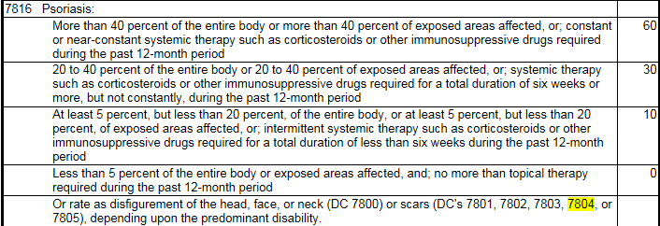
Pyramiding: Multiple Skin Conditions  Slide 36  Handout 12 | Percentage of Exposed Skin/Entire Body Affected: Multiple skin conditions may receive separate evaluations based on the percentage of exposed areas affected by each skin condition.  Example: The medical evidence clearly indicates that skin condition X alone affects 6 percent of the exposed skin, while skin condition Y alone affects 12 percent of the exposed skin. In this scenario, separate evaluations may be assigned.  Important:  If an examiner cannot provide separate percentages solely due to each skin condition, separate evaluations cannot be assigned using that criteria alone.  Medication Criteria: If the same medication is used to treat each skin condition, separate evaluations may not be assigned unless the separately evaluated condition uses alternative criteria to establish a disability evaluation.  Example: Only one skin condition may be evaluated on the basis of treatment with Corticosteroid A. The remaining condition(s) must be evaluated on the basis of percentage of exposed areas affected, percentage of entire body affected, or on the basis of duration of treatment over the past 12 month period with anything other than Corticosteroid A.
Pyramiding: Dental and Oral Conditions  Slide 37  Handout 12 | Inter-Incisal Motion: In assigning an evaluation for TMJ or any other dental disability on the basis of limited motion of temporomandibular articulation under DC 9905, do not assign separate evaluations for limited inter-incisal motion involving each side of the jaw.  - If both sides of the jaw are affected, use the limitation of motion on the side that affords the highest evaluation.  Example: Inter-incisal motion is limited to 35 mm on the right and 25 mm on the left. Assign a single 20-percent evaluation under 38 CFR 4.150, DC 9905. Do not assign separate 10-and 20-percent evaluations.

Topic 3: Muscles and Muscle Injuries
Introduction |  | This topic will introduce the trainee to combining ratings and evaluation of muscle disabilities.
Time Required |  | 1.0 hour
OBJECTIVES/  Teaching Points |  | Topic objectives and teaching points to support the topic objectives:  - The trainee will be able to understand types of muscles, muscle groups, and muscle injuries.  - The trainee will be able to demonstrate knowledge of combining ratings for muscle injuries.  - The trainee will be able to demonstrate knowledge of the evaluation of muscle disabilities.
Types of Muscles  Slide 39  Handout 13 |  | Three types of muscle structures:  - Striated (skeletal) – Muscles that are attached to bones by tendons, producing movement under conscious control. Movement occurs when stimulated muscle fibers contract to change the position of the bones at a joint.  - Cardiac – An involuntary muscle not under conscious control, forms the heart wall, and creates the pulsing beat of the heart.  - Smooth – Involuntary muscles found in the walls of hollow body organs, blood vessels, and respiratory passageways.
Muscle Groups  Slide 40  Handout 13 |  | Discuss the importance of knowing how to identify the muscle groups and anatomical regions so as to avoid pyramiding or violate statutory rules as defined in 38 CFR 4.55, Principles of Combined Ratings for Muscle Injuries.  Show and discuss 38 CFR 4.73, Schedule or Ratings – Muscle Injuries, and how the muscle groups are numbered and categorized by anatomical region. (Example DC 5301 is muscle group #1, DC 5302 is muscle group #2)  Demonstrate how to access the Muscle Group Graphic Catalog in Medical EPSS.  Rating Job Aids > Medical EPSS > Tools > Graphic Catalog > Muscle Groups
Types of Muscle Injuries  Slide 41  Handout 14 |  | Explain:  A missile that penetrates the body results in two problems  - it destroys muscle tissue in its direct path by crushing it, then  - the temporary cavitation forces stretch the tissues adjacent to the missile track and result in additional injury or destruction.  Muscles are much more severely disrupted if multiple penetrating projectiles strike in close proximity to each other. Examples of this type of injury are  - explosive device injuries  - deforming or fragmenting rifle projectiles, or  - any rifle projectile that strikes bone.  Tell the students that the next 2 slides are an overview of the types of injuries, effects, and signs and symptoms of the injuries they may encounter when evaluating muscle injuries.  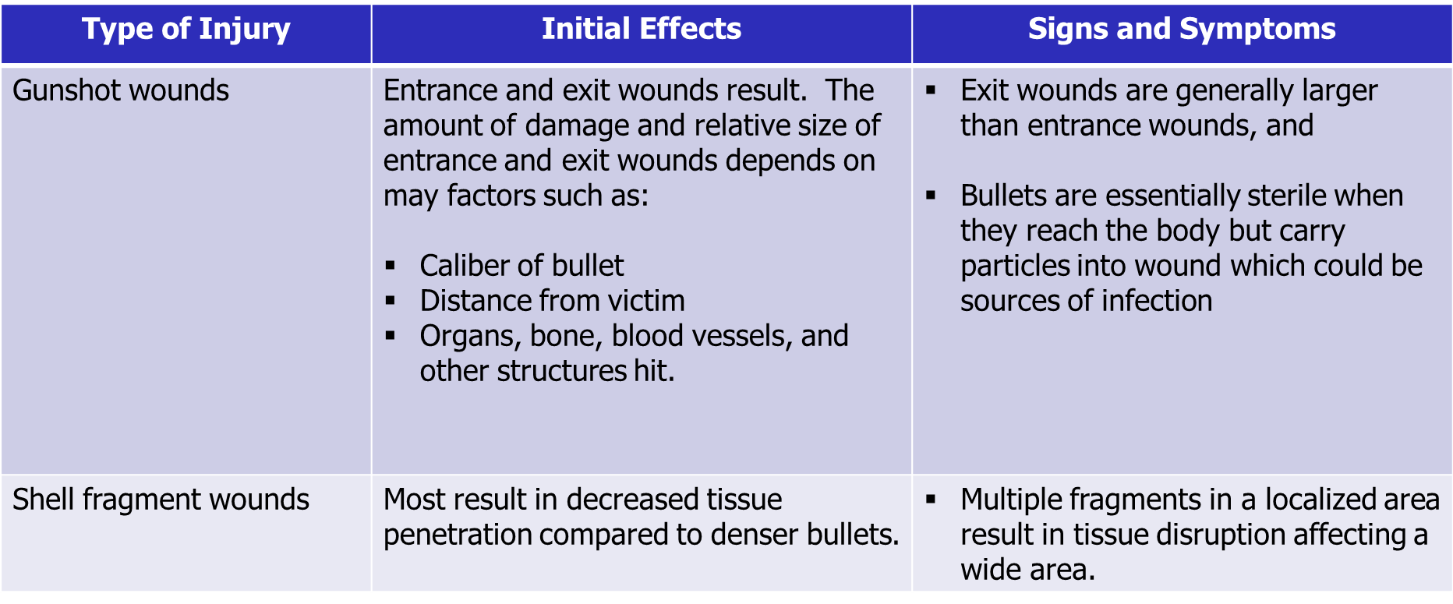
Types of Muscle Injuries  Slide 42  Handout 14 |  | 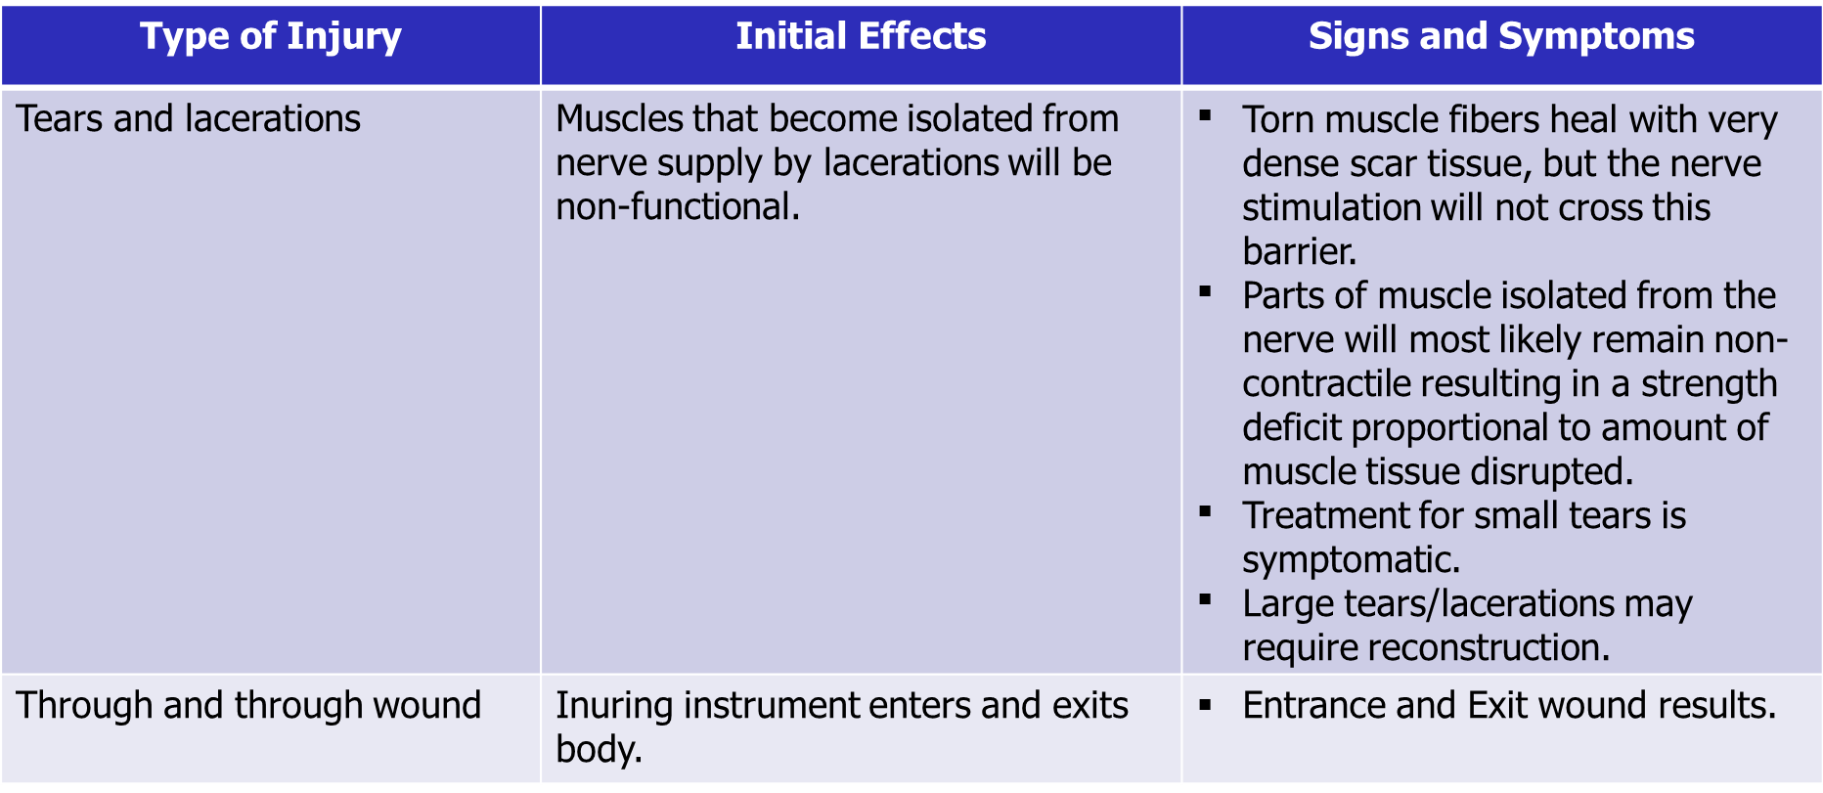
Combined Ratings for Muscle Injuries: PN Paralysis  Slide 43  Handout 14-15 |  | 38 CFR 4.55(a): A muscle injury rating will not be combined with a peripheral nerve paralysis rating of the same body part, unless the injuries affect entirely different functions.  Show and discuss: M21-1 III.iv.4.A.11.j, Considering Peripheral Nerve Involvement in Muscle Injuries  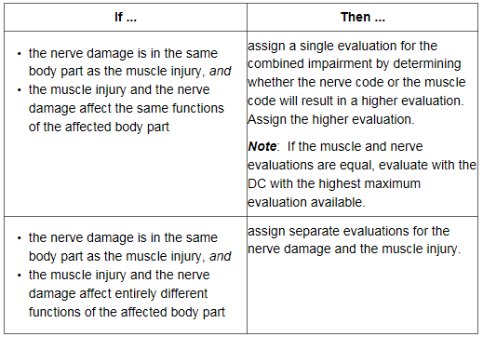  Etiology of the disability is irrelevant in rendering a determination regarding combining evaluations for muscle injuries and peripheral nerve paralysis.  Example: A Veteran is SC for GSW to the right leg MG XI at 10-percent. He develops SC diabetic peripheral neuropathy many years later. The peripheral neuropathy affects the external popliteal nerve. Since MG XI and the external popliteal nerve both control the same functions, dorsiflexion of the foot and extension of the toes, only a single disability evaluation can be assigned under either 38 CFR 4.73, DC 5311 or 38 CFR 4.73, DC 8521, whichever is more advantageous.
Combined Ratings for Muscle Injuries: Ankylosed Joints  Slide 44  Handout 14-15 |  | Explain that 38 CFR 4.55 applies to certain combinations of muscle injuries and joint conditions. When evaluating muscle injuries, they should consider if there are multiple muscle groups involved and whether the muscle group acts on a joint or joints.  Discuss the pertinent rules of Slides 44, 45, and 46.  Important: Show and discuss the following table listed at M21-1 III.iv.4.A.11.g, Applying 38 CFR 4.55 to Muscle Injuries, to assist in evaluating muscle injuries that act on joint or joints.  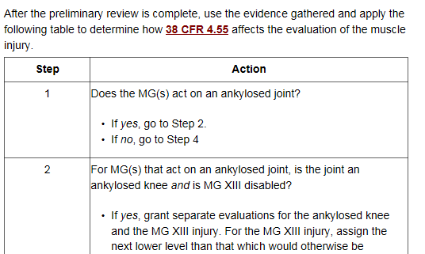  38 CFR 4.55(c): There will be no rating assigned for muscle groups which act upon an ankylosed joint, with the following exceptions:  - In the case of an ankylosed knee, if muscle group XIII is disabled, it will be rated, but at the next lower level than that which would otherwise be assigned.  - In the case of an ankylosed shoulder, if muscle groups I and II are severely disabled, the evaluation of the shoulder joint under diagnostic code 5200 will be elevated to the level for unfavorable ankylosis, if not already assigned, but the muscle groups themselves will not be rated.
Combined Rating for Muscle Injuries: Unankylosed Joint  Slide 45  Handout 14-15 |  | 38 CFR 4.55(d): The combined evaluation of muscle groups acting upon a single unankylosed joint must be lower than the evaluation for unfavorable ankylosis of that joint, except in the case of muscle groups I and II acting upon the shoulder.  If muscle groups I and II are affected and acting on the shoulder, assign separate evaluations for the muscle injuries. The combined evaluation does not have to be lower, but cannot exceed the evaluation for unfavorable ankylosis of the shoulder.
Combined Rating for Muscle Injuries: Anatomical Regions  Slide 46  Handout 14-15 |  | 38 CFR 4.55(e): For compensable muscle group injuries which are in the same anatomical region but do not act on the same joint, the evaluation for the most severely injured muscle group will be increased by one level and used as the combined evaluation for the affected muscle groups.  38 CFR 4.55(f): For muscle group injuries in different anatomical regions which do not act upon ankylosed joints, each muscle group injury shall be separately rated and the ratings combined under the provisions of §4.25.
Evaluation of Muscle Disabilities  Slides 47  Handout 15 |  | Show 38 CFR 4.73, Schedule of Ratings – Muscle Injuries. Emphasize that the evaluation criteria is based on Slight, Moderate, Moderately Severe, or Severe. Explain that 38 CFR 4.56 provides rating guidelines or categories of level of impairment based on the history and complaint, objective findings, and type of injury.  Muscle injuries are evaluated based on the following:  - History and Complaint: Review for in-service treatment, hospitalization, and cardinal signs and symptoms.  - Objective Findings: Review for types of scarring, metallic fragments, loss of muscle, and impairment of function.  - Type of Injury: Classified as slight, moderate, moderately severe, and severe.  Discuss that Slides 48-55 will cover specific guidelines to consider when assigning the level of disability. Emphasize that the evaluation of muscle disabilities is the result of a multi-factorial consideration; however, there are hallmark traits that are suggestive of certain corresponding evaluations. Highlight that no single factor is controlling for the assignment of a disability evaluation for a muscle injury. The entire evidence picture must be taken into consideration.  Important: Upon completion of slides 48-55, show and discuss the table listed in M21-1 III.iv.4.A.11.d, General Criteria for Muscle Evaluations.
Evaluation of Muscle Disabilities: Specific Guidelines  Slide 48  Handout 16-17 |  | 38 CFR 4.56(a): An open comminuted fracture with muscle or tendon damage will be rated as a severe injury of the muscle group involved unless, for locations such as in the wrist or over the tibia, evidence establishes that the muscle damage is minimal.  38 CFR 4.56(b): A through-and-through injury with muscle damage shall be evaluated as no less than a moderate injury for each group of muscles damaged.
Evaluation of Muscle Disabilities: Cardinal Signs and Symptoms  Slide 49  Handout 16-17 |  | 38 CFR 4.56(c): For VA rating purposes, the cardinal signs and symptoms of muscle disability are loss of power, weakness, lowered threshold of fatigue, fatigue-pain, impairment of coordination and uncertainty of movement.
Slight Muscle Injury  Slide 50  Handout 16-17 |  | 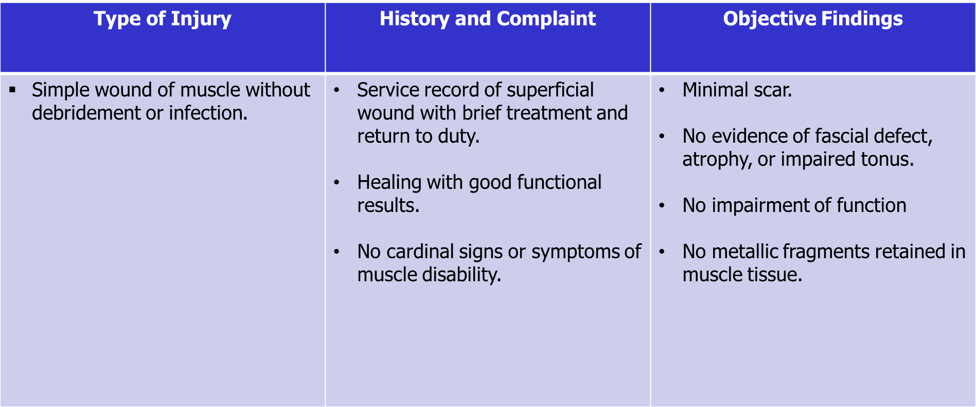
Moderate Muscle Injury  Slide 51  Handout 16-17 |  | 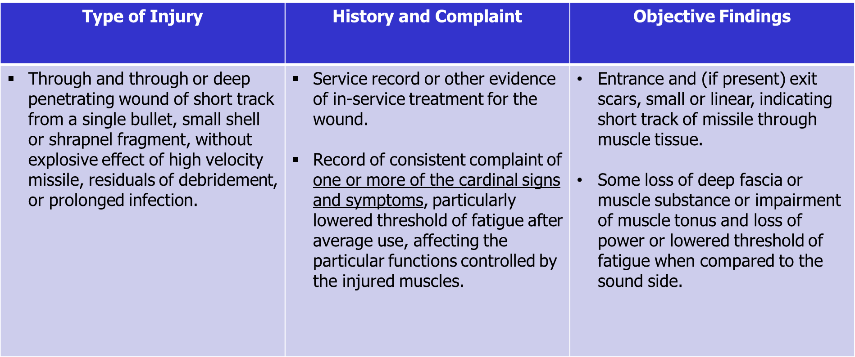
Moderately Severe Muscle Injury  Slide 52  Handout 16-17 |  | 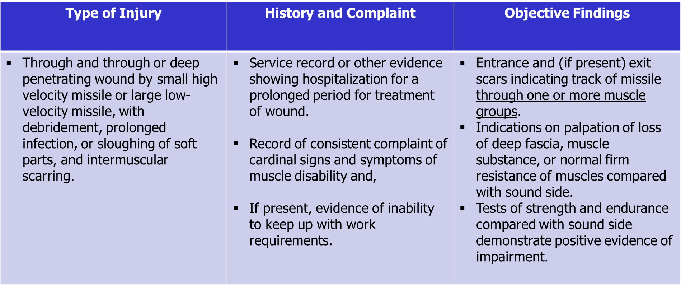
Severe Muscle Injury  Slides 53  Handout 16-17 |  | 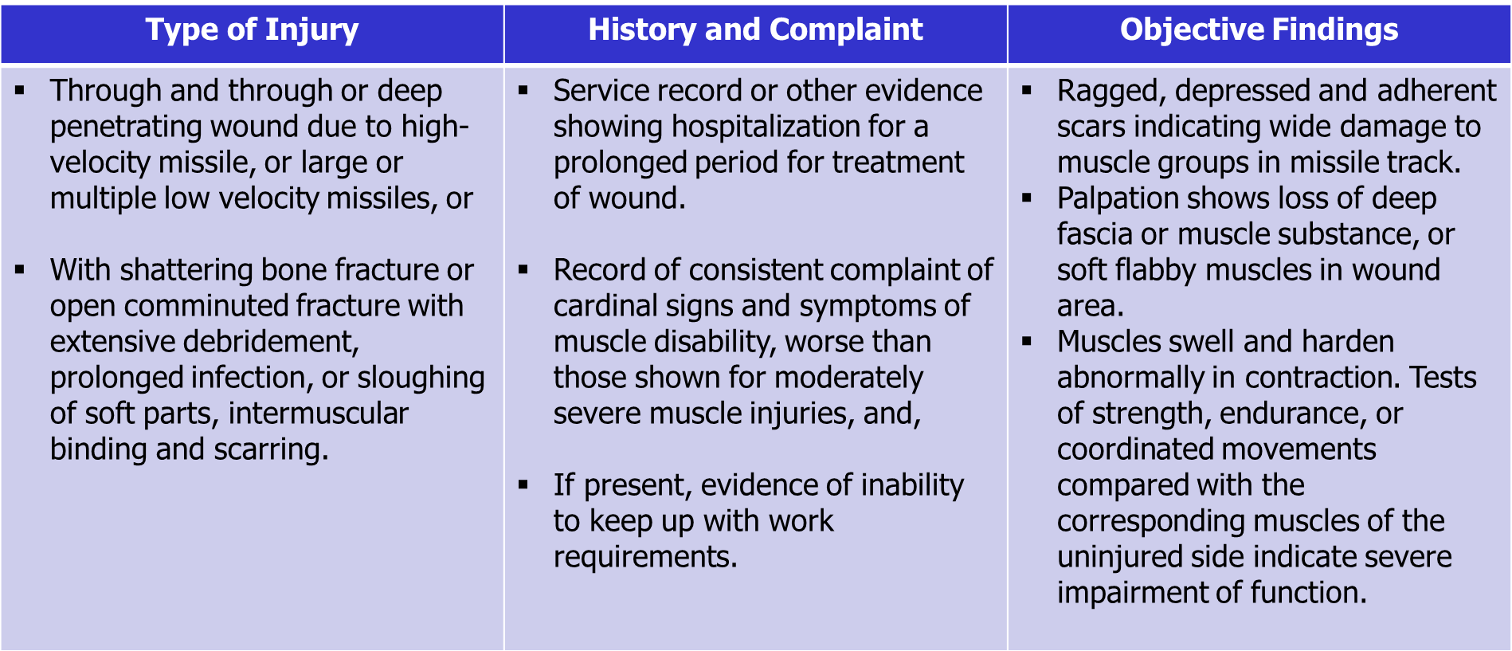
Severe Muscle Injury  Slide 54  Handout 16-17 |  | If present, the following are also signs of severe muscle disability:  - X-ray evidence of minute multiple scattered foreign bodies indicating intermuscular trauma and explosive effect of the missile.  - Adhesion of scar to one of the long bones, scapula, pelvic bones, sacrum or vertebrae, with epithelial sealing over the bone rather than true skin covering in an area where bone is normally protected by muscle.  - Diminished muscle excitability to pulsed electrical current in electrodiagnostic tests.
Severe Muscle Injury  Slide 55  Handout 16-17 |  | Visible or measurable atrophy.  Adaptive contraction of an opposing group of muscles.  Atrophy of muscle groups not in the track of the missile, particularly of the trapezius and serratus in wounds of the shoulder girdle.  Induration or atrophy of an entire muscle following simple piercing by a projectile.
Important Reminders for Muscle Injuries  Slide 56  Handout 18 |  | Rate all Disabilities  - All manifestations of a muscle injury affecting different bodily functions are separately ratable.  Amputation Rule  - The combined rating for residuals of a muscle injury to an upper or lower extremity, with certain exceptions related to osteomyelitis, cannot exceed the rating for amputation at the elective level, were amputation to be performed. 38 CFR 4.68
Important Reminders for Muscle Injuries  Slide 57  Handout 18 |  | Pleural Cavity Injury and MG XXI  - Separate ratings for a pleural cavity injury (diagnostic code 6800) and injury to Muscle Group XXI are prohibited. 38 CFR 4.97, Diagnostic Codes 6840 to 6845, note 3.  Pleural Cavity Injury and MG I & IV  - Disabling injuries of shoulder girdle muscles (Groups I and IV) shall be separately rated and combined with respiratory involvement. 38 CFR 4.97, Diagnostic Codes 6840 to 6845, note 3.
Important Reminders for Muscle Injuries  Slide 58  Handout 18 |  | Open Comminuted Fracture = Severe Muscle Rating  - Open comminuted fracture with muscle or tendon damage will be rated as a severe injury of the muscle group involved unless, for locations such as in the wrist or over the tibia, evidence establishes that the muscle damage is minimal. 38 CFR 4.56(a)  GSW/SFW Fractures Considered Open  - All GSW/SFW fractures should be considered open because all of them involve an opening to the outside. Most GSW/FSW fractures are also comminuted due to the shattering nature of the injury.
Important Reminders for Muscle Injuries  Slide 59  Handout 18 |  | Through and Through Muscle Injury = No less than Moderate  - Through and through injury with muscle damage shall be evaluated no less than a moderate injury for each muscle group affected. 38 CFR 4.56(b)  Special Monthly Compensation for Loss of Use  - Consider special monthly compensation for loss of use of any extremity or loss of use of both buttocks.
Important Reminders for Muscle Injuries  Slide 60  Handout 18 |  | Muscles Disability Benefits Questionnaire (DBQ)  - The examination report must include information to adequately identify the MG affected by either:  - specifically noting which MG is affected, or  - noting which muscles are involved so that the name of the muscles may be used to identify the MG affected.

Lesson Review, Assessment, and Wrap-up
Introduction | The Amputation Rule, Pyramiding, and Muscle Injury course is complete.  Review each lesson objective and ask the trainees for any questions or comments.
Time Required | 0.50 hours
Lesson Objectives | You have completed the Amputation Rule, Pyramiding, and Muscle Injury lesson.  The trainee should be able to:  - define the amputation rule and understand exceptions to the rule  - identify the elective level of amputations and demonstrate application of the amputation rule  - recognize how the amputation rule applies to osteomyelitis  - obtain a working knowledge of how to apply the amputation rule in VBMS-R  - define pyramiding and understand the prohibition against pyramiding  - recognize specific pyramiding principles applicable to each of the body systems  - understand types of muscles, muscle groups, and muscle injuries  - demonstrate knowledge of combining ratings for muscle injuries (38 CFR 4.55)  - demonstrate knowledge of the evaluation of muscle disabilities (38 CFR 4.56)
Assessment | Remind the trainees to complete the online assessment in TMS to receive credit for completion of the course.  The assessment will allow the participants to demonstrate their understanding of the information presented in this lesson.  The survey will allow participants to provide feedback on how Compensation Service can enhance the training course.

