Amputation Rule, Pyramiding, and Muscle Injury
Trainee Handout
Table of Contents

Objectives 1
References 1
Topic 1: Amputation Rule 2
Topic 2: Pyramiding 6
Topic 3: Muscles and Muscle Injuries 12

Objectives
This lesson is intended to provide students with instruction regarding the amputation rule, pyramiding, and evaluating muscle injuries. This lesson will contain discussions and exercises that will allow you to accomplish the following lesson objectives:
The RVSR or DRO will be able to:

- define the amputation rule and understand exceptions to the rule
- identify the elective level of amputations and demonstrate application of the amputation rule
- recognize how the amputation rule applies to osteomyelitis
- obtain a working knowledge of how to apply the amputation rule in VBMS-R
- define pyramiding and understand the prohibition against pyramiding
- recognize specific pyramiding principles applicable to each of the body systems
- understand types of muscles, muscle groups, and muscle injuries
- demonstrate knowledge of combining ratings for muscle injuries (38 CFR 4.55)
- demonstrate knowledge of the evaluation of muscle disabilities (38 CFR 4.56)

References
All M21-1 references are found in the Live Manual Website.

- 38 CFR 4.68, Amputation Rule
- 38 CFR 4.14, Avoidance of Pyramiding
- 38 CFR 4.59, Painful Motion
- 38 CFR 4.71a, Schedule of Ratings-Musculoskeletal System, DC 5120-5126, Amputations: Upper Extremity; and, 5160-5173, Amputations: Lower Extremity
- 38 CFR 4.55, Principles of Combined Ratings for Muscle Injuries
- 38 CFR 4.56, Evaluation of Muscle Disabilities
- 38 CFR 4.73, Schedule of Ratings-Muscle Injuries
- 38 CFR 4.96, Special Provisions Regarding Evaluation of Respiratory Conditions
- 38 CFR 4.115, Nephritis
- 38 CFR 4.114, Schedule of Ratings – Digestive System
- 38 CFR 3.310(d), Traumatic Brain Injury
- 38 CFR 4.126, Evaluation of Disability from Mental Disorders
- 38 CFR 4.150, Dental and Oral Conditions
- M21-1 Part III, Subpart iv, 4.A, Musculoskeletal Conditions
- M21-1 Part III, Subpart iv, 4.B.2.b, Considering Impairments of Both Visual Acuity and Visual Field
- M21-1 Part III, Subpart iv, 4.G, Neurological Conditions and Convulsive Disorders
- M21-1 Part III, Subpart iv, 4.J, Skin Conditions
- M21-1 Part III, Subpart iv, 6.D.10.a, Sample Draft Code-sheet, Amputation Rule
- VBMS Job Aid, Amputation Rule and VBMS-R
- Compensation and Pension Medical EPSS
- Esteban v. Brown, 6 Vet. App. 259, 261-62(1994)

Topic 1: Amputation Rule
Topic objectives:
- Define the amputation rule and understand exceptions to the rule.
- Identify the elective level for amputations and demonstrate application of the amputation rule.
- Recognize how the amputation rule applies to osteomyelitis.
- Obtain a working knowledge of how to apply the amputation rule in VBMS-R.

38 CFR 4.68: Amputation Rule
The combined rating for disabilities of an extremity shall not exceed the rating for the amputation at the elective level, were amputation to be performed. For example, the combined evaluations for disabilities below the knee shall not exceed the 40 percent evaluation, diagnostic code 5165. This 40 percent rating may be further combined with evaluation for disabilities above the knee but not to exceed the above the knee amputation elective level. Painful neuroma of a stump after amputation shall be assigned the evaluation for the elective site of amputation.

The amputation rule is included in the musculoskeletal section of the rating schedule and, consequently, applies only to musculoskeletal disabilities and not to disabilities affecting other body systems.
Exceptions to the amputation rule:
- Any peripheral nerve injury, associated with the musculoskeletal injury, will be considered when applying the amputation rule.
- Actual amputation with associated neuroma will be evaluated at the next higher site of elective re-amputation.
- The amputation rule does not apply to bilateral evaluations under DCs 5276-5279.
- The amputation rule does not apply when temporary evaluations are assigned to an extremity, such as Paragraph 29 and 30.

The elective level for amputations for the upper and lower extremities can be found at 38 CFR 4.71a, Schedule of Ratings – Musculoskeletal System (DCs 5120-5125 and 5160-5173)

Identifying the Elective Level of Amputations: Lower Extremity |  | 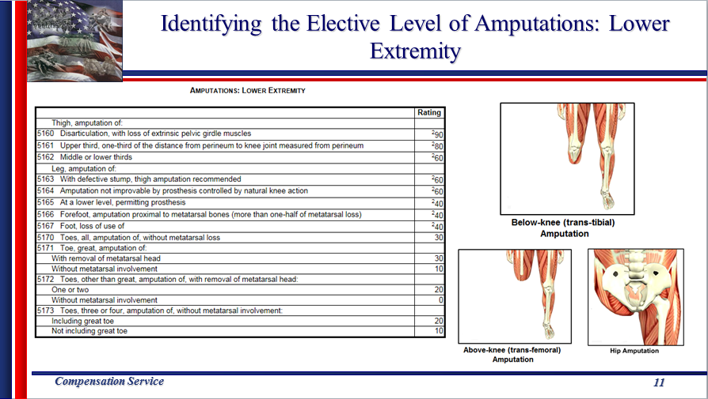
Identifying the Elective Level of Amputations: Upper Extremity |  | 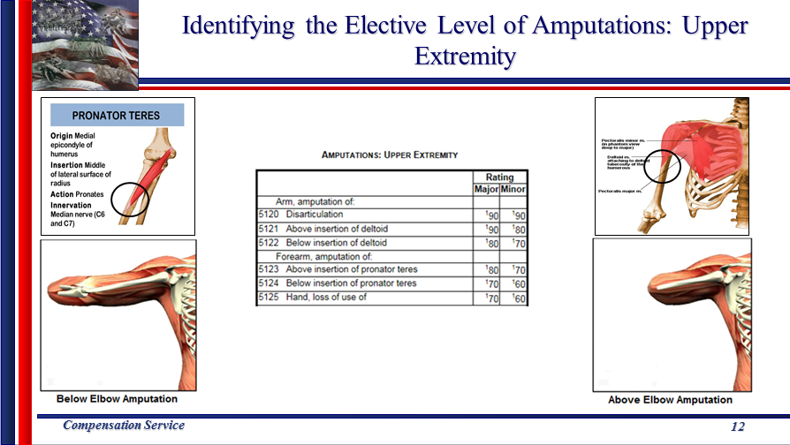
Applying the Amputation Rule |  | 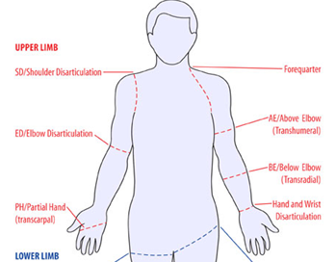  - If there is limitation of flexion of the left (minor) elbow evaluated at 40%, limitation of extension of the left elbow evaluated at 20%, prosthetic replacement of the left wrist evaluated as 30%, and three digits ankylosed in the left hand at 30%, the combined evaluation of the left extremity would be 80% disabling.  - Because amputation of the forearm above insertion of the pronator teres is evaluated as 70% disabling in the minor extremity, the amputation rule would be applied and a 70% combined evaluation would be assigned.  - If the disabilities were present in the major extremity, there would be no violation of the amputation rule, as amputation of the forearm above insertion of the pronator teres in the major extremity is evaluated as 80% disabling.
Applying the Amputation Rule |  | 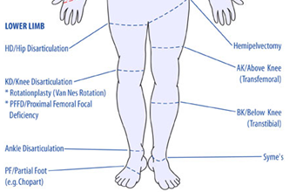  - If there is malunion of the right tibia and fibula with marked ankle disability rated 30% and right flat foot rated at 30%, the combined evaluation of the right leg below the knee would equal 50% disabling.  - Because the loss of use or amputation below the knee is evaluated as 40% disabling, the amputation rule would be applied and a 40% combined evaluation would be assigned.  - If the flat foot condition was rated as bilateral at 30%, then all the conditions could be combined. The amputation rule does not apply to bilateral evaluations under DCs 5276-5279. The combined overall rating of 60% would not be a violation of the amputation rule as only the 30% evaluation for the right tibia and fibula would be considered for the right lower extremity.
Amputation Rule and Osteomyelitis (DC 5000) |  | The amputation rule DOES NOT apply if:  - the osteomyelitis evaluation is 10% based on active osteomyelitis of a body part where the evaluation would normally be 0 percent, or  - the osteomyelitis evaluation is 60% based on constitutional symptoms of osteomyelitis.  The amputation rule DOES apply if:  - the osteomyelitis evaluation is 10% based on active osteomyelitis of a body part where the evaluation would normally be 0 percent, or  - 30% or less under DC 5000, AND  - combined with evaluations for ankylosis, limited motion, nonunion or malunion, shortening, or other musculoskeletal impairment.
Amputation Rule within VBMS-R |  | Please refer to the VBMS Job Aid for instructions on how to apply the amputation rule within VBMS-R.  Important: Note that the example in the VBMS Job Aid for applying the amputation rule is not correct as same considers bilateral flat feet for application. See the codesheet provided below in Slide 16 for an accurate portrayal of the amputation rule.  **The VBMS Job Aid for applying the amputation rule has been scheduled to be corrected, however, same has not been updated as of July 2016.  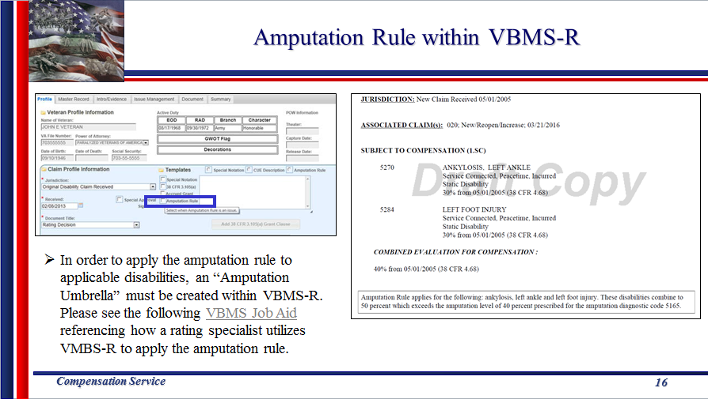

Topic 2: Pyramiding
Topic objectives:
- Define pyramiding and understand the prohibition against pyramiding.
- Recognize specific pyramiding principles applicable to each of the body systems.

38 CFR 4.14, Avoidance of Pyramiding
The evaluation of the same disability under various diagnoses is to be avoided. Disability from injuries to the muscles, nerves, and joints of an extremity may overlap to a great extent, so that special rules are included in the appropriate bodily system for their evaluation. Dyspnea, tachycardia, nervousness, fatigability, etc., may result from many causes; some may be service connected, others, not. Both the use of manifestations not resulting from service-connected disease or injury in establishing the service-connected evaluation, and the evaluation of the same manifestation under different diagnoses are to be avoided.

Pyramiding: Joints and Pain | 38 CFR 4.59 does not permit separate compensable evaluations for each painful joint motion.  When each qualifying joint motion is painful but motion is not actually limited to a compensable degree under its applicable 52XX-series DC, only one compensable evaluation can be assigned.  When more than one qualifying joint motion is actually limited to a compensable degree and there is painful but otherwise non-compensable limitation of the complementary movement(s), only one compensable evaluation can be assigned.
Pyramiding: Musculoskeletal Conditions | Degenerative Arthritis: Separate evaluations under diagnostic code 5003 with any other joint evaluation based on limitation of motion or painful motion, due to degenerative arthritis, is prohibited.  Forearm: Do not assign a compensable evaluation for both limitation of pronation and limitation of supination of the forearm in the same extremity.  Fibromyalgia: The criteria for the evaluation of fibromyalgia does not exclude assignment of separate evaluations when secondary disabilities are diagnosed. The same signs and symptoms; however, cannot be used to assign separate evaluations under different DCs.
IVDS: If the evaluation of IVDS is based on incapacitating episodes, a separate evaluation may not be assigned for limitation of motion, radiculopathy, or any other associated objective neurological abnormality.
Arthroplasty: Once joint replacement occurs, separate evaluations for range of motion and/or instability in the joint is prohibited.
Meniscus (semilunar cartilage): Do not assign separate evaluations for a meniscus disability (DC 5258/DC 5259) and limitation of motion in the same knee OR with subluxation/lateral instability.

Shin Splints: If the evaluation of shin splints is based on impairment of the knee and/or ankle joint, do not assign separate evaluations for shin splints and the applicable joint(s).
Ankle Instability: Separate evaluations for limitation of motion and instability of the ankle are prohibited.
Pes Planus/Plantar Fasciitis: When SC is established for both pes planus and plantar fasciitis, the symptoms of both symptoms are evaluated together under DC 5276 and cannot be separately evaluated.

Muscles: A separate evaluation cannot be assigned for each muscle within a single muscle group.
Muscles/Joints: 38 CFR 4.55, Principles of Combined Ratings for Muscle Injuries
Muscles/Peripheral Nerves: A muscle injury and a peripheral nerve paralysis of the same body part, whether associated with the muscle injury OR originating from other etiologies, may not be rated separately unless entirely different functions are affected.

Pyramiding: Organs of Special Sense | Vision: Separate evaluations cannot be assigned for impairments of both visual acuity and visual field defect. The evaluations must be combined as a single disability.  Meniere’s Syndrome: Do not combine an evaluation for hearing impairment, tinnitus, or vertigo with an evaluation of Meniere’s disease under DC 6205.
Pyramiding: Respiratory Conditions | Co-existing Respiratory Conditions: 38 CFR 4.96(a)  - Ratings under DCs 6600-6817 and 6822-6847 cannot be separately evaluated.  - Where there is lung or pleural involvement, ratings under DCs 6819 and 6820 cannot be separately evaluated from each other or the DCs noted above.  - Single ratings are assigned under the diagnostic code which reflects the predominant disability with elevation to the next higher evaluation when the severity of the overall disability warrant such elevation.  GSW and Respiratory: Separate evaluations for restrictive lung disease due to gunshot wound and muscle group XXI cannot be assigned.
Pyramiding: Cardiovascular | Hypertension: Evaluate hypertension due to aortic insufficiency or hyperthyroidism, as part of the condition causing it rather than by a separate evaluation.  Cardiovascular and Nephritis: 38 CFR 4.115 Separate ratings are not to be assigned for disability from disease of the heart (which includes hypertension) and any form of nephritis unless there is absence of a kidney or regular dialysis is required.  Cold Injury: Separately diagnosed residuals of cold injuries, such as Raynaud’s phenomenon, muscle atrophy, etc., cannot be assigned as separate evaluations if they are used to support an evaluation under DC 7122.
Pyramiding: Digestive | 38 CFR 4.114: Evaluations of digestive conditions under certain DCs will not be combined with each other or assigned separate evaluations. Instead, a single evaluation should be assigned under the DC which reflects the predominant disability, with elevation to the next higher evaluation when the severity of the overall disability warrants such elevation.  Do not combine separate evaluations of digestive conditions with each other under the following 38 CFR 4.114 DCs:  - 7301 to 7329, inclusive (meaning all the DCs from 7301 to 7329)  - 7331  - 7342, and  - 7345 to 7348, inclusive (meaning all the DCs from 7345 to 7348).
Pyramiding: Endocrine | Diabetic Complications:  - Evaluate compensable complications of diabetes mellitus separately unless they are a part of the criteria used to support a 100-percent evaluation under DC 7913.  - Non-compensable complications of diabetes mellitus are considered part of the diabetic process under DC 7913.  Hyperthyroidism: Symptoms of hyperthyroidism used to support the evaluation of other DCs; or, granted as separate disabilities, cannot be used to support an evaluation under DC 7900.
Pyramiding: Traumatic Brain Injury | Multiple Evaluations: In addition to the evaluation for TBI manifestations under DC 8045, separate evaluations of comorbid mental, neurologic, or other physical disorder can be assigned unless the manifestation was used to assign an evaluation under DC 8045.  TBI and Vertigo: A separate evaluation of vertigo cannot be assigned. Vertigo is a subjective symptom that is already considered in the facets of TBI criteria.
TBI and Mental Disorder: Sufficiently clear and unequivocal medical opinion evidence must be present to determine whether TBI and a mental disorder are distinct and can be separately evaluated.
38 CFR 3.310(d) established five conditions held to be secondary to TBI dependent on the initial severity of the TBI and the period of time between the injury and onset of the secondary illness. Avoid pyramiding when considering the initial TBI evaluation and symptoms that are now associated with the five secondary conditions.

Pyramiding: Peripheral Nerves | Upper Extremities: Separate evaluations may not be assigned for disability affecting multiple nerve branches of the same upper extremity.  Lower Extremities: Separate evaluations for disability affecting lower extremity nerves are warranted when symptoms arise from any of the five individual nerve branches.  - If symptoms arise from within the same nerve branch of any of the five individual nerve branches in the lower extremity, assigning separate evaluation for those symptoms would constitute pyramiding.
Pyramiding: ALS/MS | Amyotrophic Lateral Sclerosis (ALS): If a single 100 percent evaluation is warranted for a complication of ALS, assign a 100 percent for that complication and separately evaluate additional complications. Do not assign a separate evaluation under DC 8017; however, as this would constitute pyramiding.  Multiple Sclerosis (MS): Residuals of MS are evaluated separately when the combined evaluation for the residuals are 30 percent or greater. When residuals are separately evaluated, the minimum evaluation under DC 8018 may not be concurrently assigned.
Pyramiding: Mental | Physical/Mental Disorders: When a single disability has been diagnosed both as a physical condition and as a mental disorder, the rating agency shall evaluate it using a DC which represents the dominant (more disabling) aspect of the condition.  - To warrant separate evaluations, the symptoms considered must be distinct and not overlap.
Pyramiding: Skin and Scars | Disfigurement: Multiple scars may not be added together to meet the width of scarring requirement under characteristics of disfigurement.  Painful Scar(s): A separate evaluation for a painful scar under DC 7804 may be assigned when the functional impairment is:  - distinct and separate from the functional impairment addressed by another DC, and is not,  - duplicative or overlapping with symptomatology addressed under another DC.
Scars associated with Muscle Injury: If there is scarring that results in functional loss under DC 7805 that is compensable, do not assign a separate evaluation if the body part affected and the functional impairment resulting from the scar are the same as the part and function affected by the muscle injury.

Alternative Rating Criteria: When evaluating skin conditions where the DC offers variable methods to evaluate the disability, assign only a single evaluation using the criteria that results in the higher rating. Do not assign separate evaluations.

Example:

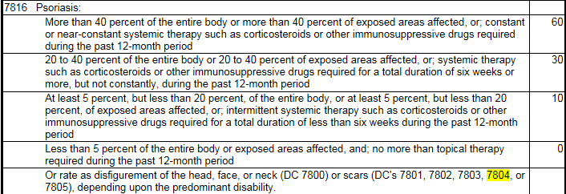

Pyramiding: Multiple Skin Conditions | Percentage of Exposed Skin/Entire Body Affected: Multiple skin conditions may receive separate evaluations based on the percentage of exposed areas affected by each skin condition.  If an examiner cannot provide separate percentages solely due to each skin condition, separate evaluations cannot be assigned using that criteria alone.  Medication Criteria: If the same medication is used to treat each skin condition, separate evaluations may not be assigned unless the separately evaluated condition uses alternative criteria to establish a disability evaluation.
Pyramiding: Dental and Oral Conditions | Inter-Incisal Motion: In assigning an evaluation for TMJ or any other dental disability on the basis of limited motion of temporomandibular articulation under DC 9905, do not assign separate evaluations for limited inter-incisal motion involving each side of the jaw.  - If both sides of the jaw are affected, use the limitation of motion on the side that affords the highest evaluation.

Topic 3: Muscles and Muscle Injuries
Topic objectives:
- Understand types of muscles, muscle groups, and muscle injuries.
- Demonstrate knowledge of combining ratings for muscle injuries.
- Demonstrate knowledge of the evaluation of muscle disabilities.

Types of Muscles | Three types of muscle structures:  - Striated (skeletal) – Muscles that are attached to bones by tendons, producing movement under conscious control. Movement occurs when stimulated muscle fibers contract to change the position of the bones at a joint.  - Cardiac – An involuntary muscle not under conscious control, forms the heart wall, and creates the pulsing beat of the heart.  - Smooth – Involuntary muscles found in the walls of hollow body organs, blood vessels, and respiratory passageways.
Muscle Groups | Review 38 CFR 4.73, Schedule or Ratings – Muscle Injuries.  Note how the muscle groups are numbered and categorized by anatomical region. (Example DC 5301 is muscle group #1, DC 5302 is muscle group #2)  Access the Muscle Group Graphic Catalog in Medical EPSS.  Rating Job Aids > Medical EPSS > Tools > Graphic Catalog > Muscle Groups  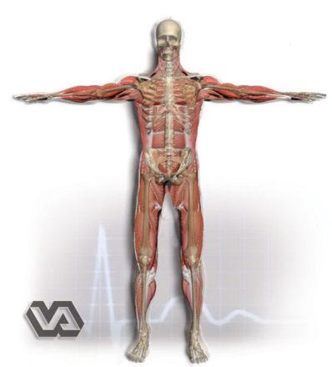
Types of Muscle Injuries | 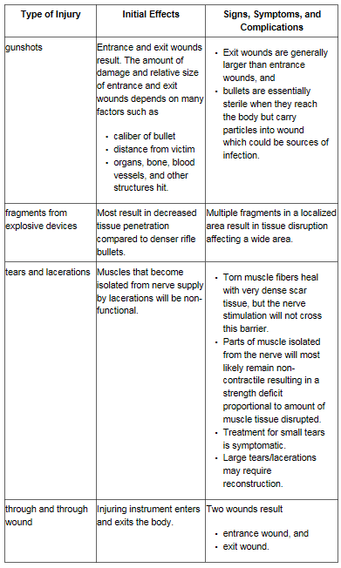
Combined Ratings for Muscle Injuries:
38 CFR 4.55
(a) A muscle injury rating will not be combined with a peripheral nerve paralysis rating of the same body part, unless the injuries affect entirely different functions.
(b) For rating purposes, the skeletal muscles of the body are divided into 23 muscle groups in 5 anatomical regions: 6 muscle groups for the shoulder girdle and arm (diagnostic codes 5301 through 5306); 3 muscle groups for the forearm and hand (diagnostic codes 5307 through 5309); 3 muscle groups for the foot and leg (diagnostic codes 5310 through 5312); 6 muscle groups for the pelvic girdle and thigh (diagnostic codes 5313 through 5318); and 5 muscle groups for the torso and neck (diagnostic codes 5319 through 5323).
(c) There will be no rating assigned for muscle groups which act upon an ankylosed joint, with the following exceptions:
(1) In the case of an ankylosed knee, if muscle group XIII is disabled, it will be rated, but at the next lower level than that which would otherwise be assigned.
(2) In the case of an ankylosed shoulder, if muscle groups I and II are severely disabled, the evaluation of the shoulder joint under diagnostic code 5200 will be elevated to the level for unfavorable ankylosis, if not already assigned, but the muscle groups themselves will not be rated.
(d) The combined evaluation of muscle groups acting upon a single unankylosed joint must be lower than the evaluation for unfavorable ankylosis of that joint, except in the case of muscle groups I and II acting upon the shoulder.
(e) For compensable muscle group injuries which are in the same anatomical region but do not act on the same joint, the evaluation for the most severely injured muscle group will be increased by one level and used as the combined evaluation for the affected muscle groups.
(f) For muscle group injuries in different anatomical regions which do not act upon ankylosed joints, each muscle group injury shall be separately rated and the ratings combined under the provisions of §4.25

Evaluation of Muscle Disabilities
Muscle injuries are evaluated based on the following:
- History and Complaint: Review for in-service treatment, hospitalization, and cardinal signs and symptoms.

- Objective Findings: Review for types of scarring, metallic fragments, loss of muscle, and impairment of function.

- Type of Injury: Classified as slight, moderate, moderately severe, and severe.

38 CFR 4.56 Evaluation of Muscle Disabilities.
(a) An open comminuted fracture with muscle or tendon damage will be rated as a severe injury of the muscle group involved unless, for locations such as in the wrist or over the tibia, evidence establishes that the muscle damage is minimal.
(b) A through-and-through injury with muscle damage shall be evaluated as no less than a moderate injury for each group of muscles damaged.
(c) For VA rating purposes, the cardinal signs and symptoms of muscle disability are loss of power, weakness, lowered threshold of fatigue, fatigue-pain, impairment of coordination and uncertainty of movement.
(d) Under diagnostic codes 5301 through 5323, disabilities resulting from muscle injuries shall be classified as slight, moderate, moderately severe or severe as follows:
(1) Slight disability of muscles—
(i) Type of injury. Simple wound of muscle without debridement or infection.
(ii) History and complaint. Service department record of superficial wound with brief treatment and return to duty. Healing with good functional results. No cardinal signs or symptoms of muscle disability as defined in paragraph (c) of this section.
(iii) Objective findings. Minimal scar. No evidence of fascial defect, atrophy, or impaired tonus. No impairment of function or metallic fragments retained in muscle tissue.
(2) Moderate disability of muscles—
(i) Type of injury. Through and through or deep penetrating wound of short track from a single bullet, small shell or shrapnel fragment, without explosive effect of high velocity missile, residuals of debridement, or prolonged infection.
(ii) History and complaint. Service department record or other evidence of in-service treatment for the wound. Record of consistent complaint of one or more of the cardinal signs and symptoms of muscle disability as defined in paragraph (c) of this section, particularly lowered threshold of fatigue after average use, affecting the particular functions controlled by the injured muscles.
(iii) Objective findings. Entrance and (if present) exit scars, small or linear, indicating short track of missile through muscle tissue. Some loss of deep fascia or muscle substance or impairment of muscle tonus and loss of power or lowered threshold of fatigue when compared to the sound side.
(3) Moderately severe disability of muscles—
(i) Type of injury. Through and through or deep penetrating wound by small high velocity missile or large low-velocity missile, with debridement, prolonged infection, or sloughing of soft parts, and intermuscular scarring.
(ii) History and complaint. Service department record or other evidence showing hospitalization for a prolonged period for treatment of wound. Record of consistent complaint of cardinal signs and symptoms of muscle disability as defined in paragraph (c) of this section and, if present, evidence of inability to keep up with work requirements.
(iii) Objective findings. Entrance and (if present) exit scars indicating track of missile through one or more muscle groups. Indications on palpation of loss of deep fascia, muscle substance, or normal firm resistance of muscles compared with sound side. Tests of strength and endurance compared with sound side demonstrate positive evidence of impairment.
(4) Severe disability of muscles—
(i) Type of injury. Through and through or deep penetrating wound due to high-velocity missile, or large or multiple low velocity missiles, or with shattering bone fracture or open comminuted fracture with extensive debridement, prolonged infection, or sloughing of soft parts, intermuscular binding and scarring.
(ii) History and complaint. Service department record or other evidence showing hospitalization for a prolonged period for treatment of wound. Record of consistent complaint of cardinal signs and symptoms of muscle disability as defined in paragraph (c) of this section, worse than those shown for moderately severe muscle injuries, and, if present, evidence of inability to keep up with work requirements.
(iii) Objective findings. Ragged, depressed and adherent scars indicating wide damage to muscle groups in missile track. Palpation shows loss of deep fascia or muscle substance, or soft flabby muscles in wound area. Muscles swell and harden abnormally in contraction. Tests of strength, endurance, or coordinated movements compared with the corresponding muscles of the uninjured side indicate severe impairment of function.
If present, the following are also signs of severe muscle disability:
(A) X-ray evidence of minute multiple scattered foreign bodies indicating intermuscular trauma and explosive effect of the missile.
(B) Adhesion of scar to one of the long bones, scapula, pelvic bones, sacrum or vertebrae, with epithelial sealing over the bone rather than true skin covering in an area where bone is normally protected by muscle.
(C) Diminished muscle excitability to pulsed electrical current in electrodiagnostic tests.
(D) Visible or measurable atrophy.
(E) Adaptive contraction of an opposing group of muscles.
(F) Atrophy of muscle groups not in the track of the missile, particularly of the trapezius and serratus in wounds of the shoulder girdle.
(G) Induration or atrophy of an entire muscle following simple piercing by a projectile.

Important Reminders for Muscle Injuries
- All manifestations of a muscle injury affecting different bodily functions are separately ratable.
- The combined rating for residuals of a muscle injury to an upper or lower extremity, with certain exceptions related to osteomyelitis, cannot exceed the rating for amputation at the elective level, were amputation to be performed. 38 CFR 4.68

- Separate ratings for a pleural cavity injury (diagnostic code 6800) and injury to Muscle Group XXI are prohibited. 38 CFR 4.97, Diagnostic Codes 6840 to 6845, note 3.
- Disabling injuries of shoulder girdle muscles (Groups I and IV) shall be separately rated and combined with respiratory involvement. 38 CFR 4.97, Diagnostic Codes 6840 to 6845, note 3.

- Open comminuted fracture with muscle or tendon damage will be rated as a severe injury of the muscle group involved unless, for locations such as in the wrist or over the tibia, evidence establishes that the muscle damage is minimal. 38 CFR 4.56(a)
- All GSW/SFW fractures should be considered open because all of them involve an opening to the outside. Most GSW/FSW fractures are also comminuted due to the shattering nature of the injury.

- Through and through injury with muscle damage shall be evaluated no less than a moderate injury for each muscle group affected. 38 CFR 4.56(b)
- Consider special monthly compensation for loss of use of any extremity or loss of use of both buttocks.

Muscles Disability Benefits Questionnaire (DBQ)
The examination report must include information to adequately identify the MG affected by either:
- specifically noting which MG is affected, or
- noting which muscles are involved so that the name of the muscles may be used to identify the MG affected.

